**Awobajo Omotoyosi Samod**

**17059**

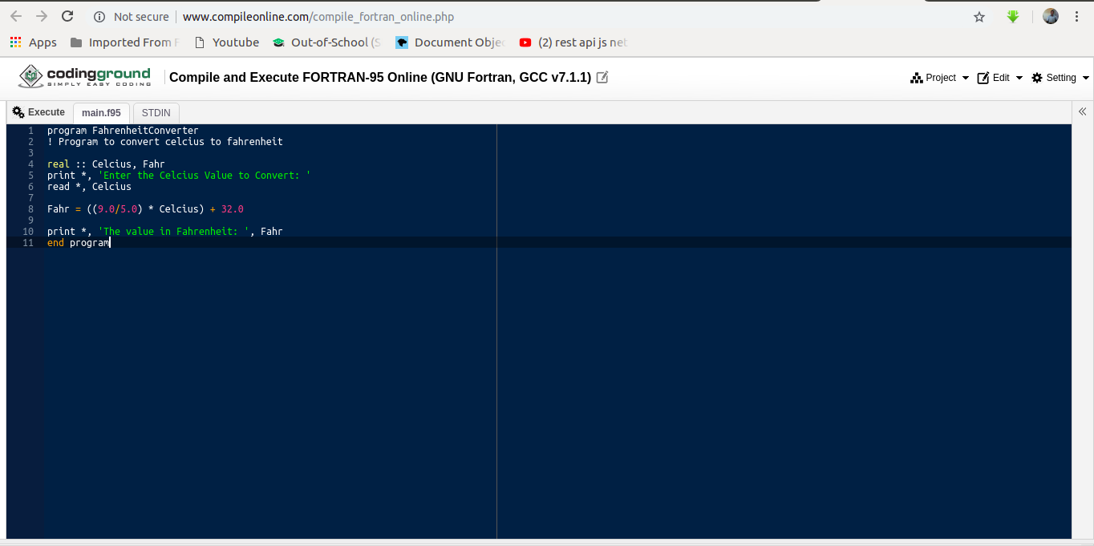

**program FahrenheitConverter**

**! Program to convert celsius to fahrenheit**

**real :: Celsius, Fahr**

**print *, 'Enter the Celsius Value to Convert: '**

**read *, Celcius**

**Fahr = ((9.0/5.0) * Celsius) + 32.0**

**print *, 'The value in Fahrenheit: ', Fahr**

**end program**

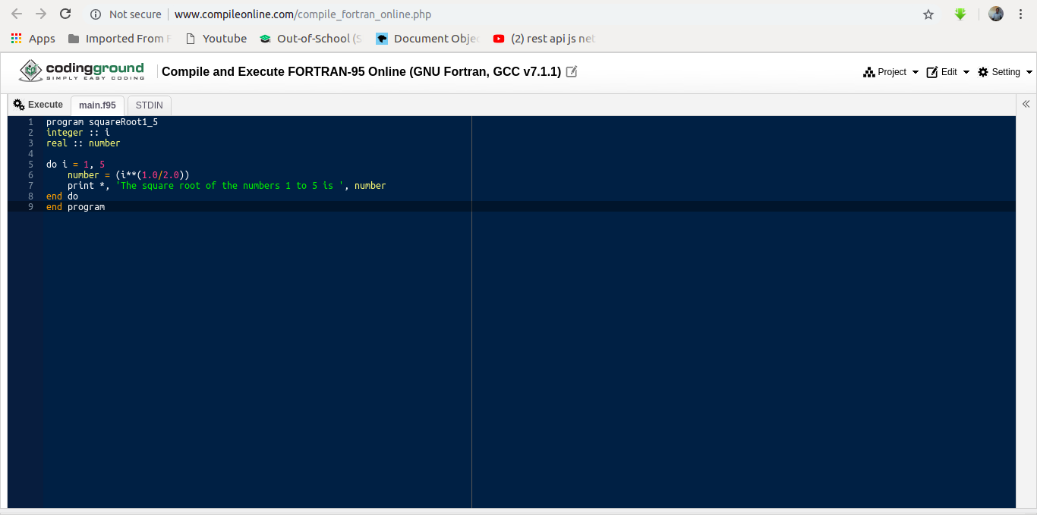

**program squareRoot1_5**

**integer :: i**

**real :: number**

**do i = 1, 5**

**number = (i**(1.0/2.0))**

**print *, 'The square root of the numbers 1 to 5 is ', number**

**end do**

**end program**

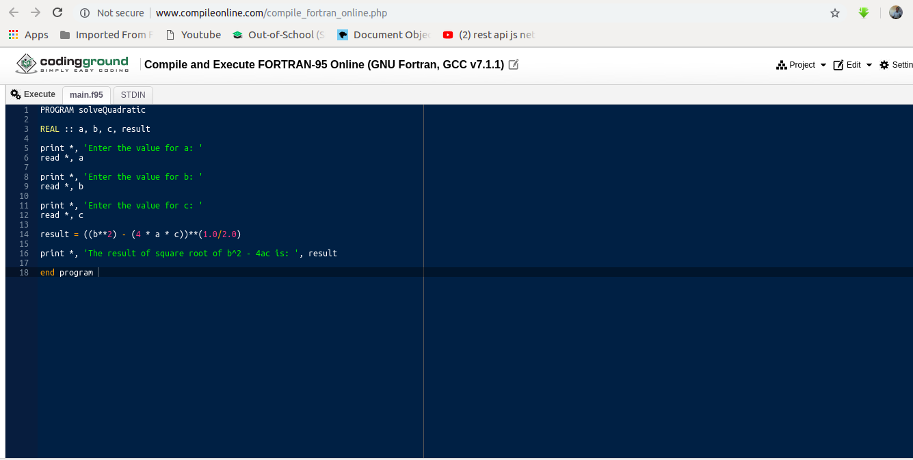

**PROGRAM solveQuadratic**

**real :: a, b, c, result**

**print *, 'Enter the value for a: '**

**read *, a**

**print *, 'Enter the value for b: '**

**read *, b**

**print *, 'Enter the value for c: '**

**read *, c**

**result = ((b**2) - (4 * a * c))**(1.0/2.0)**

**print *, 'The result of square root of b^2 - 4ac is: ', result**

**end program**