**Supporting information**

Table S1. Application rates of N, P, K and organic manure under different fertilization treatments in the paddy and upland fields. The fertilization treatments are: No fertilizer; 50%NPK, 50% mineral fertilizers; NPK, mineral fertilizers; OM, manure amendments; 50%NPK+OM, combined 50% mineral fertilizers and manure amendments.

|  |  |  |  |  |  |  |  |  |  |
| --- | --- | --- | --- | --- | --- | --- | --- | --- | --- |
| Treatments | Paddy (inputs in kg ha-1) | | | |  | Upland (inputs in kg ha-1) | | | |
| N | P2O5 | K2O | M |  | N | P2O5 | K2O | M |
| No fertilizer |  |  |  |  |  |  |  |  |  |
| 50%NPK | 90 | 45 | 75 |  |  | 60 | 30 | 60 |  |
| NPK | 180 | 90 | 150 |  |  | 120 | 60 | 120 |  |
| OM |  |  |  | 22500 |  |  |  |  | 15000 |
| 50%NPK+OM | 90 | 45 | 75 | 22500 |  | 60 | 30 | 60 | 15000 |

Table S2. Results from a Poisson generalized liner models (GLM) testing the effects of fertilization on the abundance of soil nematodes and each trophic group in the rice paddy and the upland maize field. The residual deviance relate to the reference *P*-value of the chi-square test that was used to determine the significance of the model effect.

|  |  |  |  |  |  |  |  |  |  |  |  |  |  |  |  |  |  |  |  |  |  |  |
| --- | --- | --- | --- | --- | --- | --- | --- | --- | --- | --- | --- | --- | --- | --- | --- | --- | --- | --- | --- | --- | --- | --- |
|  |  | Total abundance | | | Herbivores | | |  | | Bacterivores | | |  | | Fungivores | | |  | | Omnivores-carnivores | | |
|  |  | *﻿Residual deviance* | *P*-value | *﻿Residual deviance* | | | *P*-value | |  | | *﻿Residual deviance* | *P*-value | |  | | *﻿Residual deviance* | *P*-value | |  | | *﻿Residual deviance* | *P*-value | |
| Paddy | 4 | 232.8 | <0.0001 | | | 324.4 | <0.0001 | |  | | 137.7 | <0.0001 | |  | | 130.5 | <0.0001 | |  | | 104.9 | <0.0001 | |
| Upland | 4 | 258.7 | <0.0001 | | | 318.3 | <0.0001 | |  | | 167.7 | <0.0001 | |  | | 65.9 | <0.0001 | |  | | 59.9 | <0.0001 | |

Table S3. Results from analysis of variance (ANOVA) testing the effects of fertilization on the diversity of soil nematodes and each trophic group in the rice paddy and the upland maize field.

|  |  |  |  |  |  |  |  |  |  |  |  |  |  |  |  |  |  |
| --- | --- | --- | --- | --- | --- | --- | --- | --- | --- | --- | --- | --- | --- | --- | --- | --- | --- |
|  | df | Total diversity | |  | Herbivores | |  | Bacterivores | |  | Fungivores | |  | | Omnivores-carnivores | | |
|  | *F*-value | *P*-value |  | *F*-value | *P*-value |  | *F*-value | *P*-value |  | *F*-value | *P*-value | |  | | *F*-value | *P*-value |
| Paddy | 4 | 2.19 | 0.142 |  | 0.2 | 0.932 |  | 2.16 | 0.148 |  | 1.86 | 0.195 | |  | | 0.61 | 0.662 |
| Upland | 4 | 5.29 | 0.015 |  | 0.14 | 0.964 |  | 3.64 | 0.044 |  | 3.06 | 0.069 | |  | | 3.72 | 0.042 |

Table S4. Results from analysis of variance (ANOVA) as testing the effects of fertilization on the energy flux of soil nematodes and each trophic group in the rice paddy and the upland maize field.

|  |  |  |  |  |  |  |  |  |  |  |  |  |  |  |  |  |  |  |  |  |  |  |  |
| --- | --- | --- | --- | --- | --- | --- | --- | --- | --- | --- | --- | --- | --- | --- | --- | --- | --- | --- | --- | --- | --- | --- | --- |
|  | df | Total energy flux | |  | | Herbivores | | |  | | Bacterivores | | |  | | Fungivores | | |  | | Omnivores-carnivores | | |
|  | *F*-value | *P*-value | |  | | *F*-value | *P*-value | |  | | *F*-value | *P*-value | |  | | *F*-value | *P*-value | |  | | *F*-value | *P*-value |
| Paddy | 4 | 21.15 | <0.0001 | |  | | 9.87 | 0.002 | |  | | 11.61 | <0.0001 | |  | | 10.86 | 0.001 | |  | | 9.53 | 0.002 |
| Upland | 4 | 3.56 | 0.046 | |  | | 1.46 | 0.28 | |  | | 8.14 | 0.003 | |  | | 4.39 | 0.026 | |  | | 6.71 | 0.007 |

Table S5. Results from analysis of variance (ANOVA) testing the effects of fertilization on the flow uniformity of energy across soil nematodes in the rice paddy and the upland maize field.

|  |  |  |  |  |  |
| --- | --- | --- | --- | --- | --- |
|  | df | Flow uniformity | |  | |
|  | *F*-value | *P*-value | |
| Paddy | 4 | 3.84 | 0.038 | |
| Upland | 4 | 9.76 | 0.002 | |

Table S6. Results from analysis of variance (ANOVA) testing the effects of fertilization on the biomass of soil nematodes and each trophic group in the rice paddy and the upland maize field.

|  |  |  |  |  |  |  |  |  |  |  |  |  |  |  |  |  |  |  |  |  |  |  |
| --- | --- | --- | --- | --- | --- | --- | --- | --- | --- | --- | --- | --- | --- | --- | --- | --- | --- | --- | --- | --- | --- | --- |
|  | df | Total biomass | |  | | Herbivores | | |  | | Bacterivores | |  | | Fungivores | | |  | | Omnivores-carnivores | | |
|  | *F*-value | *P*-value | |  | | *F*-value | *P*-value | |  | *F*-value | *P*-value | |  | | *F*-value | *P*-value | |  | | *F*-value | *P*-value |
| Paddy | 4 | 24.27 | <0.0001 | |  | | 18.56 | <0.0001 | |  | 27.23 | <0.0001 | |  | | 9.78 | 0.002 | |  | | 8.77 | 0.003 |
| Upland | 4 | 5.3 | 0.015 | |  | | 0.86 | 0.522 | |  | 3.76 | 0.041 | |  | | 7.12 | 0.006 | |  | | 6.95 | 0.006 |

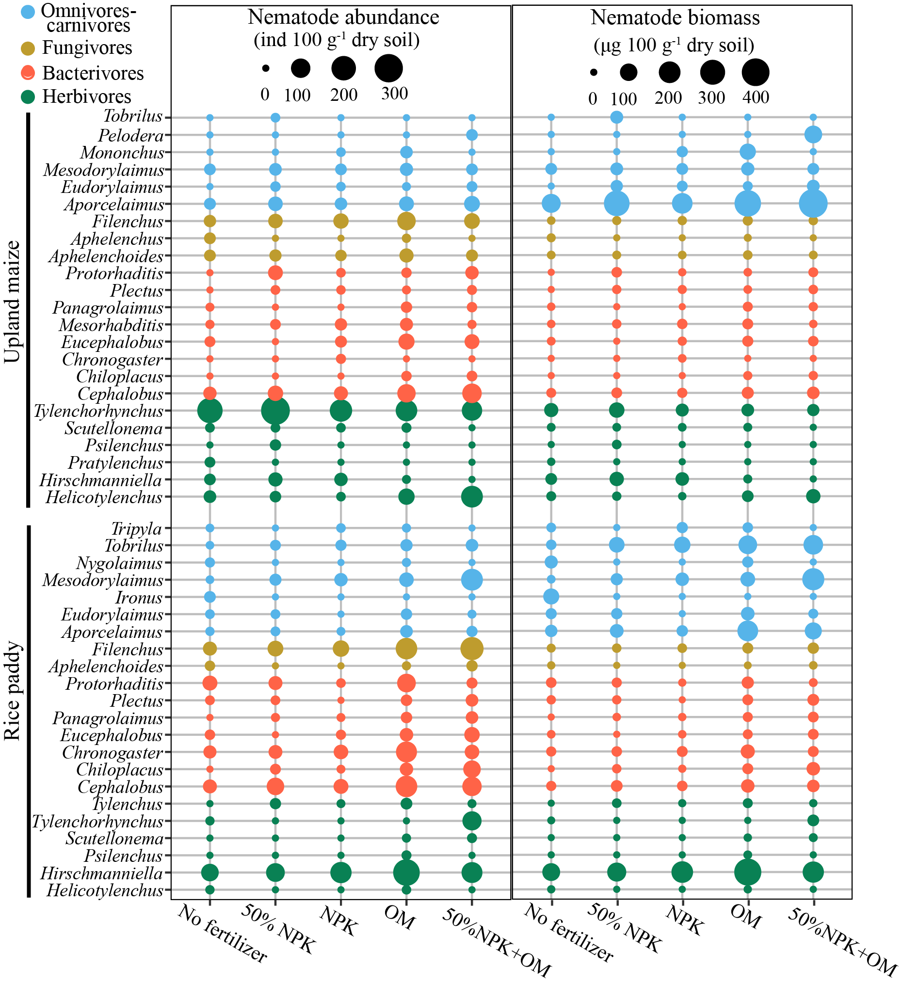Fig. S1. Effects of long-term fertilization on the mean abundance and biomass of nematode genera in the rice paddy and the upland maize field.

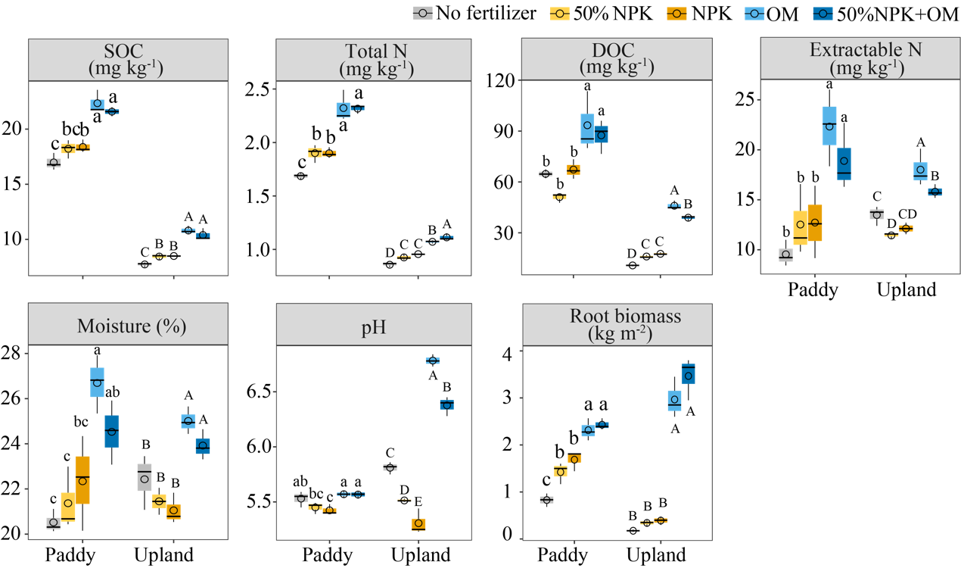Fig. S2. Effects of long-term fertilization on soil organic carbon (SOC), soil total N, dissolved organic carbon (DOC), soil extractable N (ammonium and nitrate), soil moisture, soil pH, and root biomass in the rice paddy and upland maize field. Box plots represent the lower quartile, median and upper quartile values. Black lines and circles in the boxes represent median and mean values of all variables. Different letters above the boxes indicate values that differ significantly among treatments at *p* < 0.05 (LSD’s test) in paddy (a, b, c) and upland (A, B, C) fields.