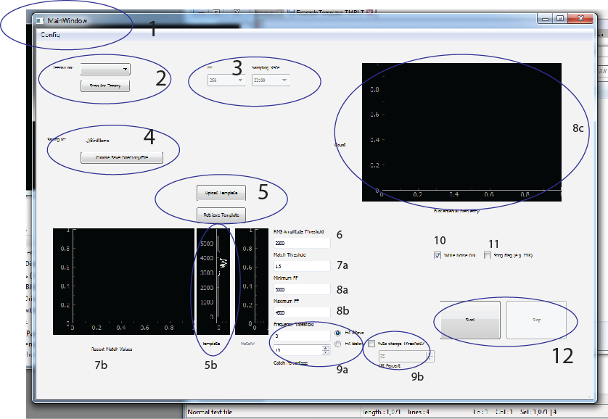

1. Configuration menu (lets you load and save .TAFCFG files- there should be an example in the directory, and it can be changes in the text editor, or exported from the GUI.
2. Scans ports for a Teensy, then lets you pick which Teensy to control.
3. Reads the FFT window (256, 512, or 1024) and the sampling rate (22100 or 44200). These have to be changes in the Teensy code itself. I’ve tried a few things, there are no guarantees that any random combination will work. I like 512/44200 or 22100/256 for fast calculations.
4. Sets a save directory and file name. Files with the name *.TAFLOG will be created here (along with an associated .TAFCFG file with all the parameters being used), and will simply be a comma-delimited string of the Fundamental Frequency, the Hit, and the template match values, along with the current time (in case you want to sync w/ audio recordings).
5. Uploads template to Teensy, or else retrieves the current Template from the Teensy. Should be half the size of the FFT window, and will be displayed in the window in 5b.

Template files end in .TEMPLT, and look like :

[template]

globalvars.template = [-0.1, -0.1, -0.1, -0.1, -0.1, -0.1, -1.1, -1.1, -0.1, -0.1, -1.1, -0.1, -1.1, -0.1, -0.1, -0.1, -0.1, -0.1, -0.1, -0.1, -0.1, -0.1, -0.1, -0.1, -0.1, -0.1, -0.1, -0.1, -0.1, -0.1, -0.1, -0.1, -0.1, -0.1, -0.1, -0.1, -0.1, -0.1, -0.1, -0.1, -0.1, -0.1, -0.1, -0.1, -0.1, -0.1, -0.1, -0.1, -0.1, -0.1, -0.1, -0.1, -0.1, -0.1, -0.1, -0.1, -0.1, -0.1, -0.1, -0.1, -0.1, -0.1, -0.1, -0.1, -0.1, 0.00076923077, -0.1, 0.0015384615, 0.0015384615, 0.0046153846, 0.0076923077, 0.0046153846, 0.0053846152, 0.0061538462, 0.028461538, 0.025384616, 0.0092307692, 0.093846157, 0.19307692, 0.32076922, 0.066153847, 0.57076925, 0.059230771, 0.31846154, 0.49076924, 0.40384614, 0.12307692, 0.27076924, 0.32461539, 0.49000001, 0.037692308, 0.15307692, 0.066923074, 0.026923077, 0.020769231, 0.0038461538, 0.0099999998, 0.012307692, 0.0084615387, 0.0084615387, 0.0061538462, 0.0069230767, 0.0023076923, -0.1, -0.1, -0.1, -0.1, -0.1, -0.1, -0.1, -0.1, -0.1, -0.1, -0.1, -0.1, -0.1, -0.1, -0.1, -0.1, -0.1, -0.1, -0.1, -0.1, -0.1, -0.1, -0.1, -0.1, -0.1]

where the comma delimted values describe the template you want to match to the syllables

1. Sets the RMS amplitude of the audio input. I find 2400-2800 works well, you can set it a little lower to get an earlier start on calculating the FFT (since the FFT calculations don’t start until the audio threshold has been passed- otherwise there are some issues).
2. Match threshold – determined empirically, the last 100 values will be plotted in a histogram in 7b and should be relatively Gaussian unless something is going wrong.
3. Max/Min FFs- tells the teensy which window to look for (first, second, whatever harmonic) for calculating FF estimates. FF estimates are calculated by parabolic interpolation around the peak value within that window. Note that these values should be a few bins apart (e.g. depending on your FFT window, they should be far enough apart that multiple bins are included in the estimates). To increase resolution, you can either increase the FFT window, or else decrease the sampling frequency, although both cause a trade-off in how quickly the syllable will be detected.

9a) Values for FF thresholding- here, you give a value (between FF_MAX and FF_MIN), used as a threshold, and set whether you want to hit syllables above, or below that frequency, as well as the percentage of syllables that are ‘catch’ trials (for e.g. triggering external stimulation).

9b) Adaptive thresholding- this will shift the template to match a given percentile of the current FF distribution (the last 100 syllables sung). It can only either increase, or decrease, depending on whether songs are being shifted up, or down (e.g. Hit Above button, or Hit Below button).

1. Turns WN on/off (and sets everything to Catch files in the TAFLOG files).
2. Arbitratary Flag (sets HIT value in the TAFLOG file to 3, skips WN playback, used for interleaved Directed song without restarting the recording, also flags to easier analysis of HIT/CATCH/DIR trials.
3. START/STOP buttons. Start will upload the current values to the Teensy, retrieve the FFT and Sampling rate values, save all values to a .TAFLOG file, and begin waiting to get data streamed off the Teensy. As FF values come in, once there are >20, the will be plotted in the window above as a histogram (this also helps ensure you’re not hitting multiple similar syllables, since again, this distribution should be relatively unimodal.