

Bosch Sensortec

Restricted data sheet

**BMP180**

Digital pressure sensor

**BMP180 Data sheet**

Document revision 2.8

Document release date May 7th, 2015

Document number BST-BMP180-DS000-12 Technical reference code(s) 0 273 300 244

Notes Data in this document are subject to change without notice. Product

photos and pictures are for illustration purposes only and may differ from the real product’s appearance.

BMP180

DIGITAL PRESSURE SENSOR

## Key features

Pressure range: 300 ... 1100hPa (+9000m ... -500m relating to sea level) Supply voltage: 1.8 3.6V (VDD)

1.62V 3.6V (VDDIO)

Package: LGA package with metal lid

Small footprint: 3.6mm x 3.8mm Super-flat: 0.93mm height

Low power: 5µA at 1 sample / sec. in standard mode

Low noise: 0.06hPa (0.5m) in ultra low power mode 0.02hPa (0.17m) advanced resolution mode

* Temperature measurement included
* I2C interface
* Fully calibrated
* Pb-free, halogen-free and RoHS compliant,
* MSL 1

## Typical applications

* + Enhancement of GPS navigation (dead-reckoning, slope detection, etc.)
  + In- and out-door navigation
  + Leisure and sports
  + Weather forecast
  + Vertical velocity indication (rise/sink speed)

## BMP180 general description

The BMP180 is the function compatible successor of the BMP085, a new generation of high precision digital pressure sensors for consumer applications.

The ultra-low power, low voltage electronics of the BMP180 is optimized for use in mobile phones, PDAs, GPS navigation devices and outdoor equipment. With a low altitude noise of merely 0.25m at fast conversion time, the BMP180 offers superior performance. The I2C interface allows for easy system integration with a microcontroller.

The BMP180 is based on piezo-resistive technology for EMC robustness, high accuracy and linearity as well as long term stability.

Robert Bosch is the world market leader for pressure sensors in automotive applications. Based on the experience of over 400 million pressure sensors in the field, the BMP180 continues a new generation of micro-machined pressure sensors.

**Index of Contents**

1. ELECTRICAL CHARACTERISTICS 6
2. ABSOLUTE MAXIMUM RATINGS 8
3. OPERATION 9
   1. GENERAL DESCRIPTION 9
   2. GENERAL FUNCTION AND APPLICATION SCHEMATICS 9
   3. MEASUREMENT OF PRESSURE AND TEMPERATURE 11
      1. Hardware pressure sampling accuracy modes 12
      2. Software pressure sampling accuracy modes 13
   4. CALIBRATION COEFFICIENTS 13
   5. CALCULATING PRESSURE AND TEMPERATURE 14
   6. CALCULATING ABSOLUTE ALTITUDE 16
   7. CALCULATING PRESSURE AT SEA LEVEL 17
4. GLOBAL MEMORY MAP 18
5. I2C INTERFACE 19
   1. I2C SPECIFICATION 19
   2. DEVICE AND REGISTER ADDRESS 20
   3. I2C PROTOCOL 20
   4. START TEMPERATURE AND PRESSURE MEASUREMENT 21
   5. READ A/D CONVERSION RESULT OR E2PROM DATA 22
6. PACKAGE 23
   1. PIN CONFIGURATION 23
   2. OUTLINE DIMENSIONS 24
      1. Bottom view 24
      2. Top view 25
      3. Side view 25
   3. MOISTURE SENSITIVITY LEVEL AND SOLDERING 26
   4. ROHS COMPLIANCY 26
   5. MOUNTING AND ASSEMBLY RECOMMENDATIONS 26
7. LEGAL DISCLAIMER 27
   1. ENGINEERING SAMPLES 27
   2. PRODUCT USE 27
   3. APPLICATION EXAMPLES AND HINTS 27
8. DOCUMENT HISTORY AND MODIFICATION 28

# Electrical characteristics

If not stated otherwise, the given values are ±3-Sigma values over temperature/voltage range in the given operation mode. All values represent the new parts specification; additional solder drift is shown separately.

Table 1: Operating conditions, output signal and mechanical characteristics

|  |  |  |  |  |  |  |
| --- | --- | --- | --- | --- | --- | --- |
| **Parameter** | **Symbol** | **Condition** | **Min** | **Typ** | **Max** | **Units** |
| Operating temperature | TA | operational | -40 |  | +85 | °C |
| full accuracy | 0 |  | +65 |
| Supply voltage | VDD | ripple max. 50mVpp | 1.8 | 2.5 | 3.6 | V |
|  | 1.62 | 2.5 | 3.6 |
| Supply current @ 1 sample / sec.  25°C | IDDLOW | ultra low power mode |  | 3 |  | µA |
| IDDSTD | standard mode |  | 5 |  | µA |
| IDDHR | high resolution mode |  | 7 |  | µA |
| IDDUHR | Ultra high res. mode |  | 12 |  | µA |
| IDDAR | Advanced res. mode |  | 32 |  | µA |
| Peak current | Ipeak | during conversion |  | 650 |  | µA |
| Standby current | IDDSBM | @ 25°C |  | 0.1 | 41 | µA |
| Relative accuracy pressure  VDD = 3.3V |  | 950 . . . 1050 hPa  @ 25 °C |  | ±0.12 |  | hPa |
|  | ±1.0 |  | m |
|  | 700 … 900hPa  25 . . . 40 °C |  | ±0.12 |  | hPa |
|  | ±1.0 |  | m |
| Absolute accuracy pressure  VDD = 3.3V |  | 300 . . . 1100 hPa  0 . . . +65 °C | -4.0 | -1.0* | +2.0 | hPa |
|  | 300 . . . 1100 hPa  -20 . . . 0 °C | -6.0 | -1.0* | +4.5 | hPa |
| Resolution of output data |  | pressure |  | 0.01 |  | hPa |
|  | temperature |  | 0.1 |  | °C |
| Noise in pressure |  | see table on page 12-13 | | | | |
| Absolute accuracy temperature VDD = 3.3V |  | @ 25 °C | -1.5 | ±0.5 | +1.5 | °C |
|  | 0 . . . +65 °C | -2.0 | ±1.0 | +2.0 | °C |

1 at 85°C

|  |  |  |  |  |  |  |
| --- | --- | --- | --- | --- | --- | --- |
| Conversion time pressure | tc_p_low | ultra low power mode |  | 3 | 4.5 | ms |
| tc_p_std | standard mode |  | 5 | 7.5 | ms |
| tc_p_hr | high resolution mode |  | 9 | 13.5 | ms |
| tc_p_luhr | ultra high res. mode |  | 17 | 25.5 | ms |
| tc_p_ar | Advanced res. mode |  | 51 | 76.5 | ms |
| Conversion time temperature | tC_temp | standard mode |  | 3 | 4.5 | ms |
| Serial data clock | fSCL |  |  |  | 3.4 | MHz |
| Solder drifts |  | Minimum solder height 50µm | -0.5 |  | +2 | hPa |
| Long term stability** |  | 12 months |  | ±1.0 |  | hPa |

* The typical value is: -1±1

** Long term stability is specified in the full accuracy operating pressure range 0 … 65°C

# Absolute maximum ratings

Table 2: Absolute maximum ratings

|  |  |  |  |  |
| --- | --- | --- | --- | --- |
| **Parameter** | **Condition** | **Min** | **Max** | **Units** |
| Storage temperature |  | -40 | +85 | °C |
| Supply voltage | all pins | -0.3 | +4.25 | V |
| ESD rating | HBM, R = 1.5kΩ, C = 100pF |  | ±2 | kV |
| Overpressure |  |  | 10,000 | hPa |

The BMP180 has to be handled as Electrostatic Sensitive Device (ESD).

Figure 1: ESD

# Operation

## General description

The BMP180 is designed to be connected directly to a microcontroller of a mobile device via the I2C bus. The pressure and temperature data has to be compensated by the calibration data of the E2PROM of the BMP180.

## General function and application schematics

The BMP180 consists of a piezo-resistive sensor, an analog to digital converter and a control unit with E2PROM and a serial I2C interface. The BMP180 delivers the uncompensated value of pressure and temperature. The E2PROM has stored 176 bit of individual calibration data. This is used to compensate offset, temperature dependence and other parameters of the sensor.

* UP = pressure data (16 to 19 bit)
* UT = temperature data (16 bit)

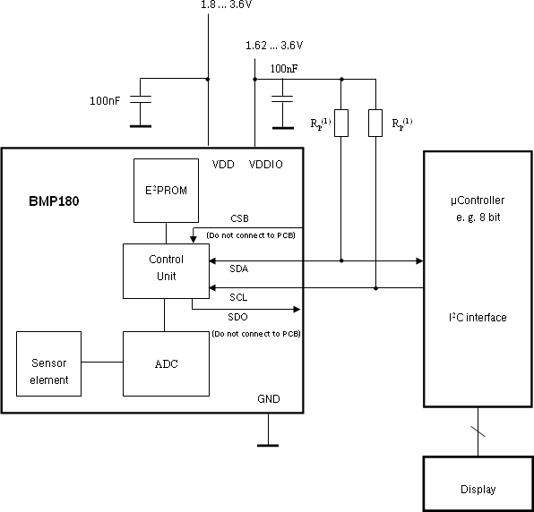

Note:

(1) Pull-up resistors for I2C bus, Rp = 2.2kΩ ... 10kΩ, typ. 4.7kΩ

Figure 2: Typical application circuit

## Measurement of pressure and temperature

For all calculations presented here an ANSI C code is available from Bosch Sensortec (“BMP180

_API”).

The microcontroller sends a start sequence to start a pressure or temperature measurement. After converting time, the result value (UP or UT, respectively) can be read via the I2C interface. For calculating temperature in °C and pressure in hPa, the calibration data has to be used. These constants can be read out from the BMP180 E2PROM via the I2C interface at software initialization.

The sampling rate can be increased up to 128 samples per second (standard mode) for dynamic measurement. In this case, it is sufficient to measure the temperature only once per second and to use this value for all pressure measurements during the same period.

Start

Start temperature measurement

wait 4.5 ms

Read UT

Start pressure measurement

wait (depends on mode, see below)

Read UP

Calculate pressure and temperature in physical units

Figure 3: Measurement flow BMP180

## Hardware pressure sampling accuracy modes

By using different modes the optimum compromise between power consumption, speed and resolution can be selected, see below table.

Table 3: Overview of BMP180 hardware accuracy modes, selected by driver software via the variable *oversampling_setting*

|  |  |  |  |  |  |  |
| --- | --- | --- | --- | --- | --- | --- |
| **Mode** | **Parameter**  ***oversampling_setting*** | **Internal number of samples** | **Conversion time pressure max. [ms]** | **Avg. current @ 1 sample/s typ. [µA]** | **RMS**  **noise typ.**  **[hPa]** | **RMS**  **noise typ.**  **[m]** |
| ultra low power | 0 | 1 | 4.5 | 3 | 0.06 | 0.5 |
| standard | 1 | 2 | 7.5 | 5 | 0.05 | 0.4 |
| high resolution | 2 | 4 | 13.5 | 7 | 0.04 | 0.3 |
| ultra high resolution | 3 | 8 | 25.5 | 12 | 0.03 | 0.25 |

For further information on noise characteristics see the relevant application note “Noise in pressure sensor applications”.

All modes can be performed at higher speeds, e.g. up to 128 times per second for standard mode, with the current consumption increasing proportionally to the sample rate.

## Software pressure sampling accuracy modes

For applications where a low noise level is critical, averaging is recommended if the lower bandwidth is acceptable. Oversampling can be enabled using the software API driver (with OSR = 3).

Table 4: Overview of BMP180 software accuracy mode, selected by driver software via the variable

*software_oversampling_setting*

|  |  |  |  |  |  |  |
| --- | --- | --- | --- | --- | --- | --- |
| **Mode** | **Parameter**  ***oversampling_setting*** | **software_ oversampl ing_settin**  **g** | **Conversion time pressure**  **max. [ms]** | **Avg. current @ 1 sample/s**  **typ. [µA]** | **RMS noise typ. [hPa]** | **RMS noise typ. [m]** |
| Advanced resolution | 3 | 1 | 76.5 | 32 | 0.02 | 0.17 |

## Calibration coefficients

The 176 bit E2PROM is partitioned in 11 words of 16 bit each. These contain 11 calibration coefficients. Every sensor module has individual coefficients. Before the first calculation of temperature and pressure, the master reads out the E2PROM data.

The data communication can be checked by checking that none of the words has the value 0 or 0xFFFF.

Table 5: Calibration coefficients

|  |  |  |
| --- | --- | --- |
|  | **BMP180 reg adr** | |
| **Parameter** | **MSB** | **LSB** |
| AC1 | 0xAA | 0xAB |
| AC2 | 0xAC | 0xAD |
| AC3 | 0xAE | 0xAF |
| AC4 | 0xB0 | 0xB1 |
| AC5 | 0xB2 | 0xB3 |
| AC6 | 0xB4 | 0xB5 |
| B1 | 0xB6 | 0xB7 |
| B2 | 0xB8 | 0xB9 |
| MB | 0xBA | 0xBB |
| MC | 0xBC | 0xBD |
| MD | 0xBE | 0xBF |

## Calculating pressure and temperature

The mode (ultra low power, standard, high, ultra high resolution) can be selected by the variable

*oversampling_setting* (0, 1, 2, 3) in the C code.

Calculation of true temperature and pressure in steps of 1Pa (= 0.01hPa = 0.01mbar) and temperature in steps of 0.1°C.

The following figure shows the detailed algorithm for pressure and temperature measurement.

This algorithm is available to customers as reference C source code (“BMP180_ API”) from Bosch Sensortec and via its sales and distribution partners. **Please contact your Bosch Sensortec representative for details.**

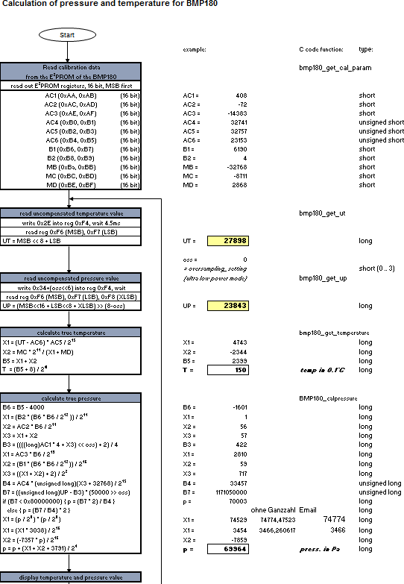

Figure 4: Algorithm for pressure and temperature measurement

## Calculating absolute altitude

With the measured pressure *p* and the pressure at sea level *p*0 e.g. 1013.25hPa, the altitude in meters can be calculated with the international barometric formula:

 1 

  p  5.255 

altitude  44330 * 1 -  p  

  0  

 

Thus, a pressure change of ∆*p* = 1hPa corresponds to 8.43m at sea level.

9000

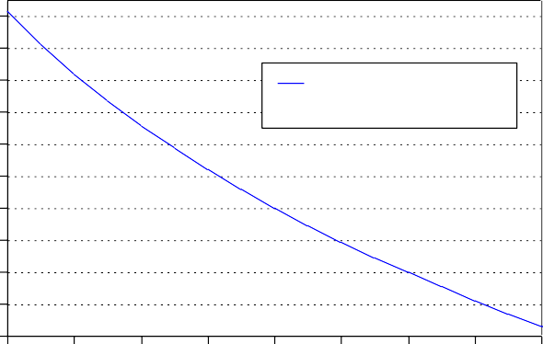

Altitude in standard atmosphere

**Altitude above sea level [m]**

8000

7000

6000

5000

4000

3000

2000

1000

0

-1000

**Barometric pressure [hPa]**

Figure 5**:** Transfer function: Altitude over sea level – Barometric pressure

## Calculating pressure at sea level

With the measured pressure *p* and the absolute altitude the pressure at sea level can be calculated:

p0 

1 -





p altitude 5.255



44330 

Thus, a difference in altitude of ∆altitude = 10m corresponds to 1.2hPa pressure change at sea level.

# Global Memory Map

The memory map below shows all externally accessible data registers which are needed to operate BMP180. The left columns show the memory addresses. The columns in the middle depict the content of each register bit. The colors of the bits indicate whether they are read-only, write-only or read- and writable. The memory is volatile so that the writable content has to be re-written after each power-on.

Not all register addresses are shown. These registers are reserved for further Bosch factory testing and trimming.

|  |  |  |  |  |  |  |  |  |  |  |
| --- | --- | --- | --- | --- | --- | --- | --- | --- | --- | --- |
| **Register Name** | **Register Address** | **bit7** | **bit6** | **bit5** | **bit4** | **bit3** | **bit2** | **bit1** | **bit0** | **Reset** |
| **out_xlsb** | F8h | adc_out_xlsb<7:3 | | | | | 0 | 0 | 0 | 00h |
| **out_lsb** | F7h | adc_out_msb<7:0> | | | | | | | | 00h |
| **out_msb** | F6h |  | |  | adc_out_lsb<7:0 | | | | | 80h |
| **ctrl_meas** | F4h | oss<1:0> | | sco | measurement | | | | | 00h |
| **soft** | E0h | reset | | | | | | | | 00h |
| **id** | D0h | id<7:0> | | | | | | | | 55h |
| **calib21 downto calib0** | BFh *down*to AAh | calib21<7:0>*down*to calib0<7:0> | | | | | | | | n/a |

**Registers:**

|  |  |  |  |
| --- | --- | --- | --- |
| Control | Calibration | Dat |  |
| registers | registers | registers | Fixed |

**Type:**

Figure 6: Memory map

**Measurement control (register F4h <4:0>)**: Controls measurements. Refer to Figure 6 for usage details.

**Sco (register F4h <5>):** Start of conversion. The value of this bit stays “1” during conversion and is reset to “0” after conversion is complete (data registers are filled).

**Oss (register F4h <7:6>)**: controls the oversampling ratio of the pressure measurement (00b: single, 01b: 2 times, 10b: 4 times, 11b: 8 times).

**Soft reset (register E0h)**: Write only register. If set to 0xB6, will perform the same sequence as power on reset.

**Chip-id (register D0h)**: This value is fixed to 0x55 and can be used to check whether communication is functioning.

After conversion, data registers can be read out in any sequence (i.e. MSB first or LSB first). Using a burst read is not mandatory.

# I2C Interface

* I2C is a digital two wire interface
* Clock frequencies up to 3.4Mbit/sec. (I2C standard, fast and high-speed mode supported)
* SCL and SDA needs a pull-up resistor, typ. 4.7kOhm to VDDIO (one resistor each for all the I2C bus)

The I2C bus is used to control the sensor, to read calibration data from the E2PROM and to read the measurement data when A/D conversion is finished. SDA (serial data) and SCL (serial clock) have open-drain outputs.

For detailed I2C-bus specification please refer to: <http://www.nxp.com/acrobat_download/literature/9398/39340011.pdf>

## I2C specification

Table 6: Electrical parameters for the I2C interface

|  |  |  |  |  |  |
| --- | --- | --- | --- | --- | --- |
| **Parameter** | **Symbol** | **Min.** | **Typ** | **Max.** | **Units** |
| Clock input frequency | fSCL |  |  | 3.4 | MHz |
| Input-low level | VIL | 0 |  | 0.2 * VDDIO | V |
| Input-high level | VIH | 0.8 * VDDIO |  | VDDIO | V |
| Voltage output low level @ VDDIO = 1.62V, IOL = 3mA | VOL |  |  | 0.3 | V |
| SDA and SCL pull-up resistor | Rpull-up | 2.2 |  | 10 | kOhm |
| SDA sink current  @ VDDIO = 1.62V, VOL = 0.3V | ISDA_sink |  | 9 |  | mA |
| Start-up time after power-up, before first communication | tStart | 10 |  |  | Ms |

## Device and register address

The BMP180 module address is shown below. The LSB of the device address distinguishes between read (1) and write (0) operation, corresponding to address 0xEF (read) and 0xEE (write).

Table 7: BMP180 addresses

**A7 A6 A5 A4 A3 A2 A1**

1 1 1 0 1 1 1

**W/R**

0/1

## I2C protocol

The I2C interface protocol has special bus signal conditions. Start (S), stop (P) and binary data conditions are shown below. At start condition, SCL is high and SDA has a falling edge. Then the slave address is sent. After the 7 address bits, the direction control bit R/W selects the read or write operation. When a slave device recognizes that it is being addressed, it should acknowledge by pulling SDA low in the ninth SCL (ACK) cycle.

At stop condition, SCL is also high, but SDA has a rising edge. Data must be held stable at SDA when SCL is high. Data can change value at SDA only when SCL is low.

Even though VDDIO can be powered on before VDD, there is a chance of excessive power consumption (a few mA) if this sequence is used, and the state of the output pins is undefined so that the bus can be locked. Therefore, VDD *must* be powered before VDDIO unless the limitations above are understood and not critical.

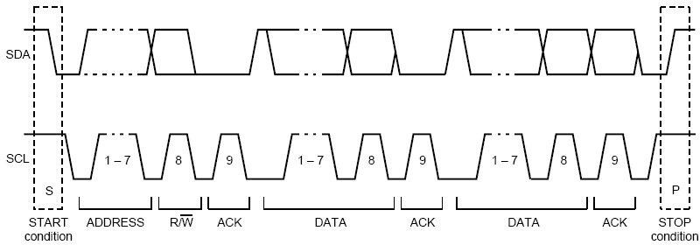

Figure 7**:** I2C protocol

## Start temperature and pressure measurement

The timing diagrams to start the measurement of the temperature value UT and pressure value UP are shown below. After start condition the master sends the device address write, the register address and the control register data. The BMP180 sends an acknowledgement (ACKS) every 8 data bits when data is received. The master sends a stop condition after the last ACKS.

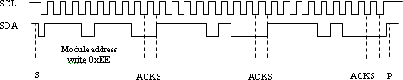

Figure 8: Timing diagram for starting pressure measurement

Abbreviations:

S Start

P Stop

ACKS Acknowledge by Slave

ACKM Acknowledge by Master NACKM Not Acknowledge by Master

Table 8: Control registers values for different internal oversampling_setting (oss)

|  |  |  |
| --- | --- | --- |
| **Measurement** | **Control register value (register address 0xF4)** | **Max. conversion time [ms]** |
| Temperature | 0x2E | 4.5 |
| Pressure (oss = 0) | 0x34 | 4.5 |
| Pressure (oss = 1) | 0x74 | 7.5 |
| Pressure (oss = 2) | 0xB4 | 13.5 |
| Pressure (oss = 3) | 0xF4 | 25.5 |

## Read A/D conversion result or E2PROM data

To read out the temperature data word UT (16 bit), the pressure data word UP (16 to 19 bit) and the E2PROM data proceed as follows:

After the start condition the master sends the module address write command and register address. The register address selects the read register:

E2PROM data registers 0xAA to 0xBF

Temperature or pressure value UT or UP 0xF6 (MSB), 0xF7 (LSB), optionally 0xF8 (XLSB)

Then the master sends a restart condition followed by the module address read that will be acknowledged by the BMP180 (ACKS). The BMP180 sends first the 8 MSB, acknowledged by the master (ACKM), then the 8 LSB. The master sends a "not acknowledge" (NACKM) and finally a stop condition.

Optionally for ultra high resolution, the XLSB register with address 0xF8 can be read to extend the 16 bit word to up to 19 bits; refer to the application programming interface (API) software rev. 1.1 (“BMP180_ API”, available from Bosch Sensortec).

SCL SDA

Module address write 0xEE

Register address

e.g. 0xF6

Module address read 0xEF

MSB e.g.

ADC result 0x5C

LSB e.g.

ADC result 0x96

S ACKS

ACKS

Restart

ACKS

ACKM

NACKM P

Figure 9: Timing diagram read 16 bit A/D conversion result

1. **Package**

## Pin configuration

Picture shows the device in top view. Device pins are shown here transparently only for orientation purposes.

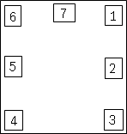

1

7

6

2

5

3

4

Figure 10: Layout pin configuration BMP180

Table 9: Pin configuration BMP180

|  |  |  |
| --- | --- | --- |
| **in No** | **Name** | **Function** |
| 1 | CSB* | Chip select |
| 2 | VDD | Power supply |
| 3 | VDDIO | Digital power supply |
| 4 | SDO* | SPI output |
| 5 | SCL | I2C serial bus clock input |
| 6 | SDA | I2C serial bus data (or SPI input) |
| 7 | GND | Ground |

* A pin compatible product variant with SPI interface is possible upon customer’s request. For I2C (standard case) CSB and SDO are not used, they have to be left open.

All pins have to be soldered to the PCB for symmetrical stress input even though they are not connected internally.

## Outline dimensions

The sensor housing is a 7Pin LGA package with metal lid. Its dimensions are 3.60mm (±0.1 mm) x 3.80mm (±0.1 mm) x 0.93mm (±0.07 mm).

Note: All dimensions are in mm.

## Bottom view

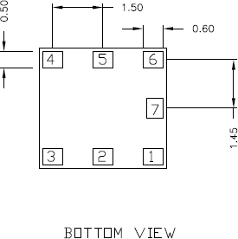

0,50

0,60

Figure 11: Bottom view BMP180

## Top view

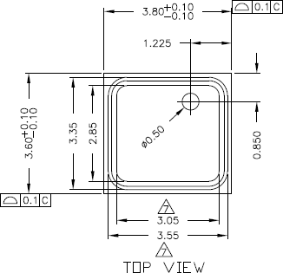

Figure 12: Top view BMP180

## Side view

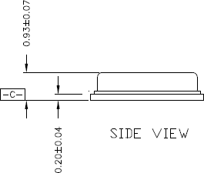

Figure 13: Side view BMP180

## Moisture sensitivity level and soldering

The BMP180 is classified MSL 1 (moisture sensitivity level) according to IPC/JEDEC standards J- STD-020D and J-STD-033A.

The device can be soldered Pb-free with a peak temperature of 260°C for 20 to 40 sec. The minimum height of the solder after reflow shall be at least 50µm. This is required for good mechanical decoupling between the sensor device and the printed circuit board (PCB).

To ensure good solder-ability, the devices shall be stored at room temperature (20°C). The soldering process can lead to an offset shift.

## RoHS compliancy

The BMP180 sensor meets the requirements of the EC directive "Restriction of hazardous substances (RoHS)", please refer also to:

"Directive 2011/65/EU of the European Parliament and of the Council of 8 June 2011 on the restriction of the use of certain hazardous substances in electrical and electronic equipment".

The BMP180 sensor is also halogen-free.

## Mounting and assembly recommendations

In order to achieve the specified performance for you design, the following recommendations and the “Handling, soldering & mounting instructions BMP180” should be taken into consideration when mounting a pressure sensor on a printed-circuit board (PCB):

* The clearance above the metal lid shall be 0.1mm at minimum.
* For the device housing appropriate venting needs to be provided in case the ambient pressure shall be measured.
* Liquids shall not come into direct contact with the device.
* During operation the sensor is sensitive to light, which can influence the accuracy of the measurement (photo-current of silicon).
* The BMP180 shall not the placed close the fast heating parts. In case of gradients > 3°C/sec. it is recommended to follow Bosch Sensortec application note ANP004, "Correction of errors induced by fast temperature changes". Please contact your Bosch Sensortec representative for details.

# Legal disclaimer

## Engineering samples

Engineering Samples are marked with an asterisk (*) or (e). Samples may vary from the valid technical specifications of the product series contained in this data sheet. They are therefore not intended or fit for resale to third parties or for use in end products. Their sole purpose is internal client testing. The testing of an engineering sample may in no way replace the testing of a product series. Bosch Sensortec assumes no liability for the use of engineering samples. The Purchaser shall indemnify Bosch Sensortec from all claims arising from the use of engineering samples.

## Product use

Bosch Sensortec products are developed for the consumer goods industry. They may only be used within the parameters of this product data sheet. They are not fit for use in life-sustaining or security sensitive systems. Security sensitive systems are those for which a malfunction is expected to lead to bodily harm or significant property damage. In addition, they are not fit for use in products which interact with motor vehicle systems.

The resale and/or use of products are at the purchaser’s own risk and his own responsibility. The examination of fitness for the intended use is the sole responsibility of the Purchaser.

The purchaser shall indemnify Bosch Sensortec from all third party claims arising from any product use not covered by the parameters of this product data sheet or not approved by Bosch Sensortec and reimburse Bosch Sensortec for all costs in connection with such claims.

The purchaser must monitor the market for the purchased products, particularly with regard to product safety, and inform Bosch Sensortec without delay of all security relevant incidents.

## Application examples and hints

With respect to any examples or hints given herein, any typical values stated herein and/or any information regarding the application of the device, Bosch Sensortec hereby disclaims any and all warranties and liabilities of any kind, including without limitation warranties of non-infringement of intellectual property rights or copyrights of any third party. The information given in this document shall in no event be regarded as a guarantee of conditions or characteristics. They are provided for illustrative purposes only and no evaluation regarding infringement of intellectual property rights or copyrights or regarding functionality, performance or error has been made.

# Document history and modification

|  |  |  |  |
| --- | --- | --- | --- |
| **Rev. No** | **Chapter** | **Description of modifications/changes** | **Date** |
| **1.0** |  | First edition for description of serial production material  – Preliminary version |  |
| **1.1** | 5.1 | New nomenclature of pin configuration | 27 July 2010 |
| **1.2** | 5 | Design change in package – hole in Lid and without slit | 13 September 2010 |
| **1.3** | 3.2  5.1 | * Standardizing pin naming over Bosch Sensortec products – typical application circuit * Optimizing pin description, SPI description | 15 December 2010 |
| **2.0** | 1 | * Non-preliminary version * Verifying parameter through characterization | 28 January 2011 |
|  | 3.2 | - Declaration of SDO and CSB pins in the typical |  |
|  |  | application circuit |  |
| **2.1** | 4  5.3 | * Adding global memory map and bits description * Power-up sequence | 1 April 2011 |
|  | 6.1 | - Description of used interfaces |  |
|  | 6.2.1 | - Dimension pin7 |  |
| **2.2** | 6.1 | Correction of the pin configuration (editorial change) | 14 April 2011 |
| **2.3** | 3.3 | Optimizing noise performance | 25 May 2011 |
| **2.4** | 6.3 | Removed shelf-life constraints | 26 January 2012 |
| page 2 | Comparison removed |
| 5.1 | Voltage output low level added |
| 5.3 | Power on sequence of VDD and VDDIO defined |
| **2.5** | 1 | Added max values for supply current for restricted version | 15 Feb 2013 |
| 1 | Added max value for standby current for restricted  version | 5 Apr 2013 |
| Figure 4 | Update of calculation of algorithm for pressure and temperature measurement |
| Page 2 | Changed wording from “ultra high resolution mode” to  “advanced resolution mode” |
| **2.6** | Page 26 | Changed document referral from ANP015 to BST- MPS-AN004-00 | 17 Jan 2014 |
| **2.7** | 3.5 | New equation for B3 | 26 Aug 2014 |
| **2.8** | Page 26 | Updated RoHS directive to 2011/65/EU effective 8  June 2011 | 07 May 2015 |

Bosch Sensortec GmbH Gerhard-Kindler-Strasse 8 72770 Reutlingen / Germany

[contact@bosch-sensortec.com](mailto:contact@bosch-sensortec.com) [www.bosch-sensortec.com](http://www.bosch-sensortec.com/)

Modifications reserved | Printed in Germany Specifications are subject to change without notice Revision_2.7_082014

Document number: BST-BMP180-DS000-11