Student ID: 103615588

Name: Hussein Hussein

# Setup Screenshot



# Task 1 Screenshot

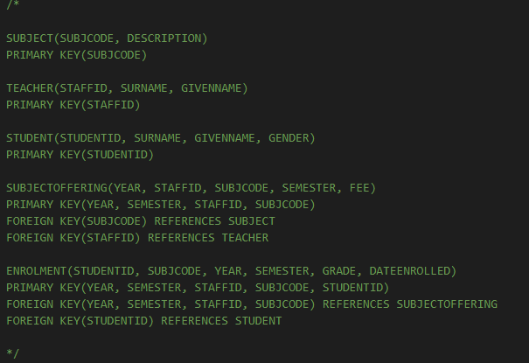

# Task 2 Screenshot

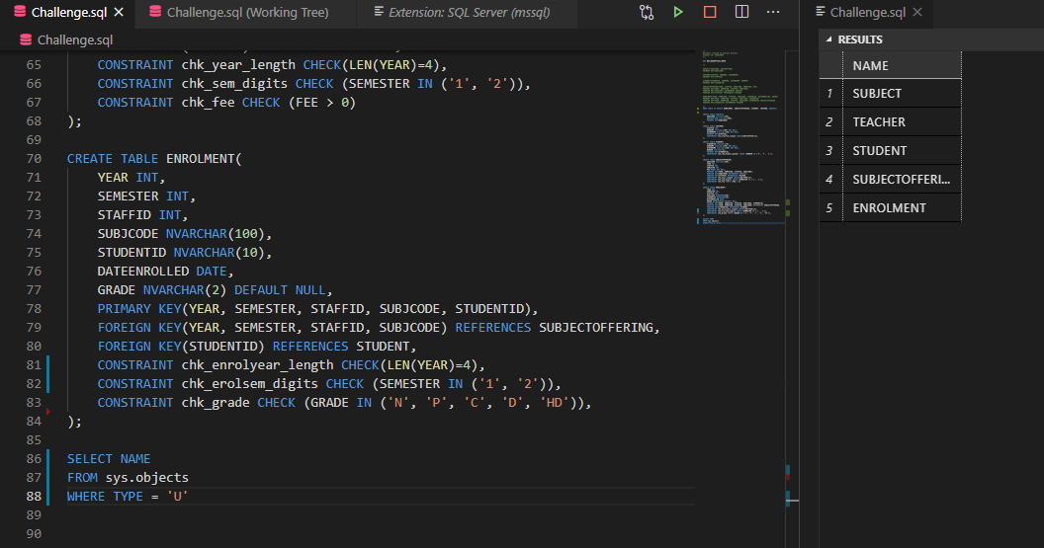

# Task 3 Screenshot

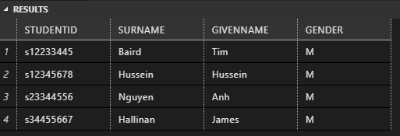

TASK 4:

[who-sane/BuildQuery: Database Assessment (github.com)](https://github.com/who-sane/BuildQuery)

TASK 5.