Student ID: 103615588

Name: Hussein Hussein

# Setup Screenshot

Using [dad] Database, pre-existing database (the one with $50 credit)



# Task 1 Screenshot

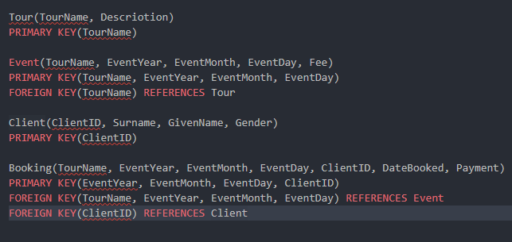

# Task 2 Screenshot

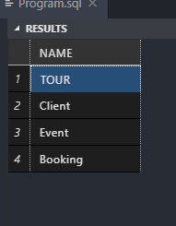

# Task 3 Screenshot

