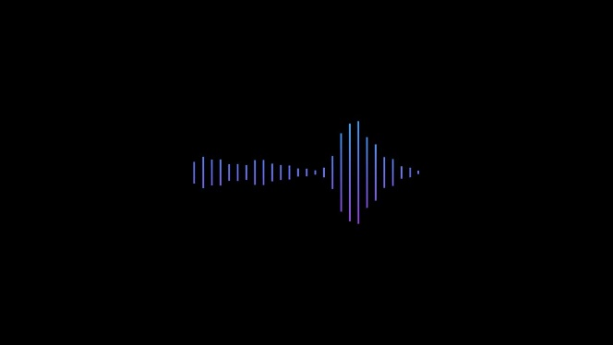
Mentorship Project 01 Barn
Overview and Setup

Engine Versions:
- Unreal Engine: Version 5.2
  - https://www.audiokinetic.com/en/download/
- Wwise: Version 2022.1.5.8242
  - https://www.unrealengine.com/en-US/download
Wwise Soundbank Path:
- Wwise: Once installed, open Wwise Project Settings and navigate to the SoundBanks Tab.
  - Locate the Root Output Path and click on the … widget.
- When the window opens, navigate to … Mento01_ScifiBase 5.2\Content\WwiseAudio\GeneratedSoundbanks
- Select the GeneratedSoundbanks folder and click Select Folder
  - This will set/check the location of your Soundbanks when they are generated.
Wwise Installation Path in Unreal Engine:
- Once the Unreal engine has been installed:
  - Open Edit > Project Settings.
    - Navigate to User Settings at the bottom under the Wwise section.
    - Change the Wwise Windows Installation Path to the location of the your local install of Wwise 2202.1.4.8242
    - This will be something like C:/Program Files (x86)/Audiokinetic/Wwise 2022.1.5.8242

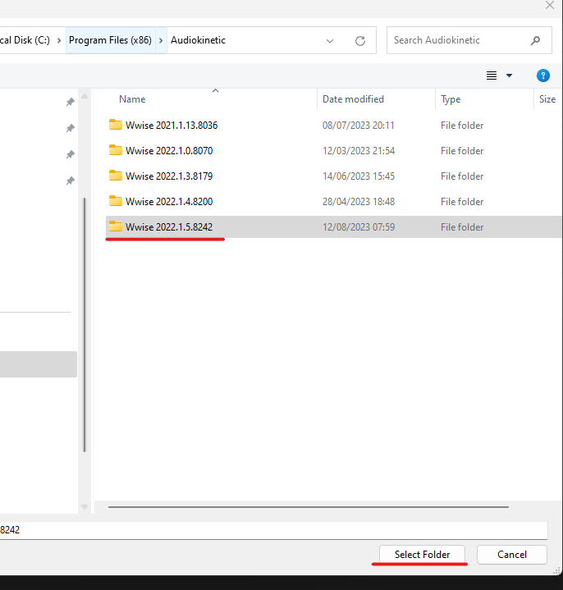

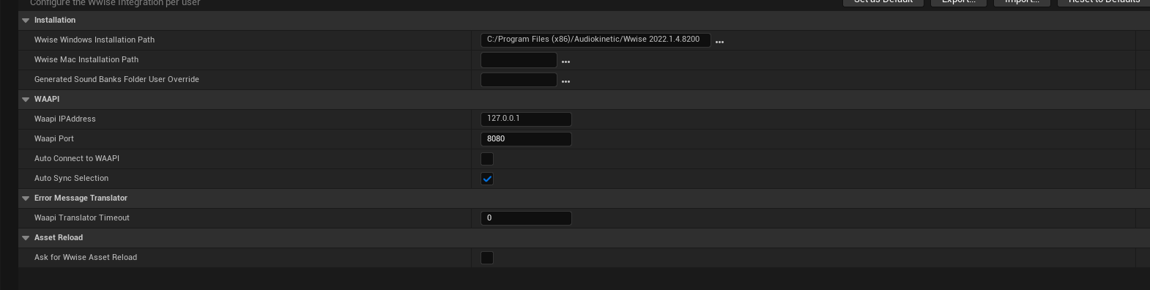
- Open Integration Settings and ensure that the Wwise Project Path and Generated Sound Banks Folder is correct.
- This will look something like this: Mentorship Projects\Mento01_ScifiBase 5.2\Content\WwiseAudio\GeneratedSoundbanks
- GeneratedSoundBanks will always/should live in this location.

