**ARTH - TASK 18**

**Task Description :-**

* **Create an AWS EC2 Instance**
* **Configure the Instance with apache webserver**
* **Download PHP Application name “WordPress”**
* **As WordPress stores data at the backend in MySQL Database server. Therefore, you need to setup a MySQL server using AWS RDS service using Free Tier.**
* **Provide the endpoint/connection string to the WordPress application to make it work.**

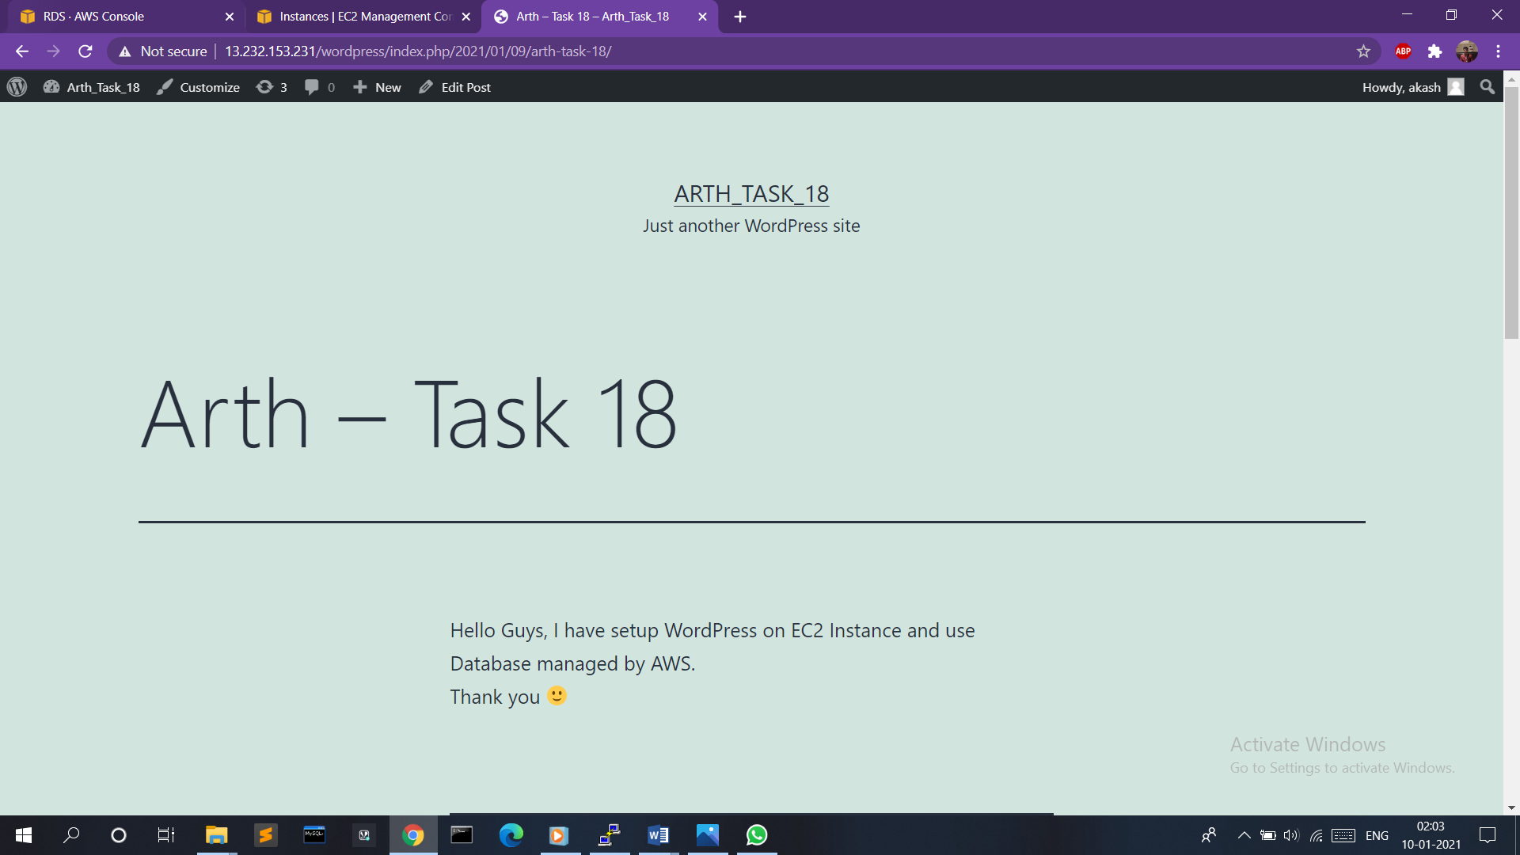

**Creation of EC2 Instance :-**

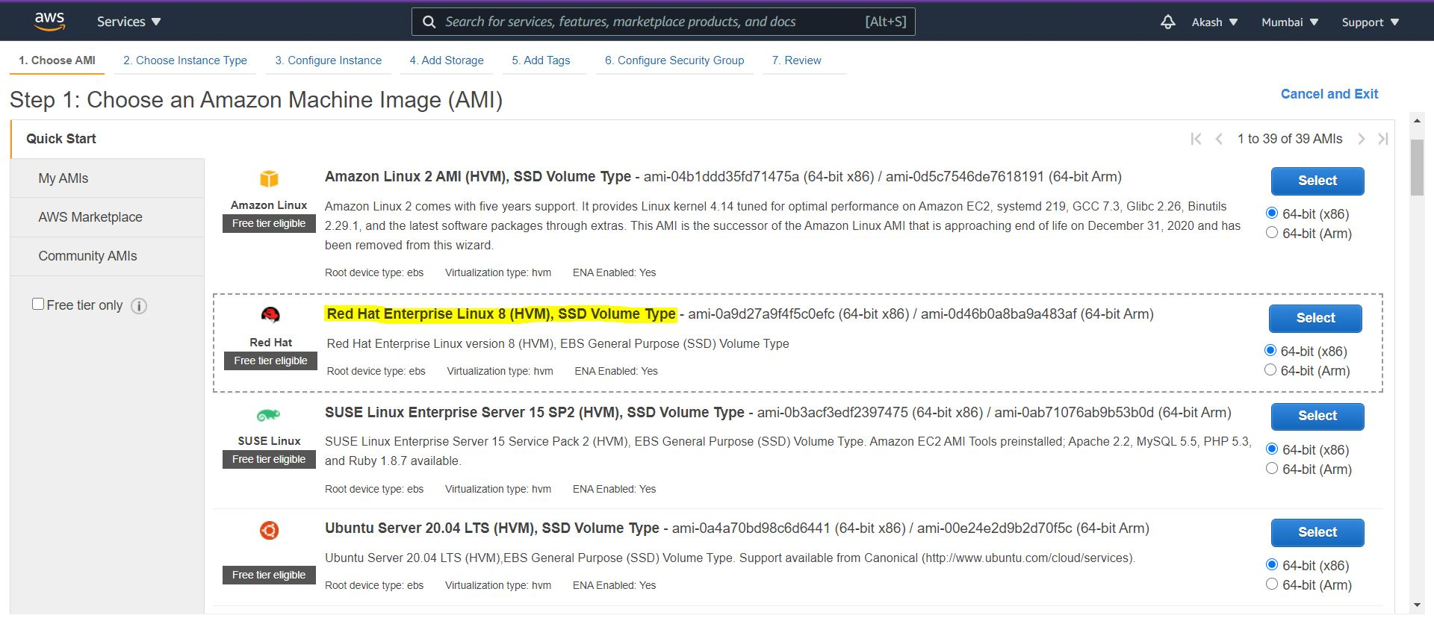

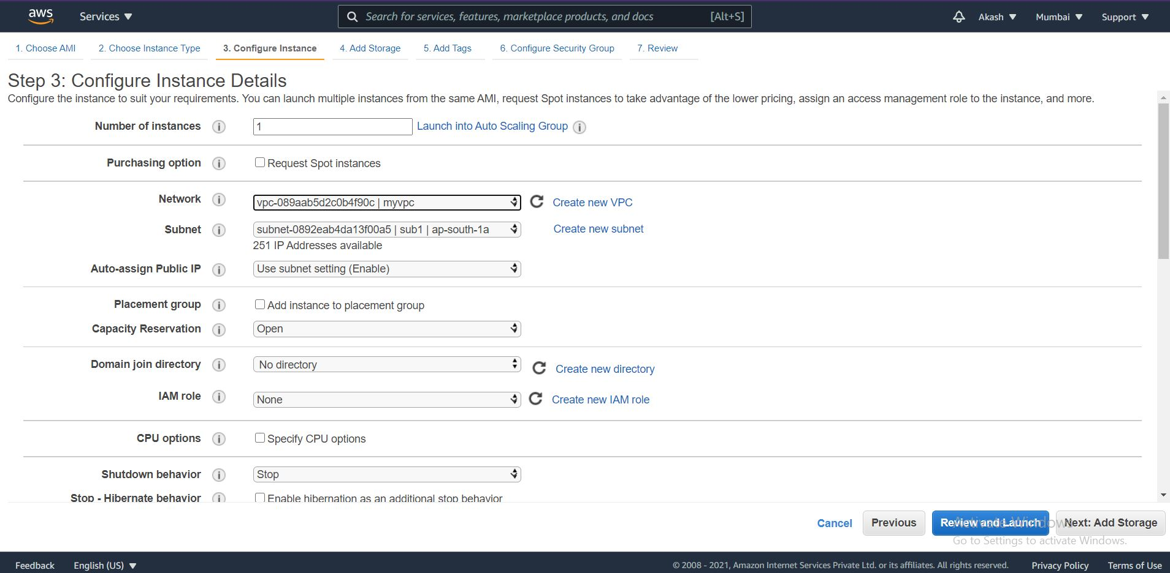

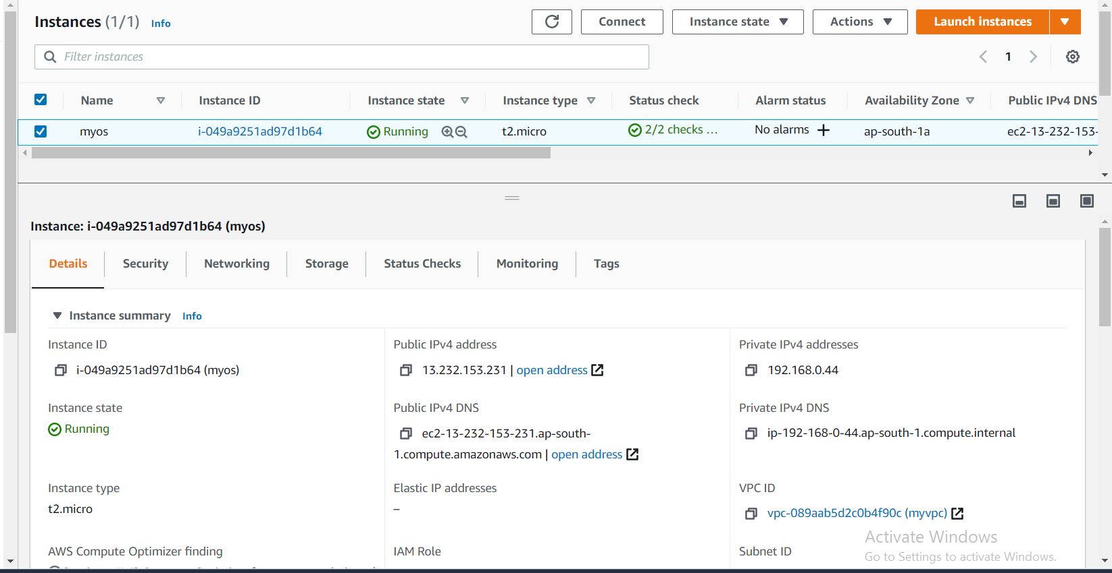

**Configure Web-Server**

**# yum install httpd vim -y**

**# systemctl start httpd**

**# systemctl enable httpd**

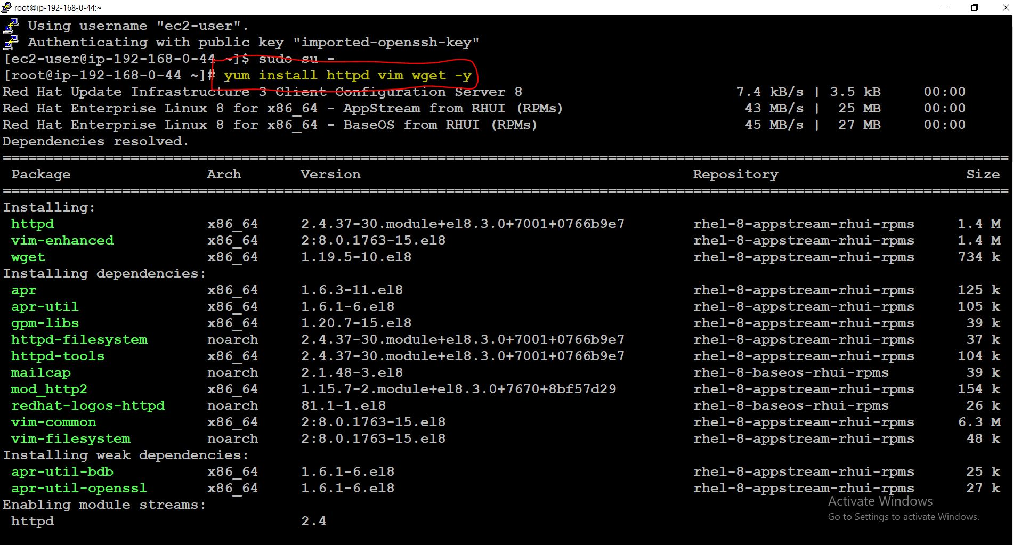

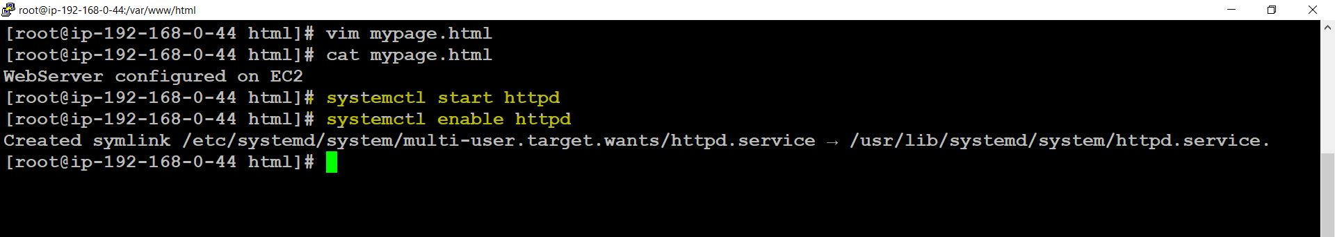

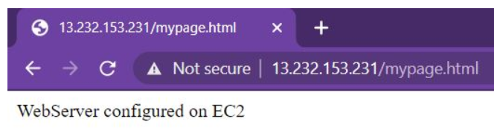

**Creation of Database in RDS**

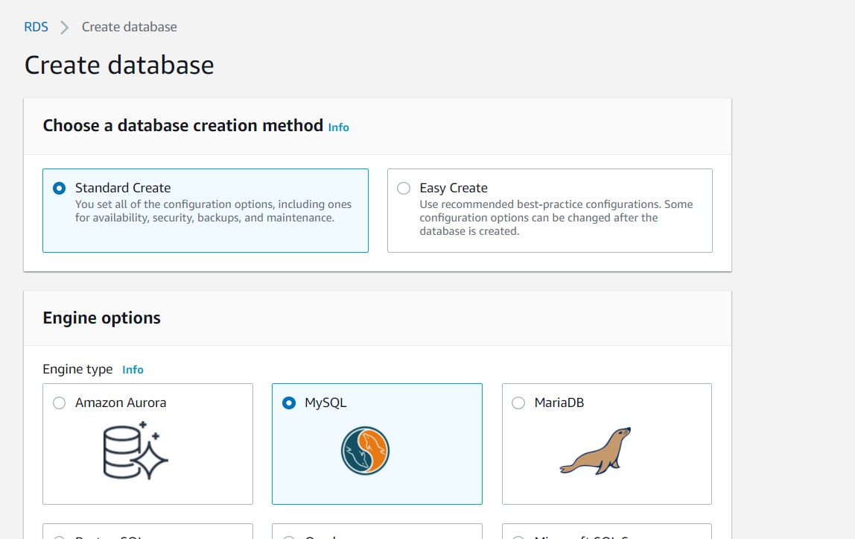

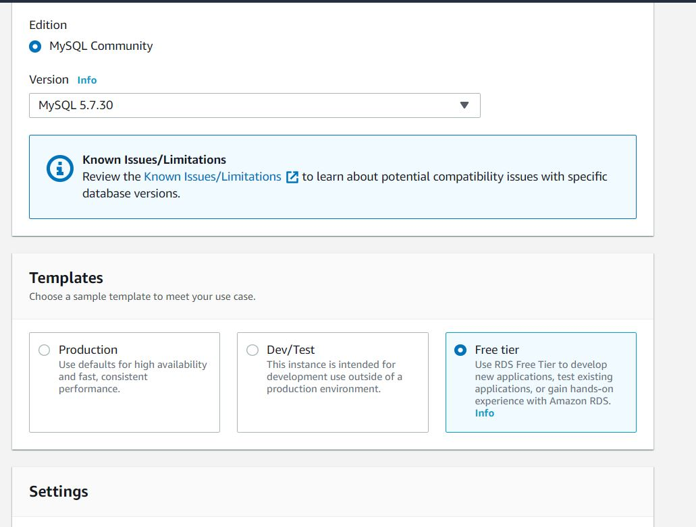

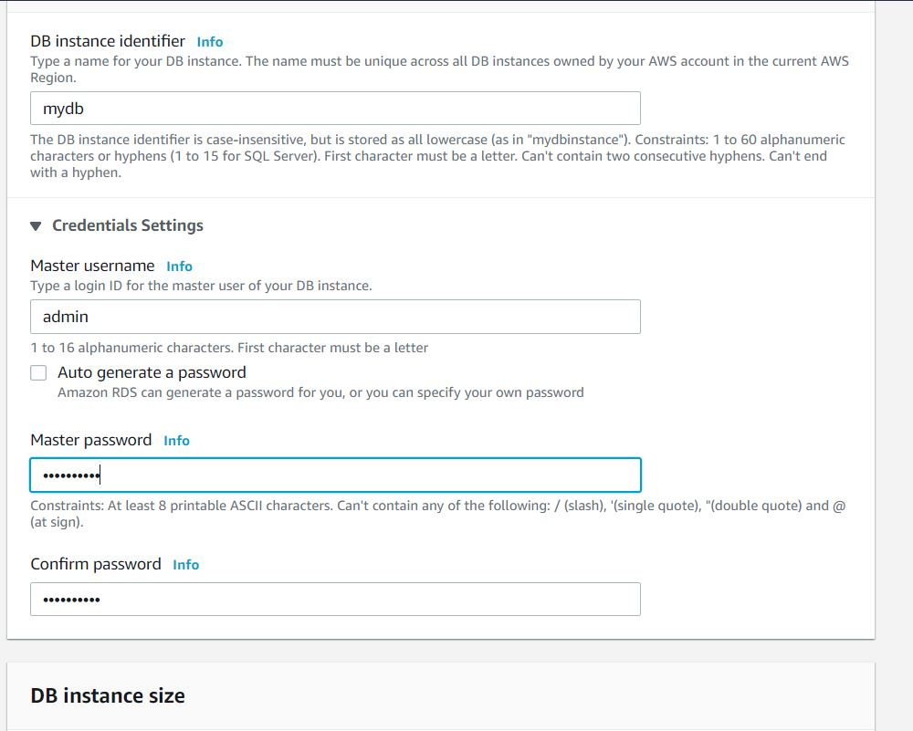

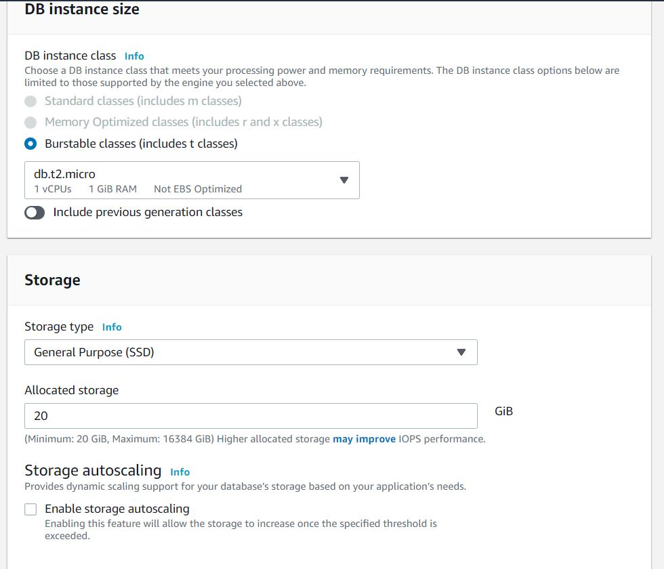

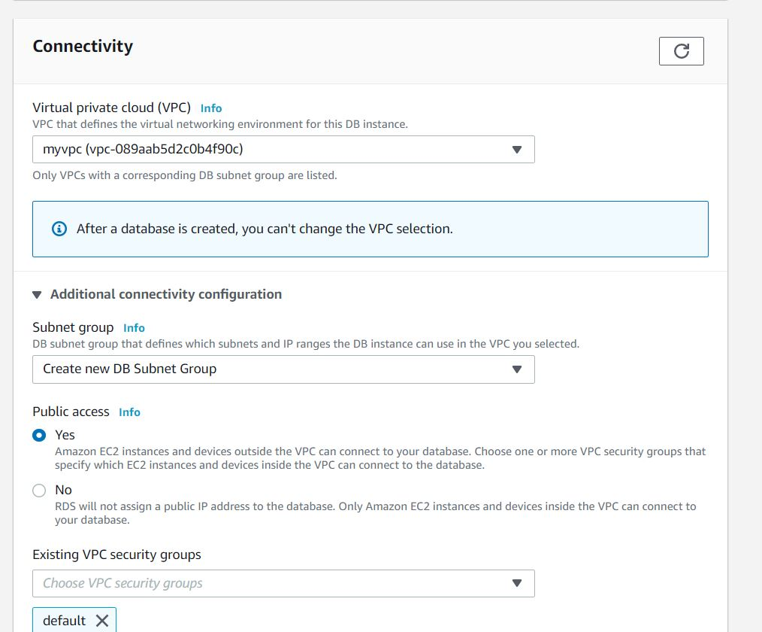

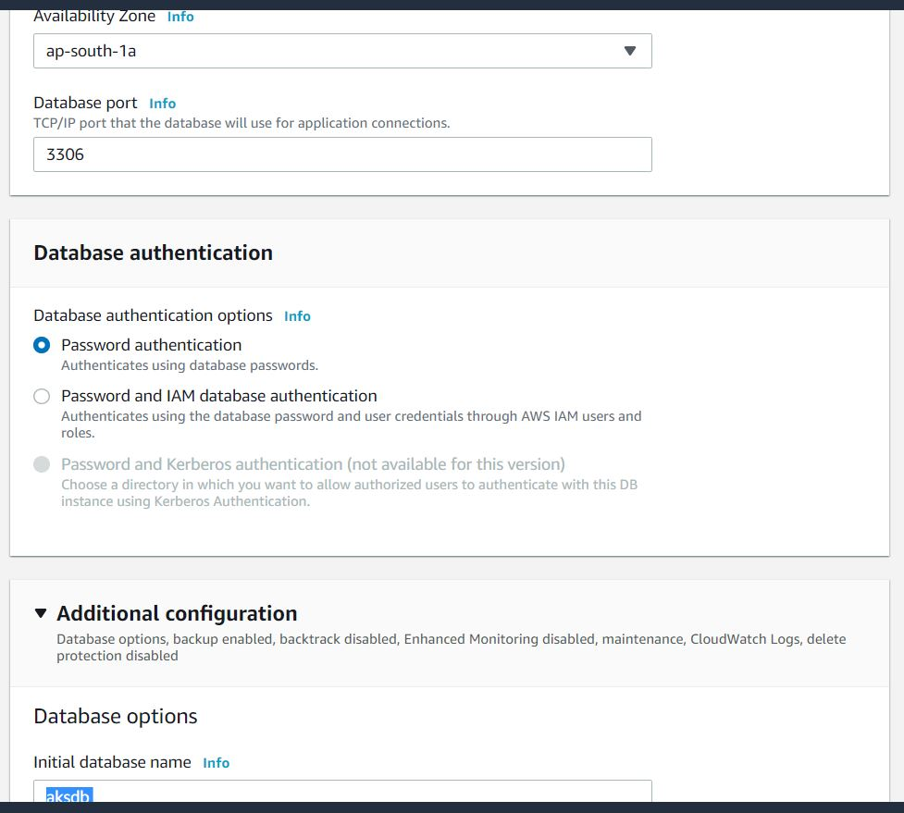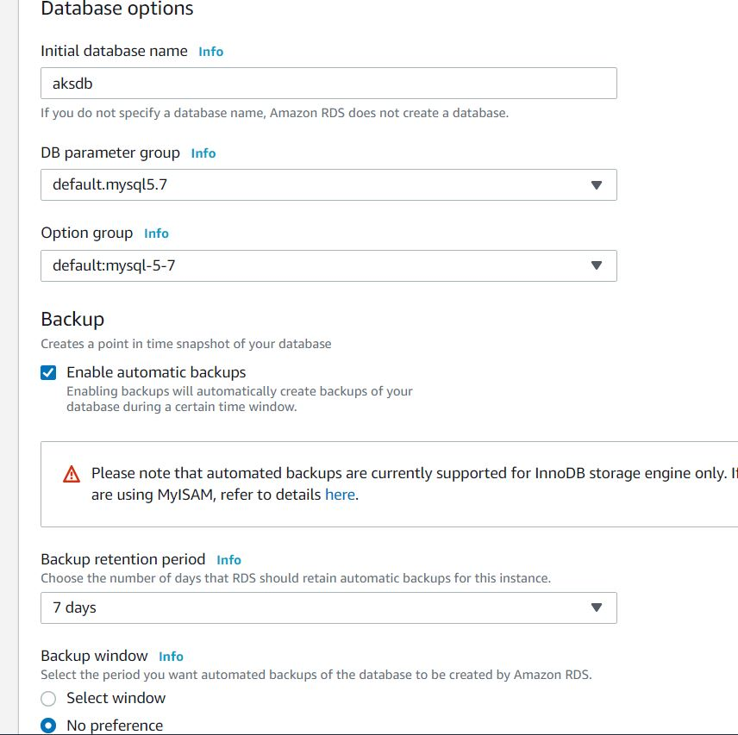

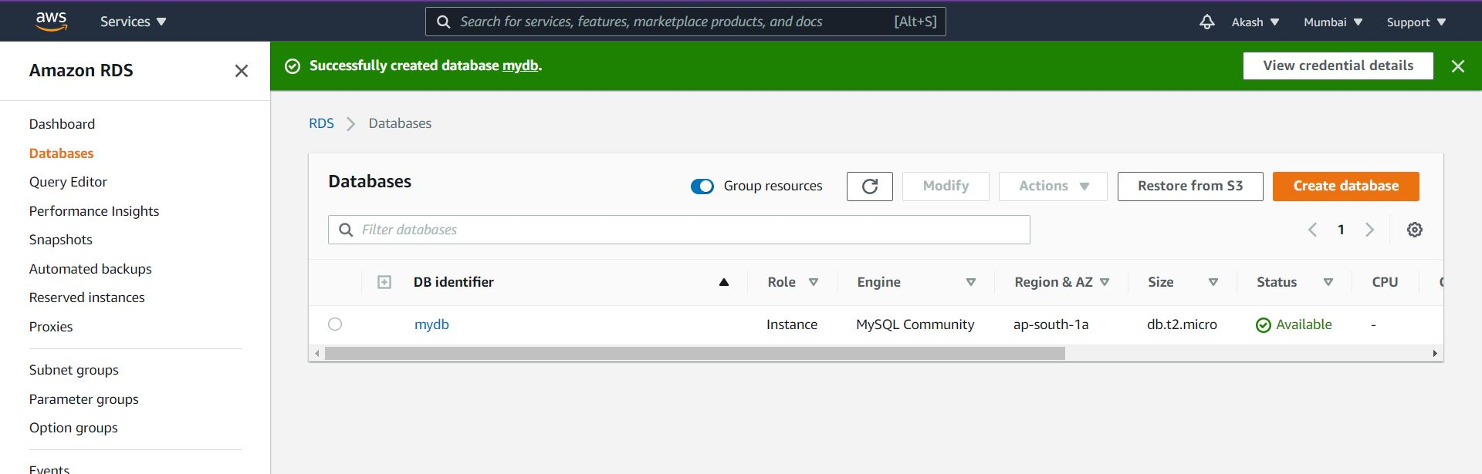

**Note :- Pre-requisite for WordPress is PHP7.4. So, we have to Install PHP version 7.4**

**Install PHP7.4 in RHEL 8**

**EPEL and REMI repositories are the main requirements for this installation**

**# yum -y install** [**https://dl.fedoraproject.org/pub/epel/epel-release-latest-8.noarch.rpm**](https://dl.fedoraproject.org/pub/epel/epel-release-latest-8.noarch.rpm)

**# yum -y install** [**https://rpms.remirepo.net/enterprise/remi-release-8.rpm**](https://rpms.remirepo.net/enterprise/remi-release-8.rpm)

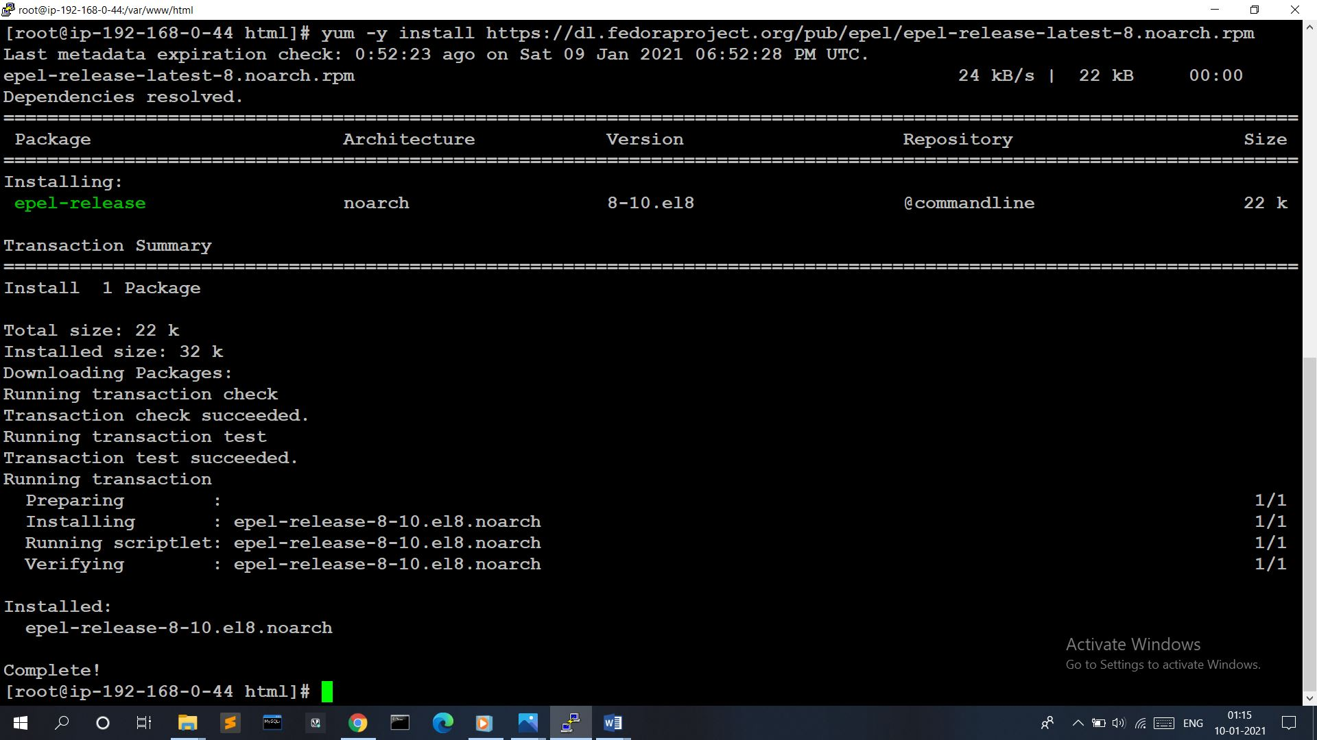

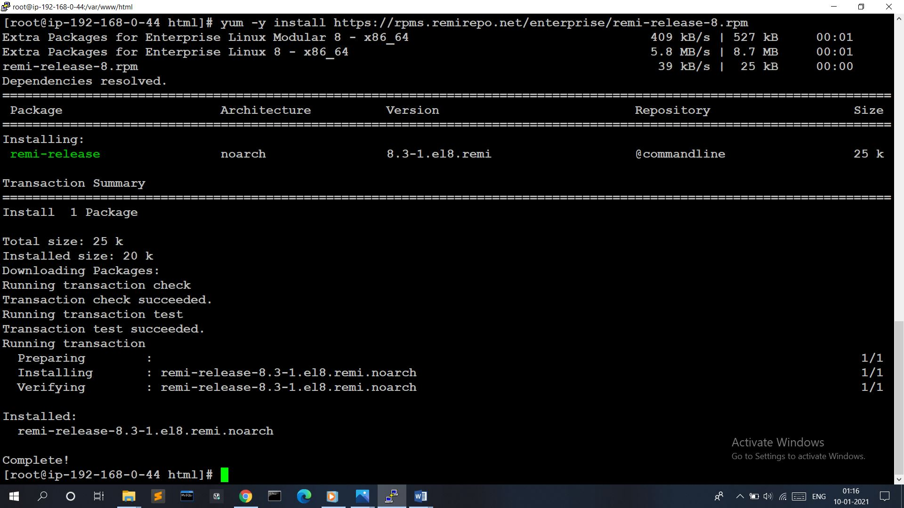

**Enable the Module Stream for PHP 7.4 on RHEL 8**

**# dnf module install php:remi-7.4**

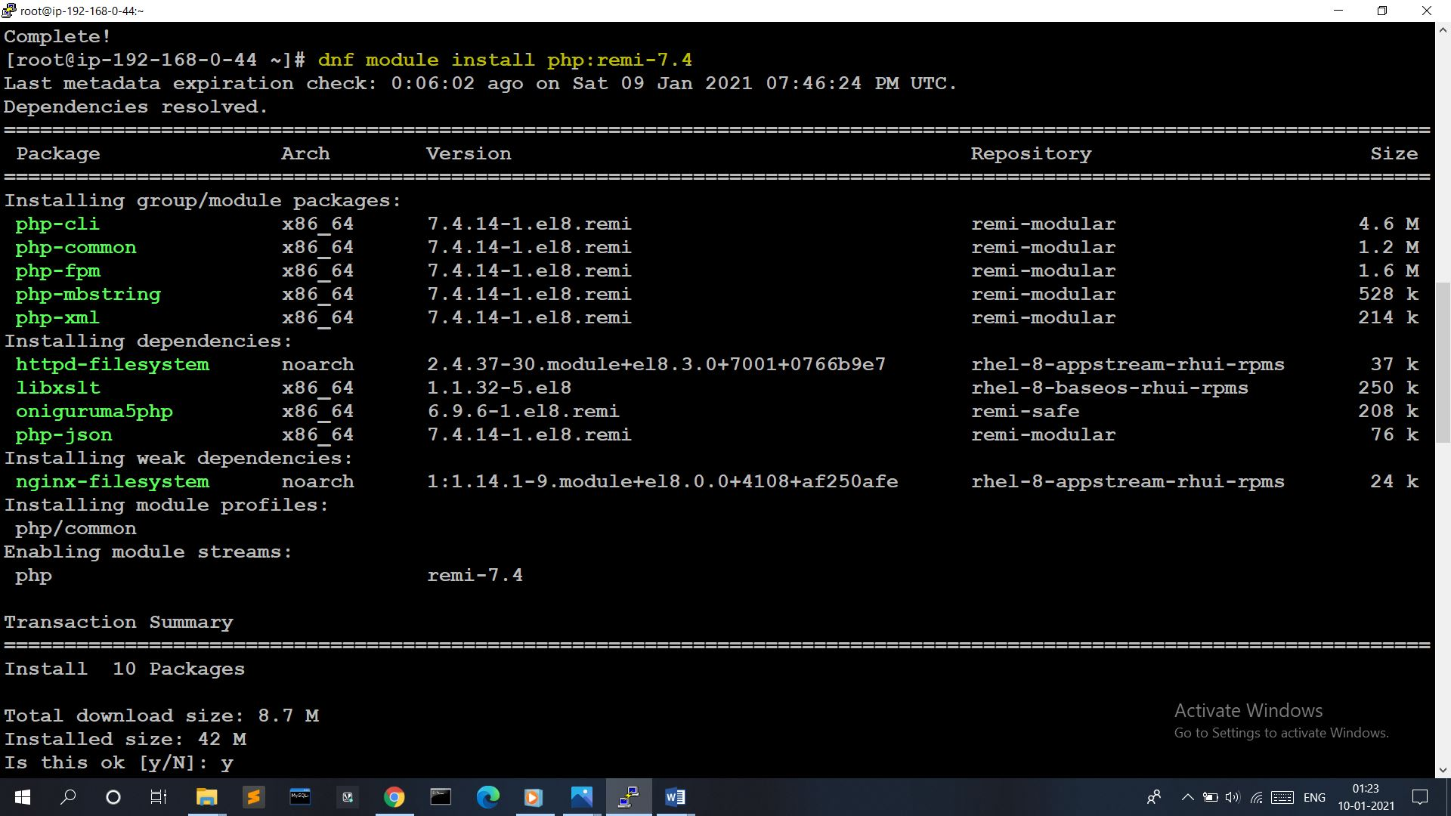

**Install mysqlnd Library**

**# dnf install php-mysqlnd**

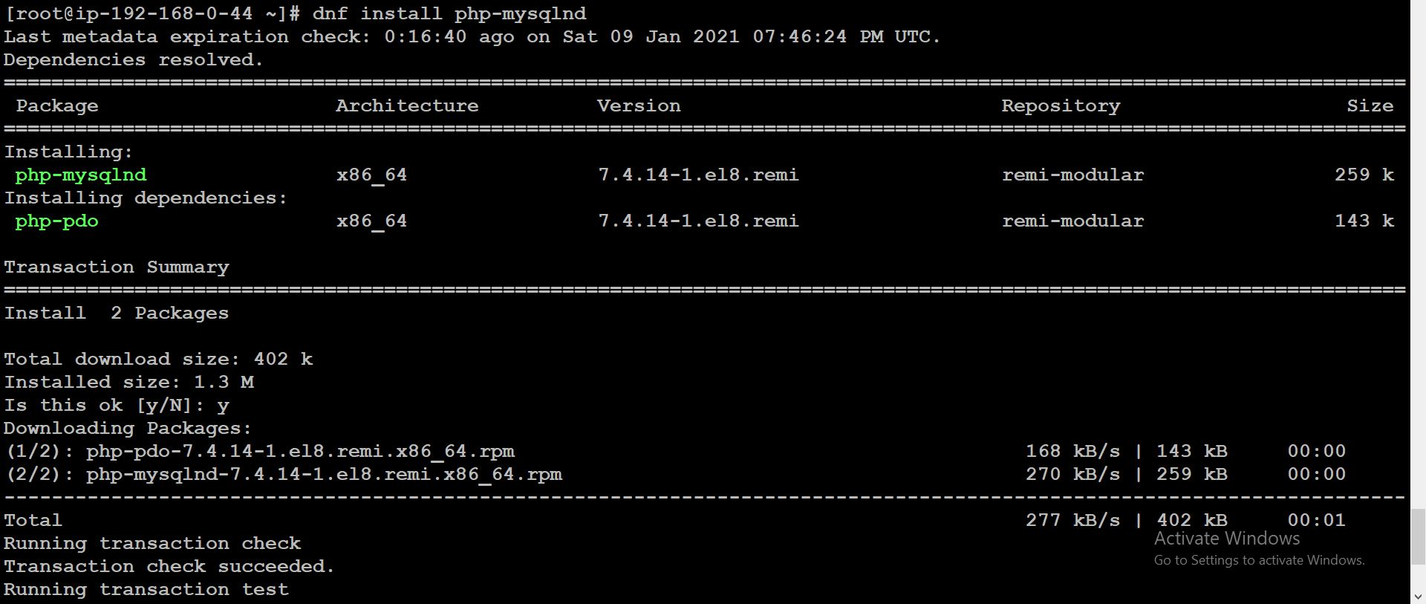

**Download and extract WordPress :-**

**# curl** [**https://wordpress.org/latest.tar.gz**](https://wordpress.org/latest.tar.gz) **--output wordpress.tar.gz**

**# tar xf wordpress.tar.gz**

**Copy the Extracted wordpress directory into /var/www/html directory**

**# cp -r wordpress /var/www/html**

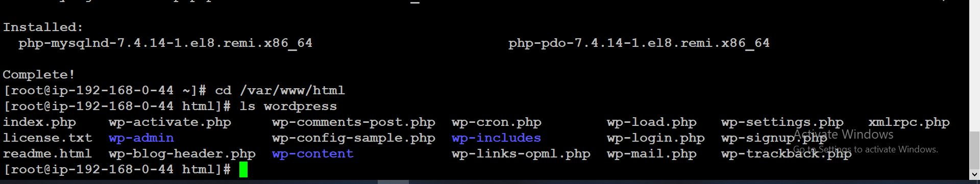

**Change Permissions and change File SELinux security context :-**

**# chown -R apache:apache /var/www/html/wordpress**

**# chcon -t httpd_sys_rw_content_t /var/www/html/wordpress -R**

**Now, we have to install mysql in EC2 Instance and create one database**

**# yum install mysql -y**

**# mysql -h mydb.cjqtq0cuxt01.ap-south-1.rds.amazonaws.com -u admin -p**

**# create database kaaash;**

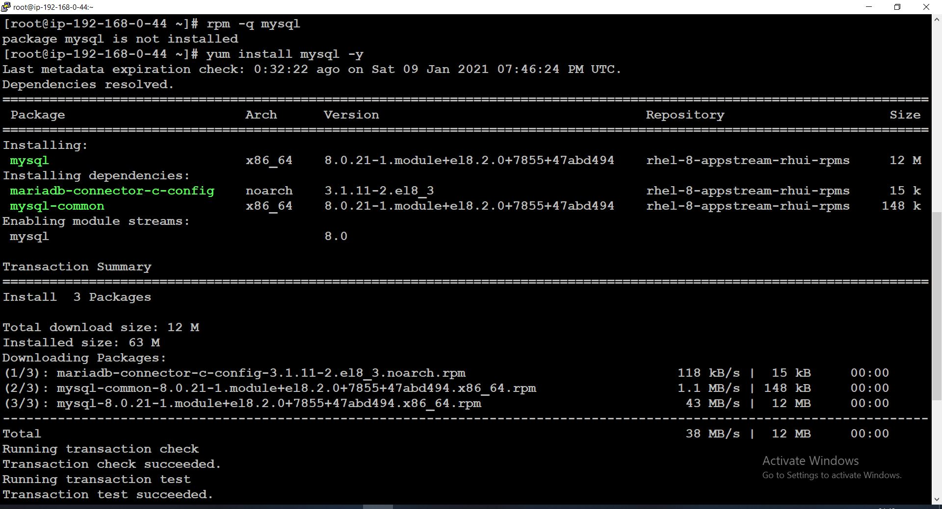

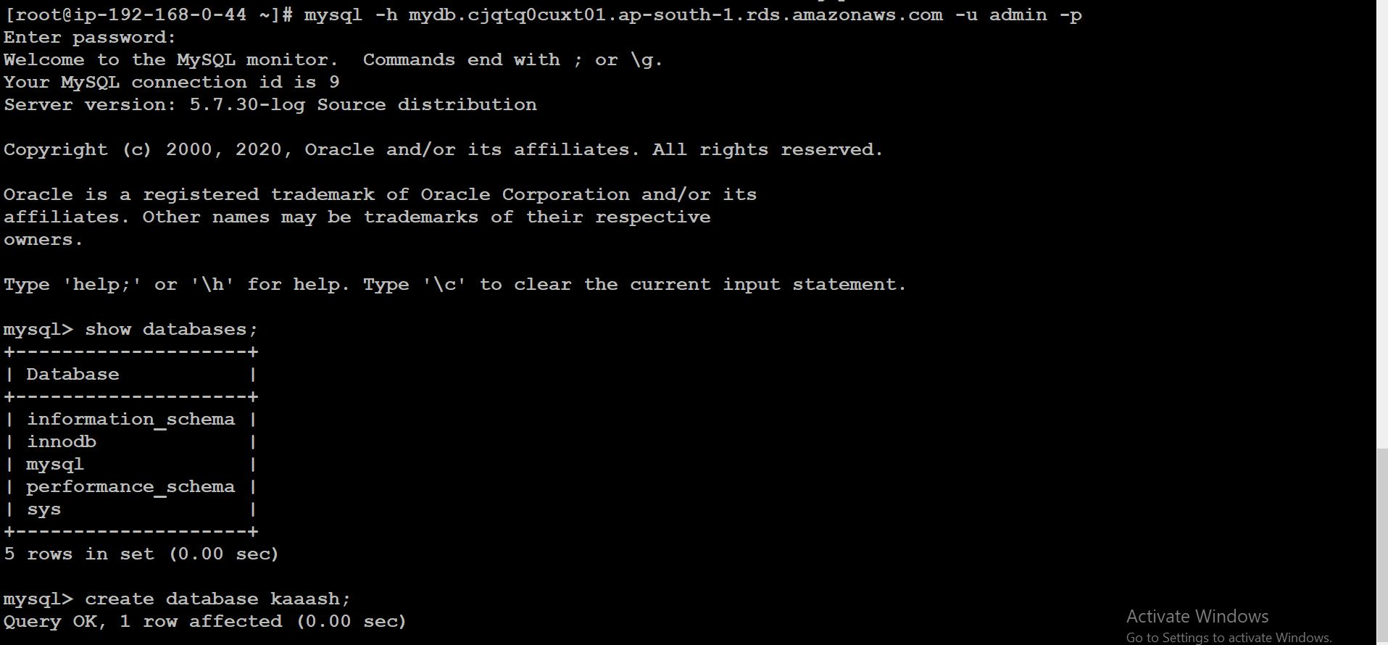

**Now, Set-up WordPress**

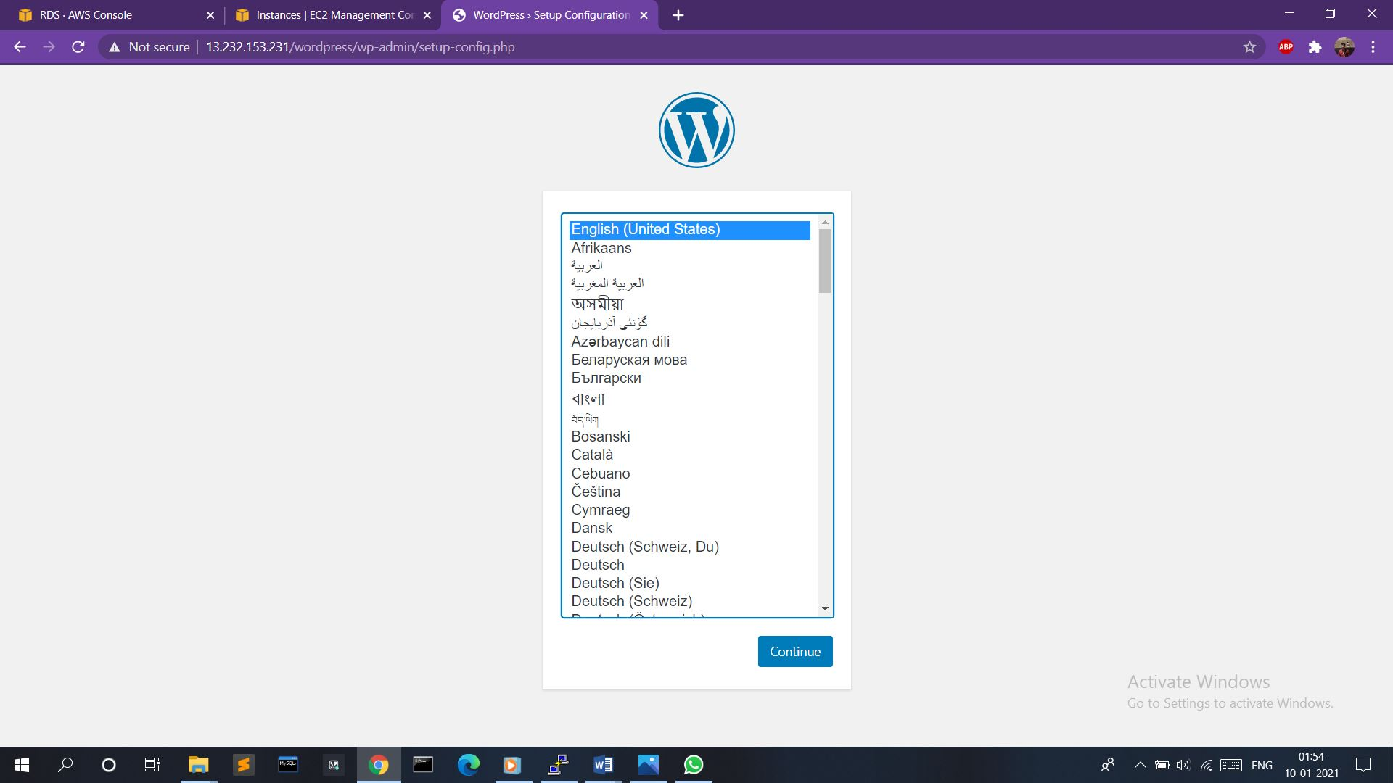

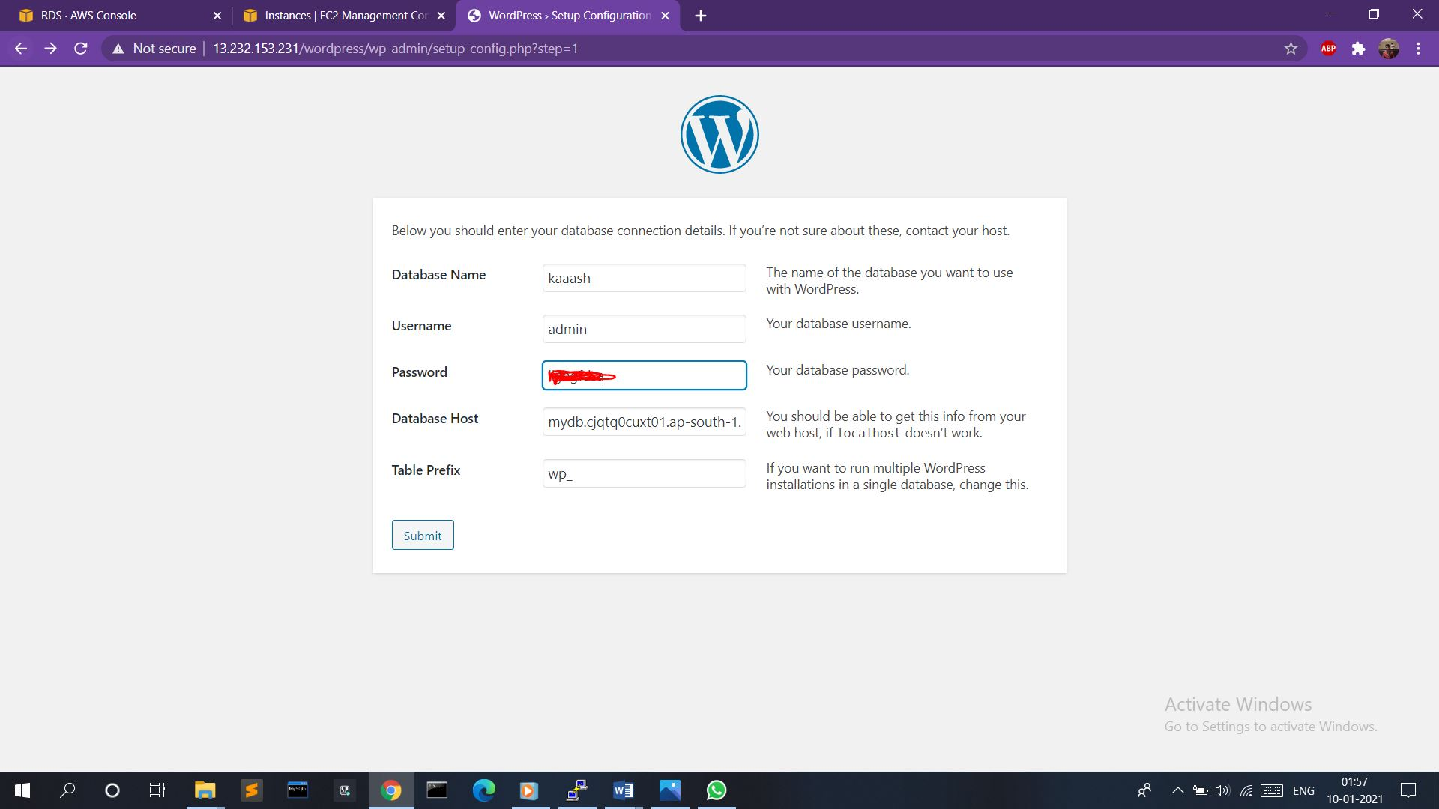

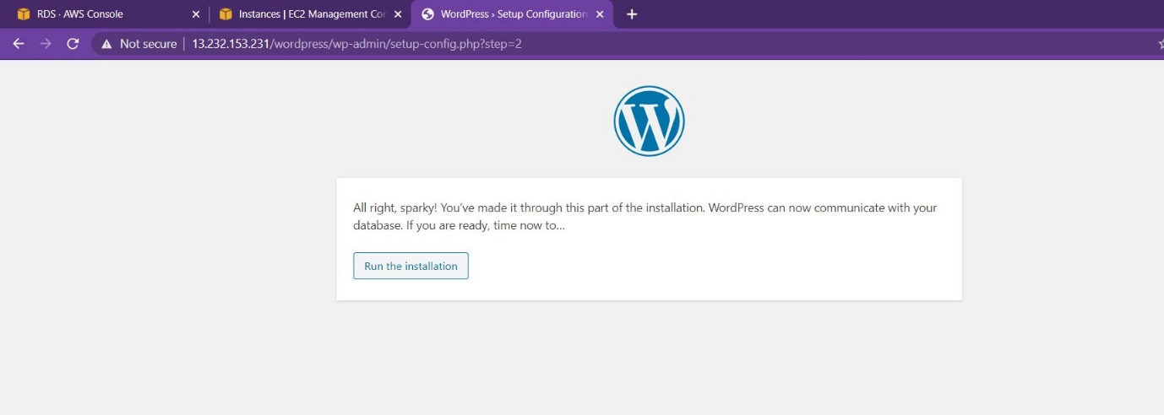

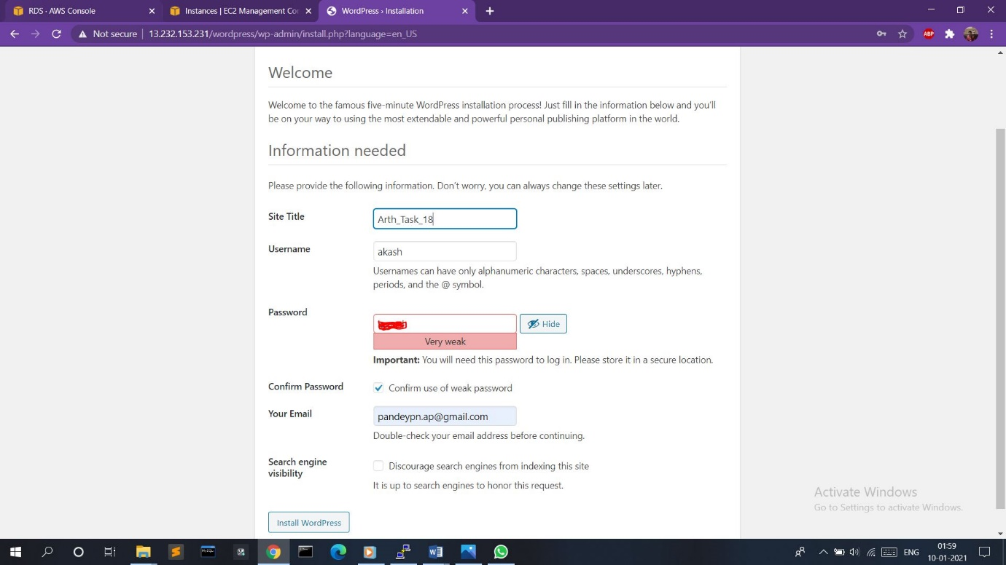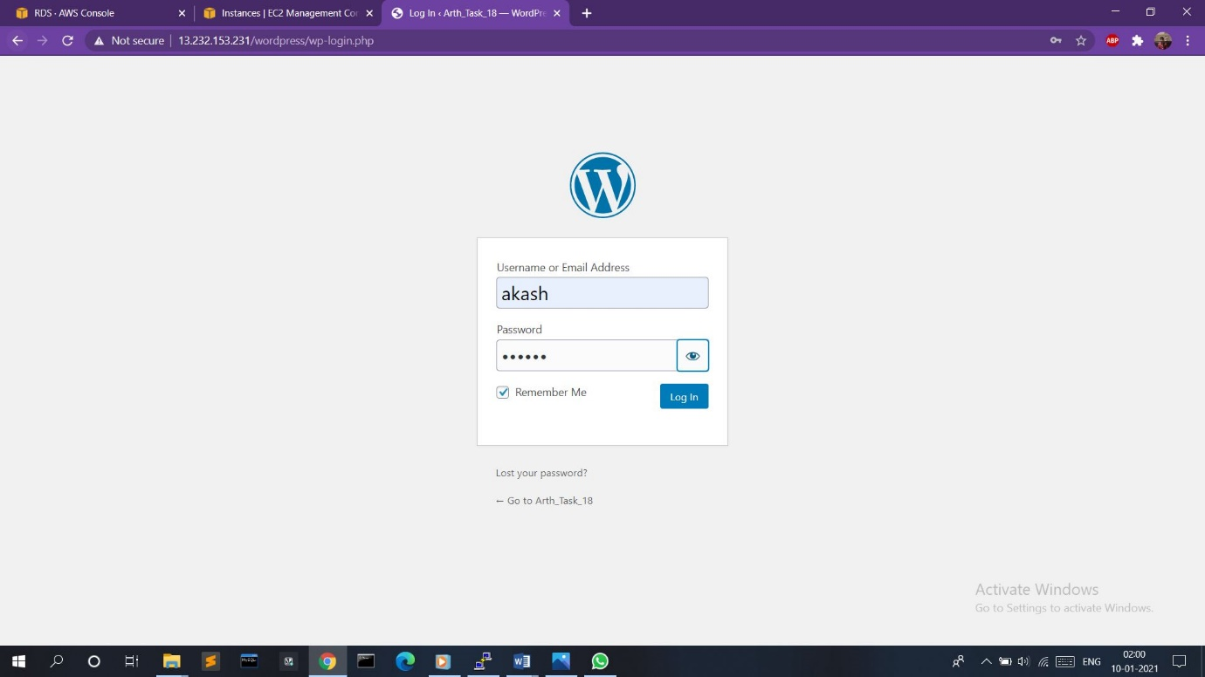

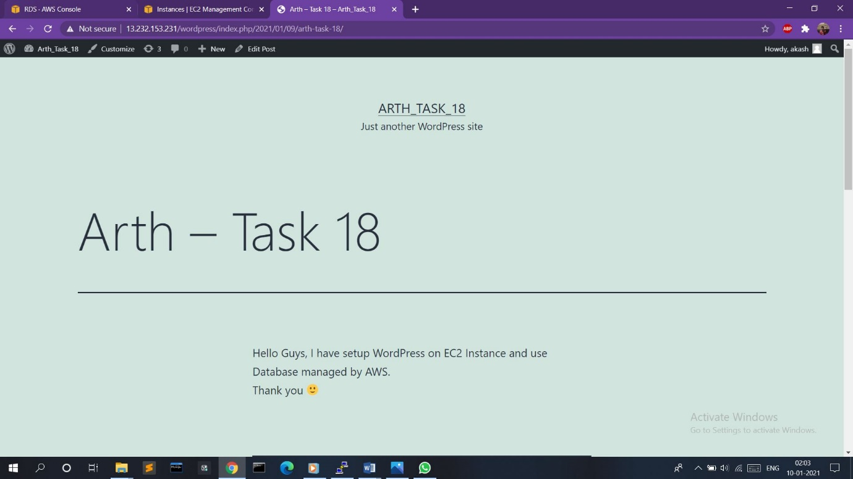

**Thank you ☺**