**WEEKLY JOURNAL REPORT**

Student Name: Raiven H. Morales

Company: Pinnacle Technologies Inc

Course, Yr. & Section: BSIT-4E

Department/Office: Hyperion/athena

**Week __8__, April 3 to April 5 , ___9:00am to_6:00pm_, _____24Hours______**

***(No.) (Date) (Time) (Total Hours Rendered)***

**Experiences / Activities**

On week 8 the trainer he assign me to creat swal alert in longin and it has condition

**Problems Encountered:**

Multiple error

I cant solve the condition in if wrong password

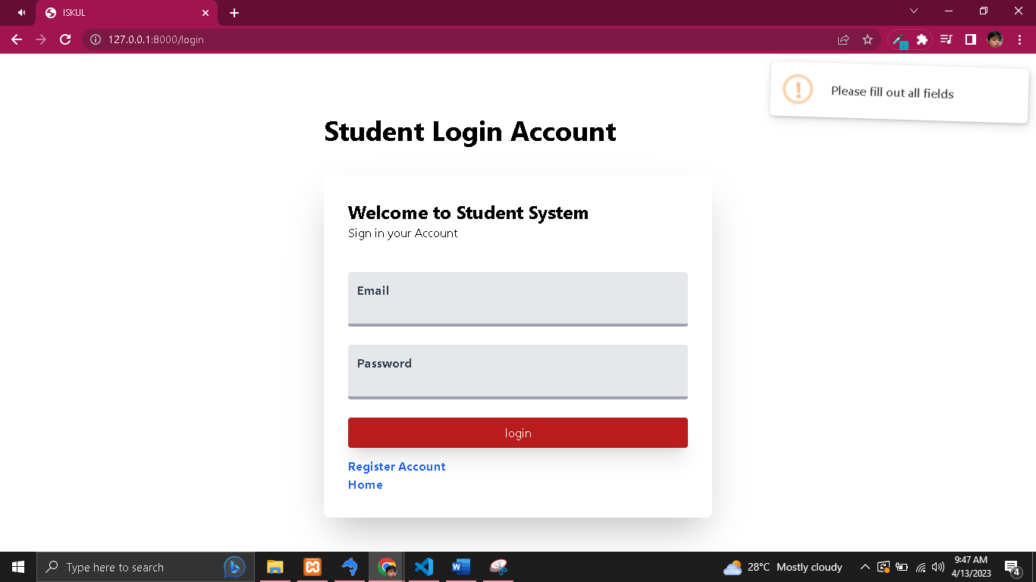**Reflections:**

