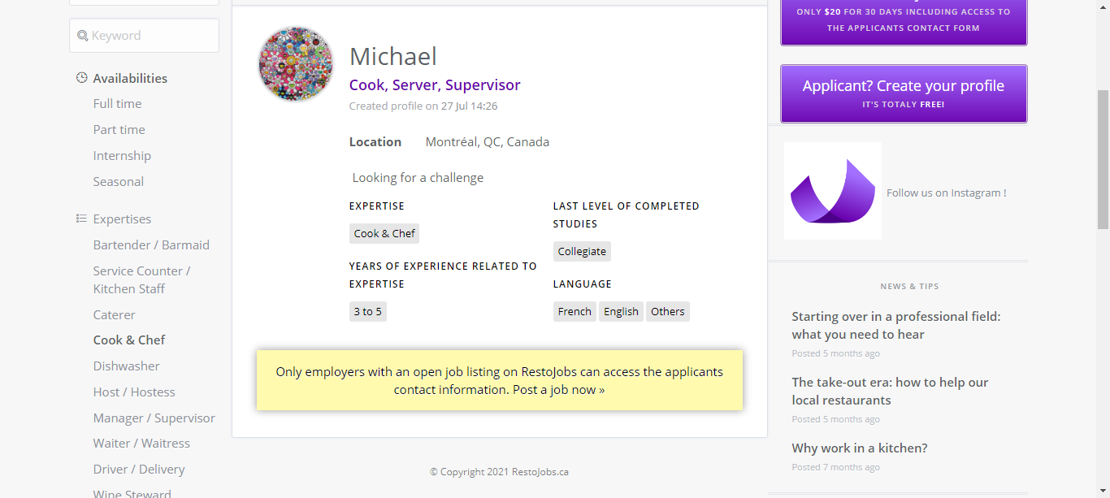Michael  
Cook, Server, Supervisor  
Created profile on 27 Jul 14:26  
Location Montréal, QC, Canada  
 Looking for a challenge  
EXPERTISE  
Cook & Chef  
YEARS OF EXPERIENCE RELATED TO EXPERTISE  
3 to 5  
LAST LEVEL OF COMPLETED STUDIES  
Collegiate  
LANGUAGE  
FrenchEnglishOthers