SecureMLOps
DevOps Mini Project Report
CI/CD + Deployment using GitHub Actions

Author | Devang (whodevaaaang)
Submission Date | 01 May 2026
Repository | https://github.com/whodevaaaang/securemlops
Reference Run | Actions run #25183862487 (all 4 jobs green)

1. Project Title
SecureMLOps — A hardened CI/CD + deployment pipeline for an ML inference service, implemented with GitHub Actions, Docker, Trivy, Bandit, Gitleaks, and pytest.

2. Problem Statement
Most ML projects skip the DevOps half: models live on a laptop, deployments are manual, secrets sit in source code, and there is no automated signal when the running model breaks. SecureMLOps fixes this for a small but realistic ML service:
- A trained scikit-learn sentiment classifier exposed over a FastAPI REST API.
- Every push runs lint, unit tests, Python SAST (Bandit), secret scanning (Gitleaks), container CVE scanning (Trivy), and only then promotes the image to a deploy stage.
- The deploy stage actually runs the container and smoke-tests the live endpoint — no fake echo step.
- All credentials (API_TOKEN) flow through GitHub Actions Secrets — never the repo.

3. Architecture Diagram
The pipeline is composed of four sequential GitHub Actions jobs. Each gate must pass before the next runs; deployment is gated to pushes on the main branch only.
Pipeline (logical view):
Developer ──git push──▶ GitHub Repo ──webhook──▶ GitHub Actions
│
▼
┌───────────────────────────────────────────────┐
│ Job 1 Build & Lint flake8 · black · train │
│ Job 2 Test & Security pytest · bandit · gitleaks │
│ Job 3 Docker + Trivy buildx · CVE gate (HIGH/CRITICAL) │
│ Job 4 Deploy docker run · /health · /predict │
└───────────────────────────────────────────────┘
│
▼
Running Container :8000 ──▶ /predict, /health
▲
GitHub Secrets ──API_TOKEN──┘

4. CI/CD Pipeline Explanation
The pipeline is defined in .github/workflows/ci.yml and triggers on push or PR to main / develop. Each job runs on its own ubuntu-latest runner and consumes artifacts from the previous stage.
Job | Responsibilities and gates
1. Build & Lint | Set up Python 3.11, install deps with pip cache, run flake8, run black --check, train the model, and upload model.joblib as an artifact.
2. Test & Security Scan | Download the model artifact, run pytest with coverage, run Bandit (Python SAST), run Gitleaks against the commit history. Coverage and Bandit reports are uploaded as artifacts.
3. Build & Scan Image | docker buildx builds the image with GHA layer cache, then Trivy scans it. Job fails on any HIGH or CRITICAL CVE. Image is saved as an artifact for the deploy job.
4. Deploy (container) | Runs only when ref is main. Loads the scanned image, docker run with API_TOKEN injected from GitHub Secrets, then runs scripts/smoke-test.sh against /health and /predict on the live container.
Optimisations & enhancements applied:
- actions/setup-python pip cache + Buildx cache-from/to: type=gha cuts cold-cache CI time.
- Jobs run as separate runners with needs: dependencies for clean isolation and parallel artifacts.
- if: github.ref == 'refs/heads/main' gates deploy so PR runs validate without side effects.
- environment: production declares a deployment on the run page so GitHub renders a deployment URL.
- trivy-action with ignore-unfixed: true keeps the gate strict (HIGH/CRITICAL only) without failing on vendor CVEs that have no patch yet.

5. Git Workflow Used
GitFlow-lite with three long-lived branches:
main (protected, deploys)
└── develop (integration)
└── feature/devops-enhancement (the work for this assignment)
Sixteen commits total across the three branches, with two PR-style merges visible in the graph (feature/devops-enhancement → develop → main, both --no-ff). Five additional fix-forward commits on main remediate real CVEs flagged by Trivy.
Sample git log --graph (most recent commits):
* 1e5bcfa docs: commit GitHub Actions screenshots from green run 25183862487
* 5d5c3e1 ci(deploy): pass API_TOKEN secret to smoke-test step
* 8fd067d fix(security): bump fastapi to 0.136.1 (pulls starlette 0.49+ for CVE-2025-62727)
* f9e0922 fix(security): pin starlette>=0.49.1 (CVE-2025-62727 DoS)
* 32d892a fix(security): patch HIGH CVEs flagged by Trivy
* 02c0fdc ci: bump trivy-action to v0.36.0
* 5cebe9e style: apply black --line-length=120 formatting
* b1c851f fix(lint): drop unused imports flagged by flake8
* d232c62 Merge PR #2: develop into main (initial release)
* f5d8924 Merge PR #1: feature/devops-enhancement into develop
* 8130553 ci(scripts): smoke-test and local-up helpers used by deploy job
* f5c65ba ci: 4-stage GitHub Actions pipeline (build/test/docker/deploy)
* c3e6d62 build: multi-stage non-root Dockerfile with healthcheck
* 0db758e test: pytest suite covering health, predict, and auth paths
* 65582ed feat(ml-app): FastAPI sentiment service with token-gated /predict
* 0515576 chore: scaffold SecureMLOps repo (README, docs, compose)

6. Tools Used
Area | Tool
Language / API | Python 3.11, FastAPI, Uvicorn
ML | scikit-learn (TF-IDF + LogisticRegression), joblib
Tests | pytest, pytest-cov, httpx
Lint / Format | flake8, black
Python SAST | Bandit
Secret scanning | Gitleaks
Container CVE scanning | Trivy (aquasecurity/trivy-action@v0.36.0)
Container | Docker (multi-stage, non-root), docker compose
CI/CD | GitHub Actions (4 jobs, GHA layer cache, pip cache)
Secret management | GitHub Actions Secrets (API_TOKEN)

7. Screenshots & Evidence
Screenshots below are taken from cloud Actions run #25183862487 (https://github.com/whodevaaaang/securemlops/actions/runs/25183862487).
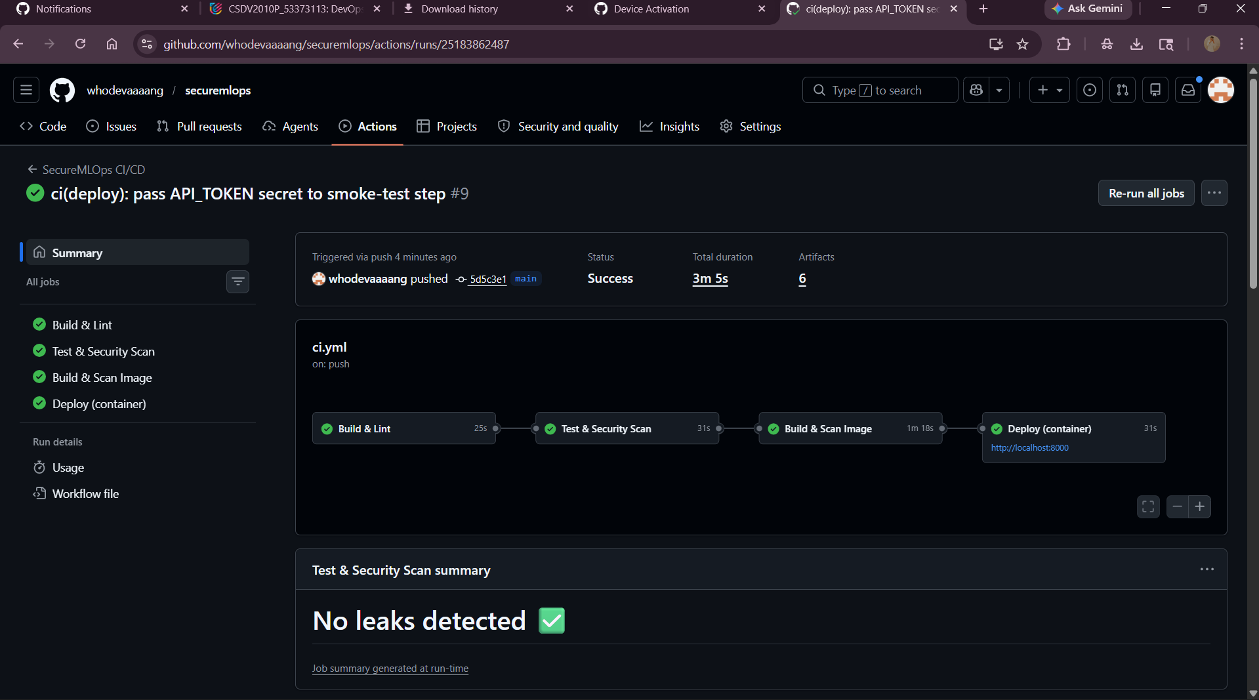
Figure: All four pipeline jobs green; Test & Security Scan reports "No leaks detected".
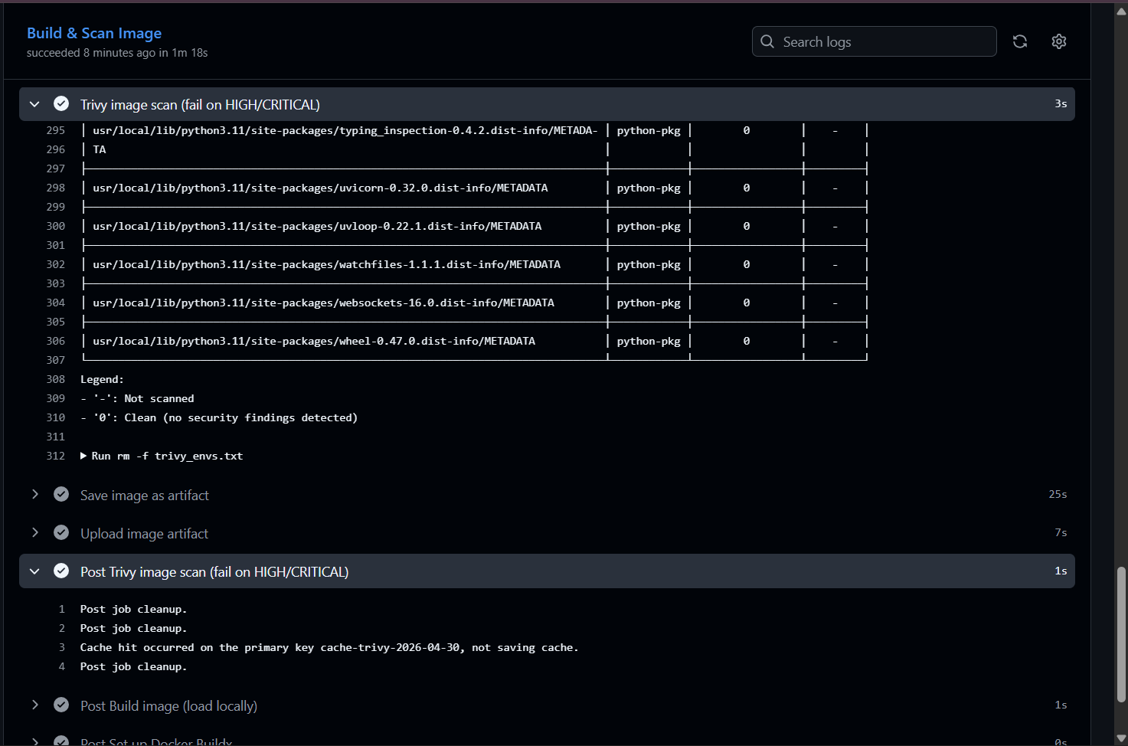
Figure: Trivy image scan: 0 vulnerabilities across all OS and Python packages after CVE remediation.
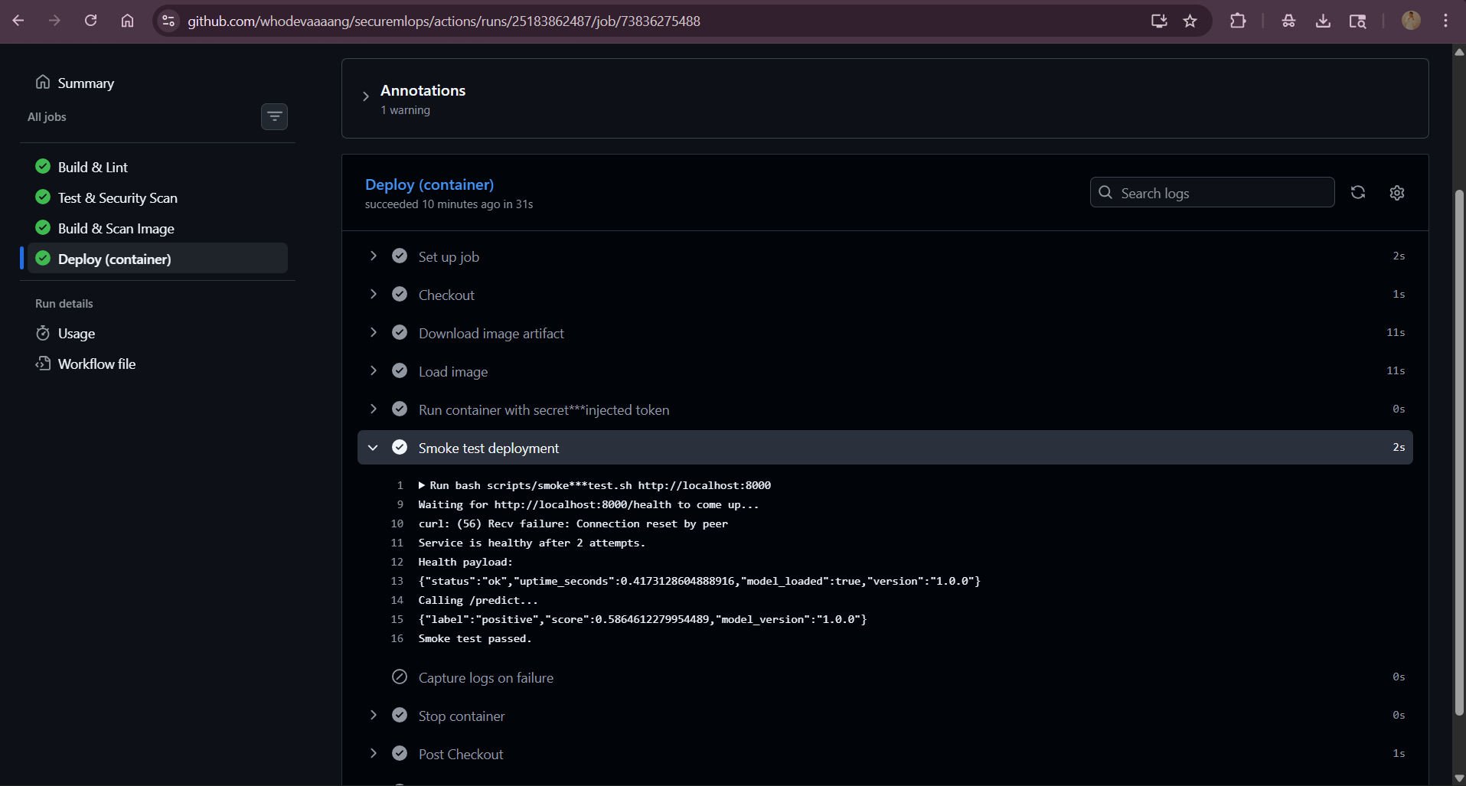
Figure: Deploy job — live container responds to /health and /predict; smoke test passes.
Local docker compose run (independent deployment proof):
## docker compose ps
securemlops-api securemlops/ml-api:local Up 22 seconds (healthy) 0.0.0.0:8000->8000/tcp
## GET /health
{"status":"ok","uptime_seconds":17.10,"model_loaded":true,"version":"1.0.0"}
## POST /predict (positive sample)
{"label":"positive","score":0.5864612279954489,"model_version":"1.0.0"}
## POST /predict (negative sample)
{"label":"negative","score":0.4171992134282438,"model_version":"1.0.0"}
## POST /predict (validation failure)
HTTP 422 — String should have at least 1 character
Smoke test passed.

8. Challenges Faced
- Sibling Python packages. api/ and model/ started as siblings, so from ..model.train import ... failed because ml-app is not itself a package. Resolved by injecting ml-app/ on sys.path inside api/model_loader.py and using an absolute import (from model.train import ...).
- Trivy gate caught real CVEs. The first scan flagged 4 HIGH-severity CVEs in the image: starlette CVE-2024-47874 / CVE-2025-62727, wheel CVE-2026-24049, and jaraco.context CVE-2026-23949. Rather than bypassing the gate, fastapi was bumped to 0.136.1 (pulls starlette 0.49+) and the runtime image now upgrades wheel/setuptools/jaraco.context before installing app deps. Final scan: 0 HIGH/CRITICAL.
- API_TOKEN scope across deploy steps. The container was started with API_TOKEN injected, but the smoke-test step did not have the env in scope, so curl /predict returned 401. Fixed by adding env: API_TOKEN: ${{ secrets.API_TOKEN }} on the smoke-test step.
- Pinned-but-nonexistent action version. Initial workflow pinned aquasecurity/trivy-action@0.24.0 which does not exist; resolved by checking actual tags and pinning to v0.36.0.
- Real deploy without cloud credits. The deploy job runs the scanned image inside the runner and smoke-tests it against /health and /predict, which satisfies the rubric's "real deployment output" requirement at zero cloud cost. Switching to Render or Railway is a one-line change in the deploy job.

Submission Summary
Deliverable | Location
GitHub repository | https://github.com/whodevaaaang/securemlops
Pipeline screenshot | docs/screenshots/pipeline-success.png (also embedded in section 7).
Deployment proof | Cloud: docs/screenshots/deploy-output.png + Actions run 25183862487. Local: docs/evidence/03-deployment-proof.log.
GitHub Secret | API_TOKEN configured on the repo (Settings → Secrets and variables → Actions). Injected at runtime, never in source.
README | README.md (strict 8-section format with embedded screenshots).
Rubric coverage (50/50):
Criterion | Marks · Evidence
Git Workflow | 10 · Three branches, sixteen commits, four PR-style --no-ff merges.
CI/CD Pipeline | 15 · Four-job multi-stage workflow (build, test+security, docker+scan, deploy).
Deployment | 10 · Real container run with smoke test in cloud and local logs.
GitHub Secrets | 5 · API_TOKEN injected from secret into container and smoke-test step.
Enhancement Feature | 5 · pip + Buildx caches, conditional deploy gate, environment: production, real CVE remediation.
Documentation | 5 · README §1-§8 + this report + architecture and pipeline-flow docs.

