Microgrid Design and Simulation: **Solar Pumping**

GROUP NAMES: Thomas Hudson, Zhen-Yu, Yen-Chun

Project Type: **Solar Pumping**

November 14, 2024

Table of Contents

Solar Pumping Microgrid - Description and Overview   
Load Calculations   
 - Electrical Lighting   
 - Domestic Water Pumping   
 - MicroGrid Peak Power   
 - MicroGrid Annual Energy Use   
 - MicroGrid Load Factor   
Summary of Homer Output   
 - Daily Average Load & Daily Peak Load   
 - Solar Cost   
 - Wind Turbine Cost   
 - Battery Cost   
 - Diesel Price   
 - Homer Output   
Translating Homer's Outputs to MAT-LAB/Simulink   
Control Strategy   
Summary of Micro-grid Parameters   
Solar PV Description and Optimization   
Micgrogrid Plots   
 Plot #2 Delta Frequency PU vs Time   
 Plot #3 - Energy Storage and State of Charge (SOC) vs Time   
 Figure 7.   
Stability Analysis   
Contengency Situation - Cloudy Day   
Conclustions  
References

# 

# Solar Pumping Microgrid - Description and Overview

This microgrid project includes non-grid supplied power systems for domestic water supply and electrical lighting serving a small community in Uganda.

In Uganda clean, potable water is often attained from vertical boreholes where aquifers are available. Hand pump kiosks allow for manual extraction of water but this is not effective for larger communities where community members face long wait times (figure 1.1).

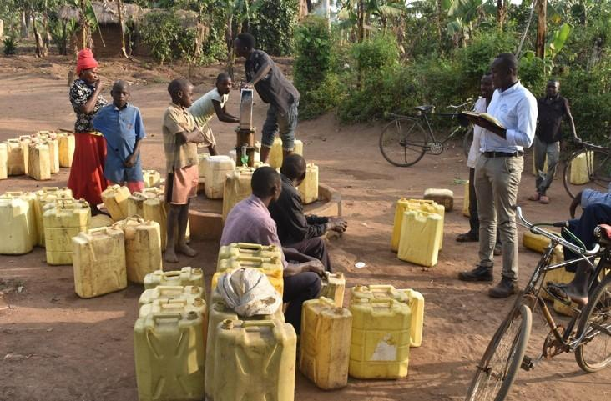

*Figure 1.1: People waiting to pump water.* [7]

This microgrid project develops electric power to pump domestic water from a borehole to a water storage tank. The system is designed to serve a community of 1800 persons. Figure 1.2 shows a general solar pumping diagram.

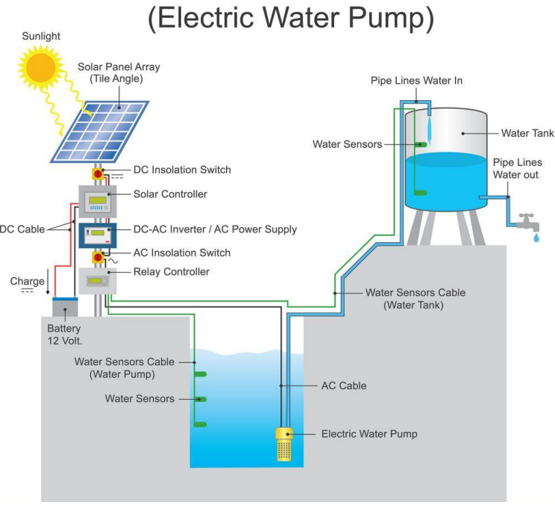

*Figure 1.2: General components for solar water pumping.* [7]

Microgrid design parameters for our community are based on an Engineering Without Borders 2020 implementation report by the Penn State University chapter of Engineers Without Borders. The chapter worked with the community of Namutamba for several years to understand design requirements such as daily water volume requirements and water storage.

Water storage is required for buffering against cloudy days when the microgrid power source for water pumping is not available.

This microgrid project includes electrical power and electrical storage requirements to serve a small school house. Electrical storage is required for inclement weather where daily power resources fall below average.

Microgrid projects (non-grid tied) with similar designs are implemented by Engineers Without Borders chapters in a number of African countries. Figure 1.3 shows solar projects in Uganda and Kenya where each colored circle indicates a solar installation. Reasons for solar adoption are solar can be more reliable than grid power, less expensive than grid power, and solar can be erected where needed.

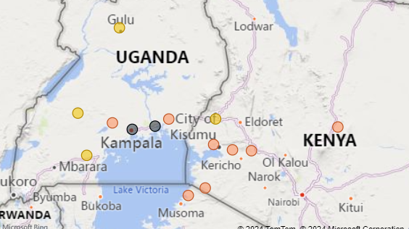

*Figure 1.3: EWB Solar Installation Projects.* [7]

Satellite images (figure 1.4) show large open areas that favor solar installation sites. The community is low density with few structures and land use includes agriculture. The Pen State University chapter has completed reports describing the demographic and socioeconomic profiles for the community.

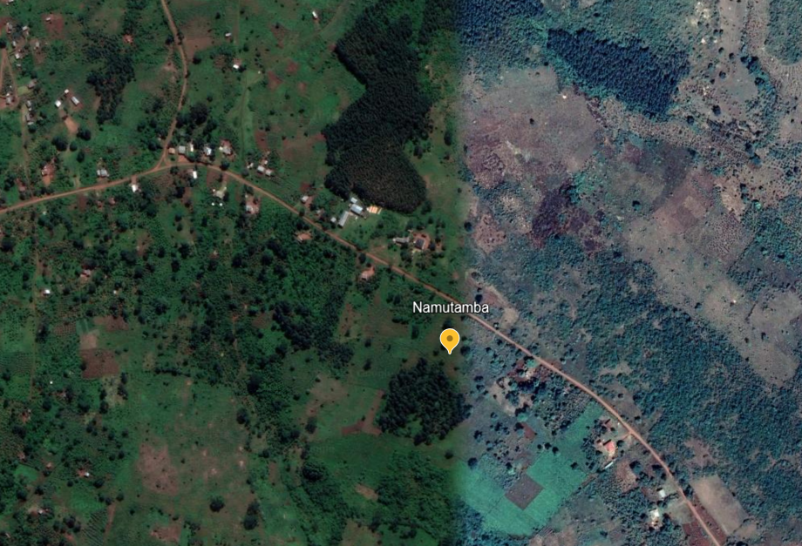

*Figure 1.4: Satellite image of Uganda community.*

The community is located at:

* latitude: 0.5345
* longitude: 32.0877

# Load Calculations

This project is designed to power both a water pump and electrical loads for a small school house.

## 

## - Electrical Lighting

The school house floor plan is shown 2.1 with a floor area of 77 sqm (UNICEF architectural designs for schools in Rwanda)[8].

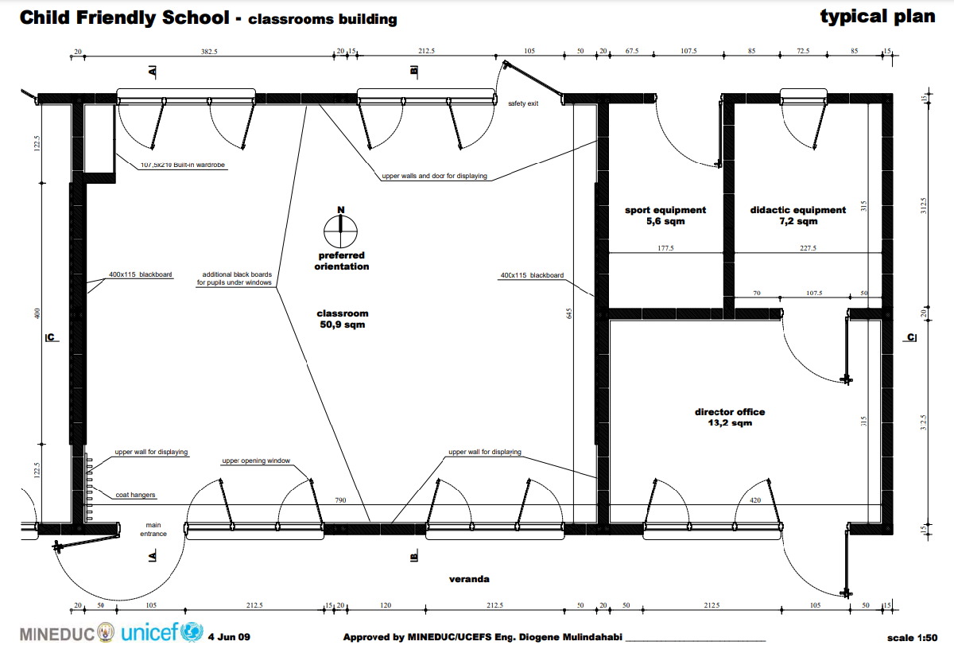

*Figure 2.1: School house drawing.* [8]

The project scope for the school house includes power for lighting and a few small plug loads for computers and a printer. Electrical lighting power continues to fall with the adoption of LEDs. Several US states have adopted the 2021 International Energy Conservation Code (IECC) standards, including its lighting power density (LPD). The 2021 IECC standards (LPD) is 0.71 watts per square foot(w/sqft) or 7.64 w/sqm. These standards are appropriate for this project as LED lighting is available in Uganda.

Plug Load estimates include 4 laptops and a small printer. Laptops are estimated to run 30 watts per device and operational 24 hrs/day. A small printer is estimated to draw 50watts and is operational 24 hrs/day.

**・ School Electrical Lighting and Power**

Electrical_Power_Use = 7.64 * 77; % 77sqm = 588 watts

Laptops = 4 * 30; % watts/each = 120 watts

Printer = 50; % watts

Total_Plug_Power = 120 + 50; % total power plug loads: 170 watts

Total_Power_School = Electrical_Power_Use + Total_Plug_Power; % total power all loads 758 watts

fprintf('Electrical_Power_Use: %0.1f watts \n',Electrical_Power_Use);

Electrical_Power_Use: 588.3 watts

fprintf('Total_Plug_Power: %0.1f watts \n',Total_Plug_Power);

Total_Plug_Power: 170.0 watts

fprintf('Total_Power_School: %0.1f watts \n',Total_Power_School);

Total_Power_School: 758.3 watts

**・ Daily Use Assumptions**

School Operational Hours: 6 days/week 8am - 5pm with 2 hours evening classes 3 times per week.

Total Operational Hours per week = 6 days * 9 hrs + 3 days * 2 hrs = 60 hrs

**・ Energy Use School per year**

Energy_Lighting = 60 * 52 * Electrical_Power_Use/1000; % = 1,834 kWh

Energy_Plug_Loads = 24 * 365 * Total_Plug_Power/1000; % 1,489 kWh

Total_Energy_School = Energy_Lighting + Energy_Plug_Loads; %kWh

fprintf('Energy_Lighting: %3.f kWh \n',Energy_Lighting);

Energy_Lighting: 1835 kWh

fprintf('Energy_Plug_Loads: %3.f kWh \n',Energy_Plug_Loads);

Energy_Plug_Loads: 1489 kWh

fprintf('Total_Energy_School: %3.f kWh \n',Total_Energy_School);

Total_Energy_School: 3325 kWh

This estimate includes no safety margins for estimated electrical lighting power or lighting schedules at this time.

## 

## - Domestic Water Pumping

Uganda has a national water standard of 20 liters per day per person. Our community of 1,800 persons requires 36,000 liters per day. The average water flow is calculated to be 1,500 liters/hr to deliver the required volume in a 24 hour period. This initial operational assumption is that electrical power is available 24 hours a day.

The total static head pressure required includes the depth of the well and head pressure to move the water from the well to a reservoir. The total dynamic head pressure is estimated at 154 to 170 meters.

Figure 2.2 is a data of available pumps to meet various pressures and flows. All these pumps can deliver 1,500 liters/hr (x-axis) and the red lines indicate the required band of 154 to 170 meters for this project. SP 2A-48 can deliver the flow and pressure required. Another pump not shown on this data sheet is SP 2A-40 that lies just under SP 2A-48 and can deliver the flow at that specified pressure. This pump has a 2.2 kw (3hp) motor. The datasheet shows 0.04 kW power per stage and the SP 2A-40 has '40 stages.' The pump power is then given as 0.04 kw x 40 stages for 1.6 kW. Pump selection is well within the estimated requirements but no pumping power safety margins are included in these calculations at this time.

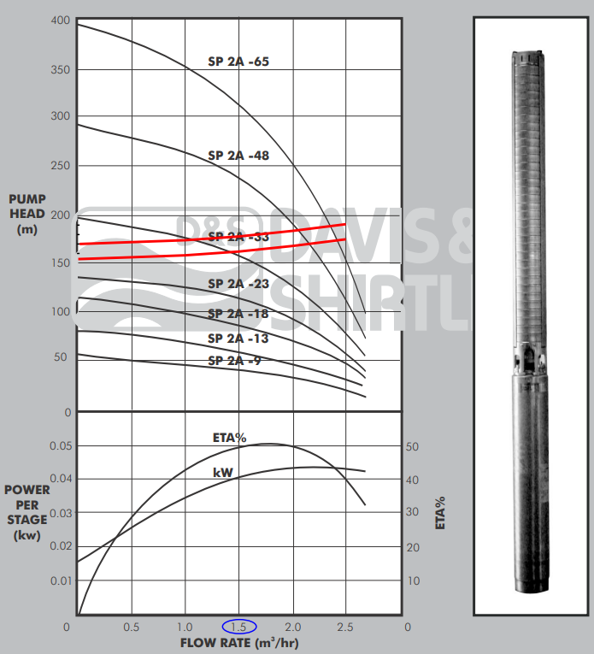

*Figure 2.2: Grundfos pump data sheet. The red lines indicate the operational band.* [9]

Pump_power = 0.040 * 40; % 1.6 kW

fprintf('Pump_power: %0.1f kW\n',Pump_power)

Pump_power: 1.6 kW

**Energy pumping power**

As with the electrical lighting, this assessment assumes power is available 24 hours a day for pumping. The pumping energy estimate is therefore given as:

Annual_Pumping_energy = Pump_power * 365 * 24; % 14,016 kWh

fprintf('Annual_Pumping_energy: %3.0f kWh \n',Annual_Pumping_energy);

Annual_Pumping_energy: 14016 kWh

Under this assessment the reservoir will be sized to hold sufficient water for daily use fluctuations but the pump will continuously fill the reservoir and the peak power will match the pump power: 1.6kW.

## 

## - MicroGrid Peak Power

The current estimated loads assume power is always available.

The total electrical lighting loads and pumping loads are given as:

Peak_Power = Total_Power_School/1000 + Pump_power; % 2.36 kW

fprintf('Peak_Power: %2.2f kW \n',Peak_Power);

Peak_Power: 2.36 kW

## 

## - MicroGrid Annual Energy Use

The annual energy usage includes electrical lighting and pumping energy and is given as:

Annual_Energy_Use = Total_Energy_School + Annual_Pumping_energy; %3,323 kWh + 14,016 kWh = 17,339 kWh

fprintf('Annual_Energy_Use: %3.0f kWh \n',Annual_Energy_Use);

Annual_Energy_Use: 17341 kWh

## 

## - MicroGrid Load Factor

This inital design reflects the 'grid like' access to electrical power; that is, electrical power is assumed to be available when needed from microgrid resources. The 1.6 kW pumping power will likely be constant as it has been sized for 24 hour operation. If the pump does turn off it will occur when little water is being used (at night) and once the reservoir has been filled. Electrical lighting power usage is shown here to operate during a Monday through Saturday and 8am - 5pm schedule and contributes to the lower load factor.

The load factor is given as Total Annual Energy Use / (Peak Demand * 365 days)

Load_factor = Annual_Energy_Use/(Peak_Power * 24 * 365);

fprintf('Load Factor: %0.2f \n\n\n',Load_factor);

Load Factor: 0.84

# 

# Summary of Homer Output

To utilize Homer, we need to know several key factors for our design: daily average load, solar cost, wind turbine cost, battery cost, and diesel price in Uganda.

## - Daily Average Load & Daily Peak Load

We simply take the annual energy use (Annual_Energy_Use) divied by 365, then we can get:

fprintf('Average Load: %0.2f kWh/day, Peak Load: %0.2f kW\n', Annual_Energy_Use/365,Peak_Power);

Average Load: 47.51 kWh/day, Peak Load: 2.36 kW

Thus, we set the Average Load to 47.51 kWh/day. The variability is set to 4% hourly and 2% daily to match our load factor of 0.84 and peak load 2.36kW as closely as possible.

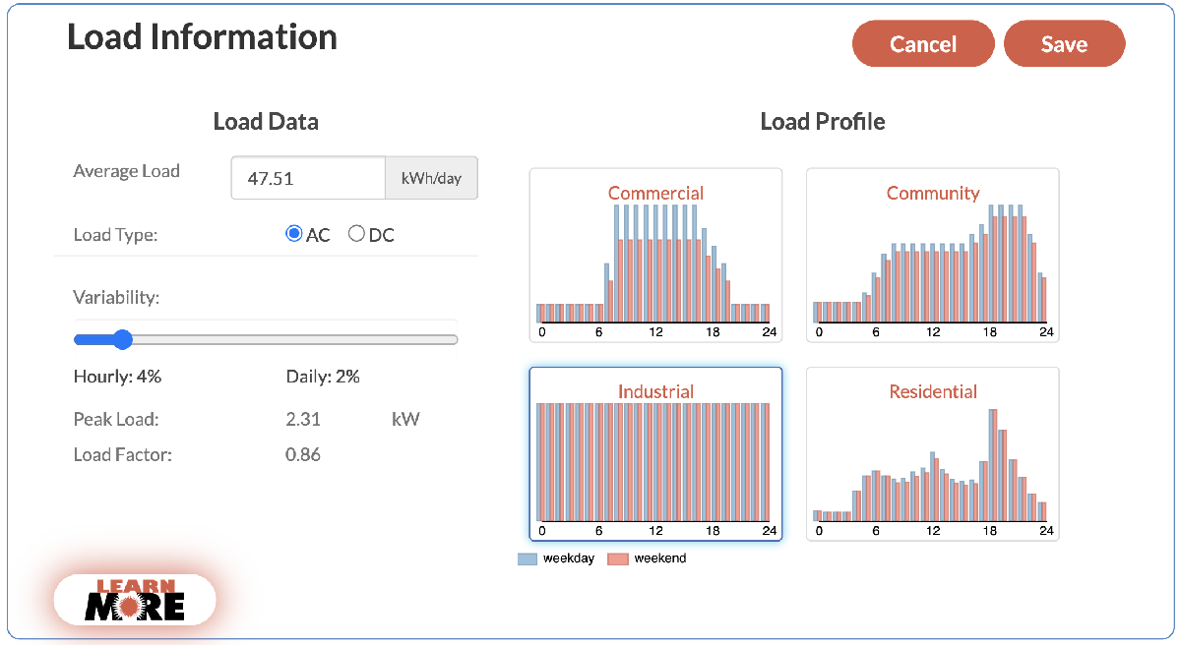

*Figure 3.1 The Load Information setting for Homer Calculation.*

## - Solar Cost

Since Uganda is spacious and the funding is relatively lower, we selected utility ground mount solar system for our design. According to the data from the National Renewable Energy Laboratory [4], the latest (2023) utility ground mount solar cost is 1.2 $/W, as shown in Figure 3.2.

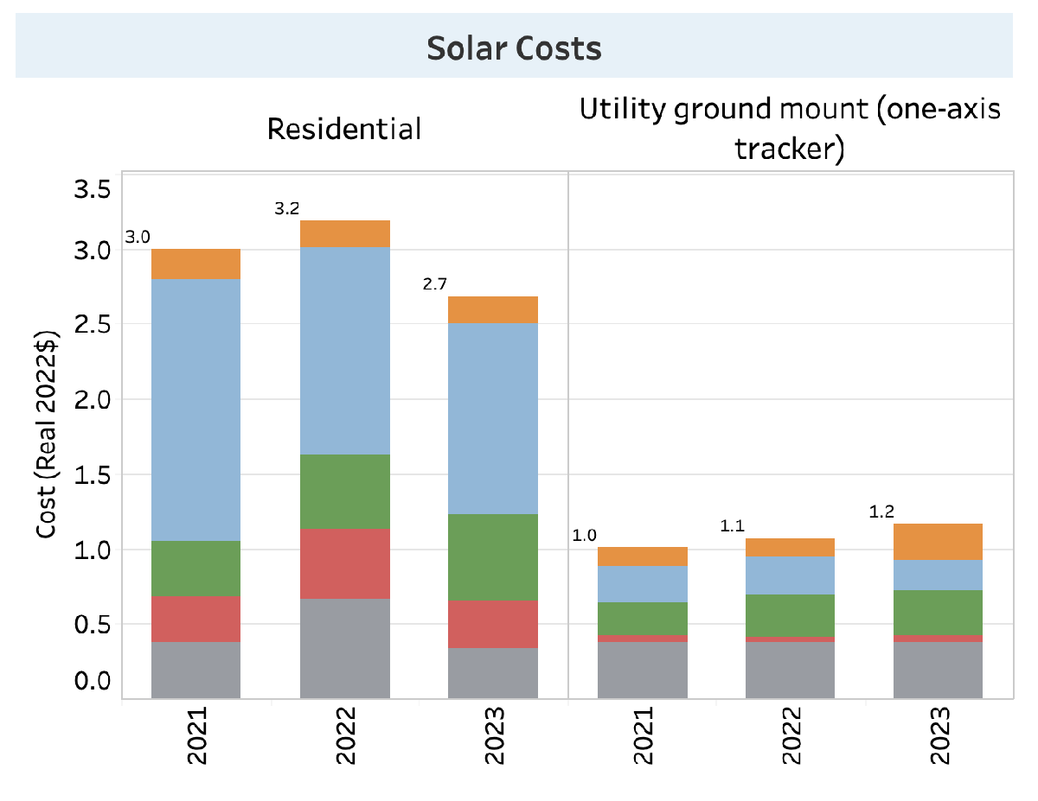

*Figure 3.2 Solar Costs in 2023 from NREL (National Renewable Energy Laboratory).*

## - Wind Turbine Cost

In our micro-grid design, we decided not to include wind power due to several important limitations [5]. First, Uganda lacks adequate and high quality wind data collected at the heights needed for energy assessments. Most wind data was gathered at lower altitudes for weather forecasting, making it less reliable for planning wind turbine installations. In addition, the high initial costs of installing wind energy infrastructure pose a huge challenge, especially in areas with limited funding for renewable energy projects. Lastly, Uganda's current energy policies offer very little support or specific incentives for wind power. This reduces the likelihood of investment in this area. Overall, these factors make wind power less practical for our project. Unsurprisingly, the result of the Homer calculation also excludes wind power, as shown in Figure. 3.4.

## - Battery Cost

* Use generic 1 kWh lithium ion batteries.
* Use $140 per battery.

## - Diesel Price

According to the Global Petrol Prices website [6], the latest deisel price in Uganda is 1.278 USD/Liter (11-Nov-2024).

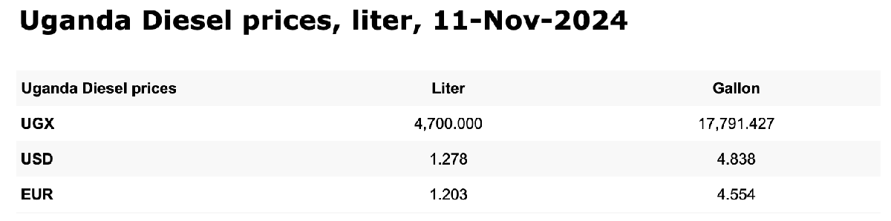

*Figure 3.3 Uganda Diesel prices from Global Petrol Prices website.*

## - Homer Output

All things considered, the simulation output from Homer is shown in Figure 3.4. We chose the micro-grid configuration with the lowest NPC, $94,924, since it is the most cost effective. This system includes a diesel generator with a capacity of 3 kW, complemented by solar PV with a capacity of 9.7 kW, and supported by 4 Li-lon batteries with a capacity of 1 kWh each. This configuration requires an initial capital investment of $14,231, with an annual operating cost of $5,123, achieving a COE of $0.35 per kWh. The diesel generator consumes 3,155 liters of fuel per year to ensure energy availability when solar output is insufficient. For more detailed information, please refer to the system report ([link](https://drive.google.com/file/d/1boekQl9hlhDZMRc6JIFEr2sqHfh6gaBv/view?usp=sharing)).

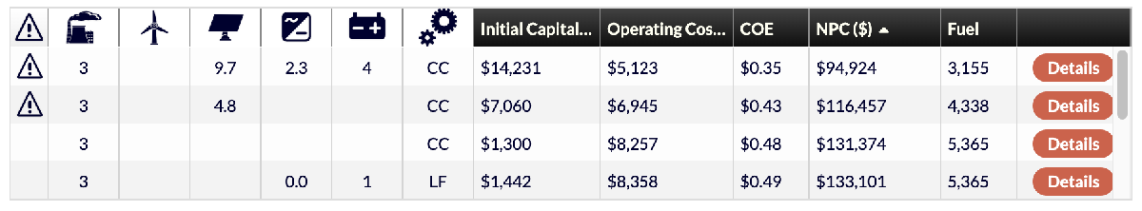

*Figure 3.4 The Homer ouput.*

# Translating Homer's Outputs to MAT-LAB/Simulink

The communities mean power and peak power are used to inform the load profile for the simulation and are given as follows:

meanLoad = 1.98e3; % Average load in Watts

peakLoadPower = 2.36e3 % in Watts

peakLoadPower = 2360

Although are simulation currently does not include wind, the average wind speed and number of turbines is as follows:

meanWindSpeed = 3.37 % Annual Average (m/s), currently not used

meanWindSpeed = 3.3700

wt.N_turbines = 0 % Not used

wt = struct with fields:

N_turbines: 0

Homer estimated 4 kWh of battery supply or 1.44e7 Joules. As a starting point we have set the rated power electronis to our peak power (2.36kW). This may have to be adjusted upwards by ~10% if we need full power and have to account for power electronics efficiencies.

es.E_rated = 4 * 1000 * 60 * 60; % 1.44e7 Enegy Storage rated energy in Joules

es.E_rated = 1.44e7; % Energy storage rated energy in Joules

es.P_pe_rated = 2.36e3; % Energy storage rated power in Watts

Homer sized the PV array for a rated capacity of 10kW.

pv.P_rated = 10e3; % Solar PV rated power in Watts

The system's rated deisel generator capacity of 3kW translates to hydroturbine capacity as follows:

ht.P_rated = 3.0e3; % hydroturbine rated power in Watts

The microgrid base power is set to our peak load power. This will define our normalization and per unit scaling.

mg.Pbase = 2.36e3; % Microgrid base power in Watts

# Control Strategy

Homer initial settings assumed very small amount of storage, 4kWh, or ~9% of the daily energy usage. Homer sized our PV (9.7kW) for almost the exactly daily energy usage. For this example we intend to optimize the system to use energy storage to capture excess PV power.

We intend to treat our solar exposure as normal, such that every day our solar availability matches our illumination time series. This is not realistic but allows us to spend time investigating and tuning our microgrid. We intend to rely heavily on PV and energy storage to meet most of our needs. In this example we omitted using the hydroturbine.

At about 8am in the morning, the sun provides sufficient power to cover our peak load. This coincides with the start of school. There is good solar availability till about 4pm. For the first 8 hours of the day we need energy storage or dispatchable power. The energy storage is sized for the first 8 hours as follows:

Energy_storage_morning = 1.6 * 8 * 1.2 % 1.6kW * 8 hours * 20% round trip charge losses => 12.8kWh

Energy_storage_morning = 15.3600

We intend to start the state of charge (SOC) at 50% so the storage is double the required monring storage. From 4pm to midnight the peak load varies between 1.6 and 2.2kW for 8 hours. The storage is shown completly exhausted at the end of the day.

Energy_storage_morning = Energy_storage_morning * 2 % double to allow state of charge to start to 50%.

Energy_storage_morning = 30.7200

es.E_rated = Energy_storage_morning * 1000 * 60 * 60; % 1.44e7 Enegy Storage rated energy in Joules

We decided to use the water pump as a deferred load during the peak solar hours. The water pump is controlled to turn on whenever the energy storage is charging. This works well because of the PV outputs significantly above our typical daily load.

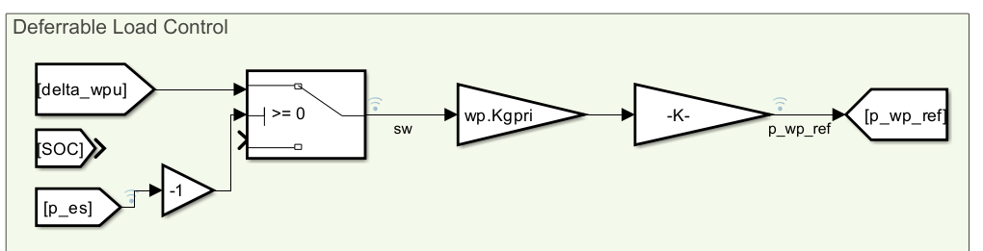

Figure 4. The deferrable load (water pump) is set to be enabled when the energy storage is charging.

# 

# Summary of Micro-grid Parameters

**Loads**

Pump Power and Energy: 1.6 kW, ~38 kWh daily usage (running 24-hours a day)

School Power and Energy (lighting and plug loads): 0.6 kW, ~6kWh daily usage

Total Daily Energy: ~44kWh

Peak Power: 2.2 kW

Power Factor: 0.84

Night time power: 1.6 kW (Pump only)

Daytime operating hours: School Schedule ~ 10 hours/day

**Generation Sources**

Photovoltaic: 9.7kW with ~ 4.5 peak hours, ~44kWh

Dispachable Hydroturbine: Did not use

**Storage**

Lithium Battery Storage: 30.7 kWh

# Solar PV Description and Optimization

Homer's estimated photovoltaic power was extremely close to matching our daily energy usage. We found our daily illumination produced about 4.5 peak sun hours and together with the elstimated 9.7kW of installed capacity produces ~44kWh of energy. This aligns eactly with our daily demand.

We found by adjusting the load resistor down from 0.005 to 0.0001 we increased the performance of the MMPT by up to 8%. This can be seen by monitoring the power at the individual modeled cell 'pv' or as the combined power 'p_pv'.

# Microgrid Plots

simresults = sim("microgrid_y24f_step10"); % ADDED to access data

loggedData = simresults.logsout; % ADDED to access data

p_ld = loggedData.get('p_ld').Values.Data; % load

p_pv = loggedData.get('p_pv').Values.Data;

p_es = loggedData.get('p_es').Values.Data;

p_ht = loggedData.get('p_ht').Values.Data;

p_wp = loggedData.get('p_wp').Values.Data; % water pump - Deferrable load

soc = loggedData.get('SOC').Values.Data;

delta_wpu = loggedData.get('delta_wpu').Values.Data;

x_time = 1:length(soc);

figure(1);

plot(x_time, p_ld, 'r-', 'LineWidth', 1.5);

hold on;

plot(x_time, p_pv, 'm-', 'LineWidth', 1.5);

plot(x_time, p_es, 'b-', 'LineWidth', 1.5);

plot(x_time, p_wp, 'g-', 'LineWidth', 1.5);

plot(x_time, p_ht, 'k-', 'LineWidth', 1.5);

ylabel('Power (watts)');

hold off;

set(gcf, 'Position', [1550, 50, 800, 900]);

xlabel('Time (seconds)');

title('Power vs Time (Load, PV, Energy Storage, Water Pump, Hydroturbine)');

legend('Total Load Power', 'PV Power','Energy Storage Power', 'Water Pump', 'HydroTurbine'); % Add legend

legend location northwest

grid on;

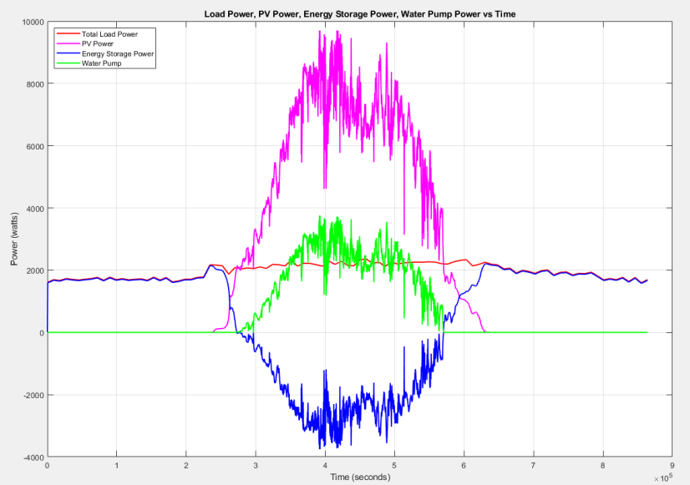

Figure 5. Load Power, PV Power, Energy Storage, Water Pump Power vs Time

### 

### Plot #2 Delta Frequency PU vs Time

The delta frequency per unit shows the frequency maintaining within +/- 2%

figure(2);

plot(x_time, delta_wpu, 'b-', 'LineWidth', 2);

ylabel('Delta Frequency Per Unit');

ylim([-0.1 .1]);

set(gcf, 'Position', [1550, 50, 800, 900]);

xlabel('Time (seconds)');

title('Delta Frequency Per Unit vs Time');

legend('Delta Frequency PU'); % Add legend

legend location northwest

grid on;

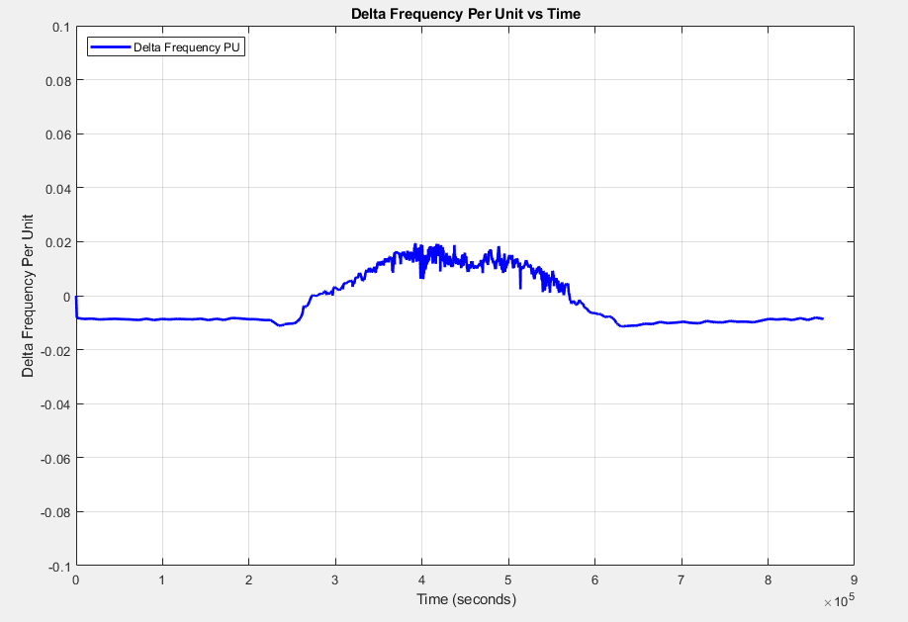

Figure 6.

### Plot #3 - Energy Storage and State of Charge (SOC) vs Time

figure(3);

yyaxis left

hold on;

plot(x_time, p_es, 'b-', 'LineWidth', 1.5);

ylabel('Energy Storage (watts)');

%set(gca, 'YColor', 'b');

%ylim([0 11e4]);

yyaxis right

plot(x_time, soc, 'k-', 'LineWidth', 2);

hold off;

ylabel('State of Charge');

%ylim([-0.1 1.015]);

set(gcf, 'Position', [1550, 50, 800, 900]);

xlabel('Time (seconds)');

title('Energy Storage and State of Charge vs Time');

legend('Energy Storage Power', 'State Of Charge (SOC)'); % Add legend

legend location northwest

grid on;

# 

### Figure 7.

# Stability Analysis

The model performs well with respect to maintaining frequency within 2% (per unit) or 1.2 hz. This is considered pretty good frequency control in a grid tied environment and excellent control in a micro-gird. Figure 6 shows during the first part of the day and the end of the day the load exceeds generation slightly and we see a decrease in frequency by -0.01 PU. During the day when the available solar resource is high (mid day), the PV generation exceeds the load slightly and there is a increase in frequency by almost 0.02 PU. This relationship between load and frequency is exactly as expected.

# Contingency Situation - Cloudy Day

For our contingency situation we ran the cloudy day time series. The reduced solar exposure resulted in reduced battery charging and the microgrid ran out of storage in ~ 20 hours. The microgrid requires more dispatchable power capacity to deal with any reduced power supply. Figure 8 shows the power dropping below demand and energy storage flipping between charging and powering the loads. Figure 9 shows where then energy storage depleted leading to frequency instability and grid collapse.

# 

Figure 8. Load and Power during a day of reduced solar exposure

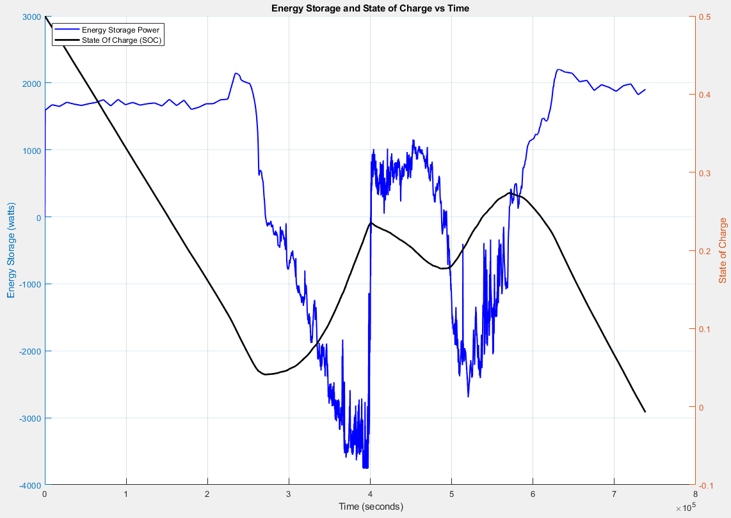

Figure 9. Energy Storage and State of Charge (SOC) during a day of reduced solar

# Conclusions

For this microgrid we included both constant power requirements (water pump) and loads that varied with schedule (school building). Having different types of loads was an interesting exercise to evaluate. Having several different types of power generation and power delivery seems key to maintain grid frequency and overcome a variety of contingencies!

It may also be interesting to split these two loads up and power them independently. For example, as we hinted at in our presentation in class, there might be an advantage in splitting up the loads such that the water supply system and storage is served separately. In this scenario, the solar, pump, and storage is oversized to provide sufficient water storage over multiple days without battery backup or dispatchable generation. These types of systems are being deployed in parts of Africa where some designs favor water storage infrastructure over battery storage. The water pumps can be selected as DC pumps to optimize efficiencies with a DC solar system. A system like this might also work well with a dispatchable generation in the form of a generator that is used maybe once a year when there is unusual cloudy weather.

The school and the water system have very different requirements and might benefit from different microgrids. The school on the other hand requires power most every day and the school power requirements are lighter and can be served by smaller battery storage systems.

For these reasons it would be interesting to explore separate microgrids for the two scenarios and evaluate what types of storage and dispatchable generation are appropriate.

# 

# References

1. Reference for IECC Lighting Power Density: <https://www.archtoolbox.com/recommended-lighting-levels>
2. 2019 Solar Prices for Kenya: <https://energypedia.info/wiki/File:Solar_Prices_KE_Matrix.xlsx>
3. Solar Powered Water Guidlines Rwanda: <https://drive.google.com/file/d/1lrx7iS9qK3hgrIIGmuUqderht0T_6Wgs/view?usp=sharing>
4. National Renewable Energy Laboratory *-* Solar Installed System Cost Analysis: <https://www.nrel.gov/solar/market-research-analysis/solar-installed-system-cost.html>
5. Wabukala, Benard M., et al. "Assessing wind energy development in Uganda: Opportunities and challenges." *Wind Engineering* 45.6 (2021): 1714-1732. <https://journals.sagepub.com/doi/full/10.1177/0309524X20985768>
6. Global Petrol Prices Website in Uganda: <https://www.globalpetrolprices.com/Uganda/diesel_prices/>
7. Image from EWB report. https://volunteer.ewb-usa.org/
8. "Child Friendly Schools in Rwanda." UNICEF, https://www.unicef.org/rwanda/education
9. Grundfoss pump curve for SP 2A series, https://product-selection.grundfos.com/products/sp-sp-g/sp/sp-2a-48-09102B48?pumpsystemid=2540071742&tab=variant-curves