CS 008 Introduction to World Wide Web Design Fall 2013

Kelly Krawczyk

Final Project

Final Project

Version <1.0>

|  |  |  |  |
| --- | --- | --- | --- |
| Time Log | | | |
| Date | Time Spent (in hours) | Description | Author |
| 5/28/12 |  | First Version of Software Requirements | Robert Erickson |
| 11/6/13 | 15 | Your estimated time to complete assignment _________ hours | Kelly Krawczyk |
|  |  |  |  |
|  |  |  |  |
|  |  |  |  |
|  |  |  |  |
|  |  |  |  |
|  |  |  |  |
|  |  |  |  |
|  |  |  |  |
|  |  |  |  |
|  |  |  |  |
|  |  |  |  |
|  |  |  |  |
|  |  |  |  |
|  |  |  |  |
|  |  |  |  |
|  |  |  |  |
|  |  |  |  |
|  |  |  |  |
|  |  |  |  |
|  |  |  |  |
|  |  |  |  |
|  |  |  |  |
|  |  |  |  |
|  |  |  |  |
|  |  |  |  |
|  |  |  |  |
|  |  |  |  |

Table Of Contents

Software Requirements Specifications 4

Introduction 4

Purpose 4

Scope 4

Definitions, acronyms, and abbreviations 4

Overview 4

Overall Description 5

Story Board 5

Specific requirements 6

# Software Requirements Specifications

## Introduction

### Purpose

The purpose of this document is to describe the requirement specification for the web site for the final project.

The intended audience for this document is the prospective developers of this site.

### Scope

The web site to be created is a site designed to show information on The Beatles as well as a form to sign up as an official fan.

### Definitions, acronyms, and abbreviations

HTML – Hypertext markup language

CSS – Cascading Style Sheets

W3 Validation – refers to both Html and CSS validation tool provided by the W3c.org. the html validator is located at:

<http://validator.w3.org/>

with the CSS validator located at:

<http://jigsaw.w3.org/css-validator/>

### Overview

The rest of this document contains an overall description of the form web site.

## Overall Description

It is your responsibility to come up with the content (both photos, pictures and text) for this site. The site will have six pages created for the fictional pizza restaurant, Andy’s Pizzeria.

### Story Board

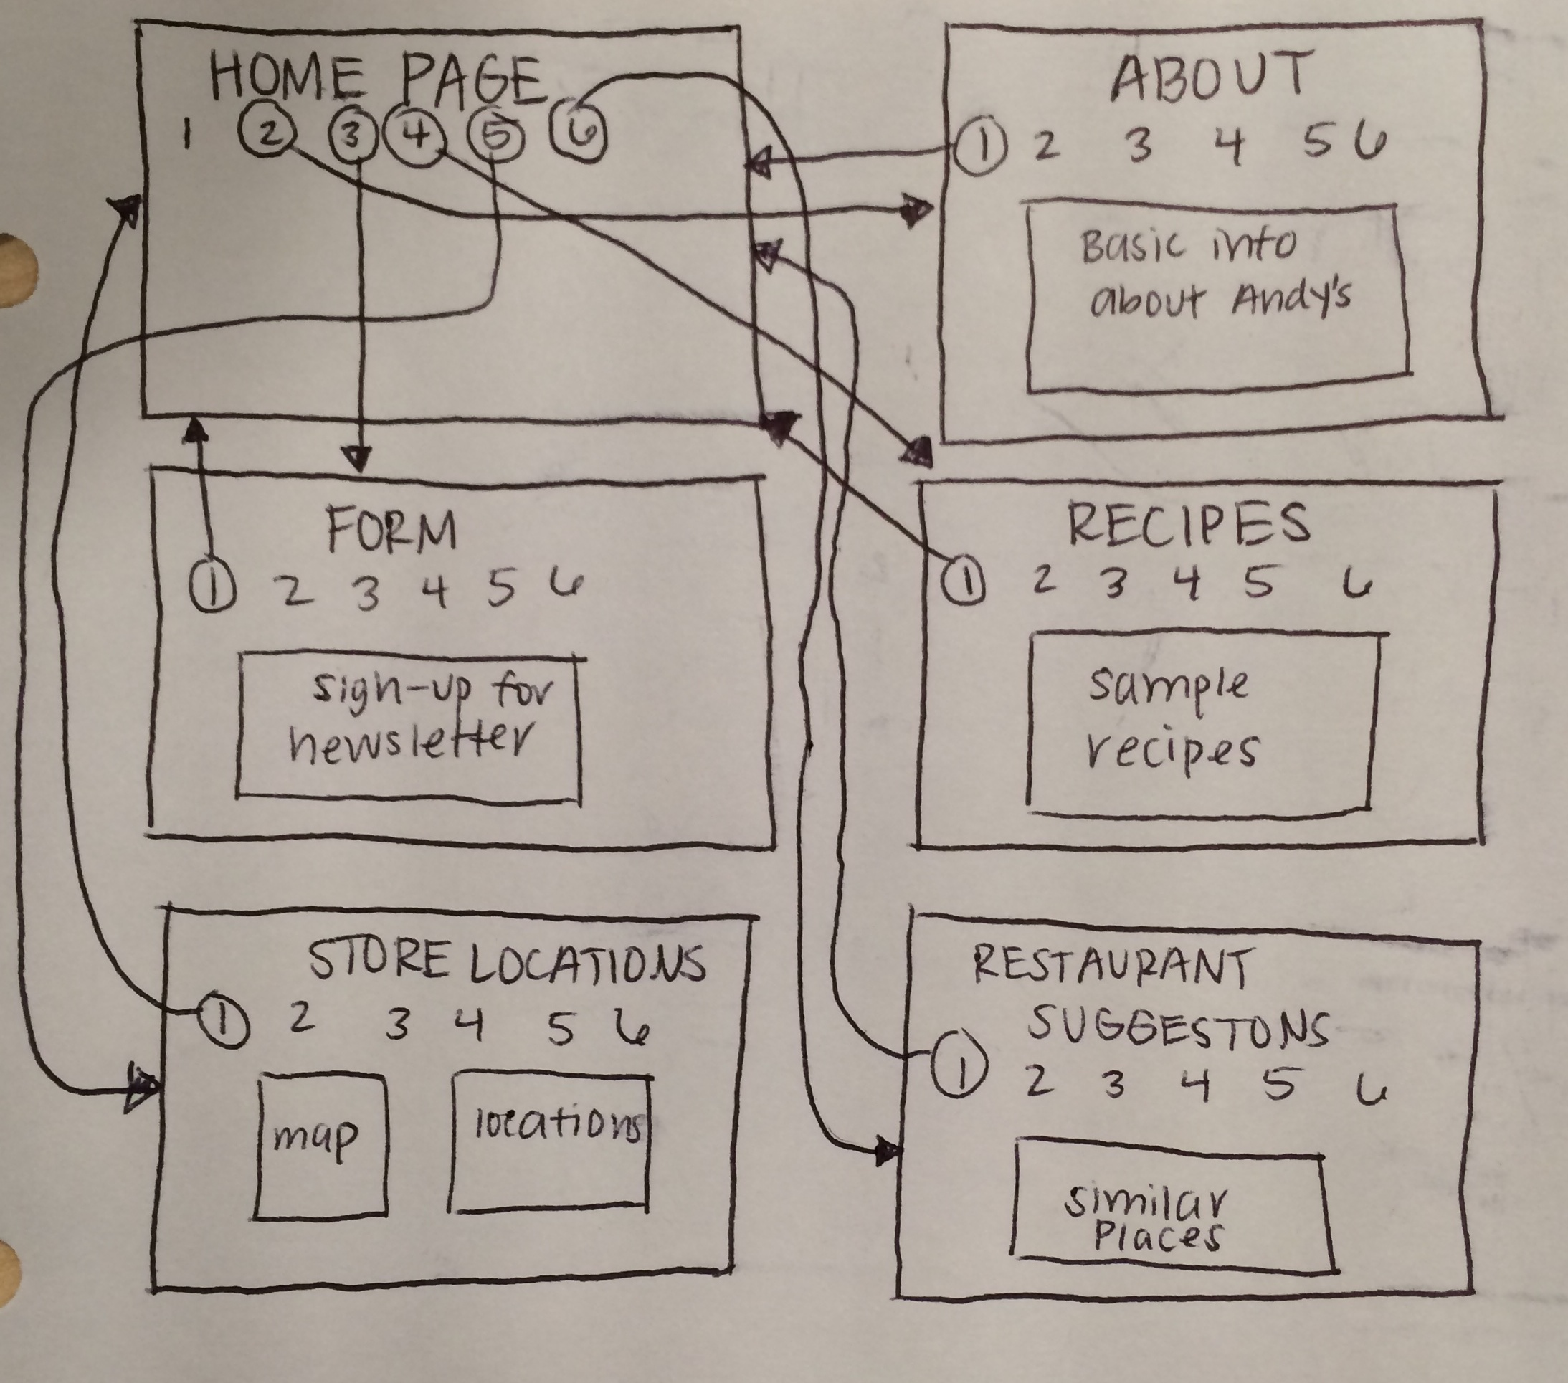

## Specific requirements

1. *Location* – all files will be located in folder as specified on the assignment page. Failure to have your site located in the correct place by the due dates will result in a zero on the assignment. Be sure to pay attention to the lowercase letters.
2. *Html Validation* – All pages will pass W3C Html validation for html 5.
3. *CSS Validation* – All pages will pass W3C 3.0 CSS validation.
4. *Meta Information* – All pages will contain a proper title tag, Meta tags (author, character set and description.
5. *Head Section* – put the doctype and head section information in a file named top.php so you can include it all the pages.
6. *Header* – All pages will contain a header with the logo about your site. File name should be header.php
7. *Navigation* – All pages will contain navigation to all other pages on the site using an ordered list. File name should be nav.php
8. *Content* – Each page will have a minimum of 150 words not counting titles, lists or links. Use the article, aside or section html elements. All files will use .php extension (main.php, photos.php, pics.php).
9. *Browser compatibility* - This site will be checked on Firefox, Safari, Chrome and Internet Explorer.
10. *Screen Resolutions* – Your site should be able to handle a little flexibility in different size screens and still look reasonable well.
11. *Footer* – All pages will contain a footer with the content determined by you. Filename will be footer.php
12. Your site will be broken up into separate functional files, ie header, nav, footer. You will use .php extension and include these files in each page.
13. *Form* – One page will be form.php will be a form to collect information from a user based on the theme of your site. Be sure to include at least:
    1. One text box for a users email address.
    2. One list box.
    3. Two check boxes.
    4. Two radio buttons.
    5. Submit and Reset command buttons.
    6. Field sets and legends as needed
    7. Data should be validated for not missing, valid format etc as needed
    8. Form should submit the form to itself.
    9. Form should email the person who filled it out
    10. Form data should be saved to a file on the uvm share
14. *Data* – one page opens a data file and displays it in some way
15. *CSS* – all pages will have a linked style sheet. I will be looking for a flexible layout like my sample (it can look different it just needs to be flexible). Be sure to use classes and ID’s as needed.