REAUX LABS (ADMIN)

- There is no option to add membership details(amount, due date) and more details like (monthly/quterly/annually) for new customer. It needs to be added in this page while adding new customer.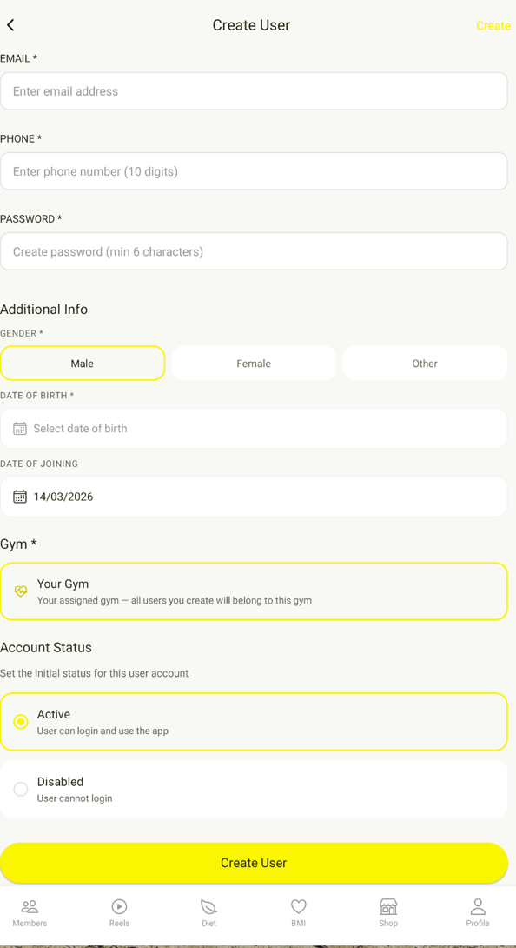

- Fee is completely paid but still showing due amount as 0 plus there is no upcoming date shown for fees, so how we got to know like on which day the fees is pending. Also please make sure the names will be filtered out automatically with context to due dates.
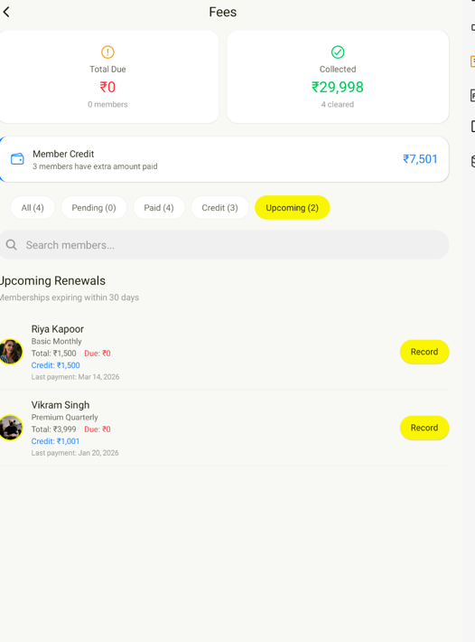

- Also there is no payment history shown anywhere except last payment date. We need all payment history individually shown while clicked on that person’s name.
- We need all details like payment history, due date, advance payment in this page as well. So that it will be easy to understand and simplified for admin. 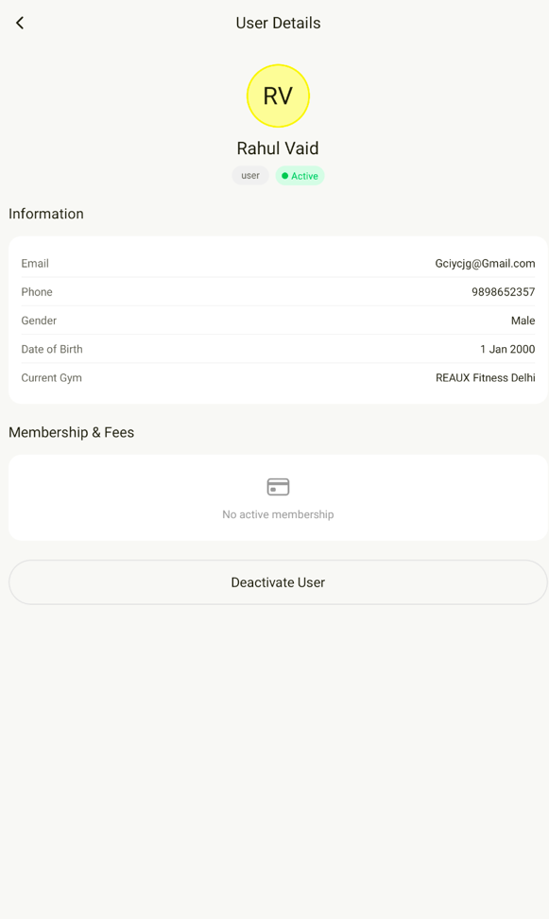
- While posting comments on the post section, everything including author’s profile image and name is getting refreshed.(blinking with each character being typed)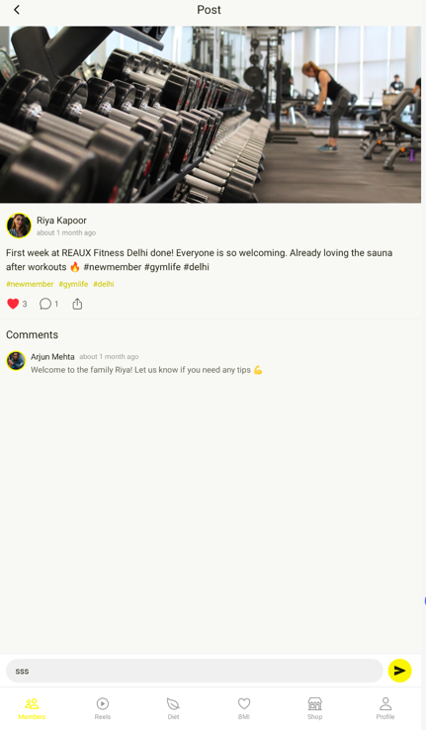
- There is no pop-up for notification.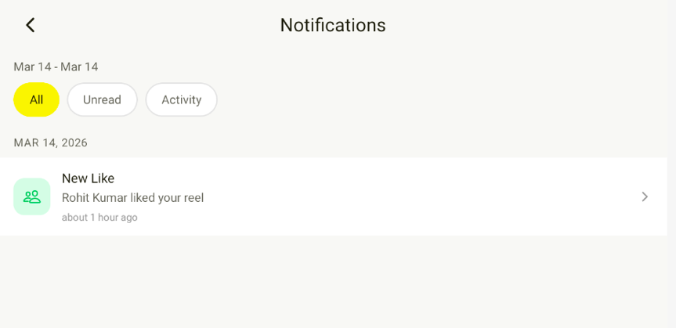
- There are some comments on some reels but there is no count under that. Please insert comment counts.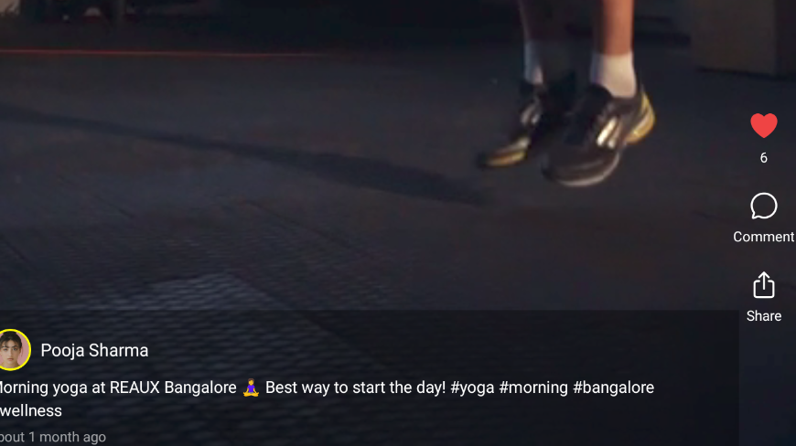
- Dropdown menu in needed for city and state in address. Also limit phone number to 10 digits in address. Right now we can put random numbers in that.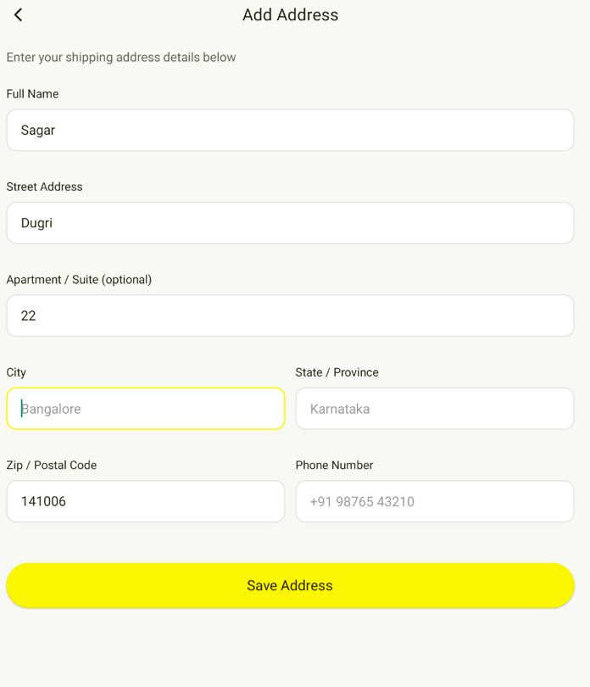
- While sharing anything this notification is showing, instead of this or addition to this if we can share link of our app from playstore/Appstore after launch and Instagram link before launch.
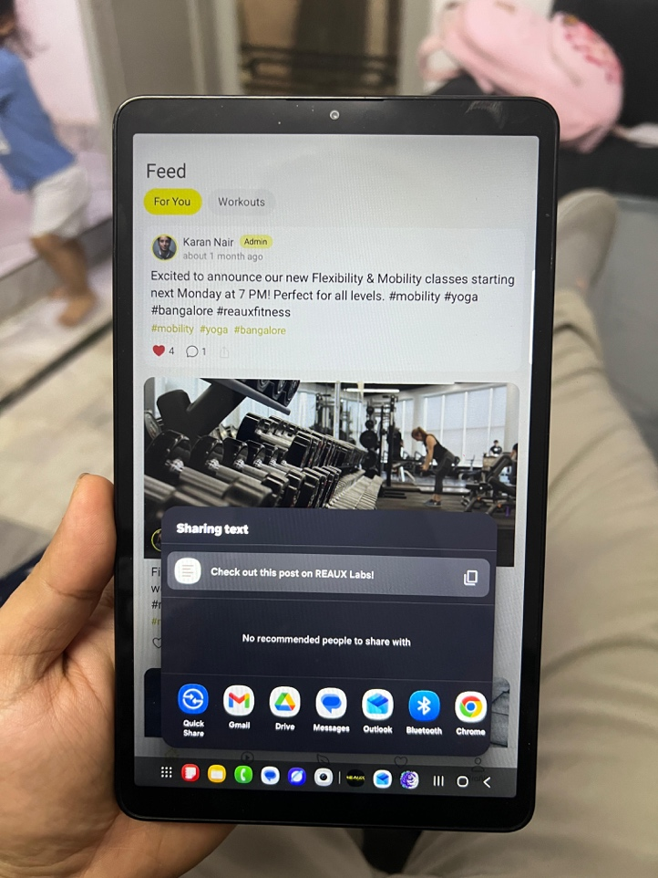
- We want reels to be refreshed every time a person opens the app or swiping down from the top like Instagram and other apps.
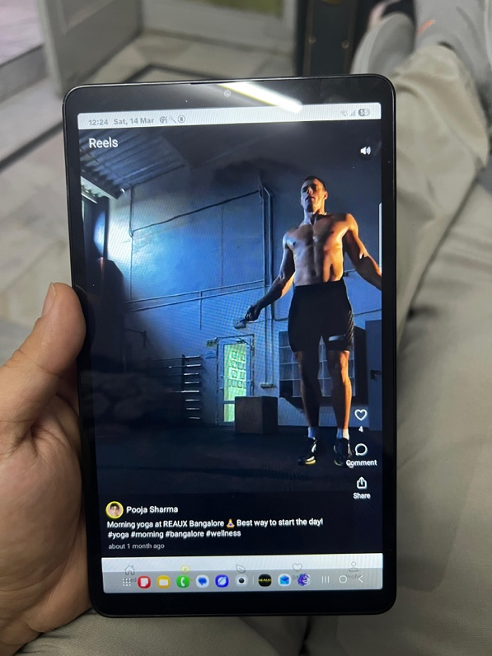
- Please add additional open of saved addresses for ease of adding multiple address in same account.
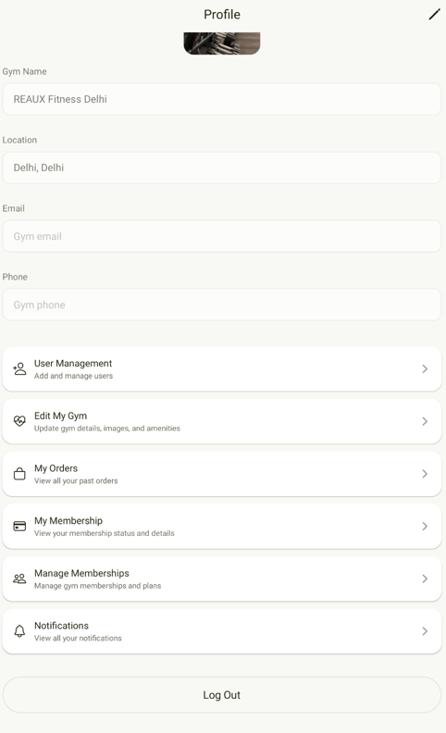
SUPER ADMIN
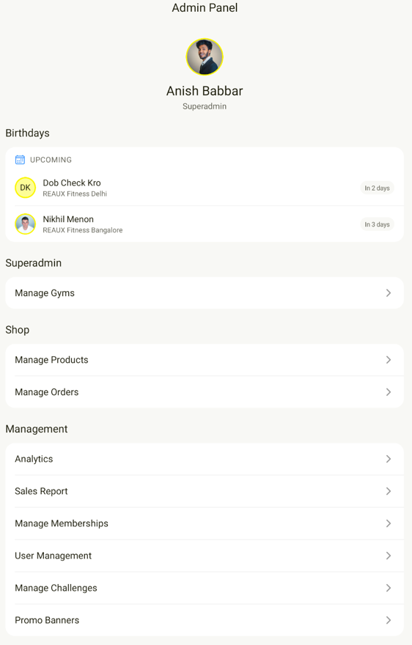
- Sales report needs to be moved up in shop section
- Please move the whole shop section with 3 sub headings ( Manage Products, Manage Orders, and sales report (mentioned in point 12.) outside in main profile section instead of my membership and my orders. These 2 sections are not for super admin as we are not going to place any order or buy any memberships.
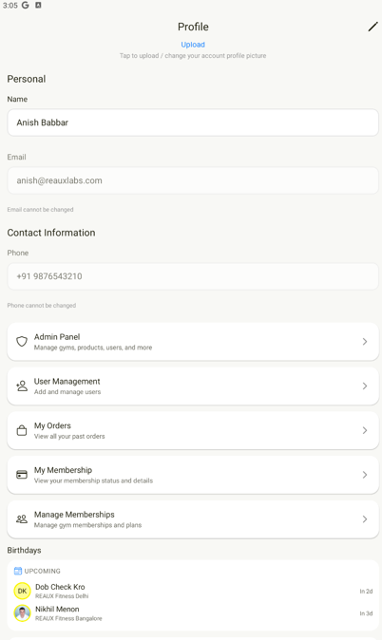
- As mentioned in previous meeting, we need details of members gym wise. For instance, if I click on Karan (admin) as super admin, we can see details of every person in his gym under his name also. Additionally, we can also export that list as pdf.
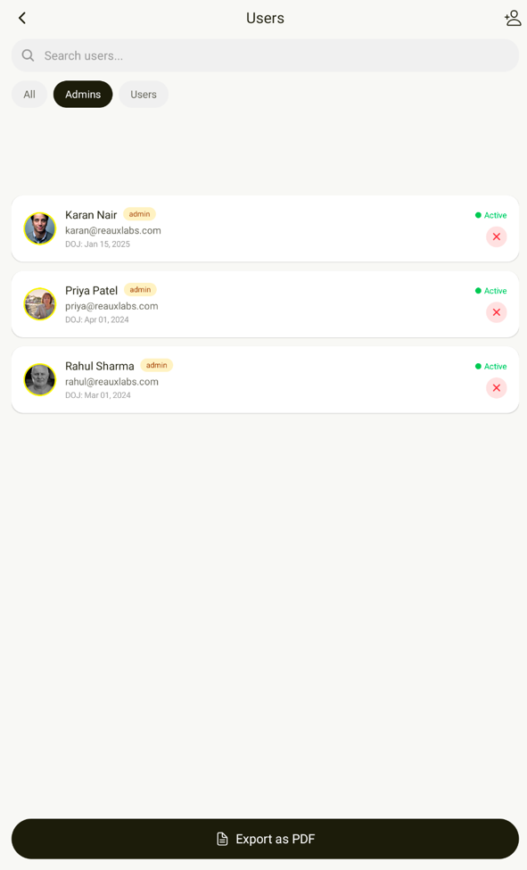

- Please add contact us section in all (Super Admin, admin and user).

15 March

- Brother, hume names ke sahmne hi active k niche uske student ki expirty date. Gym ki membership khatam hone ki date show ho… aur jab hum us member ki profile pe click kare toh humko uski details k sath sath. Detail edit ka option jo pehle tha who nahi mil raha hai . hume chahiye ki hum ager us insaan ki fees aa gayi hai toh hum wahi pr usko edit kare sake na ki hume kahi aur jaa kr edit krna pade..(pending main option hai lekin hume ander bhi chahiye ya sirf ander hi chahiye) make it easy bro.. and ek baat aur jab humare pas koi client ata hai toh hum uski month date ko fees leke extend kar sake jo ki option main nahi aa rahai for example ager paras ne gym ki 1month ki fees de di hai toh agle mahine ki fees add karne ka option toh hai lekin paras ki last date change nahi hotti who wahi pr stuck hai. And paras ki 1 month ki membership poori hogyi fr uski membership change krne ka option bhi nhi hai.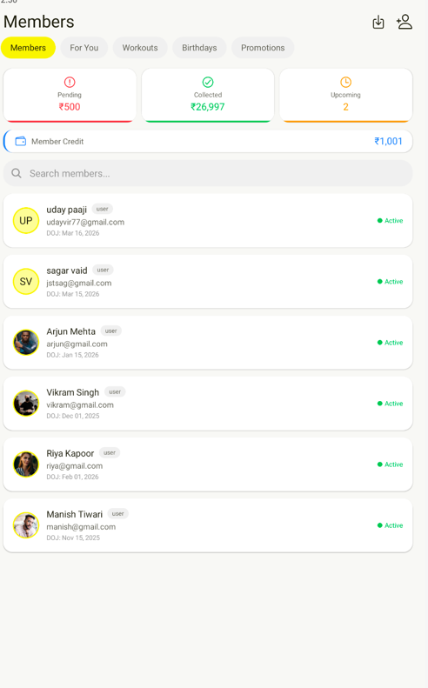

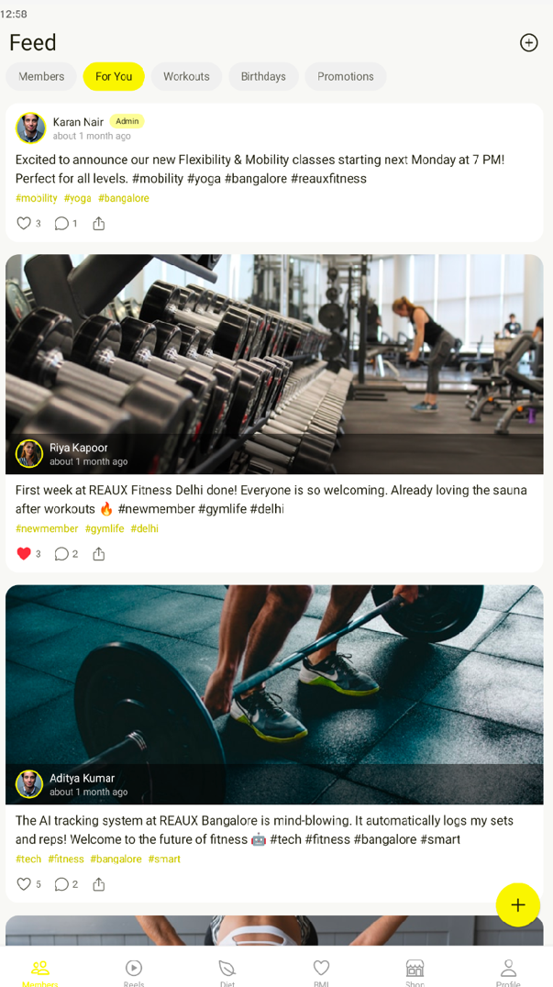
- Aur ye photos(POST) hume aise chahiye jaise normal mobile ko seedhe haath mai pakad ke show hota hai. In horizontal style.

- Type krte krte numbers mai chraters aagye and delete bhi nhi ho rhe. Plus apps both zada crash ho rhi hai.

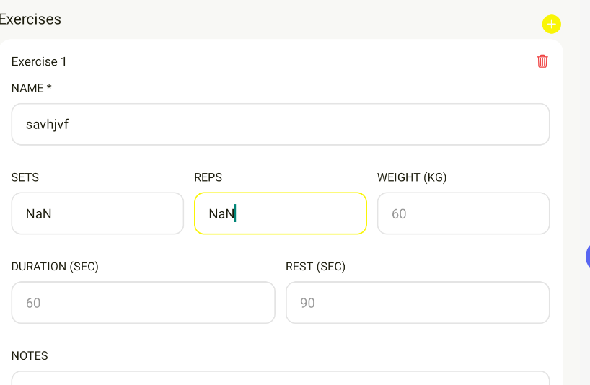

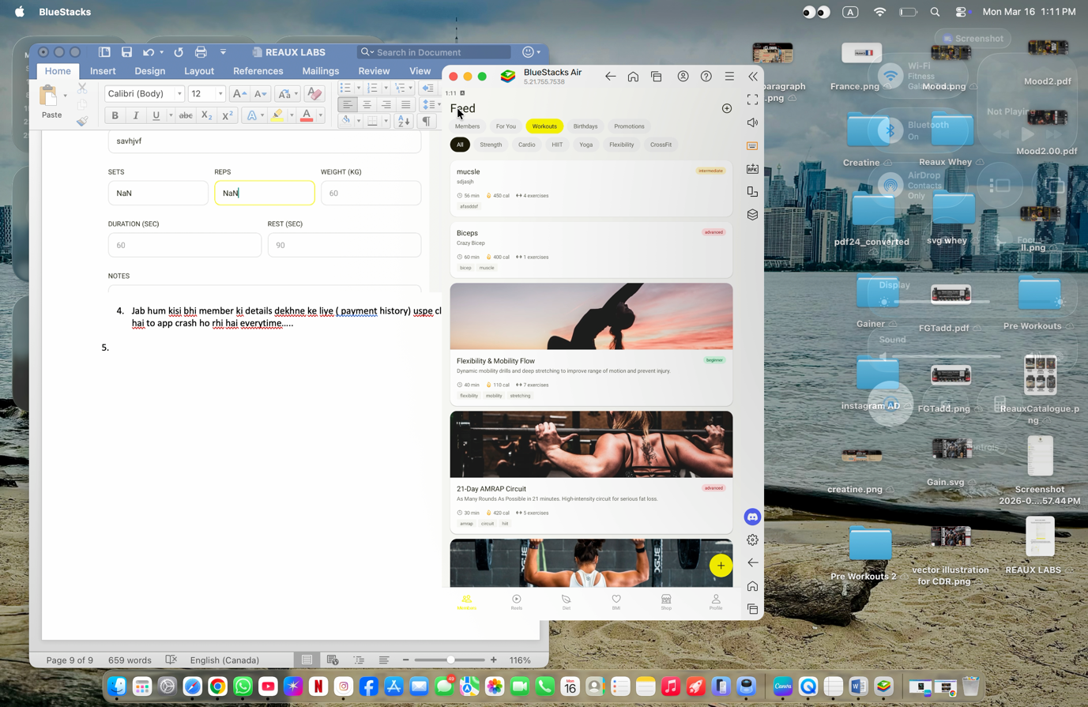
- Jab hum kisi bhi member ki details dekhne ke liye ( payment history) uspe click krte hai to app crash ho rhi hai everytime…..
- Bhai isme bugs bhi hai thode jese upr video mai hai bmi bmr pe click kro to kuch or hi khul rha hai vhn jaa hi ni rha. Thode both aur bhi hai.
- Contact us mai mobile number bhi mandatory krdo.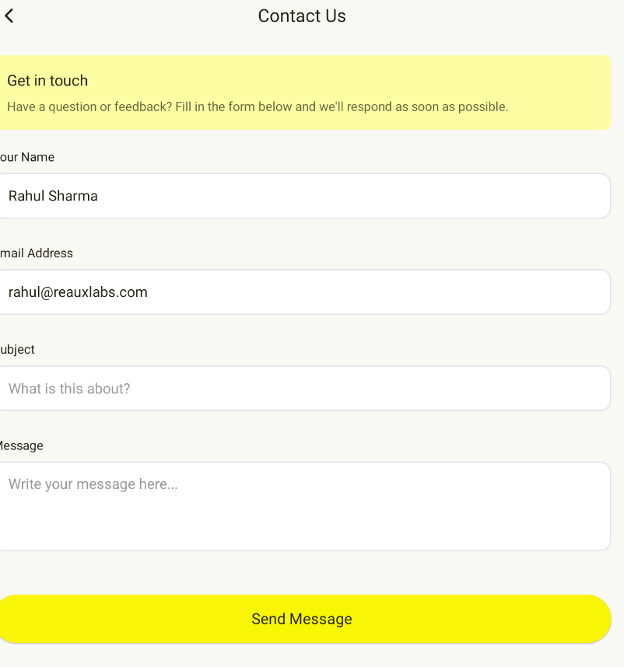
- Admin mai agar 1 gym ki 4 franchise hai and 4ro ko 1 hi banda manage kr rha hai to hum usko multiple gym assign nhi kr paa rhe. At a time ek admin ko sirf ek hi gym assign ho rha hai. For example gym add krte time humne Rahul as an admin select kr liya and uske baad humne ek or gym add kiya and uska bhi admin Rahul ko hi bna diya to rcent gym jo add kiya uska admin hi Rahul rahega.
- And as mentioned in previous document, and meeting, hum eek individual gym mai jitney bhi members hai unki details chahiye under that specific admin. Jaise humne from super admin Rahul ki profile kholi to uske under jitney gym hai vo to dropdown list aa hi jaye plus hum jo bhi gym select krein, uske under jitne members hai unki details bhi aa jaye. And usko hum export bhi kr ske.
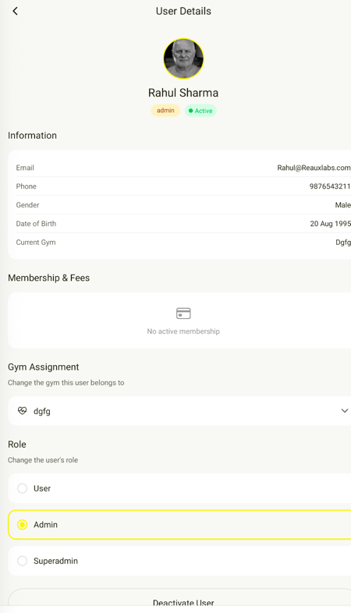

- (SUPER ADMIN) As mentioned before we need sales report under shop tab and shop tab hume bahar chahiye main profile section mai.
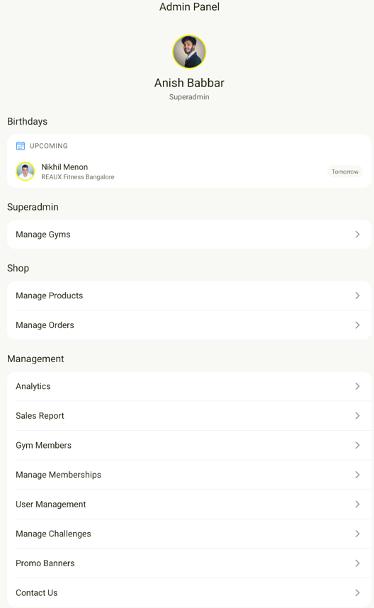

10.new gym add krte time we need real time camera access to add photos.plus gallery ka option bhi nhi aa rha. Photos kaise upload kre?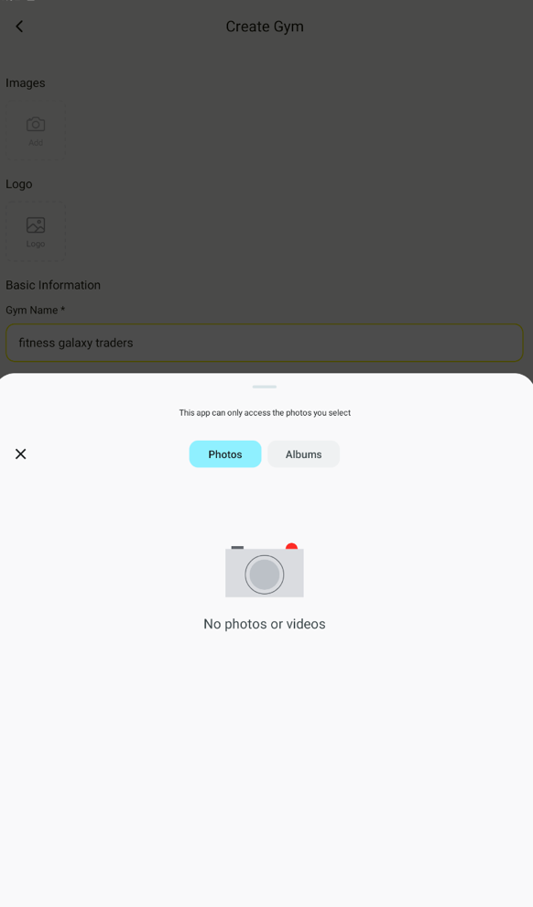

11. drop down menu for city and state in address.
12. humne admin se 2-3 orders kre hai but super admin mai koi notification nhi aya. Please fix this. 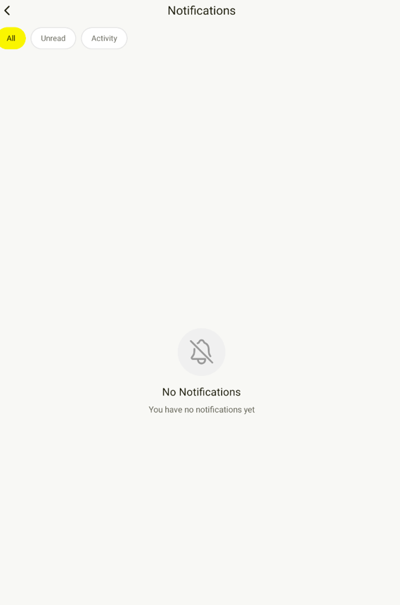

16 March

- Bhai maanlo paras ne ek month ki fee dedi and uska month end hogya fr humne record payment mai jaake 30 days extend krliye fee pay hogyi uski. But uski membership mai date change nhi ho rhi automatically. Andar start date and end date is remaining same.
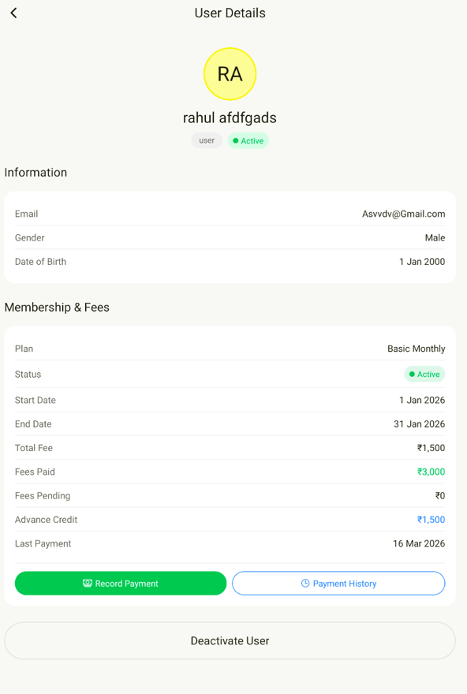

- Membership assign krte time calendar manual type ho rha hai vhn, calender add krdo.
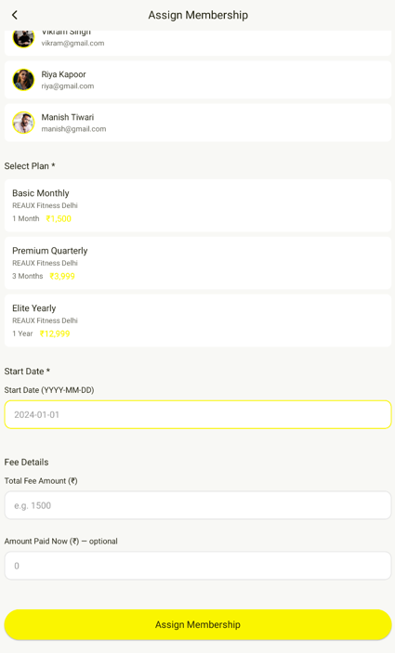
- Upr 15 march ka point.3 abhi bhi fix nhi hua.
- Brother point.4 bhi fix nhi hua abhi bhi agr workout create krte time direct back chle jao and then bmi pe click kro to create workout page hi khul rha hai.
- Point.8 and point.10 still remaining. Point 10 mai gallery ka access agya but direct camera ka option abhi bhi nhi aa rha
- Point 11. Drop down menu for states and city mai issue hai city jo vo state ke hisab se filter out ho jaye. Like isme sirf 15-20 hi major cities hai, cities like Hoshiarpur, Jalandhar hai hi nhi and I am talking about Punjab only. Baki sb states mai bhi hai problem so please make it like this kea gr koi Punjab as a state select kre to Punjab ki saari cities aa jaye and state to city ki jagah krdo nd city ko state ki jagah. So pehle banda state select krte to fr saari cities aa jaye.
- Point no. 12 notifications abhi bhi nhi aa rahe.
- And still thode both bugs hai jese super admin mai jaao and profile mai jaao and kuvh bhi khol lo like sales report or manage products, then back kro to vo back jaane ki bajaye seedha manage membership pe le jaata hai, everytimeeeee.

