**Roll No 9**

**Q1 Create an application that**

**a) Turn on and off Bluetooth**

**b) Enable and disable Wi-Fi**

**CODE**

**AndroidMainifest.xml**

<uses-permission android:name="android.permission.BLUETOOTH"/>

<uses-permission android:name="android.permission.BLUETOOTH_ADMIN"/>

<uses-permission android:name="android.permission.BLUETOOTH_CONNECT" />

<uses-permission android:name="android.permission.ACCESS_WIFI_STATE" />

<uses-permission android:name="android.permission.CHANGE_WIFI_STATE" />

**activity_main.xml**

<?xml version="1.0" encoding="utf-8"?>

<androidx.constraintlayout.widget.ConstraintLayout xmlns:android="http://schemas.android.com/apk/res/android"

xmlns:app="http://schemas.android.com/apk/res-auto"

xmlns:tools="http://schemas.android.com/tools"

android:layout_width="match_parent"

android:layout_height="match_parent"

tools:context=".MainActivity">

<Button

android:id="@+id/btn1"

android:layout_width="wrap_content"

android:layout_height="wrap_content"

android:text="BLUETOOTH ON"

app:layout_constraintBottom_toBottomOf="parent"

app:layout_constraintEnd_toEndOf="parent"

app:layout_constraintHorizontal_bias="0.538"

app:layout_constraintStart_toStartOf="parent"

app:layout_constraintTop_toTopOf="parent"

app:layout_constraintVertical_bias="0.32" />

<Button

android:id="@+id/btn3"

android:layout_width="wrap_content"

android:layout_height="wrap_content"

android:text="WIFI ON"

app:layout_constraintBottom_toBottomOf="parent"

app:layout_constraintEnd_toEndOf="parent"

app:layout_constraintHorizontal_bias="0.154"

app:layout_constraintStart_toStartOf="parent"

app:layout_constraintTop_toTopOf="parent"

app:layout_constraintVertical_bias="0.62" />

<TextView

android:id="@+id/txt1"

android:layout_width="wrap_content"

android:layout_height="wrap_content"

android:text="@string/bluetooth_and_wifi"

android:textColor="#B807D6"

android:textSize="24sp"

android:textStyle="bold"

app:layout_constraintBottom_toBottomOf="parent"

app:layout_constraintEnd_toEndOf="parent"

app:layout_constraintHorizontal_bias="0.497"

app:layout_constraintStart_toStartOf="parent"

app:layout_constraintTop_toTopOf="parent"

app:layout_constraintVertical_bias="0.071" />

<TextView

android:id="@+id/txt2"

android:layout_width="wrap_content"

android:layout_height="wrap_content"

android:text="@string/textview"

android:textColor="#B611D3"

android:textSize="20sp"

android:textStyle="bold"

app:layout_constraintBottom_toBottomOf="parent"

app:layout_constraintEnd_toEndOf="parent"

app:layout_constraintHorizontal_bias="0.493"

app:layout_constraintStart_toStartOf="parent"

app:layout_constraintTop_toTopOf="parent"

app:layout_constraintVertical_bias="0.224" />

<Button

android:id="@+id/btn2"

android:layout_width="wrap_content"

android:layout_height="wrap_content"

android:text="BLUETOOTH OFF"

app:layout_constraintBottom_toBottomOf="parent"

app:layout_constraintEnd_toEndOf="parent"

app:layout_constraintHorizontal_bias="0.552"

app:layout_constraintStart_toStartOf="parent"

app:layout_constraintTop_toTopOf="parent"

app:layout_constraintVertical_bias="0.431" />

<Button

android:id="@+id/btn4"

android:layout_width="wrap_content"

android:layout_height="wrap_content"

android:text="wifi off"

app:layout_constraintBottom_toBottomOf="parent"

app:layout_constraintEnd_toEndOf="parent"

app:layout_constraintHorizontal_bias="0.735"

app:layout_constraintStart_toStartOf="parent"

app:layout_constraintTop_toTopOf="parent"

app:layout_constraintVertical_bias="0.62" />

</androidx.constraintlayout.widget.ConstraintLayout>

**MainActivity.java**

package com.example.bluetooth_wifi;

import androidx.appcompat.app.AppCompatActivity;

import androidx.core.app.ActivityCompat;

import android.Manifest;

import android.bluetooth.BluetoothAdapter;

import android.content.Context;

import android.content.Intent;

import android.content.pm.PackageManager;

import android.net.wifi.WifiManager;

import android.os.Bundle;

import android.view.View;

import android.widget.Button;

import android.widget.TextView;

import android.widget.Toast;

public class MainActivity extends AppCompatActivity {

Button bl, wi, bl2, wi2;

TextView title, msg;

private static final int REQUEST_ENABLE_BT = 0;

private static final int REQUEST_DISCOVERABLE_BT = 0;

private WifiManager wifiManager;

final BluetoothAdapter mBluetoothAdapter = BluetoothAdapter.getDefaultAdapter();

@Override

protected void onCreate(Bundle savedInstanceState) {

super.onCreate(savedInstanceState);

setContentView(R.layout.activity_main);

bl = findViewById(R.id.btn1);

bl2 = findViewById(R.id.btn2);

wi = findViewById(R.id.btn3);

msg = findViewById(R.id.txt2);

wi2 = findViewById(R.id.btn4);

if (mBluetoothAdapter == null) {

msg.append("device not supported");

}

bl.setOnClickListener(new View.OnClickListener() {

public void onClick(View v) {

if (!mBluetoothAdapter.isEnabled()) {

Intent enableBtIntent = new Intent(BluetoothAdapter.ACTION_REQUEST_ENABLE);

if (ActivityCompat.checkSelfPermission(MainActivity.this, Manifest.permission.BLUETOOTH_CONNECT) != PackageManager.PERMISSION_GRANTED) {

startActivityForResult(enableBtIntent, REQUEST_ENABLE_BT);

// TODO: Consider calling

// ActivityCompat#requestPermissions

// here to request the missing permissions, and then overriding

// public void onRequestPermissionsResult(int requestCode, String[] permissions,

// int[] grantResults)

// to handle the case where the user grants the permission. See the documentation

// for ActivityCompat#requestPermissions for more details.

return;

}

}

}

});

bl2.setOnClickListener(new View.OnClickListener() {

@Override

public void onClick(View arg0) {

if (ActivityCompat.checkSelfPermission(MainActivity.this, Manifest.permission.BLUETOOTH_CONNECT) != PackageManager.PERMISSION_GRANTED) {

// TODO: Consider calling

// ActivityCompat#requestPermissions

// here to request the missing permissions, and then overriding

// public void onRequestPermissionsResult(int requestCode, String[] permissions,

// int[] grantResults)

// to handle the case where the user grants the permission. See the documentation

// for ActivityCompat#requestPermissions for more details.

mBluetoothAdapter.disable();

Context context = getApplicationContext();

CharSequence text = "TURNING_OFF BLUETOOTH";

int duration = Toast.LENGTH_LONG;

Toast toast = Toast.makeText(context, text,Toast.LENGTH_LONG);

toast.show();

return;

}

}

});

wifiManager = (WifiManager) getApplicationContext().getSystemService(Context.WIFI_SERVICE);

wi.setOnClickListener(new View.OnClickListener() {

@Override

public void onClick(View view) {

enableWifi();

}

});

wi2.setOnClickListener(new View.OnClickListener() {

@Override

public void onClick(View view) {

disableWifi();

}

});

}

public void enableWifi(){

wifiManager.setWifiEnabled(true);

Toast.makeText(this, "Wifi enabled", Toast.LENGTH_SHORT).show();

}

public void disableWifi(){

wifiManager.setWifiEnabled(false);

Toast.makeText(this, "Wifi Disabled", Toast.LENGTH_SHORT).show();

}

}

**Q. 2) Write a program to show the android life cycle.**

**activity_main.xml**

<?xml version="1.0" encoding="utf-8"?>

<androidx.constraintlayout.widget.ConstraintLayout xmlns:app="http://schemas.android.com/apk/res-auto"

xmlns:tools="http://schemas.android.com/tools"

xmlns:android="http://schemas.android.com/apk/res/android"

android:layout_width="match_parent"

android:layout_height="match_parent"

tools:context=".MainActivity">

<TextView

android:layout_width="wrap_content"

android:layout_height="wrap_content"

android:text="Hello World!"

app:layout_constraintBottom_toBottomOf="parent"

app:layout_constraintLeft_toLeftOf="parent"

app:layout_constraintRight_toRightOf="parent"

app:layout_constraintTop_toTopOf="parent" />

</androidx.constraintlayout.widget.ConstraintLayout>

**MainActivity.java**

package com.example.nineb;

import android.app.Activity;

import android.os.Bundle;

import android.util.Log;

import androidx.appcompat.app.AppCompatActivity;

public class MainActivity extends AppCompatActivity {

@Override

protected void onCreate(Bundle savedInstanceState) {

super.onCreate(savedInstanceState);

setContentView(R.layout.activity_main);

Log.d("lifecycle","onCreate invoked");

}

@Override

protected void onStart() {

super.onStart();

Log.d("lifecycle","onStart invoked");

}

@Override

protected void onResume() {

super.onResume();

Log.d("lifecycle","onResume invoked");

}

@Override

protected void onPause() {

super.onPause();

Log.d("lifecycle","onPause invoked");

}

@Override

protected void onStop() {

super.onStop();

Log.d("lifecycle","onStop invoked");

}

@Override

protected void onRestart() {

super.onRestart();

Log.d("lifecycle","onRestart invoked");

}

@Override

protected void onDestroy() {

super.onDestroy();

Log.d("lifecycle","onDestroy invoked");

}

}

**Roll No 10**

**Q. 1) Create a new project and create a login Activity. This creates a login UI asking user's email and password with an option of remember me checkbox. Also, a button displaying Sign In or Register using shared preferences.**

**activity_main.xml**

<?xml version="1.0" encoding="utf-8"?>

<androidx.constraintlayout.widget.ConstraintLayout xmlns:android="http://schemas.android.com/apk/res/android"

xmlns:app="http://schemas.android.com/apk/res-auto"

xmlns:tools="http://schemas.android.com/tools"

android:layout_width="match_parent"

android:layout_height="match_parent"

tools:context=".MainActivity">

<TextView

android:id="@+id/txt1"

android:layout_width="wrap_content"

android:layout_height="wrap_content"

android:text="Enter Email: -"

android:textSize="20sp"

android:textStyle="bold"

app:layout_constraintBottom_toBottomOf="parent"

app:layout_constraintEnd_toEndOf="parent"

app:layout_constraintHorizontal_bias="0.349"

app:layout_constraintStart_toStartOf="parent"

app:layout_constraintTop_toTopOf="parent"

app:layout_constraintVertical_bias="0.207" />

<EditText

android:id="@+id/et1"

android:layout_width="wrap_content"

android:layout_height="wrap_content"

android:ems="10"

android:hint="Enter your email"

android:inputType="textPersonName"

android:minHeight="48dp"

app:layout_constraintBottom_toBottomOf="parent"

app:layout_constraintEnd_toEndOf="parent"

app:layout_constraintHorizontal_bias="0.497"

app:layout_constraintStart_toStartOf="parent"

app:layout_constraintTop_toTopOf="parent"

app:layout_constraintVertical_bias="0.268" />

<TextView

android:id="@+id/txt2"

android:layout_width="wrap_content"

android:layout_height="wrap_content"

android:text="Enter Password: -"

android:textSize="20sp"

android:textStyle="bold"

app:layout_constraintBottom_toBottomOf="parent"

app:layout_constraintEnd_toEndOf="parent"

app:layout_constraintHorizontal_bias="0.4"

app:layout_constraintStart_toStartOf="parent"

app:layout_constraintTop_toTopOf="parent"

app:layout_constraintVertical_bias="0.375" />

<EditText

android:id="@+id/et2"

android:layout_width="wrap_content"

android:layout_height="wrap_content"

android:ems="10"

android:hint="Enter your password"

android:inputType="textPersonName"

android:minHeight="48dp"

app:layout_constraintBottom_toBottomOf="parent"

app:layout_constraintEnd_toEndOf="parent"

app:layout_constraintHorizontal_bias="0.497"

app:layout_constraintStart_toStartOf="parent"

app:layout_constraintTop_toTopOf="parent"

app:layout_constraintVertical_bias="0.438" />

<CheckBox

android:id="@+id/cb1"

android:layout_width="wrap_content"

android:layout_height="wrap_content"

android:text="Remember Me"

app:layout_constraintBottom_toBottomOf="parent"

app:layout_constraintEnd_toEndOf="parent"

app:layout_constraintHorizontal_bias="0.351"

app:layout_constraintStart_toStartOf="parent"

app:layout_constraintTop_toTopOf="parent"

app:layout_constraintVertical_bias="0.527" />

<Button

android:id="@+id/btn1"

android:layout_width="wrap_content"

android:layout_height="wrap_content"

android:text="SIGN IN"

app:layout_constraintBottom_toBottomOf="parent"

app:layout_constraintEnd_toEndOf="parent"

app:layout_constraintHorizontal_bias="0.498"

app:layout_constraintStart_toStartOf="parent"

app:layout_constraintTop_toTopOf="parent"

app:layout_constraintVertical_bias="0.74" />

</androidx.constraintlayout.widget.ConstraintLayout>

**activity_home.xml**

<?xml version="1.0" encoding="utf-8"?>

<androidx.constraintlayout.widget.ConstraintLayout xmlns:android="http://schemas.android.com/apk/res/android"

xmlns:app="http://schemas.android.com/apk/res-auto"

xmlns:tools="http://schemas.android.com/tools"

android:layout_width="match_parent"

android:layout_height="match_parent"

tools:context=".HomeActivity">

<TextView

android:id="@+id/txt3"

android:layout_width="wrap_content"

android:layout_height="wrap_content"

android:text="WELCOME TO APP"

android:textSize="24sp"

android:textStyle="bold"

app:layout_constraintBottom_toBottomOf="parent"

app:layout_constraintEnd_toEndOf="parent"

app:layout_constraintStart_toStartOf="parent"

app:layout_constraintTop_toTopOf="parent"

app:layout_constraintVertical_bias="0.499" />

</androidx.constraintlayout.widget.ConstraintLayout>

**MainActivity.java**

package com.example.a10a;

import androidx.appcompat.app.AppCompatActivity;

import android.content.Context;

import android.content.Intent;

import android.content.SharedPreferences;

import android.os.Bundle;

import android.view.View;

import android.widget.Button;

import android.widget.CheckBox;

import android.widget.EditText;

import android.widget.Toast;

public class MainActivity extends AppCompatActivity {

@Override

protected void onCreate(Bundle savedInstanceState) {

super.onCreate(savedInstanceState);

setContentView(R.layout.activity_main);

SharedPreferences sharedPreferences =

this.getSharedPreferences("LoginDetails", Context.MODE_PRIVATE);

String e=sharedPreferences.getString("Email","");

if(e.length()>0)startHomeActivity();

EditText email =findViewById(R.id.et1);

EditText pass = findViewById(R.id.et2);

CheckBox cbbx = findViewById(R.id.cb1);

Button button = findViewById(R.id.btn1);

button.setOnClickListener(new View.OnClickListener() {

@Override

public void onClick(View v) {

if (cbbx.isChecked())

saveLoginDetails(email.getText().toString(), pass.getText().toString());

startHomeActivity();

}

});

}

private void startHomeActivity() {

Intent intent = new Intent(this, HomeActivity.class);

startActivity(intent);

finish();

}

private void saveLoginDetails(String email, String password) {

Toast.makeText(this,"pref",Toast.LENGTH_LONG);

new Prefmanager(this).saveLoginDetails(email, password);

}

}

**Prefmanager.java**

package com.example.a10a;

import android.content.Context;

import android.content.SharedPreferences;

public class Prefmanager {

Context context;

Prefmanager(Context context) {

this.context = context;

}

public void saveLoginDetails(String email, String password) {

SharedPreferences sharedPreferences =

context.getSharedPreferences("LoginDetails", Context.MODE_PRIVATE);

SharedPreferences.Editor editor = sharedPreferences.edit();

editor.putString("Email", email);

editor.putString("Password", password);

editor.commit();

}

}

**HomeActivity.java**

package com.example.a10a;

import androidx.appcompat.app.AppCompatActivity;

import android.os.Bundle;

public class HomeActivity extends AppCompatActivity {

@Override

protected void onCreate(Bundle savedInstanceState) {

super.onCreate(savedInstanceState);

setContentView(R.layout.activity_home);

}

}

**Q. 2) Create an application to display the current location of your device.(Latitude & Longitude value)**

**build.gradle(:app)**

implementation 'com.google.android.gms:play-services-location:17.0.0'

**AndroidManifest.xml**

<uses-permission android:name="android.permission.ACCESS_COARSE_LOCATION" />

<uses-permission android:name="android.permission.ACCESS_FINE_LOCATION" />

<uses-permission android:name="android.permission.ACCESS_BACKGROUND_LOCATION" />

**activity_main.xml**

<?xml version="1.0" encoding="utf-8"?>

<LinearLayout

xmlns:android="http://schemas.android.com/apk/res/android"

android:layout_width="match_parent"

android:layout_height="match_parent"

android:gravity="center"

android:orientation="vertical">

<TextView

android:layout_width="wrap_content"

android:layout_height="wrap_content"

android:fontFamily="sans-serif-black"

android:text="Latitude:"

android:textSize="20sp" />

<TextView

android:id="@+id/latTextView"

android:layout_width="wrap_content"

android:layout_height="wrap_content"

android:text="Latitude will be here! "

android:textColor="#800080"

android:textSize="20sp" />

<TextView

android:layout_width="wrap_content"

android:layout_height="wrap_content"

android:fontFamily="sans-serif-black"

android:text="Longitude:"

android:textSize="20sp" />

<TextView

android:id="@+id/lonTextView"

android:layout_width="wrap_content"

android:layout_height="wrap_content"

android:text="Longitude will be here! "

android:textColor="#800080"

android:textSize="20sp" />

</LinearLayout>

**MainActivity.java**

package com.example.a10b;

import android.Manifest;

import android.annotation.SuppressLint;

import android.content.Context;

import android.content.Intent;

import android.content.pm.PackageManager;

import android.location.Location;

import android.location.LocationManager;

import android.os.Bundle;

import android.os.Looper;

import android.provider.Settings;

import android.widget.TextView;

import android.widget.Toast;

import androidx.annotation.NonNull;

import androidx.appcompat.app.AppCompatActivity;

import androidx.core.app.ActivityCompat;

import com.google.android.gms.location.FusedLocationProviderClient;

import com.google.android.gms.location.LocationCallback;

import com.google.android.gms.location.LocationRequest;

import com.google.android.gms.location.LocationResult;

import com.google.android.gms.location.LocationServices;

import com.google.android.gms.tasks.OnCompleteListener;

import com.google.android.gms.tasks.Task;

public class MainActivity extends AppCompatActivity {

FusedLocationProviderClient mFusedLocationClient;

TextView latitudeTextView, longitTextView;

int PERMISSION_ID = 44;

@Override

protected void onCreate(Bundle savedInstanceState) {

super.onCreate(savedInstanceState);

setContentView(R.layout.activity_main);

latitudeTextView = findViewById(R.id.latTextView);

longitTextView = findViewById(R.id.lonTextView);

mFusedLocationClient = LocationServices.getFusedLocationProviderClient(this);

// method to get the location

getLastLocation();

}

@SuppressLint("MissingPermission")

private void getLastLocation() {

// check if permissions are given

if (checkPermissions()) {

// check if location is enabled

if (isLocationEnabled()) {

// getting last

// location from

// FusedLocationClient

// object

mFusedLocationClient.getLastLocation().addOnCompleteListener(new OnCompleteListener<Location>() {

@Override

public void onComplete(@NonNull Task<Location> task) {

Location location = task.getResult();

if (location == null) {

requestNewLocationData();

} else {

latitudeTextView.setText(location.getLatitude() + "");

longitTextView.setText(location.getLongitude() + "");

}

}

});

} else {

Toast.makeText(this, "Please turn on" + " your location...", Toast.LENGTH_LONG).show();

Intent intent = new Intent(Settings.ACTION_LOCATION_SOURCE_SETTINGS);

startActivity(intent);

}

} else {

// if permissions aren't available,

// request for permissions

requestPermissions();

}

}

@SuppressLint("MissingPermission")

private void requestNewLocationData() {

// Initializing LocationRequest

// object with appropriate methods

LocationRequest mLocationRequest = new LocationRequest();

mLocationRequest.setPriority(LocationRequest.PRIORITY_HIGH_ACCURACY);

mLocationRequest.setInterval(5);

mLocationRequest.setFastestInterval(0);

mLocationRequest.setNumUpdates(1);

// setting LocationRequest

// on FusedLocationClient

mFusedLocationClient = LocationServices.getFusedLocationProviderClient(this);

mFusedLocationClient.requestLocationUpdates(mLocationRequest, mLocationCallback, Looper.myLooper());

}

private LocationCallback mLocationCallback = new LocationCallback() {

@Override

public void onLocationResult(LocationResult locationResult) {

Location mLastLocation = locationResult.getLastLocation();

latitudeTextView.setText("Latitude: " + mLastLocation.getLatitude() + "");

longitTextView.setText("Longitude: " + mLastLocation.getLongitude() + "");

}

};

// method to check for permissions

private boolean checkPermissions() {

return ActivityCompat.checkSelfPermission(this, Manifest.permission.ACCESS_COARSE_LOCATION) == PackageManager.PERMISSION_GRANTED && ActivityCompat.checkSelfPermission(this, Manifest.permission.ACCESS_FINE_LOCATION) == PackageManager.PERMISSION_GRANTED;

// If we want background location

// on Android 10.0 and higher,

// use:

// ActivityCompat.checkSelfPermission(this, Manifest.permission.ACCESS_BACKGROUND_LOCATION) == PackageManager.PERMISSION_GRANTED

}

// method to request for permissions

private void requestPermissions() {

ActivityCompat.requestPermissions(this, new String[]{

Manifest.permission.ACCESS_COARSE_LOCATION,

Manifest.permission.ACCESS_FINE_LOCATION}, PERMISSION_ID);

}

// method to check

// if location is enabled

private boolean isLocationEnabled() {

LocationManager locationManager = (LocationManager) getSystemService(Context.LOCATION_SERVICE);

return locationManager.isProviderEnabled(LocationManager.GPS_PROVIDER) || locationManager.isProviderEnabled(LocationManager.NETWORK_PROVIDER);

}

// If everything is alright then

@Override

public void

onRequestPermissionsResult(int requestCode, @NonNull String[] permissions, @NonNull int[] grantResults) {

super.onRequestPermissionsResult(requestCode, permissions, grantResults);

if (requestCode == PERMISSION_ID) {

if (grantResults.length > 0 && grantResults[0] == PackageManager.PERMISSION_GRANTED) {

getLastLocation();

}

}

}

@Override

public void onResume() {

super.onResume();

if (checkPermissions()) {

getLastLocation();

}

}

}

**Roll No 11**

**Q. 1) Create an application to parse the data using JSONObject methods and set it in the Text Views. (employee name and salary stored in JSON format)**

**activity_main.xml**

<?xml version="1.0" encoding="utf-8"?>

<androidx.constraintlayout.widget.ConstraintLayout

xmlns:android="http://schemas.android.com/apk/res/android"

xmlns:app="http://schemas.android.com/apk/res-auto"

xmlns:tools="http://schemas.android.com/tools"

android:layout_width="match_parent"

android:layout_height="match_parent"

android:orientation="vertical"

android:layout_margin="20sp"

tools:context=".MainActivity">

<LinearLayout

android:layout_width="match_parent"

android:layout_height="match_parent"

android:orientation="vertical">

<TextView

android:id="@+id/name"

android:layout_width="match_parent"

android:layout_height="wrap_content"

android:text="Name"

android:textSize="20sp" />

<TextView

android:id="@+id/salary"

android:layout_width="match_parent"

android:layout_height="wrap_content"

android:text="Salary"

android:textSize="20sp" />

</LinearLayout>

</androidx.constraintlayout.widget.ConstraintLayout>

**MainActivity.java**

package com.example.a11a;

import androidx.appcompat.app.AppCompatActivity;

import android.os.Bundle;

import android.widget.TextView;

import org.json.JSONException;

import org.json.JSONObject;

public class MainActivity extends AppCompatActivity {

String JSON_STRING = "{\"employee\":{\"name\":\"Harshdeep Sinha\",\"salary\":40000}}";

String name, salary;

TextView employeeName, employeeSalary;

@Override

protected void onCreate(Bundle savedInstanceState) {

super.onCreate(savedInstanceState);

setContentView(R.layout.activity_main);

employeeName = (TextView) findViewById(R.id.name);

employeeSalary = (TextView) findViewById(R.id.salary);

try {

JSONObject obj = new JSONObject(JSON_STRING);

JSONObject employee = obj.getJSONObject("employee");

name = employee.getString("name");

salary = employee.getString("salary");

employeeName.setText("Name: "+name);

employeeSalary.setText("Salary: "+salary);

} catch (JSONException e) {

e.printStackTrace();

}

}

}

**Roll No.12**

**Q. 2) Create an application for Unit Conversion**

**(Length/Weight/Currency/Temperature).**

**activity_main.xml**

<?xml version="1.0" encoding="utf-8"?>

<androidx.constraintlayout.widget.ConstraintLayout xmlns:android="http://schemas.android.com/apk/res/android"

xmlns:app="http://schemas.android.com/apk/res-auto"

xmlns:tools="http://schemas.android.com/tools"

android:layout_width="match_parent"

android:layout_height="match_parent"

tools:context=".MainActivity">

<Button

android:id="@+id/btn1"

android:layout_width="wrap_content"

android:layout_height="wrap_content"

android:text="LENGTH"

app:layout_constraintBottom_toBottomOf="parent"

app:layout_constraintEnd_toEndOf="parent"

app:layout_constraintHorizontal_bias="0.198"

app:layout_constraintStart_toStartOf="parent"

app:layout_constraintTop_toTopOf="parent"

app:layout_constraintVertical_bias="0.191" />

<Button

android:id="@+id/btn2"

android:layout_width="wrap_content"

android:layout_height="wrap_content"

android:text="WEIGHT "

app:layout_constraintBottom_toBottomOf="parent"

app:layout_constraintEnd_toEndOf="parent"

app:layout_constraintHorizontal_bias="0.722"

app:layout_constraintStart_toStartOf="parent"

app:layout_constraintTop_toTopOf="parent"

app:layout_constraintVertical_bias="0.191" />

<Button

android:id="@+id/btn3"

android:layout_width="wrap_content"

android:layout_height="wrap_content"

android:text="CURRRENCY"

app:layout_constraintBottom_toBottomOf="parent"

app:layout_constraintEnd_toEndOf="parent"

app:layout_constraintHorizontal_bias="0.498"

app:layout_constraintStart_toStartOf="parent"

app:layout_constraintTop_toTopOf="parent"

app:layout_constraintVertical_bias="0.38" />

<Button

android:id="@+id/btn4"

android:layout_width="wrap_content"

android:layout_height="wrap_content"

android:text="TEMPERATURE"

app:layout_constraintBottom_toBottomOf="parent"

app:layout_constraintEnd_toEndOf="parent"

app:layout_constraintHorizontal_bias="0.498"

app:layout_constraintStart_toStartOf="parent"

app:layout_constraintTop_toTopOf="parent"

app:layout_constraintVertical_bias="0.522" />

</androidx.constraintlayout.widget.ConstraintLayout>

**activity_length.xml**

<?xml version="1.0" encoding="utf-8"?>

<androidx.constraintlayout.widget.ConstraintLayout xmlns:android="http://schemas.android.com/apk/res/android"

xmlns:app="http://schemas.android.com/apk/res-auto"

xmlns:tools="http://schemas.android.com/tools"

android:layout_width="match_parent"

android:layout_height="match_parent"

tools:context=".LengthActivity">

<TextView

android:id="@+id/txt2"

android:layout_width="wrap_content"

android:layout_height="wrap_content"

android:textSize="20sp"

android:textStyle="bold"

app:layout_constraintBottom_toBottomOf="parent"

app:layout_constraintEnd_toEndOf="parent"

app:layout_constraintStart_toStartOf="parent"

app:layout_constraintTop_toTopOf="parent" />

<Button

android:id="@+id/btn6"

android:layout_width="wrap_content"

android:layout_height="wrap_content"

android:text="LENGTH"

app:layout_constraintBottom_toBottomOf="parent"

app:layout_constraintEnd_toEndOf="parent"

app:layout_constraintHorizontal_bias="0.498"

app:layout_constraintStart_toStartOf="parent"

app:layout_constraintTop_toTopOf="parent"

app:layout_constraintVertical_bias="0.346" />

<EditText

android:id="@+id/et2"

android:layout_width="wrap_content"

android:layout_height="wrap_content"

android:ems="10"

android:inputType="textPersonName"

android:hint="Enter Length"

app:layout_constraintBottom_toBottomOf="parent"

app:layout_constraintEnd_toEndOf="parent"

app:layout_constraintHorizontal_bias="0.497"

app:layout_constraintStart_toStartOf="parent"

app:layout_constraintTop_toTopOf="parent"

app:layout_constraintVertical_bias="0.169" />

</androidx.constraintlayout.widget.ConstraintLayout>

**activity_weight.xml**

<?xml version="1.0" encoding="utf-8"?>

<androidx.constraintlayout.widget.ConstraintLayout xmlns:android="http://schemas.android.com/apk/res/android"

xmlns:app="http://schemas.android.com/apk/res-auto"

xmlns:tools="http://schemas.android.com/tools"

android:layout_width="match_parent"

android:layout_height="match_parent"

tools:context=".WeightActivity">

<TextView

android:id="@+id/txt2"

android:layout_width="wrap_content"

android:layout_height="wrap_content"

android:textSize="20sp"

android:textStyle="bold"

app:layout_constraintBottom_toBottomOf="parent"

app:layout_constraintEnd_toEndOf="parent"

app:layout_constraintStart_toStartOf="parent"

app:layout_constraintTop_toTopOf="parent" />

<Button

android:id="@+id/btn6"

android:layout_width="wrap_content"

android:layout_height="wrap_content"

android:text="WEIGHT"

app:layout_constraintBottom_toBottomOf="parent"

app:layout_constraintEnd_toEndOf="parent"

app:layout_constraintHorizontal_bias="0.498"

app:layout_constraintStart_toStartOf="parent"

app:layout_constraintTop_toTopOf="parent"

app:layout_constraintVertical_bias="0.346" />

<EditText

android:id="@+id/et2"

android:layout_width="wrap_content"

android:layout_height="wrap_content"

android:ems="10"

android:inputType="textPersonName"

android:hint="Enter Weight"

app:layout_constraintBottom_toBottomOf="parent"

app:layout_constraintEnd_toEndOf="parent"

app:layout_constraintHorizontal_bias="0.497"

app:layout_constraintStart_toStartOf="parent"

app:layout_constraintTop_toTopOf="parent"

app:layout_constraintVertical_bias="0.169" />

</androidx.constraintlayout.widget.ConstraintLayout>

**activity_currency.xml**

<?xml version="1.0" encoding="utf-8"?>

<androidx.constraintlayout.widget.ConstraintLayout xmlns:app="http://schemas.android.com/apk/res-auto"

xmlns:tools="http://schemas.android.com/tools"

xmlns:android="http://schemas.android.com/apk/res/android"

android:layout_width="match_parent"

android:layout_height="match_parent"

tools:context=".CurrencyActivity" >

<EditText

android:id="@+id/et3"

android:layout_width="wrap_content"

android:layout_height="wrap_content"

android:ems="10"

android:inputType="textPersonName"

android:hint="Enter Dollar Value"

app:layout_constraintBottom_toBottomOf="parent"

app:layout_constraintEnd_toEndOf="parent"

app:layout_constraintHorizontal_bias="0.577"

app:layout_constraintStart_toStartOf="parent"

app:layout_constraintTop_toTopOf="parent"

app:layout_constraintVertical_bias="0.151" />

<Button

android:id="@+id/btn7"

android:layout_width="wrap_content"

android:layout_height="wrap_content"

android:text="DOLLAR TO RUPEES"

app:layout_constraintBottom_toBottomOf="parent"

app:layout_constraintEnd_toEndOf="parent"

app:layout_constraintHorizontal_bias="0.536"

app:layout_constraintStart_toStartOf="parent"

app:layout_constraintTop_toTopOf="parent"

app:layout_constraintVertical_bias="0.354" />

<TextView

android:id="@+id/txt3"

android:layout_width="wrap_content"

android:layout_height="wrap_content"

android:textSize="20sp"

android:textStyle="bold"

app:layout_constraintBottom_toBottomOf="parent"

app:layout_constraintEnd_toEndOf="parent"

app:layout_constraintStart_toStartOf="parent"

app:layout_constraintTop_toTopOf="parent" />

</androidx.constraintlayout.widget.ConstraintLayout>

**activity_temperature.xml**

<LinearLayout xmlns:android="http://schemas.android.com/apk/res/android"

android:id="@+id/ll"

android:layout_width="fill_parent"

android:layout_height="fill_parent"

android:orientation="vertical" >

<EditText

android:id="@+id/editText1"

android:layout_width="match_parent"

android:layout_height="wrap_content"

android:inputType="numberDecimal" >

</EditText>

<TextView

android:id="@+id/result"

android:layout_width="wrap_content"

android:layout_height="wrap_content"

android:textSize="30sp" />

<RadioGroup

android:id="@+id/radioGroup1"

android:layout_width="wrap_content"

android:layout_height="wrap_content" >

<RadioButton

android:id="@+id/cb"

android:layout_width="wrap_content"

android:layout_height="wrap_content"

android:checked="true"

android:text="Celcius" />

<RadioButton

android:id="@+id/fb"

android:layout_width="wrap_content"

android:layout_height="wrap_content"

android:text="Fahrenhiet" />

</RadioGroup>

<Button

android:id="@+id/button1"

android:layout_width="wrap_content"

android:layout_height="wrap_content"

android:onClick="add"

android:text="Convert"

android:textSize="30sp" />

</LinearLayout>

**MainActivity.java**

package com.example.converter;

import androidx.appcompat.app.AppCompatActivity;

import android.content.Intent;

import android.os.Bundle;

import android.view.View;

import android.widget.Button;

public class MainActivity extends AppCompatActivity {

Button len,weight,currency,temp;

@Override

protected void onCreate(Bundle savedInstanceState) {

super.onCreate(savedInstanceState);

setContentView(R.layout.activity_main);

len=findViewById(R.id.btn1);

weight=findViewById(R.id.btn2);

currency=findViewById(R.id.btn3);

temp=findViewById(R.id.btn4);

len.setOnClickListener(new View.OnClickListener() {

@Override

public void onClick(View v) {

Intent intent = new Intent(MainActivity.this, LengthActivity.class);

startActivity(intent);

}

});

weight.setOnClickListener(new View.OnClickListener() {

@Override

public void onClick(View v) {

Intent intent = new Intent(MainActivity.this,WeightActivity.class);

startActivity(intent);

}

});

currency.setOnClickListener(new View.OnClickListener() {

@Override

public void onClick(View v) {

Intent intent = new Intent(MainActivity.this, CurrencyActivity.class);

startActivity(intent);

}

});

temp.setOnClickListener(new View.OnClickListener() {

@Override

public void onClick(View v) {

Intent intent = new Intent(MainActivity.this, TemperatureActivity.class);

startActivity(intent);

}

});

}

}

**LengthActivity.java**

package com.example.converter;

import androidx.appcompat.app.AppCompatActivity;

import android.graphics.Color;

import android.os.Bundle;

import android.view.View;

import android.widget.Button;

import android.widget.EditText;

import android.widget.TextView;

public class LengthActivity extends AppCompatActivity {

Button length;

@Override

protected void onCreate(Bundle savedInstanceState) {

super.onCreate(savedInstanceState);

setContentView(R.layout.activity_length);

final EditText etlen;

final TextView etmsg;

length=findViewById(R.id.btn6);

etlen=findViewById(R.id.et2);

etmsg=findViewById(R.id.txt2);

length.setOnClickListener(new View.OnClickListener() {

@Override

public void onClick(View v) {

Double convert= Double.parseDouble(etlen.getText().toString());

etmsg.setText(String.valueOf(convert*100)); //Just put the formula here accordingly!!!

etmsg.setTextColor(Color.RED);

}

});

}}

**WeightActivity.java**

package com.example.converter;

import androidx.appcompat.app.AppCompatActivity;

import android.graphics.Color;

import android.os.Bundle;

import android.view.View;

import android.widget.Button;

import android.widget.EditText;

import android.widget.TextView;

public class WeightActivity extends AppCompatActivity {

Button weight;

@Override

protected void onCreate(Bundle savedInstanceState) {

super.onCreate(savedInstanceState);

setContentView(R.layout.activity_weight);

final EditText etlen;

final TextView etmsg;

weight=findViewById(R.id.btn6);

etlen=findViewById(R.id.et2);

etmsg=findViewById(R.id.txt2);

weight.setOnClickListener(new View.OnClickListener() {

@Override

public void onClick(View v) {

Double convert= Double.parseDouble(etlen.getText().toString());

etmsg.setText(String.valueOf(convert*1000)); //Just put the formula here accordingly!!!

etmsg.setTextColor(Color.RED);

}

});

}

}

**CurrencyActivity.java**

package com.example.converter;

import android.graphics.Color;

import android.os.Bundle;

import android.view.View;

import android.widget.Button;

import android.widget.EditText;

import android.widget.TextView;

import androidx.appcompat.app.AppCompatActivity;

public class CurrencyActivity extends AppCompatActivity {

Button curr;

TextView msg;

EditText value;

Double convert;

@Override

protected void onCreate(Bundle savedInstanceState) {

super.onCreate(savedInstanceState);

setContentView(R.layout.activity_currency);

value=findViewById(R.id.et3);

curr=findViewById(R.id.btn7);

msg=findViewById(R.id.txt3);

curr.setOnClickListener(new View.OnClickListener() {

@Override

public void onClick(View view) {

convert= Double.parseDouble(value.getText().toString());

msg.setText(String.valueOf(convert*81.67)); //Just put the formula here accordingly!!!

msg.setTextColor(Color.RED);

}

});

}

}

**TemperatureActivity.java**

package com.example.converter;

import android.os.Bundle;

import android.view.View;

import android.widget.EditText;

import android.widget.LinearLayout;

import android.widget.RadioButton;

import android.widget.TextView;

import android.app.Activity;

import android.graphics.Color;

import androidx.appcompat.app.AppCompatActivity;

public class TemperatureActivity extends AppCompatActivity {

@Override

protected void onCreate(Bundle savedInstanceState) {

super.onCreate(savedInstanceState);

setContentView(R.layout.activity_temperature);

}

public void add(View v)

{

LinearLayout ll=(LinearLayout)findViewById(R.id.ll);

TextView result=(TextView)findViewById(R.id.result);

EditText et1=(EditText)findViewById(R.id.editText1);

//get value from edit text box and convert into double

double a=Double.parseDouble(String.valueOf(et1.getText()));

RadioButton cb=(RadioButton)findViewById(R.id.cb);

RadioButton fb=(RadioButton)findViewById(R.id.fb);

//check which radio button is checked

if(cb.isChecked())

{

//change background colour

ll.setBackgroundColor(Color.YELLOW);

//display conversion

result.setText(f2c(a)+" degree C");

//cb.setChecked(false);

fb.setChecked(true);

}

else

{

ll.setBackgroundColor(Color.CYAN);

result.setText(c2f(a)+" degree F");

//fb.setChecked(false);

cb.setChecked(true);

}

}

//Celcius to Fahrenhiet method

private double c2f(double c)

{

return (c*9)/5+32;

}

//Fahrenhiet to Celcius method

private double f2c(double f)

{

return (f-32)*5/9;

}

}

**Roll No 13**

**Q. 1) Write a basic application to (use volley library), create a button and on click of the button an HTTP request will be sent to the server. The response from the server is then displayed using Toast on the screen.**

**AndroidManifest.xml**

<uses-permission android:name="android.permission.INTERNET" />

**build.gradle(app)**

implementation 'com.android.volley:volley:1.2.1'

**activity_main.xml**

<?xml version="1.0" encoding="utf-8"?>

<LinearLayout xmlns:android="http://schemas.android.com/apk/res/android"

xmlns:app="http://schemas.android.com/apk/res-auto"

xmlns:tools="http://schemas.android.com/tools"

android:layout_width="match_parent"

android:layout_height="match_parent"

tools:context=".MainActivity">

<Button

android:id="@+id/buttonRequest"

android:layout_width="match_parent"

android:layout_height="wrap_content"

android:text="Fetch Response" />

</LinearLayout>

**MainActivity.java**

package com.example.a13_1;

import androidx.appcompat.app.AppCompatActivity;

import android.os.Bundle;

import android.util.Log;

import android.view.View;

import android.widget.Button;

import android.widget.Toast;

import com.android.volley.Request;

import com.android.volley.RequestQueue;

import com.android.volley.Response;

import com.android.volley.VolleyError;

import com.android.volley.toolbox.StringRequest;

import com.android.volley.toolbox.Volley;

public class MainActivity extends AppCompatActivity {

private static final String TAG = MainActivity.class.getName();

private Button btnRequest;

private RequestQueue mRequestQueue;

private StringRequest mStringRequest;

private String url = "https://run.mocky.io/v3/e563fe74-f4ab-47b9-ba6c-6fc147cd6579";

@Override

protected void onCreate(Bundle savedInstanceState) {

super.onCreate(savedInstanceState);

setContentView(R.layout.activity_main);

setContentView(R.layout.activity_main);

btnRequest = (Button) findViewById(R.id.buttonRequest);

btnRequest.setOnClickListener(new View.OnClickListener() {

@Override

public void onClick(View v){

sendAndRequestResponse();

}

});

}

private void sendAndRequestResponse() {

mRequestQueue = Volley.newRequestQueue(this);

mStringRequest = new StringRequest(Request.Method.GET, url, new

Response.Listener<String>() {

@Override

public void onResponse(String response) {

Toast.makeText(getApplicationContext(),"Response :" + response.toString(), Toast.LENGTH_LONG).show();

}

}, new Response.ErrorListener() {

@Override

public void onErrorResponse(VolleyError error) {

Log.i(TAG,"Error :" + error.toString());

}

});

mRequestQueue.add(mStringRequest);

}

}

**Q. 2) Write a program to**

**a) Record audio and play it.**

**b) Play a video in a video view.**

**activity_main.xml**

<?xml version="1.0" encoding="utf-8"?>

<LinearLayout

xmlns:android="http://schemas.android.com/apk/res/android"

xmlns:app="http://schemas.android.com/apk/res-auto"

xmlns:tools="http://schemas.android.com/tools"

android:layout_width="match_parent"

android:layout_height="match_parent"

tools:context=".MainActivity"

android:orientation="vertical"

android:padding="16dp">

<TextView

android:id="@+id/head"

android:layout_width="match_parent"

android:layout_height="wrap_content"

android:layout_margin="2dp"

android:text="AUDIO PLAYER"

android:textAlignment="center"

android:textSize="24sp"

android:textStyle="bold" />

<LinearLayout

android:layout_width="match_parent"

android:layout_height="wrap_content"

android:gravity="center"

android:orientation="horizontal">

<Button

android:id="@+id/rec"

android:layout_width="wrap_content"

android:layout_height="match_parent"

android:layout_margin="5dp"

android:text="START RECORD"

android:onClick="rec"

tools:textAlignment="center" />

<Button

android:id="@+id/stop"

android:layout_width="wrap_content"

android:layout_height="match_parent"

android:layout_margin="5dp"

android:text="STOP RECORD"

android:onClick="stop"

tools:textAlignment="center" />

</LinearLayout>

<LinearLayout

android:layout_width="match_parent"

android:layout_height="wrap_content"

android:gravity="center"

android:orientation="horizontal">

<Button

android:id="@+id/play"

android:layout_width="wrap_content"

android:layout_height="match_parent"

android:layout_margin="5dp"

android:text=" PLAY AUDIO "

android:onClick="play"

tools:textAlignment="center" />

<Button

android:id="@+id/pause"

android:layout_width="wrap_content"

android:layout_height="match_parent"

android:layout_margin="5dp"

android:text=" STOP PLAY "

android:onClick="pause"

tools:textAlignment="center" />

</LinearLayout>

<TextView

android:id="@+id/textView"

android:layout_width="match_parent"

android:layout_height="wrap_content"

android:layout_margin="5dp"

android:text="VIDEO PLAYER"

android:textAlignment="center"

android:textSize="24sp"

android:textStyle="bold" />

<FrameLayout

android:layout_width="match_parent"

android:layout_height="wrap_content"

android:layout_below="@id/textView">

<VideoView

android:id="@+id/videoView"

android:layout_width="match_parent"

android:layout_height="208dp" />

</FrameLayout>

</LinearLayout>

**MainActivity.java**

package com.example.prac9;

import static android.Manifest.permission.RECORD_AUDIO;

import static android.Manifest.permission.WRITE_EXTERNAL_STORAGE;

import android.Manifest;

import android.app.AlertDialog;

import android.content.Context;

import android.content.ContextWrapper;

import android.content.DialogInterface;

import android.content.Intent;

import android.content.pm.PackageManager;

import android.location.Location;

import android.location.LocationManager;

import android.media.MediaPlayer;

import android.media.MediaRecorder;

import android.net.Uri;

import android.os.Build;

import android.os.Bundle;

import android.os.Environment;

import android.provider.Settings;

import android.util.Log;

import android.view.View;

import android.widget.Button;

import android.widget.MediaController;

import android.widget.TextView;

import android.widget.Toast;

import android.widget.VideoView;

import androidx.annotation.NonNull;

import androidx.annotation.RequiresApi;

import androidx.appcompat.app.AppCompatActivity;

import androidx.core.app.ActivityCompat;

import androidx.core.content.ContextCompat;

import java.io.File;

import java.io.IOException;

import java.util.Random;

public class MainActivity extends AppCompatActivity {

private static int MICROPHONE_PERMISSION_CODE= 200;

MediaRecorder mediaRecorder;

MediaPlayer mediaPlayer;

Button btnGetLocation;

TextView showLocation;

@Override

protected void onCreate(Bundle savedInstanceState) {

super.onCreate(savedInstanceState);

setContentView(R.layout.activity_main);

if (micCheck()){

getmicpremission();

}

VideoView videoView = findViewById(R.id.videoView);

videoView.setVideoPath("android.resource://"+getPackageName()+"/"+R.raw.parmanu);

MediaController mediaController = new MediaController(this);

mediaController.setAnchorView(videoView);

videoView.setMediaController(mediaController);

}

public void rec(View v){

try{

mediaRecorder = new MediaRecorder();

mediaRecorder.setAudioSource(MediaRecorder.AudioSource.MIC);

mediaRecorder.setOutputFormat(MediaRecorder.OutputFormat.THREE_GPP);

mediaRecorder.setOutputFile(getRecordingFilePath());

mediaRecorder.setAudioEncoder(MediaRecorder.AudioEncoder.AMR_NB);

mediaRecorder.prepare();

mediaRecorder.start();

Toast.makeText(this,"Recording Started",

Toast.LENGTH_SHORT).show();

}

catch (Exception e){

e.printStackTrace();

}}

public void stop(View v){

mediaRecorder.stop();

mediaRecorder.release();

mediaRecorder = null;

Toast.makeText(this,"Recording Stopped",

Toast.LENGTH_SHORT).show();

}

public void play(View v){

try{

mediaPlayer = new MediaPlayer();

mediaPlayer.setDataSource(getRecordingFilePath());

mediaPlayer.prepare();

mediaPlayer.start();

Toast.makeText(this,"Recorded Audiio Playing",Toast.LENGTH_SHORT).show();

}catch (Exception e){

e.printStackTrace();

}

}

public void pause(View v){

mediaPlayer.stop();

mediaPlayer.release();

mediaPlayer = null;

Toast.makeText(this,"Audio Stopped", Toast.LENGTH_SHORT).show();

}

private boolean micCheck(){

if(this.getPackageManager().hasSystemFeature(PackageManager.FEATURE_MICROPHONE)){

return true;

}

else{

return false;

}

}

private void getmicpremission(){

if (ContextCompat.checkSelfPermission(MainActivity.this,

Manifest.permission.RECORD_AUDIO)

==PackageManager.PERMISSION_DENIED) {

ActivityCompat.requestPermissions(MainActivity.this,new

String[]{

Manifest.permission.RECORD_AUDIO},MICROPHONE_PERMISSION_CODE);

}

}

private String getRecordingFilePath() {

ContextWrapper contextWrapper = new ContextWrapper(getApplicationContext());

File musicDirectory

=contextWrapper.getExternalFilesDir(Environment.DIRECTORY_MUSIC);

File file = new File(musicDirectory, "testRecordingFile"+".mp3");

return file.getPath();

}

}

**ROLL NO 15**

**Q.1) Write a program to create a sign-up page design with 3 EditTexts(name, email, and password) and one sign-up Button. With the click of a button, data in EditText is validated. Implement signup API to save the data in the database. After getting a response from the API, display the message on the screen by using a Toast.(use Retrofit)**

**activity_form.xml**

<?xml version="1.0" encoding="utf-8"?>

<androidx.constraintlayout.widget.ConstraintLayout

xmlns:android="http://schemas.android.com/apk/res/android"

xmlns:app="http://schemas.android.com/apk/res-auto"

xmlns:tools="http://schemas.android.com/tools"

android:layout_width="match_parent"

android:layout_height="match_parent"

android:orientation="vertical"

android:layout_margin="20sp"

tools:context=".MainActivity">

<LinearLayout

android:layout_width="match_parent"

android:orientation="vertical"

android:layout_height="match_parent">

<EditText

android:id="@+id/t1"

android:layout_width="match_parent"

android:layout_height="wrap_content"

android:hint="Enter Name"

android:inputType="textPersonName"

android:minHeight="48dp" />

<EditText

android:id="@+id/t2"

android:layout_width="match_parent"

android:layout_height="wrap_content"

android:hint="Enter Email"

android:inputType="textEmailAddress"

android:minHeight="48dp" />

<EditText

android:id="@+id/t3"

android:layout_width="match_parent"

android:layout_height="wrap_content"

android:hint="Enter Password"

android:inputType="textPassword"

android:minHeight="48dp" />

<Button

android:id="@+id/SignUpBtn"

android:layout_width="match_parent"

android:layout_height="wrap_content"

android:text="Sign up"/>

</LinearLayout>

</androidx.constraintlayout.widget.ConstraintLayout>

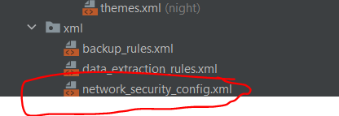

**network_security_config.xml**

<?xml version="1.0" encoding="utf-8"?>

<network-security-config>

<domain-config cleartextTrafficPermitted="true">

<domain includeSubdomains="true">https://10.0.2.2</domain>

</domain-config>

</network-security-config>

**AndroidMainfest.xml**

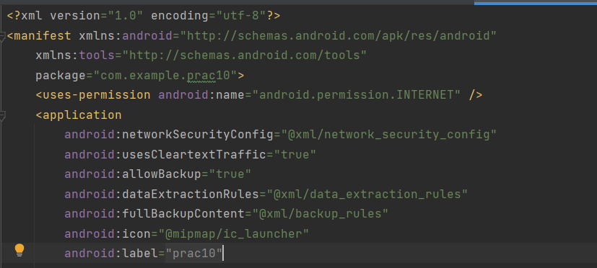

**Refer above pic for adding the code**

<uses-permission android:name="android.permission.INTERNET" />

android:networkSecurityConfig="@xml/network_security_config"

android:usesCleartextTraffic="true"

**build.gradle(:app)**

implementation 'com.squareup.retrofit2:retrofit:2.9.0'

implementation 'com.squareup.retrofit2:converter-gson:2.5.0'

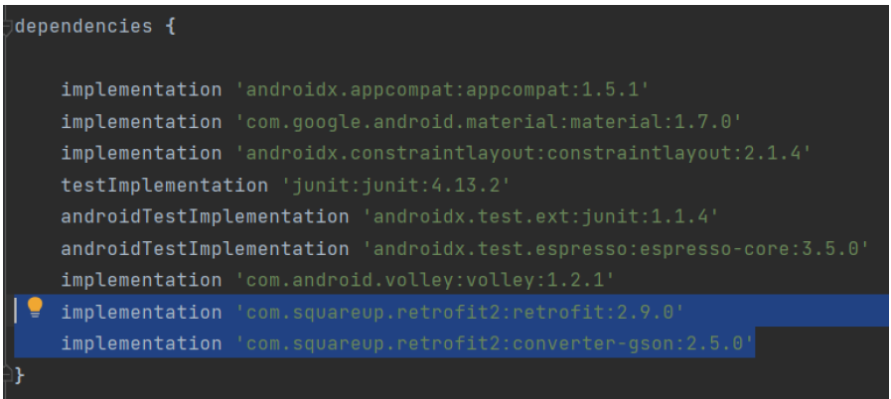

**Xampp should be there and turned on**

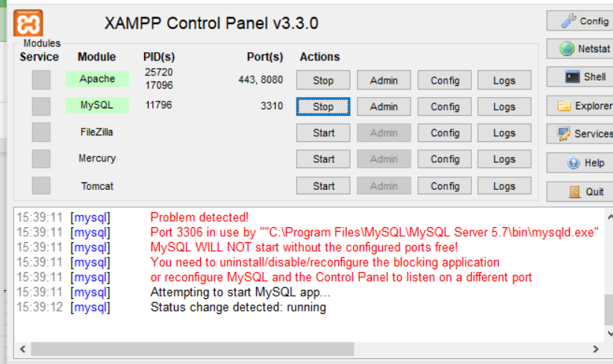

**Goto localhost:8080 in your Browser→Click on phpmyadmin**

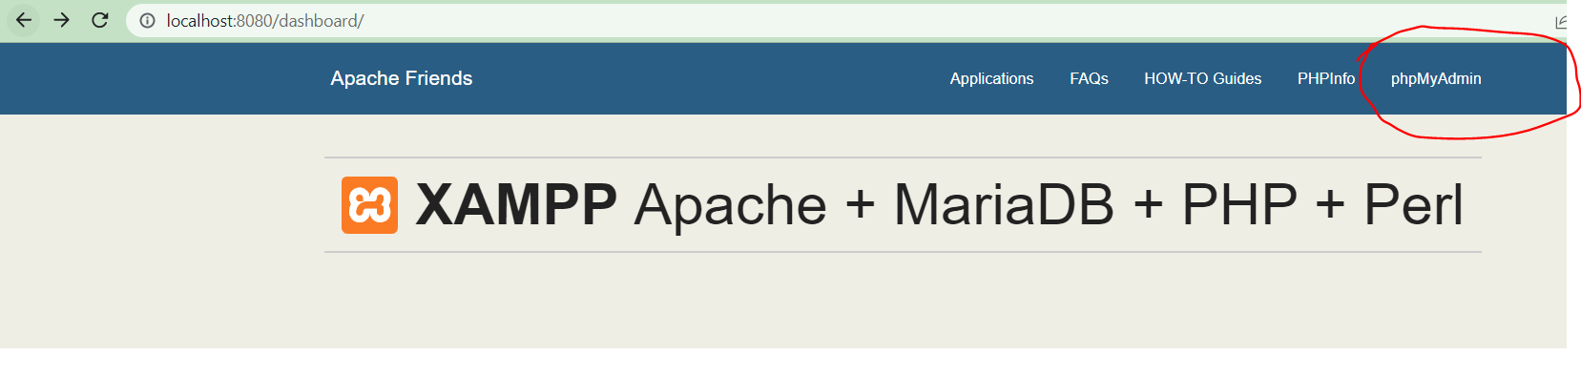

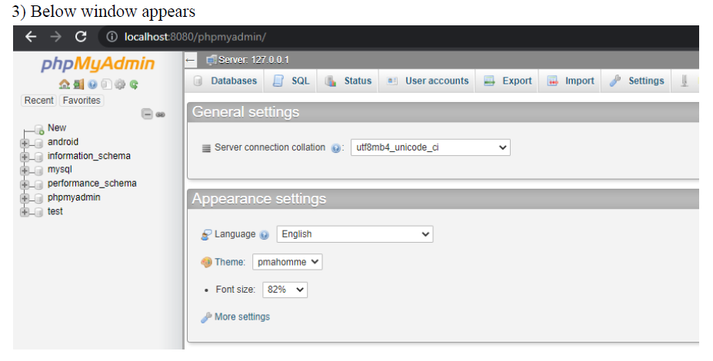

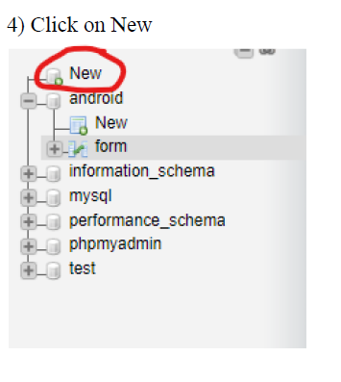

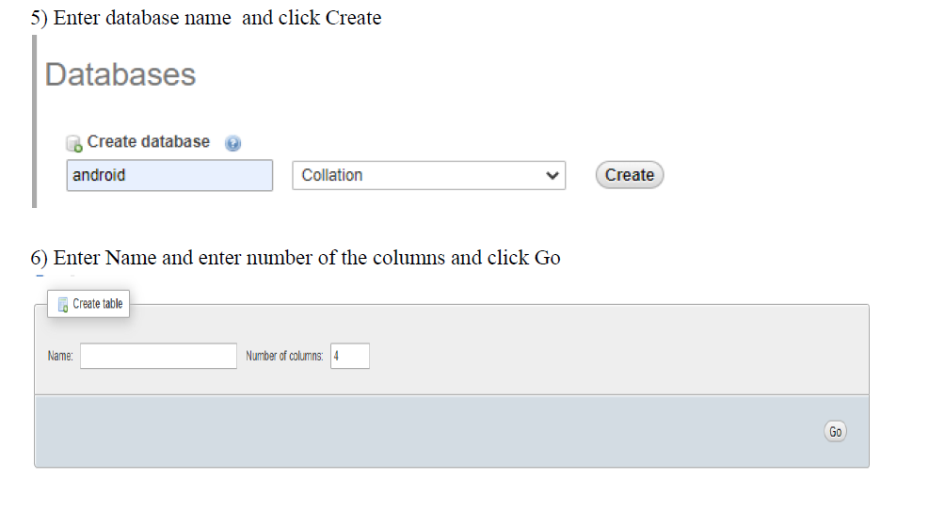

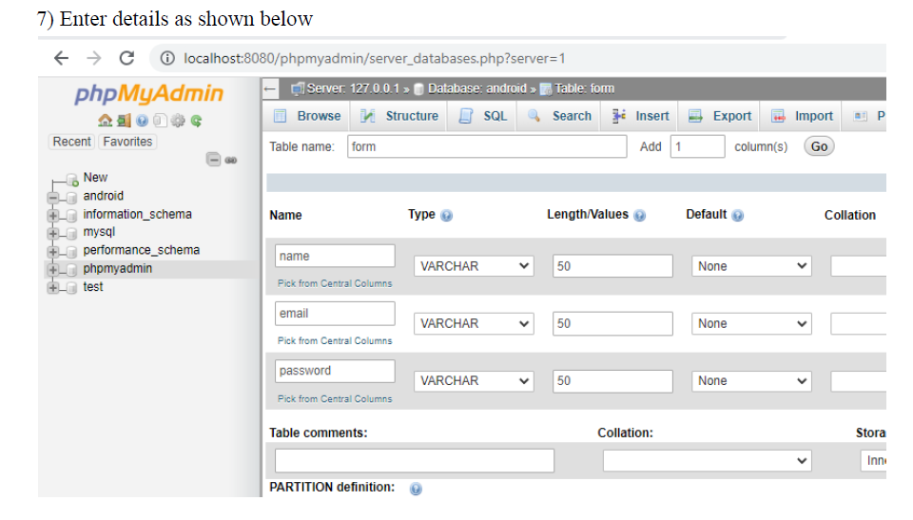

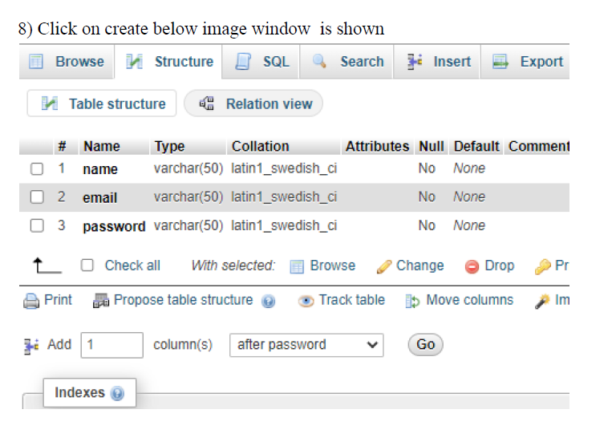

**Goto xampp folder→htdocs→Create Folder PHP→Signup.php**

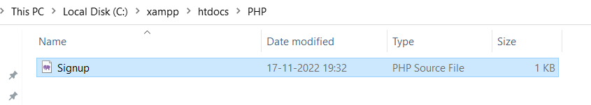

**Write code Signup.php in notepad and save it with .php extension**

**Signup.php**

<?php

$conn = mysqli_connect("localhost","root","","android");

$name=trim($_POST['name']);

$email=trim($_POST['email']);

$pass=trim($_POST['password']);

if($conn)

{

$qry = "select * from form where email='$email'";

$result = mysqli_query($conn,$qry);

if(mysqli_num_rows($result)>0)

{

$response['message']="exist";

echo json_encode($response);

}

else

{

$qry = "insert into form(name,email,password)values('$name','$email','$pass')";

if(mysqli_query($conn,$qry))

{

$response['message']="success";

}

else{

$response['message']="failed";

}

echo json_encode($response);

}

}

else{

$response['message']="failed";

echo json_encode($response);

}

?>

**FormActivity.java**

package com.example.prac10;

import androidx.appcompat.app.AppCompatActivity;

import android.graphics.Color;

import android.os.Bundle;

import android.view.View;

import android.widget.Button;

import android.widget.EditText;

import android.widget.TextView;

import android.widget.Toast;

import retrofit2.Call;

import retrofit2.Callback;

import retrofit2.Response;

public class FormActivity extends AppCompatActivity {

EditText t1,t2,t3;

Button SignUpBtn;

@Override

protected void onCreate(Bundle savedInstanceState) {

super.onCreate(savedInstanceState);

setContentView(R.layout.activity_form);

t1=(EditText)findViewById(R.id.t1);

t2=(EditText)findViewById(R.id.t2);

t3=(EditText)findViewById(R.id.t3);

SignUpBtn=(Button)findViewById(R.id.SignUpBtn);

SignUpBtn.setOnClickListener(new View.OnClickListener() {

@Override

public void onClick(View view) {

processSignUp();

}

});

}

void processSignUp(){

String name = t1.getText().toString();

String email = t2.getText().toString();

String password = t3.getText().toString();

Call<ResponseModel> call = Controller.getInstance().getapi().verifyuser(name,email,password);

call.enqueue(new Callback<ResponseModel>() {

@Override

public void onResponse(Call<ResponseModel> call,

Response<ResponseModel> response) {

ResponseModel obj=response.body();

String output=obj.getMessage();

if(output.equals("exist")) {

t1.setText("");

t2.setText("");

t3.setText("");

Toast.makeText(getApplicationContext(),"User Already Exist", Toast.LENGTH_LONG).show();

}

if(output.equals("success")) {

Toast.makeText(getApplicationContext(),"User Registered Successfully", Toast.LENGTH_LONG).show();

}

if(output.equals("failed")) {

Toast.makeText(getApplicationContext(),"Something went wrong", Toast.LENGTH_LONG).show();

}

if(output.equals("failed")) {

Toast.makeText(getApplicationContext(),"Connection failure", Toast.LENGTH_LONG).show();

}

}

@Override

public void onFailure(Call<ResponseModel> call, Throwable t) {

Toast.makeText(getApplicationContext(),t +" "+call, Toast.LENGTH_LONG).show();

}

});}}

**ResponseModel.java**

package com.example.prac10;

public class ResponseModel {

String message;

public ResponseModel(String message) {

this.message = message;

}

public ResponseModel() {}

public String getMessage() {

return message;

}

public void setMessage(String message) {

this.message = message;

}

}

**Controller.java**

package com.example.prac10;

import javax.net.ssl.HostnameVerifier;

import javax.net.ssl.SSLContext;

import javax.net.ssl.SSLSession;

import javax.net.ssl.SSLSocketFactory;

import javax.net.ssl.TrustManager;

import javax.net.ssl.X509TrustManager;

import javax.security.cert.CertificateException;

import okhttp3.OkHttpClient;

import retrofit2.Retrofit;

import retrofit2.converter.gson.GsonConverterFactory;

public class Controller {

private static final String url="https://10.0.2.2/PHP/Signup.php/";

private static Controller clientobject;

private static Retrofit retrofit;

Controller() {

retrofit=new Retrofit.Builder()

.baseUrl(url).addConverterFactory(GsonConverterFactory.create()).client(getUnsafeOkHttpClient()).build();

}

public static synchronized Controller getInstance() {

if(clientobject==null)

clientobject=new Controller();

return clientobject;

}

Apiset getapi() {

return retrofit.create(Apiset.class);

}

private static OkHttpClient getUnsafeOkHttpClient() {

try {

// Create a trust manager that does not validate certificate chains

final TrustManager[] trustAllCerts = new TrustManager[] {

new X509TrustManager() {

@Override

public void checkClientTrusted(java.security.cert.X509Certificate[] chain, String authType) {

}

@Override

public void checkServerTrusted(java.security.cert.X509Certificate[] chain, String authType) {

}

@Override

public java.security.cert.X509Certificate[] getAcceptedIssuers() {

return new java.security.cert.X509Certificate[]{};

}

}

};

// Install the all-trusting trust manager

final SSLContext sslContext = SSLContext.getInstance("SSL");

sslContext.init(null, trustAllCerts, new java.security.SecureRandom());

// Create an ssl socket factory with our all-trusting manager

final SSLSocketFactory sslSocketFactory = sslContext.getSocketFactory();

OkHttpClient.Builder builder = new OkHttpClient.Builder();

builder.sslSocketFactory(sslSocketFactory);

builder.hostnameVerifier(new HostnameVerifier() {

@Override

public boolean verify(String hostname, SSLSession session) {

return true;

}

});

OkHttpClient okHttpClient = builder.build();

return okHttpClient;

} catch (Exception e) {

throw new RuntimeException(e);

}

}

}

**Apiset.java**

package com.example.prac10;

import retrofit2.Call;

import retrofit2.http.Field;

import retrofit2.http.FormUrlEncoded;

import retrofit2.http.POST;

public interface Apiset {

@FormUrlEncoded

@POST("/PHP/Signup.php")

Call<ResponseModel> verifyuser(

@Field("name") String name,

@Field("email") String email,

@Field("password") String password

);

}

**Q. 2) Write a program that creates a basic contacts application that allows the insertion, deletion, and modification of contacts with the use of an SQLite database.**

**CODE:**

**activity_main.xml**

<?xml version="1.0" encoding="utf-8"?>

<androidx.constraintlayout.widget.ConstraintLayout

xmlns:android="http://schemas.android.com/apk/res/android"

xmlns:app="http://schemas.android.com/apk/res-auto"

xmlns:tools="http://schemas.android.com/tools"

android:layout_width="match_parent"

android:layout_height="match_parent"

tools:context=".MainActivity">

<EditText

android:id="@+id/et1"

android:layout_width="wrap_content"

android:layout_height="wrap_content"

android:ems="10"

android:hint="Enter your ROLL NO"

android:inputType="textPersonName"

android:minHeight="48dp"

app:layout_constraintBottom_toBottomOf="parent"

app:layout_constraintEnd_toEndOf="parent"

app:layout_constraintHorizontal_bias="0.338"

app:layout_constraintStart_toStartOf="parent"

app:layout_constraintTop_toTopOf="parent"

app:layout_constraintVertical_bias="0.072" />

<TextView

android:id="@+id/tv1"

android:layout_width="wrap_content"

android:layout_height="wrap_content"

android:text="ROLL NO: -"

android:textSize="16sp"

android:textStyle="bold"

app:layout_constraintBottom_toBottomOf="parent"

app:layout_constraintEnd_toEndOf="parent"

app:layout_constraintHorizontal_bias="0.205"

app:layout_constraintStart_toStartOf="parent"

app:layout_constraintTop_toTopOf="parent"

app:layout_constraintVertical_bias="0.022" />

<TextView

android:id="@+id/tv2"

android:layout_width="wrap_content"

android:layout_height="wrap_content"

android:text="NAME: -"

android:textSize="16sp"

android:textStyle="bold"

app:layout_constraintBottom_toBottomOf="parent"

app:layout_constraintEnd_toEndOf="parent"

app:layout_constraintHorizontal_bias="0.194"

app:layout_constraintStart_toStartOf="parent"

app:layout_constraintTop_toTopOf="parent"

app:layout_constraintVertical_bias="0.159" />

<EditText

android:id="@+id/et2"

android:layout_width="wrap_content"

android:layout_height="wrap_content"

android:ems="10"

android:hint="Enter your Name"

android:inputType="textPersonName"

android:minHeight="48dp"

app:layout_constraintBottom_toBottomOf="parent"

app:layout_constraintEnd_toEndOf="parent"

app:layout_constraintHorizontal_bias="0.338"

app:layout_constraintStart_toStartOf="parent"

app:layout_constraintTop_toTopOf="parent"

app:layout_constraintVertical_bias="0.214" />

<TextView

android:id="@+id/tv3"

android:layout_width="wrap_content"

android:layout_height="wrap_content"

android:text="EMAIL-ID: -"

android:textSize="16sp"

android:textStyle="bold"

app:layout_constraintBottom_toBottomOf="parent"

app:layout_constraintEnd_toEndOf="parent"

app:layout_constraintHorizontal_bias="0.214"

app:layout_constraintStart_toStartOf="parent"

app:layout_constraintTop_toTopOf="parent"

app:layout_constraintVertical_bias="0.29" />

<EditText

android:id="@+id/et3"

android:layout_width="wrap_content"

android:layout_height="wrap_content"

android:ems="10"

android:hint="Enter your Email"

android:inputType="textPersonName"

android:minHeight="48dp"

app:layout_constraintBottom_toBottomOf="parent"

app:layout_constraintEnd_toEndOf="parent"

app:layout_constraintHorizontal_bias="0.338"

app:layout_constraintStart_toStartOf="parent"

app:layout_constraintTop_toTopOf="parent"

app:layout_constraintVertical_bias="0.346" />

<TextView

android:id="@+id/tv4"

android:layout_width="wrap_content"

android:layout_height="wrap_content"

android:text="COURSE: -"

android:textSize="16sp"

android:textStyle="bold"

app:layout_constraintBottom_toBottomOf="parent"

app:layout_constraintEnd_toEndOf="parent"

app:layout_constraintHorizontal_bias="0.202"

app:layout_constraintStart_toStartOf="parent"

app:layout_constraintTop_toTopOf="parent"

app:layout_constraintVertical_bias="0.424" />

<EditText

android:id="@+id/et4"

android:layout_width="wrap_content"

android:layout_height="wrap_content"

android:ems="10"

android:hint="Enter your Course"

android:inputType="textPersonName"

android:minHeight="48dp"

app:layout_constraintBottom_toBottomOf="parent"

app:layout_constraintEnd_toEndOf="parent"

app:layout_constraintHorizontal_bias="0.348"

app:layout_constraintStart_toStartOf="parent"

app:layout_constraintTop_toTopOf="parent"

app:layout_constraintVertical_bias="0.483" />

<TextView

android:id="@+id/tv5"

android:layout_width="wrap_content"

android:layout_height="wrap_content"

android:text="CONTACT NO: -"

android:textSize="16sp"

android:textStyle="bold"

app:layout_constraintBottom_toBottomOf="parent"

app:layout_constraintEnd_toEndOf="parent"

app:layout_constraintHorizontal_bias="0.235"

app:layout_constraintStart_toStartOf="parent"

app:layout_constraintTop_toTopOf="parent"

app:layout_constraintVertical_bias="0.555" />

<EditText

android:id="@+id/et5"

android:layout_width="wrap_content"

android:layout_height="wrap_content"

android:ems="10"

android:hint="Enter your Contact No"

android:inputType="phone"

android:minHeight="48dp"

app:layout_constraintBottom_toBottomOf="parent"

app:layout_constraintEnd_toEndOf="parent"

app:layout_constraintHorizontal_bias="0.348"

app:layout_constraintStart_toStartOf="parent"

app:layout_constraintTop_toTopOf="parent"

app:layout_constraintVertical_bias="0.619" />

<TextView

android:id="@+id/tv6"

android:layout_width="wrap_content"

android:layout_height="wrap_content"

android:text="ADDRESS: -"

android:textSize="16sp"

android:textStyle="bold"

app:layout_constraintBottom_toBottomOf="parent"

app:layout_constraintEnd_toEndOf="parent"

app:layout_constraintHorizontal_bias="0.208"

app:layout_constraintStart_toStartOf="parent"

app:layout_constraintTop_toTopOf="parent"

app:layout_constraintVertical_bias="0.681" />

<EditText

android:id="@+id/et6"

android:layout_width="wrap_content"

android:layout_height="wrap_content"

android:ems="10"

android:hint="Enter your Address"

android:inputType="textPersonName"

android:minHeight="48dp"

android:textColorHint="#757575"

app:layout_constraintBottom_toBottomOf="parent"

app:layout_constraintEnd_toEndOf="parent"

app:layout_constraintHorizontal_bias="0.338"

app:layout_constraintStart_toStartOf="parent"

app:layout_constraintTop_toTopOf="parent"

app:layout_constraintVertical_bias="0.752" />

<Button

android:id="@+id/load"

android:layout_width="96dp"

android:layout_height="49dp"

android:text="LOAD"

android:onClick="loadStudents"

app:layout_constraintBottom_toBottomOf="parent"

app:layout_constraintEnd_toEndOf="parent"

app:layout_constraintHorizontal_bias="0.0"

app:layout_constraintStart_toStartOf="parent"

app:layout_constraintTop_toTopOf="parent"

app:layout_constraintVertical_bias="0.852" />

<Button

android:id="@+id/upd"

android:layout_width="wrap_content"

android:layout_height="wrap_content"

android:text="UPDATE"

android:onClick="updateStudent"

app:layout_constraintBottom_toBottomOf="parent"

app:layout_constraintEnd_toEndOf="parent"

app:layout_constraintHorizontal_bias="0.996"

app:layout_constraintStart_toStartOf="parent"

app:layout_constraintTop_toTopOf="parent"

app:layout_constraintVertical_bias="0.852" />

<Button

android:id="@+id/ins"

android:layout_width="101dp"

android:layout_height="48dp"

android:onClick="addStudent"

android:text="INSERT"

app:layout_constraintBottom_toBottomOf="parent"

app:layout_constraintEnd_toEndOf="parent"

app:layout_constraintHorizontal_bias="0.345"

app:layout_constraintStart_toStartOf="parent"

app:layout_constraintTop_toTopOf="parent"

app:layout_constraintVertical_bias="0.849" />

<Button

android:id="@+id/del"

android:layout_width="wrap_content"

android:layout_height="wrap_content"

android:text="DELETE"

android:onClick="deleteStudent"

app:layout_constraintBottom_toBottomOf="parent"

app:layout_constraintEnd_toEndOf="parent"

app:layout_constraintHorizontal_bias="0.672"

app:layout_constraintStart_toStartOf="parent"

app:layout_constraintTop_toTopOf="parent"

app:layout_constraintVertical_bias="0.852" />

<TextView

android:id="@+id/tv8"

android:layout_width="wrap_content"

android:layout_height="wrap_content"

android:text="TextView"

android:textStyle="bold"

app:layout_constraintBottom_toBottomOf="parent"

app:layout_constraintEnd_toEndOf="parent"

app:layout_constraintHorizontal_bias="0.498"

app:layout_constraintStart_toStartOf="parent"

app:layout_constraintTop_toTopOf="parent"

app:layout_constraintVertical_bias="0.924" />

</androidx.constraintlayout.widget.ConstraintLayout>

**MainActivity.java**

package com.example.database;

import android.os.Bundle;

import android.text.method.ScrollingMovementMethod;

import android.view.View;

import android.widget.EditText;

import android.widget.TextView;

import androidx.appcompat.app.AppCompatActivity;

public class MainActivity extends AppCompatActivity {

EditText rno;

EditText name;

EditText email;

EditText course;

EditText contact;

EditText address;

TextView output1;

MyDBHandler dbHandler;

@Override

protected void onCreate(Bundle savedInstanceState) {

super.onCreate(savedInstanceState);

setContentView(R.layout.activity_main);

rno = (EditText) findViewById(R.id.et1);

name = (EditText) findViewById(R.id.et2);

email = (EditText) findViewById(R.id.et3);

course = (EditText) findViewById(R.id.et4);

contact = (EditText) findViewById(R.id.et5);

address = (EditText) findViewById(R.id.et6);

output1=findViewById(R.id.tv8);

//output1.setMovementMethod(new ScrollingMovementMethod());

dbHandler= new MyDBHandler(this);

}

public void loadStudents(View view) {

output1.setText(dbHandler.loadHandler());

rno.setText("");

name.setText("");

email.setText("");

course.setText("");

contact.setText("");

address.setText("");

}

public void addStudent (View view) {

if(!rno.getText().toString().isEmpty() && !name.getText().toString().isEmpty() && !email.getText().toString().isEmpty() && !course.getText().toString().isEmpty() && !contact.getText().toString().isEmpty() && !address.getText().toString().isEmpty()) {

Integer id = Integer.parseInt(rno.getText().toString());

String nm = name.getText().toString();

String em = email.getText().toString();

String cr = course.getText().toString();

String cn = contact.getText().toString();

String ad = address.getText().toString();

Student student = new Student(id, nm, em, cr, cn, ad);

long insertId=dbHandler.addHandler(student);

if(insertId==-1){

output1.setText("Record already exists");

}

else{

rno.setText("");

name.setText("");

email.setText("");

course.setText("");

contact.setText("");

address.setText("");

output1.setText("Record added");

}

}

else{

output1.setText("Please fill correct id and name");

}

}

public void updateStudent(View view) {

if(!rno.getText().toString().isEmpty() && !name.getText().toString().isEmpty() && !email.getText().toString().isEmpty() && !course.getText().toString().isEmpty() && !contact.getText().toString().isEmpty() && !address.getText().toString().isEmpty()) {

boolean result = dbHandler.updateHandler(Integer.parseInt(rno.getText().toString()), name.getText().toString(), email.getText().toString(), course.getText().toString(), contact.getText().toString(), address.getText().toString());

if (result) {

rno.setText("");

name.setText("");

email.setText("");

course.setText("");

contact.setText("");

address.setText("");

output1.setText("Record Updated");

} else {

output1.setText("No Record Found");

}

}

else{

output1.setText("Please fill correct id and name");

}

}

public void deleteStudent(View view) {

if(!rno.getText().toString().isEmpty()) {

boolean result = dbHandler.deleteHandler(Integer.parseInt(

rno.getText().toString()));

if (result) {

rno.setText("");

name.setText("");

email.setText("");

course.setText("");

contact.setText("");

address.setText("");

output1.setText("Record Deleted");

} else {

output1.setText("No Record Found");

}

} else{

output1.setText("Please fill correct id");

}

}

@Override

protected void onDestroy() {

super.onDestroy();

dbHandler.close();

}

}

**MyDBHandler.java**

package com.example.database;

import android.content.ContentValues;

import android.content.Context;

import android.database.Cursor;

import android.database.sqlite.SQLiteDatabase;

import android.database.sqlite.SQLiteOpenHelper;

public class MyDBHandler extends SQLiteOpenHelper {

private static final int DATABASE_VERSION = 3;

private static final String DATABASE_NAME = "studentDB.db";

private static final String TABLE_STUDENTS = "newstudent";

private static final String COLUMN_RNO = "rno";

private static final String COLUMN_NAME = "name";

private static final String COLUMN_EMAIL = "email";

private static final String COLUMN_COURSE = "course";

private static final String COLUMN_CONTACT = "contact";

private static final String COLUMN_ADDRESS = "address";

MyDBHandler(Context context)

{

super(context, DATABASE_NAME, null, DATABASE_VERSION);

}

@Override

public void onCreate(SQLiteDatabase db) {

String CREATE_STUDENT_TABLE = "CREATE TABLE " +

TABLE_STUDENTS + "(" + COLUMN_RNO + " INTEGER PRIMARY KEY," + COLUMN_NAME + " TEXT, " + COLUMN_EMAIL + " TEXT, " + COLUMN_COURSE + " TEXT, " + COLUMN_CONTACT + " TEXT, " + COLUMN_ADDRESS + " TEXT" + ")";

db.execSQL(CREATE_STUDENT_TABLE);

}

@Override

public void onUpgrade(SQLiteDatabase db, int oldVersion,

int newVersion) {

db.execSQL("DROP TABLE IF EXISTS " + TABLE_STUDENTS);

onCreate(db);

}

String loadHandler() {

String result = "";

String query = "Select*FROM " + TABLE_STUDENTS;

SQLiteDatabase db = this.getWritableDatabase();

Cursor cursor = db.rawQuery(query, null);

while (cursor.moveToNext()) {

int result_0 = cursor.getInt(0);

String result_1 = cursor.getString(1);

String result_2 = cursor.getString(2);

String result_3 = cursor.getString(3);

String result_4 = cursor.getString(4);

String result_5 = cursor.getString(5);

result += String.valueOf(result_0) + " " + result_1 + " " + result_2 + " " + result_3 + " " + result_4 + " " + result_5;

System.getProperty("line.separator");

}

cursor.close();

db.close();

if(result.equals(""))

result="No Record Found";

return result;

}

long addHandler(Student student) {

long id;

ContentValues values = new ContentValues();

values.put(COLUMN_RNO, student.getID());

values.put(COLUMN_NAME, student.getName());

values.put(COLUMN_EMAIL, student.getEmail());

values.put(COLUMN_COURSE, student.getCourse());

values.put(COLUMN_CONTACT, student.getContact());

values.put(COLUMN_ADDRESS, student.getAddress());

SQLiteDatabase db = this.getWritableDatabase();

id = db.insert(TABLE_STUDENTS, null, values);

db.close();

return id;

}

boolean updateHandler(int rno, String name, String email, String course, String contact, String

address) {

SQLiteDatabase db = this.getWritableDatabase();

ContentValues args = new ContentValues();

args.put(COLUMN_RNO, rno);

args.put(COLUMN_NAME, name);

args.put(COLUMN_EMAIL, email);

args.put(COLUMN_COURSE, course);

args.put(COLUMN_CONTACT, contact);

args.put(COLUMN_ADDRESS, address);

return db.update(TABLE_STUDENTS, args, COLUMN_RNO + "=" + rno, null) > 0;

}

boolean deleteHandler(int ID) {

boolean result = false;

String query = "Select*FROM " + TABLE_STUDENTS + " WHERE " + COLUMN_RNO + " = '" + String.valueOf(ID) + "'";

SQLiteDatabase db = this.getWritableDatabase();

Cursor cursor = db.rawQuery(query, null);

Student student = new Student();

if (cursor.moveToFirst()) {

student.setID(Integer.parseInt(cursor.getString(0)));

db.delete(TABLE_STUDENTS, COLUMN_RNO + "=?",

new String[] {

String.valueOf(student.getID())

});

cursor.close();

result = true;

}

db.close();

return result;

}

}

**Student.java**

package com.example.database;

public class Student {

private int rno;

private String name;

private String email;

private String course;

private String contact;

private String address;

Student() {

}

Student(int rno, String name, String email, String course, String contact, String address) {

this.rno = rno;

this.name = name;

this.email=email;

this.course=course;

this.contact=contact;

this.address=address;

}

void setID(int id) {

this.rno = id;

}

int getID() {

return this.rno;

}

void setName(String name) {

this.name = name;

}

String getName() {

return this.name;

}

void setEmail(String email) {

this.email = email;

}

String getEmail() {

return this.email;

}

void setCourse(String course) {

this.course = course;

}

String getCourse() {

return this.course;

}

void setContact(String contact) {

this.contact = contact;

}

String getContact() {

return this.contact;

}

void setAddress(String address) {

this.address = address;

}

String getAddress() {

return this.address;

}

}

**ROLL NO 16**

**Q. 1) Write a program to capture an image and perform the following**

**animations on the image**

**a) Expand**

**b) Rotate**

**c) Move**

**Create a folder anim in res 3 xml files inside it move.xml, rotate.xml and zoom.xml**

**Add an image in a drawable**

**rotate.xml**

<?xml version="1.0" encoding="utf-8"?>

<set

xmlns:android="http://schemas.android.com/apk/res/android">

<rotate

android:duration="6000"

android:fromDegrees="0"

android:pivotX="50%"

android:pivotY="50%"

android:toDegrees="360" />

<rotate

android:duration="6000"

android:fromDegrees="360"

android:pivotX="50%"

android:pivotY="50%"

android:startOffset="5000"

android:toDegrees="0" />

</set>

**move.xml**

<?xml version="1.0" encoding="utf-8"?>

<set

xmlns:android="http://schemas.android.com/apk/res/android"

android:interpolator="@android:anim/linear_interpolator"

android:fillAfter="true">

<translate

android:fromXDelta="0%p"

android:toXDelta="75%p"

android:duration="700" />

</set>

**zoom.xml**

<?xml version="1.0" encoding="utf-8"?>

<set xmlns:android="http://schemas.android.com/apk/res/android">

<scale xmlns:android="http://schemas.android.com/apk/res/android"

android:fromXScale="0.5"

android:toXScale="3.0"

android:fromYScale="0.5"

android:toYScale="3.0"

android:duration="5000"

android:pivotX="50%"

android:pivotY="50%" >

</scale>

<scale xmlns:android="http://schemas.android.com/apk/res/android"

android:startOffset="5000"

android:fromXScale="3.0"

android:toXScale="0.5"

android:fromYScale="3.0"

android:toYScale="0.5"

android:duration="5000"

android:pivotX="50%"

android:pivotY="50%" >

</scale>

</set>

**activity_main.xml**

<?xml version="1.0" encoding="utf-8"?>

<androidx.constraintlayout.widget.ConstraintLayout xmlns:android="http://schemas.android.com/apk/res/android"

xmlns:app="http://schemas.android.com/apk/res-auto"

xmlns:tools="http://schemas.android.com/tools"

android:layout_width="match_parent"

android:layout_height="match_parent"

tools:context=".MainActivity">

<ImageView

android:id="@+id/imageView"

android:layout_width="153dp"

android:layout_height="231dp"

app:layout_constraintBottom_toBottomOf="parent"

app:layout_constraintEnd_toEndOf="parent"

app:layout_constraintStart_toStartOf="parent"

app:layout_constraintTop_toTopOf="parent"

app:layout_constraintVertical_bias="0.264"

app:srcCompat="@drawable/doraemon" />

<Button

android:id="@+id/btn1"

android:layout_width="wrap_content"

android:layout_height="wrap_content"

android:text="MOVE"

app:layout_constraintBottom_toBottomOf="parent"

app:layout_constraintEnd_toEndOf="parent"

app:layout_constraintHorizontal_bias="0.049"

app:layout_constraintStart_toStartOf="parent"

app:layout_constraintTop_toTopOf="parent"

app:layout_constraintVertical_bias="0.713" />

<Button

android:id="@+id/btn2"

android:layout_width="wrap_content"

android:layout_height="wrap_content"

android:text="ROTATE"

app:layout_constraintBottom_toBottomOf="parent"

app:layout_constraintEnd_toEndOf="parent"

app:layout_constraintStart_toStartOf="parent"

app:layout_constraintTop_toTopOf="parent"

app:layout_constraintVertical_bias="0.713" />

<Button

android:id="@+id/btn3"

android:layout_width="wrap_content"

android:layout_height="wrap_content"

android:text="EXPAND"

app:layout_constraintBottom_toBottomOf="parent"

app:layout_constraintEnd_toEndOf="parent"

app:layout_constraintHorizontal_bias="0.949"

app:layout_constraintStart_toStartOf="parent"

app:layout_constraintTop_toTopOf="parent"

app:layout_constraintVertical_bias="0.713" />

</androidx.constraintlayout.widget.ConstraintLayout>

**MainActivity.java**

package com.example.prac7;

import androidx.appcompat.app.AppCompatActivity;

import android.os.Bundle;

import android.view.View;

import android.view.animation.Animation;

import android.view.animation.AnimationUtils;

import android.widget.Button;

import android.widget.ImageView;

public class MainActivity extends AppCompatActivity {

@Override

protected void onCreate(Bundle savedInstanceState) {

super.onCreate(savedInstanceState);

setContentView(R.layout.activity_main);

ImageView im = findViewById(R.id.imageView);

Button mvbtn = findViewById(R.id.btn1);

Button robtn = findViewById(R.id.btn2);

Button zobtn = findViewById(R.id.btn3);

mvbtn.setOnClickListener(new View.OnClickListener() {

@Override

public void onClick(View v) {

// To add move animation

Animation animation = AnimationUtils.loadAnimation(getApplicationContext(), R.anim.move);

im.startAnimation(animation);

}

});

robtn.setOnClickListener(new View.OnClickListener() {

@Override

public void onClick(View v) {

// To add rotate animation

Animation animation = AnimationUtils.loadAnimation(getApplicationContext(), R.anim.rotate);

im.startAnimation(animation);

}

});

zobtn.setOnClickListener(new View.OnClickListener() {

@Override

public void onClick(View v) {

// To add zoom animation

Animation animation = AnimationUtils.loadAnimation(getApplicationContext(), R.anim.zoom);

im.startAnimation(animation);

}

});

}

}