**Abstract**

**Problem Statement:**This study aims to predict wine quality and type based on chemical properties, aiding winemakers in quality control and classification.

**Related Work:**Previous research has used machine learning techniques like decision trees and neural networks to predict wine quality. However, deep learning models for predicting both wine quality and type are less explored.

**Methodology:**Using the Wine Quality Dataset, which includes features like acidity, sugar, and alcohol, two neural network models were built:

1. A multi-class classification model for wine quality. Multiple-Classes: [6, 5, 7, 8, 4, 3, 9]
2. A binary classification model for wine type. Binary Classes: [0,1]

*Both models were trained using Keras’ Sequential API* with three hidden layers, dropout for regularization, and the Adam optimizer.

**Results:**

* Wine Quality Prediction: Achieved 56.77% accuracy. Less accuracy, more complex problem.

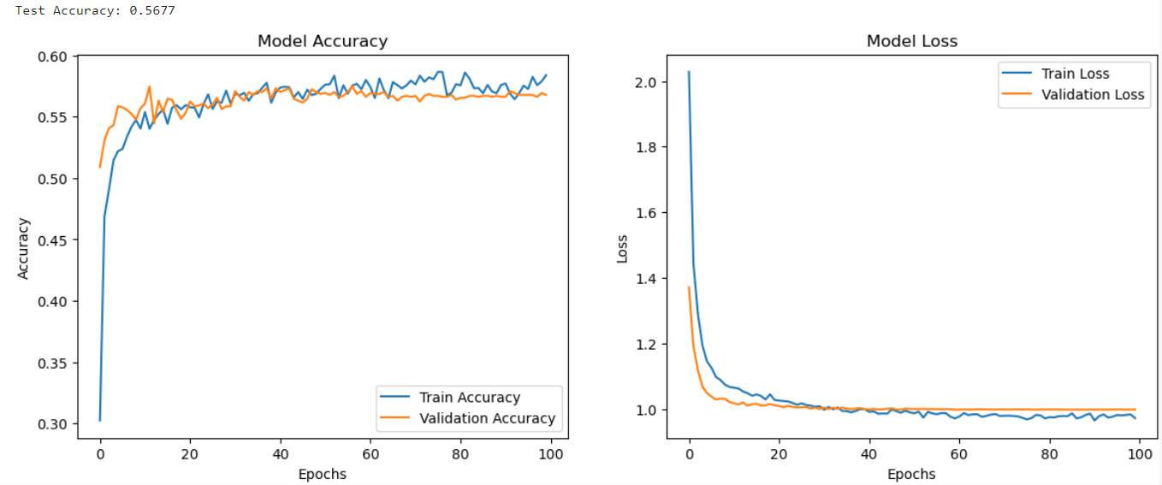

* Wine Type Prediction: Achieved 99.61% accuracy, showing strong generalization. More accuracy, less complex problem.

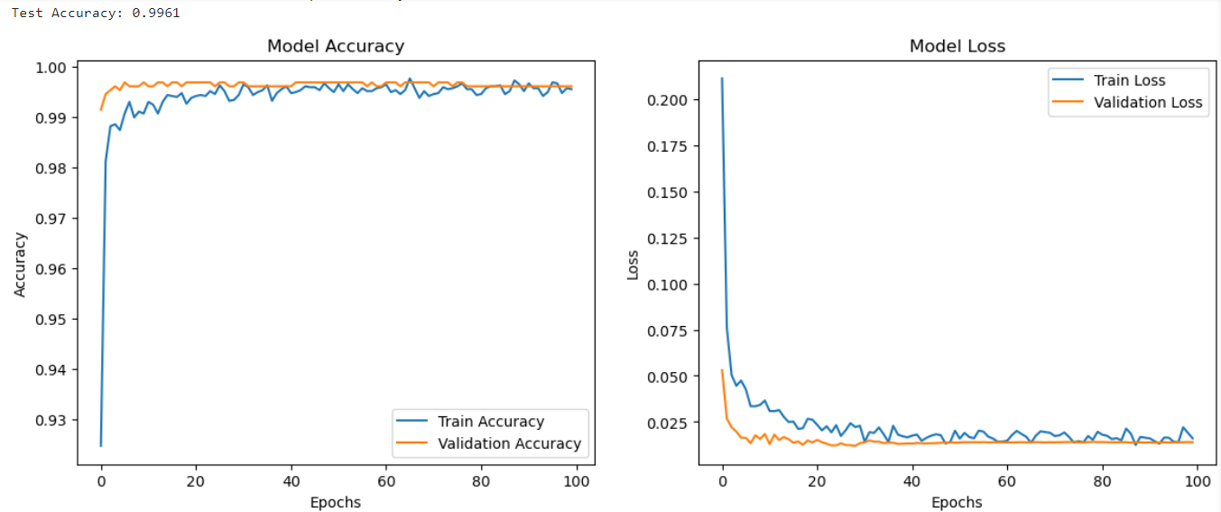

The dataset includes physicochemical inputs and sensory outputs but lacks information on grape types and wine brands. The classes are imbalanced, suggesting the need for outlier detection and feature selection methods.

**Reference:**

[1] M. Marques, "Wines Type and Quality Classification Exercises," Kaggle, 2024. [Online]. Available: https://www.kaggle.com/code/mgmarques/wines-type-and-quality-classification-exercises/notebook. [Accessed: Oct. 13, 2024].