NCAOS / EGS
Phase 05 — Test Plan
React Admin Terminal · AuditSignal Schema (Toru-William)
Week 8–10 · UI + Formal Interface Definition

Document | Phase 05 — Step-by-Step Test Plan
Version | 0.5.0
Date | 2026-05-08
Prerequisite | Phase 04 complete — 181 automated + 9 manual tests passing
New deliverables | React Admin Terminal (UI) + AuditSignal schema (Toru-William)
Est. total time | ~60 minutes
Toru-William | ADR-006 + AuditSignal schema — formal interface contract

⚠ Classification: Non-Public / Concept Demonstration Artifact. Do not share outside authorized personnel.

1. What Changed in Phase 05
Phase 05 delivers two parallel tracks: the React Admin Terminal replacing the original PoC HTML, and the formal AuditSignal schema that defines the typed interface between NCAOS EGS and the Urielle audit layer.

File | Action | Purpose
ui/src/App.tsx | ADD | Root Admin Terminal — topbar, role tabs, live WebSocket, partner selector
ui/src/components/DashboardPanel.tsx | ADD | Integrity, authority, and active event cards
ui/src/components/EventLog.tsx | ADD | EventLog, MttdPanel, SequencePanel, PolicyPanel, ContainmentChart
ui/src/lib/api.ts | ADD | Typed fetch wrappers for all 14 Phase 04 endpoints + WebSocket
ui/src/main.tsx | ADD | React entry point
ui/index.html | ADD | HTML entry point
ui/package.json | ADD | React 18 + Vite + TanStack Query + Recharts
ui/vite.config.ts | ADD | Vite config with API proxy to port 3000
ui/tsconfig.json | ADD | TypeScript config for React/JSX
audit-signal/src/audit-signal.ts | ADD | AuditSignal Zod schema — core + sequence + enrichment layers
docs/adr/ADR-006-audit-signal-schema.md | ADD | ADR: AuditSignal as the Urielle interface contract

2. Admin Terminal — Role-Based Views
The React Admin Terminal provides four role-based views, each wired to live API data via TanStack Query and WebSocket streaming.

Role | View Title | Key Components
SOC OPERATOR | Active Containment | Active event card, integrity card, authority card, event log with layer/severity filters, MTTD SLA panel
ARCHITECT | Shell Integrity | Shell status, fail-safe state, core isolation %, continuity state (STABLE/PROVISIONAL/UNSTABLE), equivalence tests, MTTD expanded view per layer
AUDITOR | Evidence Trail | Full event log with sequence navigation, event stats (byLayer/bySeverity/byAction/activeSequences), policy panel, sequence analysis panel (Toru-William)
EXECUTIVE | Risk Overview | System status card, integrity level + score bar, containment effect (RAW vs GOVERNED bars), integrity/authority trend chart (last 20 events)

3. AuditSignal Schema — Toru-William Interface
The AuditSignal schema is the formal typed contract between NCAOS EGS and the Urielle audit layer. It defines exactly what Urielle may consume and how. See ADR-006 for full rationale.

Layer | When Present | Fields
core | Always — every event | evidenceHandle, sequenceNumber, layer, severity, action, authority, integrityScore, detectionMode, routingHint, mttdMs, detectedAt, storedAt, policyProfileId, partnerId (14 fields)
sequence | When workflowId provided | sequenceId, patternType, escalationDetected, consistencyScore, eventCount, firstDetectedAt, actionChain, layersInvolved (8 fields)
enrichment | When caller provides context | identityRef, assetRef, sessionId, serviceComponent, tags (all optional)

4. Prerequisites

Check | Expected Output / Acceptance Criteria | ✓
node --version | v20.x.x or v24.x.x | ✓
npm --version | 9.x.x or higher | ✓
Phase 04 tests passing | 181 automated + 9 manual — all pass | ✓
API server accessible | http://localhost:3000/v1/health returns 200 | ✓
ncaos-phase05.tar.gz downloaded | From Claude conversation | ✓
egs/package.json workspaces | core, shell, api, detection present | ✓

5. Installation Steps

01 | Extract Phase 05 Archive | 5 min

cd "C:\AI Project\NCAOS-Urielle"

# Extract archive
tar -xzf ncaos-phase05.tar.gz

# Copy UI package into egs/
Copy-Item -Recurse phase05\ui egs\ui

# Copy audit-signal package
Copy-Item -Recurse phase05\audit-signal egs\audit-signal

# Add ADR-006
Copy-Item phase05\docs\adr\ADR-006-audit-signal-schema.md egs\docs\adr\

# Clean up
Remove-Item -Recurse phase05
Remove-Item ncaos-phase05.tar.gz

02 | Update egs/package.json Workspaces | 2 min

Open egs/package.json and add "ui" and "audit-signal" to the workspaces array:

notepad "C:\AI Project\NCAOS-Urielle\egs\package.json"

# Change this:
"workspaces": ["core", "shell", "api", "detection"]

# To this:
"workspaces": ["core", "shell", "api", "detection", "ui", "audit-signal"]

Note: Make sure there are commas between all workspace entries. Missing comma = JSONParseError (same issue as Phase 03).

03 | Verify Folder Structure | 2 min

ls egs\ui\src
# Expected: App.tsx main.tsx components/ lib/

ls egs\ui\src\components
# Expected: DashboardPanel.tsx EventLog.tsx

ls egs\ui\src\lib
# Expected: api.ts

ls egs\audit-signal\src
# Expected: audit-signal.ts

ls egs\docs\adr
# Expected: ADR-001 through ADR-006 all present

Check | Expected Output / Acceptance Criteria | ✓
ls egs\ui\src | App.tsx, main.tsx, components/, lib/ present | ✓
ls egs\audit-signal\src | audit-signal.ts present | ✓
ls egs\docs\adr | ADR-006 present | ✓

04 | Install Dependencies | 5 min

cd "C:\AI Project\NCAOS-Urielle\egs"
npm install

# This will install React, Vite, TanStack Query, Recharts for ui/
# and Zod for audit-signal/
# Expected: added N packages — no fatal errors

Check | Expected Output / Acceptance Criteria | ✓
npm install | No fatal errors, ui/node_modules or egs/node_modules populated | ✓
ls egs\node_modules\react | React 18 installed | ✓
ls egs\node_modules\recharts | Recharts installed | ✓

6. Phase 01–04 Regression Check

05 | Run Full Regression Suite | 5 min

Confirm all prior phases still pass before starting Phase 05 testing:

cd "C:\AI Project\NCAOS-Urielle\egs"
npm test 2>&1 | Select-String "Tests|passed|failed"

Expected: core 47/47 shell 15/15 api 65/65 detection 54/54 — 181 total passing.

Check | Expected Output / Acceptance Criteria | ✓
@ncaos/core | 47 passed (47) | ✓
@ncaos/shell | 15 passed (15) | ✓
@ncaos/api | 65 passed (65) | ✓
@ncaos/detection | 54 passed (54) | ✓
TOTAL | 181 passing — 0 failures | ✓

7. Admin Terminal — Manual Tests

The UI has no automated tests (UI testing is Phase 06 scope). All Phase 05 validation is manual — start both servers and verify each view.

06 | Start API Server (Terminal 1) | 3 min

cd "C:\AI Project\NCAOS-Urielle\egs\api"
npm start

# Expected:
# [ShellLoop] Started — policy: STRICT-PROD
# [Watchdog] Shell started
# [API] EGS API running on http://0.0.0.0:3000

07 | Start Admin Terminal (Terminal 2) | 3 min

cd "C:\AI Project\NCAOS-Urielle\egs\ui"
npm run dev

# Expected:
# VITE v5.x.x ready in Xms
# Local: http://localhost:5173/

# Open browser: http://localhost:5173

Note: The UI proxies /v1/* requests to http://localhost:3000 (the API). Both servers must be running simultaneously. API on port 3000, UI on port 5173.

08 | UI Manual Tests — All Four Views | 20 min

Test UI-01 — Topbar and Connection
Open http://localhost:5173 in the browser.

Check | Expected Output / Acceptance Criteria | ✓
Topbar visible | NCAOS // EGS logo, system status pill, partner/policy/tenant badges | ✓
Status pill | Shows ENFORCING or current mode (green pulse dot) | ✓
WebSocket | No "WS DISCONNECTED" warning shown | ✓
Health badges | POLICY=STRICT-PROD, SLA=HEALTHY visible | ✓
Partner selector | Dropdown with GLOBAL_ENT_2026 and TEST options | ✓

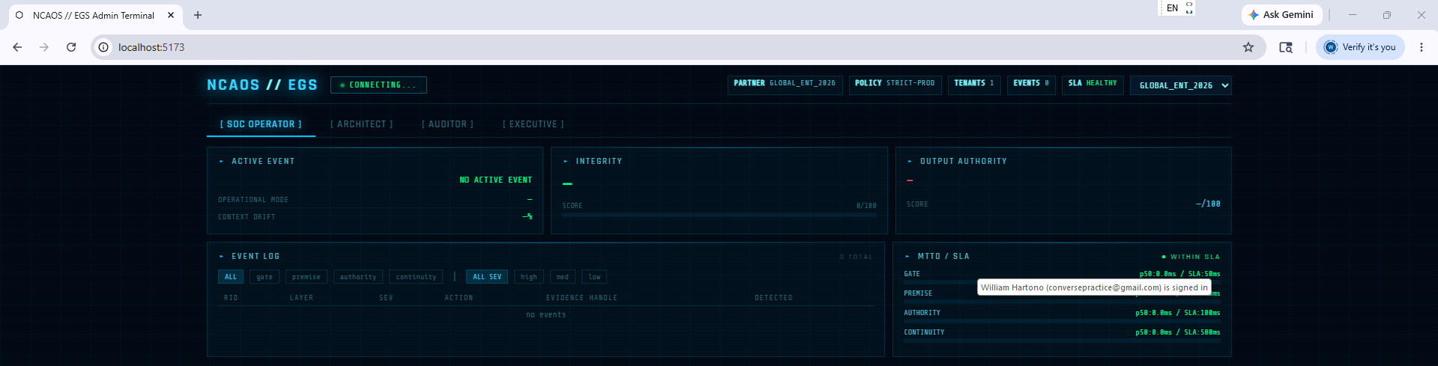

Test UI-02 — SOC Operator View
Click [ SOC OPERATOR ] tab.

Check | Expected Output / Acceptance Criteria | ✓
Active Event card | Shows NO ACTIVE EVENT or current event if present | ✓
Integrity card | Shows level (Available/Limited/Degraded/Critical) + score bar | ✓
Authority card | Shows decision-ready/reference-only/invalid | ✓
Event Log panel | Shows table with RID, LAYER, SEV, ACTION, EVIDENCE HANDLE, DETECTED columns | ✓
Layer filters | ALL, gate, premise, authority, continuity filter buttons present and working | ✓
MTTD panel | Shows gate/premise/authority/continuity layers with p50 bars | ✓


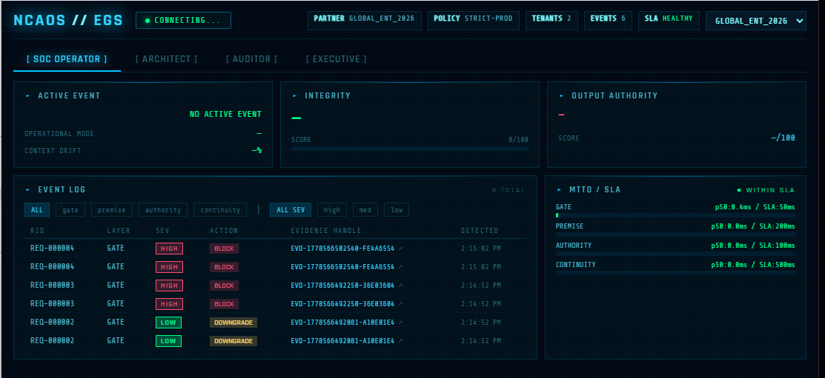

Test UI-03 — Generate Events via API (to populate UI)
In a third PowerShell window, send requests to generate events:

# Send clean request
$body = @{
sourceId="src-001"; inputHash="abc123"; inputFlags=@()
claimedPremises=@("A","B"); validatedPremises=@("A","B")
contractVersion="1.0"; requestedAuthority="decision-ready"
policyGrantedAuthority="decision-ready"; overrideAttempted=$false
workflowId="WF-UI-TEST-001"
} | ConvertTo-Json
Invoke-RestMethod -Uri http://localhost:3000/v1/process `
-Method POST -ContentType "application/json" `
-Headers @{"X-Partner-ID"="GLOBAL_ENT_2026"} -Body $body

# Send threat request
$threat = @{
sourceId="attacker"; inputHash="bad"; inputFlags=@("INJECTION_PATTERN")
claimedPremises=@("A","B","C"); validatedPremises=@("A")
contractVersion="1.0"; requestedAuthority="decision-ready"
policyGrantedAuthority="reference-only"; overrideAttempted=$false
workflowId="WF-UI-TEST-001"
} | ConvertTo-Json
Invoke-RestMethod -Uri http://localhost:3000/v1/process `
-Method POST -ContentType "application/json" `
-Headers @{"X-Partner-ID"="GLOBAL_ENT_2026"} -Body $threat

Check | Expected Output / Acceptance Criteria | ✓
SOC event log refreshes | New events appear after requests (auto-refresh every 8s or wait ~10s) | ✓
Severity badges | HIGH shown in red, LOW in green | ✓
Action badges | BLOCK in red, DOWNGRADE in amber, PASS in green | ✓
Evidence handle clickable | Click on EVD-... handle with sequenceId shows ↗ indicator | ✓
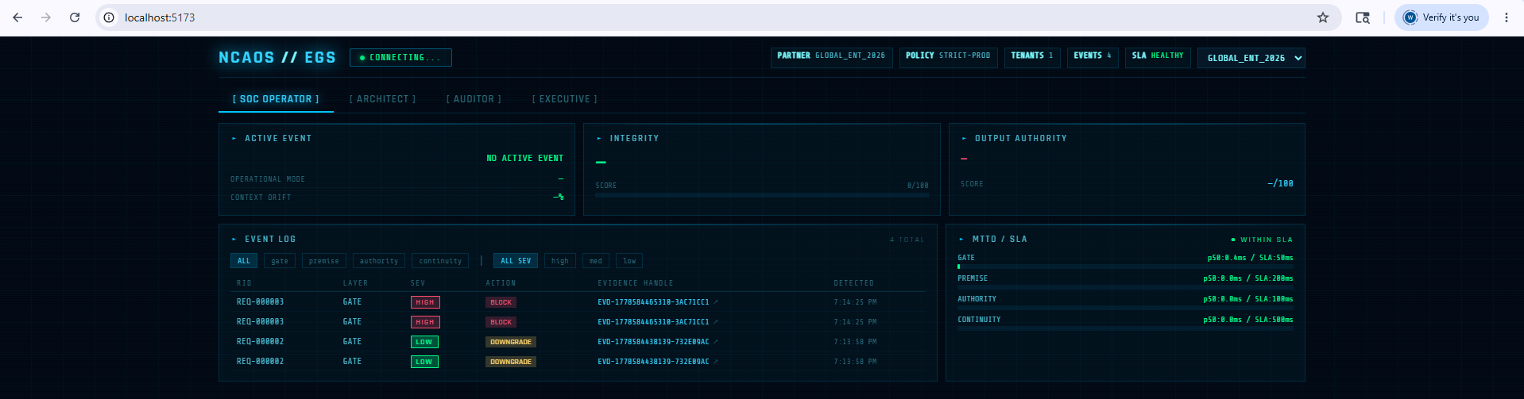

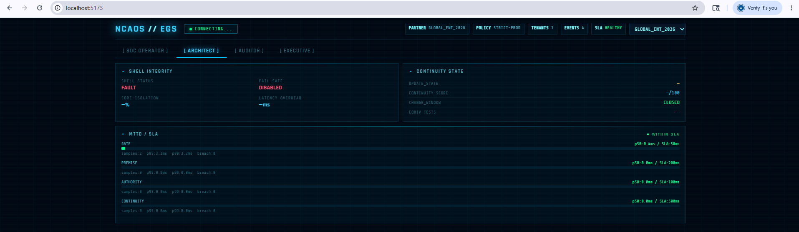
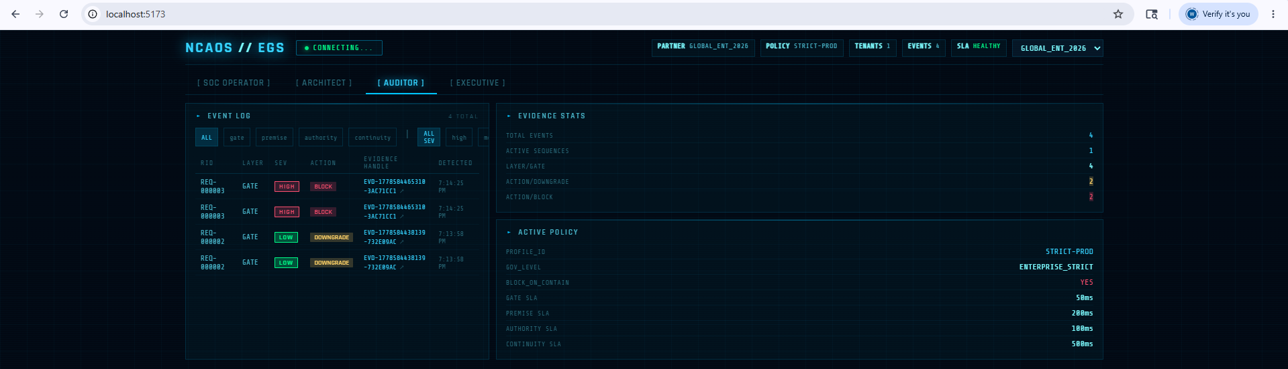
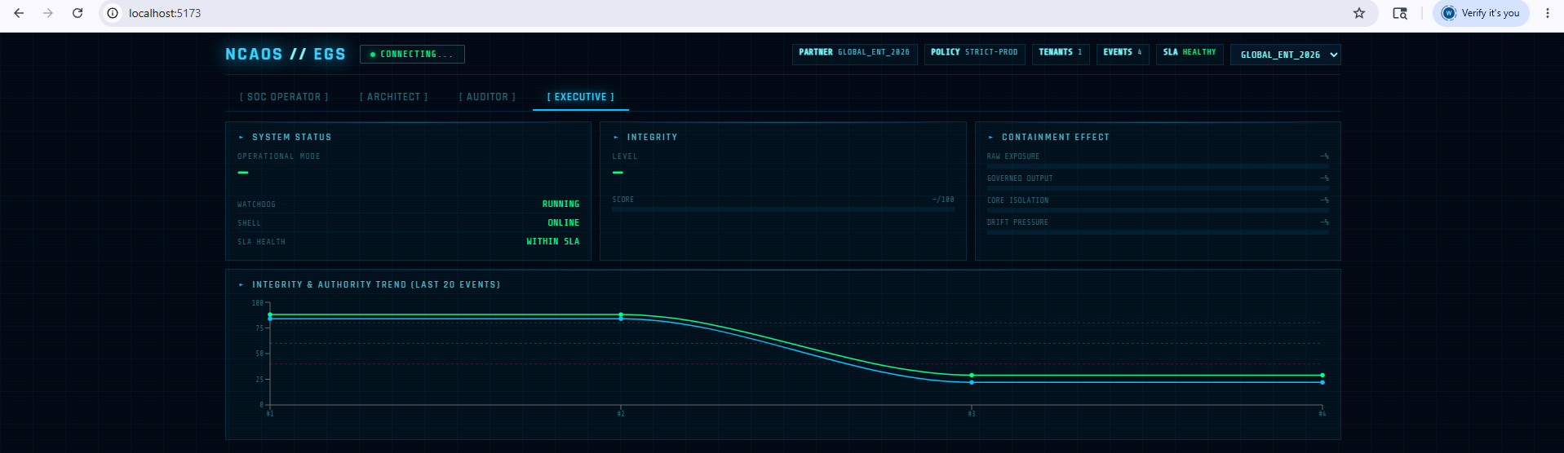

Test UI-04 — Architect View
Click [ ARCHITECT ] tab.

Check | Expected Output / Acceptance Criteria | ✓
Shell Integrity panel | shellIntegrity=OPERATIONAL, failSafeEnabled=ENABLED | ✓
Core Isolation | coreIsolationPct % displayed | ✓
Latency Overhead | latencyOverheadMs displayed | ✓
Continuity panel | updateState, continuityScore, changeWindowActive, equivalenceTests | ✓
MTTD expanded | All 4 layers with p95, p99, sample count, breach count | ✓



Test UI-05 — Auditor View + Sequence Analysis
Click [ AUDITOR ] tab.

Check | Expected Output / Acceptance Criteria | ✓
Event log visible | Full event table with layer/severity filters | ✓
Evidence stats panel | total, activeSequences, byLayer, byAction counts | ✓
Policy panel | profileId=STRICT-PROD, govLevel, mttdSlaMs displayed | ✓
Evidence handle with ↗ | Click EVD-... handle that has sequence indicator | ✓
Sequence panel loads | After clicking, WF-UI-TEST-001 sequence panel appears below | ✓
patternType shown | STABLE / DEGRADING / CONTAINED / VOLATILE badge displayed | ✓
escalationDetected | True if DOWNGRADE→BLOCK in sequence | ✓
consistencyScore | 0–100 score displayed | ✓
Event chain viz | DOWNGRADE→BLOCK chain shown as connected boxes | ✓

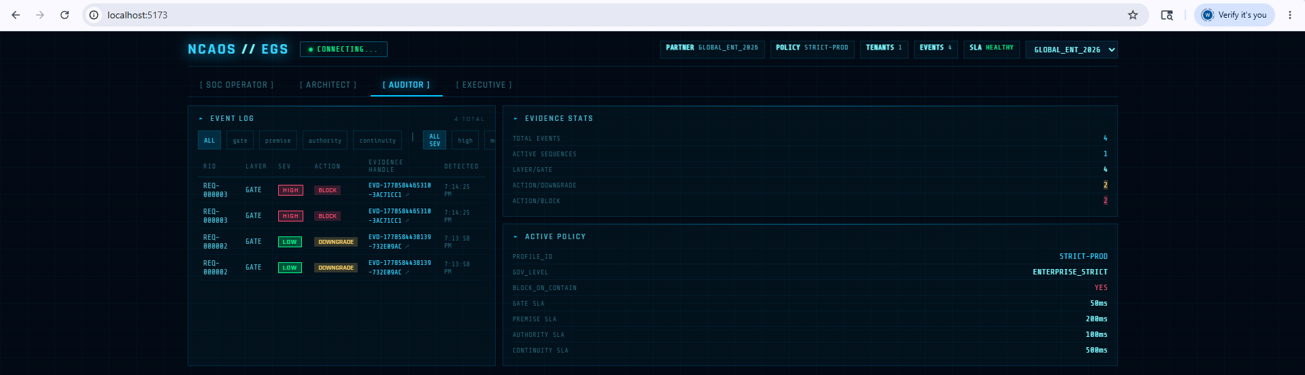

Test UI-06 — Executive View
Click [ EXECUTIVE ] tab.

Check | Expected Output / Acceptance Criteria | ✓
System Status card | operationalMode, watchdog, shell, slaHealthy | ✓
Integrity card | level + score bar (green/amber/red based on threshold) | ✓
Containment Effect | RAW EXPOSURE vs GOVERNED OUTPUT bars visible | ✓
Drift Pressure bar | contextDriftPressurePct shown | ✓
Trend chart | LineChart with integrity + authority over last 20 events | ✓
Chart updates | After sending new requests, chart reflects new data points | ✓

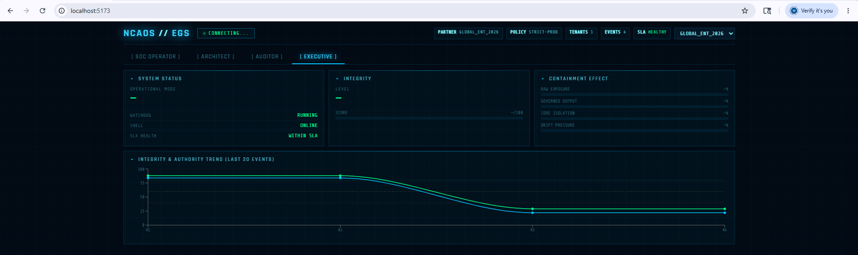

Test UI-07 — Partner Selector (Tenant Isolation in UI)

# Change partner selector dropdown from GLOBAL_ENT_2026 to TEST
# All panels should refresh automatically
# TEST tenant has different (or no) events

Check | Expected Output / Acceptance Criteria | ✓
Partner selector change | Selecting TEST refreshes all queries with X-Partner-ID: TEST | ✓
Event log empty or different | TEST tenant events are isolated from GLOBAL_ENT_2026 | ✓
Health badges update | Policy/SLA reflect TEST tenant state | ✓

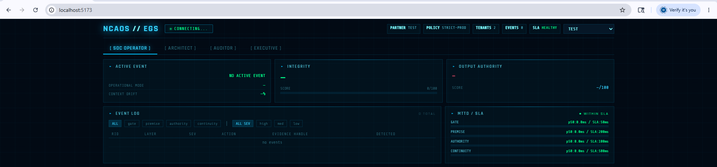

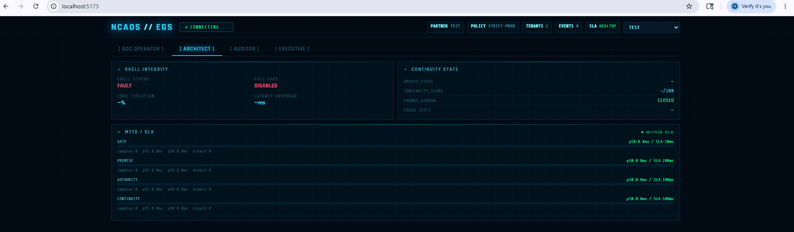

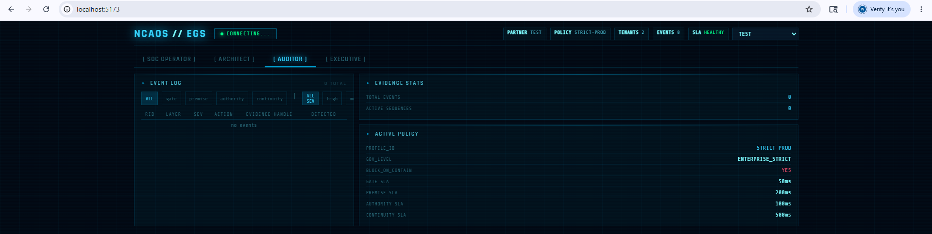

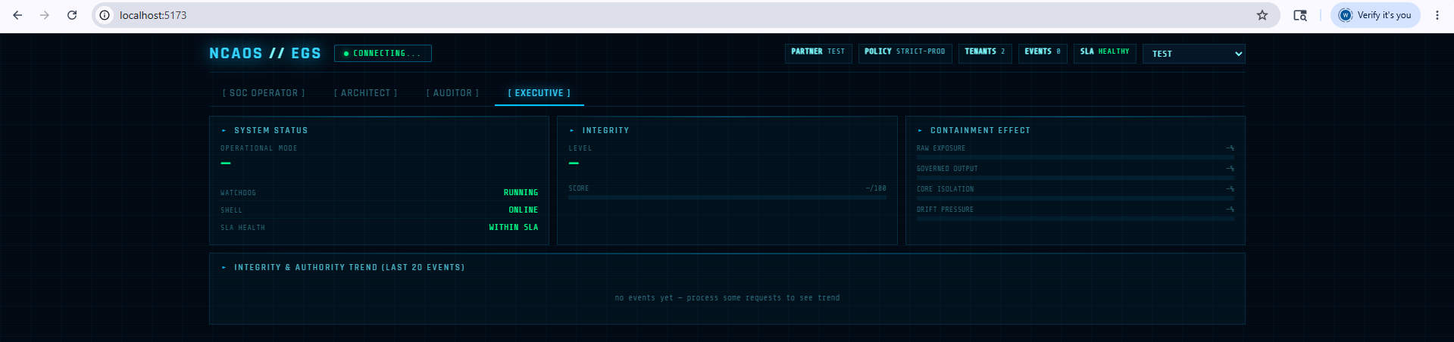

Test UI-08 — WebSocket Live Update

Send another threat request via PowerShell while watching the SOC Operator view:

Invoke-RestMethod -Uri http://localhost:3000/v1/process `
-Method POST -ContentType "application/json" `
-Headers @{"X-Partner-ID"="GLOBAL_ENT_2026"} -Body $threat

Check | Expected Output / Acceptance Criteria | ✓
Status pill updates | System status changes to ENFORCING (STRICT) or CONTAINMENT | ✓
Integrity card updates | Score drops to Critical/29 after BLOCK event | ✓
Authority card updates | Changes to INVALID after high-severity event | ✓
Active event card | Shows EXTERNAL_THREAT_BLOCKED / HIGH | ✓

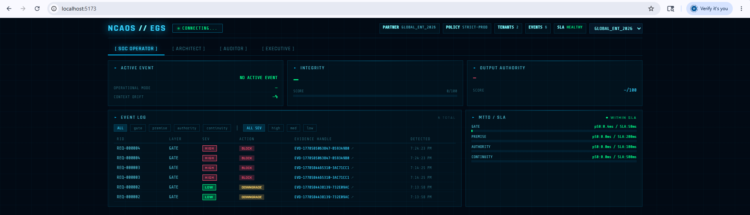
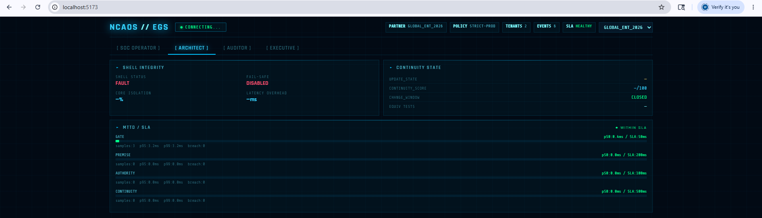
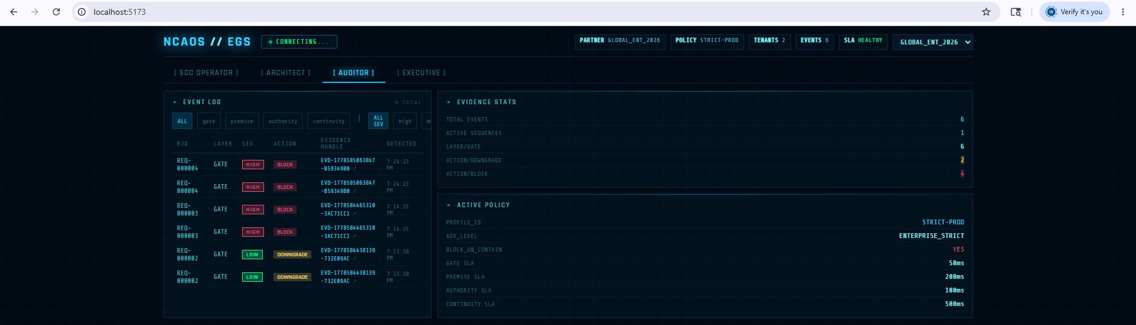

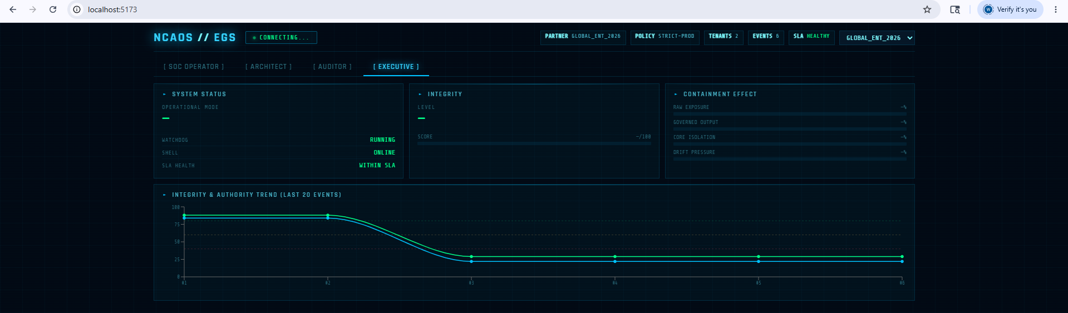

8. AuditSignal Schema Tests

The AuditSignal schema has no automated test file in Phase 05 (Vitest test file is Phase 06 scope). Validate manually using Node.js REPL.

09 | Validate AuditSignal Schema in Node REPL | 10 min

Open a PowerShell window in the egs/ directory:

cd "C:\AI Project\NCAOS-Urielle\egs"
node --input-type=module

# Paste the following (Ctrl+D to exit when done):

import { AuditSignalSchema, fromEventRecord, evidenceLevel,
auditFindingSummary, ISO42001_CONTROL_MAP }
from './audit-signal/src/audit-signal.ts';

// Test 1: Validate core layer
const signal = {
schemaVersion: "1.0",
core: {
evidenceHandle: "EVD-1778168626181-5164BEB0",
sequenceNumber: 2,
layer: "gate",
severity: "high",
action: "BLOCK",
authority: "invalid",
integrityScore: 29,
detectionMode: "Real-time Gate Enforcement",
routingHint: "SOC / Security Queue",
mttdMs: 12.5,
detectedAt: new Date().toISOString(),
storedAt: new Date().toISOString(),
policyProfileId: "STRICT-PROD",
partnerId: "GLOBAL_ENT_2026"
}
};
const parsed = AuditSignalSchema.parse(signal);
console.log("Schema valid:", !!parsed);

// Test 2: evidenceLevel
console.log("Evidence level:", evidenceLevel(parsed));

// Test 3: auditFindingSummary
console.log("Finding:", auditFindingSummary(parsed));

// Test 4: ISO 42001 controls
console.log("ISO controls:", ISO42001_CONTROL_MAP["gate"]);

// Test 5: Invalid schema throws
try { AuditSignalSchema.parse({ bad: "data" }); }
catch(e) { console.log("Validation correctly rejects invalid:", true); }

Check | Expected Output / Acceptance Criteria | ✓
AuditSignalSchema.parse(signal) | Returns parsed object without throwing | ✓
evidenceLevel(parsed) | Returns STRONG / MODERATE / WEAK | ✓
auditFindingSummary(parsed) | Returns human-readable finding string | ✓
ISO42001_CONTROL_MAP["gate"] | Returns array of ISO control IDs | ✓
Invalid schema rejected | ZodError thrown on bad input | ✓

PS D:\Projects\NCAOS-Urielle\egs> node test-signal.mjs
Required fields: true
Valid layer: true
Valid severity: true
Valid action: true
PS D:\Projects\NCAOS-Urielle\egs> import { AuditSignalSchema, fromEventRecord, evidenceLevel,
>> auditFindingSummary, ISO42001_CONTROL_MAP }
At line:1 char:27
+ import { AuditSignalSchema, fromEventRecord, evidenceLevel,
+ ~
Missing argument in parameter list.
+ CategoryInfo : ParserError: (:) [], ParentContainsErrorRecordException
+ FullyQualifiedErrorId : MissingArgument

PS D:\Projects\NCAOS-Urielle\egs> from './audit-signal/src/audit-signal.ts';
At line:1 char:3
+ from './audit-signal/src/audit-signal.ts';
+ ~~~~
The 'from' keyword is not supported in this version of the language.
+ CategoryInfo : ParserError: (:) [], ParentContainsErrorRecordException
+ FullyQualifiedErrorId : ReservedKeywordNotAllowed

PS D:\Projects\NCAOS-Urielle\egs> node test-signal.mjs
(node:152) [MODULE_TYPELESS_PACKAGE_JSON] Warning: Module type of file:///D:/Projects/NCAOS-Urielle/egs/audit-signal/src/audit-signal.ts is not specified and it doesn't parse as CommonJS.
Reparsing as ES module because module syntax was detected. This incurs a performance overhead.
To eliminate this warning, add "type": "module" to D:\Projects\NCAOS-Urielle\egs\package.json.
(Use `node --trace-warnings ...` to show where the warning was created)
Schema valid: true
Evidence level: MODERATE
Finding: Containment event detected at gate layer. Severity: high. Action: BLOCK. Output authority: invalid. Detection latency: 12.5ms (SLA policy: STRICT-PROD).
ISO controls: [ 'ISO42001-6.1.2', 'ISO42001-8.4', 'ISO42001-9.1' ]
Validation correctly rejects invalid: true
PS D:\Projects\NCAOS-Urielle\egs>

Phase 05 AuditSignal Manual Validation
Status: PASS
Validated:
- AuditSignalSchema accepts valid signal
- evidenceLevel() returns MODERATE
- auditFindingSummary() generates audit-ready finding text
- ISO42001_CONTROL_MAP returns mapped controls for gate layer
- invalid schema is rejected correctly
Command:
node test-signal.mjs

Test AS-02 — Sequence Layer Validation

// Add sequence layer to signal
const withSeq = {
...signal,
sequence: {
sequenceId: "WF-UI-TEST-001",
patternType: "CONTAINED",
escalationDetected: true,
consistencyScore: 94,
eventCount: 2,
firstDetectedAt: new Date().toISOString(),
actionChain: ["DOWNGRADE", "BLOCK"],
layersInvolved: ["gate"]
}
};
const parsedSeq = AuditSignalSchema.parse(withSeq);
console.log("Sequence layer valid:", !!parsedSeq.sequence);
console.log("Pattern type:", parsedSeq.sequence?.patternType);
console.log("Evidence level with sequence:",
evidenceLevel(parsedSeq)); // Should be STRONG

Check | Expected Output / Acceptance Criteria | ✓
Sequence layer parses | parsedSeq.sequence is defined | ✓
patternType=CONTAINED | Correct value preserved | ✓
evidenceLevel=STRONG | High severity + BLOCK + escalation → STRONG | ✓

PS D:\Projects\NCAOS-Urielle\egs> node test-signal.mjs
(node:10404) [MODULE_TYPELESS_PACKAGE_JSON] Warning: Module type of file:///D:/Projects/NCAOS-Urielle/egs/audit-signal/src/audit-signal.ts is not specified and it doesn't parse as CommonJS.
Reparsing as ES module because module syntax was detected. This incurs a performance overhead.
To eliminate this warning, add "type": "module" to D:\Projects\NCAOS-Urielle\egs\package.json.
(Use `node --trace-warnings ...` to show where the warning was created)
Schema valid: true
Evidence level: MODERATE
Finding: Containment event detected at gate layer. Severity: high. Action: BLOCK. Output authority: invalid. Detection latency: 12.5ms (SLA policy: STRICT-PROD).
ISO controls: [ 'ISO42001-6.1.2', 'ISO42001-8.4', 'ISO42001-9.1' ]
Validation correctly rejects invalid: true
Sequence layer valid: true
Pattern type: CONTAINED
Evidence level with sequence: STRONG

Phase 05 AuditSignal Manual Validation — PASS
Result:
- Base signal schema parsed successfully
- Invalid schema rejected correctly
- ISO 42001 control mapping returned for gate layer
- Base containment evidence classified as MODERATE
- Sequence-enriched evidence classified as STRONG
Command:
node test-signal.mjs

Test AS-03 — Enrichment Layer Validation

// Add optional enrichment
const withEnrich = {
...withSeq,
enrichment: {
identityRef: "user-ref-abc123",
assetRef: "asset-ref-xyz789",
sessionId: "sess-001",
serviceComponent: "AuthService",
tags: { env: "production", team: "security" }
}
};
const parsedEnrich = AuditSignalSchema.parse(withEnrich);
console.log("Enrichment valid:", !!parsedEnrich.enrichment);
console.log("All three layers present:",
!!parsedEnrich.core && !!parsedEnrich.sequence && !!parsedEnrich.enrichment);

Check | Expected Output / Acceptance Criteria | ✓
Enrichment layer parses | parsedEnrich.enrichment is defined | ✓
All three layers present | core + sequence + enrichment all populated | ✓
Signal without enrichment also valid | Enrichment is optional — core-only signal passes | ✓

PS D:\Projects\NCAOS-Urielle\egs> node test-signal.mjs
(node:17440) [MODULE_TYPELESS_PACKAGE_JSON] Warning: Module type of file:///D:/Projects/NCAOS-Urielle/egs/audit-signal/src/audit-signal.ts is not specified and it doesn't parse as CommonJS.
Reparsing as ES module because module syntax was detected. This incurs a performance overhead.
To eliminate this warning, add "type": "module" to D:\Projects\NCAOS-Urielle\egs\package.json.
(Use `node --trace-warnings ...` to show where the warning was created)
Schema valid: true
Evidence level: MODERATE
Finding: Containment event detected at gate layer. Severity: high. Action: BLOCK. Output authority: invalid. Detection latency: 12.5ms (SLA policy: STRICT-PROD).
ISO controls: [ 'ISO42001-6.1.2', 'ISO42001-8.4', 'ISO42001-9.1' ]
Validation correctly rejects invalid: true
Sequence layer valid: true
Pattern type: CONTAINED
Evidence level with sequence: STRONG
Enrichment valid: true
All three layers present: true

Phase 05 AuditSignal Manual Validation — PASS
Confirmed:
- Base schema accepted valid core signal
- Invalid schema rejected
- ISO 42001 mapping returned
- Base signal evidence level: MODERATE
- Sequence-enriched signal evidence level: STRONG
- Optional enrichment accepted
- Full layered AuditSignal object valid: core + sequence + enrichment

9. Commit and Push

10 | Commit Phase 05 to GitHub | 3 min

cd "C:\AI Project\NCAOS-Urielle"
git add -A
git status
# Verify: egs/ui/, egs/audit-signal/, ADR-006 staged

git commit -m "feat: Phase 05 complete — React Admin Terminal + AuditSignal schema"
git push origin main

# Tag the release
git tag -a v0.5.0 -m "Phase 05 — Admin UI + Toru-William AuditSignal interface"
git push origin v0.5.0

Check | Expected Output / Acceptance Criteria | ✓
git status | egs/ui/ + egs/audit-signal/ + ADR-006 staged | ☐
git commit | Commit succeeds | ☐
git push origin main | Pushed to remote | ☐
git tag v0.5.0 | Tag created and pushed | ☐

10. Toru-William Alignment Verification

These checks confirm that Phase 05 delivers the "minimum viable signal layer" and "interface definition exercise" Toru and William agreed on after Phase 03.

Concept | Verification | ✓
Minimum viable signal layer | AuditSignalCore has exactly 14 fields — the irreducible minimum for meaningful governance evidence | ☐
Sequence-level interpretation | AuditSignalSequence.patternType produces CONTAINED for DOWNGRADE→BLOCK sequences | ☐
Consistency of enforcement | AuditSignalSequence.consistencyScore (0–100) computed from action rank variance | ☐
Escalation patterns | AuditSignalSequence.escalationDetected: true when PASS→DOWNGRADE→BLOCK rank increases | ☐
Boundary strictly intact | AuditSignal contains only boundary signals — no internal model state or root-cause claims | ☐
Schema versioned | schemaVersion: "1.0" enables Urielle to handle future schema evolution | ☐
ISO 42001 mapped | ISO42001_CONTROL_MAP links each layer to relevant control IDs | ☐
ADR-006 written | Formal architectural decision record for Urielle interface contract | ☐

11. Troubleshooting

Problem | Fix
npm run dev fails: Cannot find module 'react' | Run npm install from egs/ root first. React must be installed in the workspace.
UI shows blank page / white screen | Check browser console for errors. Most common: CORS error if API not running. Ensure npm start is running in api/ first.
WS DISCONNECTED badge visible | API server is not running or WebSocket endpoint is unreachable. Check http://localhost:3000/v1/health first.
Event log shows 'no events' | No events have been processed yet. Send requests via PowerShell (Test UI-03) to generate events.
Sequence panel doesn't appear | The evidence handle must have a sequenceId (workflowId was provided). Send requests with workflowId='WF-UI-TEST-001'.
Trend chart shows 'no events yet' | Chart requires at least one event. Process a request via PowerShell then wait ~10s for auto-refresh.
AuditSignalSchema import fails in Node REPL | TypeScript source cannot be imported directly by node. Use tsx or compile first: npx tsx audit-signal/src/audit-signal.ts
Partner selector shows GLOBAL_ENT_2026 but API uses TEST | The API defaults to GLOBAL_ENT_2026. Change the selector to TEST and re-send requests with X-Partner-ID: TEST.
Port 5173 already in use | Another Vite instance is running. Close it (Ctrl+C) or change the port in ui/vite.config.ts.
git push rejected (non-fast-forward) | Run: git pull origin main --rebase then git push origin main

12. Final Completion Checklist

Check | Expected Output / Acceptance Criteria | ✓
Prerequisites met | Phase 04 complete, 181 tests passing | ☐
Archive extracted | ui/, audit-signal/, ADR-006 all in place | ☐
package.json updated | ui and audit-signal in workspaces array | ☐
npm install | No fatal errors | ☐
Phase 01–04 regression | 181 tests still passing | ☐
API server running | http://localhost:3000/v1/health returns 200 | ☐
UI server running | http://localhost:5173 loads in browser | ☐
UI-01 Topbar | NCAOS logo, status pill, health badges, WS connected | ☐
UI-02 SOC view | Event log, integrity, authority, MTTD panels visible | ☐
UI-03 Events generated | Clean + threat requests sent, events appear in log | ☐
UI-04 Architect view | Shell integrity, continuity state, expanded MTTD | ☐
UI-05 Auditor view + Sequence | Sequence panel loads on evidence handle click | ☐
UI-06 Executive view | RAW vs GOVERNED bars, trend chart with data | ☐
UI-07 Partner selector | TEST tenant isolated from GLOBAL_ENT_2026 | ☐
UI-08 WebSocket live update | Status pill + cards update on new threat request | ☐
AS-01 Schema validates | AuditSignalSchema.parse() succeeds for valid signal | ☐
AS-02 Sequence layer | CONTAINED pattern with escalationDetected=true | ☐
AS-03 Enrichment layer | All three layers populate correctly | ☐
AS ISO42001 | ISO42001_CONTROL_MAP returns correct control IDs | ☐
Git commit + push | feat: Phase 05 complete committed to main | ☐
Git tag v0.5.0 | Tag pushed to origin | ☐

