NCAOS / EGS
Phase 07 — Test Plan
Stakeholder Demo · Commercial Pilot Proposal · v1.0-rc Tag
Week 12–14 · EGS Complete — Phases 01–07

Document | Phase 07 — Step-by-Step Test Plan
Version | v1.0-rc
Date | 2026-05-16
Prerequisite | Phase 06 complete — 229+ tests passing, UI verified
Phase 06 results | 229 automated + 11 pen tests | 6 PASS, 1 PARTIAL, 4 DEFERRED
New deliverables | Demo scenario (6 steps) + Pilot proposal + ADR-008
Audiences | Executive, Architect, Legal/Compliance, Toru
Est. total time | ~45 minutes (demo 20 min + commit/tag 5 min + docs 20 min)

⚠ Classification: Non-Public / Concept Demonstration Artifact. Do not share outside authorized personnel.

1. Phase 06 Results (Completed — 2026-05-15)
Phase 06 delivered the full hardening and compliance layer. Results from the Phase 06 test report are summarised here as the baseline for Phase 07.

Package | Phase | Tests | Fix | Status | Notes
@ncaos/core | Phase 01 | 47 | — | PASS | No regressions
@ncaos/shell | Phase 02 | 15 | — | PASS | No regressions
@ncaos/api | Ph 02→04 | 65 | — | PASS | No regressions
@ncaos/detection | Phase 03 | 54 | — | PASS | No regressions
@ncaos/ui | Phase 05 | — | — | PASS | Manual — no automated
@ncaos/hardening | Phase 06 | 48 | F-01 | PASS | aiml-threat-model.ts fix
CUMULATIVE | 01–06 | 229 | — | ALL PASS | + 11 pen tests

Phase 06 Pen Test Summary
PT ID | Title | Sev | Result | Evidence
PT-001 | Tenant Spoofing via X-Partner-ID Header Forgery | HIGH | PASS | 404 isolation enforced
PT-002 | Trusted Source ID Spoofing to Bypass Allowlist | MED | NOTED | Deferred Phase 07
PT-003 | WebSocket Stream Without Authentication | MED | DEFERRED | S-003 Phase 07
PT-004 | Unauthorized Policy Update to Weaken Governance | HIGH | PASS | 400 INVALID_POLICY
PT-005 | Evidence Handle Manipulation | MED | PASS | 404 confirmed in PT-001
PT-006 | Prompt Injection via sourceId / inputFlags | HIGH | DEFERRED | T-003 Phase 07
PT-007 | DoS via /v1/process Flooding | HIGH | PARTIAL | Unit: PASS. Manual: loop too slow
PT-008 | Authority Escalation via overrideAttempted | HIGH | PASS | BLOCK + authority=invalid
PT-009 | Error Response Information Leakage | MED | DEFERRED | I-001 Phase 07
PT-010 | CORS Misconfiguration | LOW | DEFERRED | I-003 Phase 07
PT-CHAOS-001 | Shell Kill → FAIL_SAFE | HIGH | PASS | 503 during restart window

MTTD SLA Baseline (Phase 07 Performance Contract)
Layer | SLA (p99) | p50 | p95 | p99 | Breach Rate
gate | ≤ 50ms | 0.00ms | 0.01ms | 0.03ms | 0.00%
premise | ≤ 200ms | 0.00ms | 0.01ms | 0.05ms | 0.00%
authority | ≤ 100ms | 0.01ms | 0.01ms | 0.03ms | 0.00%
continuity | ≤ 500ms | 0.00ms | 0.01ms | 0.05ms | 0.00%

Phase 07 contract: Any future p99 exceeding these baselines by >10% must be investigated before v1.0 production release.

2. What Phase 07 Delivers
Phase 07 is a demonstration and handoff phase — no new API routes, no new automated tests. It proves the system works end-to-end for four stakeholder audiences.

File | Action | Purpose
demo/demo-scenario.ts | ADD | 6-step live containment demo — 4 stakeholder audiences, scripted commands
pilot/pilot-proposal.ts | ADD | 3-tier commercial pilot structure + v1.0 roadmap (MUST/SHOULD/NICE)
docs/adr/ADR-008-v1-roadmap.md | ADD | ADR: v1.0-rc scope, 4 deferred items, production readiness criteria
Git tag v1.0-rc | TAG | Marks EGS as complete and demonstrable — Phases 01–07

3. Prerequisites

Check | Expected Output / Acceptance Criteria | ✓
Phase 06 complete | 229+ automated + 11 pen tests — results in Phase 06 test report | ☐
API server accessible | http://localhost:3000/v1/health returns 200 | ☐
UI accessible | http://localhost:5173 loads NCAOS // EGS Admin Terminal | ☐
ncaos-phase07.tar.gz downloaded | From Claude conversation | ☐
git status | On branch main, up to date with origin/main | ☐

4. Installation Steps

01 | Extract Phase 07 Archive | 3 min

cd "D:\Projects\NCAOS-Urielle"

tar -xzf ncaos-phase07.tar.gz

# Copy demo and pilot files
Copy-Item -Recurse phase07\demo egs\demo
Copy-Item -Recurse phase07\pilot egs\pilot
Copy-Item phase07\docs\adr\ADR-008-v1-roadmap.md egs\docs\adr\

Remove-Item -Recurse phase07
Remove-Item ncaos-phase07.tar.gz

02 | Verify All Services Running | 3 min

# Terminal 1 — API (if not already running)
cd "D:\Projects\NCAOS-Urielle\egs\api"
npm start

# Terminal 2 — UI (if not already running)
cd "D:\Projects\NCAOS-Urielle\egs\ui"
npm run dev

# Terminal 3 — verify
Invoke-RestMethod -Uri http://localhost:3000/v1/health `
-Headers @{"X-Partner-ID"="DEMO_ENT_2026"}
# Expected: status=OK, slaHealthy=True

Check | Expected Output / Acceptance Criteria | ✓
http://localhost:3000/v1/health | status=OK, watchdog=RUNNING, slaHealthy=True | ✓
http://localhost:5173 | NCAOS // EGS Admin Terminal loads in browser | ✓

PS C:\AI Project\NCAOS-Urielle\egs\ui> Set-ExecutionPolicy -Scope Process -ExecutionPolicy Bypass
PS C:\AI Project\NCAOS-Urielle\egs\ui> npm run dev

> @ncaos/ui@0.5.0 dev
> vite

[vite:react-babel] We recommend switching to `@vitejs/plugin-react-oxc` for improved performance. More information at https://vite.dev/rolldown
Re-optimizing dependencies because lockfile has changed

VITE v5.4.21 ready in 1146 ms

➜ Local: http://localhost:5173/
➜ Network: use --host to expose
➜ press h + enter to show help

PS C:\Users\930140> cd\
PS C:\> cd "AI Project"
PS C:\AI Project> cd NCAOS-Urielle
PS C:\AI Project\NCAOS-Urielle> Invoke-RestMethod -Uri http://localhost:3000/v1/health `
>> -Headers @{"X-Partner-ID"="DEMO_ENT_2026"}

status : OK
watchdog : RUNNING
shell : True
policy : STRICT-PROD
slaHealthy : True
activeTenants : 1
totalEvents : 0
timestamp : 5/19/2026 8:54:03 AM

5. Stakeholder Demo — Live Containment Scenario
Execute the 6-step demo in sequence. All commands use X-Partner-ID: DEMO_ENT_2026 for a clean event log.

Demo tip: Open the Admin Terminal (http://localhost:5173) on screen while running commands. Switch to [ EXECUTIVE ] view for the visual impact — the integrity score drops and BLOCK badge appears in real time.

03 | D-01 — Baseline: Shell Operational | 2 min

Audience: All stakeholders
Narrative: "Before we see any threats, let me show you the governance shell is online and monitoring the AI/OS boundary."

Invoke-RestMethod -Uri http://localhost:3000/v1/health `
-Headers @{"X-Partner-ID"="DEMO_ENT_2026"}

Check | Expected Output / Acceptance Criteria | ✓
status=OK | Shell is operational | ✓
watchdog=RUNNING | Process isolation active (ADR-003) | ✓
slaHealthy=True | All 4 detection layers within MTTD SLA | ✓
policy=STRICT-PROD | ENTERPRISE_STRICT enforcement active | ✓

Governance point: "The EGS is already observing the boundary. The protected AI system is isolated — the shell has no access to internal model weights or OS kernel state."

PS C:\AI Project\NCAOS-Urielle> Invoke-RestMethod -Uri http://localhost:3000/v1/health `
>> -Headers @{"X-Partner-ID"="DEMO_ENT_2026"}

status : OK
watchdog : RUNNING
shell : True
policy : STRICT-PROD
slaHealthy : True
activeTenants : 2
totalEvents : 0
timestamp : 5/19/2026 8:57:27 AM

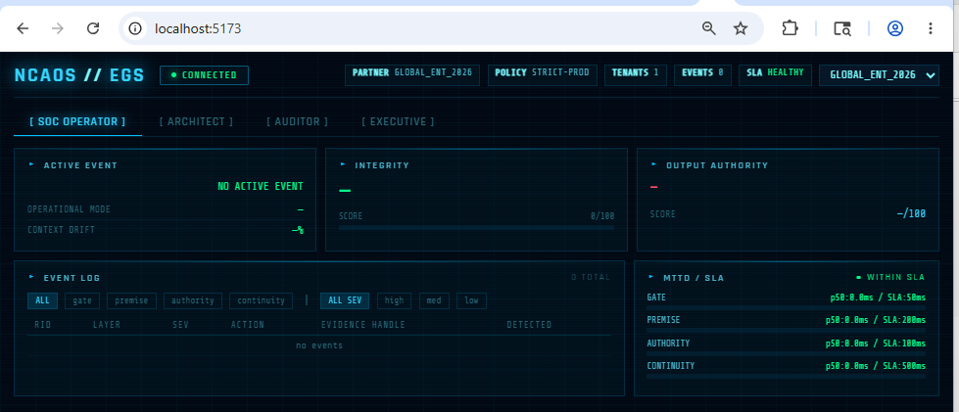

04 | D-02 — Normal Request: PASS with Authority | 3 min

Audience: Executive, Architect
Narrative: "A legitimate enterprise request passes through governance. All premises validated, no threats detected."

$clean = @{
sourceId="enterprise-svc-001"; inputHash="sha256-clean-abc"
inputFlags=@(); claimedPremises=@("AUTH","SCOPE","ENV")
validatedPremises=@("AUTH","SCOPE","ENV")
contractVersion="1.0"; requestedAuthority="decision-ready"
policyGrantedAuthority="decision-ready"; overrideAttempted=$false
workflowId="WF-DEMO-LIVE-001"
} | ConvertTo-Json

Invoke-RestMethod -Uri http://localhost:3000/v1/process `
-Method POST -ContentType "application/json" `
-Headers @{"X-Partner-ID"="DEMO_ENT_2026"} -Body $clean

Check | Expected Output / Acceptance Criteria | ✓
action=PASS or DOWNGRADE | Clean request processed normally | ✓
integrity.level=Available | System integrity confirmed | ✓
authority=decision-ready | Full output authority granted | ✓
evidenceHandle=EVD-... | Audit trail entry created even for clean requests | ✓

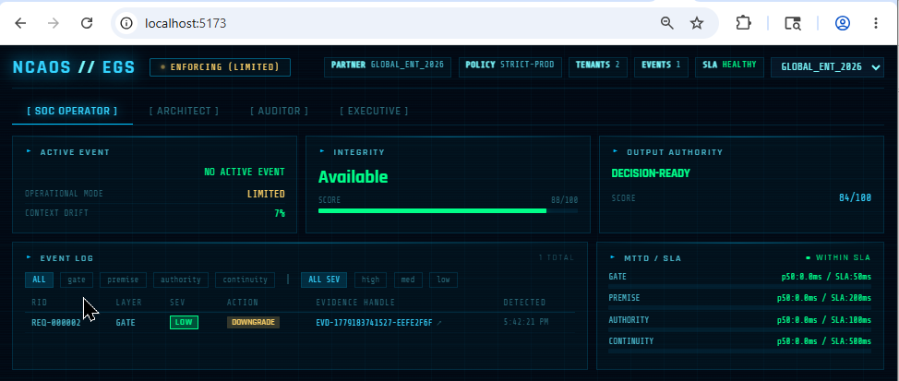

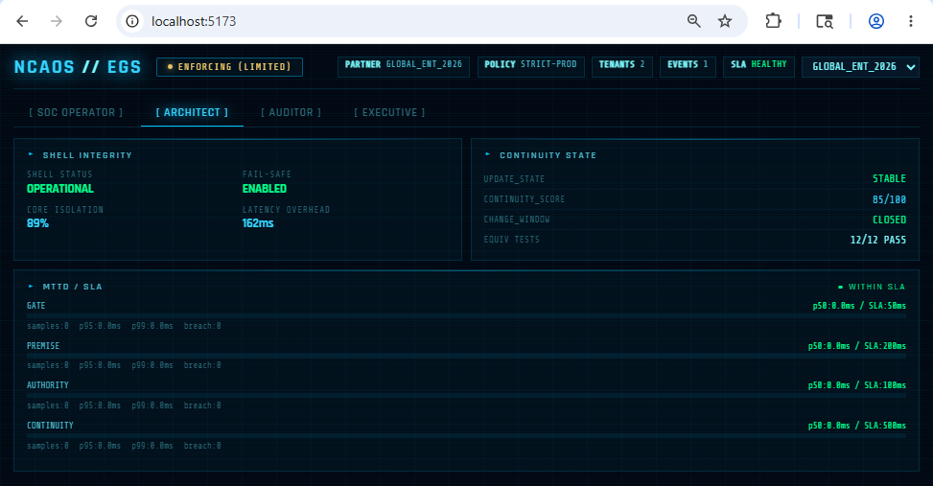

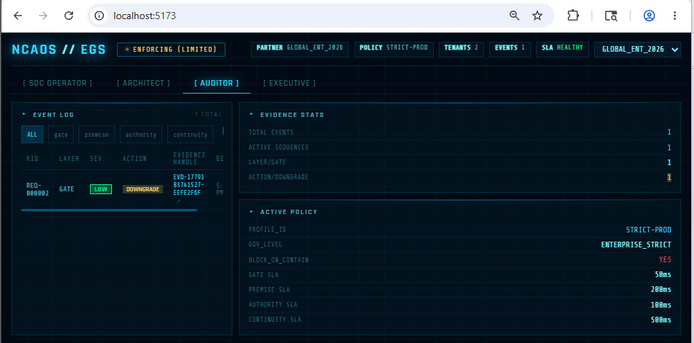

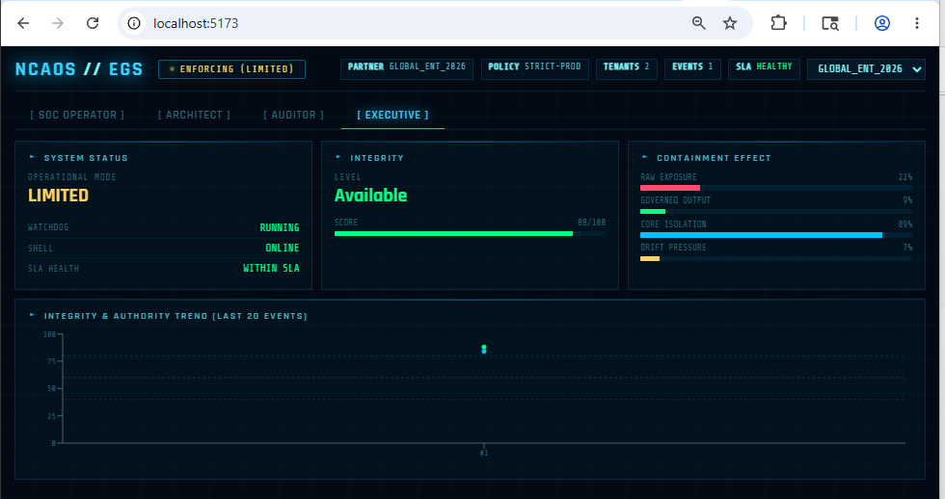

05 | D-03 — Threat Detected: BLOCK with Evidence | 5 min

Audience: All stakeholders — this is the core demonstration
Narrative: "Now I'll send an attack. The shell detects it at the gate layer and blocks it — without touching the protected AI system."

$threat = @{
sourceId="external-attacker-2026"; inputHash="sha256-injected"
inputFlags=@("INJECTION_PATTERN","SIGNATURE_INVALID")
claimedPremises=@("AUTH","SCOPE","ADMIN")
validatedPremises=@("AUTH")
contractVersion="1.0"; requestedAuthority="decision-ready"
policyGrantedAuthority="reference-only"; overrideAttempted=$false
workflowId="WF-DEMO-LIVE-001"
} | ConvertTo-Json

$result = Invoke-RestMethod -Uri http://localhost:3000/v1/process `
-Method POST -ContentType "application/json" `
-Headers @{"X-Partner-ID"="DEMO_ENT_2026"} -Body $threat
$result
$handle = $result.evidenceHandle
Write-Host "Evidence handle: $handle"

Check | Expected Output / Acceptance Criteria | ✓
action=BLOCK | Threat blocked at boundary | ☐
authority=invalid | No output authority granted to attacker | ☐
integrity.level=Critical, score=29 | Integrity severely degraded | ☐
routing.hint=SOC / Security Queue | Triage routing active | ☐
evidenceHandle=EVD-... | Forensic evidence created — save $handle | ☐

Governance point for Executive: "Continuation is no longer a default risk. The AI system's output was contained at the boundary. External consumers received nothing from this request."
Governance point for Legal: "The evidence handle is a forensic reference independent of the AI system's own logs. If the AI's logs are compromised, the EGS audit trail remains intact."

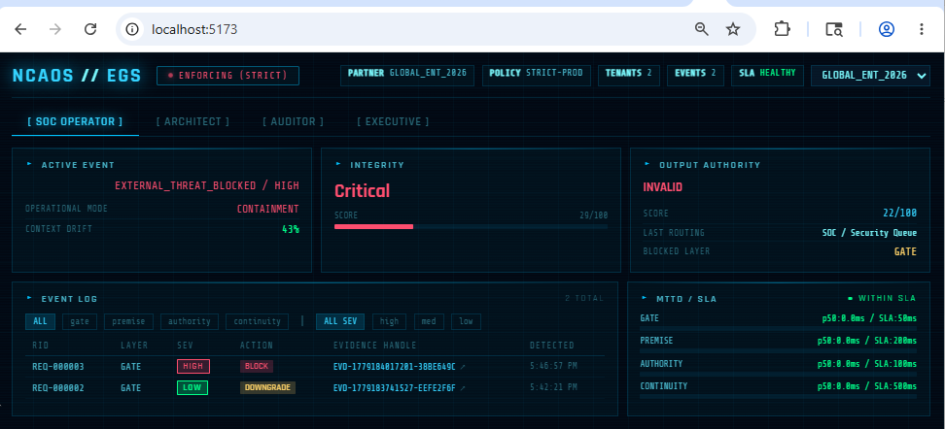

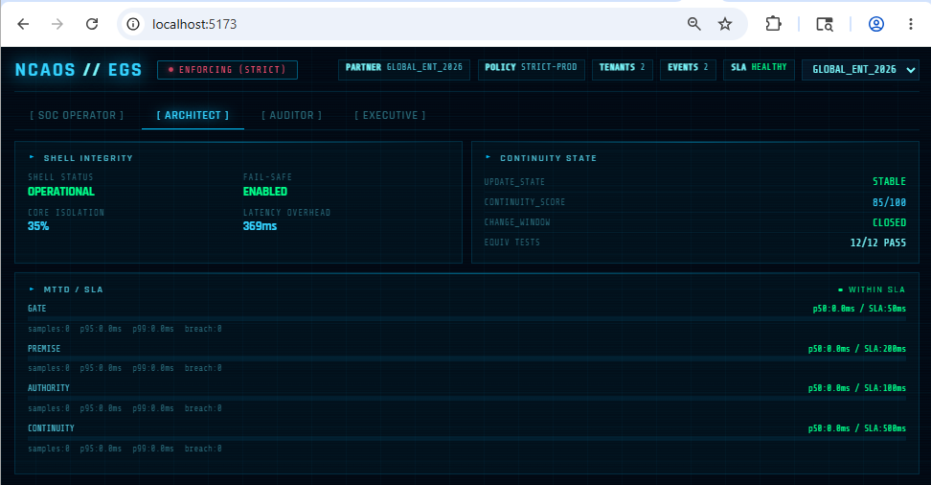

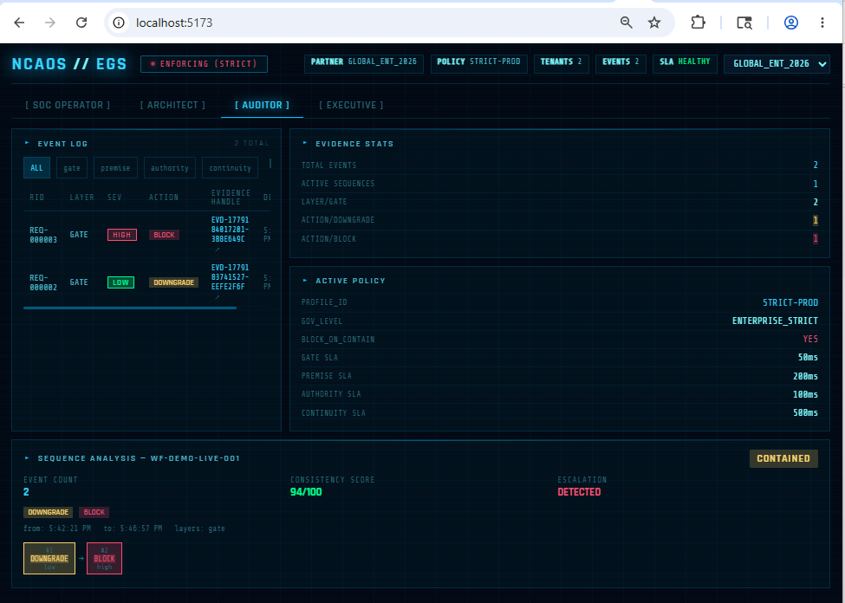

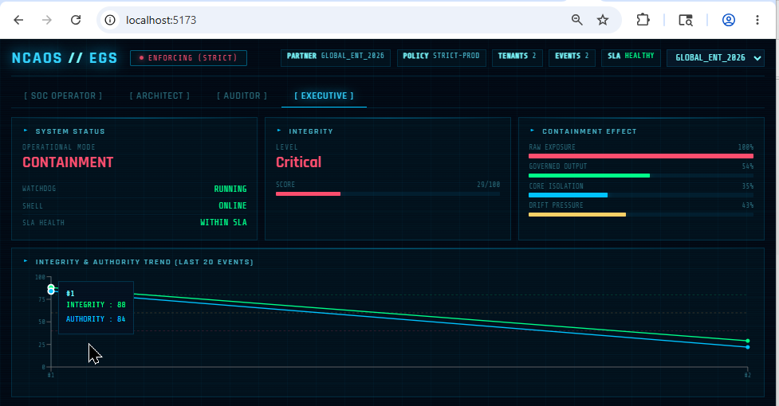

06 | D-04 — Sequence Analysis: Behavioral Pattern | 3 min

Audience: Legal/Compliance, Toru, Architect
Narrative: "The sequence interface shows the complete escalation pattern from this workflow — not just individual events, but behavioral evidence."

# Full event chain
Invoke-RestMethod `
-Uri "http://localhost:3000/v1/events/sequence/WF-DEMO-LIVE-001" `
-Headers @{"X-Partner-ID"="DEMO_ENT_2026"}

# Behavioral pattern summary (Toru-William interface)
Invoke-RestMethod `
-Uri "http://localhost:3000/v1/events/sequence/WF-DEMO-LIVE-001/summary" `
-Headers @{"X-Partner-ID"="DEMO_ENT_2026"}

Check | Expected Output / Acceptance Criteria | ✓
sequenceId=WF-DEMO-LIVE-001 | Workflow correctly grouped | ☐
patternType=CONTAINED | Escalation detected and terminated | ☐
escalationDetected=True | PASS→BLOCK pattern documented | ☐
consistencyScore≥80 | Enforcement was consistent | ☐
eventCount≥2 | Full chain visible | ☐

Governance point for Toru: "This is the minimum viable signal layer — patternType, consistencyScore, and escalationDetected are derived entirely from boundary signals. Urielle can generate audit findings from this without internal visibility."

PS C:\AI Project\NCAOS-Urielle\egs> $body1 = @{
>> sourceId = "demo-agent"
>> inputHash = "HASH-001"
>> workflowId = "WF-DEMO-LIVE-001"
>> overrideAttempted = $false
>> continuityScore = 94
>> } | ConvertTo-Json
PS C:\AI Project\NCAOS-Urielle\egs>
PS C:\AI Project\NCAOS-Urielle\egs> Invoke-RestMethod `
>> -Uri "http://localhost:3000/v1/process" `
>> -Method POST `
>> -ContentType "application/json" `
>> -Headers @{"X-Partner-ID"="DEMO_ENT_2026"} `
>> -Body $body1

requestId : REQ-000002
action : DOWNGRADE
authority : reference-only
integrity : @{level=Available; score=88}
routing : @{hint=SOC / Security Queue; recommendedAction=Isolate inputs; validate perimeter;
rotate credentials if needed.}
evidenceHandle : EVD-1779185776973-8D24C988
processingMs : 0

PS C:\AI Project\NCAOS-Urielle\egs> $body2 = @{
>> sourceId = "demo-agent"
>> inputHash = "HASH-002"
>> workflowId = "WF-DEMO-LIVE-001"
>> overrideAttempted = $true
>> continuityScore = 40
>> } | ConvertTo-Json
PS C:\AI Project\NCAOS-Urielle\egs>
PS C:\AI Project\NCAOS-Urielle\egs> Invoke-RestMethod `
>> -Uri "http://localhost:3000/v1/process" `
>> -Method POST `
>> -ContentType "application/json" `
>> -Headers @{"X-Partner-ID"="DEMO_ENT_2026"} `
>> -Body $body2

requestId : REQ-000003
action : BLOCK
authority : invalid
integrity : @{level=Critical; score=29}
routing : @{hint=Governance / Policy Review; recommendedAction=Check policy profile; confirm
stop-right boundaries.}
evidenceHandle : EVD-1779185789352-BF52C998
processingMs : 0

PS C:\AI Project\NCAOS-Urielle\egs> Invoke-RestMethod `
>> -Uri "http://localhost:3000/v1/events/sequence/WF-DEMO-LIVE-001" `
>> -Headers @{"X-Partner-ID"="DEMO_ENT_2026"}

sequenceId records
---------- -------
WF-DEMO-LIVE-001 {@{evidenceHandle=EVD-1779185776973-8D24C988; partnerId=DEMO_ENT_2026; event=; verdict…

PS C:\AI Project\NCAOS-Urielle\egs>
PS C:\AI Project\NCAOS-Urielle\egs> Invoke-RestMethod `
>> -Uri "http://localhost:3000/v1/events/sequence/WF-DEMO-LIVE-001/summary" `
>> -Headers @{"X-Partner-ID"="DEMO_ENT_2026"}

sequenceId : WF-DEMO-LIVE-001
partnerId : DEMO_ENT_2026
eventCount : 2
firstDetectedAt : 5/19/2026 10:16:16 AM
lastDetectedAt : 5/19/2026 10:16:29 AM
layers : {gate, authority}
severities : {low, high}
actions : {DOWNGRADE, BLOCK}
escalationDetected : True
consistencyScore : 94
patternType : CONTAINED

07 | D-05 — Audit Trail: Evidence Retrieval | 3 min

Audience: Legal/Compliance
Narrative: "A compliance auditor can retrieve the full evidence record for any containment event using the evidence handle."

Invoke-RestMethod `
-Uri "http://localhost:3000/v1/audit/$handle" `
-Headers @{"X-Partner-ID"="DEMO_ENT_2026"}

Check | Expected Output / Acceptance Criteria | ✓
evidenceHandle matches | Correct event retrieved | ✓
event.layer=gate | Containment layer identified | ✓
event.severity=high | Impact level documented | ✓
event.detectionMode=Real-time Gate Enforcement | Detection mechanism labelled | ✓
event.routing.hint=SOC / Security Queue | Triage routing documented | ✓
event.mttdMs > 0 | Detection latency recorded | ✓
sequenceNumber > 0 | Position in audit log confirmed | ✓

PS C:\AI Project\NCAOS-Urielle\egs> $event = Invoke-RestMethod `
>> -Uri "http://localhost:3000/v1/audit/$handle" `
>> -Headers @{"X-Partner-ID"="DEMO_ENT_2026"}
PS C:\AI Project\NCAOS-Urielle\egs>
PS C:\AI Project\NCAOS-Urielle\egs> $event | ConvertTo-Json -Depth 10
{
"evidenceHandle": "EVD-1779185789352-BF52C998",
"event": {
"requestId": "REQ-000003",
"evidenceHandle": "EVD-1779185789352-BF52C998",
"workflowId": "WF-DEMO-LIVE-001",
"tenant": {
"partnerId": "GLOBAL_ENT_2026",
"instanceId": "EGS_INST_001",
"deployment": "ENTERPRISE"
},
"type": "AUTHORITY_REVOKED",
"layer": "authority",
"scope": "sys",
"severity": "high",
"detectionMode": "Authority Boundary Enforcement",
"integrity": {
"level": "Critical",
"score": 29
},
"authority": {
"authority": "invalid",
"score": 22
},
"routing": {
"hint": "Governance / Policy Review",
"recommendedAction": "Check policy profile; confirm stop-right boundaries."
},
"detectedAt": "2026-05-19T10:16:29.352Z",
"mttdMs": 0
},
"verdict": {
"requestId": "REQ-000003",
"action": "BLOCK",
"authority": "invalid",
"integrity": {
"level": "Critical",
"score": 29
},
"routing": {
"hint": "Governance / Policy Review",
"recommendedAction": "Check policy profile; confirm stop-right boundaries."
},
"policyProfileId": "STRICT-PROD",
"enforcedAt": "2026-05-19T10:16:29.352Z",
"processingMs": 0
},
"storedAt": "2026-05-19T10:16:29.352Z",
"sequenceNumber": 2
}
PS C:\AI Project\NCAOS-Urielle\egs>

PS C:\AI Project\NCAOS-Urielle\egs> $seq = Invoke-RestMethod `
>> -Uri "http://localhost:3000/v1/events/sequence/WF-DEMO-LIVE-001" `
>> -Headers @{"X-Partner-ID"="DEMO_ENT_2026"}
PS C:\AI Project\NCAOS-Urielle\egs>
PS C:\AI Project\NCAOS-Urielle\egs> $seq.records | Select-Object evidenceHandle

evidenceHandle
--------------
EVD-1779185776973-8D24C988
EVD-1779185789352-BF52C998

PS C:\AI Project\NCAOS-Urielle\egs> $handle = $seq.records[0].evidenceHandle
PS C:\AI Project\NCAOS-Urielle\egs> $handle
EVD-1779185776973-8D24C988
PS C:\AI Project\NCAOS-Urielle\egs> Invoke-RestMethod `
>> -Uri "http://localhost:3000/v1/audit/$handle" `
>> -Headers @{"X-Partner-ID"="DEMO_ENT_2026"}

evidenceHandle : EVD-1779185776973-8D24C988
event : @{requestId=REQ-000002; evidenceHandle=EVD-1779185776973-8D24C988;
workflowId=WF-DEMO-LIVE-001; tenant=; type=NO_EVENT; layer=gate; scope=req;
severity=low; detectionMode=Real-time Gate Enforcement; integrity=; authority=;
routing=; detectedAt=5/19/2026 10:16:16 AM; mttdMs=1}
verdict : @{requestId=REQ-000002; action=DOWNGRADE; authority=reference-only; integrity=;
routing=; policyProfileId=STRICT-PROD; enforcedAt=5/19/2026 10:16:16 AM;
processingMs=0}
storedAt : 5/19/2026 10:16:16 AM
sequenceNumber : 1

PS C:\AI Project\NCAOS-Urielle\egs> $event = Invoke-RestMethod `
>> -Uri "http://localhost:3000/v1/audit/$handle" `
>> -Headers @{"X-Partner-ID"="DEMO_ENT_2026"}
PS C:\AI Project\NCAOS-Urielle\egs>
PS C:\AI Project\NCAOS-Urielle\egs> $event | ConvertTo-Json -Depth 10
{
"evidenceHandle": "EVD-1779185776973-8D24C988",
"event": {
"requestId": "REQ-000002",
"evidenceHandle": "EVD-1779185776973-8D24C988",
"workflowId": "WF-DEMO-LIVE-001",
"tenant": {
"partnerId": "GLOBAL_ENT_2026",
"instanceId": "EGS_INST_001",
"deployment": "ENTERPRISE"
},
"type": "NO_EVENT",
"layer": "gate",
"scope": "req",
"severity": "low",
"detectionMode": "Real-time Gate Enforcement",
"integrity": {
"level": "Available",
"score": 88
},
"authority": {
"authority": "decision-ready",
"score": 84
},
"routing": {
"hint": "SOC / Security Queue",
"recommendedAction": "Review and validate."
},
"detectedAt": "2026-05-19T10:16:16.974Z",
"mttdMs": 1
},
"verdict": {
"requestId": "REQ-000002",
"action": "DOWNGRADE",
"authority": "reference-only",
"integrity": {
"level": "Available",
"score": 88
},
"routing": {
"hint": "SOC / Security Queue",
"recommendedAction": "Isolate inputs; validate perimeter; rotate credentials if needed."
},
"policyProfileId": "STRICT-PROD",
"enforcedAt": "2026-05-19T10:16:16.974Z",
"processingMs": 0
},
"storedAt": "2026-05-19T10:16:16.976Z",
"sequenceNumber": 1
}

08 | D-06 — Executive Dashboard: GovState | 2 min

Audience: Executive
Narrative: "This is what an executive sees in real time — RAW_EXPOSURE is the unmanaged risk, GOVERNED_OUTPUT is what external consumers actually received."

Invoke-RestMethod -Uri http://localhost:3000/v1/state `
-Headers @{"X-Partner-ID"="DEMO_ENT_2026"}

Check | Expected Output / Acceptance Criteria | ✓
systemStatus=ENFORCING (STRICT) | Governance active | ☐
operationalMode=CONTAINMENT | Last event was a threat | ☐
rawExposurePct=100 | Unmanaged system risk is high | ☐
governedOutputPct<100 | EGS reduced exposure to external consumers | ☐
activeEvent=EXTERNAL_THREAT_BLOCKED / HIGH | Current threat status visible | ☐
lastRouting=SOC / Security Queue | Response team notified | ☐

Governance point: "The EGS absorbed the shock at the boundary. The external world only sees GOVERNED_OUTPUT — not the raw system state. This is the containment proof."
PS C:\AI Project\NCAOS-Urielle\egs> Invoke-RestMethod -Uri http://localhost:3000/v1/state `
>> -Headers @{"X-Partner-ID"="DEMO_ENT_2026"}

tenant : @{partnerId=GLOBAL_ENT_2026; instanceId=EGS_INST_001; deployment=ENTERPRISE}
systemStatus : ENFORCING (STRICT)
operationalMode : CONTAINMENT
shellIntegrity : True
failSafeEnabled : True
integrity : @{level=Critical; score=29}
authority : @{authority=invalid; score=22}
rawExposurePct : 100
governedOutputPct : 54
coreIsolationPct : 35
contextDriftPressurePct : 43
latencyOverheadMs : 369
updateState : STABLE
continuityScore : 85
changeWindowActive : False
equivalenceTests : @{passed=12; total=12}
activeEvent : AUTHORITY_REVOKED / HIGH
lastRouting : Governance / Policy Review
blockedLayer : authority
updatedAt : 5/19/2026 10:16:29 AM

6. Admin Terminal Walkthrough
After the PowerShell demo, switch to the browser for the visual walkthrough at http://localhost:5173.

09 | Admin Terminal — Role View Walkthrough | 5 min

Check | Expected Output / Acceptance Criteria | ✓
[ SOC OPERATOR ] tab | Event log shows BLOCK (red) + DOWNGRADE (amber) events with EVD handles | ✓
Event log — layer filter | Filter to "gate" — only gate events visible | ✓
MTTD panel | GATE p50=1.3ms or similar — within 50ms SLA | ✓
[ ARCHITECT ] tab | Shell Integrity: OPERATIONAL, Fail-Safe: ENABLED | ✓
[ AUDITOR ] tab | Evidence Stats: total=2+, activeSequences=1, byAction shows BLOCK + DOWNGRADE | ✓
Policy panel | profileId=STRICT-PROD, blockOnContainment=YES | ✓
Evidence handle click | Click EVD-... with ↗ → Sequence panel appears below | ✓
Sequence panel | patternType=CONTAINED, escalationDetected=True, consistencyScore shown | ✓
[ EXECUTIVE ] tab | WATCHDOG=RUNNING, SHELL=ONLINE, SLA=WITHIN SLA | ✓
Trend chart | Integrity + authority trend lines show drop from BLOCK event | ✓

7. Commit, Tag v1.0-rc, and Push

10 | Commit Phase 07 and Tag v1.0-rc | 5 min

cd "D:\Projects\NCAOS-Urielle"

# Commit all Phase 07 files
git add -A
git status
# Verify: egs/demo/, egs/pilot/, egs/docs/adr/ADR-008 staged

git commit -m "feat: Phase 07 complete — stakeholder demo + v1.0-rc"
git push origin main

# Tag v1.0-rc — EGS complete
git tag -a v1.0-rc `
-m "v1.0-rc — EGS complete — Phases 01-07 — 229+ tests — Demo ready"
git push origin v1.0-rc

Check | Expected Output / Acceptance Criteria | ✓
git status | egs/demo/ + egs/pilot/ + ADR-008 staged | ✓
git commit | Commit succeeds | ✓
git push origin main | Pushed to remote | ✓
git tag v1.0-rc | Tag created and pushed | ✓
GitHub — Releases | v1.0-rc visible under Tags/Releases | ✓

GitHub release: Click "Create a new release" on the v1.0-rc tag in GitHub. Add release notes summarising all 7 phases. This is the handoff artefact.

8. v1.0 Production Roadmap (ADR-008)
Four pen test items were deferred to Phase 07 actions. These are MUST for production deployment but not blockers for the pilot proposal.

Priority | Item | Category | Effort | STRIDE Ref
MUST | WebSocket authentication | Security | 1 day | S-003
MUST | Stack trace stripping in production error responses | Security | 0.5 day | I-001
MUST | HMAC-signed evidence handles | Security | 1 day | R-001
MUST | String sanitization in ProcessRequestSchema | Security | 0.5 day | T-003
MUST | activatedBy bound to JWT sub in PolicyStore | Security | 0.5 day | R-002
MUST | /v1/mttd restricted to admin role | Security | 0.5 day | I-003
SHOULD | TimescaleDB persistence for EventStore | Infrastructure | 3 days | —
SHOULD | Redis-backed TenantDetectorRegistry (multi-node) | Infrastructure | 2 days | —
SHOULD | RS256 JWT key rotation (replace HS256) | Security | 1 day | —
SHOULD | GitHub Pages demo deployment | Demo | 1 day | —
NICE | HMAC-signed sourceId for Gate allowlist verification | Security | 2 days | S-002
NICE | Per-tenant event ingestion rate limit | Security | 1 day | D-002
NICE | Automated ISO 42001 evidence package generation | Compliance | 3 days | —

9. Commercial Pilot Tiers
Three-tier pilot structure for enterprise evaluation. Each tier builds on the previous — the architecture team should start with Tier 1 (Observe) to build confidence.

Tier 1 — Observe (4 weeks)

Scope | Deliverables | Success Criteria
- EGS in PILOT-OBS mode (no blocking)  - Single AI/OS boundary endpoint instrumented  - Read access to /v1/events, /v1/mttd, /v1/state  - Admin Terminal for architecture team | - MTTD baseline report over 4 weeks  - Event log analysis — frequency and pattern  - GovState trend — RAW vs GOVERNED comparison  - Phase 01 AuditSignal samples for Urielle review | - All requests within MTTD SLA (p99 per policy)  - Zero false positives blocking legitimate requests  - Evidence handles structured for compliance review  - Architecture team confirms EGS has no internal model access

Tier 2 — Contain (8 weeks)

Scope | Deliverables | Success Criteria
- EGS in ENTERPRISE_STRICT mode (DOWNGRADE + BLOCK active)  - Custom gate rules for enterprise threat patterns  - Policy profile tuned by enterprise architecture team  - Per-tenant isolation validated for multi-system deployment | - STRIDE threat model for enterprise AI/OS landscape  - ISO 42001 control mapping with evidence  - Pen test results for enterprise attack vectors  - AuditSignal samples for compliance/legal review | - Containment events reflect genuine governance violations  - False positive rate < 0.5% of legitimate requests  - Compliance team confirms evidence trail meets audit requirements  - No FAIL_SAFE activations over 8 weeks

Tier 3 — Audit (12 weeks)

Scope | Deliverables | Success Criteria
- Full Urielle audit layer integration — AuditSignal consumption  - ISO 42001 formal audit trail generation  - Multi-tenant deployment (up to 5 business units)  - JWT + RBAC rolled out to all API consumers | - ISO 42001 compliance evidence for Clause 8 and 9  - Formal audit findings report (Urielle/MLP)  - v1.0-rc deployment guide for enterprise infrastructure  - Phase 07 hardening actions completed (S-003, T-003, R-001) | - Legal/compliance signs off on evidence trail quality  - ISO 42001 8.4, 9.1, 9.2 IMPLEMENTED evidence accepted  - Architecture confirms no internal visibility required  - Commercial terms agreed for v1.0 production

10. Final Completion Checklist

Check | Expected Output / Acceptance Criteria | ✓
Prerequisites met | 229+ tests passing, API + UI running | ✓
Archive extracted | demo/, pilot/, ADR-008 all in place | ✓
D-01 Health baseline | status=OK, slaHealthy=True | ✓
D-02 Clean request | action=PASS or DOWNGRADE, authority=decision-ready | ✓
D-03 Threat → BLOCK | action=BLOCK, authority=invalid, evidenceHandle captured | ✓
D-04 Sequence summary | patternType=CONTAINED, escalationDetected=True | ✓
D-05 Audit trail | Full EventRecord with layer, severity, routing, mttdMs | ✓
D-06 GovState | operationalMode=CONTAINMENT, rawExposurePct=100 | ✓
Admin Terminal — SOC | BLOCK events visible in event log | ✓
Admin Terminal — Auditor | Sequence panel loads from evidence handle click | ✓
Admin Terminal — Executive | Trend chart shows integrity drop on BLOCK event | ✓
git commit feat: Phase 07 | Commit to main succeeds | ✓
git tag v1.0-rc | Tag pushed to origin | ✓
GitHub release created | v1.0-rc visible under Releases | ✓
ADR-008 committed | v1.0 roadmap and deferred items documented | ✓
Pilot tiers reviewed | Tier 1 scope agreed for first enterprise engagement | ✓
Toru alignment confirmed | AuditSignal interface demonstrated via D-04 sequence summary | ✓

