SuperAudioBoard User Guide

RF William Hollender
8/17/2015

Table of Contents
1.Introduction 3
2.Electrical Connections 3
1.Power Supplies 3
2.Audio Inputs and Outputs 4
3.Connecting a Teensy 3.x 5
4.Connecting a Raspberry Pi or other controller 5
3.Software setup 6
1.Teensy 3.x 6
2.Raspberry Pi 7
4.Appendix: Other power supply configurations 7

Introduction

Electrical Connections
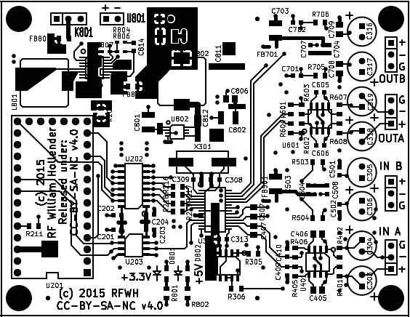Illustration 2.1: Super Audio Board Top View

Power Supplies
The first step in getting the board set up is getting the power supplies ready. For most applications, the board should be powered through header pins marked U801 (upper left corner of the board), with the power select header (K801) on the right (see Illustration 2.2). This power supply setup is designed to accept between 3V and 7V, perfect for 4 AA batteries or a USB power supply.
There is no on/off switch on the Super Audio Board, so the board will turn on immediately when power is applied. However, the board will remain in reset until it is released by the controller, and no sound should be heard until then. The current draw of the board while in reset is minimal.
There are a few other ways of powering the board, but they require some board modifications, so only advanced users should attempt them (see Appendix ).
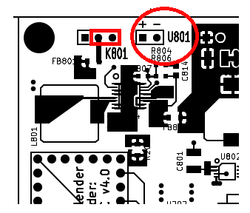Illustration 2.2: Power supply connections

Audio Inputs and Outputs
All the analog inputs and outputs are on the right side of the board when viewed from the top. The inputs and outputs are all fully differential for the best performance, but can be used in a single-ended mode if connections with other single-ended equipment is required.
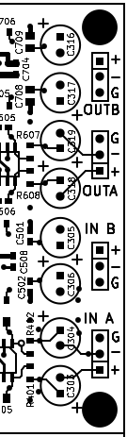Illustration 2.3: Audio Inputs and Outputs
The inputs and outputs are labeled “A” and “B” instead of left and right because the actual channel setup is determined by a register setting in the CS4272 codec. The default channel setting is that channel “A” is left, and channel “B” is the right channel. Other available configurations are detailed in Section 8.3.3 of the CS4272 datasheet.
For differential connections, use all three connections per channel. These are labeled “+” for the positive signal line, “-” for the negative signal line, and “G” for ground.
Single-ended connections are also possible with somewhat degraded performance. For single-ended outputs, use only the positive signal output, “+”, and the ground, “G”. For single-ended inputs, connect the signal to the positive input, connect the grounds, and connect the negative input to ground. Do not leave the negative input open!

Connecting a Teensy 3.x
Teensy 3.x's can be directly connected to the U-shaped set of headers on the left side of the board. This set of headers is designed to mate directly with the Teensy using your choice of connection options (directly soldered using long headers, using a socket and headers, etc). The five horizontal pins are not used and can be left out if necessary (they may be removed in future versions of the board).
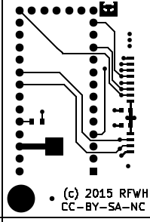Illustration 2.4: Teensy Connection

Connecting a Raspberry Pi or other controller
Other controllers can also be used to control the Super Audio Board. The only requirements for the controller is that it has both an I2C and an I2S interface, and that it has a GPIO pin that can drive the reset line to start the codec. The controller's I2S interface must be capable of running in slave mode, where the interface clocks are generated by the audio device (the Super Audio Board in this case).
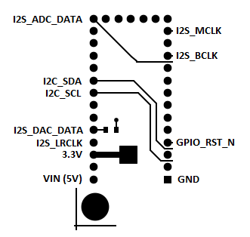Illustration 2.5: Super Audio Board Controller Pinout
The pinout of the Super Audio Board is shown in Illustration 2.5.
Raspberry Pi connections are shown in the table below:

SuperAudioBoard pin name | Raspberry Pi pin # | Raspberry Pi pin name
+3.3V | 1 | +3V3
GND | 39 | GND
I2C_SCL | 5 | GPIO3/SCL1
I2C_SDA | 3 | GPIO2/SDA1
I2S_MCLK | Not used | Not used
I2S_LRCLK | 35 | GPIO19/MISO
I2S_BCLK | 12 | GPIO18
I2S_DAC_DATA | 40 | SCLK/GPIO21
I2S_ADC_DATA | 38 | MOSI/GPIO20
GPIO_RST_N | 37 | GPIO26
+5V (Optional) | 2 | +5V

Software setup

Teensy 3.x
At the time of writing, the SuperAudioBoard is not integrated into the Teensy Audio Library that makes audio processing very really easy on the Teensy 3.x. Until the integration is complete, there is some barebones example code in the SuperAudioBoard github repository (https://github.com/whollender/SuperAudioBoard) under the “SineTestCode” directory. The code simply outputs a 1kHz tone on one channel and records a number of ADC samples. A binary of the program that is ready to download to a Teensy is included in the repository root directory under “sine_test.hex”. Instructions for running the program:
- Download the hex file to the Teensy and reboot the Teensy using the downloader included in Teensyduino (from PJRC.com)
- Turn on power to the SuperAudioBoard
- Connect a serial terminal to the COM port corresponding to the Teensy
  - May need to use Windows device manager to determine correct port
  - For other operating systems, see instructions @ http://pjrc.com/teensy/index.html
- If nothing appears in the terminal, press enter, and “Init codec? (y/n)” should appear
- Pressing 'y' and return will release the codec from reset, setup the codec, and read back the codecs configuration registers over I2C. The program will then pause for 10 seconds while the codec's high pass filter stabilizes.
- Another prompt should appear: “Start test? (y/n)”
- When the test begins, the board will output a 1kHz sine wave to the left channel, and record on both the left and right channels.
- Once the input buffer is full, it will stop, and print the recorded samples back to the serial monitor.
  - Around 8k samples are returned, so be patient. This step can take 5-10 minutes.

Raspberry Pi
(Note: I haven't tested these instructions, so there may be errors.)
At the time of this writing, the SuperAudioBoard drivers are not automatically included in any Raspberry Pi OS releases, so the kernel must be rebuilt to include SuperAudioBoard support.
Follow instructions at https://www.raspberrypi.org/documentation/linux/kernel/building.md to build the kernel for the Raspberry Pi, but use the repository at https://github.com/whollender/linux instead of the github repo mentioned in the article.
There should now be a “superaudioboard-overlay.dtb” file in the /boot/overlays directory.
Now, edit the /boot/config.txt file, add the following line: “dtoverlay=superaudioboard”, and make sure that the “dtparam=i2c_arm=on” and “dtparam=i2s=on” lines are un-commented.
On the next reboot, the Raspberry Pi should recognize the SuperAudioBoard. To verify that the board is ready for use, run “aplay -l” to list the sound cards. The SuperAudioBoard should be first in the list.

Appendix: Other power supply configurations
To be filled out.

