Create directory git-repo, file, open in editor and save it

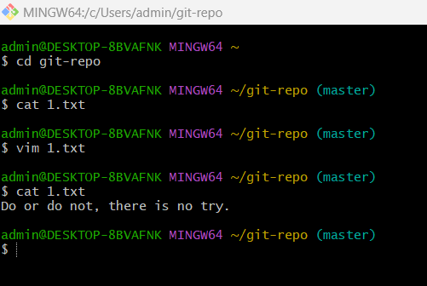

Create other files with echo and add content in it

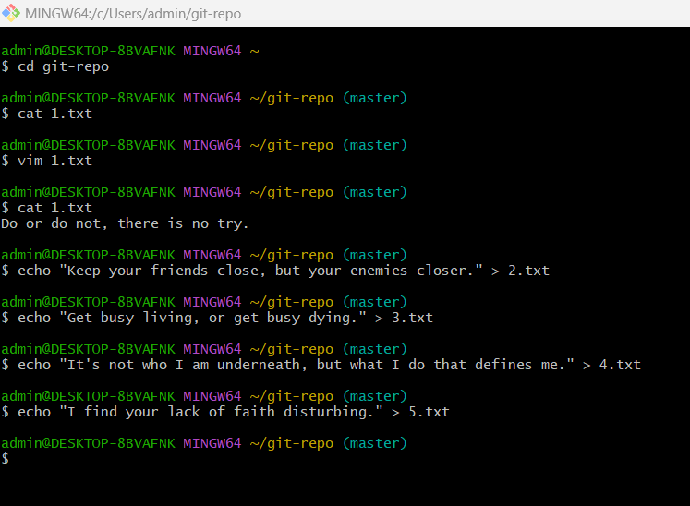

Set Credentials:

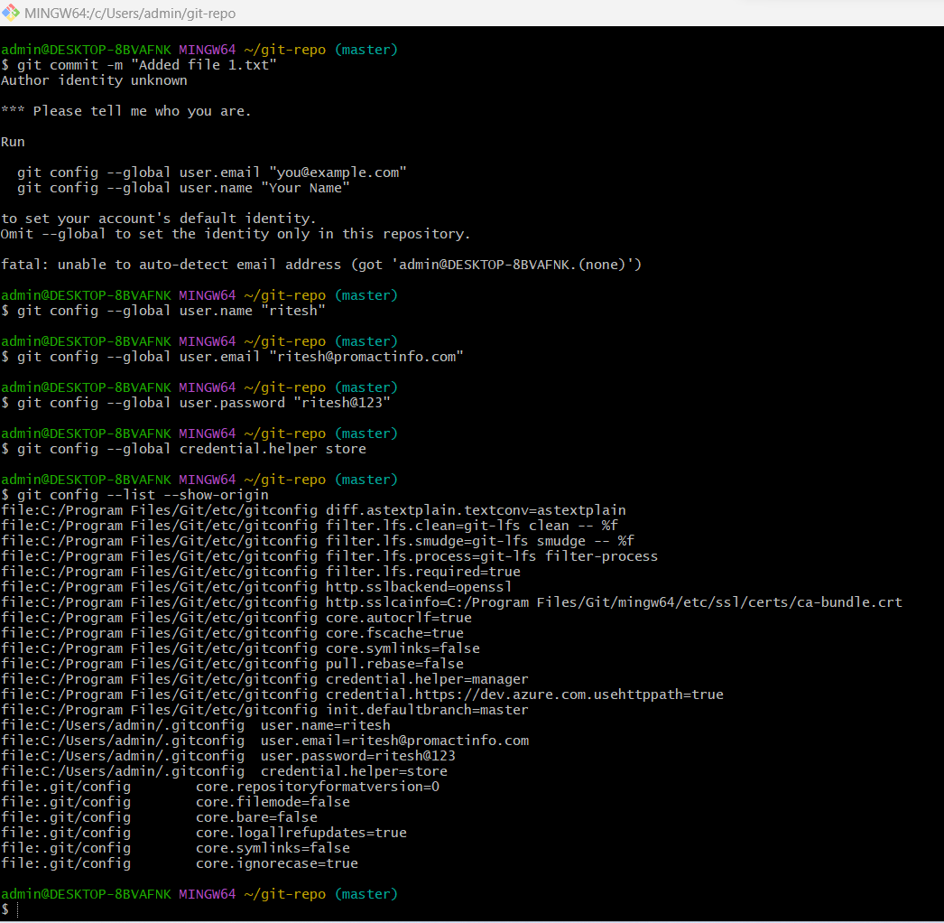

Add and commit recently created files:

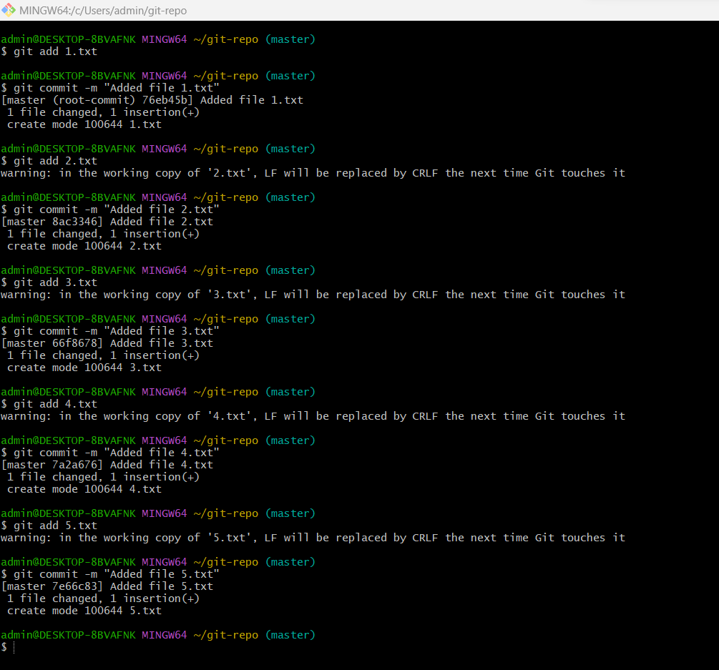

Push to origin master:

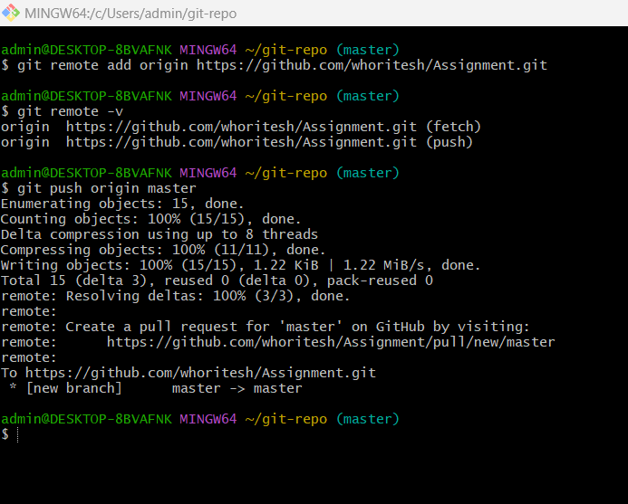

create one branch called **"feature-rename-files", rename files** and merge this **feature-rename-files** branch into **master** branch:

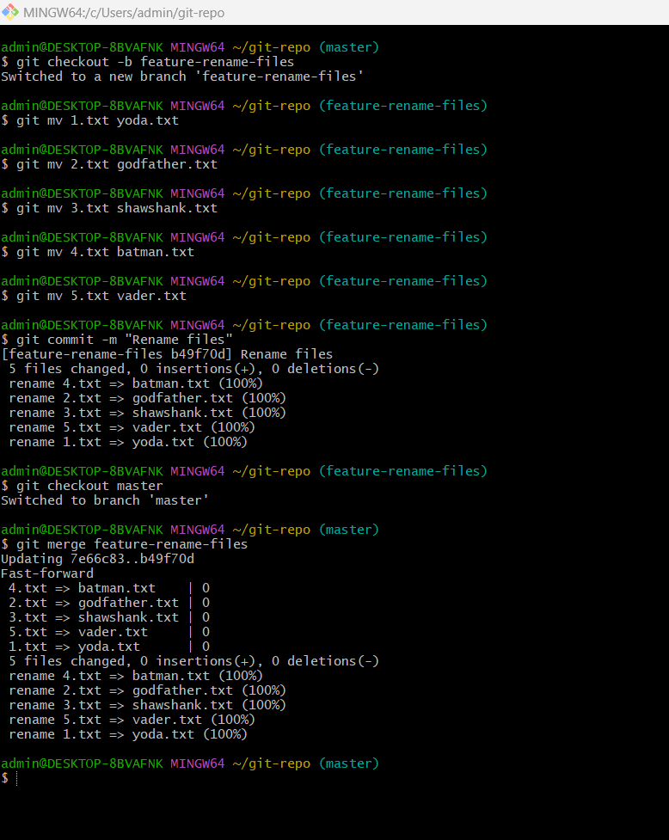

Change content in file and push two separate commits in **master** branch:.

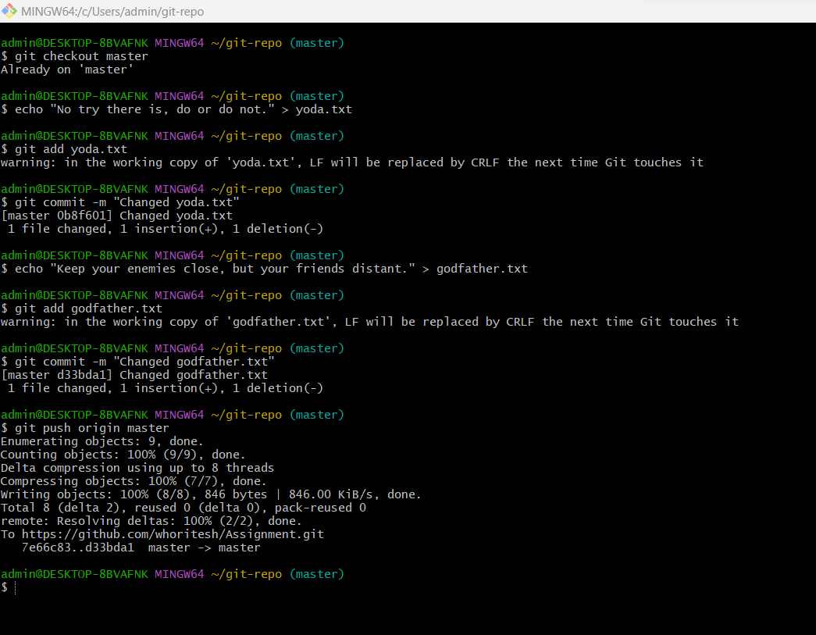

checkout the **feature-rename-files** branch and push two different commits in **feature-rename-files** branch:

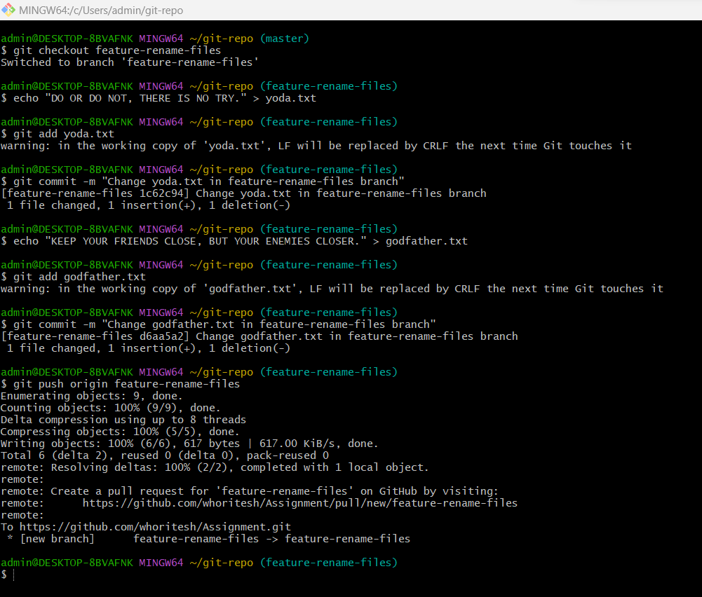

rebase your **feature-rename-files** branch with the **master** branch. If there are any conflicts while rebasing, choose the followings to resolve conflicts:

1.Pick all changes of **master** for conflicts in Yoda.txt  
 2. Pick all changes of **feature-rename-files in** godfather.txt

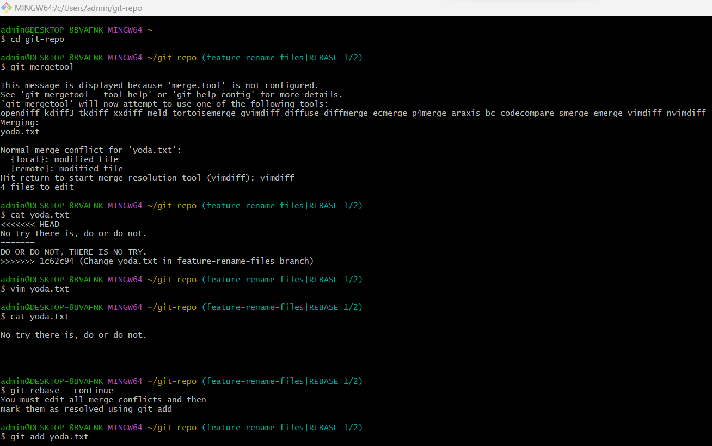

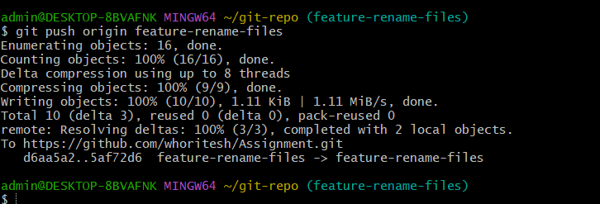

send the Pull request in Github from **feature-rename-files** to **master**

create one folder with the name **Assignment.**

