SENS-ROTATION PRO  Real-Time 3D Spatial Attitude & Fallback Architecture | PAGE 1 OF 2  FYP Technical Spec

1. Adaptive Dual-Pipeline Sensor Architecture
Smartphones differ by hardware tiers: premium devices feature a physical 3-axis Rate Gyroscope, whereas value-tier devices (such as Samsung Galaxy A06) rely solely on a 3-axis MEMS Accelerometer. To achieve universal compatibility, Sens-Rotation Pro deploys an autonomous dual-pipeline detection engine:
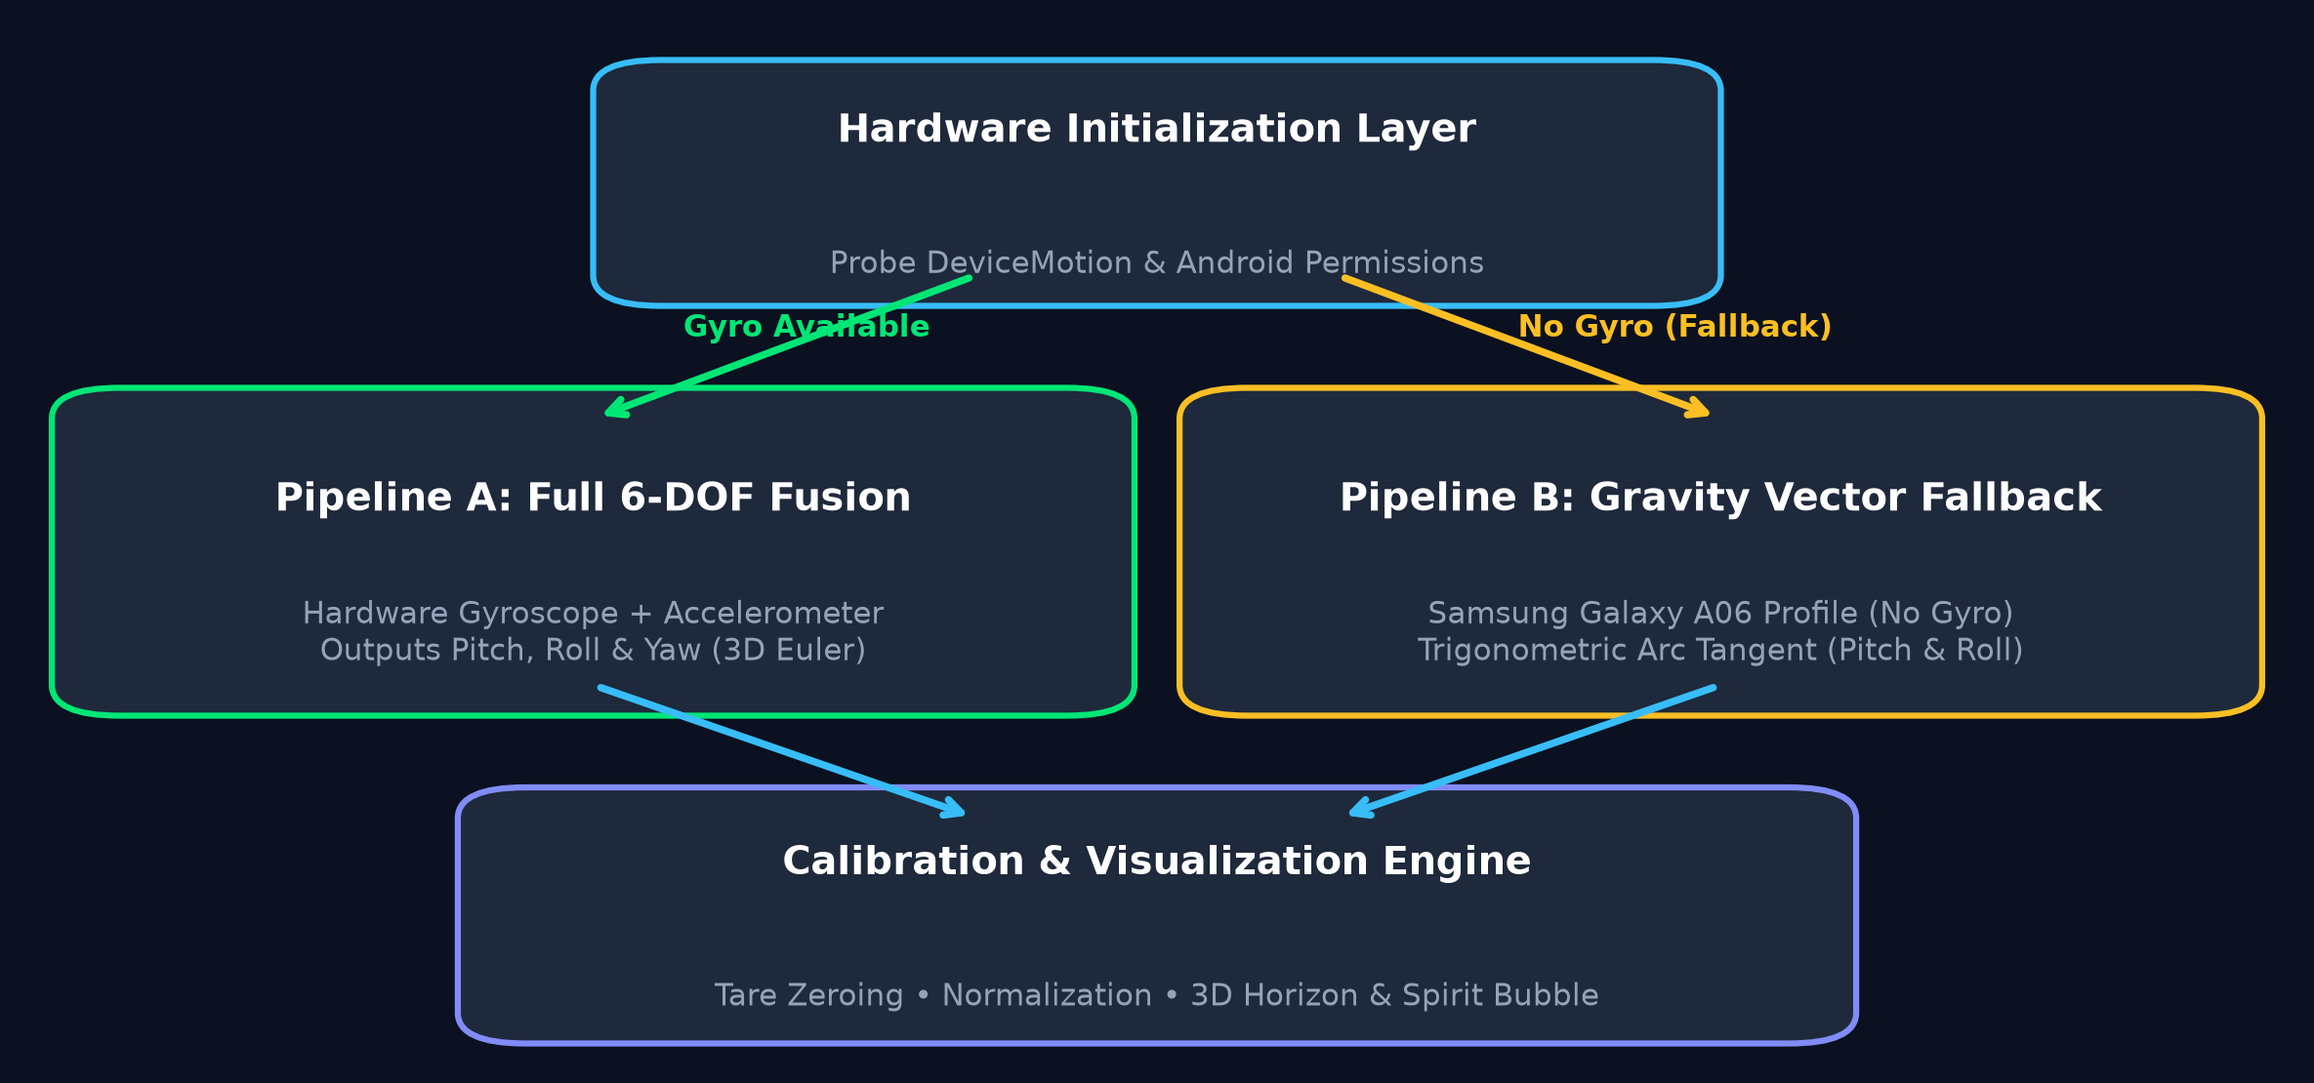
2. Spatial Coordinate System & The 3 Degrees of Freedom
The device adheres to a standard right-handed Cartesian frame where +X points right, +Y points toward the top edge, and +Z extends orthogonally outwards from the screen toward the user:
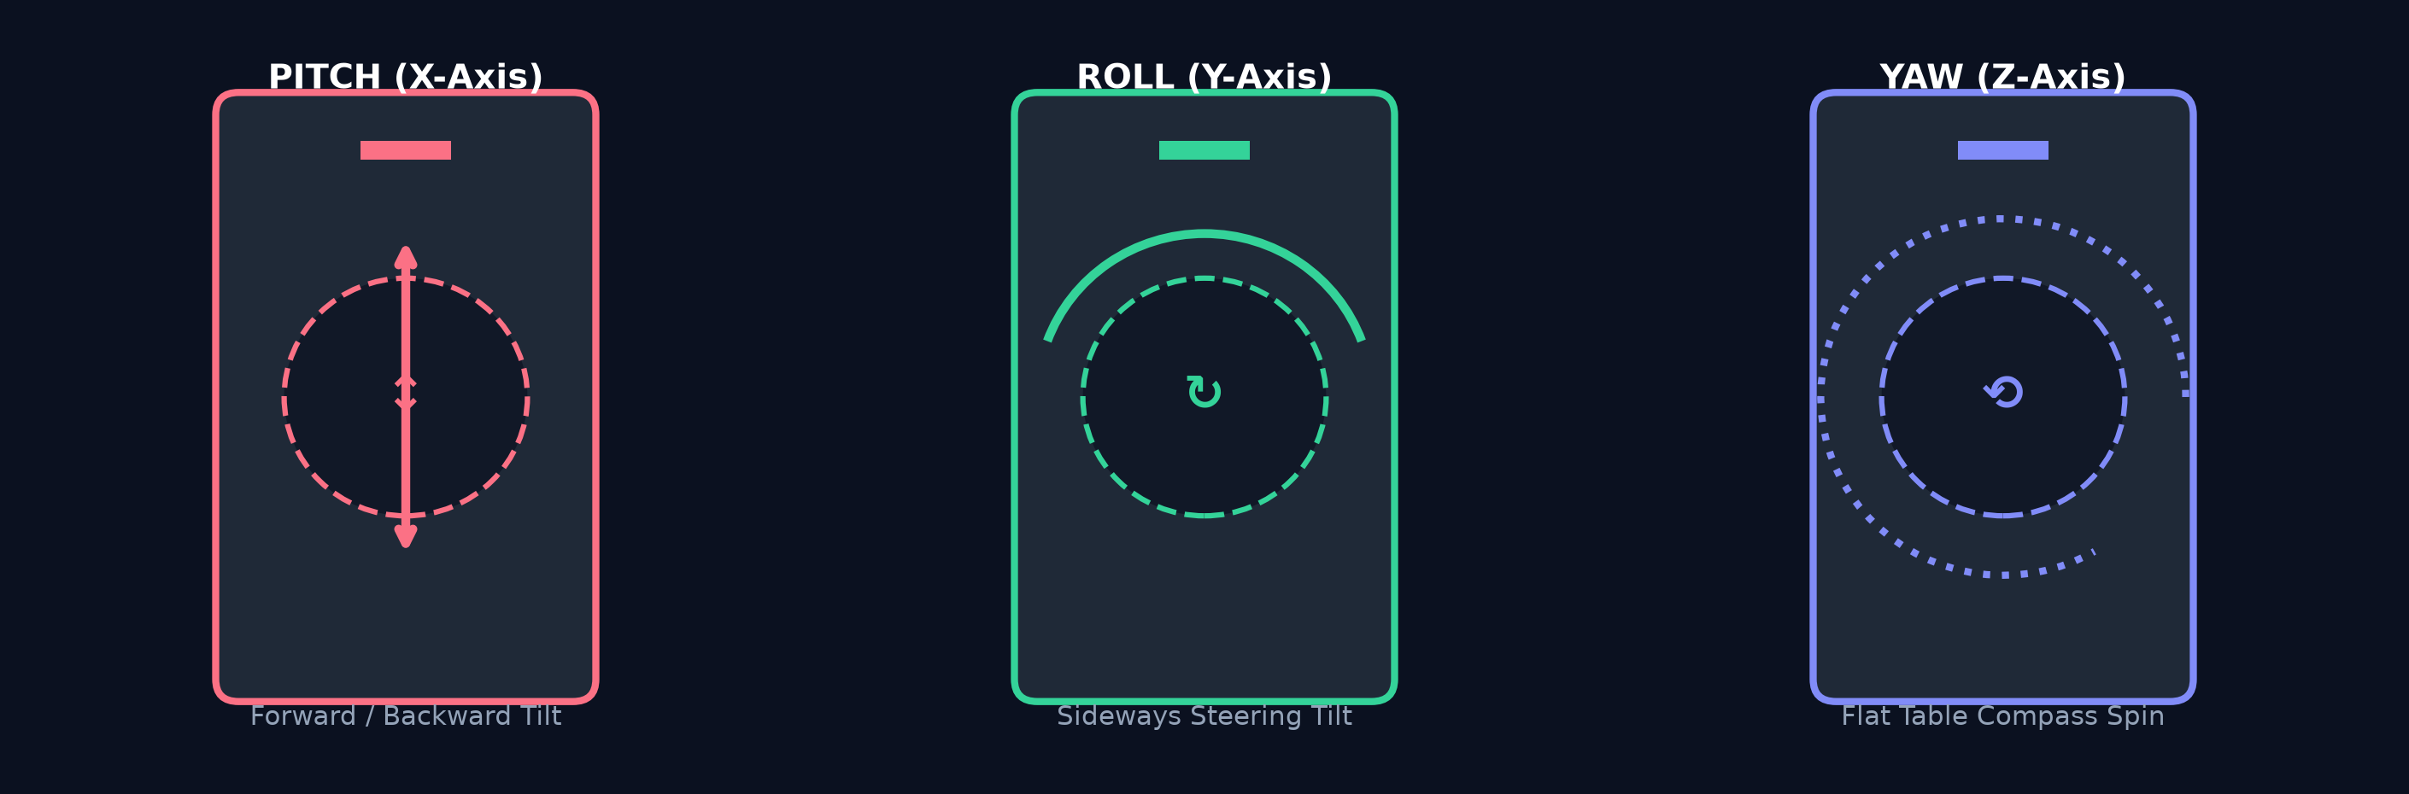
Rotation | Axis | Physical Motion | Sensor Resolution Mode
Pitch (θ / β) | X-Axis (Transverse) | Tilting top up/down (elevation) | Full Gyro OR Gravity Accel (ax)
Roll (ϕ / γ) | Y-Axis (Longitudinal) | Tilting sideways like steering wheel | Full Gyro OR Gravity Ratio (ay / az)
Yaw (ψ / α) | Z-Axis (Vertical) | Twisting flat on a table (heading) | Gyro only (Locked to 0° in Fallback)

MATHEMATICAL FORMULATIONS & LOGIC  Trigonometric Estimations, Zero-Point Tare & Tuning | PAGE 2 OF 2  Formulas & Code

3. Mathematical Calculations & Trigonometric Derivations
Pipeline A: Gyroscope Fusion  Converts internal OS Kalman angles (radians) to degrees:  • Pitch = round( β × 180° / π )  • Roll = round( γ × 180° / π )  • Yaw = round( α × 180° / π )  Tracks dynamic rotations continuously across all 3 spatial axes. | Pipeline B: Accelerometer Tilt (Samsung A06)  Resolves static gravity acceleration g = [ax, ay, az]^T:  • Pitch = atan2( -ax, √(ay² + az²) ) × (180° / π)  • Roll = atan2( ay, az ) × (180° / π)  • Yaw = 0° (Invariance limitation)  The norm √(ay² + az²) isolates perpendicular gravity to prevent gimbal singularity.

4. Tare Calibration, Normalization & UI Transformations
Relative Zero-Point Tare Calibration | Allows user to calibrate phone on any slanted mount:  Δθ = Pitch - Pitch_cal  Δϕ = Roll - Roll_cal
Circular [-180°, +180°] Normalization | Eliminates 360° wrapping discontinuity:  let val = deg % 360;  if (val > 180) val -= 360; if (val < -180) val += 360;
Total Tilt Magnitude (L2 Norm) | Quantifies combined angular deflection from reference plane:  Total Tilt = round( √(Pitch² + Roll²) )

5. Samsung Galaxy A06 (4GB RAM) Optimization Profile
Optimization Metric | Configured Value | Technical & Hardware Rationale
Update Interval | 60ms (~16.6 FPS) | Prevents JS thread lag on MediaTek Helio G85 while maintaining fluid animation.
Battery Budget | < 1.8% battery / hour | Eliminates excessive heating from continuous 60Hz/100Hz hardware polling.
Pause Suspension | 1,000,000ms throttle | Immediately suspends hardware polling on pause without unbinding listeners.

