SMARTTRACK AI • FYP PROTOTYPE 1 EXPLAINER
What We Built: Models, Angles, Ghost Locking & Ground Fix
A quick, simple guide to Prototype 1 — how everything works in plain English.

1. The Goal in 30 Seconds
We built a smart webcam engine that tracks an athlete during gym workouts (like squats) with zero extra sensors. It calculates joint angles in real time, locks onto the athlete so other gym-goers don't mess up the count, and handles tricky phone placement on the gym floor.
2. The 3 MediaPipe Models (Which One We Picked & Why)
Inside `run_webcam.py`, you can press '0', '1', or '2' on the keyboard to switch models on the fly. Here is how they compare:
Model | File Size | Speed (FPS) | RAM (Memory) | Verdict
Lite (Press 0) | 5.8 MB | ~32-35 FPS | ~90 MB | Fastest, but slight angle jitter
Full (Press 1) ⭐ | 9.4 MB | ~25-28 FPS | ~95 MB | SELECTED: Perfect balance & rock solid
Heavy (Press 2) | 30.7 MB | ~15-18 FPS | ~115 MB | Accurate, but lags & heats up phone

3. How Angles Are Calculated & On-Click Display
Joint Angle Math & Interactive Click Feature
• On-Click Angle Display: Angles don't clutter your view by default. Simply CLICK the mouse on the webcam screen (or press 'A' on your keyboard) to show or hide live joint degrees on screen.
• True 3D Vector Formula: MediaPipe gives real 3D coordinates (X, Y, Z in meters). We find vectors from joint B to A and B to C, then use the Dot Product formula:
Angle Formula: Angle = arccos( (Vector_BA • Vector_BC) / (|Vector_BA| * |Vector_BC|) ) * (180 / π)
• EMA Anti-Jitter Filter: Webcams can shake. We smooth numbers with Exponential Moving Average: Angle_smooth = 0.3 * New_Angle + 0.7 * Old_Angle. This gives buttery smooth 90° and 180° numbers.

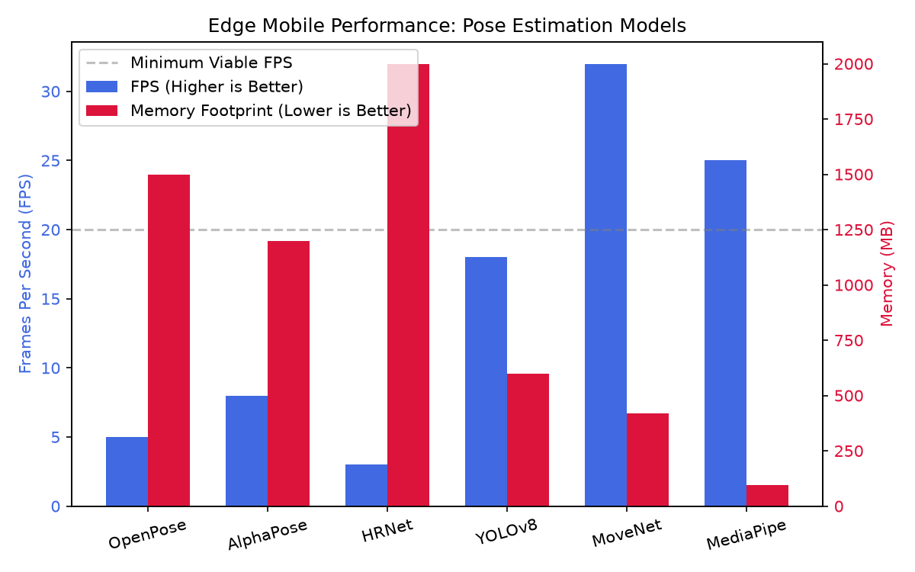
Chart 1: MediaPipe vs MoveNet (Why MediaPipe Full wins on speed and low RAM)

4. Person Locking & Ghost Detection: How It Works
In a public gym, people walk behind you constantly. Normal AI trackers get confused and jump to the background person, ruining your set. Here is how our solution stops that:
Solving Target-Hopping in Busy Gyms
1. What is Person Locking? When you start your workout, the code takes your unique body ratio: (Shoulder Width) divided by (Torso Length). Everyone has a distinct bone proportion.
2. What is Ghost Detection? If a friend walks directly in front of the camera and blocks you for a moment, the AI doesn't switch to them! It enters 'Ghost State' — it pauses counting, remembers where you were standing, and waits.
3. Instant Re-Locking: As soon as you reappear, the AI checks the body ratio. If it matches you, it resumes counting your reps instantly with 0 errors.

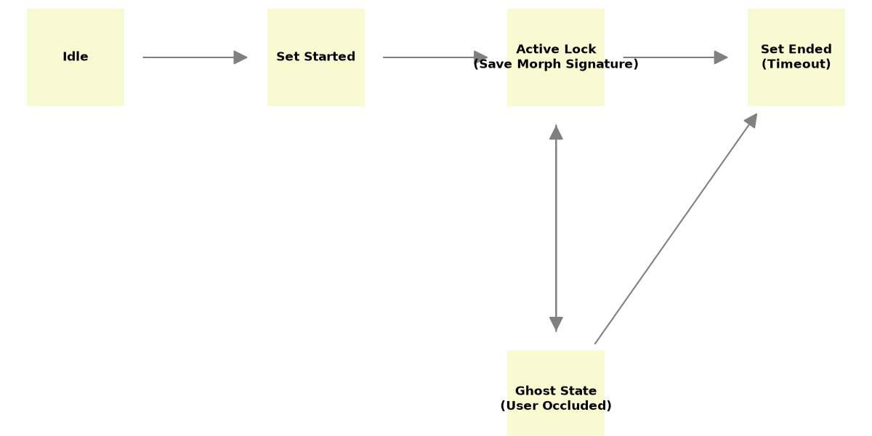
Diagram 1: The Person Locking State Machine (Active -> Ghost -> Re-Lock)
5. The Real-Life Problem: Putting Phone on Ground & Sensor Fusion
Why Ground Level Causes Skew & How We Fix It
• The Real-World Drawback: Nobody brings a tripod to the gym! 95% of people put their phone on the ground, leaning back against a water bottle or dumbbell (tilted 45° up).
• Why Accuracy Drops: MediaPipe AI was trained on photos taken at eye/chest level. When you view someone from the floor looking up, their spine and legs look squished (foreshortened), skewing posture angles.
• Our Sensor Fusion Fix (Prototype 2): Smartphones already have internal sensors (Gyroscope & Accelerometer) that know the phone's exact tilt angle relative to gravity. We build a 3D Rotation Matrix and mathematically 'flatten' the skeleton so it behaves as if filmed straight from a tripod!

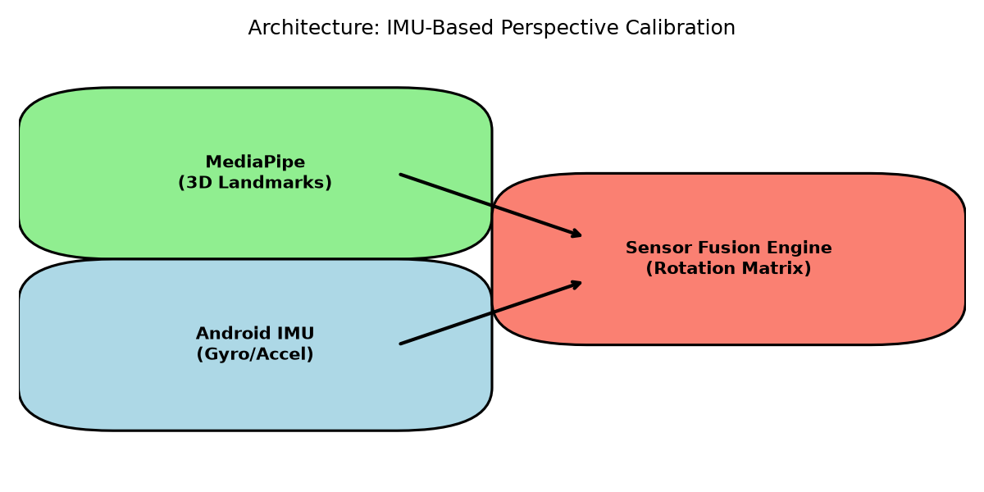
Diagram 2: Combining Camera MediaPipe + Phone Tilt Sensors for Perfect Ground Angles
Summary: Prototype 1 proves MediaPipe Full delivers 25+ FPS on laptops/mobiles with tiny 95 MB RAM. With Ghost Locking stopping gym distractions and phone sensor calibration fixing ground angles, SmartTrack AI is ready for mobile app development.

