Circleclass dll:

using System;

using System.Collections.Generic;

using System.Linq;

using System.Text;

using System.Threading.Tasks;

namespace circleclass

{

[Serializable]

public class circle

{

double radius,a;

public void set(double r)

{

radius = r;

}

public void area()

{

a=2*3.147*radius;

Console.WriteLine("The area of the circle:{0}", a);

}

}

}

Circle console application(XML):

using System;

using System.Collections.Generic;

using System.Linq;

using System.Text;

using System.Threading.Tasks;

using System.Runtime.Serialization.Formatters.Soap;

using System.IO;

using circleclass;

namespace circle

{

class Program

{

static void Main(string[] args)

{

double r;

circleclass.circle c1 = new circleclass.circle();

Console.WriteLine("Enter the radius:");

r = Convert.ToDouble(Console.ReadLine());

c1.set(r);

FileStream f1 = File.Create("area.xml");

SoapFormatter sf = new SoapFormatter();

sf.Serialize(f1, c1);

f1.Close();

Console.ReadKey();

FileStream f2 = File.OpenRead("area.xml");

SoapFormatter sf1 = new SoapFormatter();

circleclass.circle a1 = (circleclass.circle)sf1.Deserialize(f2);

a1.area();

Console.ReadKey();

}

}

}

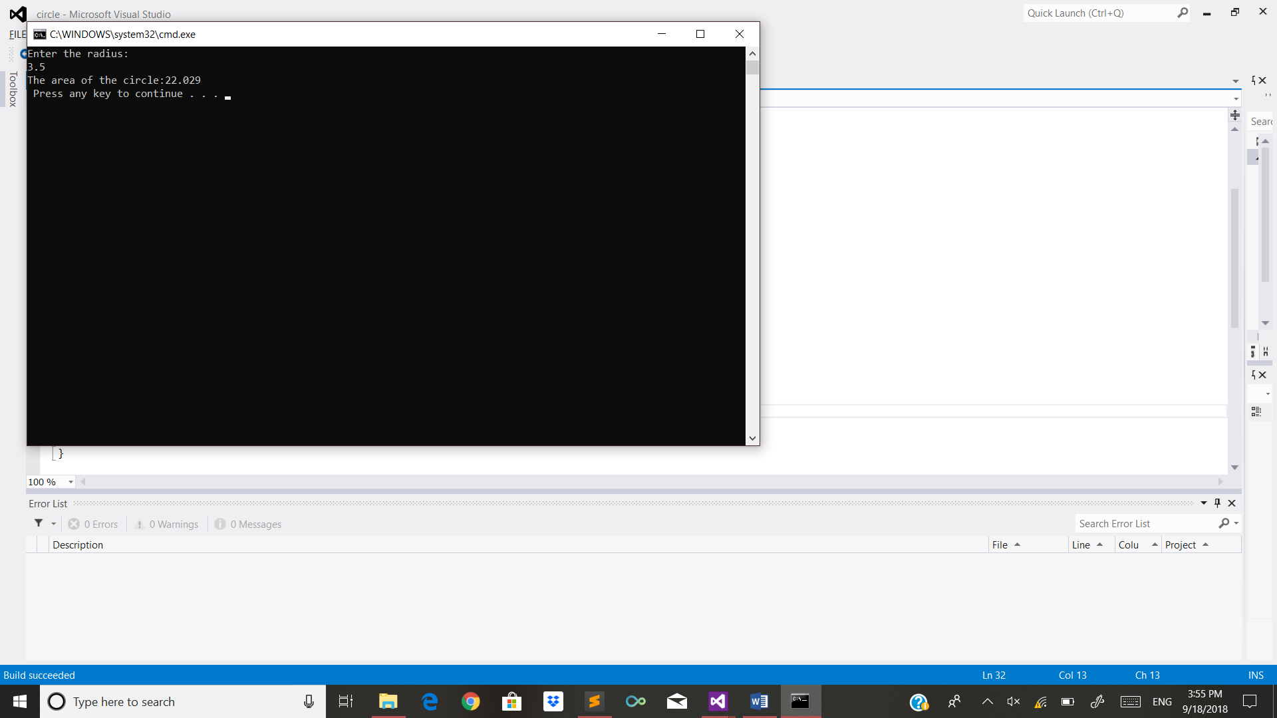

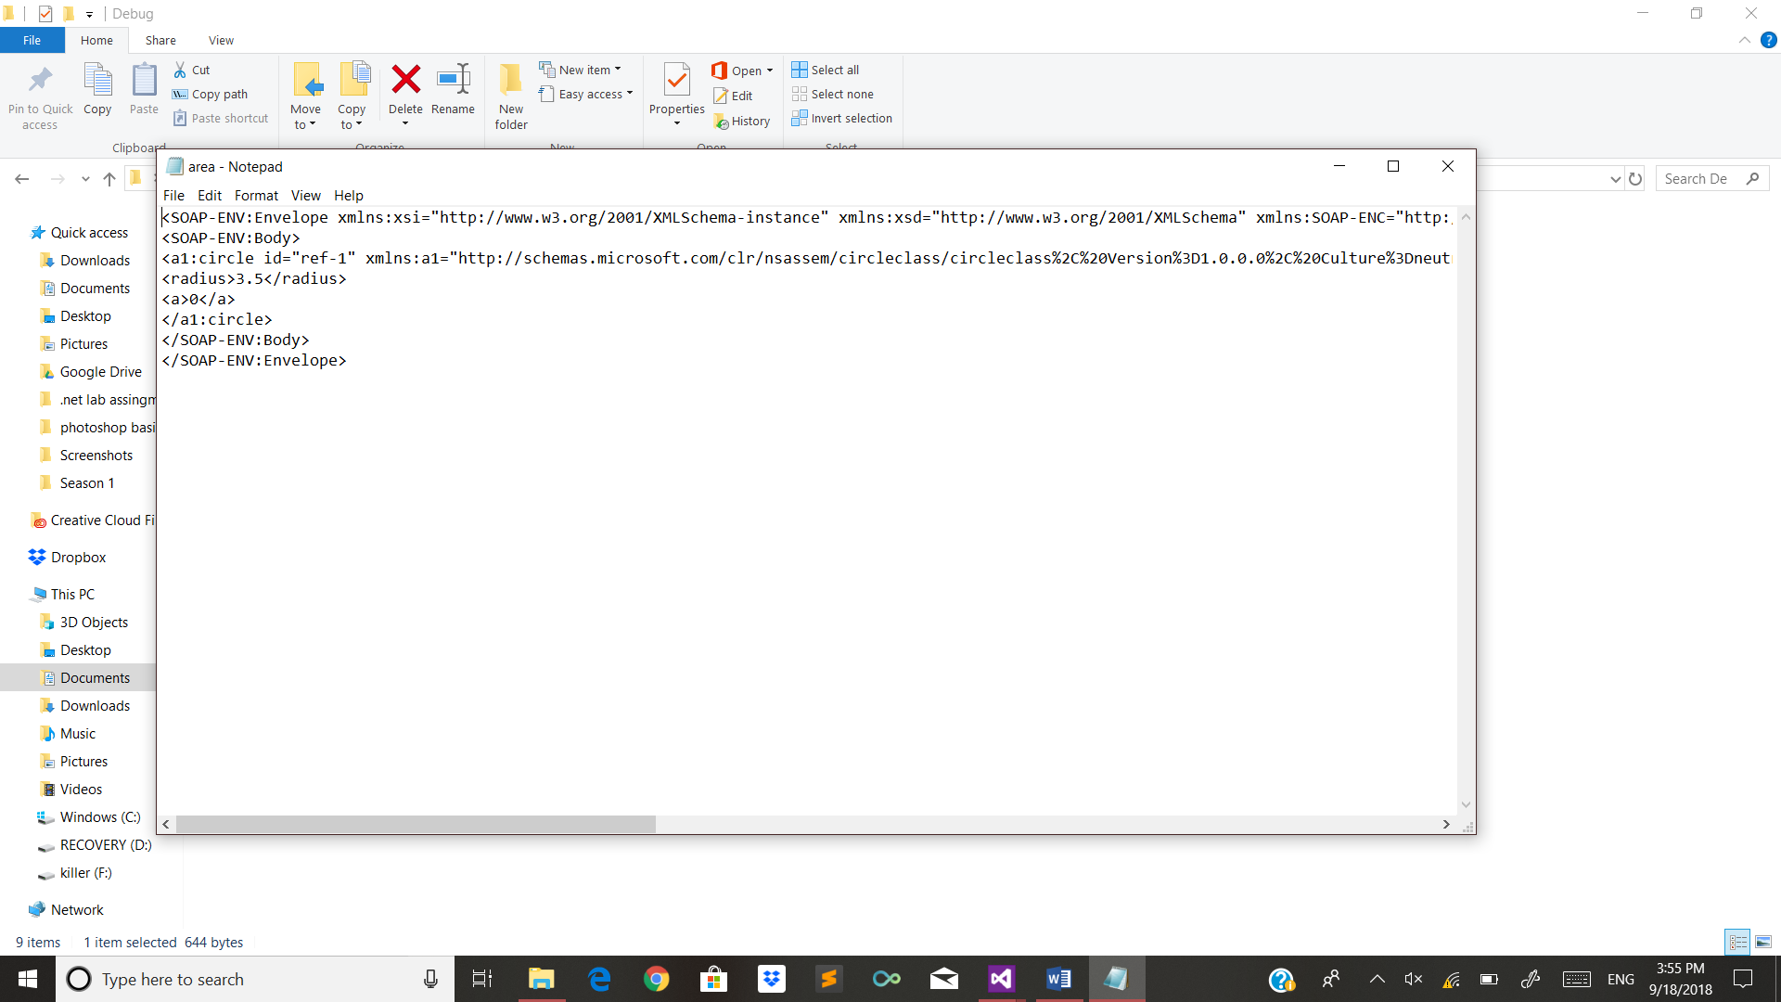

Circle console application(BINARY):

using System;

using System.Collections.Generic;

using System.Linq;

using System.Text;

using System.Threading.Tasks;

using System.Runtime.Serialization.Formatters.Binary;

using System.IO;

using circleclass;

namespace circle

{

class Program

{

static void Main(string[] args)

{

double r;

circleclass.circle c1 = new circleclass.circle();

Console.WriteLine("Enter the radius:");

r = Convert.ToDouble(Console.ReadLine());

c1.set(r);

FileStream f1 = File.Create("area.dat");

BinaryFormatter bf = new BinaryFormatter();

bf.Serialize(f1, c1);

f1.Close();

Console.ReadKey();

FileStream f2 = File.OpenRead("area.dat");

BinaryFormatter bf1 = new BinaryFormatter();

circleclass.circle a1 = (circleclass.circle)bf1.Deserialize(f2);

a1.area();

Console.ReadKey();

}

}

}

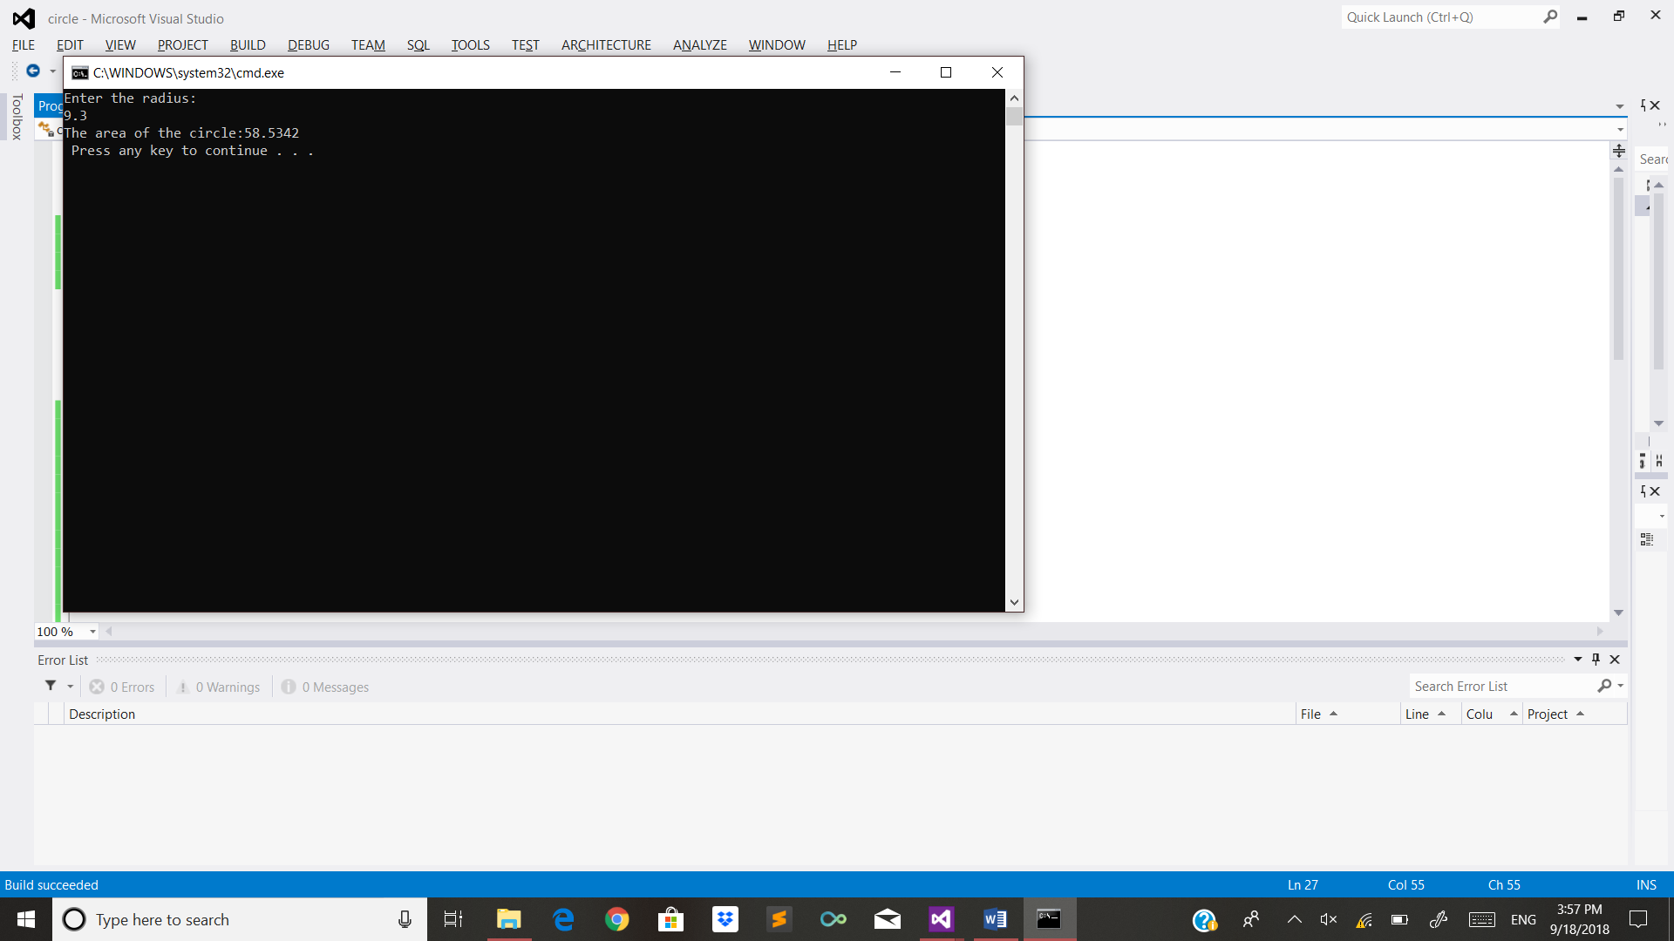

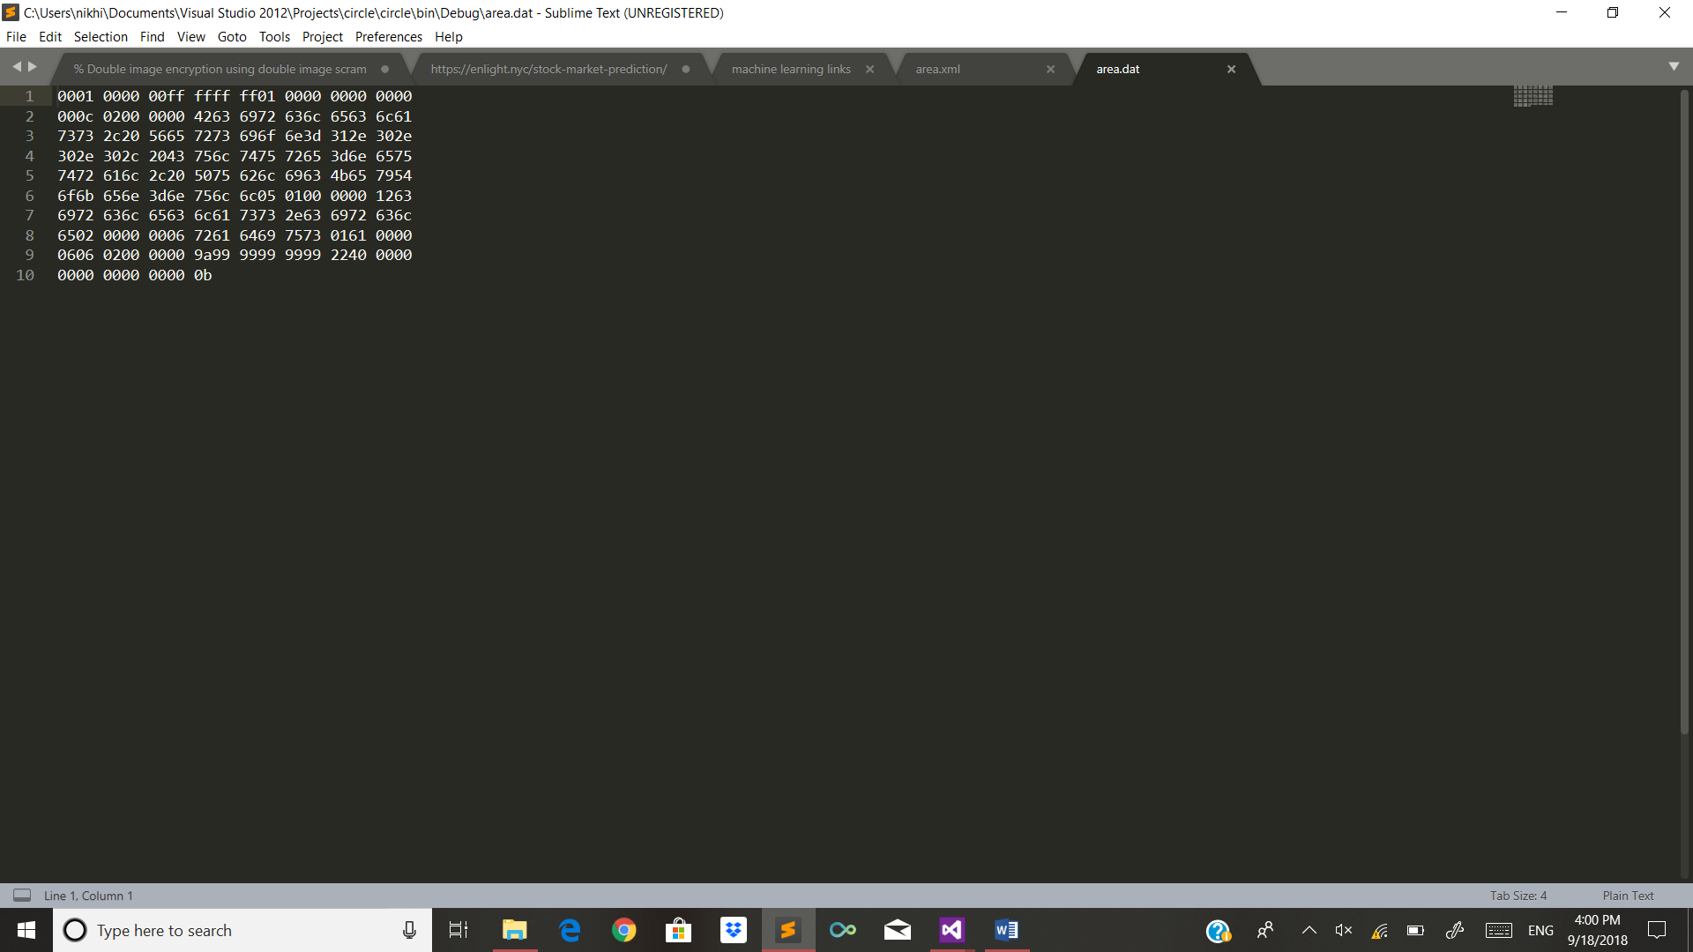

Supermarket bill:

using System;

using System.Collections.Generic;

using System.ComponentModel;

using System.Data;

using System.Drawing;

using System.Linq;

using System.Text;

using System.Threading.Tasks;

using System.Windows.Forms;

namespace WindowsFormsApplication1

{

public partial class Form1 : Form

{

public Form1()

{

InitializeComponent();

}

private void label1_Click(object sender, EventArgs e)

{

}

private void Form1_Load(object sender, EventArgs e)

{

}

private void button1_Click(object sender, EventArgs e)

{

//string[] item = { "rice", "wheat", "sugar", "salt" };

int pno = int.Parse(textBox1.Text);

string nop= textBox2.Text;

int pop = int.Parse(textBox3.Text);

int quantity = int.Parse(textBox4.Text);

if (nop == "rice" || nop=="wheat"||nop=="sugar"||nop=="salt")

{

int amount = pop * quantity;

textBox5.Text = amount.ToString();

}

else

{

//textBox5.Text = "Product not available";

MessageBox.Show("Product not available");

}

}

}

}

