MIKROTIK

BASIC CONFIGURATION

Subash Subedi

2025

# Bridge Port Configuration

Step 1: Select “**Bridge**” On that, you will find the “**Bridge**” option.

Step 2: Click on the “**add**” symbol “**+**”.

Step 3: In “**Name**” if you want to change the name, then change; otherwise, leave it.

Step 4: Now we will not change anything; select “**Apply**” & “**OK**”

Step 5: Select “**Bridge**” On that you will find the “**Ports**” option.

Step 6: Click on the “**add**” symbol “**+**”.

Step 7: In “**Interface**” select the “**ethernet**” port, & In “Bridge” select the name of bridge In step 3, you have

create.

Step 8: Select “**Apply**” & “**OK**” Same process step for other Ethernet port also.

**CMD**

/interface bridge add name=[Name of bridge port]

interface bridge port add bridge=[Name of bridge port] interface=ether[ether port]

interface bridge port print brief

**EXAMPLE**

interface bridge add name=bridge1

interface bridge port add bridge=bridge1 interface=ether2

interface bridge port add bridge=bridge1 interface=ether3

interface bridge port add bridge=bridge1 interface=ether4

interface bridge port add bridge=bridge1 interface=ether5

interface bridge port add bridge=bridge1 interface=ether6

interface bridge port add bridge=bridge1 interface=ether7

interface bridge port add bridge=bridge1 interface=ether8

interface bridge port add bridge=bridge1 interface=ether9

interface bridge port print brief

Figure 1

# IP Address Assign

Step 1: Select “**IP**” On that you will find the “**Addresses**” option.

Step 2: Click on the “**add**” symbol “**+**”.

Step 3: In “**Address**” enter the public IP & In “**Network**” enter the gateways of that IP.

Step 4: In “**Interface**” select which interface you want to assign.

Step 5: Select “**Apply**” & “**OK**”.

Step 2: Click on the “**add**” symbol “**+**”.

Step 6: In “**Address**” enter the local IP & In “**Network**” enter the gateways of that IP.

Step 7: In “**Interface**” select which interface you want to assign. For now, name of bridge

Step 8: Select “**Apply**” & “**OK**”

**CMD**

ip address/

add address=[Public Ip ] interface=[name of ethernet]

add address=[local ip range] interface=[name of bridge interface]

**EXAMPLE**

ip address/

add address=10.10.69.50/24 interface=ether1

add address=192.168.1.1/24 interface=ether1

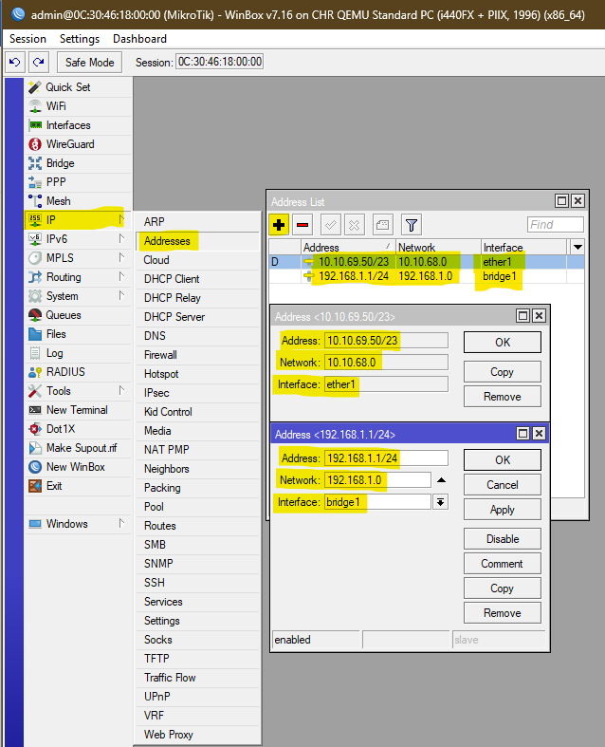

Figure 2

1. **DNS Assign**

Step 1: Select “**IP**” On that you will find the “**DNS**” option.

Step 2: In “**Servers**” enter the DNS of your ISP.

Step 3: Select “**Apply**” & “**OK**”

**CMD**

ip dns/

set servers=[Enter your ISP DNS]

**Example**

ip dns/

set servers=8.8.8.8

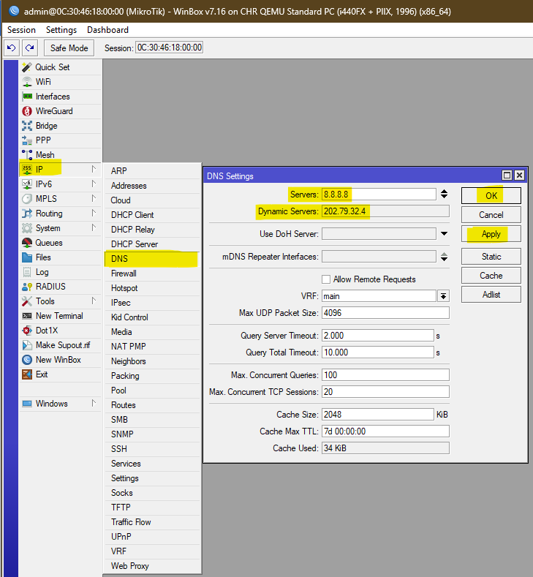

Figure 3

# DHCP Configuration

Step 1: Select “**IP**” On that you will find the “**DHCP SERVER**” option.

Step 2: In “**DHCP**” there you will find “**DHCP Setup**” Click on that option. Then a popup setup will come.

Step 3: In “**DHCP Server Interface**” Select the bridge name in 1 you have created and “**Next**”.

Step 4: In “**DHCP Address Space**” insert the local IP and their subnet as required, or it will come automatically and “**Next**”.

Step 5: In “**Gateway for DHCP Network**” provide the local IP gateways, or it will come automatically and “**Next**”.

Step 6: In the “**Addresses to Give Out**” range of IP addresses, or it will come automatically and “**Next**”.

Step 7: In “**DNS Servers**” enter the ISP DNS that we have given Google for now; it will come automatically and “**Next**”.

Step 8: In “**Lease Time**” set as default and click “**Next**”

**CMD**

ip pool add name=[Name of DHCP Pool] ranges=[Range of local ip]

ip dhcp-server add name=[Name of dhcp server] interface=[Assign Interface] address-pool=[ Name of DHCP Pool] disabled=no

ip dhcp-server network add address=[Local Ip Address with subnet] gateway=[gateway of local IP] dns-server=[DNS of ISP]

ip dhcp-server enable [Name of dhcp server]

**EXAMPLE**

ip pool add name=dhcp_pool ranges=192.168.1.2-192.168.1.254

ip dhcp-server add name=dhcp1 interface=bridge1 address-pool=dhcp_pool disabled=no

ip dhcp-server network add address=192.168.1.0/24 gateway=192.1.68.1.1 dns-server=8.8.8.8,8.8.4.4

ip dhcp-server enable dhcp1

ip dhcp-server/print

ip dhcp-server lease print

Figure 4

|  |  |
| --- | --- |
| Figure 5 | Figure 6 |
| Figure 7 | Figure 8 |
| Figure 9 | Figure 10 |
| Figure 11 | Figure 12 |

# Configure the route

Step 1: Select “**IP**” On that you will find the “**Routes**” option.

Step 2: Click on the “**add**” symbol “**+**”.

Step 3: In “**Dst. Address**” Enter “0.0.0.0/0” & In “**Gateway**” Public IP that is provided by ISP

Step 4: Select “**Apply**” & “**OK**”

**CMD**

/ip route add dst-address=0.0.0.0/0 gateway=[Public Ip]

**Example**

/ip route add dst-address=0.0.0.0/0 gateway=10.10.69.250

Figure 13

# Set up NAT

Step 1: Select “**IP**” On that you will find the “**Routes**” Option.

Step 2: Click on the “**add**” symbol “**+**”.

Step 3: In “**General**” you will find “**Chain**” leave it default “**srcnat**”

Step 4: Select “**Action**” you will find “Action” in that select “**masquerade**”

Step 5: Select “**Apply**” & “**OK**”

**CMD**

ip firewall nat/

add chain=srcnat action=masquerade

**Example**

ip firewall nat/

add chain=srcnat action=masquerade

Figure 14

FINISHED

NOW CONNECTED TO YOUR PC and Internet connection will arrive.