
L2TP VPN
CONFIGRATION AND SETUP

2025
SUBASH SUBEDI

Configure L2TP Server
Step 1: Click on PPP
Step 2: Search for “L2TP Server” option
Step 3: “Enabled” by check the enabled box
Step 4: Set “Default Profile” in “default-encryption”
Step 5: In “Use IPsec” select “required”
Step 6: In “IPsec Secret” enter your PreSharedKey
Step 7: Select “Apply” & “OK”

CMD:
/interface l2tp-server server
set enabled=yes default-profile=default-encryption use-ipsec=required ipsec-secret=[Enter your password]

EXAMPLE
/interface l2tp-server server
set enabled=yes default-profile=default-encryption use-ipsec=required ipsec-secret=YourStrongPreSharedKey

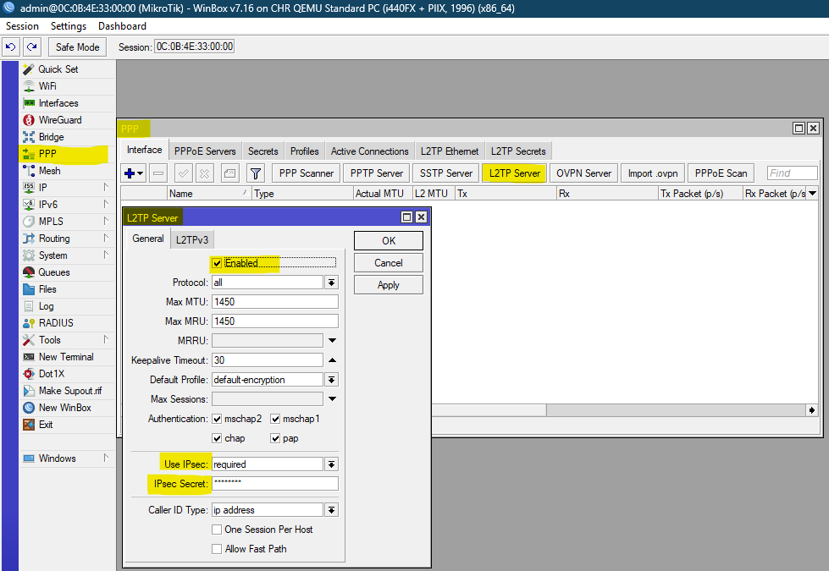
Figure 1

Create IP Pool for VPN Clients
Step 1: Click on “IP” on that you will find “Pool” Option.
Step 2: Click on “add” symbol “+”.
Step 3: In “Name” write name of your vpn
Step 4: In “Addresses” write local ip address range
Step 5: Select “none”
Step 6: Select “Apply” & “OK”

CMD
/ip pool
add name=[Name of your l2tp-vpn] ranges=[Range of ip] comment=[give the comment name for that]
/

EXAMPLE
/ip pool
add name=L2TP-VPN ranges=192.168.1.200-192.168.1.250 comment= “IP POOL FOR VPN CLIENT”
/
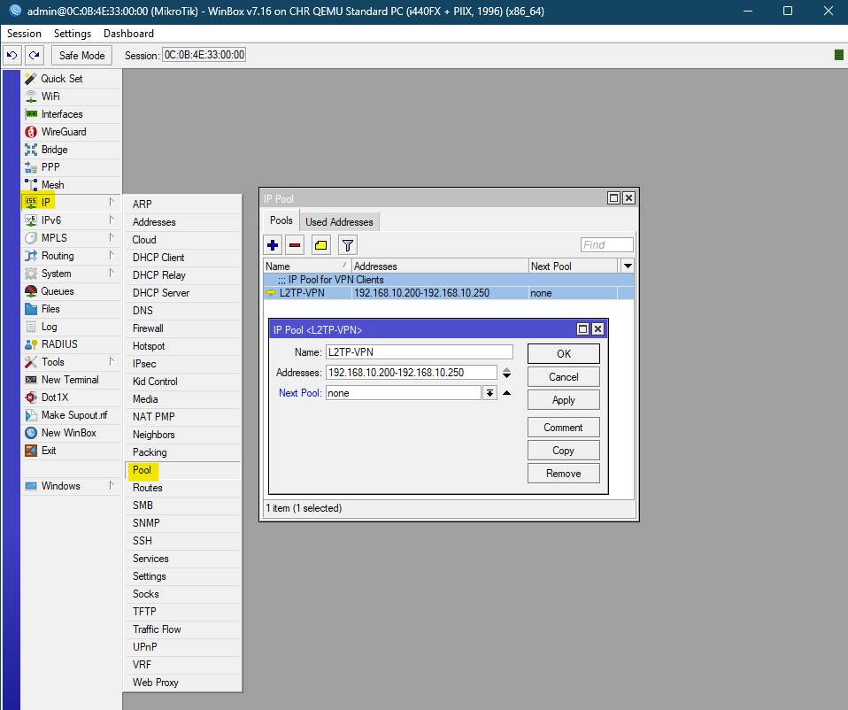
Figure 2

Configure PPP Profile
Step 1: Click on “PPP” in there you will find “Profiles” Option click on that.
Step 2: In “Name” write name of your PPP Profile.
Step 3: In “Local Address” Give the gateway of your local IP Address.
Step 4: In “Remote Address” select your IP pool name
Step 5: In “Change TCP MSS” select “Yes” && In “Use UPnP” select “default”
Step 6: There you will find the “Protocols” option in there you have to change only “Use Encryption” in “yes”
| other leave it as.
Step 7: Select “Apply” & “OK”

CMD
/ppp profile
add name=[name of your ppp profile] local-address=[gateway of local ip] remote-address=[name your L2TP VPN IP pool] change-tcp-mss=yes use-upnp=default use-encryption=yes
/

EXAMPLE
/ppp profile
add name=L2TP-VPN local-address=192.168.1.1 remote-address=L2TP-VPN change-tcp-mss=yes use-upnp=default use-encryption=yes
/
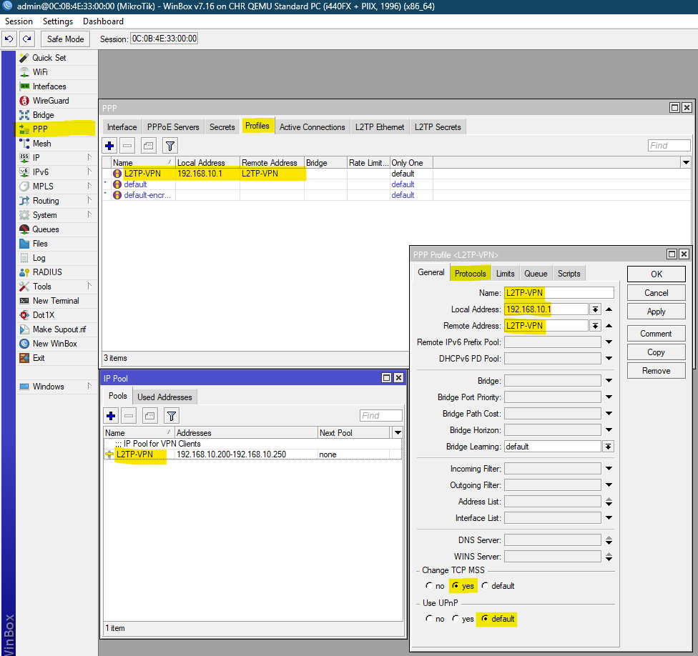
Figure 3

Add VPN User Credentials / Configure PPP Profile
Step 1: Click on “PPP” in there you will find “Secrets” Option click on that.
Step 2: Click on “add” symbol “+”.
Step 3: In “Name” write name of your customer or staff.
Step 4: In “Password” Enter the credentials of your customer or staff.
Step 5: In “Service” select “l2tp”
Step 6: Select “Apply” & “OK”

CMD
ppp secret
add name=[write name of your customer or staff] password=[Enter the credentials of your customer or staff] service=l2tp comment [enter name of your customer or staff] comment=[enter what comment you want to write]
/

EXAMPLE
ppp secret
add name=vpnuser password=yourpassword service=l2tp comment=customer1
/

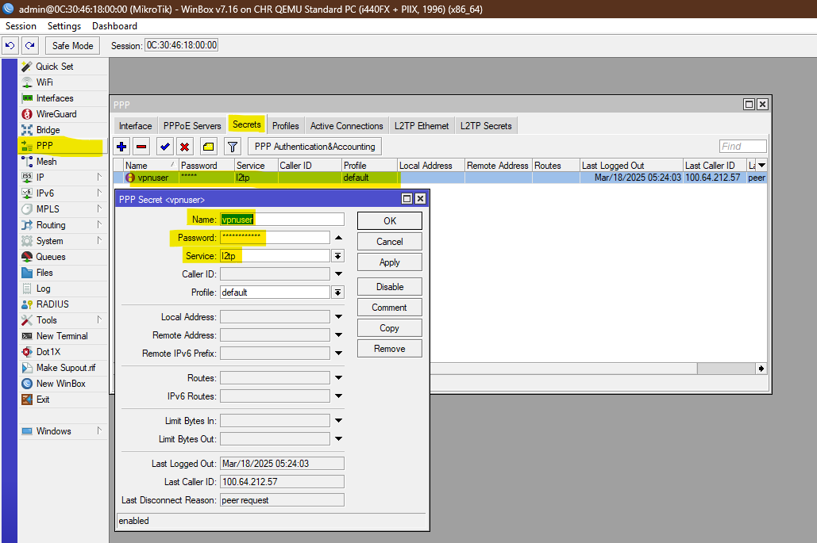
Figure 4

Firewall Configuration

Allow L2TP/IPsec Traffic:
Step 1: Click on “IP” in there you will find “Firewall” Option click on that.
Step 2: Click on “add” symbol “+”.
Step 3: In “Chain” select “input”.
Step 4: In “Protocol” select “udp” [17 protocol of udp]
Step 5: In “Any.Port” Enter the port number
Step 6: Select “Apply” & “OK”
Step 7: Select the “comment” and write the comment.
Step 8: Again Click on “add” symbol “+”.
Step 9: In “Chain” select “input”.
Step 10: In “Protocol” select “ipsec-esp” [port of udp]
Step 6: Select “Apply” & “OK”

CMD
ip firewall filter
add chain=input protocol=ipsec-esp comment=[Comment of your 50 (ipsec-esp)]
add chain=input protocol=udp port=[Enter the port number] comment=[Comment Name]
/

EXAMPLE
/ip firewall filter
add chain=input protocol=udp port=500,1701,4500 action=accept comment="Allow L2TP/IPsec"
add chain=input protocol=ipsec-esp action=accept comment="Allow ESP"

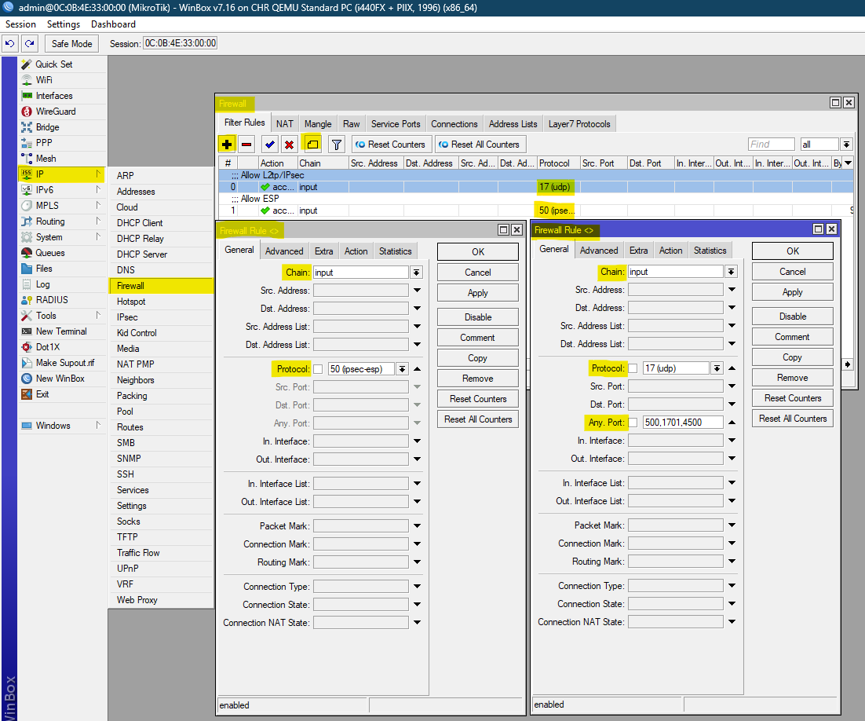
Figure 5

Masquerade NAT (for internet access):
Step 1: Select “IP” On that you will find the “Routes” Option.
Step 2: Click on the “add” symbol “+”.
Step 3: In “General” you will find “Chain” leave it default “srcnat” & In “Src. Address” enter the local gateways IP.
Step 4: Select “Action” you will find “Action” in that select “masquerade”
Step 5: Select “Apply” & “OK”

CMD
/ip firewall nat
add chain=srcnat src-address=[Gateways of local IP] out-interface=bridge1 action=masquerade

EXAMPLE
/ip firewall nat
add chain=srcnat src-address=192.168.1.0/24 out-interface=bridge1 action=masquerade

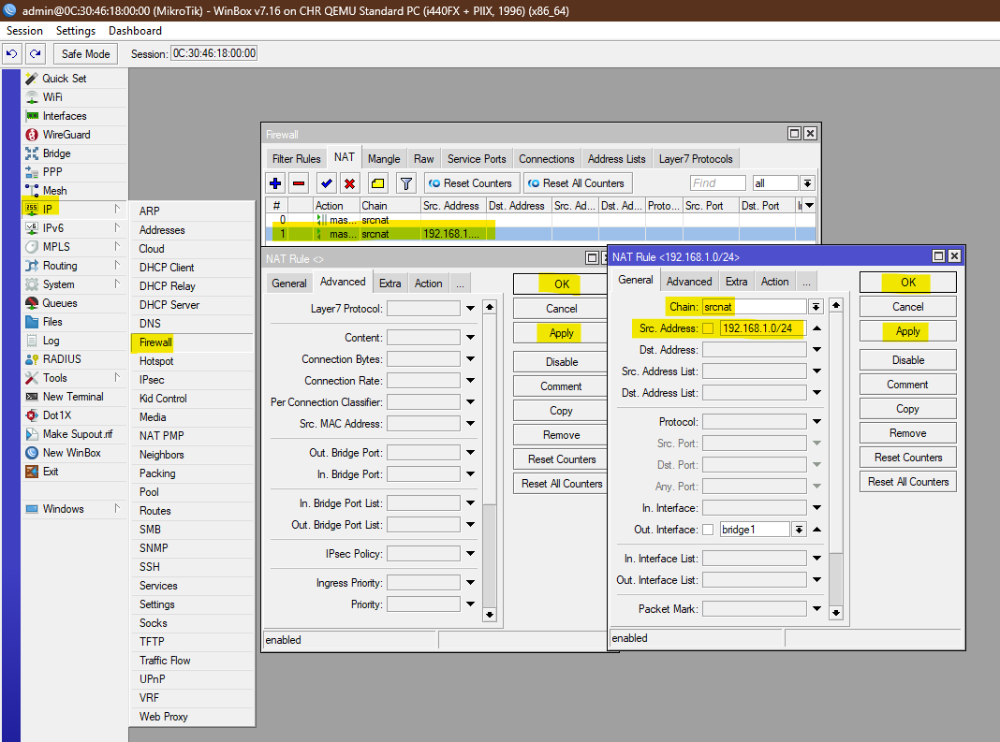
Figure 6

