

Vlan configuration

Mikrotik Router



2025

subash subedi

# Create a Bridge and Add All Ports

Step 1: Select “**Bridge**” On that, you will find the “**Bridge**” option.

Step 2: Click on the “**add**” symbol “**+**”.

Step 3: In “**General**” you will find the option “**Name**” if you want to change the name, then change; otherwise, leave it. **&&** Same line of general you will find “**VLAN**” option the “**Enable**” VLAN Filtering.

Step 4: Now we will not change anything; select “**Apply**” & “**OK**”

Step 5: Select “**Bridge**” On that you will find the “**Ports**” option.

Step 6: Click on the “**add**” symbol “**+**”.

Step 7: In “**Interface**” select the “**ethernet**” port, & In “**Bridge**” select the name of bridge In step 3, you have

create.

Step 8: Select “**Apply**” & “**OK**” Same process step for other Ethernet port also.

**CMD**

Since multiple VLANs will use the same physical router, we will **bridge all interfaces** and configure VLANs using bridge VLAN filtering.

/interface bridge add name=[BRIDGE_NAME] vlan-filtering=yes

/

Now, **add all LAN interfaces** to the bridge.

/interface bridge port

add bridge=[NAME OF BRIDGE PORT] interface= ether[ether port]

/

**EXAMPLE**

/interface bridge add name=bridge1 vlan-filtering=yes

/

/interface bridge port

add bridge=bridge1 interface=ether2

add bridge=bridge1 interface=ether3

add bridge=bridge1 interface=ether4

add bridge=bridge1 interface=ether5

/

Figure 1

# Configure VLANs

Step 1: Select “**Interfaces**” On that, you will find the “**VLAN**” option.

Step 2: Click on the “**add**” symbol “**+**”.

Step 3: In “**Name**” Enter your vlan name **&&** IN “**VLAN ID**” Enter your vlan id number **&&** In “**Interfaces**”

select the name of bridge In first, you have create.

Step 4: Now we will not change anything; select “**Apply**” & “**OK**”

**CMD**

We will define VLAN IDs for each department and assign their respective interfaces.

/interface vlan

add interface=[BRIDGE_NAME] name=[VLAN_INTERFACE_NAME] vlan-id=[VLAN_NUMBER]

/

**EXAMPLE**

/interface vlan

add interface=bridge1 name=vlan2 vlan-id=2

add interface=bridge1 name=vlan3 vlan-id=3

add interface=bridge1 name=vlan4 vlan-id=4

add interface=bridge1 name=vlan5 vlan-id=5

/

Figure 2

# IP ASSIGN

Step 1: Select “**IP**” On that you will find the “**Addresses**” option.

Step 2: Click on the “**add**” symbol “**+**”.

Step 3: In “**Address**” enter the public IP & In “**Network**” enter the gateways of that IP.

Step 4: In “**Interface**” select which interface you want to assign.

Step 5: Select “**Apply**” & “**OK**”.

Step 2: Click on the “**add**” symbol “**+**”.

Step 6: In “**Address**” enter the local IP & In “**Network**” enter the gateways of that IP.

Step 7: In “**Interface**” select which VLAN interface you want to assign.

Step 8: Select “**Apply**” & “**OK**”

**CMD**

Assign IP addresses to VLAN interfaces:

/ip address

add address=[PUBLIC_IP/NETMASK] interface=[NAME_OF_ETHERNET]

add address=[LOCAL_IP_RANGE/NETMASK] interface=[NAME_OF_VLAN_INTERFACE]

/

**EXAMPLE**

/ip address

add address=192.168.2.1/24 interface=vlan2

add address=192.168.3.1/24 interface=vlan3

add address=192.168.4.1/24 interface=vlan4

add address=192.168.5.1/24 interface=vlan5

/

Figure 3

# Configure VLAN Filtering on the Bridge

We need to **define which ports are assigned to each VLAN**.

Step 1: Select “**Bridge**” On that, you will find the “**VLANs**” option.

Step 2: Click on the “**add**” symbol “**+**”.

Step 3: In “**Bridge**” select the name of bridge In first, you have create. && In “**VLAN IDs**” enter the vlan number. && In “**Tagged**” select the name of bridge In first, you have create. && In “**Untagged**” select the “**ether interface**”

Step 4: Now we will not change anything; select “**Apply**” & “**OK**”

CMD

/interface bridge vlan

add bridge=[BRIDGE_NAME] vlan-ids=[VLAN_NUMBER] tagged=[BRIDGE_NAME] untagged=[PHYSICAL_PORT]

/

EXAMPLE

/interface bridge vlan

add bridge=bridge1 vlan-ids=2 tagged=bridge1 untagged=ether2

add bridge=bridge1 vlan-ids=3 tagged=bridge1 untagged=ether3

add bridge=bridge1 vlan-ids=4 tagged=bridge1 untagged=ether4

add bridge=bridge1 vlan-ids=5 tagged=bridge1 untagged=ether5

/

Figure 4

*Ensure that* ***each VLAN is untagged on the correct port*** *and* ***tagged on the bridge*** *(so the router can process VLAN traffic).*

# Configure Port VLAN IDs (PVIDs) on Bridge Port Interface

Set **Port VLAN IDs (PVIDs)** to make sure untagged traffic entering the port gets assigned the correct VLAN:

Step 1: Select “**Bridge**” On that, you will find the “**Port**” option.

Step 2: There you will find “**Bridge ether Interface**” && Double click on one option && In top you will find “**VLAN**” option select that option.

Step 3: In “**PVID**” you have insert the VLAN number According to interface

Step 4: Now we will not change anything; select “**Apply**” & “**OK**”

**CMD**

/interface bridge port

set [find interface=ether[NUMBER]] pvid=[VLAN_NUMBER]

/

**Example**

/interface bridge port

set [find interface=ether2] pvid=2

set [find interface=ether3] pvid=3

set [find interface=ether4] pvid=4

set [find interface=ether5] pvid=5

/

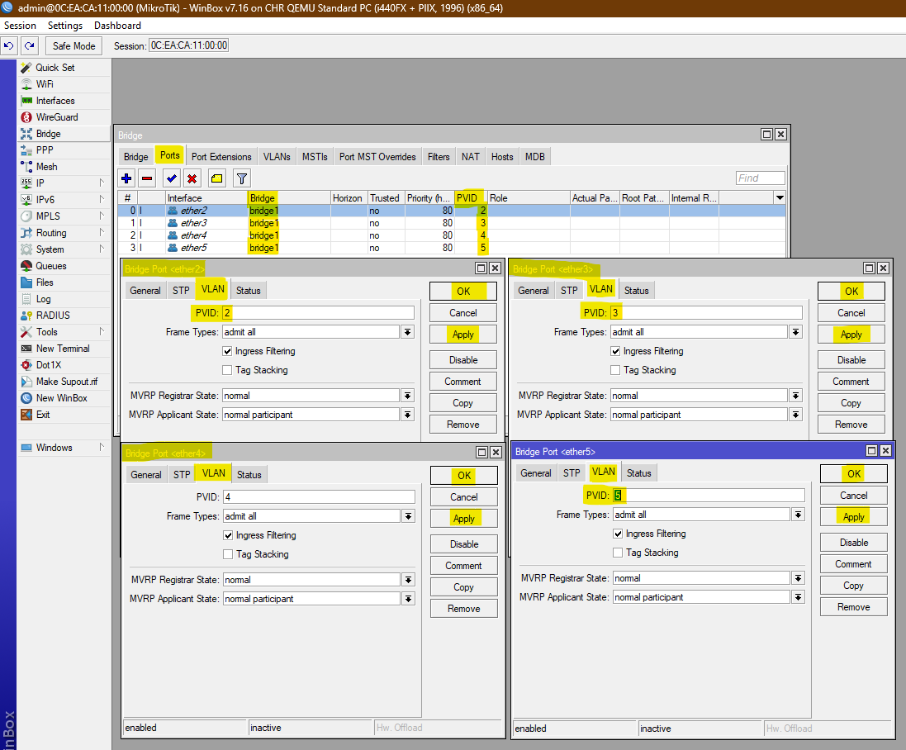

Figure 5

# Configure DHCP for Each VLAN

Step 1: Select “**IP**” On that you will find the “**DHCP SERVER**” option.

Step 2: In “**DHCP**” there you will find “**DHCP Setup**” Click on that option. Then a popup setup will come.

Step 3: In “**DHCP Server Interface**” Select the “**VLAN**” name that you have created and “**Next**”.

Step 4: In “**DHCP Address Space**” insert the local IP and their subnet as required, or it will come automatically and “**Next**”.

Step 5: In “**Gateway for DHCP Network**” provide the local IP gateways, or it will come automatically and “**Next**”.

Step 6: In the “**Addresses to Give Out**” range of IP addresses, or it will come automatically and “**Next**”.

Step 7: In “**DNS Servers**” enter the ISP DNS that we have given Google for now; it will come automatically and “**Next**”.

Step 8: In “**Lease Time**” set as default and click “**Next**”

**CMD**

/ip pool add name=[NAME OF DHCP POOL] ranges=[RANGE OF IP]

/ip dhcp-server add name=[NAME OF DHCP SERVER] interface=[ASSIGN VLAN INTERFACE] address-pool=[NAME OF DHCP POOL] disabled=no

/ip dhcp-server network add address=[VLAN IP ADDRESS WITH SUBNET] gateway=[GATEWAY OF LOCAL IP] dns-server=[DNS OF ISP]

/ip dhcp-server enable [NAME OF DHCP SERVER]

**EXAMPLE**

To assign IPs automatically to devices in each VLAN, create **DHCP servers**:

/ip pool

add name=pool_vlan2 ranges=192.168.2.2-192.168.2.200

add name=pool_vlan3 ranges=192.168.3.2-192.168.3.200

add name=pool_vlan4 ranges=192.168.4.2-192.168.4.200

add name=pool_vlan5 ranges=192.168.5.2-192.168.5.200

/

/ip dhcp-server

add interface=vlan2 address-pool=pool_vlan2 name=dhcp_vlan2 disabled=no

add interface=vlan3 address-pool=pool_vlan3 name=dhcp_vlan3 disabled=no

add interface=vlan4 address-pool=pool_vlan4 name=dhcp_vlan4 disabled=no

add interface=vlan5 address-pool=pool_vlan5 name=dhcp_vlan5 disabled=no

/

/ip dhcp-server network

add address=192.168.2.0/24 gateway=192.168.2.1 dns-server=8.8.8.8

add address=192.168.3.0/24 gateway=192.168.3.1 dns-server=8.8.8.8

add address=192.168.4.0/24 gateway=192.168.4.1 dns-server=8.8.8.8

add address=192.168.5.0/24 gateway=192.168.5.1 dns-server=8.8.8.8

/

**DHCP-VLAN2**

|  |  |
| --- | --- |
| Figure 6 | Figure 7 |
| Figure 8 | Figure 9 |
| Figure 10 | Figure 11 |

**DHCP-VLAN3**

|  |  |
| --- | --- |
| Figure 12 | Figure 13 |
| Figure 14 | Figure 15 |
| Figure 16 | Figure 17 |

**DHCP-VLAN4**

|  |  |
| --- | --- |
| Figure 18 | Figure 19 |
| Figure 20 | Figure 21 |
| Figure 22 | Figure 23 |

**DHCP-VLAN5**

|  |  |
| --- | --- |
| Figure 24 | Figure 25 |
| Figure 26 | Figure 27 |
| Figure 28 | Figure 29 |

# Configure DNS && Route to WAN (LAN1 - ether1)

## DNS

Step 1: Select “**IP**” On that you will find the “**DNS**” option.

Step 2: In “**Servers**” enter the DNS of your ISP.

Step 3: Select “**Apply**” & “**OK**”

**CMD**

ip dns/

set servers=[Enter your ISP DNS]

/

**Example**

ip dns/ set servers=8.8.8.8,1.1.1.1

/

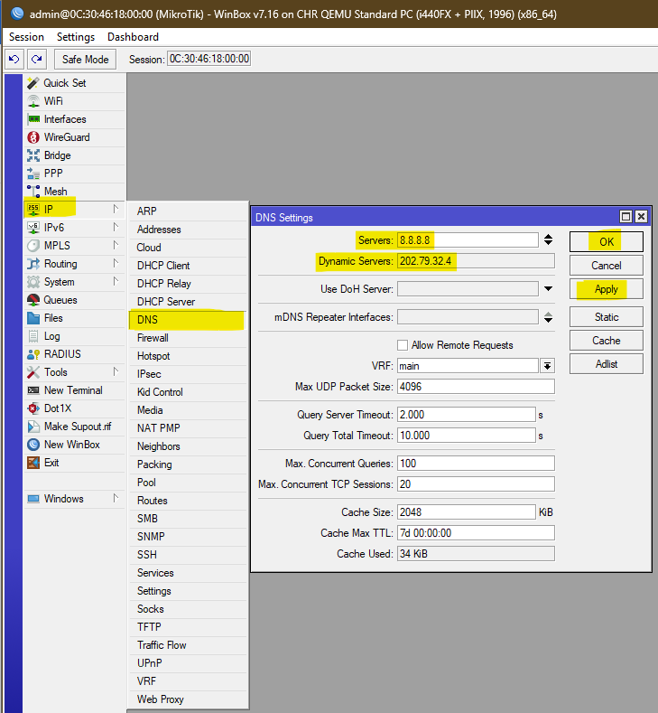

Figure 30

## Route

We assume **LAN1 (ether1) is connected to the internet with PUBLIC IP**.

Step 1: Select “**IP**” On that you will find the “**Routes**” option.

Step 2: Click on the “**add**” symbol “**+**”.

Step 3: In “**Dst. Address**” Enter “0.0.0.0/0” & In “**Gateway**” Public IP that is provided by ISP

Step 4: Select “**Apply**” & “**OK**”

**CMD**

/ip route add dst-address=0.0.0.0/0 gateway=[Gateway_IP]

**Example**

/ip route add dst-address=0.0.0.0/0 gateway=192.168.1.254

Figure 31

# Enable NAT (*Masquerade*) for Internet Access && Block traffic from Vlan

## Enable NAT (*Masquerade*) for Internet Access

Step 1: Select “**IP**” On that you will find the “**FireWall**” Option.

Step 2: Click on the “**add**” symbol “**+**”.

Step 3: In “**General**” you will find “**Chain**” leave it default “**srcnat**”

Step 4: Select “**Action**” you will find “Action” in that select “**masquerade**”

Step 5: Select “**Apply**” & “**OK**”

**CMD**

/ip firewall nat

add chain=srcnat out-interface=[Uplink_Interface] action=masquerade

/

**Example**

/ip firewall nat

add chain=srcnat out-interface=ether1 action=masquerade

/

Figure 32

## Block traffic from VLAN

Step 1: Select “**IP**” On that you will find the “**FireWall**” Option.

Step 2: Select “**Fliter Rules**” && Click on the “**add**” symbol “**+**”.

Step 3: In “**General**” you will find “**chain**” there you have to select “**forward**” && In “**In. Interface**” and “**Out. Interface**” you have selected “**Ether interface 1 / Uplink**” also check box.

Step 4: Select “**Action**” you will find “Action” in that select “**drop**”

Step 5: Select “**Apply**” & “**OK**”

To **allow internet access but block VLAN-to-VLAN traffic**, use:

**CMD**

/ip firewall filter

add chain=forward in-interface=!ether1 out-interface=!ether1 action=drop

Figure 33

## # Block traffic from

By default, all VLANs can talk to each other. If you want to **block communication between VLANs**, you need firewall rules.

Step 1: Select “**IP**” On that you will find the “**FireWall**” Option.

Step 2: Select “**Fliter Rules**” && Click on the “**add**” symbol “**+**”.

Step 3: In “**General**” you will find “**chain**” there you have to select “**forward**” && In “**In. Interface**” you have to select that “**VLAN**” for traffic pass and In “**Out. Interface**” you have select that “**VLAN**” to block the traffic.

Step 4: Select “**Action**” you will find “Action” in that select “**drop**”

Step 5: Select “**Apply**” & “**OK**”

CMD

/ip firewall filter

add chain=forward in-interface=[source-VLAN-interface] out-interface=vlan3 action=[action] comment=[your comment]

**EXAMPLE**

/ip firewall filter

**# Block traffic from VLAN2 to VLAN3, VLAN4, and VLAN5**

add chain=forward in-interface=vlan2 out-interface=vlan3 action=drop comment="Drop VLAN2 -> VLAN3"

add chain=forward in-interface=vlan2 out-interface=vlan4 action=drop comment="Drop VLAN2 -> VLAN4"

add chain=forward in-interface=vlan2 out-interface=vlan5 action=drop comment="Drop VLAN2 -> VLAN5"

**# Block traffic from VLAN3 to VLAN2, VLAN4, and VLAN5**

add chain=forward in-interface=vlan3 out-interface=vlan2 action=drop comment="Drop VLAN3 -> VLAN2"

add chain=forward in-interface=vlan3 out-interface=vlan4 action=drop comment="Drop VLAN3 -> VLAN4"

add chain=forward in-interface=vlan3 out-interface=vlan5 action=drop comment="Drop VLAN3 -> VLAN5"

**# Block traffic from VLAN4 to VLAN2, VLAN3, and VLAN5**

add chain=forward in-interface=vlan4 out-interface=vlan2 action=drop comment="Drop VLAN4 -> VLAN2"

add chain=forward in-interface=vlan4 out-interface=vlan3 action=drop comment="Drop VLAN4 -> VLAN3"

add chain=forward in-interface=vlan4 out-interface=vlan5 action=drop comment="Drop VLAN4 -> VLAN5"

# Block traffic from VLAN5 to VLAN2, VLAN3, and VLAN4

add chain=forward in-interface=vlan5 out-interface=vlan2 action=drop comment="Drop VLAN5 -> VLAN2"

add chain=forward in-interface=vlan5 out-interface=vlan3 action=drop comment="Drop VLAN5 -> VLAN3"

add chain=forward in-interface=vlan5 out-interface=vlan4 action=drop comment="Drop VLAN5 -> VLAN4"

**# Block traffic from VLAN2 to VLAN3, VLAN4, and VLAN5**

Figure 34

**# Block traffic from VLAN3 to VLAN2, VLAN4, and VLAN5**

Figure 35

**# Block traffic from VLAN4 to VLAN2, VLAN3, and VLAN5**

Figure 36

**# Block traffic from VLAN4 to VLAN2, VLAN3, and VLAN5**

Figure 37

***NOW CONNECTED TO YOUR PC and Internet connection will arrive as per VLAN interface port.***