1. First, change the switch name with “hostname and time” command.
Switch>
Switch>en
Switch>enable
Switch#configure terminal
Switch(config)#
Switch(config)#hostname KTM
KTM(config)#
KTM#clock set 09:15:30 november 20 2023
KTM#
KTM#show clock
9:15:35.873 UTC Mon Nov 20 2023
KTM#
KTM#wr
Building configuration...
[OK]
KTM#

2. Now create the VLANs using “VLAN” command.
KTM>enable
KTM#configure terminal
KTM(config)#
KTM(config)#vlan 10
KTM(config-vlan)#name Marketing
KTM(config-vlan)#vlan 20
KTM(config-vlan)#name Accounting
KTM(config-vlan)#vlan 30
KTM(config-vlan)#name Sales
KTM(config-vlan)#vlan 40
KTM(config-vlan)#name Administrator
KTM#wr
Building configuration...
[OK]
KTM#

3. Just type the “do sh vlan” command from config mod to see whether VLANs are created or not.

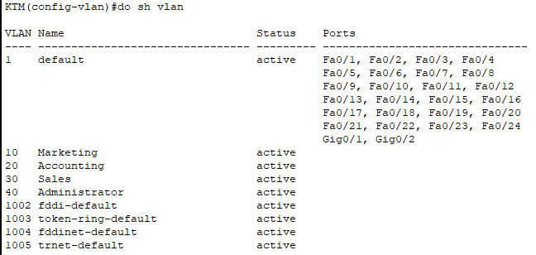

4. Now try to add interfaces to each of these VLANs. All the Interfaces ports are within the default VLAN and not yet grouped to Marketing, Accounting, and Sales. So try to add an interface to a VLAN with the “Switchport” command.

KTM>enable
KTM#configure terminal
Enter configuration commands, one per line. End with CNTL/Z.
KTM(config)#
KTM(config)#interface fastEthernet 0/1
KTM(config-if)#switchport mode access
KTM(config-if)#switchport access vlan 10
KTM(config-if)#exit
KTM(config)#interface fastEthernet 0/2
KTM(config-if)#switchport mode access
KTM(config-if)#switchport access vlan 20
KTM(config-if)#exit
KTM(config)#interface fastEthernet 0/3
KTM(config-if)#switchport mode access
KTM(config-if)#switchport access vlan 30
KTM(config-if)#exit
KTM(config)#interface fastEthernet 0/4
KTM(config-if)#switchport mode access
KTM(config-if)#switchport access vlan 40
KTM(config-if)#exit
KTM(config)#interface fastEthernet 0/5
KTM(config-if)#switchport mode access
KTM(config-if)#switchport access vlan 10
KTM(config-if)#exit
KTM(config)#interface fastEthernet 0/6
KTM(config-if)#switchport mode access
KTM(config-if)#switchport access vlan 20
KTM(config-if)#exit
KTM(config)#interface fastEthernet 0/7
KTM(config-if)#switchport mode access
KTM(config-if)#switchport access vlan 30
KTM(config-if)#exit
KTM(config)# interface fastEthernet 0/8
KTM(config-if)#switchport access mode
KTM(config-if)#switchport access vlan 40
KTM(config-if)#exit
KTM(config)# wr

