FEDERAL STATE AUTONOMOUS
EDUCATIONAL INSTITUTION OF HIGHER EDUCATION
NATIONAL RESEARCH UNIVERSITY
"HIGHER SCHOOL OF ECONOMICS"
Graduate School of Business

Artem Kozin

Navigating Market Shifts: Predictive Insights into Success and Failure Factors Across Industries

MASTER'S THESIS

Field of Study 38.04.05 "Business Informatics"
Educational Programme "Business Analytics and Big Data Systems"
Supervisor
Armen Beklaryan
Associate Professor
Moscow, 2026

Table of Contents
Abstract 4
List of Abbreviations 5
1. Introduction 5
1.1 Research Questions 7
1.2 Research Design Overview 8
2. Literature Review 9
2.1 Critical Synthesis of the Research Gap 13
3. Research Methodology 14
3.1 Research Design and Data Architecture 14
3.2 Target Construction and Missingness Logic 17
3.3 Temporal Validation and Modeling Protocol 19
3.4 Evaluation, Leakage Control, and Dashboard Design 19
4. Results 21
4.1 Panel Integrity and Target Coverage 21
4.2 Temporal Model Metrics 22
4.3 Interpretation, Calibration, and Dashboard Result 24
5. Discussion 26
5.1 Implications, Limitations, and Future Research 26
Conclusion 28
References 30
Appendices 33
Appendix A. Target Definitions and Missingness Rules 33
Appendix B. Feature-Family Dictionary 34
Appendix C. Leakage and Audit Controls 34
Appendix D. Temporal Validation Split 36
Appendix E. Dashboard Artifact 37
Appendix F. Model-Output Support 44

Abstract
This thesis develops and evaluates an audited predictive-analytics framework for examining observable company success and failure factors across industries during market shifts. The empirical artifact combines SEC Financial Statement Data Sets, EDGAR metadata, FRED macro-financial variables, a curated global-event layer, source-verified strict distress events, temporal supervised models, leakage audits, feature-family interpretation, and a dashboard artifact.
The analysis is conducted at the level of a U.S. public-company firm-period observation dated by the SEC filing date rather than by the fiscal period end date. This information-date choice keeps the empirical question forward-looking and preserves the central claim boundary: the thesis studies predictive association, not causality.
The accepted production panel contains 31,702 rows, 190 columns, 540 SEC CIKs, and 540 ticker or display identifiers. Period dates run from 2009-03-31 to 2026-02-28, and prediction dates run from 2009-04-15 to 2026-03-31.
The target hierarchy separates strict legal distress, broader conservative failure pressure, success/resilience, and four validated secondary outcomes. In the accepted temporal tests, strict legal distress functions as a clean but rare benchmark, with PR-AUC of 0.104 and F1 of 0.182. Broader failure pressure is the main failure-factor target, with random forest PR-AUC of 0.758 and F1 of 0.725. Success/resilience provides the strongest positive counterpart, with random forest PR-AUC of 0.975 and F1 of 0.938.
At the interpretation level, accounting fundamentals, financial ratios, and firm trend or deterioration features provide the main economic signal. Macro regimes and global-event windows add market-shift context for segmentation and dashboard exploration.
Keywords: predictive analytics; financial distress; firm resilience; SEC Financial Statement Data Sets; FRED; temporal validation; machine learning; dashboard; market shifts.

List of Abbreviations
- CIK: Central Index Key, the stable company identifier used by the U.S. Securities and Exchange Commission.
- EDGAR: Electronic Data Gathering, Analysis, and Retrieval system.
- FRED: Federal Reserve Economic Data.
- ML: Machine learning.
- NFCI: National Financial Conditions Index.
- P0 audit: Blocking project-integrity audit covering prediction timestamps, event-date provenance, leakage, macro timing, global-event timing, and post-event row handling.
- PR-AUC: Precision-recall area under the curve.
- ROC-AUC: Receiver operating characteristic area under the curve.
- SEC: U.S. Securities and Exchange Commission.
- SHAP: Shapley additive explanations; reviewed as interpretability literature and future-work terminology, not used as an implemented final-result method.
- VIX: CBOE Volatility Index.
- XAI: Explainable artificial intelligence.

1. Introduction
Understanding why firms remain resilient or move into pressure during market shifts is a practical problem for business analytics. Public companies disclose structured accounting data at scale, but those disclosures are observed inside changing macro-financial conditions: interest-rate cycles, credit stress, inflation shocks, oil-price movements, supply-chain disruption, banking stress, and geopolitical events.
The analytical challenge is not to find one variable that explains failure. It is to determine which observable signals help separate resilient firms from firms under pressure, and to evaluate those signals without turning prediction into causal explanation.
The thesis title, Navigating Market Shifts: Predictive Insights into Success and Failure Factors Across Industries, therefore requires more than a conventional bankruptcy-prediction exercise. Formal legal distress is useful because it has a clean event boundary, but it is rare and legally specific. Many firms experience repeated financial pressure without filing for bankruptcy, while financial resilience does not prove strategic success in the broader organizational sense.
This is why the empirical design is built around a target hierarchy. Strict legal distress anchors the study to a formal event definition; broader conservative failure pressure provides the main failure-factor outcome; and success/resilience supplies the positive counterpart. The secondary outcomes then extend the analysis into sector-relative resilience, stress resilience, recovery, and cash-flow-supported success.
The topic is timely in both practice and research. Recent bankruptcy and financial-stability reporting continues to show why distress analysis matters [1], [2]. At the same time, the academic literature shows that accounting ratios, profitability, leverage, liquidity, macro-financial conditions, and repeated firm observations can be informative for default or distress prediction. It also shows that reported performance depends heavily on target definition, validation design, and sample construction.
Classical studies by Beaver [3], Altman [4], Ohlson [5], and Zmijewski [6] established that accounting information can contain failure signals. Later work by Shumway [7], Duffie, Saita and Wang [8], Campbell, Hilscher and Szilagyi [9], Tinoco and Wilson [10], and Barboza, Kimura and Altman [11] moved the field toward dynamic, macro-aware, and machine-learning designs. The remaining problem is practical as well as methodological: a single distress label can hide the difference between legal failure, financial weakness, recovery, and resilience; random row splitting can overstate performance in time-ordered financial panels; and explanation outputs can be mistaken for causal mechanisms.
The research problem is therefore formulated as follows: how can a reproducible, temporally valid, and interpretable predictive-analytics framework be used to identify and compare observable success and failure factors across industries under market-shift conditions?
The goal of the thesis is to develop and evaluate an audited predictive-analytics framework for studying firm failure pressure, strict legal distress, and financial success/resilience across U.S. public companies and market environments. Model performance is only one part of that evaluation. The framework is also judged by target validity, timestamp discipline, leakage controls, missingness handling, feature-family interpretation, and the dashboard artifact through which results are explored. These concerns are operationalized through four research questions.

1.1 Research Questions
- RQ1 (Factor identification). Which economic feature groups are most strongly associated with strict legal distress, broader conservative failure pressure, and success/resilience across U.S. public companies?
- RQ2 (Target definition and model performance). How does target definition affect predictive performance and interpretation under temporal validation?
- RQ3 (Market-shift context). How do macro regimes and global-event windows contextualize firm outcomes across industries?
- RQ4 (Decision-support artifact). How can an audited dashboard artifact support transparent interpretation of predictive outputs without implying causal proof?

1.2 Research Design Overview
Table 1. Research design overview
Element | Definition in the thesis
Research problem | Identification and interpretation of observable success and failure factors under changing market conditions.
Research object | U.S. public-company firm-period observations built from SEC filings and market-context data.
Research subject | Predictive association between accounting fundamentals, ratios, deterioration, industry context, macro regimes, global-event windows, and future firm outcomes.
Main artifact | Audited firm-period panel, temporal models, feature-family interpretation, and dashboard artifact.
Central boundary | Predictive association and model behavior are analyzed; causal proof and live bankruptcy prediction are not claimed.
Note: The table defines the thesis at the level required for committee readability. Source: Author's synthesis from the empirical design and project audit outputs.
The research tasks follow from this design. The study first reviews literature on strategic adaptation, financial distress prediction, macro-financial market shifts, machine learning, rare-event evaluation, interpretability, missing data, and design science. It then constructs a firm-period panel from audited SEC, macro, event, and metadata sources; formalizes strict distress, broader failure pressure, success/resilience, and secondary targets; trains and evaluates temporal baseline models; audits leakage, timestamp alignment, event timing, and post-event rows; interprets model behavior through economic feature groups; and presents results through a dashboard artifact with explicit caveats.
The object of the research is the financial condition and forward outcome profile of public companies observed through structured filings and market-context variables. The subject is the observable relationship between firm financial signals, contextual market-shift variables, and future labels representing legal distress, conservative failure pressure, and financial resilience. The methods combine literature synthesis, data engineering, feature construction, temporal train-validation-test splitting, supervised learning, PR-AUC and F1 evaluation, calibration and ranking diagnostics, leakage auditing, feature-family interpretation, and design-science artifact evaluation.
The scientific novelty lies in integration and discipline rather than in a new bankruptcy algorithm. This study brings together a filing-date-aligned SEC/FRED/global-event panel, a target hierarchy, temporal validation, leakage audits, missing-aware label logic, feature-group interpretation, and a dashboard artifact in one reproducible business-analytics framework. Its practical significance is the ability to support transparent historical exploration of firm pressure and resilience while keeping the limitations of the data, targets, and model outputs visible.
The thesis is organized as follows. Chapter 1 presents the research problem, goal, questions, object, subject, methods, novelty, and practical significance. Chapter 2 reviews the literature and connects each stream to a methodological choice. Chapter 3 describes the empirical methodology, including data sources, target definitions, temporal validation, leakage controls, and dashboard design. Chapter 4 reports panel integrity, target counts, model metrics, calibration and ranking diagnostics, feature-family interpretation, and dashboard evidence. Chapter 5 discusses implications, limitations, and future research. The conclusion answers RQ1 to RQ4 directly, and the appendices provide target definitions, feature families, leakage controls, temporal split details, dashboard screenshots, and model-output support.

2. Literature Review
This chapter synthesizes six literature streams that shape the empirical design: strategic adaptation and resilience, classical distress prediction, dynamic and macro-financial default prediction, machine learning and rare-event evaluation, interpretability and decision support, and missing-data and data-integrity methods. The review is not intended as a source-by-source inventory. Its purpose is to show why the study requires a target hierarchy, a firm-period panel, filing-date timestamps, temporal validation, feature-family interpretation, and a dashboard artifact.
Strategic-management theory gives the thesis title its broader vocabulary of success and failure. Barney [12] links performance differences to resources that are valuable, rare, difficult to imitate, and organizationally embedded. Teece, Pisano and Shuen [13] move the discussion toward dynamic capabilities, which is important in market-shift settings because firms must adapt as environments change. Hannan and Freeman [14] provide a contrasting organizational-ecology view in which inertia and selection also shape survival. These theories justify the broad framing, but they also set a measurement boundary: SEC financial statements do not directly observe capabilities, culture, managerial quality, or strategic choice. The empirical target therefore measures financial resilience, not total organizational success.
Resilience research sharpens the same boundary. Linnenluecke [15] and Duchek [16] show that organizational resilience involves preparation, adaptation, response, and learning. Hepfer and Lawrence [17] emphasize that resilience is heterogeneous rather than a single measurable trait. A financial success/resilience target should therefore be read as a measurable counterpart, not as a complete theory of resilient organizations. In this thesis, success/resilience means future profitability, positive ROA, acceptable leverage, and absence of formal distress under a missing-aware rule.
Once the scope is narrowed to financial evidence, classical distress prediction becomes the accounting foundation. Beaver [3] showed that financial ratios can separate failed and non-failed firms before failure. Altman [4] combined ratios into a discriminant model, while Ohlson [5] introduced probabilistic bankruptcy prediction and Zmijewski [6] highlighted methodological concerns in distress modeling. Taffler [18], Platt and Platt [19], and Altman and Narayanan [20] further show that solvency and failure classification are long-standing research problems rather than recent inventions of machine learning. The contribution here is not the discovery that ratios matter; it is the disciplined integration of ratio, fundamental, trend, macro, event, target, validation, and dashboard components.
The move from static classification to repeated observation is developed in dynamic and market-based default research. Shumway [7] criticizes static designs and argues that bankruptcy prediction should treat firms as observed repeatedly over time. Duffie, Saita and Wang [8] use stochastic covariates in multi-period default prediction, and Campbell, Hilscher and Szilagyi [9] link distress risk to profitability, leverage, and market information. Merton [21], Hillegeist et al. [22], Bharath and Shumway [23], and Bauer and Agarwal [24] provide the structural, distance-to-default, and hazard-model comparison tradition. These works justify the firm-period perspective and future horizons. They also mark a scope boundary: market-value and volatility features are not part of the final production model in this thesis.
Market shifts enter the design through macro-financial literature. Bernanke, Gertler and Gilchrist [25] describe the financial accelerator, in which credit frictions amplify shocks. Gilchrist and Zakrajsek [26] show that credit spreads contain business-cycle information, while Longstaff, Mithal and Neis [27] caution that spread measures combine default and liquidity components. Tinoco and Wilson [10] explicitly combine accounting, market, and macro variables in distress prediction. In the present study, macro and global-event fields provide market-shift context and segmentation; they are not claimed to replace firm-level financial condition as the main empirical signal.
Recent systematic reviews confirm that bankruptcy and distress prediction remain active, methodologically diverse fields [28]-[31]. Bragoli et al. [32] show that industry variables may matter. Other studies also warn that country, sector, and institutional setting influence predictor behavior [33]-[39]. These findings support a cautious boundary for the present thesis: results from a U.S. SEC panel cannot be mechanically generalized to private firms, Russian companies, emerging markets, or other accounting regimes.
Method choice follows from that literature. Breiman [40] provides the random-forest foundation, Friedman [41] the gradient-boosting foundation, and Pedregosa et al. [42] the scikit-learn implementation reference. Lessmann et al. [43] and Barboza, Kimura and Altman [11] justify comparing multiple model families rather than relying on one specification. Rare-event evaluation is especially important because strict legal distress is sparse. Fawcett [44] explains ROC analysis, while Davis and Goadrich [45] and Saito and Rehmsmeier [46] show why precision-recall metrics are more informative when positives are rare. Chawla et al. [47] and Burez and Van den Poel [48] show that class imbalance is a real modeling issue, although this thesis does not make synthetic oversampling the main empirical story.
Interpretability is necessary because predictive insights must be understandable to be useful. Lundberg and Lee [49], Ribeiro, Singh and Guestrin [50], Guidotti et al. [51], Bussmann et al. [52], Zhang et al. [53], and Molnar [54] show how explanation methods can make complex predictors more usable. The same literature also requires caution: explanation is not causality. The final empirical results in this thesis use bounded feature-family interpretation and do not claim that feature importance proves a causal mechanism. SHAP and LIME are reviewed as literature and future-work context, not as implemented final-result methods.
This interpretability problem connects naturally to design-science and business-analytics research. Hevner et al. [55] and Peffers et al. [56] justify evaluating an information-system artifact, not only a statistical model. Chen, Chiang and Storey [57] position business analytics as a field that links data, methods, and decision processes. Shneiderman [58] and Arnott and Pervan [59] support interactive decision-support design. The dashboard is therefore treated as a research artifact for historical exploration, model transparency, and caveat communication rather than as a governed production system or live legal-bankruptcy oracle.
Finally, missing-data literature is central because SEC accounting panels contain structural, reporting, and derivation gaps. Rubin [60], Little and Rubin [61], Graham [62], and van Buuren [63] show that missingness mechanisms affect inference and should not be ignored. The empirical design preserves nulls, distinguishes unknown future labels from negatives, and excludes missingness indicators from substantive feature-group interpretation. Missingness indicators may help a model handle data structure, but they are not interpreted as economic causes of success or failure.
Table 2. Literature synthesis and design response
Literature stream | Representative authors | Contribution to thesis | Prior limitation | Thesis response
Classical distress prediction | Beaver; Altman; Ohlson; Zmijewski [3]-[6] | Supports accounting ratios, profitability, leverage, and liquidity. | Often static and tied to one distress definition. | Uses target hierarchy and firm-period panel.
Dynamic/default prediction | Shumway; Duffie et al.; Campbell et al. [7]-[9] | Supports repeated observations and forward horizons. | Often not connected to dashboard artifact or missing-aware targets. | Uses filing-date timestamps and temporal validation.
Macro-finance and market shifts | Bernanke et al.; Gilchrist and Zakrajsek; Tinoco and Wilson [10], [25], [26] | Supports macro regimes, spreads, rates, inflation, and financial conditions. | Macro variables can be detached from firm-specific interpretation. | Combines firm features with macro regimes and event windows.
Machine learning and rare events | Breiman; Friedman; Davis and Goadrich; Saito and Rehmsmeier [40], [41], [45], [46] | Supports tabular ML, PR-AUC, F1, ranking, and imbalanced evaluation. | High ROC-AUC may mislead under rare positives. | Reports PR-AUC, F1, positives, calibration, and ranking diagnostics.
Interpretability and design science | Lundberg and Lee; Ribeiro et al.; Hevner et al.; Peffers et al. [49], [50], [55], [56] | Supports interpretation and artifact evaluation. | Explanations can be mistaken for causality. | Uses bounded feature-family interpretation and dashboard caveats.
Note: The table summarizes how the reviewed literature informs the empirical design. Source: Author's synthesis from the cited literature.

2.1 Critical Synthesis of the Research Gap
The literature establishes strong foundations, but it does not remove the need for the present empirical design. Classical distress models demonstrate the usefulness of accounting signals, yet many were built around smaller samples, static comparisons, or a single failure definition. Dynamic default models address part of the time dimension, but they often emphasize event prediction rather than dashboard-supported interpretation. Machine-learning studies improve classification power; their results are difficult to defend when target construction, timestamp alignment, and leakage controls are underdocumented.
The first gap is target ambiguity. A study of success and failure factors cannot rely only on formal bankruptcy, because bankruptcy is legally specific and sparse. It also cannot treat every weak financial ratio as failure, because that would erase the difference between pressure, distress, and ordinary variation. The target hierarchy responds by assigning different empirical roles to strict legal distress, broader conservative pressure, success/resilience, and secondary dimensional outcomes.
The second gap is validation realism. Financial panels are time ordered, and firm observations are serially related. Random row splitting can make results look better than they would in a forward-looking setting because the model can learn from later market regimes or adjacent observations. The study therefore separates train, validation, and test observations by prediction date, which is closer to the setting in which a user has past filings and evaluates later outcomes.
The third gap is interpretation discipline. Interpretability literature offers many methods, but explanation outputs become risky when they are read as causal proof. This thesis uses economic feature-family interpretation because it is easier to defend at the level of business factors: fundamentals, ratios, trends, macro context, and industry context. Individual feature rankings remain useful diagnostics, but the argument emphasizes groups because they connect model behavior to economic categories without overstating precision.
The fourth gap is artifact integration. A model table alone cannot show whether data coverage, target denominators, missing labels, feature groups, and caveats are understandable to a user. A dashboard can make these elements inspectable, but only if limitations remain part of the artifact rather than an afterthought. For this reason, the thesis treats the dashboard as a design-science output, not as a decorative visualization layer.

3. Research Methodology

3.1 Research Design and Data Architecture
The methodology follows an applied predictive-analytics and design-science design. The empirical system builds a firm-period panel, constructs future outcome labels, trains baseline models under temporal validation, audits the data and feature set, interprets model behavior through economic feature families, and presents the results in a dashboard artifact. The unit of observation is one firm, one accounting period, and one prediction date. The prediction date is the SEC filing date, which represents the information availability date used for prediction.
Four source families support this design. SEC Financial Statement Data Sets and EDGAR metadata provide structured accounting facts and filing dates [64], [65]. FRED and the Chicago Fed provide official macro-financial time series for rates, spreads, inflation, labor, demand, oil, volatility, and financial-conditions context [66], [67]. A curated global-event calendar maps observed event windows to market-shift context. A manually maintained and source-verified formal distress-event file supplies strict legal distress labels. These sources are joined with industry and firm metadata for sector filtering and dashboard interpretation.
SEC accounting facts are processed conservatively because period alignment is central to the study. Balance-sheet variables use point-in-time values. Flow variables use current-period values when reported and avoid selecting prior-year comparative facts as current-period facts. The selected-fact provenance audit verifies current-period alignment and selected-value consistency. The final acceptance audit reports 700,844 selected SEC fact rows, zero selected rows with ddate not equal to period, and zero selected-value mismatches above tolerance. This does not mean that SEC taxonomy harmonization is perfect; it means that the selected production values are auditable under the implemented conservative mapping rules.
The information-date logic is one of the most important controls in the empirical design. A fiscal period end date identifies the period covered by a report, but it is not the date when an analyst could have used the information. The production panel therefore defines prediction_date as the SEC filing date for every observation, preventing the model from treating a December fiscal period end as if the full filed report were observable on that date.
Identifier handling follows the same conservative logic. CIK is treated as the stable SEC company key. Tickers are useful for readability, dashboard filters, and event-source matching, but they can change, delist, or function as aliases. The PCG/PGNPQ duplicate-CIK issue was resolved by preserving one CIK history and retaining alias metadata for event lookup. Without this control, duplicate histories with different labels could create artificial evidence and contaminate both counts and model training.
The macro layer is joined by prediction date and interpreted as context available at or before the information date. It includes rate, spread, volatility, inflation, labor, demand, housing, credit, oil, dollar, and financial-conditions variables, as well as regime indicators derived from those series. The global-event layer provides curated historical context for periods such as pandemic stress, banking stress, oil shocks, geopolitical war, monetary inflation, sovereign debt stress, and supply-chain disruption; it is not a live event feed.
Table 3. Data sources and methodological role
Source family | Role in thesis | Important limitation
SEC Financial Statement Data Sets | Accounting fundamentals, filing dates, and structured firm-period facts. | Requires conservative concept mapping, period selection, and provenance audits.
SEC EDGAR metadata | Filing information date and identifier context. | Filing availability differs from fiscal period end date.
FRED and macro-financial series | Rates, spreads, inflation, labor, demand, credit, oil, VIX, and financial-conditions context. | Contextual variables, not causal firm-level explanations by themselves.
Curated global-event calendar | Historical market-shift windows for dashboard and sector/event comparison. | Not a full live news or event database.
Distress-event date file | Strict legal distress labels and forward event windows. | Clean benchmark, but rare and not a universal bankruptcy database.
Industry and firm metadata | Sector filters, CIK/ticker identifiers, SIC, and dashboard context. | Identifiers and sampling metadata are excluded from economic prediction features when inappropriate.
Note: Source roles are limited to the empirical scope implemented in the thesis. Source: Author's synthesis from project data documentation and official source documentation.
Table 4. Current production panel
Item | Current value
Rows | 31,702
Columns | 190
SEC CIKs | 540
Ticker/display identifiers | 540
Period-date range | 2009-03-31 to 2026-02-28
Prediction-date range | 2009-04-15 to 2026-03-31
Prediction-date policy | prediction_date = filed_date for all rows
Note: These are the accepted May 12, 2026 production values. Historical 260-firm, 16,640-row, and random-split values are not used in the final empirical claims. Source: THESIS_PROJECT_AUDIT_REVIEW_20260512.md and FINAL_SOURCE_OF_TRUTH_INDEX.md.

3.2 Target Construction and Missingness Logic
With information dates fixed, target construction becomes the next major design choice. The strict legal distress target uses formal distress event dates after the prediction date and within 456 days. Broader conservative failure pressure uses strict distress or repeated future financial weakness with balance stress, deterioration, or unhealthy-future signals. Success/resilience uses future observations with positive net income, positive ROA, acceptable leverage/assets, and no formal distress. Secondary outcomes support dimensional analysis; they do not replace the three primary targets.
The suffixes in target names require careful reading. The strict distress target uses a four-quarter legal-event horizon operationalized as 456 calendar days. The broader and secondary next_4obs targets evaluate the next four future firm observations. The success_resilience_next_4q name is retained from the production workflow, but the implemented missing-aware logic evaluates the next four future firm observations. Missing future information is preserved as unknown when a valid label cannot be assigned.
Broader failure pressure is conservative by design. A temporary weak quarter is not enough for a positive label. Positive labels require formal distress or repeated future profitability weakness combined with serious balance stress, deterioration, or unhealthy-future evidence. This makes the target broader than legal distress but narrower than loose financial weakness. It is suitable for failure-factor analysis, not as a bankruptcy label.
Success/resilience is conservative in a different way. It requires enough observed future components to judge the label. If future net income, ROA, and leverage/assets are not sufficiently observed, the target remains missing rather than becoming an automatic non-success label. This missing-aware logic prevents missing leverage or accounting fields from being silently converted into negative success outcomes.
The secondary targets are included because success and failure are multidimensional. Industry-relative resilience asks whether a firm performs well compared with sector-year peers. Stress resilience restricts attention to elevated market-stress observations. Recovery starts from weak current conditions. Quality-success-cashflow adds operating-cash-flow support to the success idea. These targets enrich the interpretation while remaining secondary to the three primary outcomes.
Table 5. Target hierarchy and label counts
Target | Known | Pos. | Missing | Role
Strict legal  distress | 31,702 | 207 | 0 | Strict legal distress benchmark
Broader failure  pressure | 29,805 | 3,003 | 1,897 | Main broader failure-pressure target
Success/  resilience | 20,152 | 12,519 | 11,550 | Main success/resilience target
Industry-relative  resilience | 20,039 | 8,093 | 11,663 | Validated secondary production outcome
Stress  resilience | 5,901 | 3,707 | 25,801 | Validated secondary production outcome
Recovery | 11,375 | 5,578 | 20,327 | Validated secondary production outcome
Cash-flow quality  success | 16,767 | 9,852 | 14,935 | Validated secondary production outcome
Note: Known rows exclude target-missing observations for each label. Missing labels are validity-preserving unknowns, not automatic negatives. Display-label mapping: Strict legal distress = distress_next_4q; broader failure pressure = failure_pressure_conservative_v2_next_4obs; success/resilience = success_resilience_next_4q; industry-relative resilience = industry_relative_resilience_next_4obs; stress resilience = stress_resilience_next_4obs; recovery = recovery_next_4obs; cash-flow quality success = quality_success_cashflow_next_4obs. Source: Author's calculations from the production panel and saved target-definition outputs.

3.3 Temporal Validation and Modeling Protocol
Table 6. Primary temporal-validation split
Split | Prediction-date  range | Target | Rows | Positives | Purpose
Train | 2009-04-15 to 2018-12-27 | Strict legal  distress | 17,145 | 58 | Model fitting
Train | 2009-04-15 to 2018-12-27 | Broader failure  pressure | 17,156 | 1,557 | Model fitting
Train | 2009-04-15 to 2018-12-21 | Success/  resilience | 11,064 | 7,034 | Model fitting
Validation | 2019-01-08 to 2021-12-22 | Strict legal  distress | 6,045 | 53 | Model and threshold selection
Validation | 2019-01-08 to 2021-12-22 | Broader failure  pressure | 6,032 | 836 | Model and threshold selection
Validation | 2019-01-08 to 2021-12-22 | Success/  resilience | 4,192 | 2,415 | Model and threshold selection
Test | 2022-01-05 to 2024-12-20 | Strict legal  distress | 5,872 | 96 | Final forward-time evaluation
Test | 2022-01-05 to 2024-12-20 | Broader failure  pressure | 5,735 | 575 | Final forward-time evaluation
Test | 2022-01-05 to 2024-12-20 | Success/  resilience | 4,047 | 2,648 | Final forward-time evaluation
Note: The split is based on prediction_date, not period_date. Later observations are not used to train earlier predictions. Counts are target-specific because missing-aware targets have different known-label denominators. Display-label mapping: Strict legal distress = distress_next_4q; broader failure pressure = failure_pressure_conservative_v2_next_4obs; success/resilience = success_resilience_next_4q. Source: Author's calculations from saved temporal model outputs.
Although the accepted production panel includes later filing observations through 2026 for data coverage and dashboard context, the final temporal test window ends in 2024. This is because the forward-looking labels require sufficient subsequent observations or event horizons to mature. Later rows are therefore retained for panel completeness and latest-filing exploration, but they are not used as final temporal test observations.

3.4 Evaluation, Leakage Control, and Dashboard Design
This temporal split is deliberately different from a random 80/20 split. A random row split can let the model learn from later periods while being evaluated on earlier or adjacent observations from the same time environment. The risk is especially high in repeated firm-period panels, where the same company can appear many times. The final design evaluates forward-time generalization: earlier prediction dates train the model, the intermediate period selects thresholds and model choices, and the later period is held for final evaluation.
The baseline model families are intentionally standard and reproducible: logistic regression as a linear reference, random forest for nonlinear tabular interactions, and gradient boosting for boosted-tree comparison. Numeric features are imputed within the training pipeline using training-learned medians; categorical features are encoded within the pipeline. Missingness indicators created by the imputer may support prediction, but they are excluded from substantive feature-family interpretation. The final production workflow does not rely on AutoGluon as the main empirical model.
Evaluation metrics are matched to target prevalence. ROC-AUC is reported as a ranking measure across thresholds, but PR-AUC, precision, recall, F1, confusion matrices, calibration, and top-rank diagnostics are more informative for rare or imbalanced outcomes. Because strict distress is especially rare, its PR-AUC and top-rank enrichment are more informative than any general claim of bankruptcy prediction accuracy.
Leakage control is treated as part of the methodology rather than as a post-hoc check. The feature blacklist excludes target columns, future outcome columns, post-event indicators, event dates, days-to-event fields, future observations, sample-design labels, identifiers not intended as economic predictors, and dashboard-only explanatory fields. The May 12 audit reports that model feature-list leakage checks passed for the production targets. Macro and global-event timing audits also passed, supporting the claim that future market information is not used as a predictor.
The dashboard artifact follows design-science logic. It exposes dataset composition, target coverage, data missingness, model metrics, feature groups, firm trajectories, macro and event comparisons, and caveat panels. Its purpose is transparent decision support and historical exploration, not production risk scoring, live SEC monitoring, or legal-bankruptcy prediction.
The model-output protocol separates model selection from final evaluation. Candidate models and thresholds are selected on the validation period. Final test metrics are reported after those choices are fixed. Calibration diagnostics use validation-period predictions to choose calibration and then report test-period calibration outputs. This ordering protects the test period from becoming a tuning set.
Feature interpretation is organized at two levels. Economic feature-family importance is the primary interpretation layer in the thesis. Detailed feature and reason-code outputs remain useful for secondary diagnostics. The study emphasizes the first level because it is more stable for academic interpretation and less likely to invite causal overreading than isolated single-feature ranks.

4. Results

4.1 Panel Integrity and Target Coverage
The results are presented in an order that supports empirical interpretation: panel integrity, target prevalence, baseline temporal model metrics, target-specific interpretation, calibration and ranking diagnostics, feature-family interpretation, and dashboard evidence. This sequence matters because model scores are only meaningful after the reader understands what data were built, what the labels mean, and how the test period was protected from future information.
The structural result is straightforward. The accepted production panel contains 31,702 rows, 190 columns, 540 SEC CIKs, and 540 ticker/display identifiers. Prediction dates are filing dates for all rows. Duplicate ticker-period-prediction and CIK-period-prediction rows are zero after the duplicate-handling fixes. Post-event rows are retained for historical dashboard context but excluded from primary forward-looking model training. These checks support the audit-readiness of the empirical system.
Target prevalence gives the first substantive reading of the hierarchy. Strict legal distress has 207 positives among 31,702 known rows, making it a rare-event benchmark. Broader conservative failure pressure has 3,003 positives among 29,805 known rows, which makes it better suited for failure-factor analysis. Success/resilience has 12,519 positives among 20,152 known rows, giving the thesis a positive financial-resilience counterpart with a different denominator and class balance. The secondary targets add interpretable dimensions, but they remain secondary production outcomes.
These denominator differences are not technical clutter. A strict legal distress target can be known for every row because a formal event either falls within the 456-day window or does not. A missing-aware success target requires future observations with enough financial components. A secondary stress-resilience target is only meaningful when current stress is present and future health can be observed. For that reason, the thesis reports known rows, missing rows, positives, and test positives rather than only percentages.
The audit outputs also distinguish structural readiness from empirical validity. Passing file parsing, leakage, and timestamp audits does not prove the economic truth of the model. It shows that the empirical artifact is coherent enough for model evaluation and thesis interpretation. Data-engineering success is therefore a necessary condition for the thesis, not the final research result by itself.

4.2 Temporal Model Metrics
Table 7. Baseline temporal test metrics
Target | Best  model | Test rows | Test positives | PR-AUC | F1
Strict legal  distress | Gradient boosting | 5,872 | 96 | 0.104 | 0.182
Broader failure  pressure | Random forest | 5,735 | 575 | 0.758 | 0.725
Success/  resilience | Random forest | 4,047 | 2,648 | 0.975 | 0.938
Industry-relative  resilience | Gradient boosting | 4,098 | 1,678 | 0.855 | 0.787
Stress  resilience | Random forest | 3,028 | 1,920 | 0.974 | 0.937
Recovery | Random forest | 2,419 | 1,199 | 0.977 | 0.915
Cash-flow quality  success | Gradient boosting | 3,998 | 2,458 | 0.953 | 0.920
Note: Test-period metrics from accepted baseline outputs; labels follow Table 5. Source: Author's calculations from saved baseline model outputs.
Strict legal distress is best read as a rare-event benchmark and ranking problem. In the temporal test period, the accepted gradient-boosting baseline records PR-AUC of 0.104 and F1 of 0.182 with 96 positive cases. The modest values are substantively informative: formal legal distress is difficult to predict in a broad public-company panel, but the target anchors the hierarchy to a clean event definition and allows top-ranked observations to be compared with the rare-event base rate.
Broader conservative failure pressure provides the main failure-factor lens. The random forest baseline reaches test PR-AUC of 0.758 and F1 of 0.725 with 575 positives in the test period. Its stronger performance follows from a more learnable and economically broader label: repeated serious financial pressure can be observed even when it does not culminate in formal legal distress. The interpretation remains bounded. This target is a conservative pressure label for factor analysis, not bankruptcy itself.
Success/resilience plays the complementary role. The random forest baseline reaches test PR-AUC of 0.975 and F1 of 0.938 with 2,648 positives in the test period. Because the positive class is much more common than strict distress, the metric should be interpreted relative to the target definition and base rate rather than compared mechanically with the rare legal-event benchmark. Its meaning is narrower and precise: future observations with positive net income, positive ROA, acceptable leverage/assets, and no formal distress under missing-aware label logic.
The four validated secondary production outcomes add dimensional support. Industry-relative resilience captures peer-relative performance and leverage standing. Stress resilience focuses on observations in elevated market stress. Recovery asks whether weak current observations later move toward healthier future states. Quality-success-cashflow requires resilience supported by positive operating cash flow. Together, these outcomes strengthen dashboard exploration and target comparison without replacing the primary hierarchy or implying causal turnaround mechanisms.
Metric choice is part of the interpretation. For rare targets, a model can rank some positives higher than negatives while still producing limited precision or recall at a decision threshold. PR-AUC, F1, and top-rank enrichment make this tradeoff visible. For common positive targets, very high PR-AUC must be read together with the base rate and target definition. This discipline matters because the three primary targets differ sharply in prevalence.
The accepted baselines are not presented as an exhaustive algorithm search. Random forest and gradient boosting are strong tabular baselines, and advanced boosted-tree robustness exists in the project outputs. The thesis argument does not depend on claiming that every possible model family was tried. Its empirical contribution is the audited target-and-validation framework and its interpretable results, not a leaderboard competition.
Table 8. P0 audit summary
Audit | Status | Interpretation
Prediction timestamp | PASS | All rows use filing-date prediction timestamps in the current panel.
Distress event dates | PASS | Formal strict-distress rows have source-provenance records.
Leakage | PASS | Target, future, event, and metadata leakage fields are excluded from model features.
Macro lag | PASS | Macro variables are aligned to prediction dates.
Global-event timing | PASS | Event fields are attached through observed event windows.
Post-event rows | PASS | Post-event rows are retained for history but excluded from primary forward models.
Note: The audit results support structural validity and timing discipline; causal validity is outside the claim. Source: Author's synthesis from project audit outputs.

4.3 Interpretation, Calibration, and Dashboard Result
Table 9. Economic feature-group interpretation for primary targets
Target | Model | Feature group | Share excl.  missingness
Strict legal  distress | Gradient boosting | Accounting fundamentals | 53.2%
Strict legal  distress | Gradient boosting | Firm trend / deterioration | 27.9%
Strict legal  distress | Gradient boosting | Financial ratios | 16.7%
Broader failure  pressure | Random forest | Accounting fundamentals | 36.9%
Broader failure  pressure | Random forest | Firm trend / deterioration | 34.6%
Broader failure  pressure | Random forest | Financial ratios | 27.3%
Success/  resilience | Random forest | Financial ratios | 43.2%
Success/  resilience | Random forest | Firm trend / deterioration | 29.1%
Success/  resilience | Random forest | Accounting fundamentals | 26.2%
Note: Shares are aggregated by economic feature family and exclude missingness indicators from substantive interpretation. Target display labels follow the mapping in Table 5. Source: Author's calculations from saved feature-contribution outputs.
Table 10. Calibration and ranking interpretation
Target | Calibration / ranking evidence | Interpretation
Strict legal  distress | Calibrated test PR-AUC about 0.100; top 1% precision 18.6% and 11.4x lift. | Rare formal events remain difficult, but top-ranked observations are enriched relative to the base rate.
Broader failure  pressure | Calibrated test PR-AUC about 0.739; top 10% captures 73.7% of positives with 73.9% precision. | Useful alert-list behavior for broader failure-pressure review.
Success/  resilience | Calibrated test PR-AUC about 0.972 and test Brier 0.0615. | Strong positive financial-resilience counterpart under missing-aware labels.
Note: Calibrated probabilities are validation-calibrated model outputs, not true live event probabilities. Target display labels follow the mapping in Table 5. Source: Author's calculations from saved calibration and ranking outputs.
Feature-family interpretation provides the most defensible answer to the substantive factor question. Across the primary targets, accounting fundamentals, financial ratios, and firm trend/deterioration features dominate the economic interpretation layer. This pattern is consistent with the classical financial-distress literature and modern numerical-indicator reviews [3]-[6], [28]-[31]. Macro conditions, regimes, and global-event variables still matter because they describe the market-shift setting in which firm condition is observed. The current results do not support a claim that macro variables replace firm fundamentals as the main predictive signal.
The dashboard result is practical rather than purely statistical. The artifact presents dataset and target composition, data coverage and missingness, primary and secondary model metrics, feature groups, firm explorer views, macro/event comparisons, target timelines, and caveat panels. By placing these elements together, it helps users separate raw accounting values, target labels, model scores, feature groups, and claim boundaries. This supports decision-making transparency without turning the dashboard into live legal-bankruptcy prediction or causal proof.
Taken together, the empirical answer is balanced. Strict legal distress is clean, rare, and difficult. Broader failure pressure is the main failure-factor outcome because it has enough positives and a conservative economic interpretation. Success/resilience is the strongest positive counterpart. The secondary targets extend the analysis into relative resilience, stress resilience, recovery, and cash-flow-supported quality. The main associated factor groups are financial and accounting in nature, while macro and event windows provide context and segmentation.
Additional project checks are consistent with this interpretation: firm-level fundamentals, ratios, and deterioration remain the central layer, while macro and event features support contextual segmentation.
The dashboard evidence closes the empirical loop by making the results inspectable. A reader can move from aggregate target counts to model metrics, from model metrics to feature groups, from feature groups to firm trajectories, and from firm trajectories to macro/event context. The caveat panels are part of that contribution because they reduce the risk that predictive outputs will be read as causal diagnosis or live operational risk scoring.

5. Discussion

5.1 Implications, Limitations, and Future Research
The first implication is that the thesis should not be presented as a simple bankruptcy-prediction success story. The strict legal distress target is valuable precisely because it is clean, rare, and difficult. Its modest PR-AUC and F1 are not weaknesses to hide; they show that formal legal distress is a hard benchmark in a broad public-company panel. That result makes the broader target hierarchy necessary rather than cosmetic.
A second implication concerns target design. A single binary success/failure label would mix formal legal events, repeated financial weakness, ordinary profitability, sector-relative performance, stress survival, and recovery into one ambiguous category. The hierarchy separates these meanings. As a result, differences in performance across targets become interpretable: target definition changes prevalence, denominator, learnability, and managerial meaning.
The third implication is substantive. Firm-level accounting and deterioration signals remain central in the accepted models. The feature-group outputs show that accounting fundamentals, ratios, and trends are the main economic interpretation groups for the primary tree-based models. This does not prove causality, but it does indicate that model behavior is economically plausible and not driven by hidden identifiers or target leakage. For managers and analysts, profitability, leverage, liquidity, cash availability, balance-sheet structure, operating performance, and deterioration trends remain visible in predictive systems.
Macro regimes and global events should be read as context rather than as a competing master explanation. A high-rate regime, oil shock, pandemic window, banking-stress episode, or supply-chain event does not affect every firm equally. The dashboard helps compare firms and sectors within these environments, but the current evidence does not justify a claim that market-shift variables dominate firm condition. Their main value is segmentation, historical comparison, and interpretation of the environment surrounding the firm-level signal.
In practical terms, the artifact has bounded but concrete managerial value. A manager, analyst, investor, or supervisor can use the dashboard to inspect target coverage, compare strict distress with broader pressure and resilience, review model metrics, identify top feature groups, and examine firm histories under macro contexts. The artifact supports triage and explanation. It does not replace detailed due diligence, legal analysis, credit underwriting, or managerial judgment.
For researchers, the most transferable contribution is the target-design discipline. The same hierarchy could be adapted to other jurisdictions, private-company datasets, banking portfolios, or sector-specific studies, but only if outcome definitions, timestamps, missingness rules, and leakage controls are rebuilt for the new setting. The U.S. SEC/FRED design is reproducible and useful, but it is not automatically portable to Russian firms, emerging markets, or private-company data.
The limitations follow from the same design choices. The panel is U.S. public-company oriented and reflects SEC reporting rules, public-firm disclosure incentives, and U.S. market institutions. Strict distress event dates are source-verified for the current formal rows, but the file is not a universal legal bankruptcy database. SEC concept mapping is conservative and audited, but it is not perfect taxonomy harmonization. Missingness remains material for some accounting concepts and targets. Feature importance and feature-family shares are model-behavior evidence, not causal mechanisms. Finally, the dashboard is a research artifact, not a governed production system.
Future research can extend the framework in several directions. Market-price variables and distance-to-default measures would connect the accounting panel with structural credit-risk literature, provided that timestamp alignment and coverage are maintained. Textual disclosures, earnings-call language, ESG ratings, patents, HR measures, and customer sentiment could add richer explanatory dimensions, but none of these should be claimed without implementation and audit. Formal interpretability methods such as SHAP, permutation importance, partial dependence, and stability testing could deepen explanation in later versions. User studies could evaluate whether the dashboard improves analyst understanding of target definitions, uncertainty, and caveats.

Conclusion
The thesis set out to determine how a reproducible, temporally valid, and interpretable predictive-analytics framework can identify and compare observable success and failure factors across industries under market-shift conditions. The answer is that such a framework must combine audited data construction, filing-date prediction timestamps, target hierarchy, temporal validation, leakage controls, missing-aware labels, feature-family interpretation, and transparent dashboard presentation. Its contribution is not causal discovery or a universal bankruptcy model. It is a disciplined business-analytics artifact for predictive association and decision support.
For RQ1, the evidence points to accounting fundamentals, financial ratios, and firm trend/deterioration features as the economic feature groups most strongly associated with strict legal distress, broader conservative failure pressure, and success/resilience across the primary targets. Missingness indicators are excluded from substantive interpretation. Macro regimes and global-event variables provide context and segmentation, but the current results do not show that they replace firm-level financial condition as the main predictive signal.
RQ2 is answered by the contrast among the targets. Target definition changes both performance and meaning. Strict legal distress is rare and difficult, with test PR-AUC of 0.104 and F1 of 0.182 in the accepted baseline. Broader conservative failure pressure is more suitable for failure-factor analysis, with test PR-AUC of 0.758 and F1 of 0.725. Success/resilience is the strongest positive counterpart, with test PR-AUC of 0.975 and F1 of 0.938. These results cannot be ranked as if they were the same outcome; each target has a different denominator, prevalence, and interpretation.
RQ3 concerns the role of macro regimes and global-event windows. They contextualize firm outcomes across industries by supporting sector comparison, dashboard filtering, and historical interpretation. Interest rates, credit spreads, inflation, volatility, oil prices, financial conditions, banking stress, pandemic windows, supply-chain stress, and geopolitical events help describe the environment in which firm outcomes occur. In the current results, they do not displace fundamentals, ratios, and deterioration as the main factor-interpretation layer.
RQ4 is answered through the dashboard artifact. The dashboard supports transparent exploration of dataset composition, target coverage, firm trajectories, model metrics, feature groups, macro context, event windows, and caveats. It improves interpretation by separating data, labels, predictions, explanations, and limitations. Its claim boundary remains explicit: it is a historical decision-support and research artifact, not a live bankruptcy oracle and not causal evidence.
The final contribution is bounded and defensible. The thesis delivers an audited SEC/FRED/global-event firm-period panel, a target hierarchy aligned with the success/failure research question, forward-time validation, leakage and timing audits, feature-family interpretation, and a dashboard artifact. Taken together, these elements show how predictive analytics can support disciplined analysis of success and failure factors across industries while preserving scientific caution.

References
[1] Federal Reserve Board. (2025). Financial Stability Report. Accessed May 12, 2026. https://www.federalreserve.gov/publications/financial-stability-report.htm
[2] S&P Global Market Intelligence. (2025). U.S. corporate bankruptcy filings. Accessed May 12, 2026. https://www.spglobal.com/market-intelligence/en/news-insights/latest-news-headlines/us-bankruptcy-tracker
[3] Beaver, W. H. (1966). Financial ratios as predictors of failure. Journal of Accounting Research, 4, 71-111. https://doi.org/10.2307/2490171
[4] Altman, E. I. (1968). Financial ratios, discriminant analysis and the prediction of corporate bankruptcy. The Journal of Finance, 23(4), 589-609. https://doi.org/10.1111/j.1540-6261.1968.tb00843.x
[5] Ohlson, J. A. (1980). Financial ratios and the probabilistic prediction of bankruptcy. Journal of Accounting Research, 18(1), 109-131. https://doi.org/10.2307/2490395
[6] Zmijewski, M. E. (1984). Methodological issues related to the estimation of financial distress prediction models. Journal of Accounting Research, 22, 59-82. https://doi.org/10.2307/2490859
[7] Shumway, T. (2001). Forecasting bankruptcy more accurately: A simple hazard model. The Journal of Business, 74(1), 101-124. https://doi.org/10.1086/209665
[8] Duffie, D., Saita, L., and Wang, K. (2007). Multi-period corporate default prediction with stochastic covariates. Journal of Financial Economics, 83(3), 635-665. https://doi.org/10.1016/j.jfineco.2005.10.011
[9] Campbell, J. Y., Hilscher, J., and Szilagyi, J. (2008). In search of distress risk. The Journal of Finance, 63(6), 2899-2939. https://doi.org/10.1111/j.1540-6261.2008.01416.x
[10] Tinoco, M. H., and Wilson, N. (2013). Financial distress and bankruptcy prediction among listed companies using accounting, market and macroeconomic variables. International Review of Financial Analysis, 30, 394-419. https://doi.org/10.1016/j.irfa.2013.02.013
[11] Barboza, F., Kimura, H., and Altman, E. (2017). Machine learning models and bankruptcy prediction. Expert Systems with Applications, 83, 405-417. https://doi.org/10.1016/j.eswa.2017.04.006
[12] Barney, J. (1991). Firm resources and sustained competitive advantage. Journal of Management, 17(1), 99-120. https://doi.org/10.1177/014920639101700108
[13] Teece, D. J., Pisano, G., and Shuen, A. (1997). Dynamic capabilities and strategic management. Strategic Management Journal, 18(7), 509-533. https://doi.org/10.1002/(SICI)1097-0266(199708)18:7%3C509::AID-SMJ882%3E3.0.CO;2-Z
[14] Hannan, M. T., and Freeman, J. (1984). Structural inertia and organizational change. American Sociological Review, 49(2), 149-164. https://doi.org/10.2307/2095567
[15] Linnenluecke, M. K. (2017). Resilience in business and management research. International Journal of Management Reviews, 19(1), 4-30. https://doi.org/10.1111/ijmr.12076
[16] Duchek, S. (2020). Organizational resilience: A capability-based conceptualization. Business Research, 13, 215-246. https://doi.org/10.1007/s40685-019-0085-7
[17] Hepfer, M., and Lawrence, T. B. (2022). The heterogeneity of organizational resilience. Organization Theory, 3(1), 26317877221074701. https://doi.org/10.1177/26317877221074701
[18] Taffler, R. J. (1983). The assessment of company solvency and performance using a statistical model. Accounting and Business Research, 13(52), 295-308. https://doi.org/10.1080/00014788.1983.9729767
[19] Platt, H. D., and Platt, M. B. (1994). Bankruptcy prediction with real variables. Journal of Business Finance and Accounting, 21(4), 491-510. https://doi.org/10.1111/j.1468-5957.1994.tb00332.x
[20] Altman, E. I., and Narayanan, P. (1997). An international survey of business failure classification models. Financial Markets, Institutions and Instruments, 6(2), 1-57. https://doi.org/10.1111/1468-0416.00010
[21] Merton, R. C. (1974). On the pricing of corporate debt: The risk structure of interest rates. The Journal of Finance, 29(2), 449-470. https://doi.org/10.1111/j.1540-6261.1974.tb03058.x
[22] Hillegeist, S. A., Keating, E. K., Cram, D. P., and Lundstedt, K. G. (2004). Assessing the probability of bankruptcy. Review of Accounting Studies, 9, 5-34. https://doi.org/10.1023/B:RAST.0000013627.90884.b7
[23] Bharath, S. T., and Shumway, T. (2008). Forecasting default with the Merton distance to default model. The Review of Financial Studies, 21(3), 1339-1369. https://doi.org/10.1093/rfs/hhn044
[24] Bauer, J., and Agarwal, V. (2014). Are hazard models superior to traditional bankruptcy prediction approaches? A comprehensive test. Journal of Banking and Finance, 40, 432-442. https://doi.org/10.1016/j.jbankfin.2013.12.013
[25] Bernanke, B. S., Gertler, M., and Gilchrist, S. (1999). The financial accelerator in a quantitative business cycle framework. Handbook of Macroeconomics, 1, 1341-1393. https://doi.org/10.1016/S1574-0048(99)10034-X
[26] Gilchrist, S., and Zakrajsek, E. (2012). Credit spreads and business cycle fluctuations. American Economic Review, 102(4), 1692-1720. https://doi.org/10.1257/aer.102.4.1692
[27] Longstaff, F. A., Mithal, S., and Neis, E. (2005). Corporate yield spreads: Default risk or liquidity? The Journal of Finance, 60(5), 2213-2253. https://doi.org/10.1111/j.1540-6261.2005.00797.x
[28] Billios, D., Seretidou, D., and Stavropoulos, A. (2024). The power of numerical indicators in predicting bankruptcy: A systematic review. Journal of Risk and Financial Management, 17(10), 433. https://doi.org/10.3390/jrfm17100433
[29] Dasilas, A., and Rigani, A. (2024). Machine learning techniques in bankruptcy prediction: A systematic literature review. Expert Systems with Applications, 255, 124761. https://doi.org/10.1016/j.eswa.2024.124761
[30] Zhao, J., Ouenniche, J., and De Smedt, J. (2024). Survey, classification and critical analysis of the literature on corporate bankruptcy and financial distress prediction. Machine Learning with Applications, 15, 100527. https://doi.org/10.1016/j.mlwa.2024.100527
[31] Kim, M., Cho, S., and Ryu, D. (2020). Corporate default predictions using machine learning: Literature review. Sustainability, 12(16), 6325. https://doi.org/10.3390/su12166325
[32] Bragoli, D., Ferretti, C., Ganugi, P., Marseguerra, G., Mezzogori, D., and Zammori, F. (2022). Machine-learning models for bankruptcy prediction: Do industrial variables matter? Spatial Economic Analysis, 17(2), 1-22. https://doi.org/10.1080/17421772.2021.1977377
[33] Tian, S., and Yu, Y. (2017). Financial ratios and bankruptcy predictions: An international evidence. International Review of Economics and Finance, 51, 510-526. https://doi.org/10.1016/j.iref.2017.07.025
[34] Alaminos, D., del Castillo, A., and Fernandez, M. A. (2016). A global model for bankruptcy prediction. PLOS ONE, 11(11), e0166693. https://doi.org/10.1371/journal.pone.0166693
[35] Charalambakis, E., and Garrett, I. (2015). On the prediction of financial distress in developed and emerging markets. Review of Quantitative Finance and Accounting, 45, 349-368. https://doi.org/10.1007/s11156-014-0492-y
[36] Hunter, J., and Isachenkova, N. (2001). Failure risk: A comparative study of UK and Russian firms. Journal of Policy Modeling, 23(5), 511-521. https://doi.org/10.1016/S0161-8938(01)00064-3
[37] Afanasev, V. (2023). Default prediction model for emerging capital market service companies. Journal of Corporate Finance Research, 17(1), 64-77. https://doi.org/10.17323/j.jcfr.2073-0438.17.1.2023.64-77
[38] Fedorova, E. A., Musienko, S. O., and Fedorov, F. Y. (2020). Analysis of the external factors influence on the forecasting of bankruptcy of Russian companies. St Petersburg University Journal of Economic Studies, 36(1), 117-133. https://doi.org/10.21638/spbu05.2020.106
[39] Nevredinov, A. R. (2021). The instrumental machine learning methods for corporate bankruptcy prediction. Finance and Credit, 27(9), 2118-2138. https://doi.org/10.24891/fc.27.9.2118
[40] Breiman, L. (2001). Random forests. Machine Learning, 45, 5-32. https://doi.org/10.1023/A:1010933404324
[41] Friedman, J. H. (2001). Greedy function approximation: A gradient boosting machine. The Annals of Statistics, 29(5), 1189-1232. https://doi.org/10.1214/aos/1013203451
[42] Pedregosa, F., Varoquaux, G., Gramfort, A., Michel, V., Thirion, B., Grisel, O., Blondel, M., Prettenhofer, P., Weiss, R., Dubourg, V., VanderPlas, J., Passos, A., Cournapeau, D., Brucher, M., Perrot, M., and Duchesnay, E. (2011). Scikit-learn: Machine learning in Python. Journal of Machine Learning Research, 12, 2825-2830. https://www.jmlr.org/papers/v12/pedregosa11a.html
[43] Lessmann, S., Baesens, B., Seow, H. V., and Thomas, L. C. (2015). Benchmarking state-of-the-art classification algorithms for credit scoring. European Journal of Operational Research, 247(1), 124-136. https://doi.org/10.1016/j.ejor.2015.05.030
[44] Fawcett, T. (2006). An introduction to ROC analysis. Pattern Recognition Letters, 27(8), 861-874. https://doi.org/10.1016/j.patrec.2005.10.010
[45] Davis, J., and Goadrich, M. (2006). The relationship between precision-recall and ROC curves. Proceedings of the 23rd International Conference on Machine Learning, 233-240. https://doi.org/10.1145/1143844.1143874
[46] Saito, T., and Rehmsmeier, M. (2015). The precision-recall plot is more informative than the ROC plot when evaluating binary classifiers on imbalanced datasets. PLOS ONE, 10(3), e0118432. https://doi.org/10.1371/journal.pone.0118432
[47] Chawla, N. V., Bowyer, K. W., Hall, L. O., and Kegelmeyer, W. P. (2002). SMOTE: Synthetic minority over-sampling technique. Journal of Artificial Intelligence Research, 16, 321-357. https://doi.org/10.1613/jair.953
[48] Burez, J., and Van den Poel, D. (2009). Handling class imbalance in customer churn prediction. Expert Systems with Applications, 36(6), 10365-10375. https://doi.org/10.1016/j.eswa.2009.05.027
[49] Lundberg, S. M., and Lee, S. I. (2017). A unified approach to interpreting model predictions. Advances in Neural Information Processing Systems 30. https://papers.neurips.cc/paper/7062-a-unified-approach-to-interpreting-model-predictions
[50] Ribeiro, M. T., Singh, S., and Guestrin, C. (2016). Why should I trust you? Explaining the predictions of any classifier. Proceedings of the 22nd ACM SIGKDD International Conference on Knowledge Discovery and Data Mining, 1135-1144. https://doi.org/10.1145/2939672.2939778
[51] Guidotti, R., Monreale, A., Ruggieri, S., Turini, F., Giannotti, F., and Pedreschi, D. (2018). A survey of methods for explaining black box models. ACM Computing Surveys, 51(5), 93. https://doi.org/10.1145/3236009
[52] Bussmann, N., Giudici, P., Marinelli, D., and Papenbrock, J. (2021). Explainable machine learning in credit risk management. Computational Economics, 57, 203-216. https://doi.org/10.1007/s10614-020-10042-0
[53] Zhang, Z., Wu, C., Qu, S., and Chen, X. (2022). An explainable artificial intelligence approach for financial distress prediction. Information Processing and Management, 59(4), 102988. https://doi.org/10.1016/j.ipm.2022.102988
[54] Molnar, C. (2025). Interpretable Machine Learning. Accessed May 12, 2026. https://christophm.github.io/interpretable-ml-book/
[55] Hevner, A. R., March, S. T., Park, J., and Ram, S. (2004). Design science in information systems research. MIS Quarterly, 28(1), 75-105. https://doi.org/10.2307/25148625
[56] Peffers, K., Tuunanen, T., Rothenberger, M. A., and Chatterjee, S. (2007). A design science research methodology for information systems research. Journal of Management Information Systems, 24(3), 45-77. https://doi.org/10.2753/MIS0742-1222240302
[57] Chen, H., Chiang, R. H. L., and Storey, V. C. (2012). Business intelligence and analytics: From big data to big impact. MIS Quarterly, 36(4), 1165-1188. https://doi.org/10.2307/41703503
[58] Shneiderman, B. (1996). The eyes have it: A task by data type taxonomy for information visualizations. Proceedings of the IEEE Symposium on Visual Languages, 336-343. https://doi.org/10.1109/VL.1996.545307
[59] Arnott, D., and Pervan, G. (2014). A critical analysis of decision support systems research revisited: The rise of design science. Journal of Information Technology, 29, 269-293. https://doi.org/10.1057/jit.2014.16
[60] Rubin, D. B. (1976). Inference and missing data. Biometrika, 63(3), 581-592. https://doi.org/10.1093/biomet/63.3.581
[61] Little, R. J. A., and Rubin, D. B. (2019). Statistical Analysis with Missing Data. Wiley. https://doi.org/10.1002/9781119482260
[62] Graham, J. W. (2009). Missing data analysis: Making it work in the real world. Annual Review of Psychology, 60, 549-576. https://doi.org/10.1146/annurev.psych.58.110405.085530
[63] van Buuren, S. (2018). Flexible Imputation of Missing Data. CRC Press. https://doi.org/10.1201/9780429492259
[64] U.S. Securities and Exchange Commission. (2024). EDGAR application programming interfaces. Accessed May 12, 2026. https://www.sec.gov/search-filings/edgar-application-programming-interfaces
[65] U.S. Securities and Exchange Commission. (2026). Financial Statement Data Sets. Accessed May 12, 2026. https://www.sec.gov/data-research/sec-markets-data/financial-statement-data-sets
[66] Federal Reserve Bank of St. Louis. (2026). FRED API. Accessed May 12, 2026. https://fred.stlouisfed.org/docs/api/fred/
[67] Federal Reserve Bank of Chicago. (2026). National Financial Conditions Index. Accessed May 12, 2026. https://www.chicagofed.org/research/data/nfci/current-data

Appendices

Appendix A. Target Definitions and Missingness Rules
Appendix Table A1. Formal target-definition table
Target | Positive condition | Negative condition | Missing condition | Forward horizon | Interpretation | Claim boundary
Strict legal  distress | Formal distress event after prediction_date and within 456 days. | No formal distress event within the 456-day forward window. | None in full panel; post-event rows are excluded from primary models. | 456 calendar days. | Strict legal distress benchmark. | Clean but rare; not a complete bankruptcy database.
Broader failure  pressure | Formal distress or at least three future nonpositive net-income observations plus balance stress, deterioration, or unhealthy-future signal. | Known future horizon and positive rule not met. | Post-event rows or fewer than three future observations unless formal distress occurs. | Next four future firm observations. | Main broader failure-pressure target. | Financial pressure, not legal bankruptcy.
Success/  resilience | At least three future healthy observations with positive net income, positive ROA, leverage/assets from 0 to 0.85, and no formal distress. | At least three valid future health observations and positive rule not met. | Fewer than three valid future health observations. | Next four future firm observations. | Main financial success/resilience counterpart. | Financial resilience, not total organizational success.
Industry-relative  resilience | At least three future observations above sector-year profitability median and not in the worst leverage quartile. | Known peer-relative future horizon and positive rule not met. | Insufficient relative-profitability or leverage comparison data, or post-event rows. | Next four future firm observations. | Peer-relative resilience. | Secondary dimensional outcome.
Stress  resilience | Current elevated stress and at least three future healthy observations without formal distress. | Current elevated stress, known future horizon, and positive rule not met. | No current stress condition, insufficient future health data, or post-event rows. | Next four future firm observations. | Resilience conditional on stress. | Secondary dimensional outcome.
Recovery | Current weak condition followed by at least two future healthy, positive-income, positive-ROA, and leverage-acceptable observations without formal distress. | Current weak condition, known future horizon, and positive rule not met. | No current weakness, insufficient future health data, or post-event rows. | Next four future firm observations. | Recovery from weak current condition. | Secondary dimensional outcome.
Cash-flow quality  success | At least three future observations that are healthy and have positive operating cash flow, without formal distress. | Known future quality/cash-flow horizon and positive rule not met. | Insufficient future net income, ROA, leverage, or operating-cash-flow observations, or post-event rows. | Next four future firm observations. | Cash-flow-supported financial success. | Secondary dimensional outcome.
Note: Production target logic and missingness rules. Null labels preserve validity when future information is insufficient; production-name mappings are given in Table 5. Source: Author's synthesis from production target-definition and audit outputs.

Appendix B. Feature-Family Dictionary
Appendix Table B1. Feature-family dictionary
Feature family | Examples | Interpretation rule
Accounting fundamentals | total_assets; total_liabilities; current_assets; cash_equivalents; revenue; operating_income; net_income; operating_cash_flow; capital_expenditure | Direct SEC-derived firm condition and scale variables.
Financial ratios | ROA; leverage/assets; current_ratio; cash/assets; net_margin; operating_margin; gross_margin; R&D intensity | Comparable firm condition relative to size or revenue.
Firm trend and deterioration | Lags; four-observation changes; growth rates; prior negative-income counts | Direction and persistence of firm-level change.
Macro and regime context | Interest rates; Treasury spreads; VIX; credit spreads; NFCI; inflation; oil prices; yield-curve inversion; high-rate regime | Market-shift context and segmentation, not standalone causality.
Global-event context | Pandemic windows; banking stress; supply-chain stress; oil shock; geopolitical war; monetary inflation | Discrete historical event windows for dashboard comparison.
Industry and metadata | Sector; SIC; CIK; ticker/display identifier | Sector context and identifiers; identifiers are not interpreted as economic predictors.
Excluded or auxiliary fields | Targets; future outcomes; post-event indicators; source labels; missingness indicators | Excluded from economic interpretation or from predictive features when leakage-prone.
Note: Predictive feature families are separated from identifiers, sampling metadata, and target-derived fields. Source: Author's synthesis from model feature lists, feature blacklist, and interpretation outputs.

Appendix C. Leakage and Audit Controls
Appendix Table C1. Leakage blacklist categories
Blacklisted category | Reason for exclusion
Target columns | Would directly reveal the outcome being predicted.
Future outcome columns | Contain information from after the prediction date.
Post-event indicators | Reveal whether a formal event has already occurred.
Distress event dates | Encode future legal-event timing.
Days-to-event fields | Directly reveal proximity to the target event.
Future observations | Break forward-time prediction logic.
Sampling metadata | Can reveal case-control construction rather than economics.
Source labels | May expose how firms entered the sample.
Identifiers not intended as predictors | Useful for joins and dashboard filters, not economic prediction.
Dashboard-only explanatory fields | Used for presentation and caveats, not model training.
Note: The audit checks model feature lists against the leakage blacklist and passed for the production outputs. Source: Author's synthesis from project audit outputs.

Appendix D. Temporal Validation Split
Appendix Table D1. Primary target temporal split detail
Split | Prediction  years | Target | Rows | Positives | Purpose
Train | 2009-2018 | Strict legal  distress | 17,145 | 58 | Fit model parameters.
Train | 2009-2018 | Broader failure  pressure | 17,156 | 1,557 | Fit model parameters.
Train | 2009-2018 | Success/  resilience | 11,064 | 7,034 | Fit model parameters.
Validation | 2019-2021 | Strict legal  distress | 6,045 | 53 | Choose model and threshold.
Validation | 2019-2021 | Broader failure  pressure | 6,032 | 836 | Choose model and threshold.
Validation | 2019-2021 | Success/  resilience | 4,192 | 2,415 | Choose model and threshold.
Test | 2022-2024 | Strict legal  distress | 5,872 | 96 | Final forward-time evaluation.
Test | 2022-2024 | Broader failure  pressure | 5,735 | 575 | Final forward-time evaluation.
Test | 2022-2024 | Success/  resilience | 4,047 | 2,648 | Final forward-time evaluation.
Note: The split uses prediction_date year after post-event and known-label filters; it is not a random split. Target display labels follow the mapping in Table 5. Source: Author's calculations from saved temporal split outputs.

Appendix E. Dashboard Artifact
Figure E1. Dashboard overview and target composition
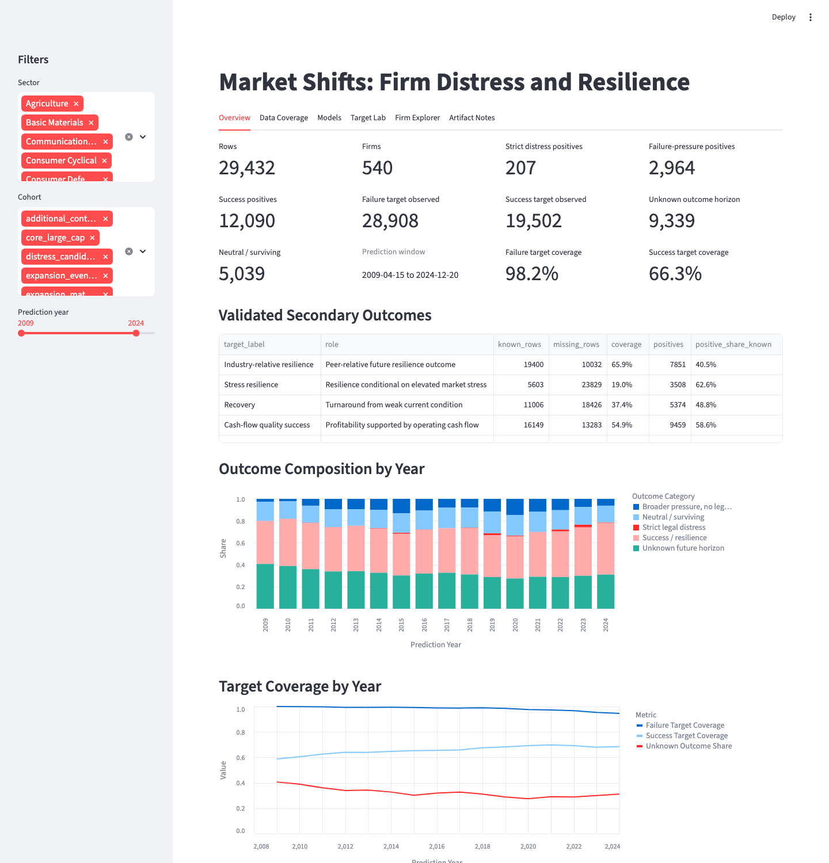
Note: The overview compares strict distress, broader pressure, success/resilience, and unknown horizons for the selected model window. It supports target-composition review without implying causal relationships. Source: Dashboard artifact.
Figure E2. Data coverage and missingness
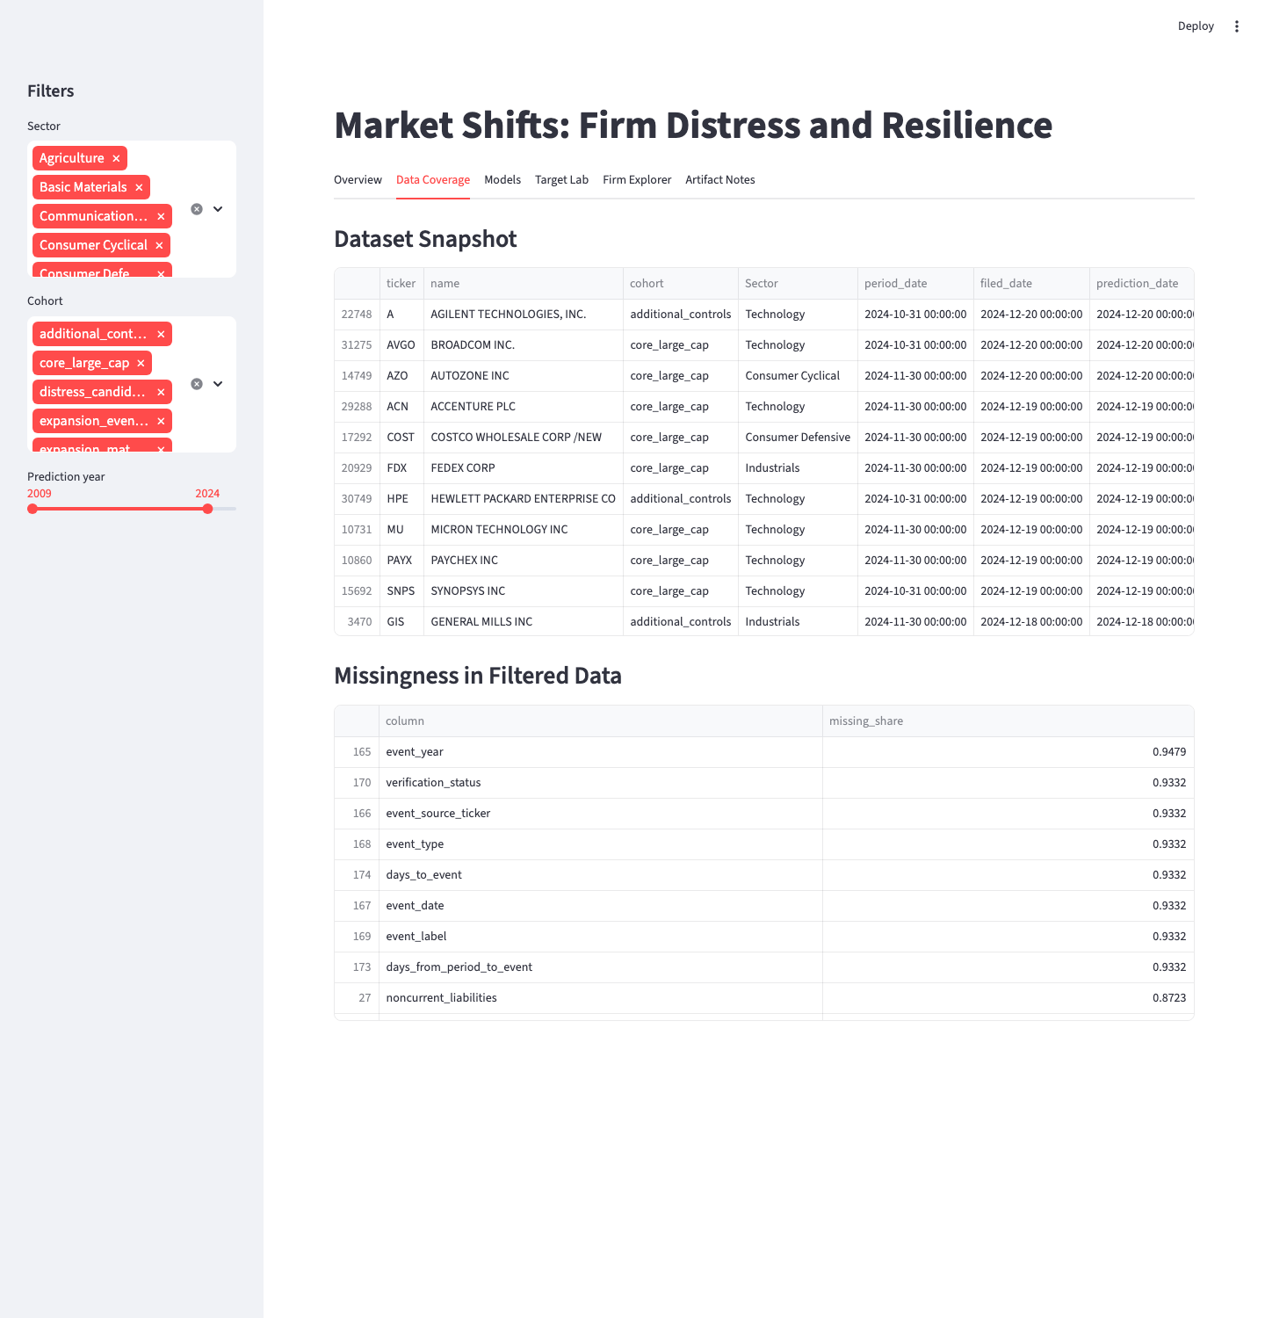
Note: The view summarizes coverage and missingness by feature family, explaining why nulls are preserved without treating missingness as an economic cause. Source: Dashboard artifact.
Figure E3. Model metrics view
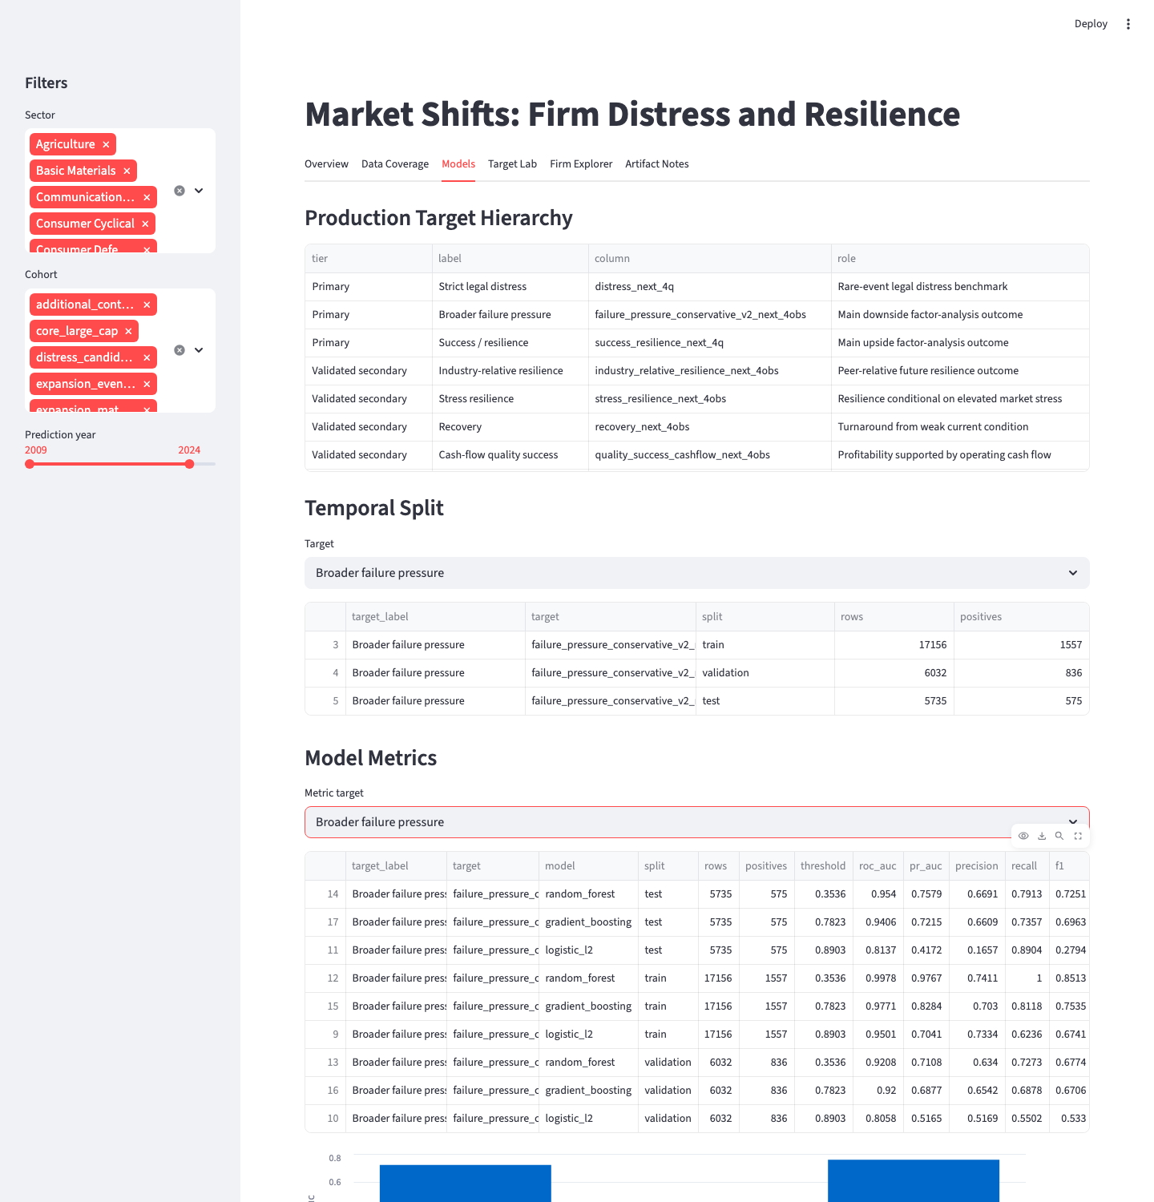
Note: The metrics view compares temporal model behavior for a primary target. It is an interpretation screen, not a live probability guarantee. Source: Dashboard artifact.
Figure E4. Feature-group interpretation view
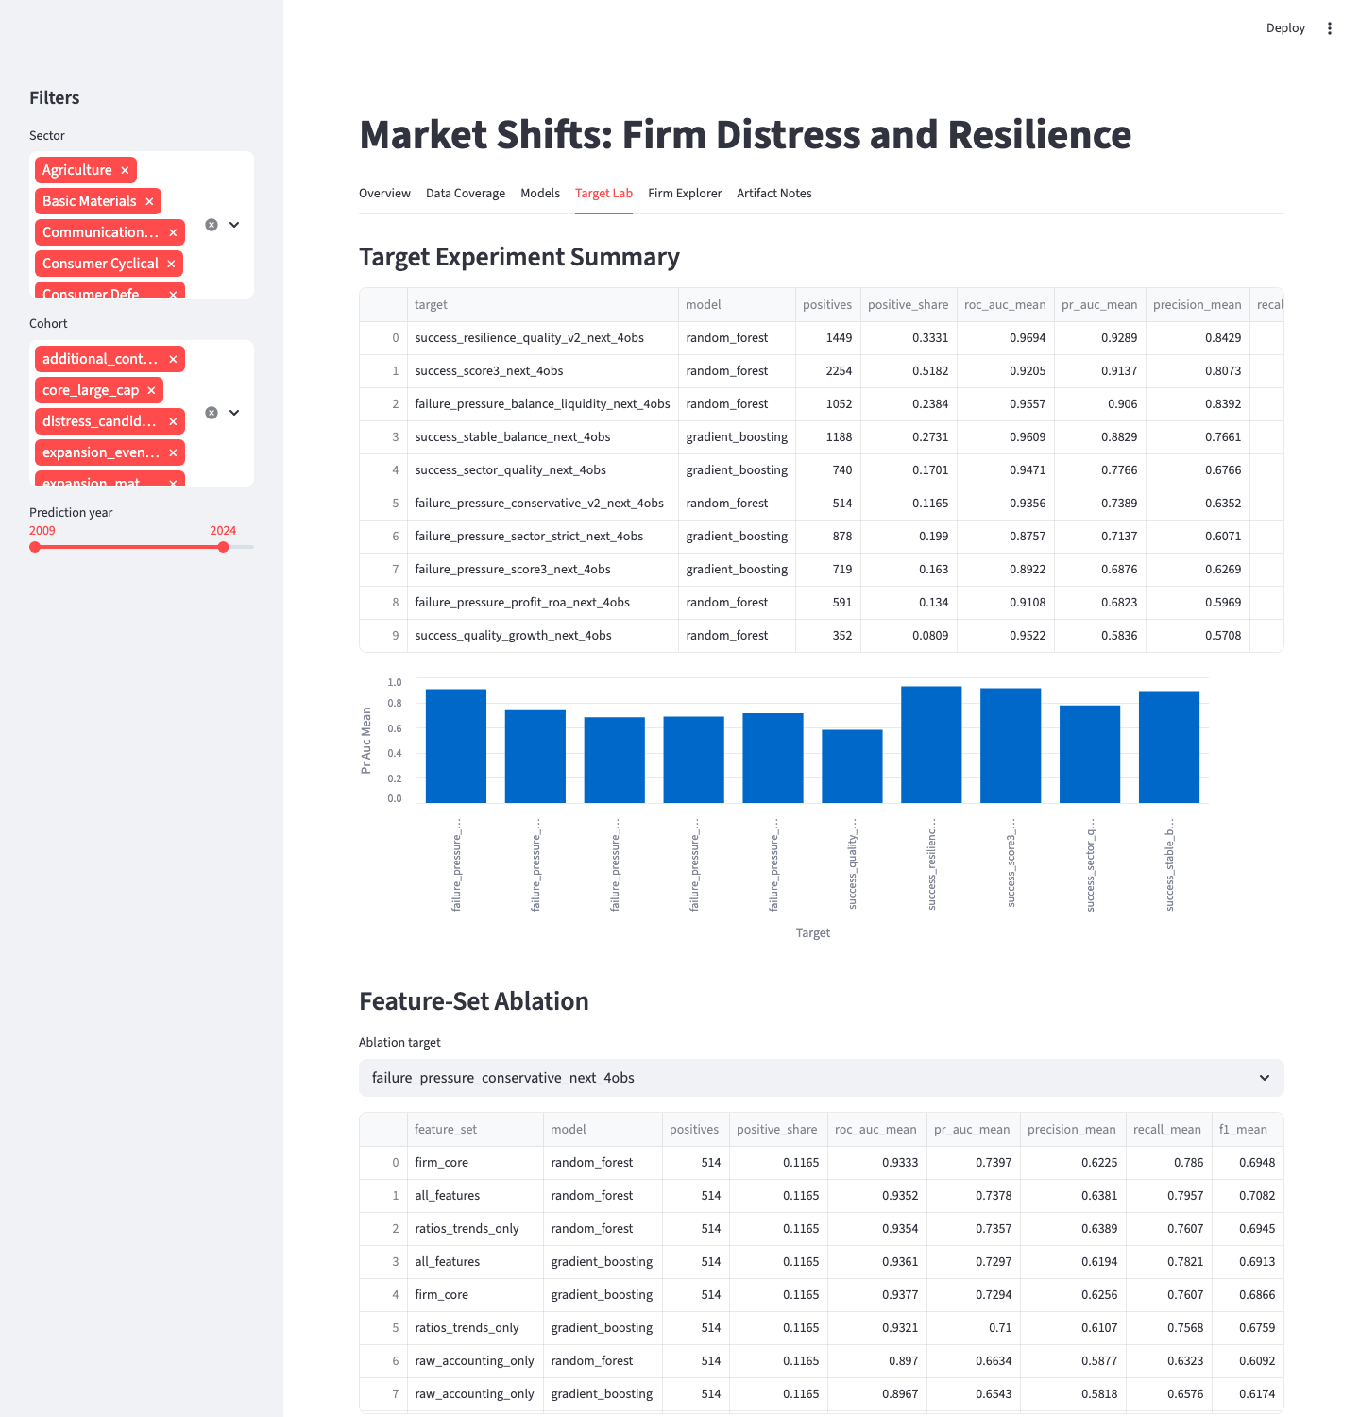
Note: The feature-group view organizes model behavior into economic factor families. It supports interpretation without turning importance into causality. Source: Dashboard artifact.
Figure E5. Firm explorer view
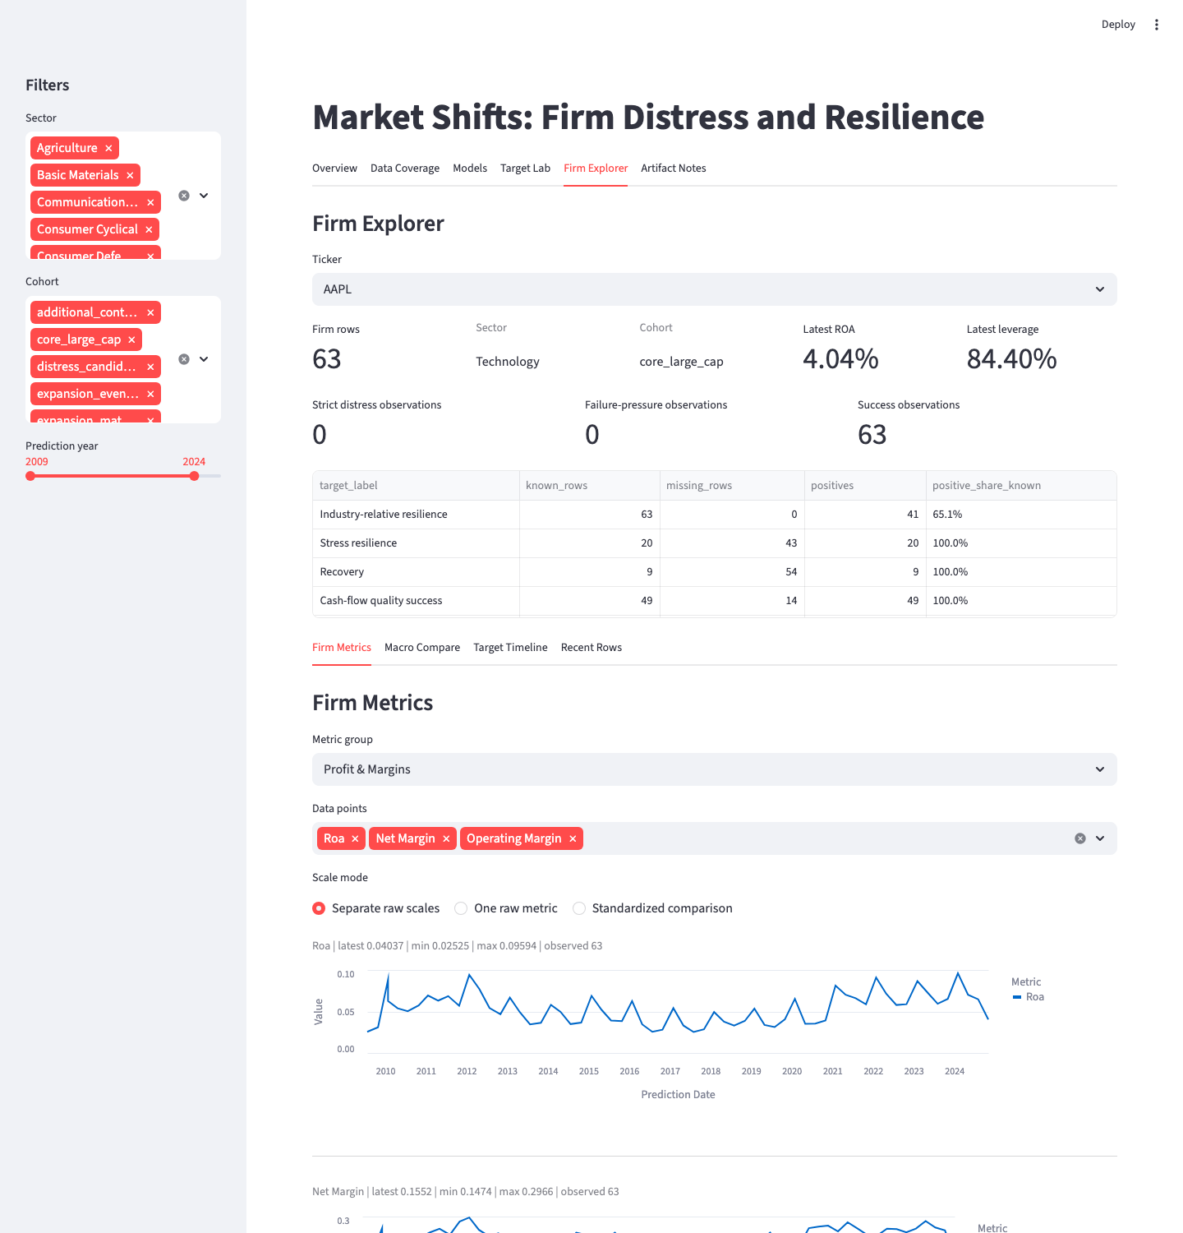
Note: The firm explorer presents trajectory and context for case review. It supports due diligence but does not replace it. Source: Dashboard artifact.
Figure E6. Macro/event comparison view
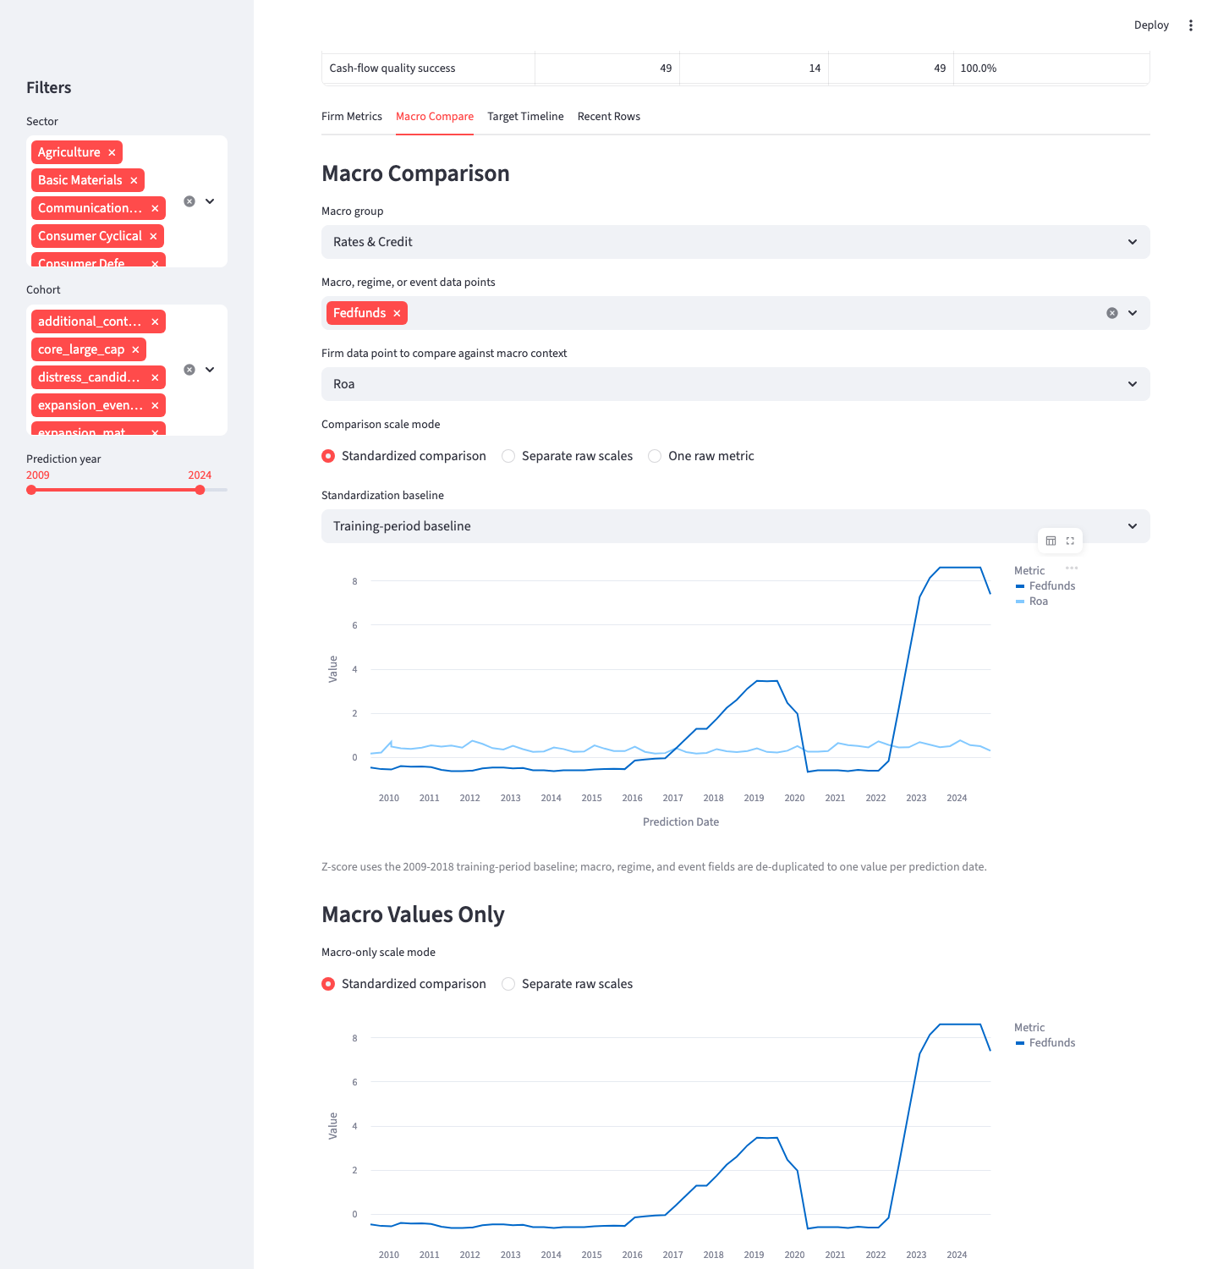
Note: The macro/event view compares observations against a training-period baseline and provides market-shift context, not evidence of macro dominance. Source: Dashboard artifact.
Figure E7. Artifact notes and caveats
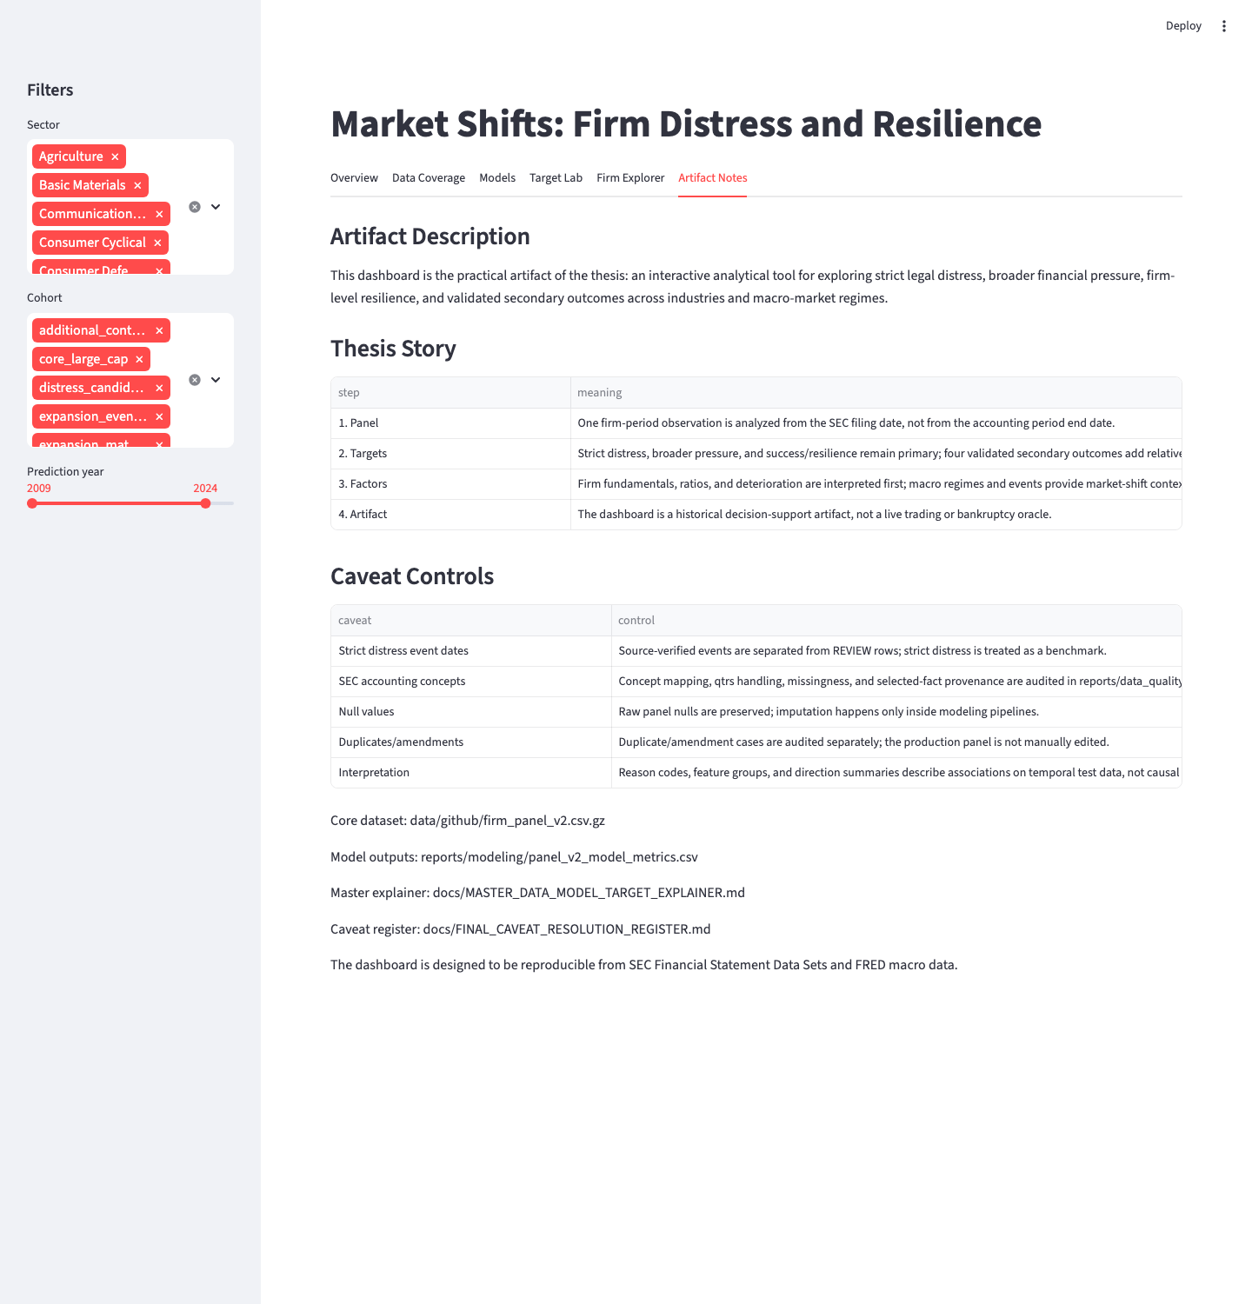
Note: The artifact notes state the scope and caveats needed to prevent overinterpretation of dashboard outputs. Source: Dashboard artifact.

Appendix F. Model-Output Support
Appendix Table F1. Accepted primary model-output support
Target | Best  model | ROC-AUC | PR-AUC | Precision | Recall | F1
Strict legal  distress | Gradient boosting | 0.816 | 0.104 | 0.120 | 0.375 | 0.182
Broader failure  pressure | Random forest | 0.954 | 0.758 | 0.669 | 0.791 | 0.725
Success/  resilience | Random forest | 0.967 | 0.975 | 0.941 | 0.934 | 0.938
Note: Primary model outputs come from saved model files, with validation used for threshold/model selection and test reserved for final evaluation. Target display labels follow the mapping in Table 5. Source: Author's calculations from saved model metrics and best-model outputs.

