Assignment 2
Unix File System:

General Description
The main goal of this assignment is to deepen your understanding of the mechanisms that are required for implementing a file system. This includes data structures, naming, access procedures, etc. The assignment is based on the Unix file system organization.
The central goal is to model a file system on a local machine and to allow processes to access that file system and perform different operations on files. The system you will construct will provide one local file system for all processes. The program can service multiple processes simultaneously. A hierarchy can be defined between different processes, allowing the child to have the same file descriptors table as its parent. Other processes can be defined with no direct parents, starting with a clean fd table.
Another feature you will implement is links. The system will allow the creation of both hard links and soft links and will maintain all necessary information to deal with them correctly.

Threads
The threads you use in the assignment are Linux's (POSIX) threads. Each thread represents a process. Each process has its own working directory (pwd). Processes can be created via the shell you will implement. A process can be created without any relation to other processes in the system; in this case, the process' file descriptor table is initialized without any open files. A process may also be created as a child of a different process in the system. In this case, the fd table of the child is initialized as a copy of the parent's fd table.

Simulator description
The following chart is a layer scheme of the simulator:
Library functions/UI
System calls layer
File-System layer
Low level disk services
Simulated Disk – a Physical file
Each layer uses the services of the layer under it.
Library functions access data in a file by a byte (char) offset. All operations use byte counts and view a file as a stream of bytes starting at byte address 0 and going up to the size of the file. The system calls layer converts the user's view of bytes into a view of blocks: The file starts at logical block 0 and continues to a logical block number that corresponds to file size. The "Low level disk services" layer accesses the i-node and converts the logical file block into the appropriate disk block. The Disk-Physical file is the collection of blocks that are accessed.
The File System level is composed of 2 parts:
1. The simulated disk, which includes the disk and its resources. Disk contents are stored at a file maintained by your program, named FILE_SYS.
2. The file-system layer, which uses the simulated disk and displays a logical structure of a file system to the user. It includes the i-nodes table, maintenance of free blocks, etc.

Simulated Disk
The entire simulated disk is contained in one Unix file called: FILE_SYS. Like a real disk FILE_SYS is divided into blocks, all of identical size, each of which is addressed by its physical number. File size and block size are both defined at execution time via a configuration file.
FILE_SYS is composed of 5 parts (first three parts are in the super-block):
1. A superblock is stored in physical blocks 0-2, containing:
1. General data:
1. The size of the file system (in blocks)
2. The size of a block (in bytes, minimum size is 64 bytes).
3. Number of root i-node.
2. Blocks Control:
1. The number of free blocks in the file system
2. A block of free-block addresses. The file-system keeps a list of all free blocks in the system. Each node in the list is a block containing the address of many free blocks. There may be many blocks still unused, and more than one node may be needed to list all the addresses of these blocks. To keep track of all nodes, the last address in each node is to the next node of free blocks and not the address of another free block. The first block in the list is in the super-block.
3. A pointer into the block of free-blocks, showing the location of the first free block in it. This is needed after already allocating some of the free block in the node, so as to keep track of the location of the next free block in the node.
4. A pointer to the last block, to add free blocks.
3. I-Node Control
1. The size of the i-nodes array
2. The number of free i-nodes in the file system
3. A block of free i-nodes addresses. The file-system keeps a list of all free i-nodes in the system. Each node in the list is a block containing the address of many free i-nodes. There may be many i-nodes still unused, and more than one node may be needed to list all the addresses of these i-nodes. To keep track of all nodes, the last address in each node is to the next node of free blocks and not the address of another free i-node. The first block in the list is in the super-block.
4. A pointer into the block of free-i-nodes, showing the location of the first free i-node in it.
5. A pointer to the last block, to add free i-nodes.
The rest of the disk is composed of the two parts below:
4. An array of i-nodes (the i-nodes table) (The array's size will be an exact multiple of the block size, even though there may be free space at the end of the last block. It is possible to read an i-node without reading the entire block the i-node is in.)
5. An array of blocks.

Each i-node has the following structure:
File type: file, directory, soft-link. (1 byte)
Number of hard links. (1 byte)
File size in bytes. (4 bytes)
10 direct blocks. (10*4 bytes)
1 single-indirect block. (4 bytes)
It is important to note that all metadata should be saved in its original form, numbers shouldn't be saved as ASCII characters. On the other hand files' data is ASCII characters.

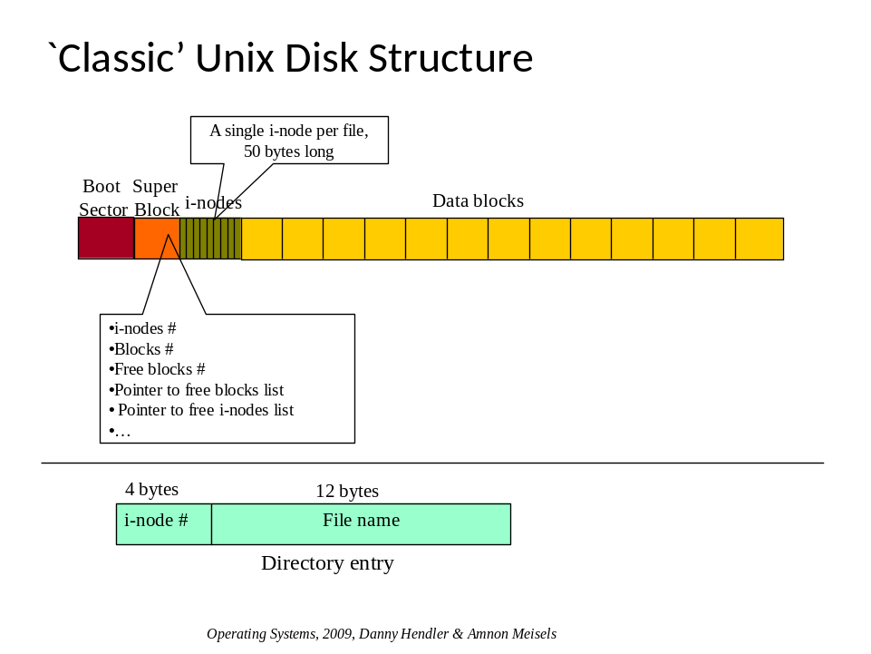

Low level disk services
The low Level Disk offers the following services:
allocateInode() – allocates a new i-node and returns its number
freeInode(int i-node) –frees the specified i-node and also frees all the data blocks pointed to by it (directly or indirectly).
allocateDataBlock() – allocates a data block and returns its number
freeDataBlock(int dblock) – frees the specified block.
Use (and update) the maps in the super block in these allocate/free methods.
getInodeType(int i-node) – return the type of the file (normal/directory/soft-link).
setInodeType(int i-node, filetype) – set the type of the file (normal/directory/soft-link).
getDataBlock (int i-node, int i) – return the number of the i-th data block containing the data of this file (for 0<=i<=9 this is just stored in the 10 pointers in this i-node, for i>9, you must retrieve it from the indirect data block..).
setDataBlock (int i-node, int i, int dblockNum ) – sets the i-th data block of this file to be dblockNum.
readBlock(int dblockNum, char* buf) – read the entire content of the dblockNum's and copy it into buf.
writeBlock(int dblockNum, char* newdata) – overwrite the content of block with number dblockNum with the newdata block. Assume newdata's length is equal to dataBlockSize.
getFileSize(int i-node) – return the file size saved in the given i-node. This is the exact size of the file in bytes, not the number of blocks used by this file.
setFileSize(int i-node, int newSize) – set the file size.
Regular files simply store the data written to them by user programs. A directory file stores a sequence of directory entries, each of which having the following structure:
i-node number [4 bytes].
file name [12 bytes].

Note – file names in dir-entries are kept without their path (so the file name of /ab/cd.out is just 'cd.out' ).
Note – all services mentioned above should return appropriate error codes to stderr, when things go bad (for example: requesting to free an i-node that was not allocated, requesting to allocate an i-node when there are none free, asking for the file name of a free i-node, asking the 34th data block of a file that contains only 30 data blocks, etc.).

File System
This layer provides the following methods and uses the underlying low level local disk services:
createFile(flag) – creates a file returning its i-node number. Flag indicates whether the file to create is a regular file or a soft link.
createDir( ) – creates a directory, returning its i-node number.
getFileType(int i-node) – Returns the type of the file this i-node represents.
f_read( i-node, buffer, offset, nBytes ) – reads nBytes (at most) from the given file (represented by this i-node) at the given offset inside the file into the buffer.
f_write( i-node, buffer, offset, nBytes ) – writes nBytes (at most) to the given file (represented by this i-node) at the given offset inside that file, from the buffer. If the amount to be written exceeds the current allocated block, a new block should be allocated to accommodate the rest of the data.
Notice that both f_read and f_write only work on normal files (not directories).
d_read(i-node) – reads the entire content of the directory file specified by the given i-node. This information is then entered into a data structure (a vector or list) that lists the files in this directory. Each element in this list therefore contains a filename and i-node number.
d_write(i-node, list ) – replaces the content of the given directory file (specified by i-node) with the information stored in the list. The list has the same format as that returned by d_read().
f_delete(i-node) – delete the file.
d_delete(i-node) – delete the directory if it is empty.

The System Call Layer
This layer keeps the open file table. This table is saved in memory (not on the disk):
int MakeFile(char* file-name,type, flag access-permissions) - creates and opens a new file named ‘file_name’ returning a fd to the new file. If type is soft-link mark it as such. Opens the file with the specified permissions.
int MakeHLink(char* target-file-name, char*file-name) - creates a hard link with name file-name, linked to target. Returns a new fd.
int MakeDir(char* dir-name) - creates a new directory named ‘dir-name’
int RmDir(char* dir-name) - removes the directory ‘dir-name’
int RmFile(char* file-name) - removes the file ‘file-name’
int ls(char*dir-name, char * buf) - lists the content of the location-directory. Return list in buf.
int Open(char* filename, flag access-permissions) - opens the file ‘file-name’. Needs to deal with soft-links. Opens the file with the specified permissions.
int Close(int fd) - closes the entry of the file in the file table, and frees the entry in the fd table.
int Seek(int fd, int location) - moves the file curser to ‘location’.
int Read (int fd, int nBytes, char *Buffer) - reads nBytes from the received file into the buffer.
int Write (int fd, int nBytes,char * Buffer) - writes nBytes from buffer into the file.
moveFile(char* parendDir, char * new_dest) - Moves the child's i-node from its current directory to new destination.
bool isDir(char * address) - Ret urns whether this address is a directory or not. Needs to deal with soft-links.
int lockRead <fd> - locks file, so that only read operations are allowed. There is no limit on the number of processes that are allowed to concurrently read the file. No processes are allowed to write to the file if there is an open read lock on the file. It is not obligatory to lock the file to read it. You should not block if it is locked rather return an error.
int lockWrite<fd> -locks file, so that only one process may hold the lock. This process may write to the file, and no other files may write to it or read from it. A child does not inherit this lock. It is not obligatory to lock the file to write to it. You should not block if it is locked rather return an error
int releaseLockRead<fd> -releases the reading lock held by this process. Only the process which locked the file may release the lock.
int releaseLockWrite<fd> -releases the writing lock held by this process. Only the process that locked the file may release this lock.

Remember that read and write operations use the current file pointer to know where to start writing/reading from, and that these operation advances the file pointer.
Allowing related processes to have the same fd table, and the same pointer into the file, demands implementing a more complex file descriptor table, as shown in class:
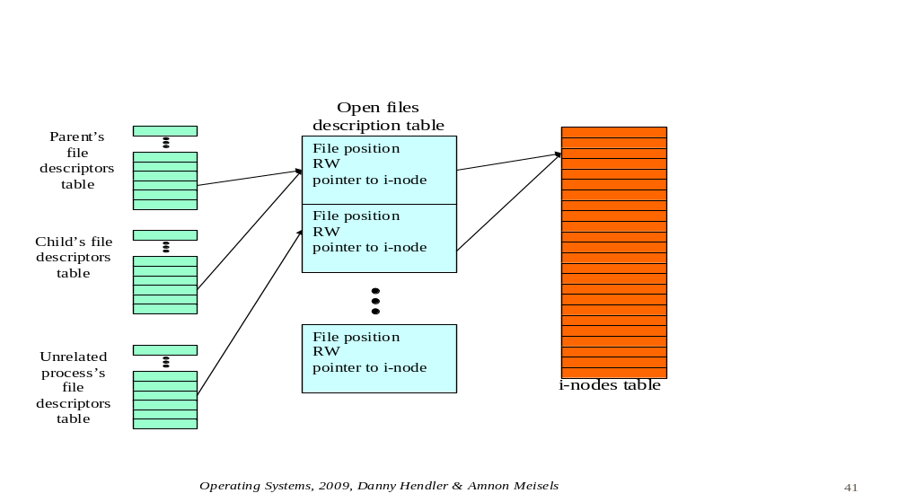
Each process has its private descriptor table with 12 entries. Each open entry points to another table owned by the system-call layer which contains all open files. If the child inherited a fd from its parent it will point to the same entry as the parent. If it opened the file independently, it will point to a different entry. This intermediate table consists of the offset to the current position inside the file, actions permitted on file (specified at open time) and i-node number. The maximum number of open files (including the same file which has been opened more than once) in the system cannot exceed 128.

Library Functions/UI
All commands should return the output specified in the command if successful or a specification of the error. If no output is specified, return the output 1 when the command succeeded, or 0 if failed. Error description should be output to stderr. Support the following commands:
mkdir <dir-name> - makes a directory with the given name.
create <file-name> - creates an empty file. Returns a file descriptor <fd>.
hdlink<file-to-link-to><new-file-name> - creates a hard link to file-to-link-to. Making a hard link to directories is not allowed.
sflink<dest-to-link-to><new-file-name> -creates a soft link to dest-to-link-to. dest can be either a directory or a file.
open <file-name><flags> - opens an existing file returning a file descriptor <fd>. The fd returned should always be the lowest one still free. Flag can be set to "read-only" or "read-and-write". Always remember to check when reading or writing that the file was actually opened for that purpose, otherwise return an error. Your flags should be in the exact syntax specified.
close <fd> - close the file associated with the given file descriptor. Release locks on this file held by this process.
read <fd> <num-bytes> - Read num-bytes from the file that is identified by fd. Returns the string read, followed by a newline and then the number of bytes that were actually read. Remember read uses the current file pointer to know where to start reading from, and the operation advances the file pointer. The output should be shown on stdout.
write <fd> <string> - writes the string to the file. Returns the number of bytes actually written. Remember write uses the current file pointer to know where to start writing from, and the operation advances the file pointer.
writeFile <fd><fileName> -imports a real file from linux's file system from the given address into the file fd. In this way files can be imported into the system.
lck_rd <fd> - locks file, so that only read operations are allowed. There is no limit on the number of processes permitted to read the file. No processes are allowed to write to the file while a process holds a read lock to the file. It is not obligatory to lock the file to read it. You should not block if it is locked, rather return an error.
lck_wr<fd> -locks file, so that only one process may hold the lock. This process may write to the file, and no other processes may write to it or read from it. A child does not inherit this lock. It is not obligatory to lock the file to write to it. You should not block if it is locked, rather return an error.
rlslck_rd<fd> -releases the reading lock held by this process. No other process may release this lock.
rlslck_wr<fd> -releases the writing lock held by this process. Only the process which locked the file may release the lock.
lseek <fd> <offset> - moves the file pointer to the given offset from start of file. If the pointer is set to an offset after the end of the file, this is o.k. If data is later written at this point, subsequent reads of the data in the gap return bytes of zeros (until data is actually written into the gap). The size of the file should not be updated until data is written to that point.

rm <file-name> - deletes the file.
rmdir <dir-name> - deletes the directory. A directory can only be deleted if it is empty.
rmdir_r<dir-name> - recursively deletes directory, all sub-directories and all files. If one of the files is open, terminate and return error. It is o.k. if the system starts deleting files and then finds one open, to then return an error. This means that the command may be executed partially.
ls <dir-name> - returns a list of the files in the given directory, each file in a different line and including the file-name and its size (in bytes). If ls is given without an argument, the ls of the current directory should be returned. Output should be as follows: each file/dir in the given directory in a separate line, directories have the "/" char appended to the end of their name.
mv<old-file-name>< new-file-name> - changes the old-file-name to new file name. This can be just changing its name in the same directory, or even moving the file to a different directory.
cd<new-directory > - changes current working directory of the current process to new-directory.
swprc<int new-process-num> - Switches to the context of a different process. Make sure to also switch to the new process' fd table and working directory.
crprc<int id>< int parent> -Creates a process with the given id. If a process with this id already exists, return an error. If parent == -1, this process is created with no open files. If parent > -1, this process is defined as the child of the process with id parent. This means that it is created with an exact copy of the fd table of the parent. If process with id parent doesn’t exist return an error. This function doesn’t switch to the context of the newly created process, rather it stays in the context of the current process.
batch<file-name> - This function is needed to test the file system intensively. It allows executing many commands quickly from a file given as input. Do not wait for a command to return before dispatching the next command. For example, if requested to read a large amount of data, the shell should be able to receive another command even though the read command hasn't finished yet. Each command has the following syntax: [commandName][space][first arg][space][second arg] etc. Each space will be exactly one space. Each command is terminated by a '\n'.
Note – Your shell should support relative paths (e.g. ../../Mydir/a.out) and absolute paths ( e.g. /users/studs/bcs/2009/josh/a.out), for all commands requiring a file-name/dir-name as argument. Whenever a file-name or dir-name parameter is supplied, it is assumed to include the path (either relative or absolute).

File systems are non-volatile, available even after turning the computer off. Our file system will also behave this way. When executing the simulator, it will first try and reload file FILE_SYS and use the existing file system. If it doesn't exist, start a new file system using the parameters defined in the configuration file.

Implementation Issues
- Parts of the file system you will implement need to be synchronized. It is not necessary to do fine-grained synchronization; 3-5 mutexes will do the job nicely. DO NOT implement synchronization by locking the whole file system and allowing access to your file system to only one thread.
- Do not implement process synchronization using busy wait.
- You may find xxd a useful tool for debugging the low levels of your implementation. For more information see the following:
http://www.linuxjournal.com/article/7330
http://aplawrence.com/Unixart/xxd.html

- In many places we didn't specify the implementation; rather we focused on the behaviour we expect from the system. This was done deliberately, we left some design issues open.
- Your system should never crash (You can assume the configuration file is correct).
- In the library layer, allow any number of spaces between arguments.

The Configuration File
Has the following format:
dataBlockSize = [integer]
numberOfInodes = [integer]
diskSize = [integer]
Disk size and block size are measured in bytes.
You may assume the given file will have this exact format. Integers are of course positive only. Notice that there is exactly a single space between the field name and the '=' char, and also a single space between the '=' char and the value.

Running your program
Is done by typing:
> sim <config_filename>
The prompt symbol printed by the UI should be ">".
There are two possible run types based on whether the file " FILE _SYS " exists or does not exist.
If it does not exist, then this must be a 'fresh' run, and the whole system is created according to the information in the configuration file.
If it exists, then we IGNORE the configuration file, and instead continue using the existing files. Notice we do not need the configuration file since we can get all needed information we need from disk0's boot block and super block.

Submitting Requirements & Technical Information
Programming language to be used is C++.
Submittal is in groups of two.
A makefile should be submitted
Submit a single tar.gz file called ID1_ID2.tar.gz (where the ID is your and your partner's ID). This tar.gz file should contain only source code (cpp and h files) as well as your makefile.
Decompressing your program and running 'make' should compile your code and create the executable 'sim'.
Your program will be tested on local Linux machines as installed in the labs. Make sure the code and makefile you submit run flawlessly on these machines before submitting.
Submit your tar.gz file using the submission system.

Q & A
Q: If I create a local file and write a byte at offset 1025, and
dataBlockSize=256, then:
I allocate 5 blocks for the file and write on the 5th block the byte and
update the i-node 1st -5th entries?
or
I allocate just only 1 block, write the byte at the right offset and update only
the 5th entry in the i-node?
A: You must allocate 5 blocks (first option). You may initialize the blocks with
some value like 0, or leave it un-initialized.

Enjoy

