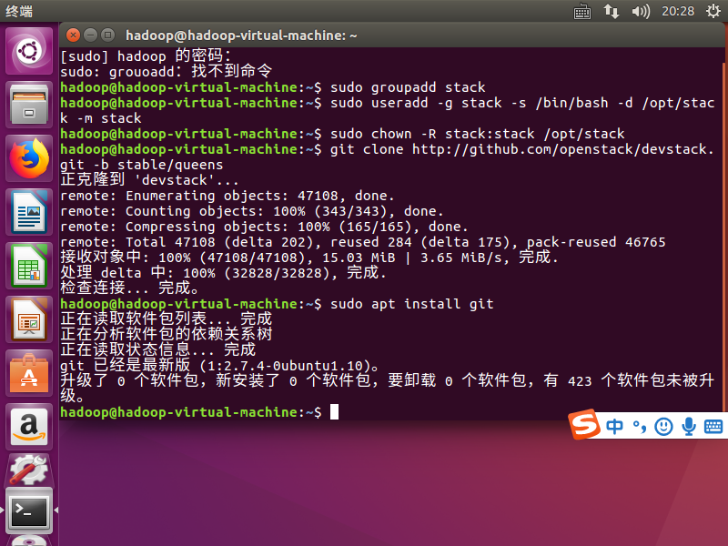

git clone https://github.com/openstack/devstack.git -b stable/queens

在devstack文件夹中创建local.conf

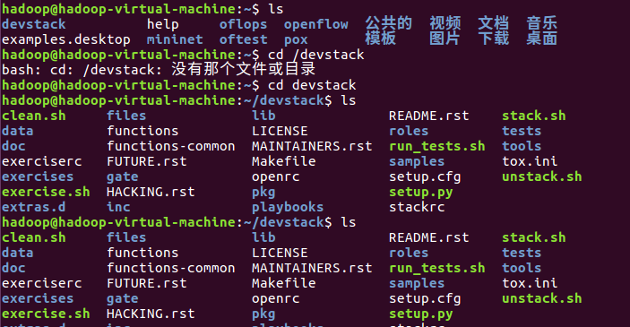

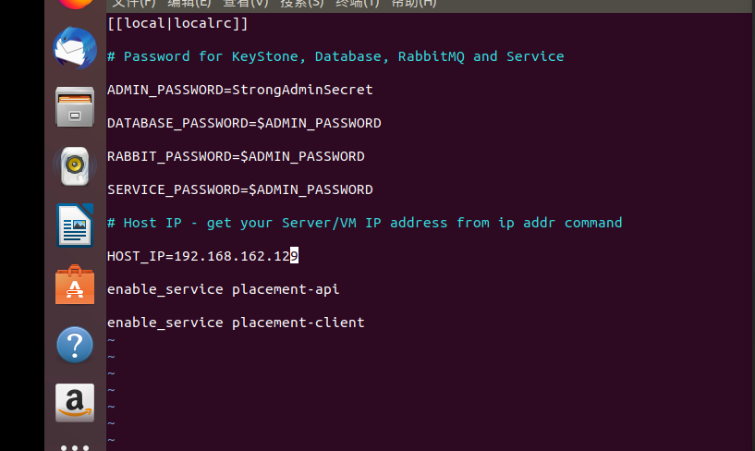

FORCE=yes ./stack.sh

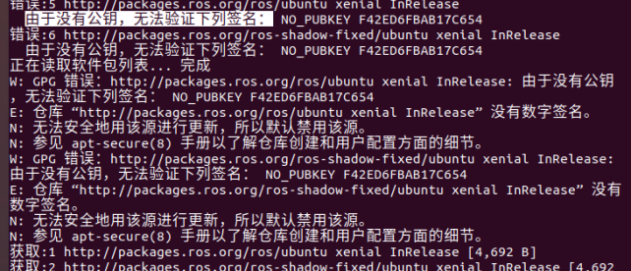

sudo apt-key adv --keyserver keyserver.ubuntu.com --recv-keys F42ED6FBAB17C654

FORCE=yes ./stack.sh