Objective, Baselines, and RGB Transfer Learning
This report completes the final project requirements after Report 1. The task is eight-class object recognition for autonomous driving
using RGB and infrared patches. Report 1 established the custom CNN baselines; this report adds RGB VGG16 transfer learning, IR autoencoder features, sensor comparison, misclassification analysis, and final model selection.
Model |  | Train Acc |  | Val Acc |  | Train F1 |  | Val F1
RGB Part 1 Arch D |  | 0.9999 |  | 0.9201 |  | 0.9999 |  | 0.9185
IR Part 1 Arch D |  | 0.9766 |  | 0.8880 |  | 0.9772 |  | 0.8792
Freeze | Train Acc |  | Val Acc |  | Train F1 |  | Val F1
F1 | 0.9547 |  | 0.8961 |  | 0.9539 |  | 0.8914
F2 | 0.9941 |  | 0.9392 |  | 0.9941 |  | 0.9370
F3 | 0.9999 |  | 0.9475 |  | 0.9999 |  | 0.9466
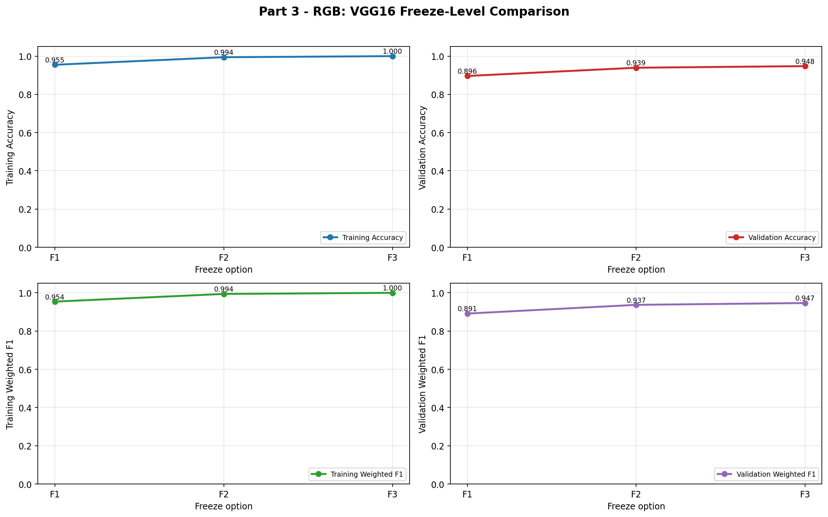

IR Autoencoder Feature Classifiers
The IR autoencoder experiment used six encoder configurations and two dense-head regularization settings, for 12 total options. The best AE option was AE6-R1 with validation F1 0.7820. The supervised IR Part 1 baseline validation F1 was 0.8792.
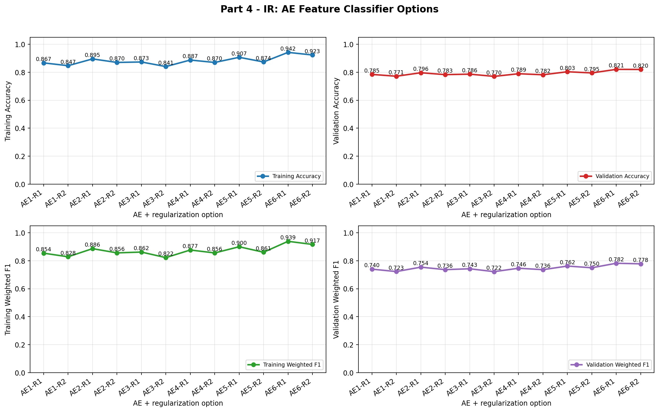

Final Model Selection and Refinement
Candidate | Train Acc | Val Acc | Train F1 | Val F1
RGB final | 0.9955 | 0.9498 | 0.9955 | 0.9480
Best RGB VGG16 | 0.9999 | 0.9475 | 0.9999 | 0.9466
RGB Part 1 Arch D | 0.9999 | 0.9201 | 0.9999 | 0.9185
IR final | n/a | 0.9263 | n/a | 0.9227
Best IR AE | 0.9420 | 0.8206 | 0.9389 | 0.7820
IR Part 1 Arch D | 0.9766 | 0.8880 | 0.9772 | 0.8792
- Final RGB model: RGB VGG16 refined (validation F1 0.9480).
- Final IR model: IR CNN Arch D + Aug L2 (validation F1 0.9227).
- Blind-test strategy: select by validation weighted F1 and avoid using withheld labels. Transfer learning and AE results are retained even when the custom CNN remains stronger.
- IR AE did not come within 0.02 F1 of IR Part 1 Arch D; final IR uses the stronger supervised CNN reference.
Observed reliability pattern: RGB generally benefits from color and texture detail for traffic signs, lights, and object boundaries. Infrared can be more stable where visible color/texture is degraded, but small or low-resolution classes remain difficult in both sensors. The paired examples on page 5 show cases where the sensors disagree.

Misclassified Samples By Sensor
The grids below show up to two validation misclassifications per class where available. Counts are tracked in the generated Part 5 JSON summary so classes with fewer than two misses are explicitly documented.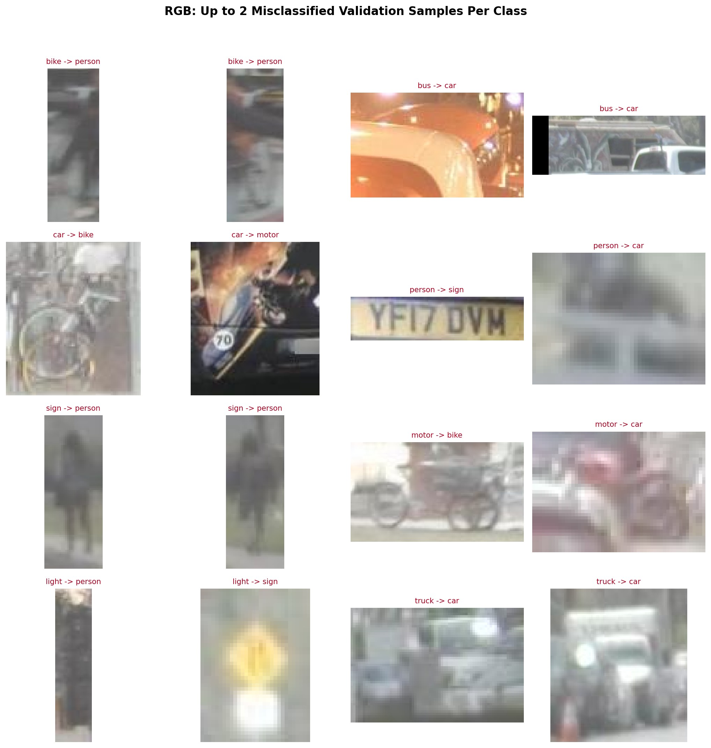
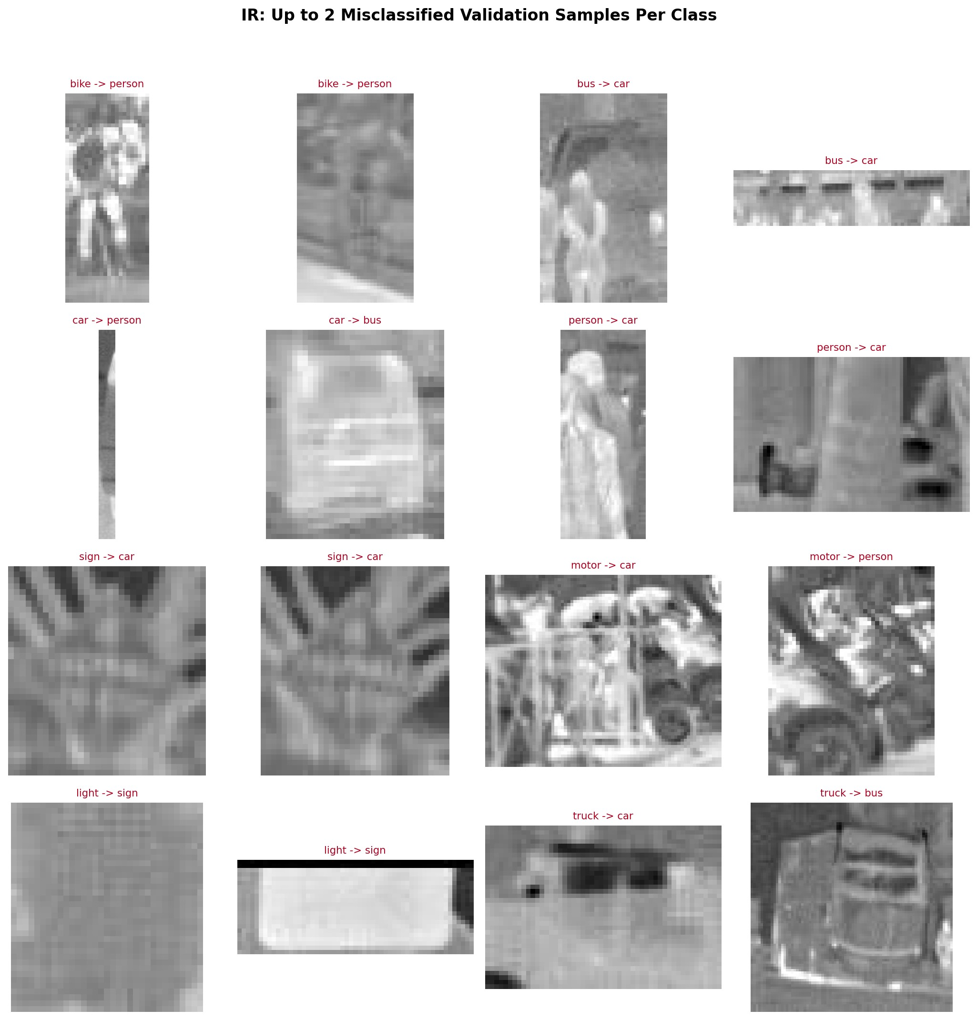

RGB-vs-IR Sensor Disagreement Analysis
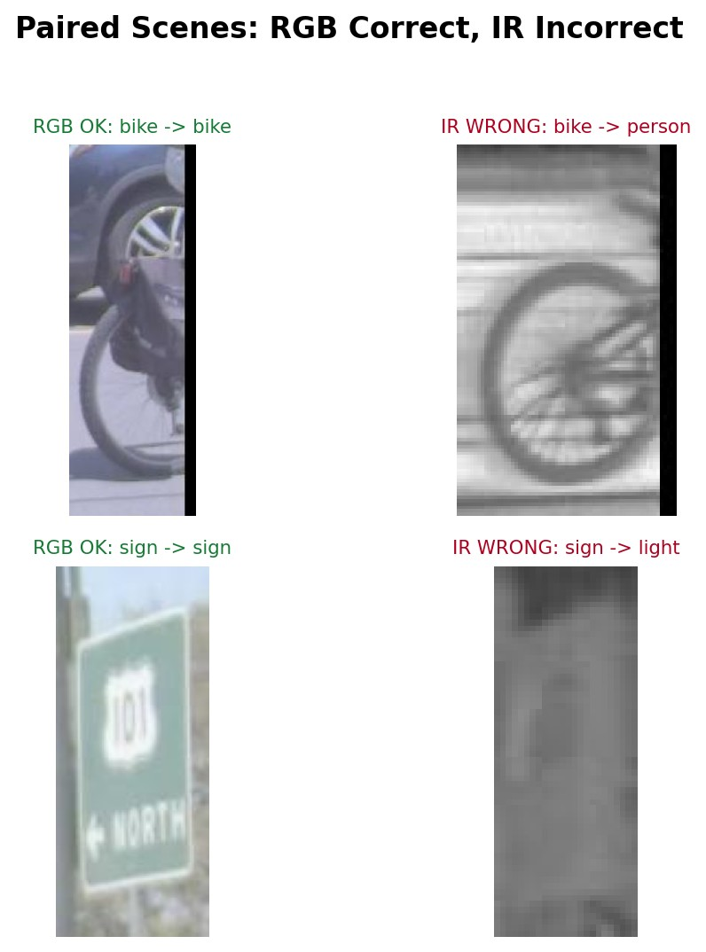
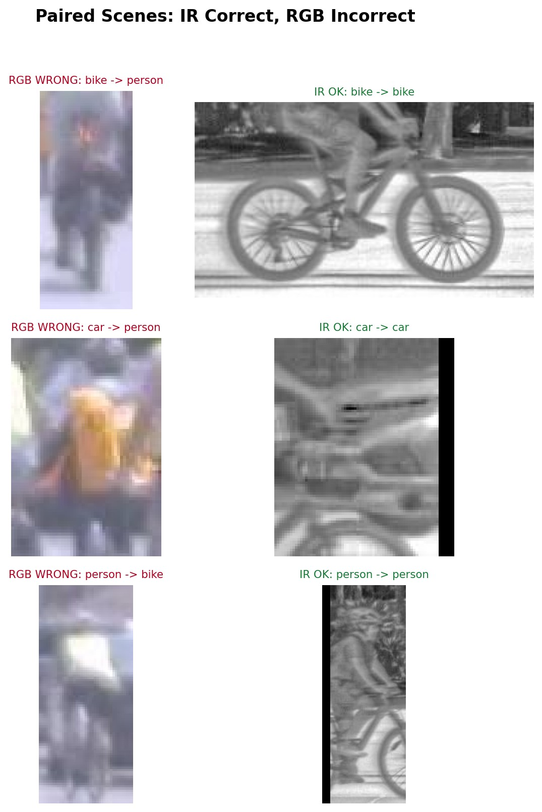
Paired examples found: RGB-correct/IR-wrong = 2, IR-correct/RGB-wrong = 3. When exact same-class paired examples were unavailable, the notebook used same-frame paired-scene examples and labels them as scene-level comparisons.

