Final Project Report 1
CNN Architectures, Regularization, and Data Augmentation for RGB and Infrared ADAS Object Recognition
University of Louisville | Speed School of Engineering
Course: CSE 547 - Deep Learning Algorithms and Methods
Section: CSE 547_51 | Spring 2026
Instructor: Dr. Hichem Frigui
Student: Jose Fuentes
Due Date: April 12, 2026

Abstract
This report evaluates RGB and infrared object recognition on the FLIR ADAS v2 dataset for eight autonomous-driving classes: bike, bus, car, person, sign, motor, light, and truck. Part 1 compares four CNN architectures per modality with approximately 10x parameter growth between consecutive models. Part 2 evaluates L2 regularization, dropout, data augmentation, and combined regularization settings. The best raw Part 1 model was Arch D for both modalities, with RGB reaching Val F1 = 0.9185 and IR reaching Val F1 = 0.8792. In Part 2, IR benefited most from moderate data augmentation, reaching Val F1 = 0.9227, while RGB benefited most from light dropout on Arch C, reaching Val F1 = 0.9099.

1. Dataset and Experimental Setup
The experiments use extracted object patches from the FLIR ADAS v2 dataset. The IR manifest contains 52,930 thermal patches and the RGB manifest contains 108,297 RGB patches. Training and validation splits were assigned at the video level for each modality to reduce leakage from nearby frames and repeated scene conditions.
Table 1. Patch distribution by modality.
Class | IR patches | RGB patches
car | 31,513 | 54,462
person | 12,432 | 25,030
bike | 3,105 | 6,304
sign | 2,021 | 11,358
bus | 1,721 | 1,629
light | 848 | 7,075
motor | 730 | 1,408
truck | 560 | 1,031
Total | 52,930 | 108,297

2. Part 1 - CNN Architecture Comparison
Four CNN architectures were trained per modality. The parameter counts were 880, 14,600, 148,200, and 2,459,848, satisfying the required 10x growth rule.
Table 2. CNN architecture summary.
Model | Architecture summary | Parameters
Arch A | 2 conv layers with 8 filters, global average pooling, linear output | 880
Arch B | Conv 16, Conv 32, Conv 32, global average pooling, linear output | 14,600
Arch C | 2x Conv 32, 2x Conv 64, Conv 128, global average pooling, dense head | 148,200
Arch D | 2x Conv 64, 2x Conv 128, 2x Conv 256, Conv 512, batch norm, dense head | 2,459,848
Table 3. Part 1 IR architecture results.
Model | Params | Best Ep | Train Acc | Val Acc | Train F1 | Val F1
Arch A | 880 | 41 | 0.7663 | 0.7251 | 0.7168 | 0.6520
Arch B | 14,600 | 62 | 0.8702 | 0.8070 | 0.8507 | 0.7563
Arch C | 148,200 | 64 | 0.9552 | 0.8616 | 0.9535 | 0.8340
Arch D | 2,459,848 | 9 | 0.9766 | 0.8880 | 0.9772 | 0.8792
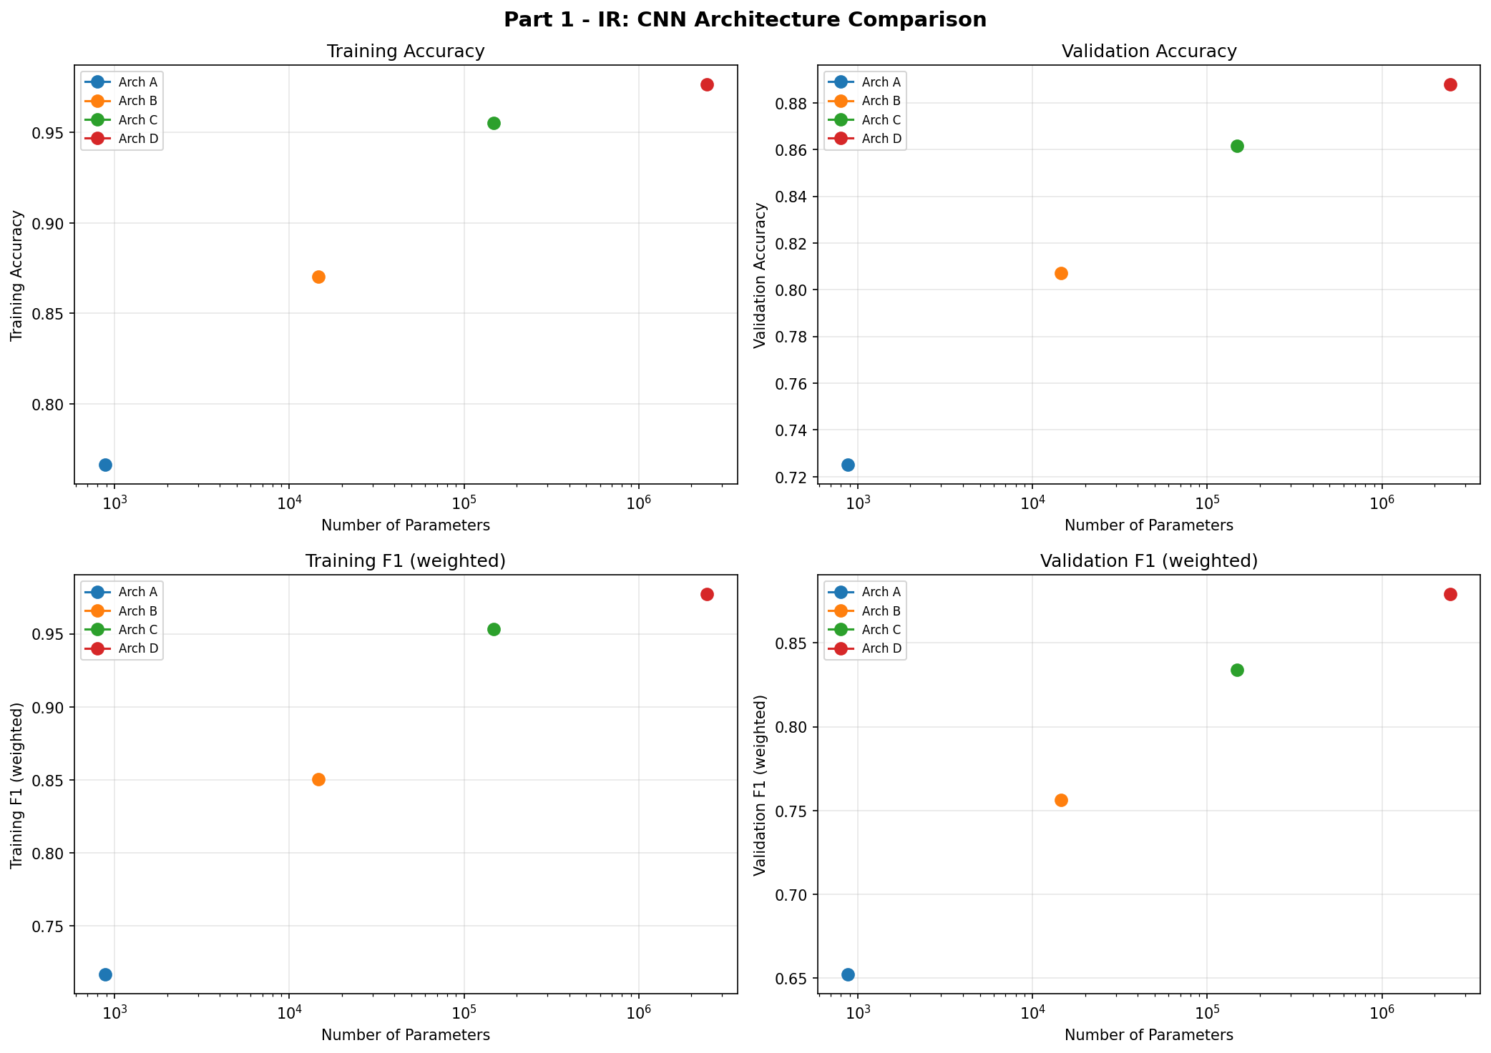
Figure 1. IR architecture comparison.
Table 4. Part 1 RGB architecture results.
Model | Params | Best Ep | Train Acc | Val Acc | Train F1 | Val F1
Arch A | 880 | 24 | 0.6249 | 0.5988 | 0.5785 | 0.5384
Arch B | 14,600 | 64 | 0.8393 | 0.7959 | 0.8230 | 0.7665
Arch C | 148,200 | 70 | 0.9468 | 0.8909 | 0.9453 | 0.8857
Arch D | 2,459,848 | 39 | 0.9999 | 0.9201 | 0.9999 | 0.9185
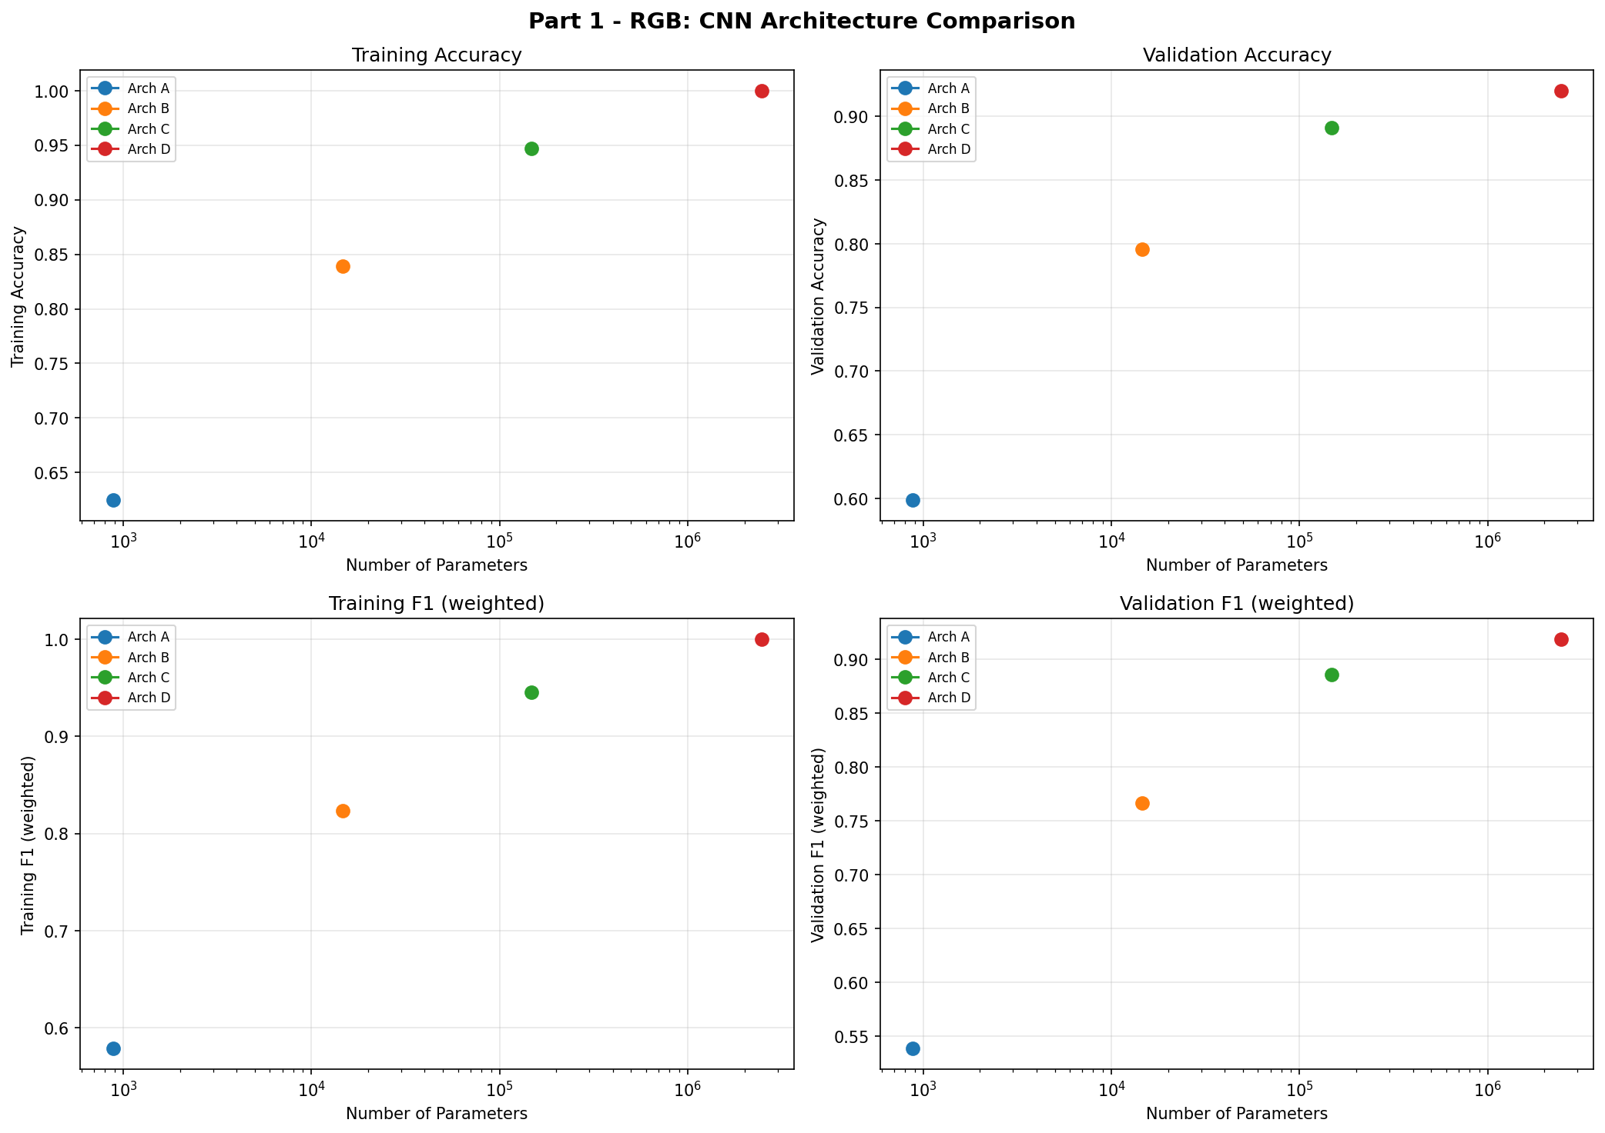
Figure 2. RGB architecture comparison.
Arch D achieved the strongest Part 1 result for both modalities. RGB outperformed IR in raw Part 1 validation performance, reaching Val F1 = 0.9185 compared to IR Val F1 = 0.8792.

3. Part 2 - IR Regularization and Augmentation
For IR, Arch D was selected from Part 1 because it produced the best validation performance and had sufficient capacity for regularization experiments.
Table 5. Data augmentation level definitions.
Level | Transformations
Aug L1 | Random horizontal flip only
Aug L2 | Flip, rotation 10 degrees, affine translation 0.05
Aug L3 | Flip, rotation 20 degrees, affine translation 0.10, color jitter 0.2
Aug L4 | Flip, rotation 30 degrees, affine translation 0.15, color jitter 0.3
Table 6. IR L2 regularization results.
Setting | Val Acc | Val F1
L2 = 1e-5 | 0.8984 | 0.8984
L2 = 1e-4 | 0.8862 | 0.8903
L2 = 1e-3 | 0.8724 | 0.8491
L2 = 1e-2 | 0.9064 | 0.8973
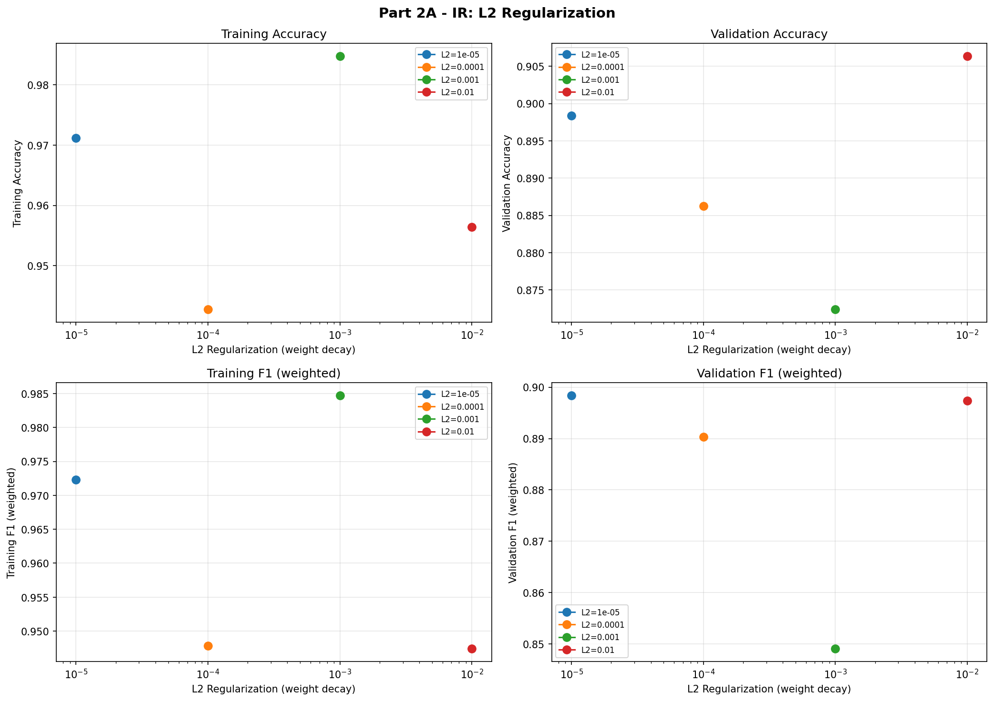
Figure 3. IR L2 regularization sweep.
Table 7. IR dropout results.
Setting | Val Acc | Val F1
Dropout = 0.10 | 0.8984 | 0.8838
Dropout = 0.25 | 0.8924 | 0.8743
Dropout = 0.40 | 0.8977 | 0.8809
Dropout = 0.60 | 0.8746 | 0.8420
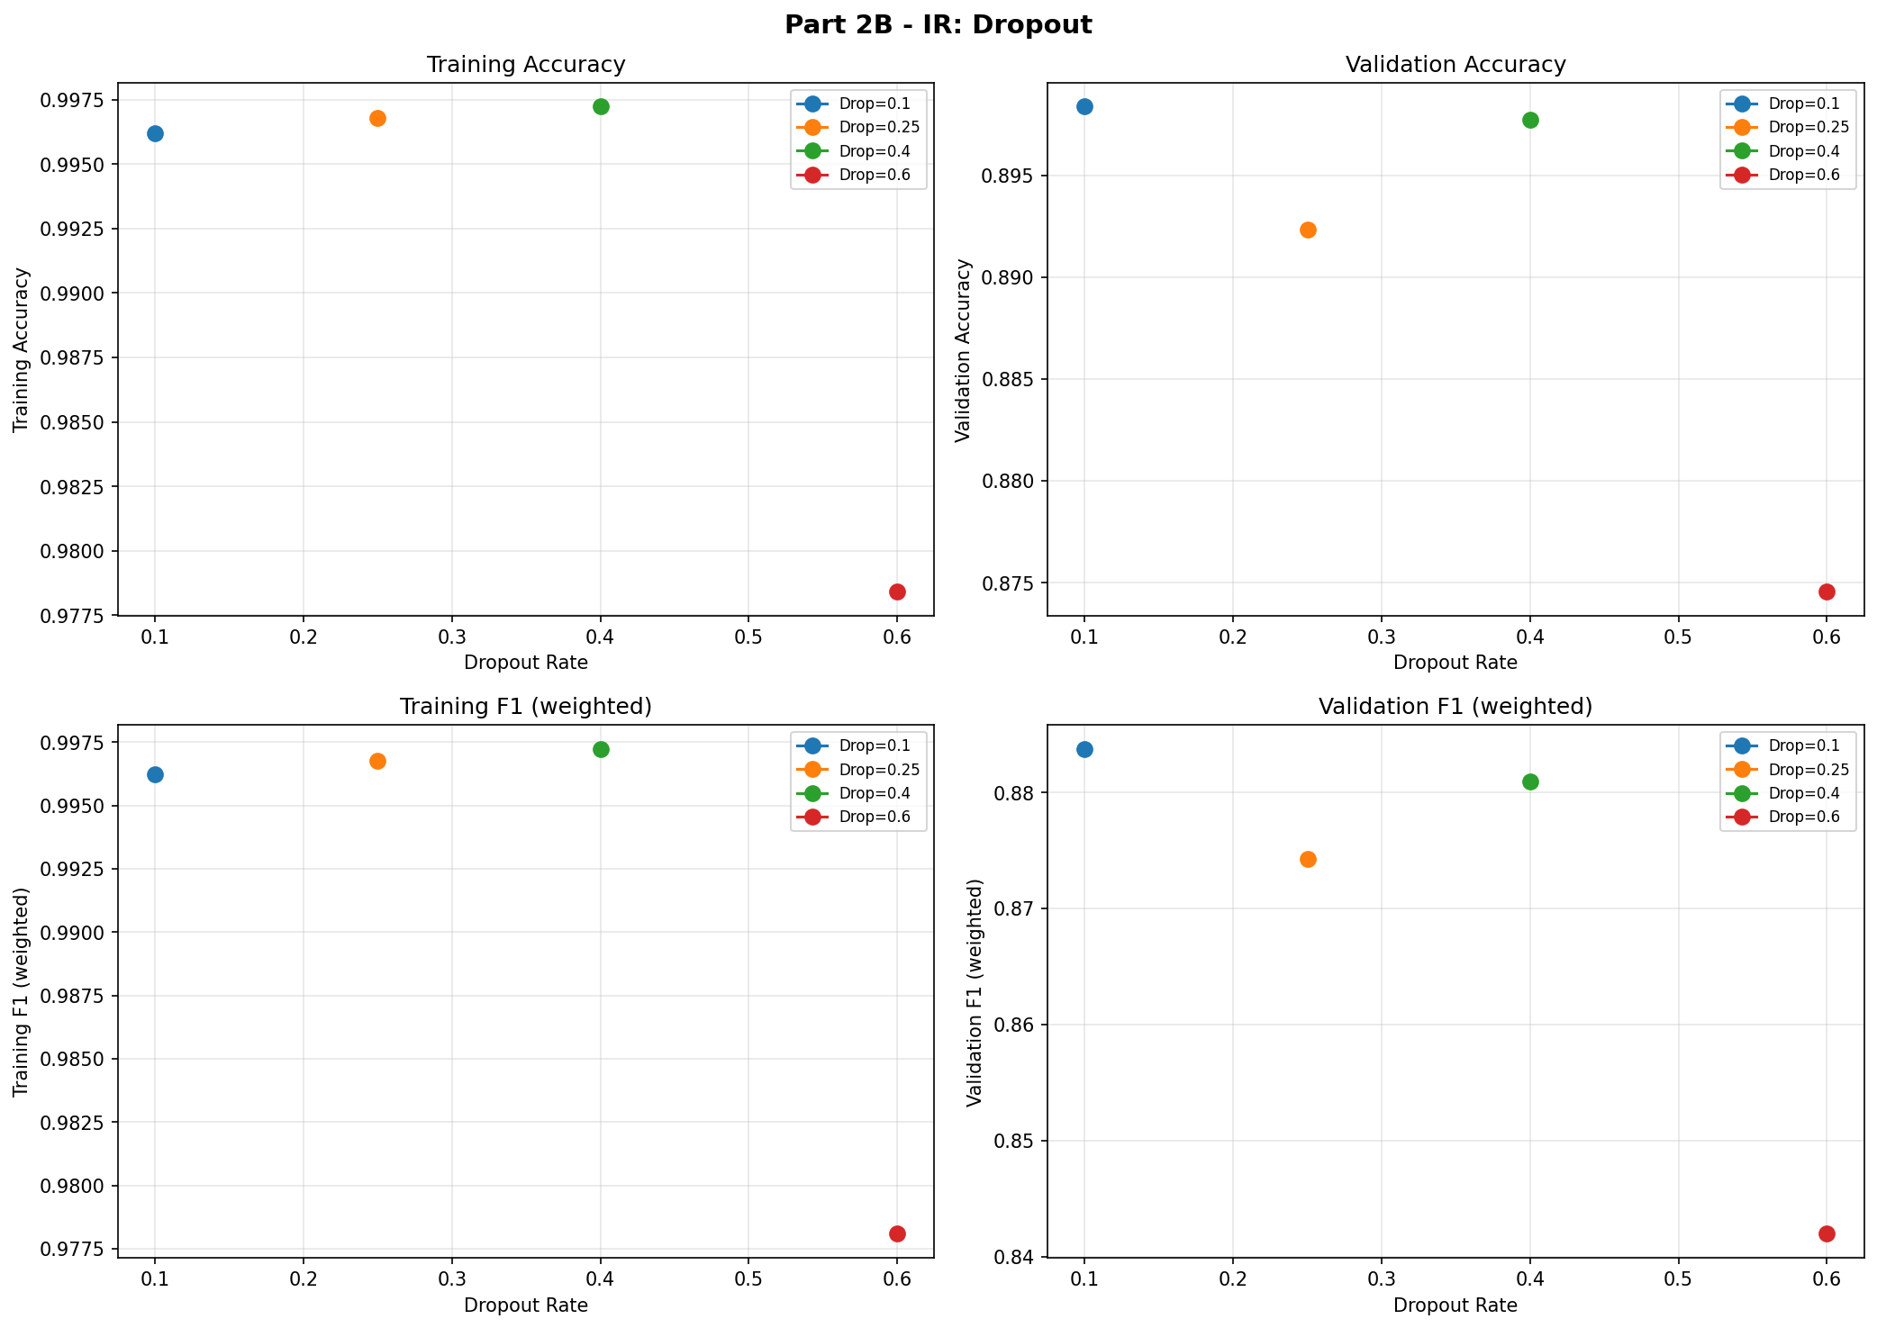
Figure 4. IR dropout sweep.
Table 8. IR augmentation results.
Setting | Val Acc | Val F1
Aug L1 | 0.9085 | 0.8967
Aug L2 | 0.9263 | 0.9227
Aug L3 | 0.8908 | 0.8837
Aug L4 | 0.8865 | 0.8872
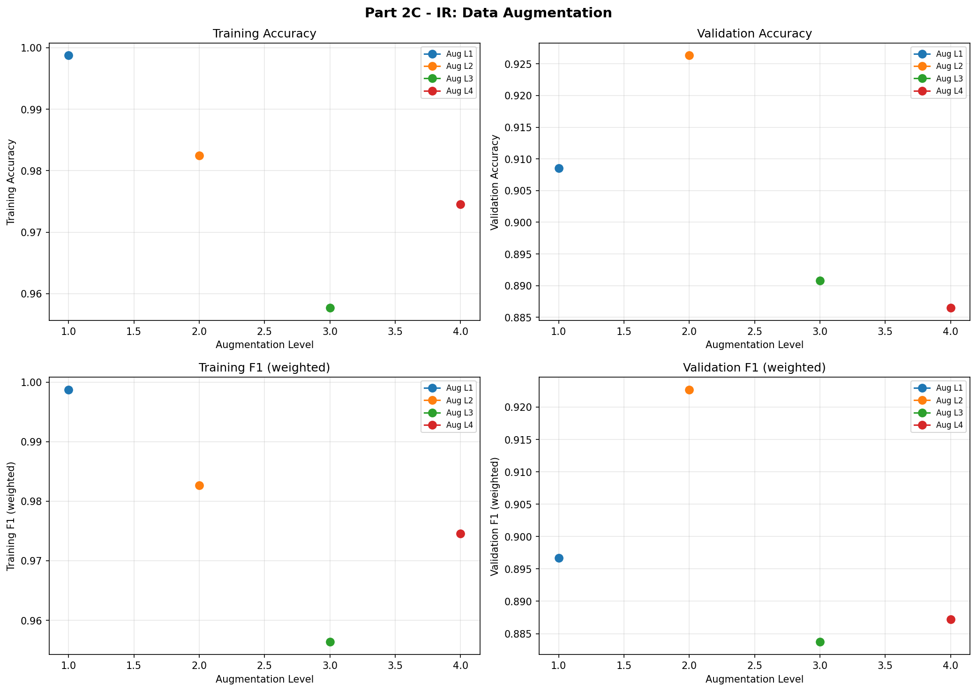
Figure 5. IR data augmentation sweep.
Table 9. IR combined regularization results.
Setting | Val Acc | Val F1
L2 = 1e-5 + Dropout = 0.1 | 0.8786 | 0.8601
L2 = 1e-5 + Aug L2 | 0.9129 | 0.9035
Dropout = 0.1 + Aug L2 | 0.8988 | 0.8837
L2 + Dropout + Aug | 0.9057 | 0.8981
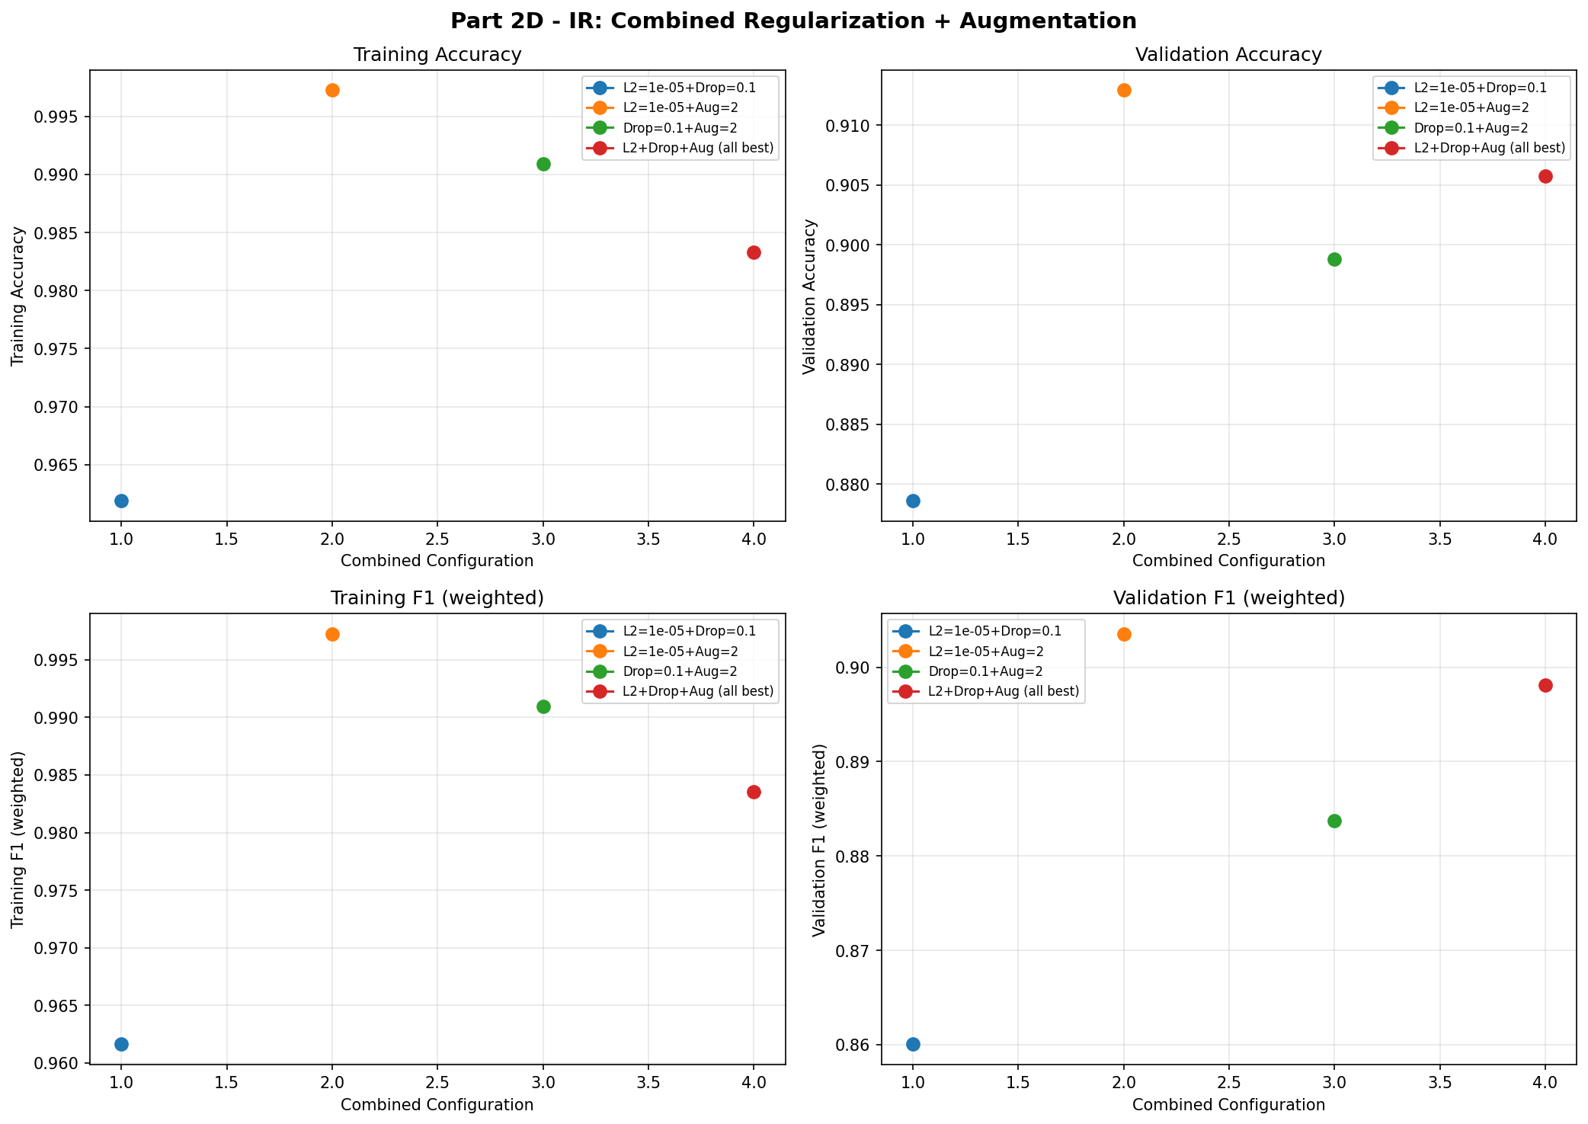
Figure 6. IR combined regularization sweep.
The strongest IR Part 2 result was Aug L2 with Val Acc = 0.9263 and Val F1 = 0.9227. This improved over the Part 1 IR Arch D baseline by 0.0435 F1.

4. Part 2 - RGB Regularization and Augmentation
For RGB, Arch C was selected because it exhibited moderate overfitting while maintaining strong validation performance. Arch D produced the best Part 1 score but nearly memorized the training set.
Table 10. RGB L2 regularization results.
Setting | Val Acc | Val F1
L2 = 1e-5 | 0.8883 | 0.8835
L2 = 1e-4 | 0.8965 | 0.8894
L2 = 1e-3 | 0.8495 | 0.8335
L2 = 1e-2 | 0.6777 | 0.5766
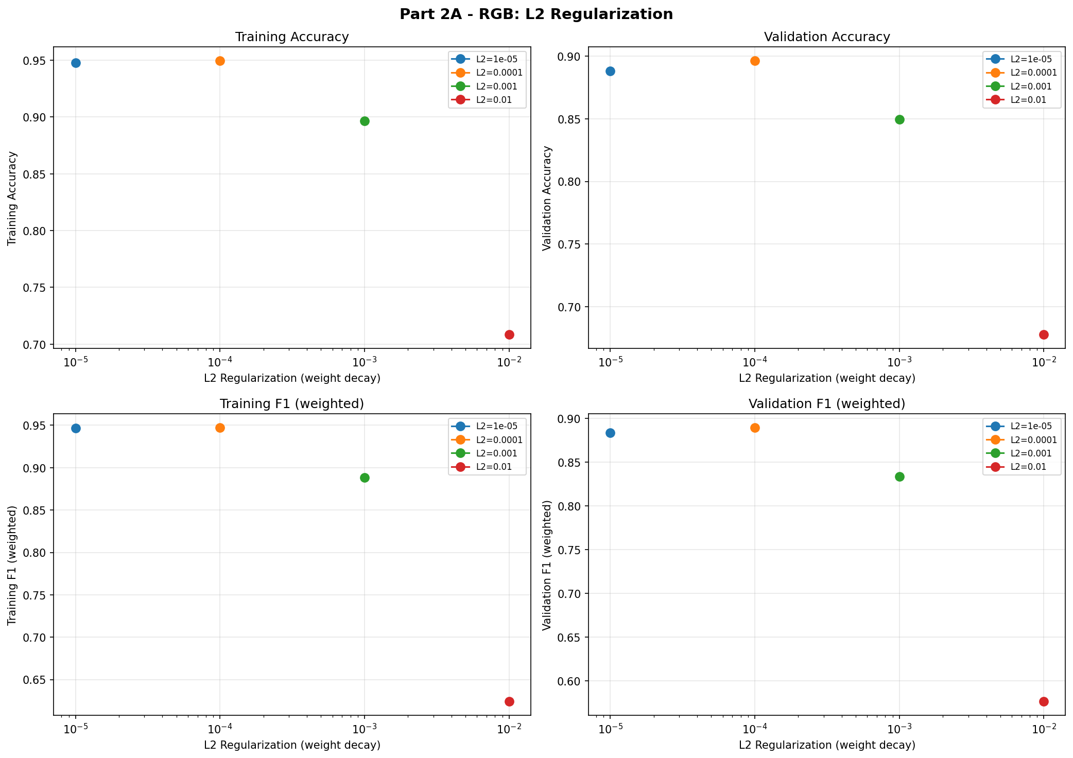
Figure 7. RGB L2 regularization sweep.
Table 11. RGB dropout results.
Setting | Val Acc | Val F1
Dropout = 0.10 | 0.9144 | 0.9099
Dropout = 0.25 | 0.8898 | 0.8778
Dropout = 0.40 | 0.8801 | 0.8602
Dropout = 0.60 | 0.8453 | 0.8162
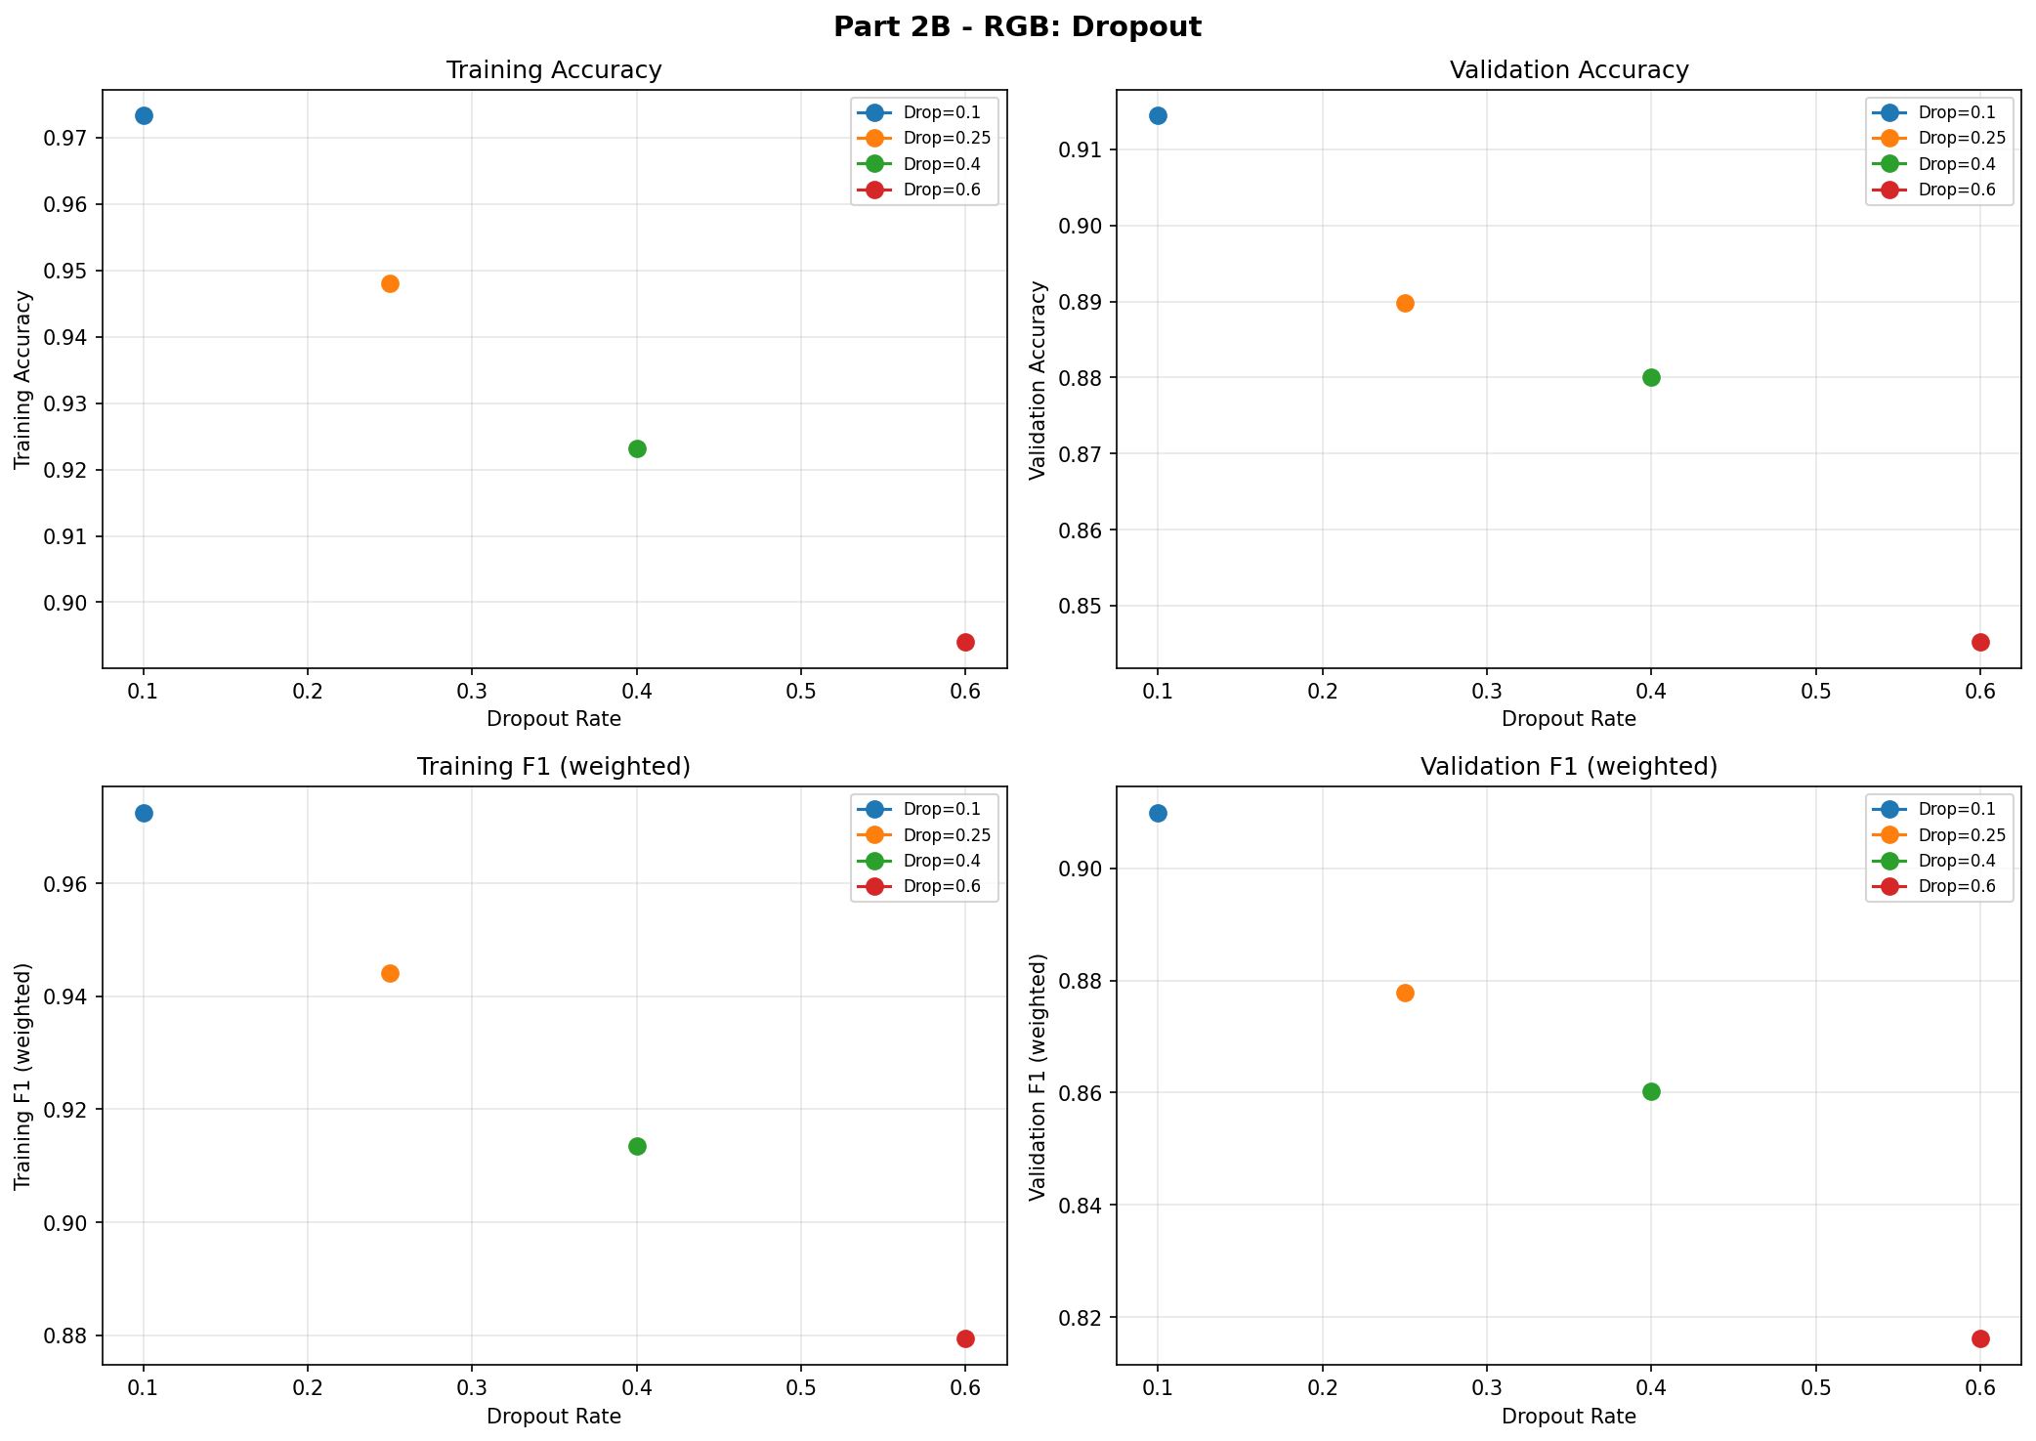
Figure 8. RGB dropout sweep.
Table 12. RGB augmentation results.
Setting | Val Acc | Val F1
Aug L1 | 0.9094 | 0.9059
Aug L2 | 0.9043 | 0.8997
Aug L3 | 0.8846 | 0.8765
Aug L4 | 0.8447 | 0.8231
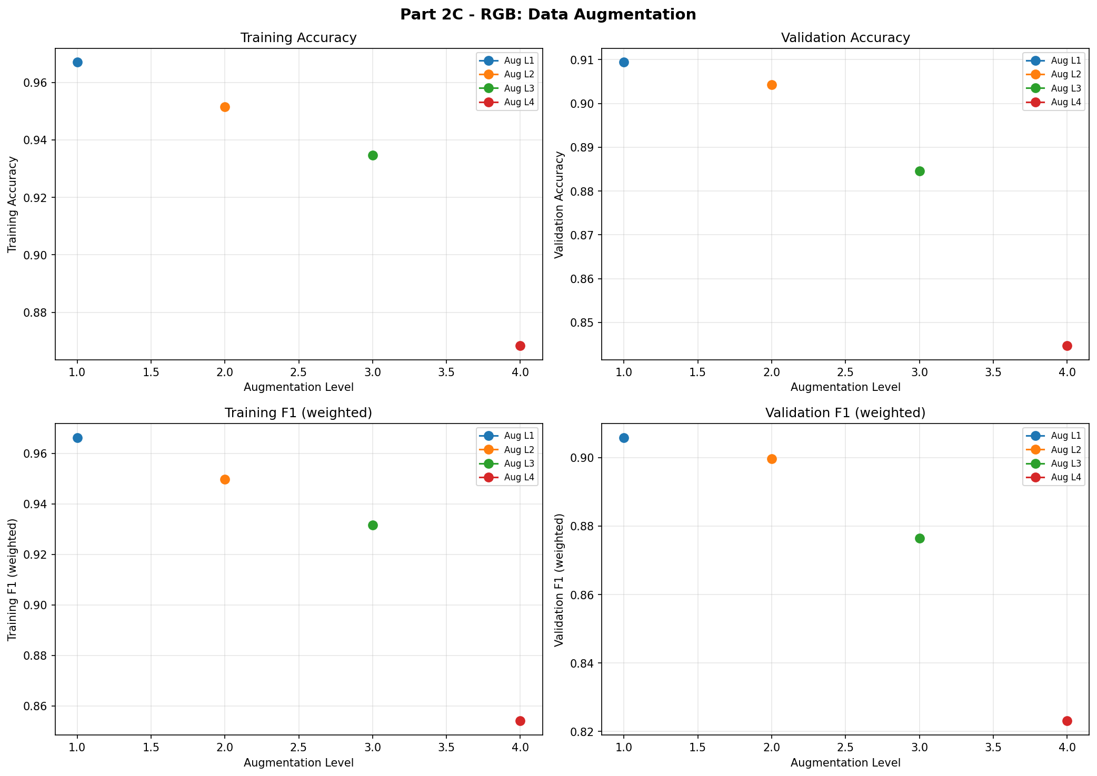
Figure 9. RGB data augmentation sweep.
Table 13. RGB combined regularization results.
Setting | Val Acc | Val F1
L2 = 1e-4 + Dropout = 0.1 | 0.8994 | 0.8947
L2 = 1e-4 + Aug L1 | 0.8818 | 0.8721
Dropout = 0.1 + Aug L1 | 0.9091 | 0.9032
L2 + Dropout + Aug | 0.8909 | 0.8744
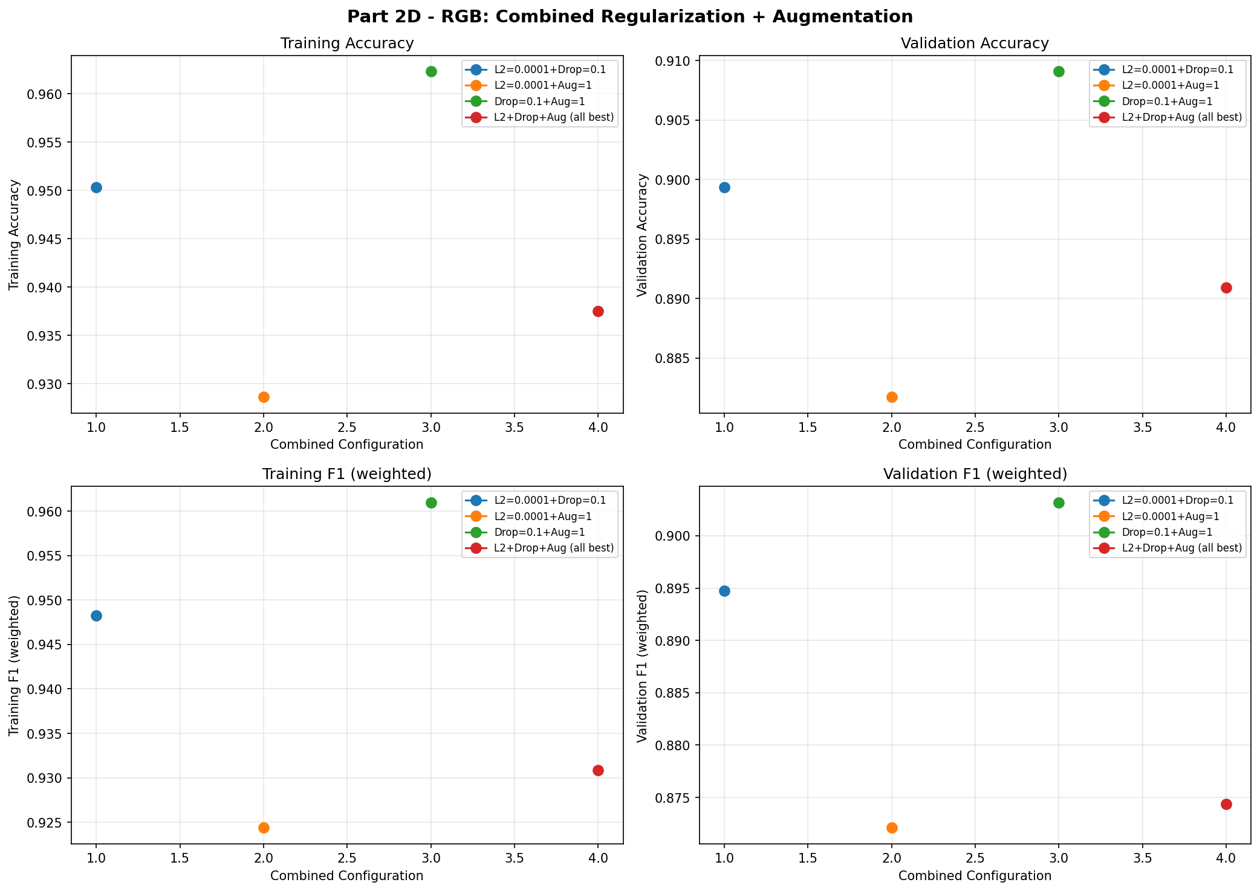
Figure 10. RGB combined regularization sweep.
The best RGB Part 2 result was dropout = 0.1 with Val Acc = 0.9144 and Val F1 = 0.9099. Mild augmentation also helped, but stronger augmentation reduced validation performance.

5. Cross-Modality Discussion
RGB achieved higher raw validation performance than IR in Part 1, likely due to richer texture, color, and edge information. IR benefited more from augmentation in Part 2, suggesting that moderate geometric transformations improved robustness to object placement and thermal-shape variation. In both modalities, combining individually best settings did not outperform the best single strategy.

6. Conclusions
- Increasing CNN capacity improved validation performance for both modalities.
- Arch D was the best Part 1 architecture for both RGB and IR.
- IR Part 2 performed best with augmentation level 2, reaching Val F1 = 0.9227.
- RGB Part 2 performed best with dropout = 0.1 on Arch C, reaching Val F1 = 0.9099.
- The best combined regularization settings did not outperform the best individual settings.
- Future work should add class weighting, per-class confusion analysis, transfer learning, autoencoder features, and final blind-test notebooks.

References
- Frigui, H. (2026). CSE 547 - Deep Learning Algorithms and Methods. University of Louisville.
- Teledyne FLIR. FLIR ADAS Dataset v2.
- Paszke, A. et al. (2019). PyTorch: An Imperative Style, High-Performance Deep Learning Library.
- TorchVision documentation. Image transformations and pretrained model utilities.
Note: The code, trained checkpoints, generated manifests, and figures referenced in this report are available in the accompanying project directory and notebooks.

