- 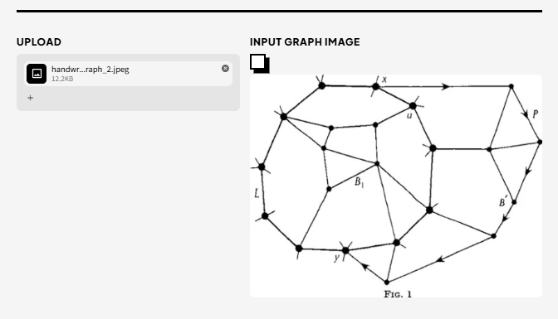
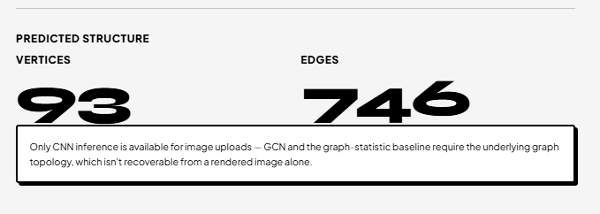
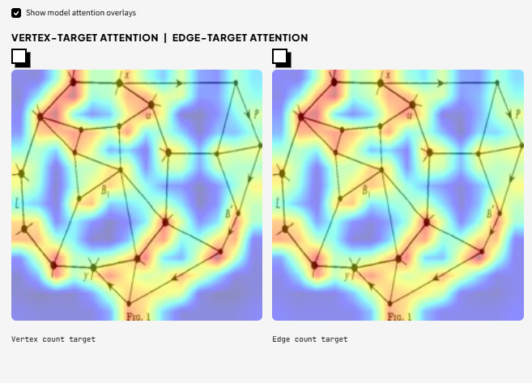

- 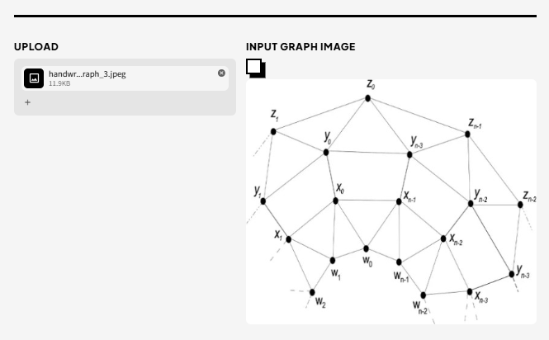
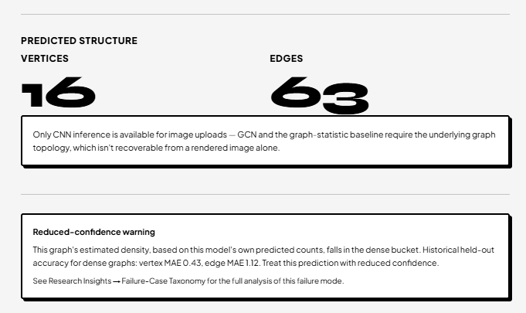
Only CNN inference is available for image uploads — GCN and the graph-statistic baseline require the underlying graph topology, which isn't recoverable from a rendered image alone.

Reduced-confidence warning
This graph's estimated density, based on this model's own predicted counts, falls in the dense bucket. Historical held-out accuracy for dense graphs: vertex MAE 0.43, edge MAE 1.12. Treat this prediction with reduced confidence.
See Research Insights → Failure-Case Taxonomy for the full analysis of this failure mode

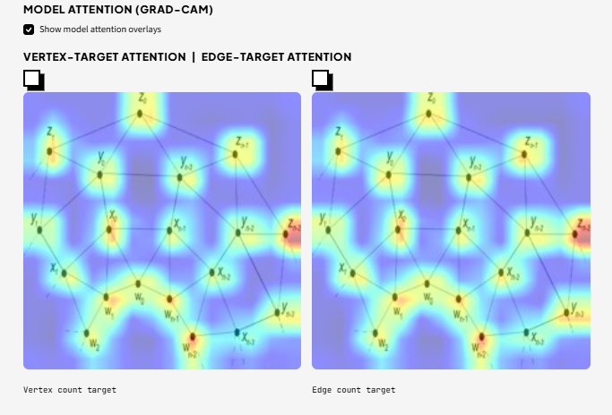

- 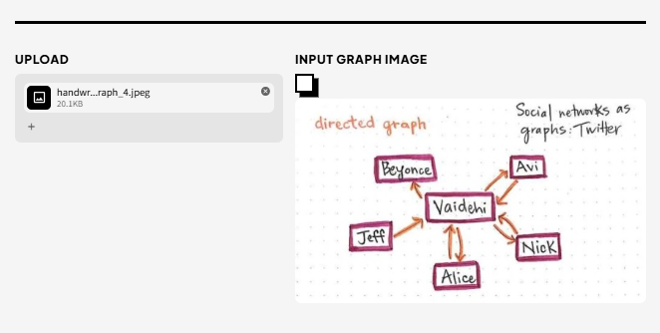
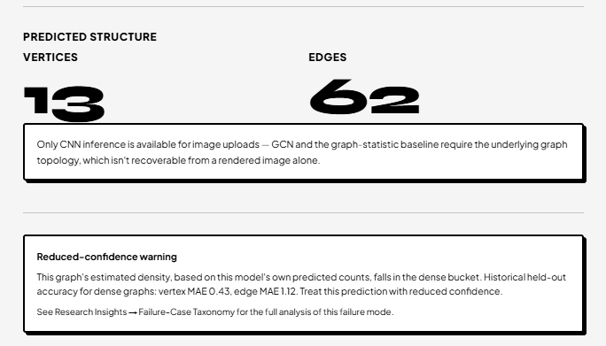
Only CNN inference is available for image uploads — GCN and the graph-statistic baseline require the underlying graph topology, which isn't recoverable from a rendered image alone.

Reduced-confidence warning
This graph's estimated density, based on this model's own predicted counts, falls in the dense bucket. Historical held-out accuracy for dense graphs: vertex MAE 0.43, edge MAE 1.12. Treat this prediction with reduced confidence.
See Research Insights → Failure-Case Taxonomy for the full analysis of this failure mode.
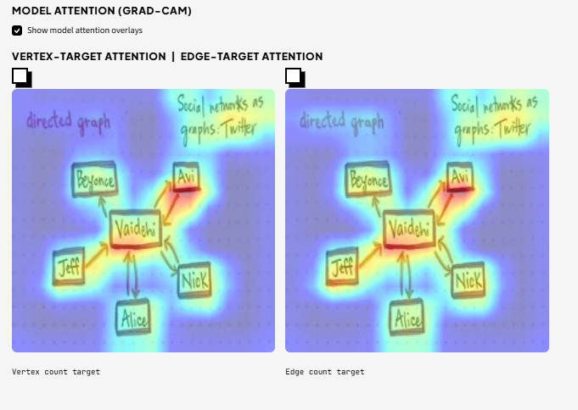

- 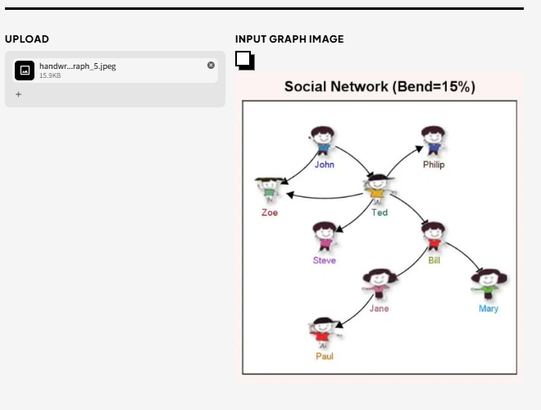
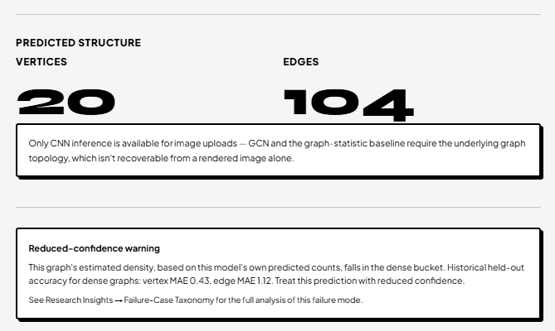
Only CNN inference is available for image uploads — GCN and the graph-statistic baseline require the underlying graph topology, which isn't recoverable from a rendered image alone.

Reduced-confidence warning
This graph's estimated density, based on this model's own predicted counts, falls in the dense bucket. Historical held-out accuracy for dense graphs: vertex MAE 0.43, edge MAE 1.12. Treat this prediction with reduced confidence.
See Research Insights → Failure-Case Taxonomy for the full analysis of this failure mode.
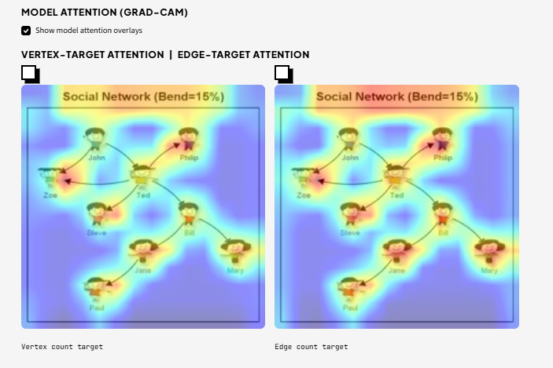

- 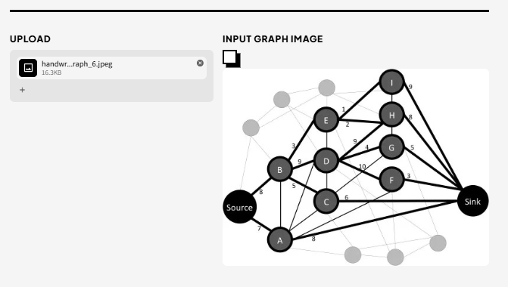
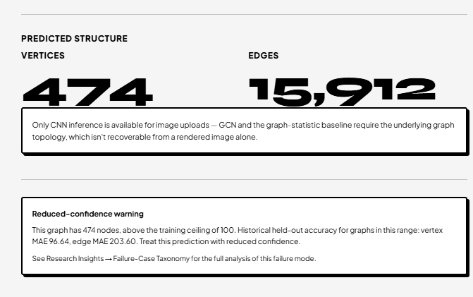

Only CNN inference is available for image uploads — GCN and the graph-statistic baseline require the underlying graph topology, which isn't recoverable from a rendered image alone.

Reduced-confidence warning
This graph has 474 nodes, above the training ceiling of 100. Historical held-out accuracy for graphs in this range: vertex MAE 96.64, edge MAE 203.60. Treat this prediction with reduced confidence.
See Research Insights → Failure-Case Taxonomy for the full analysis of this failure mode.



 