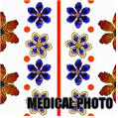

MedicalPhoto

**Installation Manual**

***Author: Seung Seog Han***

***Version 1.1***

***01 March 2025***

**Introduction**

 **MedicalPhoto** is a non-commercial medical image management program developed primarily for dermatologists, but it can also be used by plastic surgeons and dentists. Originally designed for dermatology at Asan Medical Center in 2003, MedicalPhoto was created to efficiently manage the 200–300 clinical photos captured daily. Organizing clinical photos is a repetitive task, and locating a specific image in Windows can be time-consuming due to the sheer volume of accumulated photos. With its built-in database, MedicalPhoto allows users to find images in under one second. MedicalPhoto supports ICD-10 diagnosis and can identify most conditions documented in dermatology textbooks. Users can also define custom diagnoses or procedure names if they are not predefined and tag photos accordingly. Additionally, MedicalPhoto supports multiple monitors, allowing for side-by-side photo comparisons on two or three screens. Its server-client structure enables access from multiple computers within an office, ensuring seamless integration across different workstations.

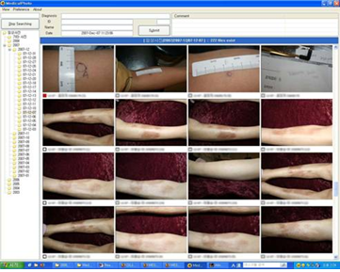

**Official Homepage :** [**https://medicalphoto.modelderm.com**](https://medicalphoto.modelderm.com)

**Download :** [**http://release.medicalphoto.org**](http://release.medicalphoto.org)

# **Salient Features**

* **Simple and easy to use**
* **Network support (server - client structure)**
* **Support for dual or multiple monitors**
* **Built-in diagnosis (ICD-10 and Dermatologic Textbook Diagnosis)**
* **Define a new diagnosis or procedure and tag photos with it**

# **Minimum System Requirements**

MedicalPhoto is compatible with Microsoft Windows XP, Vista, 7, 8, and 10.

# **Installation**

"Setup.exe" file can be downloaded from https://medicalphoto.modelderm.com

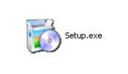

**Setup.exe** - MedicalPhoto installer

## 1. Server Side Installation

1) Install server

Run the installer ("Setup.exe"). In the "Select Type" section, you can choose either "Client Only" or "Server and Client." MedicalPhoto runs on multiple clients connected to a single server. If this is your first time installing the software, select "Server and Client." If the server is already installed and you are installing MedicalPhoto on additional computers, select "Client." After installation, the configuration wizard will launch automatically. ( “Configure”).

2) Configuration

Select the main directory where photos will be saved.

… Select Folders (Click on the button below “PhotoGraphy Folder”)

*Specify a location on your hard disk to save the photos. Make sure to select a drive with sufficient storage capacity.*

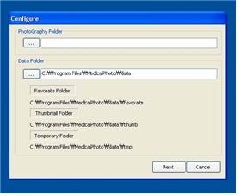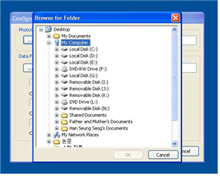

Select a main photo folder

If the specified folder contains previously taken photos, MedicalPhoto will gather their information. This process may take some time depending on the number of photos.

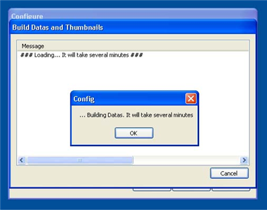

Building data and install a service

3) Check IP Address

"MedicalPhotoServer" appears as an icon in the system tray at the bottom right of the Windows screen.  "MedicalPhotoServer" is a server monitoring tool that checks the current state of the server and logs its activity. On the log screen, the server's [IP Address] will be displayed upon startup. The [Host Address] refers to the server's internal IP address. For setting up the client side, it is essential to remember the server's IP address.

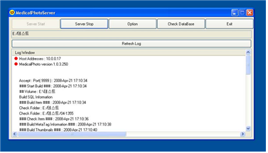

MedicalPhotoServer

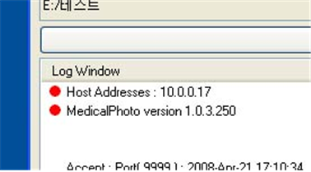

IP address and application version

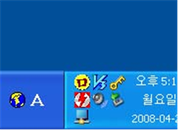

MedicalPhotoServer in tray area

## 2. Client Side Installation

Before installing a client, you must first install the MedicalPhoto server.

Run "Setup.exe" on the client computer and select "Client" from the "Select Type" menu.

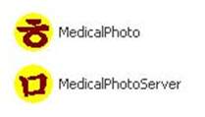

MedicalPhoto is an icon of the client. MedicalPhotoServer is the icon of server management tool.

# **Client Usage**

## 1. Connect to the Server

Run "MedicalPhoto".**** Enter the [IP Address] of the server. You can change the IP address later in "Preference" → "Server Information."

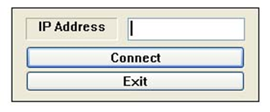

Login Box

## 2. Client Window

The client window consists of the following components: *“Search Box”, “Folder Tree”, “Patient Information Box”, “Comment Box” and “Photographic Listbox”*.

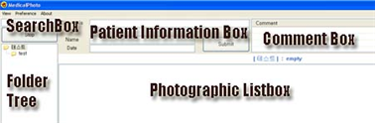

Client Window

1) “Search Box”

Search for photos by entering a keyword (Shortcut: F12 key). You can specify the field using [DX], [ICD], [NAME], [<], [>], [ID] and use "AND" or "OR" for more precise searches.

Ex) tinea pedis AND smith

Ex) “tinea pedis”[DX] AND smith[NAME]

Ex) 2010[<] AND 2015[>] AND tinea

Tip) 1y AND tinea → “1y” is already defined as “2015[<]” (current year - 1). To find recently taken photos, use “1y” keyword.

2) “Folder Tree”

Right-click shows various options such as *“Download”, “Upload”, “Create”, “Rename”, and “Delete”*.

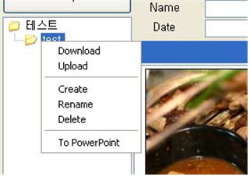

Popup menu

3) “Patient Information Box”

It consists of "Diagnosis," "ID," "Name," and "Date" fields, along with a "Submit" button. To search for a diagnosis, enter part of its name and press Enter. MedicalPhoto will search for matching keywords within the diagnosis database. If you want to use a custom keyword instead of a built-in diagnosis, enter any surgical procedure or diagnosis of your choice and click "Submit." MedicalPhoto stores all previously entered keywords. User-defined diagnoses can be edited in "Preference" → "Custom Diagnosis" from the menu. When you press the Submit button, the filename will be automatically generated based on the diagnosis, patient’s name, ID, and date.

Cf) If you don’t want to change the filename, go to **“Preference” → “General” → “Automation”** and uncheck **“Change Filename”** option.

4) “Comment Box”

You can leave comments in the comments field. Comments do not affect the filename of the photo.

5) “Photographic Listbox”

**Left-click** : Select or deselect an image. If you select photos while holding the **CTRL** key, all photos taken around the same time or with similar filenames will be selected automatically.

**Right click** : D*ownload”, “Upload”, “Rename”, and “Delete”* menu appears.

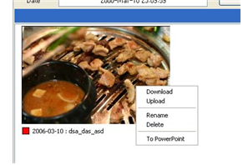

Popup menu

**Double-click** : A photo can be displayed in full screen by double-clicking on it. In full-screen mode:

Use the arrow buttons to rotate photos.

Press the Spacebar to enlarge photos.

On a dual-monitor setup, use the PageUp and PageDown keys to send photos to the secondary monitor.

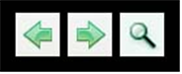

Move the image to another monitor / magnify the image

Cf) To change the thumbnail size, modify the thumbnail size option in the "s_config.txt" file on the server. In most cases, a size of 300 × 200 pixels is suitable.

6) “Selected Photos Listbox”

The filename of the currently selected photo is displayed in the "Selected Photos Listbox" at the bottom left. Files that are automatically selected using the Ctrl key appear in red.

## 3. Menu

1) View Mode [ Ctrl-T ]

MedicalPhoto supports a two-screen mode. Simple mode is useful when using a monitor with a resolution lower than 1024×768.

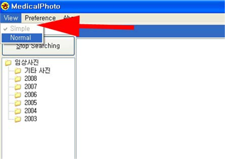

Select view mode in the menu

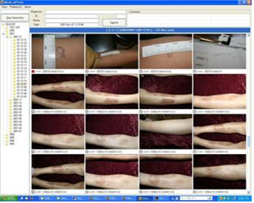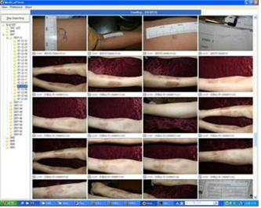

<Normal> <Simple>

2) Upload [ Ctrl+U ]

Based on the date a photo was taken, a date-named folder will be created automatically. For example: "2007/2007-01/07-01-24".

If EXIF (photo date information) is unavailable, the photo will be placed in the "Unknown Date" folder.

3) User Diagnosis

User diagnoses are shared across all clients.

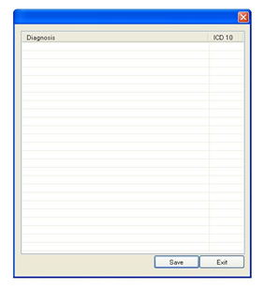

User Diagnosis

4) Preference

… General

**Server Information** : You can get the [IP address] by the server management tool, *“MedicalPhotoServer”* which is running at the tray of the server.

**Automation** : *“MedicalPhoto”* changes the filename on the basis of date and diagnosis information.

**Search Option** : Search option for *“search box”*

**Diagnosis Files** : MedicalPhoto includes a built-in **"derma.dat"** file containing dermatology diagnoses and **ICD-10** codes.

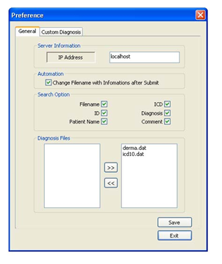

Preference / General

## 4. Uploading and Downloading Photo

The easiest way to upload a photo is to use the Upload-Ex menu button on the program menu.

## 5. Keyboard Shortcuts

|  |  |
| --- | --- |
| **Keyboard Shortcuts** | |
| **F12** | Set focus to a search-box |
| Ctrl + E | Set focus to a diagnosis-box |
| Ctrl + A | Select all |
| **Ctrl + Click** | Select time-related or filename-related photos |
| Ctrl + D | Download |
| **Ctrl + U** | UploadEx |
| **Double click** | Full Screen View |
| **ESC** | Desselect or Uncheck all |

|  |  |
| --- | --- |
| **Keyboard Shortcuts (FULL SCREEN VIEW STATE)** | |
| PageUp | Move a photo to the next monitor |
| PageDown | Move a photo to the previous monitor |
| **Space** | Loupe |
| E, R | Rotate image |
| ← → | Next and Previous image |
| ESC | Close window |

# **Server Management**

The server application consists of *"MedicalphotoServer "* and *"console.exe"*.

"MedicalPhotoServer" - Server Monitor

"Console.exe" - Server Core

## 1. Console.exe

It is the main server program that runs as Windows Service Mode in the background.

## 2. MedicalPhotoServer

It is a monitoring tool for the MedicalPhoto server, appearing as a tray icon at the bottom right. It allows you to monitor, start, stop, and configure the server.

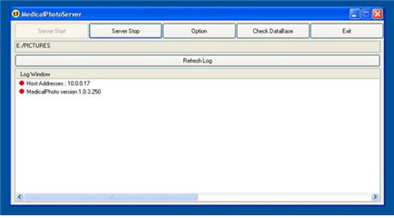

MedicalPhotoServer

**1) Server Start** : Start a server. It launches *“console.exe”* in the background.

**2) Server Stop** : Stop a server. It stops *“console.exe”* running in the background.

**3) Option** : Configuration of a server.

**4) Check DataBase** : You need to try to check the Database if you cannot find photo in the MedicalPhoto even though there is a photo file in the server folder. We have to correct the error by comparing the database information to the photos in the folder.

**5) Log Window** : Display the [Host IP Address] and [the application version] at startup. All logs are saved in *“log.txt”* file.

## 3. Security

The security password can be defined in the server configuration file (c:\program files(x86)\medicalphoto\s_config.txt , ADMIN_PASS).

Ex) ADMIN_PASS=1234 → Medicalphoto will be unlocked after typing “1234”

# **Troubleshooting**

***Please report any bugs to whria78@gmail.com***

# **Copyright**

All Rights Reserved by ***Seung Seog Han (whria78@gmail.com)***

I Dermatology, Seoul Korea

<http://whria.net>