
MedicalPhoto

Installation Manual
Author: Han Seung Seog
Version 1.1
30 Aug 2016

Introduction

 MedicalPhoto is a non-commercial medical image management program. MedicalPhoto has been developed for dermatologists, but it also can be used by plastic surgeons and dentists.
This program was developed for use in dermatology at the Asan Medical Center in 2007. As 200-300 clinical photos were captured daily, it was developed as an easy and efficient photo management tool. Organizing clinical photos involves a series of repetitive tasks. Given the volume of accumulated clinical photography over the years, locating a particular photo in Windows is time consuming. Photos can be found within 1 second in MedicalPhoto, based on the built-in database. MedicalPhoto can perform ICD-10 diagnosis as well as diagnosis of most cases documented in dermatology textbooks. A user can also define a diagnosis or procedure name if the diagnosis is not defined as a reserved word, and tag photos with it. MedicalPhoto supports multiple monitors; therefore, 2-3 monitors can be used to enable comparison of photos. MedicalPhoto employs server-client structure, permitting access from any of the numerous computers in your office.

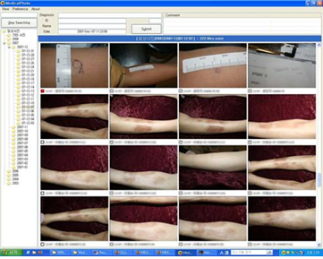

Official Homepage : http://medicalphoto.org
Download : http://release.medicalphoto.org

Salient Features

- Simple and easy to use
- Network support (server - client structure)
- Support for dual or multiple monitors
- Built-in diagnosis (ICD-10 and Dermatologic Textbook Diagnosis)
- Define a new diagnosis or procedure and tag photos with it
- Photos can be converted to Microsoft PowerPoint

Minimum System Requirements
Microsoft Windows XP, Vista, 7, 8 or 10. MedicalPhoto does not support Linux and Mac, but core libraries are written in standard C + +. The function to export photos to Microsoft PowerPoint works if Microsoft PowerPoint is installed.

Installation
"Setup.exe" file can be downloaded from http://release.medicalphoto.org

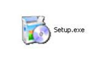
Setup.exe - MedicalPhoto installer

1. Server Side Installation

1) Install server
Run the installer(“Setup.exe”). In "Select Type", you can select either "client only" or "server and client". MedicalPhoto runs on multiple clients connected to a single server. If this is a first time installation, please select "server and client". If you already Installed the server and Medicalphoto is being installed on other computers, please select "client". After installation, it will launch configuration wizard ( “Configure”).

2) Configuration
Select the main directory to save photos.

… Select Folders (Click on the button below “PhotoGraphy Folder”)
And specify a location on your hard disk to save the photo. Select a drive with sufficient capacity.

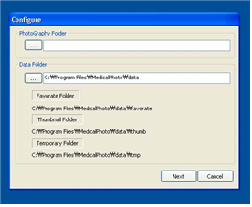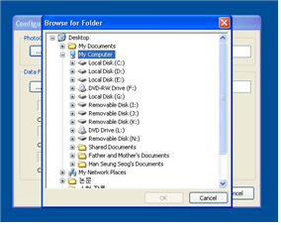
Select a main photo folder
If the specified folder contains photos taken previously, MedicalPhoto gathers their information. This process may take a while depending on the number of photos.

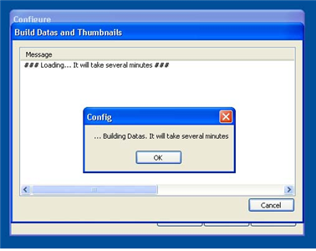
Building data and install a service

3) Check IP Address
"MedicalPhotoServer" appears as an icon in the tray region at the bottom right of the Windows(screen).  "MedicalPhotoServer" is a server-mo nitoring tool that examines the current state of the server and logging. On the log screen, [IP Address] of the server will be displayed when it start up. The [Host Address] is the internal IP address of the server. For setting up client side, it is essential for you to memorize the server IP address.

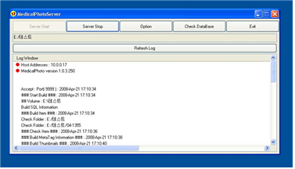
MedicalPhotoServer
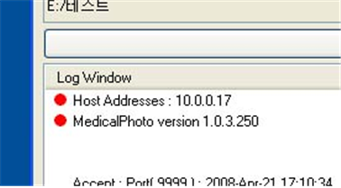
IP address and application version
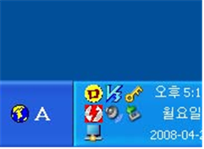
MedicalPhotoServer in tray area

2. Client Side Installation

Before installing a client, you must install MedicalPhoto server first.
Run, "Setup.exe" on the client computer and select "client" from the "Select Type".

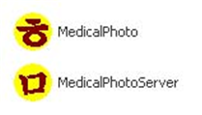
MedicalPhoto is an icon of the client. MedicalPhotoServer is the icon of server management tool.

Client Usage

1. Connect to the Server
Run "MedicalPhoto". Enter the [IP Address] of the server. You can change the IP address at "Preference" -> "Server Information" ,later.
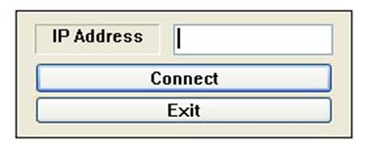
Login Box

2. Client Window
The client window consists of “Search Box”, “Folder Tree”, “Patient Information Box”, “Comment Box” and “Photographic Listbox”.
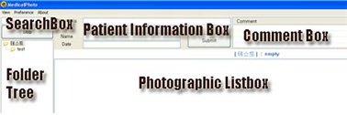
Client Window
1) “Search Box”
Search photography by entering a keyword. (Shortcut : F12 key). You can use [DX], [ICD], [NAME],[<],[>], [ID] to specify the field. You can use “AND” or “OR”. Here are few examples.

Ex) tinea pedis AND smith
Ex) “tinea pedis”[DX] AND smith[NAME]
Ex) 2010[<] AND 2015[>] AND tinea

Tip) 1y AND tinea → “1y” is already defined as “2015[<]” (current year - 1). To find recently taken photos, use “1y” keyword.

2) “Folder Tree”
Right-click shows various options such as “Download”, “Upload”, “Create”, “Rename”, “Delete” and “to PowerPoint”.
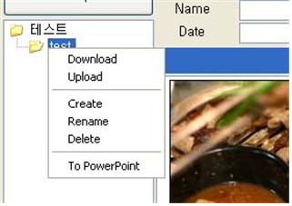
Popup menu
3) “Patient Information Box”
It consists of “Diagnosis”, “ID”, “Name” and “Date” boxes and “submit” button. On Entering part of the name of the diagnosis and pressing the Enter key, the name of the keyword in the diagnosis is searched. If you want to use a keyword other than built-in diagnosis, enter any name of the surgery and any diagnosis they want and click the "submit". MedicalPhoto stores all previously entered keywords. The user diagnosis can be edited at ("Preference" → "Custom Diagnosis") from the menu. When you press the Submit button, it will automatically convert filename on the basis of diagnosis, patient's name, ID and date.

Cf) If you don’t want to change the filename, go to “Preference” → “General” → “Automation” and uncheck “Change Filename” option.

4) “Comment Box”
You can leave comments. Comments field do not change filename of photo.

5) “Photographic Listbox”

Left-click : Select / deselect the image, If you select photos while pressing (CTRL) key, all photos either taken around the same time or having similar filenames, are selected automatically.
Right click : Download”, “Upload”, “Rename”, “Delete” and “To PowerPoint” menu appears.
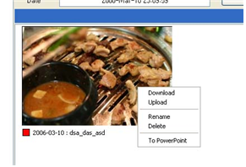
Popup menu
Double-click : A photo can be displayed in full screen by double-clicking on it. Photos can be rotated using the arrow buttons in full screen mode. Photos can be enlarged by pressing spacebar key. The PageUp and PageDown keys can send photos to the other(secondary) monitor when viewed on dual monitors.

Move the image to another monitor / magnify the image

Cf) “Export images to Microsoft PowerPoint” : The results are stored in slide.ppt (desktop foler). Template file exists at "c \ program files \ medical photo \ template". You can edit template file to get the desired result.

Cf) If you want to change thumbnail size, change the thumbnail size option in the "s_config.txt" on the server. In a typical environment, 300 * 200 pixel are suitable.

6) “Selected Photos Listbox”
The filename currently selected is displayed in the "Selected Photos Listbox" box at the bottom left. Files automatically selected using the Ctrl key are displayed in red.

3. Menu

1) View Mode [ Ctrl-T ]
MedicalPhoto supports a two-screen mode. Simple mode is useful if you are using a monitor supporting a resolution lower than 1024x768.

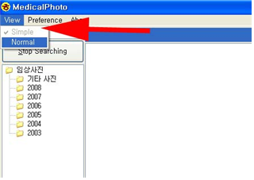
Select view mode in the menu
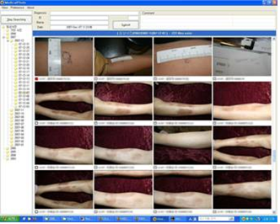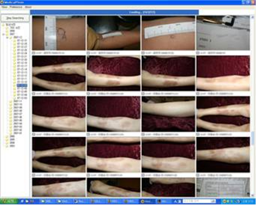
<Normal> <Simple>
2) Upload [ Ctrl+U ]
Based on the date a photo was taken, a date-named folder will be created automatically; for example, "2007/2007-01/07-01-24". If EXIF(photo date information) is unavailable, it is placed in the "unknown date" folder.

3) User Diagnosis
User Diagnosis is shared by all clients.
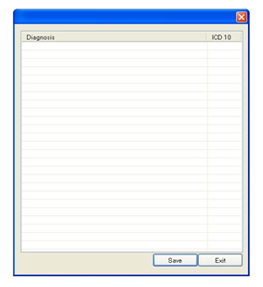
User Diagnosis

4) Preference
… General
Server Information : You can get the [IP address] by the server management tool, “MedicalPhotoServer” which is running at the tray of the server.
Automation : “MedicalPhoto” changes the filename on the basis of date and diagnosis information.
Search Option : Search option for “search box”
Diagnosis Files : MedicalPhoto has a built-in (derma.dat) dermatology diagnosis and ICD-10.
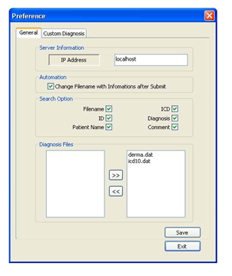
Preference / General

4. Uploading and Downloading Photo

The easiest way to upload a photo is to use the Upload-Ex menu button on the program menu.

5. Keyboard Shortcuts

Keyboard Shortcuts
F12 | Set focus to a search-box
Ctrl + E | Set focus to a diagnosis-box
Ctrl + A | Select all
Ctrl + Click | Select time-related or filename-related photos
Ctrl + D | Download
Ctrl + U | UploadEx
Double click | Full Screen View
ESC | Desselect or Uncheck all

Keyboard Shortcuts (FULL SCREEN VIEW STATE)
PageUp | Move a photo to the next monitor
PageDown | Move a photo to the previous monitor
Space | Loupe
E, R | Rotate image
← → | Next and Previous image
ESC | Close window

Server Management
The server application consists of "MedicalphotoServer " and "console.exe".
"MedicalPhotoServer" - Server Monitor
"Console.exe" - Server Core

1. Console.exe
It is the main server program that runs as Windows Service Mode in the background.

2. MedicalPhotoServer
It is a monitoring tool of the MedicalPhoto server. It appears as a tray icon at right bottom. It assists you to monitor, start, stop and configure a server.

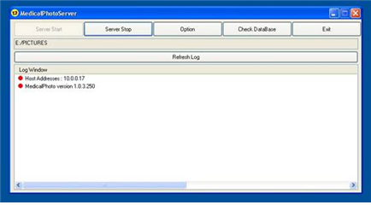
MedicalPhotoServer

1) Server Start : Start a server. It launches “console.exe” in the background.
2) Server Stop : Stop a server. It stops “console.exe” running in the background.
3) Option : Configuration of a server.
4) Check DataBase : You need to try to check the Database if you cannot find photo in the MedicalPhoto even though there is a photo file in the server folder. We have to correct the error by comparing the database information to the photos in the folder.
5) Log Window : Display the [Host IP Address] and [the application version] at startup. All logs are saved in “log.txt” file.

3. Security
The security password can be defined in the server configuration file (c:\program files(x86)\medicalphoto\s_config.txt , ADMIN_PASS).
Ex) ADMIN_PASS=1234 → Medicalphoto will be unlocked after typing “1234”

Troubleshooting
Please report any bugs to whria78@gmail.com

Copyright
All Rights Reserved by Han Seyung Seog (whria78@gmail.com)
I Dermatology, Seoul Korea
http://medicalphoto.org
http://whria.net
2016.8.30

