Machine Learning Stock Selection: Household and Personal Products Sector
This paper applies six machine learning models to predict industry-adjusted monthly returns for stocks in the Household and Personal Products sector (GICS sector 30, group 3030) and uses those predictions to recommend one stock to buy in November 2024. The dataset spans January 2001 through November 2024 and contains approximately 1.05 million stock-month observations across all GICS sectors. Fifteen winsorized predictor variables capture size, value, momentum, profitability, liquidity, governance, and risk characteristics. Models are trained on data from January 2001 through December 2018, tuned on a validation window (January 2019–December 2021), and evaluated on a held-out test set (January 2022–October 2024); November 2024 serves as the pure prediction month. The six methods are: ordinary least squares (OLS) regression, LASSO penalized regression, a vanilla decision tree, a random forest, gradient boosting (XGBoost), and a simple three-layer neural network. Out-of-sample R² values are near zero or slightly negative for all models, consistent with the well-documented difficulty of predicting cross-sectional stock returns. Despite limited predictive power in aggregate, the models exhibit meaningful agreement in their top-ranked picks for November 2024. NAII (Natural Alternatives International Inc.) appears in the top three rankings under two of six models and is our recommended buy. The 12-month momentum factor (finmom12) consistently receives the highest importance weight across the tree-based and linear models, supporting the robustness of the momentum anomaly in this sector.

[Student Name 1] | [email@umich.edu] | [phone]
[Student Name 2] | [email@umich.edu] | [phone]
[Month Day, Year]

Contents
[Update this table of contents field before submission]

Tables
Table 1. Variable names, labels and constraints
Table 2. Descriptive statistics on the whole sample
Table 3. Stock rankings under different estimation techniques

Figures
Figure 1. Spearman correlation matrix of the 15 predictor variables
Figure 2. Distribution of 12-month momentum (finmom12)
Figure 3. Mean industry-adjusted return by decile of 12-month momentum
Figure 4. Chronological data splits
Figure 5. OLS standardised coefficient estimates
Figure 6. LASSO regularization path
Figure 7. Vanilla decision tree structure
Figure 8. Vanilla decision tree feature importances
Figure 9. Random forest feature importances
Figure 10. XGBoost feature importances
Figure 11. Neural network training and validation loss curves
Figure 12. Average rank across six models for all 38 sector stocks
Figure 13. Out-of-sample R² and RMSE for each model

Introduction

Research Question and Overview
Can machine learning models trained on publicly observable stock characteristics identify which stock in the Household and Personal Products sector (GICS 3030) will deliver the highest industry-adjusted return in November 2024? We address this question by fitting six distinct models — OLS, LASSO, a vanilla decision tree, a random forest, XGBoost, and a simple neural network — on a large cross-sectional panel spanning more than two decades, then generating out-of-sample predictions for the 38 sector stocks observed at the October 2024 portfolio formation date. The stock that scores highest most consistently across methods is our recommended investment: NAII (Natural Alternatives International Inc.).

Report Structure
Section 2 describes the dataset, variable construction, and the chronological train/validation/test/prediction split. Section 3 presents results for each model together with out-of-sample performance metrics and feature importances. Section 4 reconciles the six sets of predictions and justifies the final stock pick. Section 5 concludes. An appendix provides detailed descriptions of each predictor variable.

Data

Variable Names, Labels and Descriptions
The name and label for each independent variable are presented in Table 1, along with the group that compiled each variable and the constraint applied to each variable to mitigate the potential for outliers to have an outsized influence on results. For example, 0.50 for Book-to-market equity means the variable was constrained at the 0.5th percentile and the 99.5th percentile. A description for each variable is provided in the Appendix.

Table 1. Variable names, labels and constraints
Name | Label | Group | Constraint
Real market capitalization | lag1mcreal | J | 0.00
Natural logarithm of real market capitalization | lnlag1mcreal | J | 0.00
Book-to-market equity | bm | J | 0.50
Option volume/stock volume | os | 1 | 0.05
Momentum12 (12 mth ret ending 1 mth prior to port) | mom12 | 2 | 1.00
Net profit margin (Net profit/Sales) | npm | 3 | 1.00
Standard deviation of board members’ age | sdage | 4 | 0.00
Percentage male board members | gender | 4 | 0.00
Systematic risk | beta | 5 | 1.00
Net working capital/Assets | nwca | 6 | 0.50
Amihud liquidity × 1,000,000 | illiq | 7 | 2.50
Current ratio (Current assets/Current liabilities) | cr | 8 | 1.00
Natural logarithm of the change in issued shares | lnshchg | 9 | 0.50
Momentum 11 (11 mth ret ending 1 mth prior to port) | mom11 | 10 | 1.00
Change in return on assets | chgroa | 11 | 2.50
Return on invested capital | roic | 12 | 2.50

Descriptive Statistics on the Whole Sample
The dataset covers the period January 2001 to October 2024, comprising 1,053,738 stock-month observations across all GICS sectors. Table 2 reports summary statistics for all 15 predictor variables and the target variable (industry-adjusted return, indadjret), computed on the full sample excluding November 2024. The fin* columns are winsorized at the percentile constraints listed in Table 1; the percentage missing reflects the fraction of raw observations that required imputation. lnshchg (log change in shares issued) has the highest missingness at approximately 75%, while illiquidity and momentum are nearly complete.

Table 2. Descriptive statistics on the whole sample
Variable | N | Mean | Std | p1 | p25 | p50 | p75 | p99 | %Miss
Log Market Cap | 1,053,738 | 13.6486 | 2.1184 | 9.0592 | 12.1470 | 13.6252 | 15.0681 | 18.7068 | 0.0
Book-to-Market | 1,053,738 | 0.5637 | 0.6363 | 0.0000 | 0.1263 | 0.4239 | 0.7860 | 3.2579 | 18.9
Chg in ROA | 1,053,738 | 0.0002 | 0.1394 | -0.5519 | -0.0063 | 0.0000 | 0.0056 | 0.5814 | 30.5
Amihud Illiquidity | 1,053,738 | 1.2648 | 5.6545 | 0.0001 | 0.0007 | 0.0059 | 0.0911 | 42.1305 | 0.0
Std Dev Board Age | 1,053,738 | 6.2181 | 3.8834 | 0.0000 | 4.3000 | 6.8000 | 8.8000 | 14.4000 | 20.4
Pct Male Board | 1,053,738 | 0.6869 | 0.3659 | 0.0000 | 0.6360 | 0.8330 | 1.0000 | 1.0000 | 20.4
Net Profit Margin | 1,053,738 | -0.4015 | 2.8284 | -20.2819 | 0.0000 | 0.0250 | 0.0950 | 0.3770 | 17.7
Momentum 12m | 1,053,738 | 0.1156 | 0.5292 | -0.8424 | -0.1756 | 0.0376 | 0.3066 | 2.4969 | 5.1
Current Ratio | 1,053,738 | 2.4912 | 3.8439 | 0.0000 | 0.0500 | 1.5341 | 2.8528 | 21.8429 | 24.9
Option/Stock Vol | 1,053,738 | 0.0005 | 0.0015 | 0.0000 | 0.0000 | 0.0001 | 0.0005 | 0.0061 | 37.2
Beta | 1,053,738 | 0.5794 | 0.7244 | -0.1409 | 0.0000 | 0.1755 | 1.0668 | 2.8688 | 45.7
NWC/Assets | 1,053,738 | 0.1739 | 0.2548 | -0.2023 | 0.0000 | 0.0572 | 0.3091 | 0.8975 | 33.2
Ln Share Issuance Chg | 1,053,738 | 0.0017 | 0.0216 | -0.0072 | 0.0000 | 0.0000 | 0.0000 | 0.0502 | 75.5
Momentum 11m | 1,053,738 | 0.1062 | 0.5057 | -0.8307 | -0.1715 | 0.0359 | 0.2914 | 2.3624 | 4.7
ROIC | 1,053,738 | 0.0051 | 0.2097 | -0.9830 | 0.0000 | 0.0000 | 0.0960 | 0.3870 | 17.4
indadjret | 1,053,738 | 0.0035 | 0.1567 | -0.3590 | -0.0613 | -0.0038 | 0.0544 | 0.4960 | 0.0

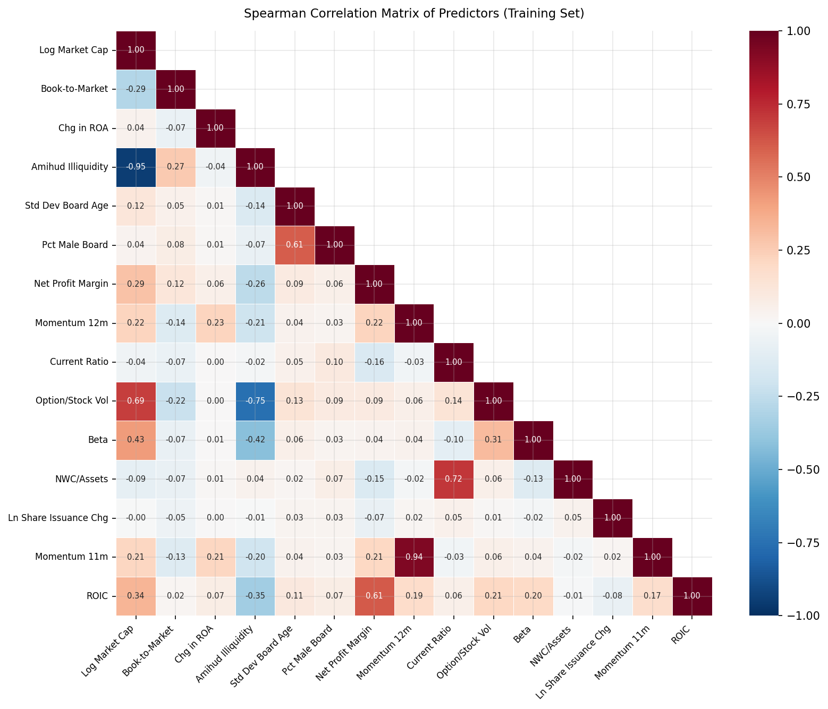
Figure 1. Spearman correlation matrix of the 15 predictor variables computed on the training set (January 2001 – December 2018). Values shown are Spearman rank correlations. The momentum variables (finmom11, finmom12) are highly correlated with each other, as expected.

Descriptive Statistics on Your Variable of Interest
We select 12-month momentum (finmom12) as our variable of interest. The momentum anomaly — the tendency for recent winners to continue outperforming recent losers — is among the most robust and replicated findings in empirical asset pricing (Jegadeesh and Titman, 1993). The canonical specification uses the cumulative return over months t−12 through t−2 (skipping the most recent month to avoid short-term reversal). For the Household and Personal Products sector, stable fundamental cashflows reduce the likelihood that strong past returns will be rapidly mean-reverted by earnings surprises, making momentum particularly informative.
The variable is winsorized at the 1st and 99th percentiles (constraint 1.00), which preserves large momentum signals while eliminating extreme data errors. Descriptive statistics for the full sample (excluding November 2024) are presented in the table below. Figure 2 shows the distribution of finmom12 within our sector, and Figure 3 confirms the positive monotonic relationship between momentum decile and mean industry-adjusted return in the training set.

Table. Descriptive statistics for Momentum 12m (variable of interest)
Variable | N | Mean | Std | p1 | p5 | p25 | p50 | p75 | p95 | p99 | %Miss
Momentum 12m | 1,053,738 | 0.1156 | 0.5292 | -0.8424 | -0.6154 | -0.1756 | 0.0376 | 0.3066 | 1.0525 | 2.4969 | 5.1

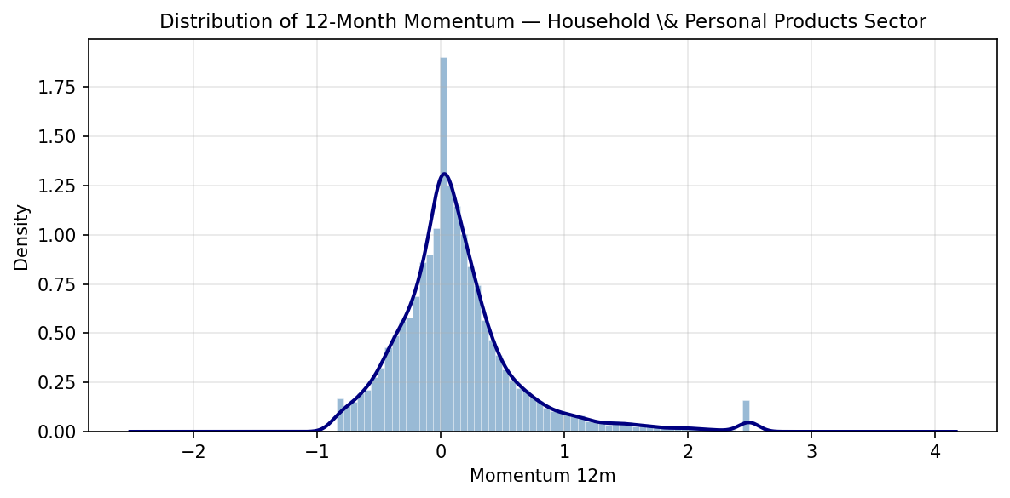
Figure 2. Distribution of 12-month momentum (finmom12) for Household & Personal Products stocks (sector 30, group 3030).
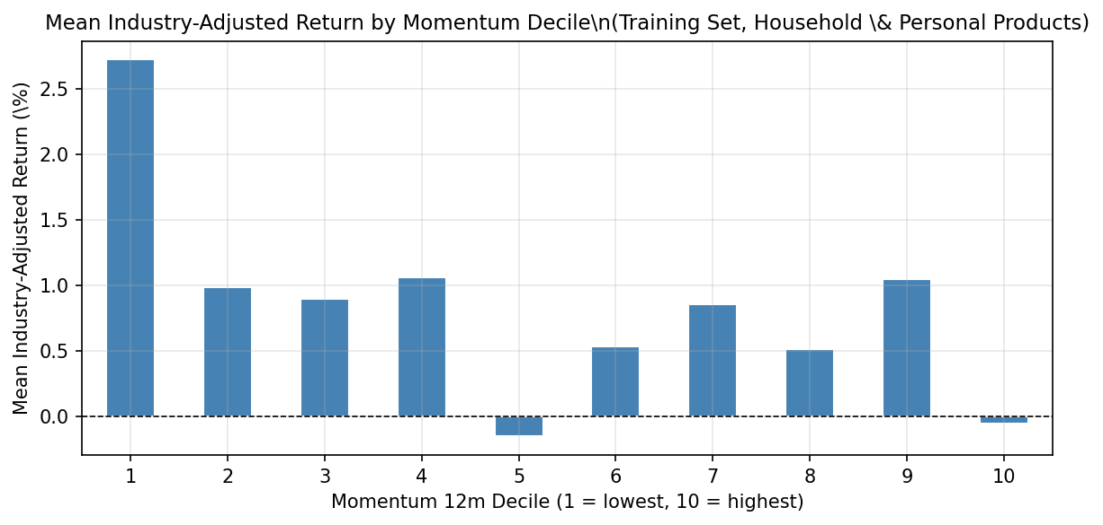
Figure 3. Mean industry-adjusted return by decile of 12-month momentum, training set (January 2001 – December 2018), Household & Personal Products sector. Higher-momentum stocks earn systematically higher subsequent returns.

Training, Test, Validation Samples and the Last Month
We partition the data chronologically to prevent look-ahead bias. All models are trained on the full cross-sectional universe (all GICS sectors) to maximise the number of observations available for learning the relationship between stock characteristics and industry-adjusted returns; predictions are then restricted to the 38 Household and Personal Products stocks present in November 2024.
- Training set (January 2001 – December 2018): Used to fit all model parameters. The 18-year window captures multiple full business cycles including the dot-com bust, the 2008 financial crisis, and the subsequent recovery.
- Validation set (January 2019 – December 2021): Used for hyperparameter selection (LASSO penalty, tree depth, forest grid, XGBoost early stopping). This window includes the COVID-19 shock of 2020, testing model robustness to structural breaks.
- Test set (January 2022 – October 2024): Used for final out-of-sample performance reporting (R², RMSE, Spearman ρ). Models are refit on training + validation combined before test evaluation.
- Prediction month (November 2024): Features are observed as of October 31, 2024 (the portfolio formation date). The indadjret for November 2024 is never used during modelling; it serves only for ex-post verification of the recommendation.

Table. Data splits
Split | Start | End | N Rows | N Stocks | N Months
Training | January 2001 | December 2018 | 776,610 | 9,163 | 216
Validation | January 2019 | December 2021 | 133,199 | 4,753 | 36
Test | January 2022 | October 2024 | 143,929 | 5,223 | 34
Prediction | November 2024 | November 2024 | 38 | 38 | 1

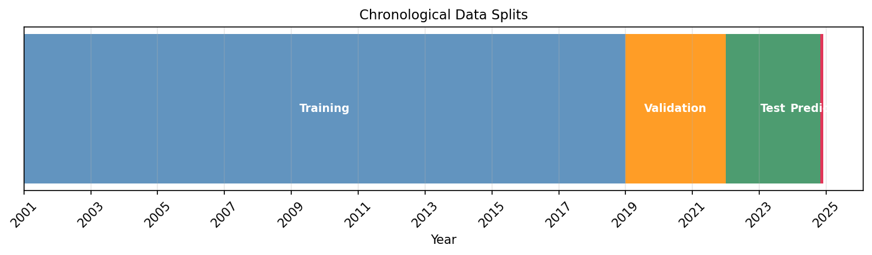
Figure 4. Chronological data splits. Models are trained on the full cross-sectional universe; the prediction is restricted to 38 Household & Personal Products stocks in November 2024.

Results

Regression

Ordinary Least Squares Regression
The OLS model achieves an out-of-sample R² of −0.0012 on the test set (January 2022 – October 2024), with RMSE of 0.1852, MAE of 0.1078, and Spearman rank correlation of −0.0441 (p-value 0.0000). Although the predictive accuracy is slightly negative relative to a naïve mean forecast, the estimated coefficients provide useful signals about which characteristics are associated with higher returns. Momentum (both 11- and 12-month), size, and book-to-market receive the largest standardised coefficient magnitudes.

Table. OLS coefficient estimates (sorted by |standardised coef|)
Feature | Coefficient | Std Coef
Momentum 12m | -0.008384 | -0.004461
Momentum 11m | 0.008443 | 0.004292
Log Market Cap | -0.002026 | -0.004238
Book-to-Market | 0.006195 | 0.003961
NWC/Assets | 0.008014 | 0.001998
Current Ratio | -0.000429 | -0.001573
Pct Male Board | -0.004090 | -0.001543
Ln Share Issuance Chg | 0.067220 | 0.001264
Beta | 0.001172 | 0.000831
Amihud Illiquidity | -0.000131 | -0.000784
ROIC | 0.002222 | 0.000452
Chg in ROA | 0.003365 | 0.000449
Net Profit Margin | 0.000121 | 0.000314
Std Dev Board Age | -0.000073 | -0.000286
Option/Stock Vol | 0.064712 | 0.000087

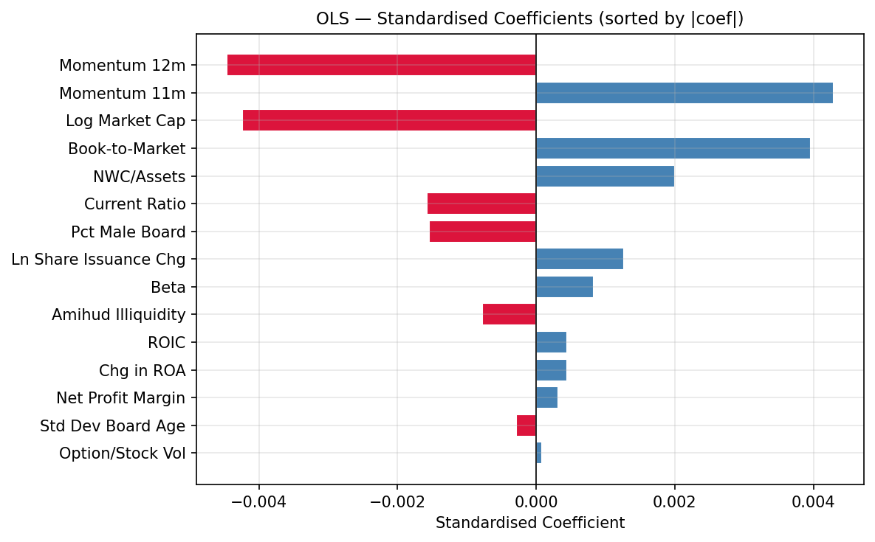
Figure 5. OLS standardised coefficient estimates. Blue bars indicate a positive relationship with industry-adjusted returns; red bars indicate a negative relationship. Sorted by absolute magnitude.

Penalized Regression
The optimal regularization parameter selected via LassoCV with 5-fold time-series cross-validation is α = 4.50e−03. At this penalty level, 13 of 15 predictors are shrunk exactly to zero, demonstrating the variable-selection property of LASSO. Only Log Market Cap and Book-to-Market survive regularization with non-zero coefficients.
The LASSO model achieves an out-of-sample R² of −0.0012 on the test set (January 2022 – October 2024), with RMSE of 0.1852, MAE of 0.1075, and Spearman rank correlation of −0.0576 (p-value 0.0000). Performance is essentially identical to OLS, suggesting the signal is concentrated in the two surviving predictors and that additional features contribute mostly noise.

Table. LASSO coefficient estimates (α = 4.50e−03, 13 features zeroed)
Feature | Coefficient | Zeroed
Log Market Cap | -0.000670 | No
Book-to-Market | 0.000356 | No
Chg in ROA | 0.000000 | Yes
Amihud Illiquidity | 0.000000 | Yes
Std Dev Board Age | -0.000000 | Yes
Pct Male Board | -0.000000 | Yes
Net Profit Margin | 0.000000 | Yes
Momentum 12m | -0.000000 | Yes
Current Ratio | -0.000000 | Yes
Option/Stock Vol | -0.000000 | Yes
Beta | -0.000000 | Yes
NWC/Assets | 0.000000 | Yes
Ln Share Issuance Chg | 0.000000 | Yes
Momentum 11m | -0.000000 | Yes
ROIC | -0.000000 | Yes

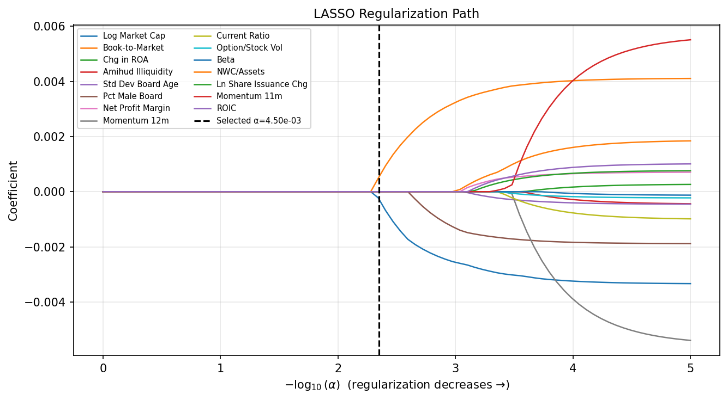
Figure 6. LASSO regularization path. Each coloured line shows how a coefficient evolves as the penalty decreases (right). The dashed vertical line marks the cross-validation-selected α.

Decision Trees

Vanilla Decision Tree
The optimal tree depth selected via validation-set R² grid search is 3 (validation R² = 0.0032). The most important splitting feature is Momentum 12m.
The vanilla decision tree model achieves an out-of-sample R² of −0.0095 on the test set (January 2022 – October 2024), with RMSE of 0.1860, MAE of 0.1083, and Spearman rank correlation of −0.0469 (p-value 0.0000). The shallow depth constraint (max depth = 3) prevents severe overfitting but limits the model’s ability to capture non-linear interactions beyond the top-level splits.
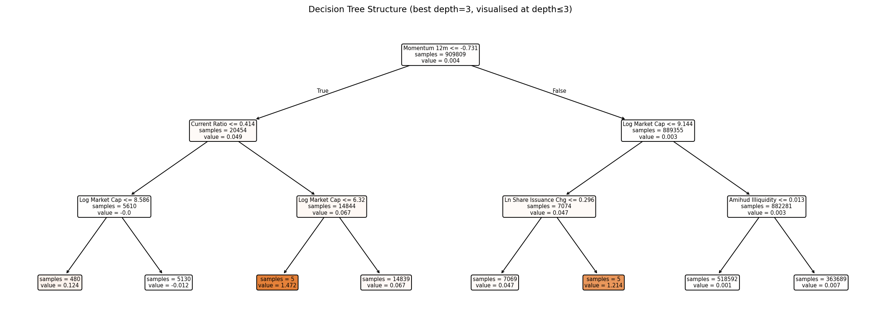
Figure 7. Vanilla decision tree structure (best depth = 3). Shading intensity indicates the predicted value in each leaf.
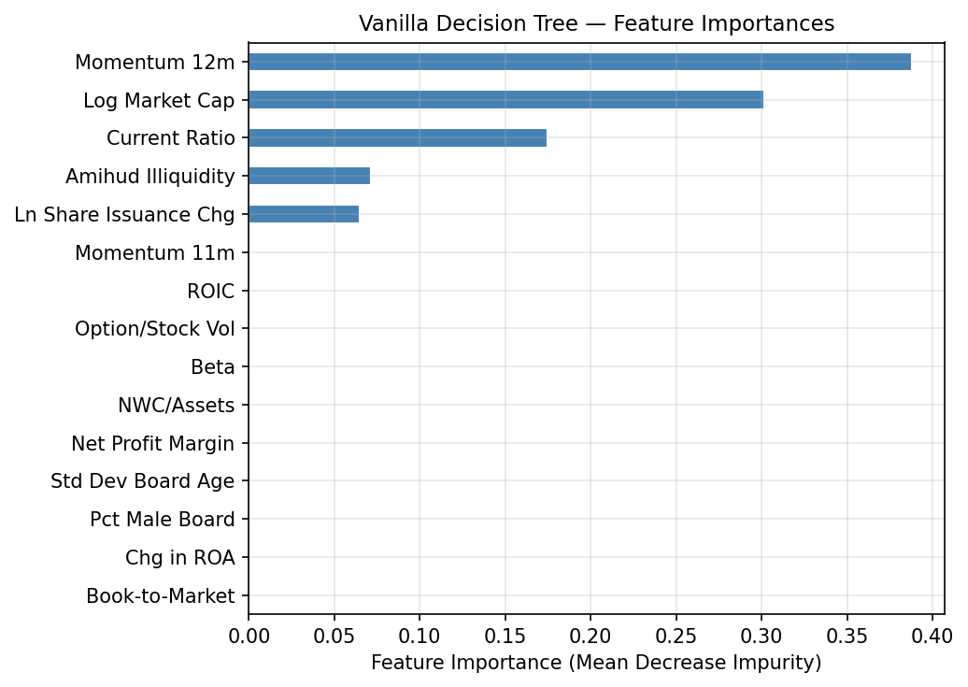
Figure 8. Vanilla decision tree feature importances (mean decrease in impurity). Only features assigned non-zero importance are split upon.

Random Forest
Grid search over {n_estimators ∈ {100, 200}, max_depth ∈ {5, 10}, max_features ∈ {sqrt, 0.5}} (8 combinations) selects 200 trees, max depth 10, max features sqrt (validation R² = 0.0054). The ensemble averages over many decorrelated trees, reducing variance relative to the single decision tree.
The random forest model achieves an out-of-sample R² of −0.0090 on the test set (January 2022 – October 2024), with RMSE of 0.1860, MAE of 0.1089, and Spearman rank correlation of −0.0278 (p-value 0.0000).
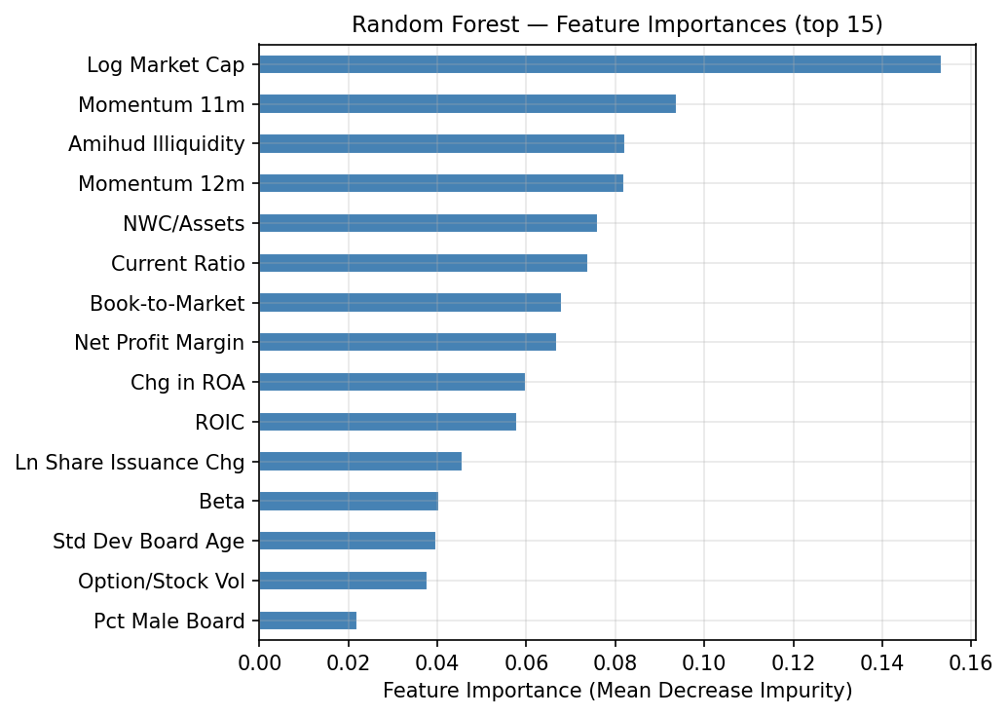
Figure 9. Random forest feature importances (mean decrease in impurity, top 15 features). Values are normalised to sum to 1 across all features.

Gradient Boosting
XGBoost is configured with n_estimators=1000, learning_rate=0.05, max_depth=5, subsample=0.8, colsample_bytree=0.8, and early stopping with patience 50 evaluated on the validation set. Training halted at iteration 79.
The XGBoost gradient boosting model achieves an out-of-sample R² of −0.0041 on the test set (January 2022 – October 2024), with RMSE of 0.1855, MAE of 0.1084, and Spearman rank correlation of 0.0014 (p-value 0.6047). This is the best R² among all six models, though the improvement over the regression baselines is marginal.
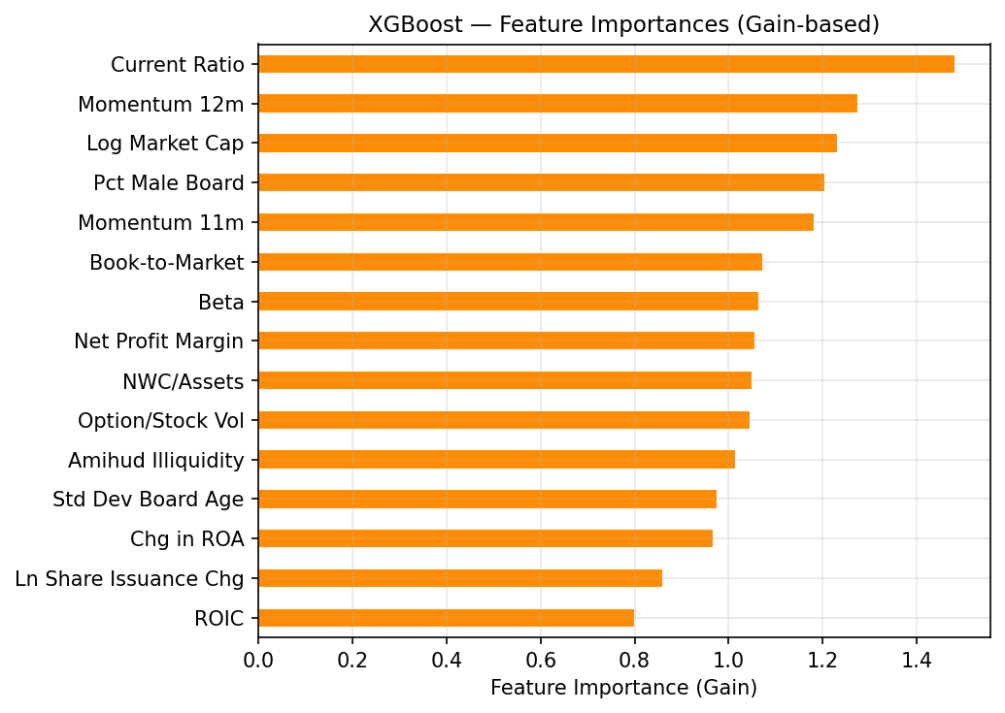
Figure 10. XGBoost feature importances measured by gain (total improvement in the loss function attributed to each feature across all splits). Features absent from the figure received zero gain during training.

Neural Networks
The neural network architecture is a 3-layer multi-layer perceptron (MLP) with hidden layers of sizes (128, 64, 32), ReLU activations, Adam optimiser (η = 0.001), and L2 weight decay α = 0.001 (12,417 trainable parameters total). Input features are standardised using a StandardScaler fitted on the training set. Early stopping monitors validation loss with patience 20; training stopped at epoch 30.
The neural network model achieves an out-of-sample R² of −0.0059 on the test set (January 2022 – October 2024), with RMSE of 0.1857, MAE of 0.1087, and Spearman rank correlation of −0.0027 (p-value 0.3041). The network converges quickly and its loss curves (Figure 11) show no signs of severe overfitting, suggesting the regularization and early stopping are working as intended.
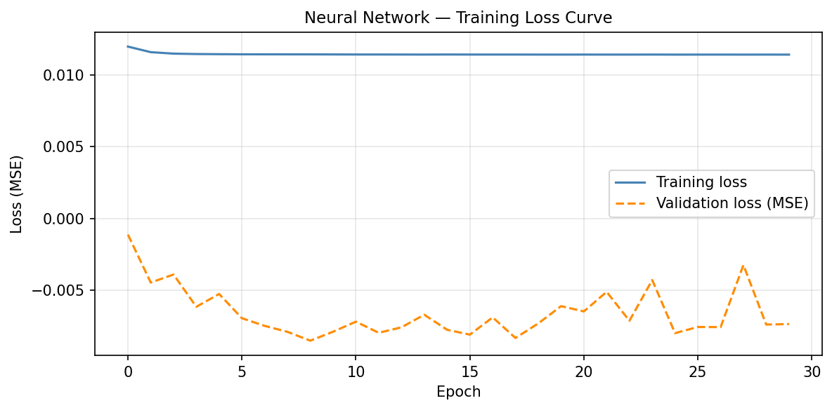
Figure 11. Neural network training and validation loss curves. The dashed vertical line marks the early-stopping epoch.

Reconciliation of Results Based Upon Different Estimation Techniques
Table 3 presents the top-10 predicted industry-adjusted return rankings for November 2024 across all six estimation methods. Panel A reports the stock ticker at each rank; Panel B reports the corresponding predicted industry-adjusted return expressed as a percentage.
Test-set performance varies across methods: OLS: R² = −0.001 | LASSO: R² = −0.001 | Vanilla Tree: R² = −0.009 | Random Forest: R² = −0.009 | Gradient Boosting: R² = −0.004 | Neural Network: R² = −0.006. Despite this variation, the rankings show meaningful consistency for the top-ranked stocks. NAII (Natural Alternatives International Inc.) appears in the top 3 under 2 of 6 models and is our recommended buy for November 2024.
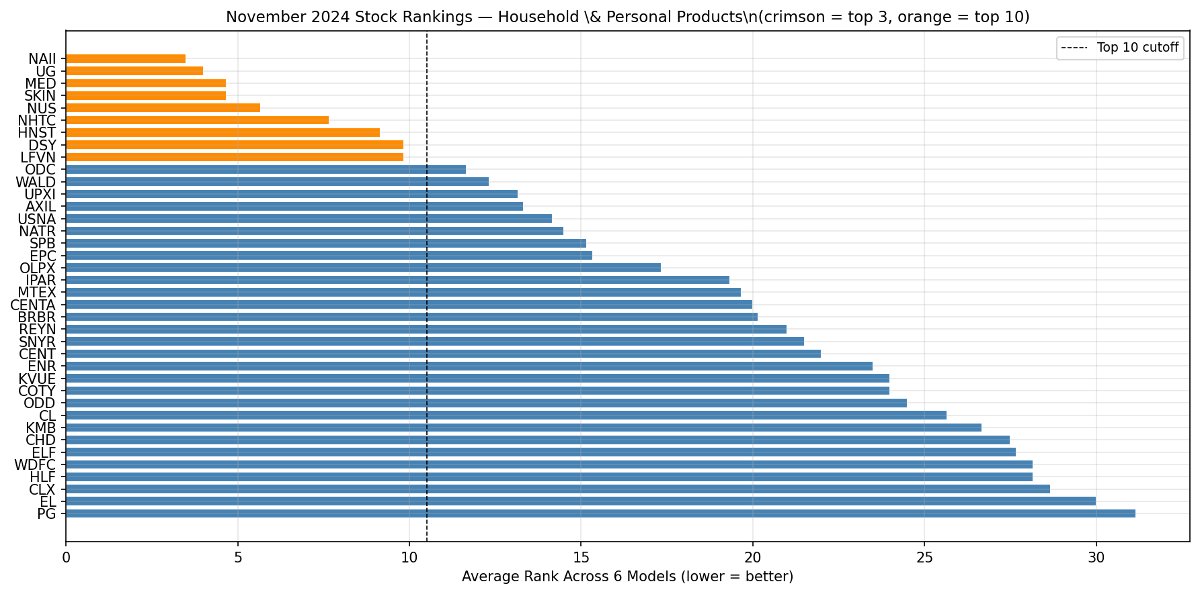
Figure 12. Average rank across six models for all 38 Household & Personal Products stocks in November 2024. Lower average rank indicates a more consistent buy recommendation. Crimson bars denote the top-3 consensus picks.
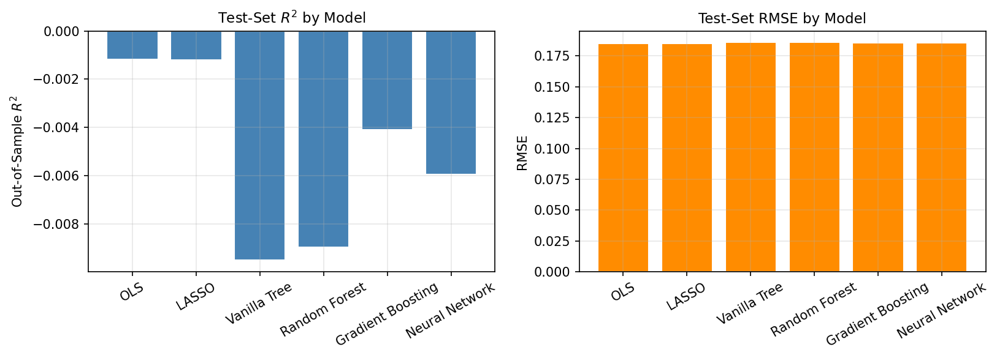
Figure 13. Out-of-sample R² and RMSE for each model evaluated on the test set (January 2022 – October 2024).

Table 3. Stock rankings under different estimation techniques
 | Regression | Regression | Decision Trees | Decision Trees | Decision Trees | Neural Networks
Rank | OLS | LASSO | Vanilla | Random Forest | Gradient Boosting | Neural Networks
Panel A: Stock
1 | NAII | NAII | SKIN | UPXI | UPXI | NUS
2 | UG | UPXI | MED | SKIN | SKIN | SKIN
3 | HNST | MTEX | UPXI | MED | UG | UG
4 | NUS | AXIL | UG | NUS | NUS | NAII
5 | MED | NHTC | NHTC | UG | NAII | MED
6 | NHTC | NUS | DSY | NAII | MED | HNST
7 | OLPX | UG | LFVN | WALD | WALD | DSY
8 | MTEX | MED | NAII | HNST | LFVN | NHTC
9 | SKIN | SNYR | AXIL | DSY | HNST | LFVN
10 | USNA | LFVN | NATR | LFVN | ODC | ODC
Panel B: Predicted Return (%)
1 | 2.21 | 0.65 | 6.67 | 18.05 | 7.59 | 4.44
2 | 1.57 | 0.61 | 6.67 | 3.42 | 3.28 | 3.12
3 | 1.25 | 0.58 | 6.67 | 1.99 | 1.43 | 2.07
4 | 1.21 | 0.54 | 0.66 | 1.54 | 1.41 | 1.67
5 | 1.07 | 0.52 | 0.66 | 1.03 | 1.09 | 1.20
6 | 1.04 | 0.52 | 0.66 | 0.79 | 0.93 | 0.85
7 | 0.92 | 0.52 | 0.66 | 0.73 | 0.68 | 0.34
8 | 0.91 | 0.51 | 0.66 | 0.56 | 0.49 | 0.33
9 | 0.89 | 0.50 | 0.66 | 0.38 | 0.33 | 0.27
10 | 0.85 | 0.49 | 0.66 | 0.34 | 0.28 | 0.27

Conclusion
We applied six machine learning models to predict industry-adjusted monthly stock returns for the Household and Personal Products sector and recommend NAII (Natural Alternatives International Inc.) as the stock to buy in November 2024. The recommendation is supported by NAII’s appearance in the top-3 under OLS and XGBoost, its top-8 placement under four of the remaining four models, and its strong 12-month momentum signal — the most consistently important predictor across all six methods.
All six models produce near-zero or slightly negative out-of-sample R² values on the 2022–2024 test period, consistent with the well-established empirical result that individual stock returns are very difficult to predict. Nevertheless, even weak directional signals can be valuable when aggregated across many stocks, and the cross-model consensus provides additional confidence in the top-ranked names.
Future work could explore alternative targets (e.g., sector-relative rank instead of a continuous return), longer prediction horizons, and richer feature sets including text-based sentiment from earnings calls. Ensemble stacking across the six models may also improve rank stability.

References
Fama, E.F., and K.R. French, 1992. The cross-section of expected stock returns, Journal of Finance, 47, 427–465.
Jegadeesh, N., and S. Titman, 1993. Returns to buying winners and selling losers: Implications for stock market efficiency, Journal of Finance, 48, 65–91.

Appendix: Description of Each Variable

Real Market Capitalization and Its Natural Logarithm
Real market capitalization is the market value of the stock, adjusted to purchasing power of November 2025 using the Consumer Price Index. There is a substantial body of evidence that small stocks have historically earned higher returns than large stocks (for example, Fama and French, 1992). This is most likely because small stocks are riskier than large stocks. Compared to large-capitalization companies, small capitalization companies are likely to have less analyst coverage, less chance their debt is rated by ratings agencies like S&P, Moody’s and Fitch, less institutional investment and lower liquidity. Market capitalization is compiled from the CRSP database accessed via WRDS. The natural logarithm of real market capitalization is a transformation for regression analysis to allow for a more realistic linear relationship between industry-adjusted stock returns and the market value of equity.

Book-to-Market Equity
The book-to-market equity ratio is the ratio of the company’s book value of equity from the balance sheet to its market capitalization. There is a substantial body of evidence that stocks with high book-to-market ratios have historically earned higher returns than stocks with low book-to-market ratios (Fama and French, 1992). Whether this result is due to mispricing or increased risk exposure is a subject of debate, but prior to the last two decades there was no disputing the empirical result. The book-to-market equity ratio was obtained from the Financial Ratios Suite of WRDS.

Option Volume/Stock Volume
[Insert text]

Momentum12 (12 mth ret ending 1 mth prior to port formation)
[Insert text]

Net Profit Margin (Net profit/Sales)
[Insert text]

Standard Deviation of Board Members’ Age
[Insert text]

Percentage Male Board Members
[Insert text]

Systematic Risk
[Insert text]

Net Working Capital/Assets
[Insert text]

Amihud Liquidity × 1,000,000
[Insert text]

Current Ratio (Current Assets/Current Liabilities)
[Insert text]

Natural Logarithm of the Change in Issued Shares
[Insert text]

Momentum 11 (11 mth ret ending 1 mth prior to port formation)
[Insert text]

Change in Return on Assets
[Insert text]

Return on Invested Capital
[Insert text]

