Project title. This will flow through to the header
[Insert an abstract here. Summarize your project in 400 words or less. It should fit on this page. Put your names, email addresses, phone numbers and date below the abstract.]

Jimmy Connors | jimmy.connors@usopen.com | 734-111-1111
John McEnroe | john.mcenroe@wimbledon.com | 734-000-0000
March 13, 2026
Contents
Introduction 1
[What goes in the introduction?] 1
[The template] 1
[Heading 2 example] 1
[Heading 3 example] 1
Data 1
Variable names, labels and descriptions 1
Descriptive statistics on the whole sample 2
Descriptive statistics on your variable of interest 2
Training, test, validation samples and the last month 2
Results 2
Regression 3
Ordinary least squares regression 3
Penalized regression 3
Decision trees 3
Vanilla decision tree 3
Random forest 3
Gradient boosting] 3
Neural networks 3
Reconciliation of results based upon different estimation techniques 3
Conclusion 4
References 4
Appendix: Description of each variable 4

Tables
Table 1. Variable names, labels and constraints 2
Table 2. Descriptive statistics 2
Table 3. Stock rankings under different estimation techniques 4
Figures
Figure 1. Percentage change from a year ago in the U.S. Consumer Price Index for all urban consumers: All items in U.S. City Average, seasonally-adjusted 3

Introduction

[What goes in the introduction?]
Tell the reader what your overall question is, how you went about answering the question, and what your conclusion is.

[The template]
[Please use this template to make your report. It will help me to compare projects across groups. Use the style formatting above to automatically create headings, and use “Insert Caption” under the References tab to automatically create captions for tables and figures.]
- If you use the style formatting to automatically create headings you will be able to populate the table of contents.
- If you use captions you will be able to automatically create a list of tables and a list of figures. Make sure that you update the table of contents, and lists of tables and figures because they don’t automatically update. You right click on the list and select “update field” and then select the option to update the entire table.
- How many tables and charts is best at your discretion. Exercise your judgment about presentation of tables (borders, right justification versus center justification, headings, layout etc.). Don’t let tables span one page to the next unless the table is so large is cannot fit on one page.
[The this template has examples of the following styles: Heading 1, Heading 2, Heading 3, and a bulleted list paragraph. It also has examples of a table and figure.]

[Heading 2 example]

[Heading 3 example]
- Bullets example
  - Bullets example
    - Bullets example

Data

Variable names, labels and descriptions
The name and label for each independent variable are presented in Table 1, along with the group that compiled each variable and the constraint that was applied to each variable to mitigate the potential for outliers to have an outsized influence on the results. For example, 0.50 for Book-to-market equity means the variable was constrained at 0.5th percentile and the 99.5th percentile. A description for each variable is in the appendix. Each group has compiled a paragraph explaining how the variable is computed, the source of the data and why there is a plausible reason this characteristic is associated with industry-adjusted returns.
Table 1. Variable names, labels and constraints
Name | Label | Group | Constraint
Real market capitalization | lag1mcreal | J | 0.00
Natural logarithm of real market capitalization | lnlag1mcreal | J | 0.00
Book-to-market equity | bm | J | 0.50
Option volume/stock volume | os | 1 | 0.05
Momentum12 (12 mth ret ending 1 mth prior to port formation) | mom12 | 2 | 1.00
Net profit margin (Net profit/Sales) | npm | 3 | 1.00
Standard deviation of board members’ age | sdage | 4 | 0.00
Percentage male board members | gender | 4 | 0.00
Systematic risk | beta | 5 | 1.00
Net working capital/Assets | nwca | 6 | 0.50
Amihud liquidity x 1,000,000 | illiq | 7 | 2.50
Current ratio (Current assets/Current liabilities) | cr | 8 | 1.00
Natural logarithm of the change in issued shares | lnshchg | 9 | 0.50
Momentum 11 (11 mth ret ending 1 mth prior to port formation) | mom11 | 10 | 1.00
Change in return on assets | chgroa | 11 | 2.50
Return on invested capital | roic | 12 | 2.50

Descriptive statistics on the whole sample
[Insert a table of descriptive statistics on all variables and comment on the most important aspects of that table, mentioning the time period under study, the number of observations, and the stock characteristics.]
Table 2. Descriptive statistics
[Table to be inserted. Use one column for the percentage missing, which is computed simply using the “miss” variables and taking an average. Suppose there were 10 observations and two were missing so have a value of 1 in the miss variable and zero for the eight cases in which the data was not missing. The average is 20 per cent, so 20 the figure that goes in the percentage missing is 20. Report the mean and standard deviation and selected percentiles, which includes the 50th percentile but you can decide what other percentiles to comment on. Run the descriptive statistics on the aggregate dataset you have been provided, not your own data that you submitted. The dataset should exclude the last month but keep all the other months.]

Descriptive statistics on your variable of interest
[Explain why you chose your recommended variable of interest and comment on descriptive statistics. Run the descriptive statistics on your variable of interest on the aggregate dataset you have been provided, not your own data that you submitted. The dataset should exclude the last month but keep all the other months.]

Training, test, validation samples and the last month
[Describe your selection of cut-off points for training, test and validation samples, and what you actually do with those samples. The dataset starts with January 2001 and the last month is November 2024. You must exclude November 2024 from the dataset for training, test and validation samples and use November 2024 as the last month. So we will pretend that on October 31, 2024, we form our portfolio for the first time. You will make predictions of industry-adjusted returns for stocks in your industry for November 2024 using all available data prior to that month.]

Results
[There are sub-headings below to structure your results. Prior to introducing those sub-headings I have included an example table and an example chart.]
[Earlier you have an example of a table. Because I inserted a caption before making the table I can use Cross-reference under the References tab to refer to the table using above/below, table number or the table number and heading. For example, I can write “in the table above” and put in “below” using the Cross-reference button; or I can write “in Table 1” and put in the table number using the Cross-reference button; or I can write “in Table 1. Variable names, labels and constraints” and put in the entire heading.]
[Here is an example of a figure. Using Cross-references I can refer to the figure below, I can refer to Figure 1, and I can refer to Figure 1. Percentage change from a year ago in the U.S. Consumer Price Index for all urban consumers: All items in U.S. City Average, seasonally-adjusted.]

Figure 1. Percentage change from a year ago in the U.S. Consumer Price Index for all urban consumers: All items in U.S. City Average, seasonally-adjusted
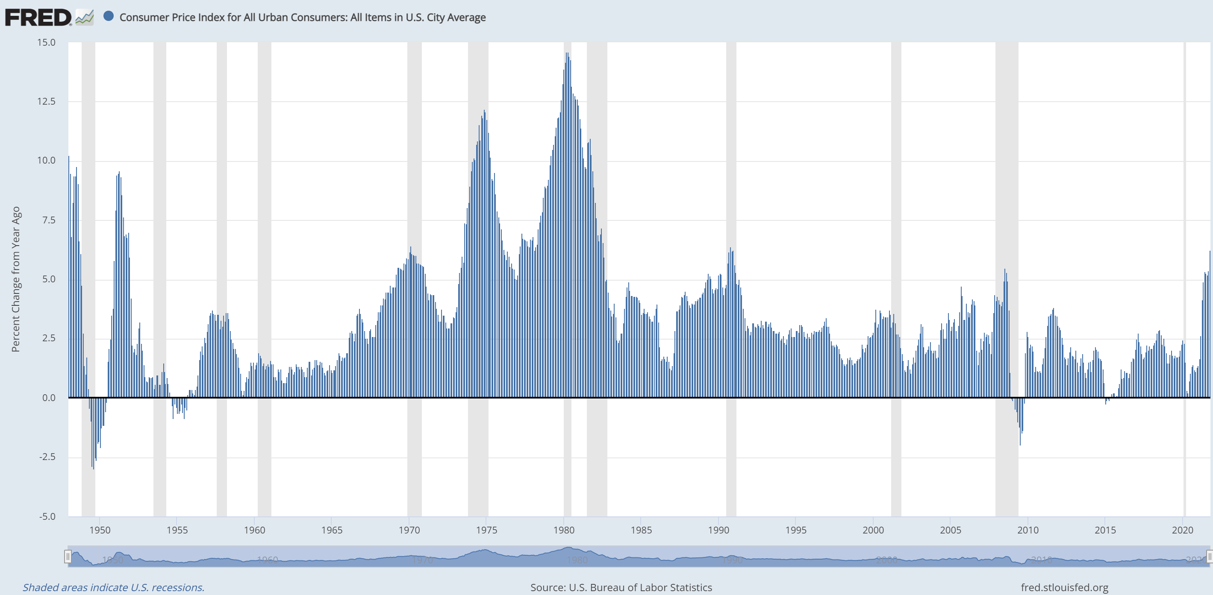

Regression

Ordinary least squares regression
[Insert analysis based upon ordinary least squares regression.]

Penalized regression
[Insert analysis based upon penalized regression.]

Decision trees

Vanilla decision tree
[Insert analysis based upon one decision tree.]

Random forest
[Insert analysis based upon random forest.]

Gradient boosting]
[Insert analysis based upon gradient boosting.]

Neural networks
Insert analysis based upon neural networks.

Reconciliation of results based upon different estimation techniques
[Insert text reconciling results summarized in the table below. You must include this table.]
Table 3. Stock rankings under different estimation techniques
 | Regression |  | Decision trees |  |  | Neural networks
Rank | OLS | LASSO | Vanilla | Random Forest | Gradient boosting
Panel A: Stock
1
2
3
4
5
6
7
8
9
10
Panel B: Industry-adjusted predicted return (%)
1
2
3
4
5
6
7
8
9
10

Conclusion
[Reach your conclusion in this section. ]

References
Fama, E.F., and K.R. French, 1992. The cross-section of expected stock returns, Journal of Finance, 47, 427–465.

Appendix: Description of each variable

Real market capitalization and its natural logarithm
Real market capitalization is the market value of the stock, adjusted to purchasing power of November 2025 using the Consumer Price Index. There is a substantial body of evidence that small stocks have historically earned higher returns than large stocks (for example, Fama and French, 1992). This is most likely because small stocks are riskier than large stocks. Compared to companies with market capitalization, small capitalization companies are likely to have less analyst coverage, less chance their debt is rated by ratings agencies like S&P, Moody’s and Fitch, less institutional investment and lower liquidity. Market capitalization is compiled from the CRSP database accessed via WRDS. The natural logarithm of real market capitalization is simply a transformation of real market capitalization for regression analysis to allow for a more realistic linear relationship between industry-adjusted stock returns and the market value of equity. Stocks listed in North America, and indeed most equity markets, have a small percentage of very large companies and a high percentage of medium and small companies.

Book-to-market equity
The book-to-market equity ratio is the ratio of the company’s book value of equity from the balance sheet to its market capitalization. There is a substantial body of evidence that stocks with high book-to-market ratios have historically earned higher returns than stocks with low book-to-market ratios (or example, Fama and French, 1992). Whether this result is due to mispricing of increased risk exposure is a subject of debate, but prior to the last two decades there was no disputing the empirical result. Data from the last 20 years suggests that the book-to-market equity ratio has not been as useful a signal of high future returns as in the past. This could be due to increased market efficiency, or a diminished relevance of the book value of equity as a proxy for the equity holders’ investment base. In recent years, there has been an increase in research and development spending and most expenditure on R&D is expensed rather than being capitalized on the balance sheet and therefore flowing to equity value. The book-to-market equity ratio was obtained from the Financial Ratios Suite of WRDS.

Option volume/stock volume
[Insert text]

Momentum12 (12 mth ret ending 1 mth prior to port formation)
[Insert text]

Net profit margin (Net profit/Sales)
[Insert text]

Standard deviation of board members’ age
[Insert text]

Percentage male board members
[Insert text]

Systematic risk
[Insert text]

Net working capital/Assets
[Insert text]

Amihud liquidity x 1,000,000
[Insert text]

Current ratio (Current assets/Current liabilities)
[Insert text]

Natural logarithm of the change in issued shares
[Insert text]

Momentum 11 (11 mth ret ending 1 mth prior to port formation)
[Insert text]

Change in return on assets
[Insert text]

Return on invested capital
[Insert text]

