CompositePattern

컨테이너/내용물/동일시

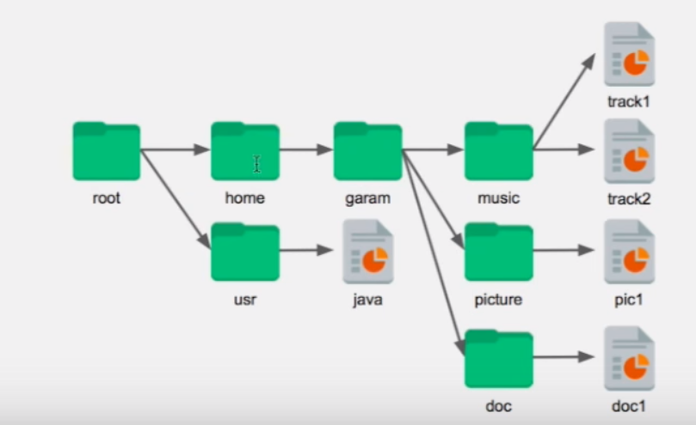

import java.util.ArrayList;

import java.util.List;

public class CompositePattern {

public static void main(String[] args) {

Folder root = new Folder("root"), home = new Folder("home"), garam = new Folder("garam"),

music = new Folder("music"), picture = new Folder("picture"), doc = new Folder("doc"),

usr = new Folder("usr");

File track1 = new File("track1"), track2 = new File("track2"), pic1 = new File("pic1"), doc1 = new File("doc1"),

java = new File("java");

// 폴더 파일시스템 처럼 집어넣기

root.addComponent(home);

home.addComponent(garam);

garam.addComponent(music);

music.addComponent(track1);

music.addComponent(track2);

garam.addComponent(picture);

picture.addComponent(pic1);

garam.addComponent(doc);

doc.addComponent(doc1);

root.addComponent(usr);

usr.addComponent(java);

show(root);

}

// 확인

private static void show(Component component) {

System.out.println(component.getClass().getName() + "|"+component.getName());

if (component instanceof Folder) {

for (Component c : ((Folder) component).getChilderen()) {

show(c);

}

}

}

}

abstract class Component {

private String name;

public Component(String name) {

this.name = name;

}

public String getName() {

return name;

}

public void setName(String name) {

this.name = name;

}

}

class File extends Component {

public File(String name) {

super(name);

}

private Object data;

public Object getData() {

return data;

}

public void setData(Object data) {

this.data = data;

}

}

class Folder extends Component {

public Folder(String name) {

super(name);

}

List<Component> childeren = new ArrayList<>();

public List<Component> getChilderen() {

return childeren;

}

public void setChilderen(List<Component> childeren) {

this.childeren = childeren;

}

public boolean addComponent(Component component) {

return childeren.add(component);

}

public boolean removeComponent(Component component) {

return childeren.remove(component);

}

}

실행화면

Folder|root

Folder|home

Folder|garam

Folder|music

File|track1

File|track2

Folder|picture

File|pic1

Folder|doc

File|doc1

Folder|usr

File|java