RB Exome Manuscript
Kevin Stachelek
Carly Stewart
Jonathan Kim
Narine Harutyunyan
Jennifer Aparicio
Thomas C. Lee
Linn Murphree
C. Patrick Reynolds
David Cobrinik
today

Intro
General and brief background of retinoblastoma Retinoblastoma is a disease of the developing retina. Retinoblastoma is initiated, in most cases, by inactivation of two copies of the RB gene and subsequent loss of RB protein. The unique sensitivity of the developing retina to loss of RB results in tumor formation. Retinoblastoma can also form with amplification of the MYCN oncogene. Retinoblastomas of this type, termed MYC are less frequent and may be subject to alternative signaling pathways in the course of proliferation.
eventually noting progression-related changes which are …..and lack of understanding of what they do. Genetic changes to p16^{INK4a} and p130 have been suggested to drive Rb-/- pre-malignant retinomas to formation of Retinoblastoma(Dimaras et al. 2008). The role of secondary mutations in progression of retinoblastoma has been previously studied, but the comparatively shallow depth of sequencing used may have limited detection of low frequency variants associated with progression of retinoblastoma(Kooi, Mol, Massink, Ameziane, et al. 2016).
Lack of validated cell lines with known genetic background to explore Rb progression. Canonical retinoblastoma cell line models such as Weri and Y79 are well characterized but are subject to genetic drift after extensive laboratory passaging. In addition, evidence indicates that Y79 and Weri lines share extensive genetic background to the extent that Weri may be considered a sub-line of Y79 (Bejjani et al. 2012). Models of RB^{MYC} are limited relative to canonical Rb -/- cell lines. A shortage of low passage, well-characterized retinoblastoma cell lines may limit study of complex genetic variants beyond the classical two-hit model, in particular MYC retinoblastoma.
Detection of low frequency variants in heterogeneous tumors. We carried out exome sequencing on eleven retinoblastoma tumors along with matched normal and tumor-derived cell lines. We selected a sequencing depth of 150x for normal and cell line samples and 300x for tumor samples. We present supporting evidence for recently identified variants targeting MYCN and BCOR and SCs known to arise in retinoblastoma. We make available ten retinoblastoma cell lines with fully characterized genetic background. Finally, using two of the cell lines featured in the study, we investigate the impact of BCOR deletion and predicted BCOR loss-of-function mutations on growth of retinoblastoma cell lines.

Methods

Samples
Untreated retinoblastoma tumor samples were obtained with informed consent under approved IRB protocols immediately following enucleation. One fraction of tumor was rapidly frozen in liquid nitrogen. A second fraction was placed in culture to establish cell lines. Matched normal samples were obtained from mesenchymal cells isolated from orbital fat pad tissue collected during enucleation.

Establishing and propagating retinoblastoma cell lines
Dissociated retinoblastoma cells were prepared after culturing freshly explanted tumors in RB culture medium consisting of IMDM (Mediatech Inc.,Herndon, VA) with 10% FBS (Sigma-Aldrich, St. Louis, MO), 2mM glutamine (Mediatech Inc., Herndon, VA), 55uΜ beta-mercaptoethanol (Sigma-Aldrich, St. Louis, MO), and 10ug/ml insulin (Humulin-R, Eli Lilly and Company) at 37º C in a humidified incubator with 5% CO2 [Xu, 2013].

DNA isolation and Sequencing
Flash-frozen tumor samples were dissociated by triteration and immediately prepared for D extraction. In the same fashion, cryopreserved cell lines and normal MSC samples were dissociated and D was isolated using the Qiaamp D Minikit (Qiagen, Hilden, Germany). A minimum of 1 ug of D was submitted for D Exome Sequencing on Illumina HiSeq by Macrogen Inc. (Seoul, South Korea). A sequencing depth of 150x for cell line and matched normal samples and 300x for tumor samples was requested.

Methods-Variant Calling Pipeline
Exome capture sites were defined according to the Agilent Sureselect V5 Capture Library. Sequences were aligned to human reference hg19 using bwa (Li and Durbin 2010). Following the GATK best practices workflow for somatic variant discovery, duplicate reads were removed and quality scores were recalibrated. Variant calling was done using GATK Mutect2 for somatic variants between tumor and matched-normal samples.(DePristo et al. 2011; Van der Auwera et al. 2013). Putative germline variants were assessed by assembling a panel of normals with mutect2 in variant detection mode.

Methods-Variant Filtration
Variants were removed if they were documented in the Genome Aggregation Database (gnomAD) Lek et al. (2016) at an allele frequency greater than ten percent . All admitted variants were marked “PASS” by GATK. Variants were removed if they appeared in the matched normal at greater than Low frequency (<5% VAF ???) . Variants were also filtered out if they appeared in a panel of normals at Low frequency (<5% VAF ???) . Two variants were considered identical when they had identical genomic coordinates, reference and mutant allele sequences, and GATK genotype calls (AA, AB, BB).

Somatic Copy Number Alteration
Somatic copy number alteration (SC) were detected using the R package CopywriteR which uses off-target reads in targeted sequencing experiments (Kuilman et al. 2015).

Allelic Imbalance
Variant sites detected by Mutect2 in any sample were collected into a single .bed file. B allele frequencies for all samples were calculated at these sites. B allele frequency segmentation was performed as described Staaf et al. (2008), yielding a mirrored B allele frequencey(mBAF) representing an abnormal B allele frequency over a given region. A region was designated as having allelic imbalance if mBAF was greater than 0.56 and was designated as having loss of heterozygosity (LOH) if mBAF was greater than 0.7.

Results

Characteristics of Cell Lines growth curves
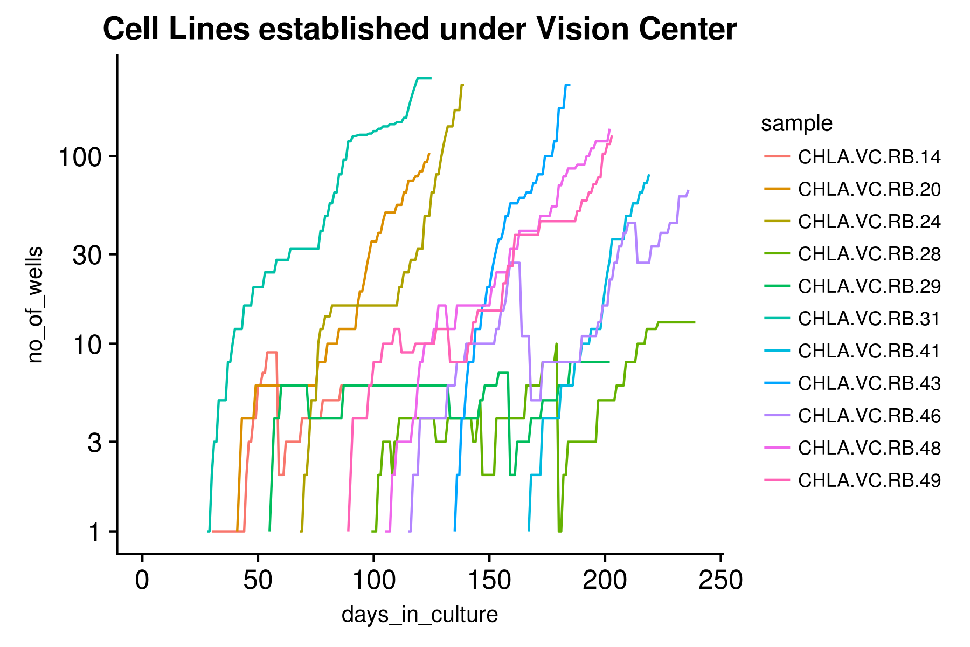
Figure 1. Retinoblastoma cell line growth curves.
All are pre-treatment , CHLA, established by either of two protocols (Reynolds and KS), Cells were passaged on a schedule of 1-2 days upon color change of phenol red to amber. With an intial volume of 200 ul cell solution per 96 well plate, cells were split 1:2 wells following successive days of sufficient color change. A log of well number was maintained for each cell line, correcting for cells banked in liquid nitrogen storage at regular intervals. Indicate range of cell # used to start cultures

RB patient characteristics
Sample | Sex | Laterality | Age (mo.)
CHLA-VC-RB-14 | M | Unilateral | 21
CHLA-VC-RB-20 | M | Unilateral | 27
CHLA-VC-RB-24 | M | Unilateral | 5
CHLA-VC-RB-28 | F | Unilateral | 44
CHLA-VC-RB-29 | F | Unilateral | 34
CHLA-VC-RB-31 | M | Unilateral | 23
CHLA-VC-RB-33 | F | Bilateral | 16
CHLA-VC-RB-41 | M | Bilateral | 2
CHLA-VC-RB-46 | M | Unilateral | 28
CHLA-VC-RB-48 | M | Unilateral | 32
CHLA-VC-RB-49 | M | Unilateral | 18
[1] “Table 1: Patient Characteristics” Clinical characteristics of study participants. Clinical sequencing records for four of twelve samples are available in supplementary info, all rb1 clinical variants were recapitulated by exome sequencing with the exception of biallelic promoter methylation reported in sample T-20.

RB1 Status in Tumor and Cell Line Samples
Sample | RB1 copy number | RB1 VAF | Somatic SNV AA Change | Loss of Heterozygosity (LOH) | RB1  mBAF | MYCN Status | RB1 alleles  inactivated | notes
14-T | 0 |  |  |  |  |  | 2
14-CL | 2 |  |  |  |  |  | 2
20-T |  |  |  | CN-LOH | 1 |  | N.D. | promoter methylation detected by clinical sequencing
20-CL |  |  |  | CN-LOH | 0.96 |  | N.D. | promoter methylation detected by clinical sequencing
24-T |  |  |  |  |  | Amplified | 0 | MYC
24-CL | 1 |  |  | LOH | 0.97 | Amplified | 1 | MYC
28-T |  | 0.553; 0.47 | V725fs  Q257X |  |  |  | 2
28-CL |  | 0.44; 0.51 | V725fs; Q257X |  |  |  | 2
29-T |  | 1 | E137X | CN-LOH | 1 |  | 2
29-CL |  | 1 | E137X | CN-LOH | 1 |  | 2
31-T | 1 | 1 | R579X | LOH | 0.93 |  | 2
31-CL | 1 | 1 | R579X | LOH | 1 |  | 2
33-T | 1 | 1 | R552X | LOH | 0.9 |  | 2
41-T |  |  |  | CN-LOH | 0.98 |  | 2
41-CL |  |  |  | CN-LOH | 0.99 | Focal gain | 2
43-CL |  | 1 | R368X | CN-LOH | 1 |  | 2
46-T |  | 0.585; 0.32 | R320X;  R552fs |  |  |  | 2
46-CL |  | 0.56; 0.25 | R320X;  R552fs |  |  |  | 2
48-T |  | 0.5; 0.492 | exon6:c.607+1G>T; exon13:c.406+2A>G |  |  |  | 2
48-CL |  | 0.478; 0.541 | exon6:c.607+1G>T; exon13:c.406+2A>G |  |  |  | 2
49-T | 0 |  |  |  | 0.92 |  | 2
49-CL | 0 |  |  |  | 1 |  | 2
[1] “Table 2: RB1 and MCY status in Tumor and Cell Line Samples”
Samples are displayed by cell line id. The estimated number of RB1 alleles subject to SC loss is displayed for each sample along with detected LOF mutations to RB with variant allele frequency (VAF). Also displayed are determinations of copy-neutral loss of heterozygosity (CN-LOH) with mBAF spanning RB. If a copy number gain spanning MYC was detected, the samples is labeled MYC. In each case RB1 initiation could be accounted for by the sum of alterations in RB1 or through MYC, with the exception of samples 20-T and 20-CL. These samples were determined to be subject to RB1 promoter methylation by clinical sequencing.

Germline variants
No germline RB1 mutations were detected for the 10 tumors from unilaterally affected patients, consistent with these patients having acquired two somatic RB1 alterations.
One bilateral pt had 13q focal deletion that included the RB1 gene. In addition, in a second bilateral case (VCRBVC41) we did not detect a germline variant. However, the tumor showed RB1 LOH, there is likely to be a hidden germline RB1 abnormality, such as promoter mutation (ref) or deep intron mutation (ref). As a less likely possibility, this patient could have a low-level mosaic mutation or promoter methylation that was not detected in the MSC D. However, mosaicism seems unlikely to yield bilateral tumors. (let’s check for low VAF changes in normal D). [check Gallie/Lohmann paper and Rushlow MYC paper might mention other alternatives to explain lack of RB1 mutation detection)

Somatic Variants
Following variant calling, a total of 643,581 variants were discovered. After filtering out variants that were found in the panel of matched normal controls, 16,348 (16,348/643,581; 2.5%) variants were recorded. After further filtering by pathogenicity, functional annotation, and variant allele frequency (VAF) in gnomAD, a final tally of 679 variants were found (679/16,348; 4%). Details can be found in Table 3.

Somatic Variants Shared Between Tumor and Cell Line (besides RB1)
Gene | Tumor ID | Tumor Allele Frequency | Cell Line ID | Cell Line Allele Frequency | Zhang et al VAF | Kooi et al incidence (VAF)
ADAMTS7 | 28-T | 0.429 | 28-C | 0.579 | 0/4
ADGRB1 | 48-T | 0.504 | 48-C | 0.475
AKAP12 | 46-T | 0.361 | 46-C | 0.571 |  | 1
ARHGAP35 | 29-T | 0.279 | 29-C | 0.119
C9 | 20-T | 0.163 | 20-C | 0.214
CC2D2A | 49-T | 0.143 | 49-C | 0.145
DDX1 | 14-T | 0.694 | 14-C | 0.833
EP300 | 24-T | 0.115 | 24-C | 0.121
EP300 | 31-T | 0.143 | 31-C | 0.232
EP300 | 46-T | 0.242 | 46-C | 0.137
FAM102A | 31-T | 0.429 | 31-C | 0.5
FAM136A | 49-T | 0.143 | 49-C | 0.103
GFI1 | 31-T | 0.373 | 31-C | 0.4
GIT2 | 48-T | 0.131 | 48-C | 0.55
KRT19 | 14-T | 0.372 | 14-C | 0.51
LINC00910 | 31-T | 0.26 | 31-C | 0.165
MED25 | 14-T | 0.263 | 14-C | 0.426
MIR99A | 31-T | 0.442 | 31-C | 0.466
NFKBIZ | 49-T | 0.178 | 49-C | 0.195
PAN2 | 29-T | 0.282 | 29-C | 0.472 |  | 0.5294
PDX1 | 46-T | 0.462 | 46-C | 0.625
PI4KA | 28-T | 0.361 | 28-C | 0.471
RTP3 | 29-T | 0.497 | 29-C | 0.506
SAMD12-AS1 | 28-T | 0.53 | 28-C | 0.449
TAS1R2 | 48-T | 0.136 | 48-C | 0.308
TMEM135 | 48-T | 0.539 | 48-C | 0.659
TTLL5 | 48-T | 0.108 | 48-C | 0.143
TTLL5 | 48-T | 0.108 | 48-C | 0.137
ZNF717 | 49-T | 0.125 | 49-C | 0.125
BCOR | 28-T | 0.394 | N.D. | N.D. | 0.095 | 0.9167
NAF1 | 24-T | 0.135 | N.D. | N.D. |  | 0.28
[1] “**Table 3: Variants Recurrrent in Tumor and Cell Line Samples" Somatic variants shared between matched retinoblastoma tumor and cell line samples included RB1, PAN2, EP300, and , recurrent in six of 12 samples. Additional SNVs including BCOR, previously identified Kooi, Mol, Massink, Ameziane, et al. (2016), Zhang et al. (2012) and F1 were not detected in cell line samples but were found in tumor. Recurrent variants included RB1 and EP300, closely related to CREBBP identified by Kooi, Mol, Massink, Ameziane, et al. (2016). Additional somatic variants exclusive to tumor and cell line samples can be found in supplementary info S1.
See PMID: 27881443 for EP300 mutations in cancer.
Discussion: describe new recurrent changes, and value of seq more samples for more recurrent change detection.

Indicate TTL5 changes as one variant
Table with allele
(Discussion: BCOR mutation in T28 ‘lost’ in CL 28; suggesting does not help and might hurt growth. 5 of 7 other CNAs were retained (all except 12-) suggesting that the rare BCOR wild type and chr12 normal cell was selected; suggesting that 12- and BCOR mutation were the last changes in the evolution of the tumor (consisstent with BCOR VAF = 0.394); suggesting either selection for two copies of chr 12 or for wild type BCOR. [also check CL28 for CN-LOH]
(similar points for NAF1)

PAN2 AKAP12: mention increase VAF in cell lines – though not much can be made of it. DO indicate likely effects of mutation on protein structure and function.
If they are heterozygous in cancer cell may be dominant acting oncogenic or haplo-insufficent if mutation inactivates a tumor suppressor function.
Discussion: note prior evidence for role in Cancer (AKAP12) but no prior papers for PAN2; how affects RNA metabolism/processing it may be consistent with Kooi observation that progression is associated with increased RNA biogenesis???
Are EP300 ‘mutations’ also found at very low frequency in other tumors, cell lines, normals in our cohort.

Somatic Copy Number Alterations
Somatic copy number alterations (SC) were detected in all twelve samples. Regions of copy number change included 1q, 2p, 6p, 7q and 13q–conistent with (Kooi, Mol, Massink, Jong, et al. 2016). We detected amplification of 2p in the region spanning the MYCN oncogene in sample 24-T and matched cell line. We also found SC loss in sample 14-T on the X chromosome covering BCOR, previously implicated in retinoblastoma pathogenesis (Zhang et al. 2012, Kooi, Mol, Massink, Ameziane, et al. (2016)).
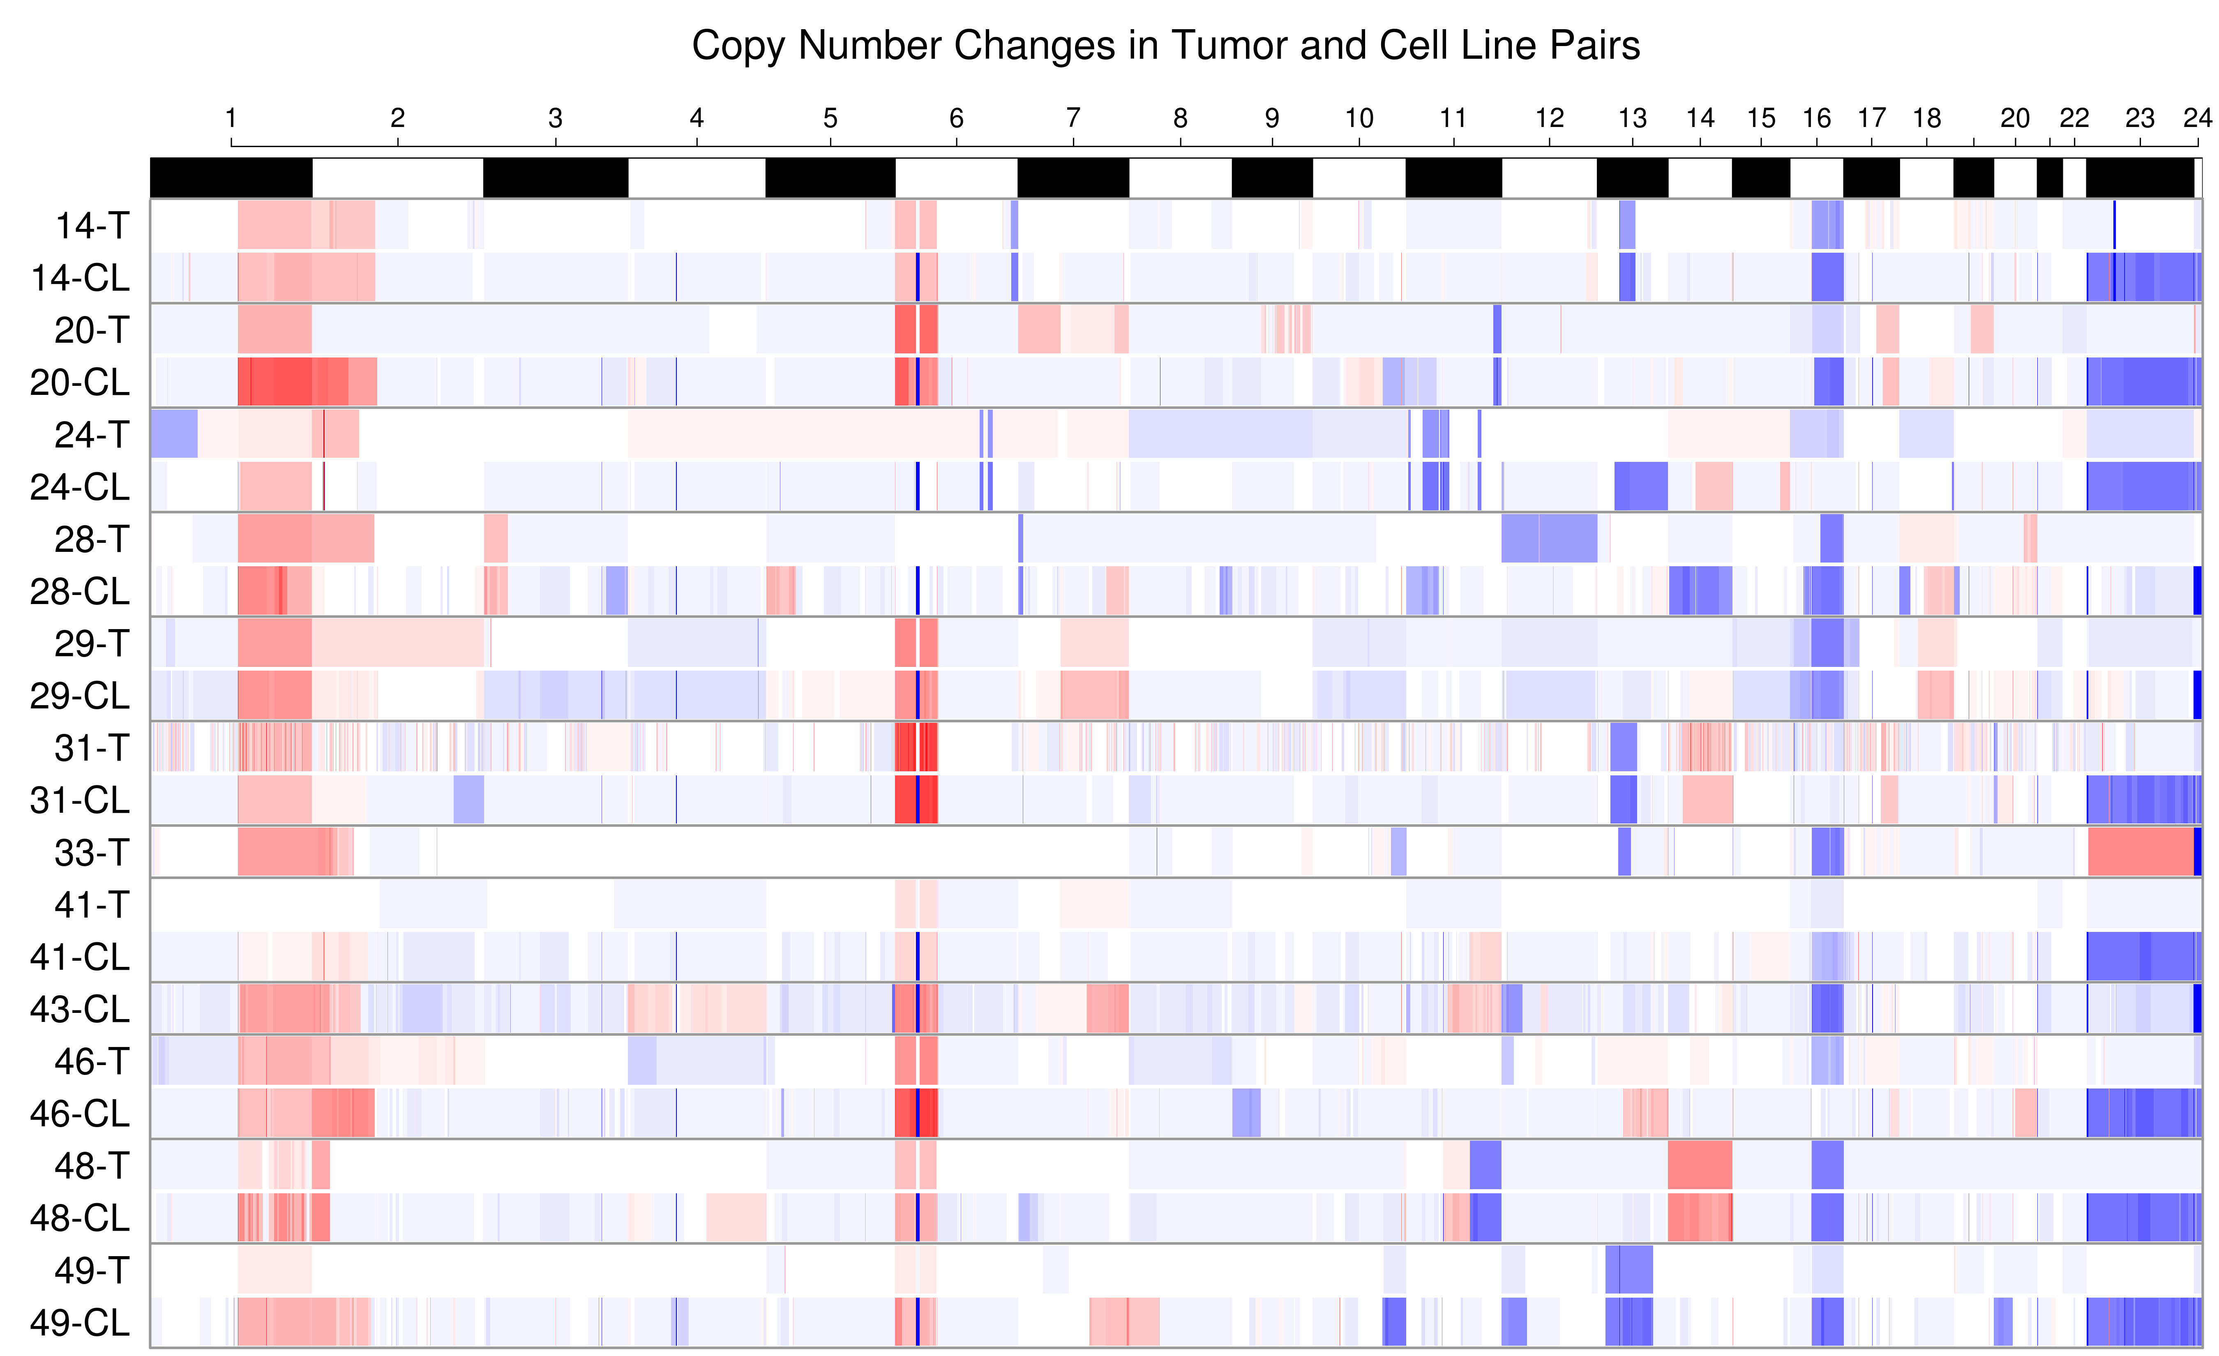
Somatic Copy Number Alterations

Allelic Imbalance Loss of Heterozygosity
Regions of loss of heterozygosity with a threshold of 0.7 mBAF are shown in supplementary info.

BCOR restoration to RB31

Discussion
Cell line - Tumor Comparisons We noticed ……….(this never done before for retinoblastoma -=- especially want to know if there were recurrent (in our dataset or with others) Cs or SNVs needed to establish in culture).
C and SNVs – shared, lost in cell line, gained in cell line. Polyclonality??? Check PE300 for artifact, perhaps in Kooi as well.

RB1 Hits
The number of
- Previous studies have found that somatic genomic alterations are rare in retinoblastoma (Kooi, Mol, Massink, Ameziane, et al. 2016). Our findings are that retinoblastoma variants are almost exclusively within the RB1 gene. We did not find a dramatic increase in recurrent copy number changes despite our aim for increased sequencing depth. The most common variants

Supplementary Info Somatic Variants
[1] “variants in tumors”

Supplementary Info Somatic Variants
[1] “variants in cell lines”

Supplementary Info Somatic Variants shared with Kooi
[1] “somatic variants recurrent in Kooi et. al”

To Do
Create visualization of mBAF regions (similar ot SC heatmap) Mention STR in results/methods

Discussion section
- Develop discussion section regarding evolution of tumor 24 (mycn amp but 13q loss only in cell lines; presence of somatic mutation in 13q cell line?)
- Add BCOR to where deleted in 14-T, 31-T. Interested in discovering effect as evidenced by 28-T/28-CL discrepancy CHeck for BCORL1 in kooi variants and tidy_vars_tumors
- Identify oncogences selectively increased in VAF in cell lines
- Look up PAN2 and F1 in unfiltered results ##20170824
- Should I do 16q loss correlation with tumor clonality as Kooi did? ## 20170821
- Find BCOR in 28-CL
- provided spreadsheet detailing presence of BCOR in cell lines

20170905
- Introduction (bullet points)
- Need to check Nautica submitted grant copy
- Results
- Culture conditions not established
- Cell Lines
- Variants of SC in
- T/N
- Are variants in CNV target regions
- In that tumor?
- In Irsan meta-analysis
- Are these mutations previously found as private?
- SC copy number changes
- Previously id’d by Kooi et al
- Characterize “sub” sC in tumors
- Relative to Kooi data
- Specific changes in CL for either
- SC
- Bases ## 20170903
- Need to find Irsan’s candidate targets in chromosome 7 and 11 more so others. none in chr11 **These included
- Kooi data includes candidates at less than het levels? YES ABSOLUTELEY
- What percent of samples are germline/hereditary? for RB mutations?

References
Bejjani, Anthony, Mee Rim Choi, Linda Cassidy, David W. Collins, Joan M. O’Brien, Tim Murray, Bruce R. Ksander, and Gail M. Seigel. 2012. “RB116: An RB1+ Retinoblastoma Cell Line Expressing Primitive Markers.” Molecular Vision 18: 2805. https://www.ncbi.nlm.nih.gov/pmc/articles/PMC3519375/.
DePristo, Mark A, Eric Banks, Ryan Poplin, Kiran V Garimella, Jared R Maguire, Christopher Hartl, Anthony A Philippakis, et al. 2011. “A Framework for Variation Discovery and Genotyping Using Next-Generation D Sequencing Data.” Nature Genetics 43 (5): 491–98. doi:10.1038/ng.806.
Dimaras, Helen, Vikas Khetan, William Halliday, Marija Orlic, Nadia L. Prigoda, Beata Piovesan, Paula Marrano, et al. 2008. “Loss of RB1 Induces Non-Proliferative Retinoma: Increasing Genomic Instability Correlates with Progression to Retinoblastoma.” Human Molecular Genetics 17 (10): 1363–72. doi:10.1093/hmg/ddn024.
Kooi, Irsan E., Berber M. Mol, Maarten P. G. Massink, Najim Ameziane, Hanne Meijers-Heijboer, Charlotte J. Dommering, Saskia E. van Mil, et al. 2016. “Somatic Genomic Alterations in Retinoblastoma Beyond RB1 Are Rare and Limited to Copy Number Changes.” Scientific Reports 6 (1). doi:10.1038/srep25264.
Kooi, Irsan E., Berber M. Mol, Maarten P. G. Massink, Marcus C. de Jong, Pim de Graaf, Paul van der Valk, Hanne Meijers-Heijboer, et al. 2016. “A Meta-Analysis of Retinoblastoma Copy Numbers Refines the List of Possible Driver Genes Involved in Tumor Progression.” Edited by Ralf Krahe. PLOS ONE 11 (4): e0153323. doi:10.1371/journal.pone.0153323.
Kuilman, Thomas, Arno Velds, Kristel Kemper, Marco Ranzani, Lorenzo Bombardelli, Marlous Hoogstraat, Ekaterina Nevedomskaya, et al. 2015. “CopywriteR: D Copy Number Detection from Off-Target Sequence Data.” Genome Biology 16 (1). doi:10.1186/s13059-015-0617-1.
Lek, Monkol, Konrad J. Karczewski, Eric V. Minikel, Kaitlin E. Samocha, Eric Banks, Timothy Fennell, Anne H. O’Donnell-Luria, et al. 2016. “Analysis of Protein-Coding Genetic Variation in 60,706 Humans.” Nature 536 (7616): 285–91. doi:10.1038/nature19057.
Li, Heng, and Richard Durbin. 2010. “Fast and Accurate Long-Read Alignment with Burrows-Wheeler Transform.” Bioinformatics 26 (5): 589–95. doi:10.1093/bioinformatics/btp698.
Staaf, Johan, David Lindgren, Johan Vallon-Christersson, Anders Isaksson, Hanna Goransson, Gunnar Juliusson, Richard Rosenquist, Mattias Hoglund, Ake Borg, and Markus Ringner. 2008. “Segmentation-Based Detection of Allelic Imbalance and Loss-of-Heterozygosity in Cancer Cells Using Whole Genome SNP Arrays.” Genome Biology 9 (9): R136. doi:10.1186/gb-2008-9-9-r136.
Van der Auwera, Geraldine A., Mauricio O. Carneiro, Christopher Hartl, Ryan Poplin, Guillermo del Angel, Ami Levy-Moonshine, Tadeusz Jordan, et al. 2013. “From FastQ Data to High-Confidence Variant Calls: The Genome Analysis Toolkit Best Practices Pipeline: The Genome Analysis Toolkit Best Practices Pipeline.” In Current Protocols in Bioinformatics, edited by Alex Bateman, William R. Pearson, Lincoln D. Stein, Gary D. Stormo, and John R. Yates, 11.10.1–11.10.33. Hoboken, NJ, USA: John Wiley & Sons, Inc. http://doi.wiley.com/10.1002/0471250953.bi1110s43.
Zhang, Jinghui, Claudia A. Benavente, Justina McEvoy, Jacqueline Flores-Otero, Li Ding, Xiang Chen, Anatoly Ulyanov, et al. 2012. “A Novel Retinoblastoma Therapy from Genomic and Epigenetic Analyses.” Nature, January. doi:10.1038/nature10733.

