RB Exome Manuscript

Kevin Stachelek

July 11, 2017

## 20170822

1. test

/newpage

##### 20170821

1. Find BCOR in 28-CL
   1. provided spreadsheet detailing presence of BCOR in cell lines
2. Look up PAN2, NAF1 on genecards
3. Does DNM3 have extra copies?
4. find RB1 in 31-T (It is present in 31-CL)
5. establish functional assay for PAN2
6. Got through all T/CL variants for listing as oncogene or tumor suppressor
   1. Check COSMIC? provide file tidy_tumors_w_cosmic.csv
7. Look up Steve Ellidge for oncongene
8. Identify oncogences selectively increased in VAF in cell lines
9. Remove pathogenicity as an excluding filter
10. Identify activating mutations in oncogenes in the literature
11. check VAF in all data (prefiltered, esp. for PAN2, NAF1)
12. Add BCOR to where deleted in 14-T, 31-T. Interested in discovering effect as evidenced by 28-T/28-CL discrepancy CHeck for BCORL1 in kooi variants and tidy_vars_tumors

## 20170818

1. Find BCOR in 28-CL
   1. examined tidy_cell_lines0 for all variants of BCOR, no trace found in 28-CL see "./doc/20170818/bcor_in_cell_line.csv"
2. Look up PAN2 and NAF1 in unfiltered results

## 20170807

1. Need to quantify differnece between Agilent baits, targets, and caputure regions
2. Need to get metrics of exome coverage

## Methods

1. Need to find Irsan’s candidate targets in chromosome 7 and 11 more so others. none in chr11
2. Kooi data includes candidates at less than het levels? YES ABSOLUTELEY
3. What percent of samples are germline/hereditary? for RB mutations?
4. Email laura Li about common Rb mutations/genetics no specific guidance

## Structure of paper

1. Introduction (bullet points)
2. Need to check Nautica submitted grant copy
3. Results
   1. Patient characteristics
      1. Age
      2. Sex
      3. Laterality
      4. Family history
4. Culture conditions not established
   1. Cell Lines
5. Variants of SCNA in
   1. T/N

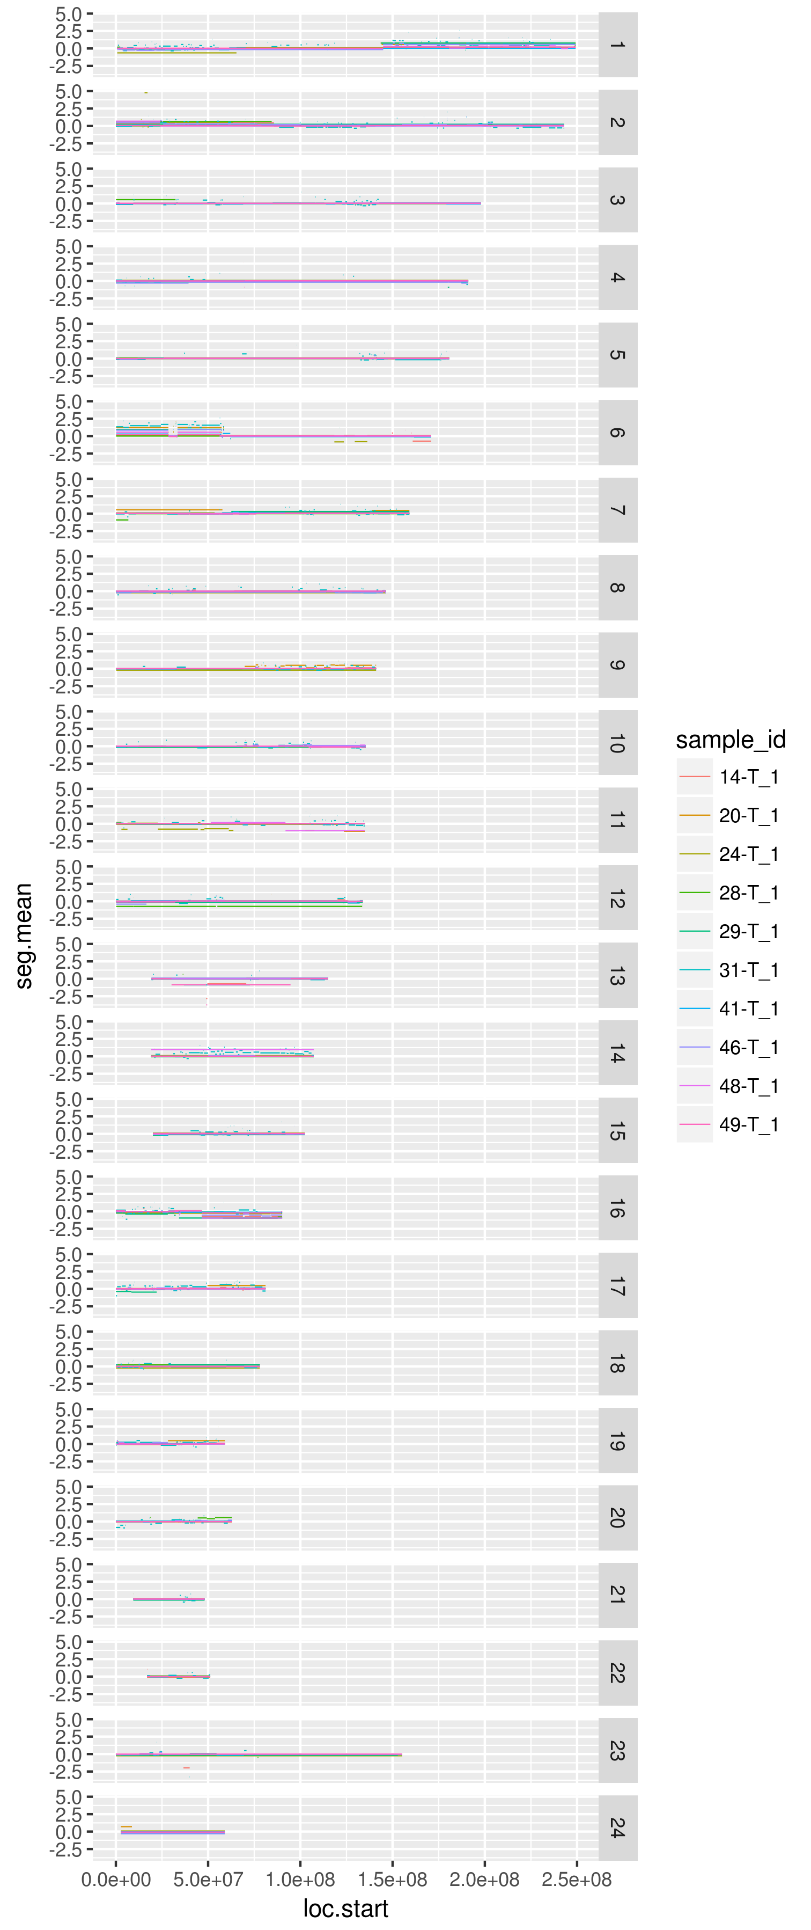  
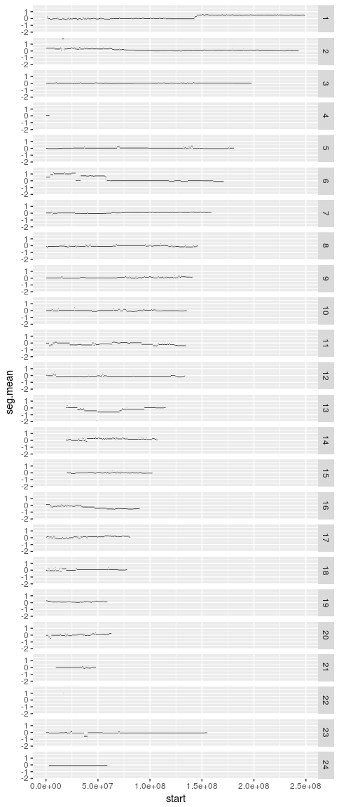

|  |  |  |  |  |  |  |  |
| --- | --- | --- | --- | --- | --- | --- | --- |
| entrezgene | hgnc_symbol | chromosome_name | transcript_start | transcript_end | start | end | seg.mean |
| 103752554 | MYCNUT | 2 | 15920399 | 15936017 | 15530000 | 17150000 | 1.783 |
| 10408 | MYCNOS | 2 | 15939898 | 15941723 | 15530000 | 17150000 | 1.783 |
| 4613 | MYCN | 2 | 15940564 | 15947007 | 15530000 | 17150000 | 1.783 |

2. CL/N

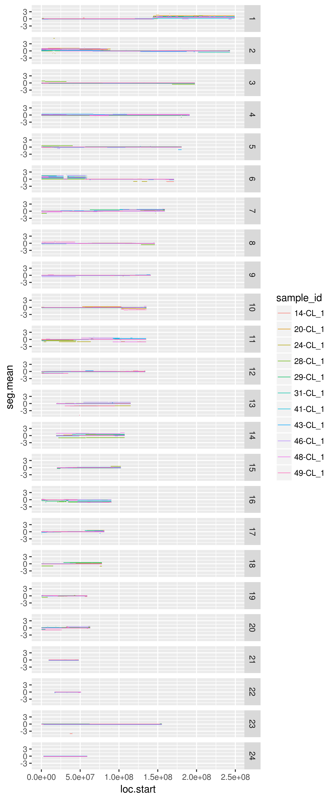

SCNAs found in Retinoblastoma Cell Lines

1. Variants of bases
   1. T/N

|  |  |
| --- | --- |
| sample | SYMBOL |
| 24-T | FOXL2,RIMS1,NUDT18,BCLAF1,PDHX,KIAA1586,C11orf40,MPEG1,MMP10,BIRC6,TSPYL6,CX3CR1,INPP5B,SLC22A24,NAF1,ADAM3A,DYNC2H1,PLA2G7,DAGLA,MYSM1,CCDC74A,VENTX,SLC39A4,TFDP2,KIAA0319,OR2A1,SMTNL1,PPP4R3B,SPOCD1,ACCS,CATSPER4,LINC01587 |
| 28-T | DHX29,PAWR,ADAMTS7,NUPR2,SELENOO,RB1,C17orf97,CHCHD10,CORO6,BCOR,PI4KA,FASN,LRRC3B,NSUN5P2,C1orf229,ADAM2,GATA4,HGC6.3,TMEM191C,PRPF40A,DDX60,LILRB1,CDK13 |
| 29-T | RB1,TRIP6,C2CD4A,IER5,TTLL3,SFT2D3,DNLZ,PAN2,ARHGAP35,PDZD4,GAS6,C7orf26,MCF2,BICRA,DHFR,SBNO2 |
| 31-T | LOR,VPS54,CPS1,NT5DC2,GBP1,ANKRD36,GFI1,NOTCH2,PELI1,ORC4,PLEKHB2,ZFP69,IMPG2 |
| 41-T | RNF215,FAM131C,GIPC1,FAM86C1,SOX10,ESRRA,CNN2,GXYLT1,TLN2,NCKAP1L,KRTAP5-1,CABLES1 |
| 46-T | ZNF318,NSMAF,MAP6D1,GUCY2C,RB1,SCARF2,DNAH12,RNF5P1,ARHGEF28,C14orf39,METTL24,PDX1,FLT3,FAM86C1,PIP5K1C,TARSL2,RBM15B,FOXO3,ITIH2,FAM86C2P,GRIN3B,PLK4,SIGLEC10,ANKRD30B,LCE1D,SLC6A10P,MNS1 |
| 48-T | TRMT6,LRP8,TMEM135,NLRP12,PLCG1,PI4KAP2,KLF14,PLD2,TTLL1 |

2. CL/N

1. Are these mutations previously found as private?
2. SCNA copy number changes
   1. Previously id’d by Kooi et al
   2. Characterize “sub” sCNA in tumors
      1. Relative to Kooi data
3. Specific changes in CL for either
   1. SCNA
   2. Bases

## DC

1. Need to unfilter existing RB gene/variant table
2. Mutations recurrecnt?
3. Tumor v other rb tumors
   1. Kooi
   2. Zhang
4. Cell line vs. other rb tumors
   1. Kooi
   2. Zhang
5. Are variants in CNV target regions
   1. In that tumor?
   2. In Irsan meta-analysis

|  |  |  |  |  |  |  |
| --- | --- | --- | --- | --- | --- | --- |
| Sample | DOB | Date_surgery | Sex | Laterality | family_history | Age_at_surgery |
| CHLA-VC-RB-14 | 05/01/09 | 01/25/11 | 0 | uni_right | NA | 20 |
| CHLA-VC-RB-20 | 02/12/09 | 05/19/11 | 0 | uni_left | NA | 27 |
| CHLA-VC-RB-24 | 02/05/11 | 07/08/11 | 0 | uni_left | NA | 5 |
| CHLA-VC-RB-28 | 01/31/08 | 10/06/11 | 1 | uni_right | NA | 45 |
| CHLA-VC-RB-29 | 12/19/08 | 10/27/11 | 1 | uni_right | NA | 34 |
| CHLA-VC-RB-31 | 12/26/09 | 11/23/11 | 0 | uni_right | NA | 23 |
| CHLA-VC-RB-33 | 08/26/10 | 12/30/11 | 1 | bilateral | NA | 16 |
| CHLA-VC-RB-41 | 04/14/12 | 06/29/12 | 0 | uni_right | NA | 2 |
| CHLA-VC-RB-43 | 10/01/09 | 07/20/12 | 1 | uni_left | NA | 33 |
| CHLA-VC-RB-46 | 07/08/10 | 10/26/12 | 0 | uni_right | NA | 27 |
| CHLA-VC-RB-48 | 11/08/10 | 07/25/13 | 0 | uni_right | NA | 32 |
| CHLA-VC-RB-49 | 06/22/11 | 01/04/13 | 0 | uni_right | NA | 19 |

## Including Plots

You can also embed plots, for example:

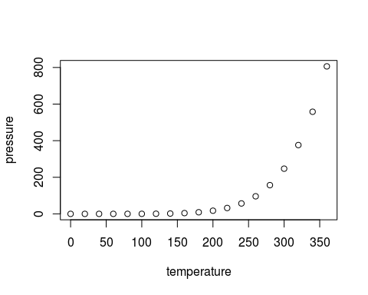

Note that the echo = FALSE parameter was added to the code chunk to prevent printing of the R code that generated the plot.

## References

(Kuilman et al. 2015)

Kuilman, Thomas, Arno Velds, Kristel Kemper, Marco Ranzani, Lorenzo Bombardelli, Marlous Hoogstraat, Ekaterina Nevedomskaya, et al. 2015. “CopywriteR: DNA copy number detection from off-target sequence data.” *Genome Biology* 16 (1): 49. doi:[10.1186/s13059-015-0617-1](https://doi.org/10.1186/s13059-015-0617-1).