Devolatilized Samples (No Peaks)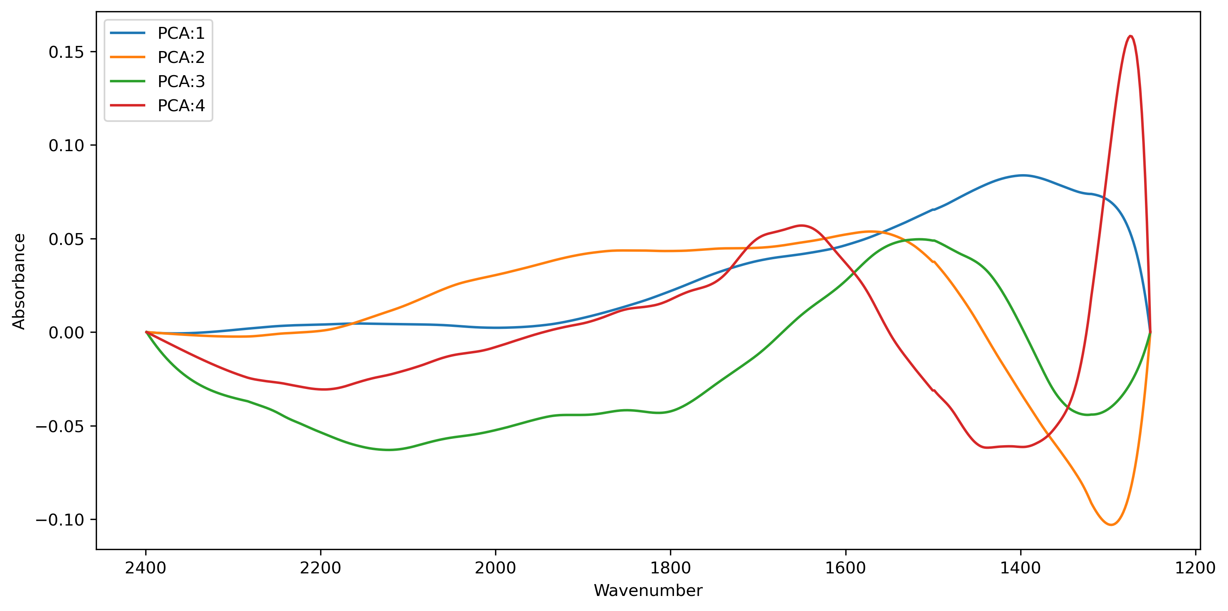

PCA from Spectra with Baseline removed