Wave flume test on 3/18

**Flume dimensions**

L = 432cm, W = 30 cm, H = 45cm

**PVC pipe array**

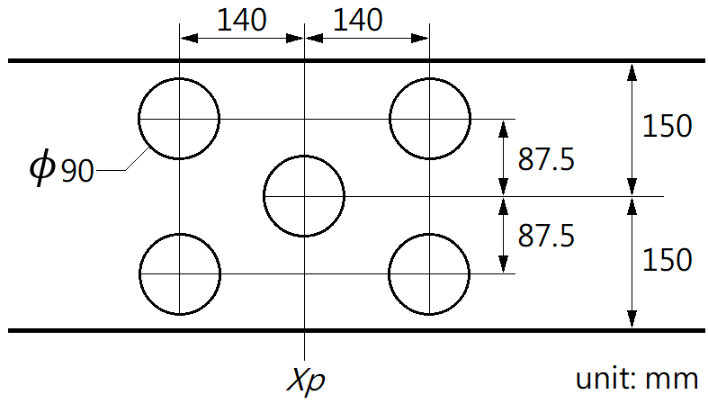

**Wave gauge location**

The first wave gauge at x = 0cm; the second wave gauge at x = 221cm; and the third wave gauge at x = 262cm. Note that in the videos, the wave gauges are located at 170”, 83”, and 67”, respectively. These numbers are the readings on the ruler but not the x coordinates.

**Case conditions**

|  |  |  |  |  |  |
| --- | --- | --- | --- | --- | --- |
| case | Pipe array | Xp (cm) | Depth (cm) | Amplitude | Frequency |
| A (w1-off) | Off | NA | 9.0 | Small | High |
| B (w1-on) | On | 242 | 9.2 | Small | High |
| C (w2-off) | Off | NA | 8.8 | Small | Low |
| D (w2-on) | On | 242 | 8.6 | Small | Low |
| E (w3-off) | Off | NA | 8.2 | Large | Low |
| F (w3-on) | On | 242 | 8.4 | Large | Low |

Note:

The amplitude of the wavemaker was not measured. The wave frequency can be obtained by frequency-domain analysis.