Wave flume test on 3/22/2023

**Flume dimensions**

L = 432cm, W = 30 cm, H = 45cm

**PVC pipe array – high density**

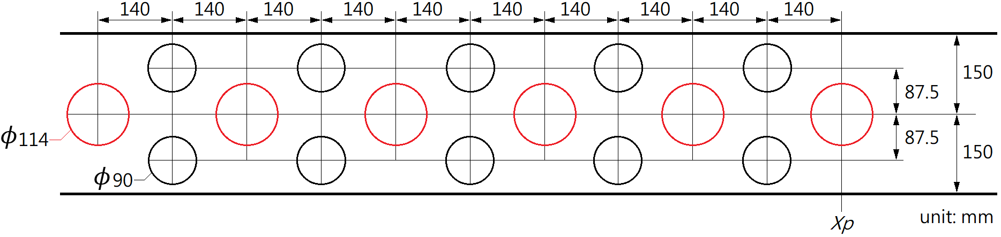

**PVC pipe array – low density**

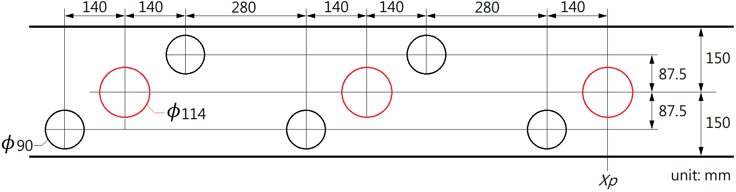

**Wave gauge location of wave condition 1**

For the first wave gauge at x = 0cm, the second wave gauge is at x = 119cm and the third wave gauge is at x = 279cm. Note that in the videos, the wave gauges are located at 140”, 93”, and 30”, respectively. These numbers are the readings on the ruler but not the x coordinates.

**Wave gauge location of wave condition 2**

For the first wave gauge at x = 0cm, the second wave gauge is at x = 117cm and the third wave gauge is at x = 279cm. Note that in the videos, the wave gauges are located at 140”, 94”, and 30”, respectively. These numbers are the readings on the ruler but not the x coordinates.

**Case conditions**

|  |  |  |  |  |  |
| --- | --- | --- | --- | --- | --- |
| case | Pipe array | Xp (cm) | Depth (cm) | Amplitude | Frequency |
| 1_BL | Off | NA | 13.2 | Large | Low |
| 1_LD | Low density | 127.6 | 13.4 | Large | Low |
| 1_HD | High density | 127.6 | 13.8 | Large | Low |
| 2_BL | Off | NA | 12.8 | Small | High |
| 2_LD | Low density | 126 | 12.5 | Small | High |
| 2_HD | High density | 126 | 12.0 | Small | High |

Note:

The amplitude of the wavemaker was not measured. The wave frequency can be obtained by frequency-domain analysis. See the Matlab script.