**Experiment report**

**Experiment name**: Dynamics of a floating offshore wind turbine under different maritime conditions.

**Name**: Diego Fernando Bernal Camacho.

**Position**: PhD student at National Autonomous University of Mexico (UNAM).

**Date**: 30/12/2022.

**Purpose of the experiment**

Analyze the dynamics of a floating offshore wind turbine under different maritime conditions such as; the most probability of occurrence and severe maritime conditions.

**Objectives**

* Analyze the degrees of freedom surge, heave and pitch.
* Design a device made from a centreboard and heave plate to reduce the platform's motions.
* Propose safe strategies for floating platforms under severe maritime conditions.

**Employed materials.**

* Floating offshore wind turbine (FOWT) (Robertson et al., 2014)
* Catenary mooring lines.
* Wave tank.
* Wind tunnel.
* High Speed Camera (HSC) and led lights.
* Water level sensors.
* Solid disk to simulate the wind thrust on the platform.
* Ballast water.

**Methodology**

The experiment's methodology is next; the floating turbine was positioned in the middle of the tank employing three catenary mooring lines (Musial et al., 2004) and a solid disk (Roddier et al., 2010) to simulate the wind thrust on the platform, meanwhile, the HSC was installed next to the tank to capture 4670 frames per second of the floating platform motions with different maritime conditions. In addition, two water level sensors forward and aft direction of the FOWT were installed. Then, the frames were analyzed in ImageJ as a TIFF file to convert them to binary images and obtain surge, heave and pitch degrees of freedom values, which are being processed in MATLAB to plot Response Amplitude Operators (Ghadimi et al., 2020). The tests were carried out with regular wave with/without wind, extreme regular wave with/without wind and only with wind.

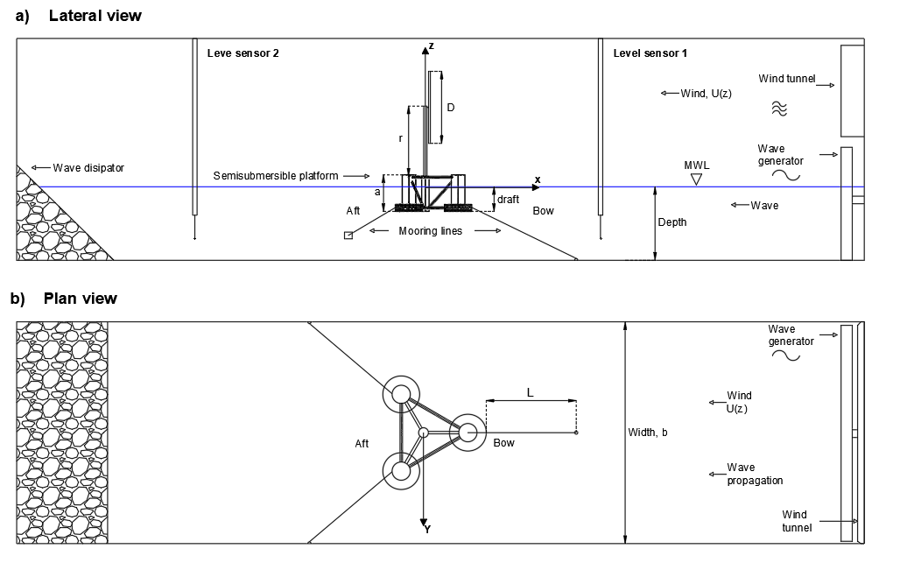

Figure 1. Floating platform in the wind tank and wind tunnel.

|  |  |
| --- | --- |
|  |  |
| a) | b) |

Figure 2. Wave tank and wind tunnel, front view a), and isometric view b).

Figure 1 shows the position of the FOWT, water level sensor and the catenary mooring lines in the wave tank and wind tunnel. On the other side, figure 2 illustrates the test facility at UNAM.

**References**

Ghadimi, P., Pourmostafa, M., & Najafi, S. (2020). Investigating the Response Amplitude Operator of a Heaving Pontoon under the Influence of a Submerged Trapezoidal Breakwater. *Advances in Civil Engineering*, *2020*. https://doi.org/10.1155/2020/8813096

Musial, W., Butterfield, S., & Boone, A. (2004). Feasibility of Floating Platform Systems for Wind Turbines. *In 42nd AIAA Aerospace Sciences Meeting and Exhibit*, (p. 1007).

Robertson, A., Jonkman, J., Masciola, M., Song, H., Goupee, A., Coulling, A., & Luan, C. (2014). *Definition of the Semisubmersible Floating System for Phase II of OC4.*

Roddier, D., Cermelli, C., Aubault, A., & Weinstein, A. (2010). WindFloat: A floating foundation for offshore wind turbines. *Journal of Renewable and Sustainable Energy*, *2*(3). https://doi.org/10.1063/1.3435339