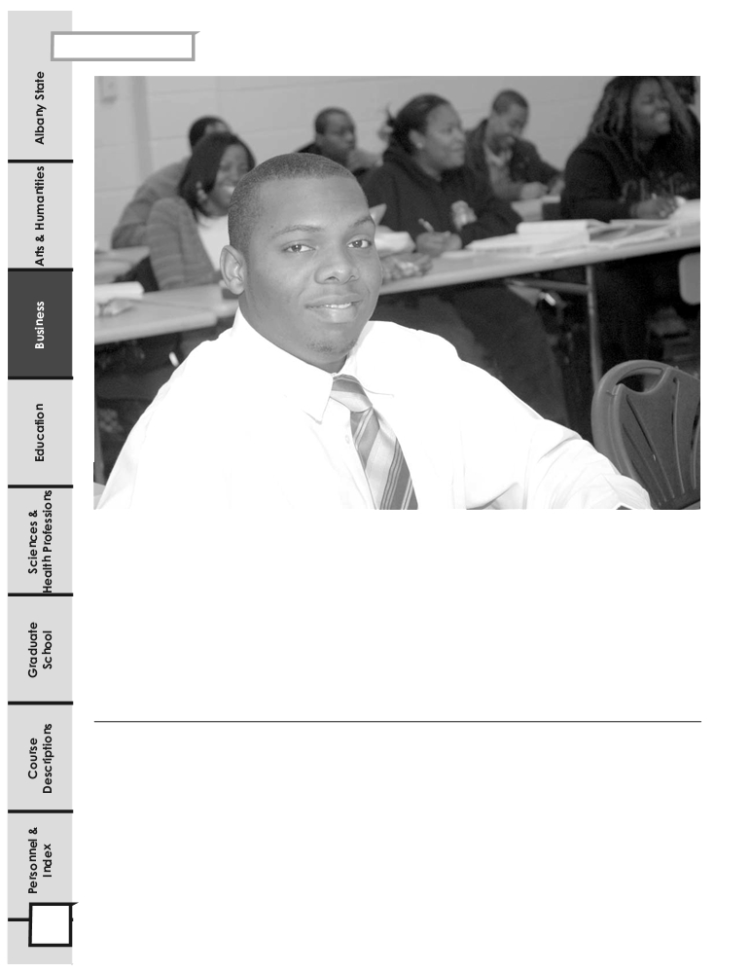

Business

COLLEGE OF
BUSINESS

CONTENTS

Internship . . . . .99 Technology Management Curriculum…. …106
Weekend College . . . . .99 Department of Accounting, Information
Two-Plus-Two Program . . . . . .99 Systems and Marketing . . . . .108
Department of Business Administration .100 Accounting Curriculum . . . . .109
Business Management Curriculum . . . . .101 Business Information Systems Curriculum . . . . .111
Healthcare Management Curriculum . . . .103
Marketing Curriculums . . . . . .113

98 2008 -2012 Undergraduate Catalog
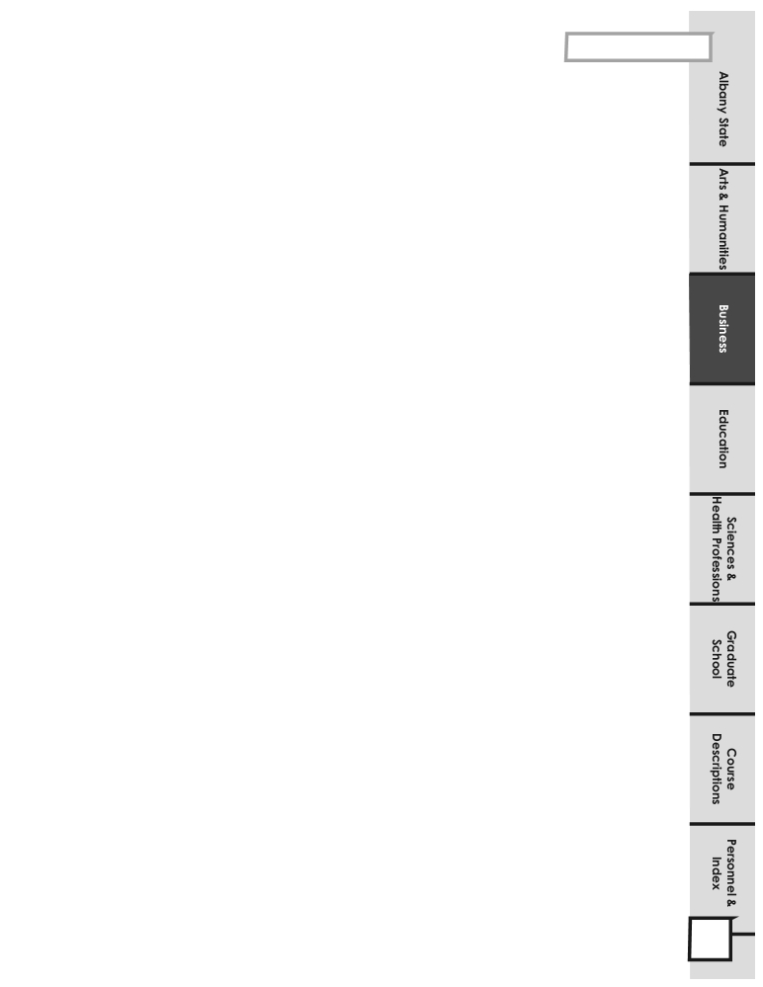

Business
COLLEGE OF BUSINESS
The College of Business includes two departments: (1) Business Administration and (2) Accounting, Business Information Systems and Marketing.

The mission of the College of Business is to create a learning community in which all who want a quality business education can gain the measurable skills and competencies demanded by global employers, required for self-employment or admission to graduate school. The college serves the educational needs of an increasingly diverse student population. The college offers undergraduate degrees in accounting, business information systems, management, supply chain and logistics management, technology management, and marketing, as well as a concentration area in health care management. A graduate degree in Business Administration (MBA) is also offered (see ASU Graduate Catalog for details).
The undergraduate and graduate curricula developed by the College of Business meet the highest academic standards in preparing graduates for positions of responsibility in our global, highly competitive economy. The instructional approach of the business faculty is to engage students in “learning by doing” - encouraging open discussion, debate and other experiential work, including learning teams preparing case analyses and students using technology to enhance their critical thinking skills.

The college’s core values include integrity and trust, continuous improvement, and professionalism. The vision of the college is to become one of the preeminent business colleges in the University System of Georgia and throughout the Southeastern United States.

The following baccalaureate and master’s degree programs of the College of Business at Albany State University are accredited by the Southern Association of Colleges and Schools and the Association of Collegiate Business Schools and Programs (ACBSP):

1. Bachelor of Science in Accounting

2. Bachelor of Science in Business Information Systems

3. Bachelor of Science in Management

4. Bachelor of Science in Management (Healthcare Administration)

5. Bachelor of Applied Science in Technology Management

6. Bachelor of Science in Marketing

7. Bachelor of Science in Supply Chain and Logistics Management

8. Master of Business Administration
The College of Business is housed in Peace Hall, a modern two-story building with spacious and attractive classrooms, a large lecture room, computer labs, student lounge, faculty lounge, conference room, and administrative and faculty offices. The overall setting is highly conducive to learning, leadership and character-molding activities.
INTERNSHIP PROGRAM (WORK-BASED PARADIGM)
The College of Business actively supports the Work-Based Paradigm (WBP) of the University by involving students in the WBP major components: shadowing, mentoring, interning and cooperative education. Internships normally consist of students working full or part time for a semester at a cooperating firm. Internships may be for pay, volunteer and/or for course credit. Business students are expected to complete internship
experiences in their major area of study before graduation. The college offers three formal courses for internship credit: BUSA 3100 (3hrs), BUSA 4100 (3hrs) and MGHC 4110 (4hrs). Cooperative Education assignments are normally at out-of-state locations, although a
limited number of COOP assignments are available in the Albany area. Students may earn University credit for cooperative education courses
while on assignments.

WEEKEND COLLEGE
All degrees in the college of business can be earned either during regular work hours or in evening classes. Weekend classes are scheduled when enrollment demands are sufficient.
Two-Plus-Two Program
The College of Business has several articulation agreements which allow students with associate degrees to transfer easily to Albany State University. These agreements include technology management, accounting, information systems, marketing and management. Normally, students transfer no more than 60 semester hours and complete at least 60 semester hours at Albany State University.

On-Line Degree Programs
The college offers two formal degree programs online: the BS Degree in Business Information Systems and the Technology Management Degree. In addition, the logistics courses are offered online, as well as all Area F and G courses.

2008 -2012 Undergraduate Catalog 99
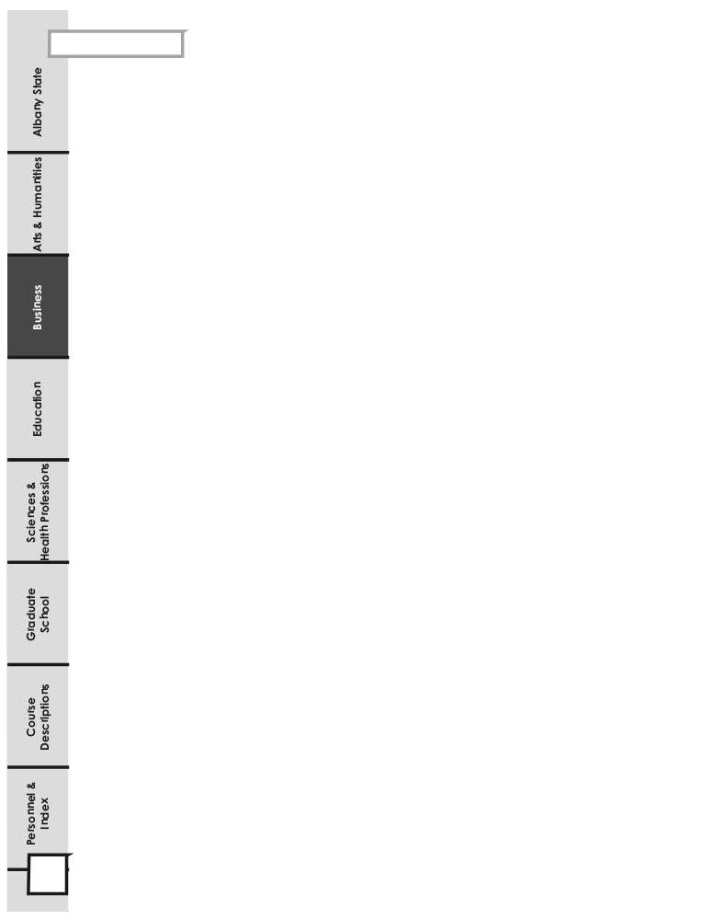

Business Administration
DEPARTMENT OF BUSINESS
ADMINISTRATION
The Department of Business Administration offers the Bachelor of Science degree in Management with concentrations in either Business Management or Healthcare Administration. The Department also offers the Bachelor of Applied Science in Technology Management.
The degree programs in the Department of Business Administration are nationally accredited by the Association of Collegiate Business Schools and Programs (ACBSP), and by the Southern Association of Colleges and Schools (SACS).

The mission of the management program is to enable students to develop analytical skills, reflective thinking, logical reasoning, and a sound understanding of the quantitative techniques and computer applications used in decision-making processes. Career options may include industrial and service management, financial analysis, quality control management, and first level supervision in industry, business and government. Many of our majors are interested in entrepreneurship and small business management.

The Healthcare Administration area of concentration is structured as a four-year generic program to provide specialty training for the entering freshman or transfer student. The 2 ± 2 program is designed to permit students to continue their education beyond the associate degree level with full credit. Healthcare graduates have experienced an employer-based practicum and are prepared for entry level management and supervisory practice in the healthcare industry.
The Bachelor of Applied Science degree in Technology Management is designed to prepare students who have successfully completed the Associate of Applied Science (AAS) degree in Technology or the Associate of Applied Technology (AAT) degree from SACS accredited institutions to earn Bachelor of Applied Science (BAS) degree in Technology Management. Online BAS in Technology Management that offers all coursework online is available for location-bound students who can not take advantage of the traditional in-class instructions to earn a BAS degree in Technology Management. Through a combination of business management and business information systems courses, the BAS curriculum provides a solid grounding in the skills needed to manage human and technology resources in today’s global and dynamic business and industry settings. Career opportunities in Technology Management include industrial and service management, technology security specialist, quality control management, business/management information systems specialist, and other related fields.

The Department of Business Administration faculty is also committed to serving the economic and organizational needs of the business community in Albany and Southwest Georgia.
REQUIREMENTS FOR A BACHELOR OF SCIENCE DEGREE IN MANAGEMENT
1. The student must complete a minimum of 124 semester hours with a cumulative grade point average of 2.25 in the overall program, and a grade of “C” or above in all business (Areas F, G, and H) courses.

2. The student must have a cumulative grade point average of 2.25 or higher to be admitted to the program.
3. The student must complete 30 hours of business courses beyond Area F requirements plus an additional 27 hours of management concentration courses (Area H).

4. The student must complete the Major Field Achievement Test (MFAT) as a part of course requirements for MGMT 4199, Business Policy, which is taken the graduating senior semester.

100 2008 -2012 Undergraduate Catalog
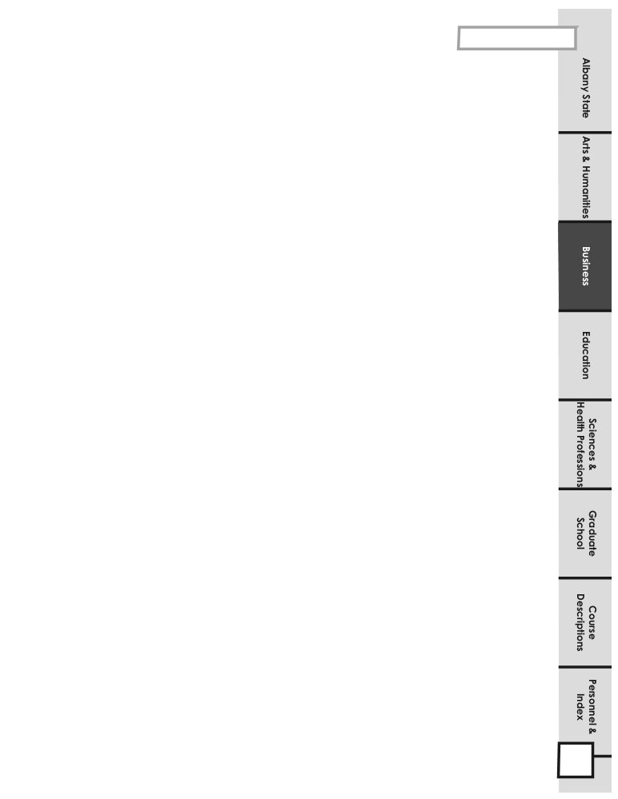

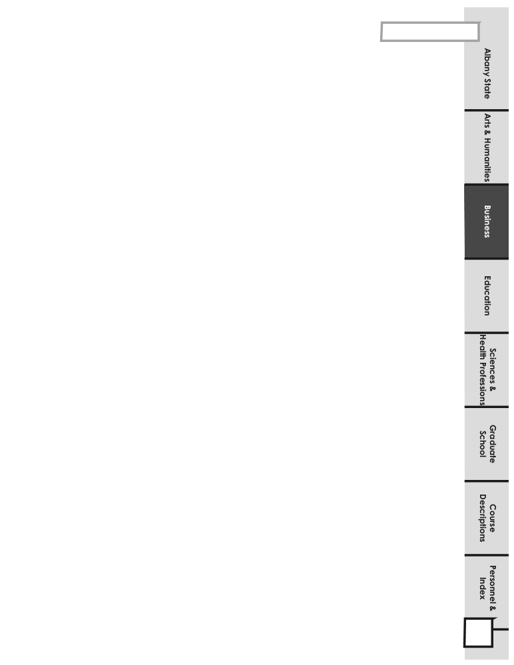
Business Administration
BACHELOR OF SCIENCE DEGREE IN MANAGEMENT (BUSINESS MANAGEMENT CONCENTRATION)

Courses Titles Prerequisites Credit Hrs.
Area F: Program of Study Related Courses
ACCT 2101 Principles of Accounting I MATH 1111 3
ACCT 2102 Principles of Accounting II ACCT 2101 3
BISE 2010 Fundamentals of Computer Applications 3
BISE 2040 Communication for Management ENGL 1102 3
ECON 2105 Principles of Macroeconomics 3
ECON 2106 Principles of Microeconomics 3
Subtotal 18

Area G: Business Major Required Courses
BUSA 4105 International Business ECON 2105/ECON 2106, MGT 3105 3
ECON 3205 Economic and Business Statistics ECON 2105 /ECON 2106 3
FINC 3105 Foundations of Financial Management ACCT 2101 3
MGMT 3105 Legal Environment of Business 3
MGMT 3106 Management Science and Operation Mgmt. ECON 3205 3
MGMT 4110 Organizational Behavior MGMT 3105 3
MGMT 4125 Human Resource Management MGMT 3105 3
MGMT 4205 Management Information Systems BISE 2010 3
MGMT 4199 Business Policy 3
MKTG 3120 Principles of Marketing ECON 2106 3
Subtotal 30

Area H: Management Majors Required Courses
BUSA 3100 Business Internship I 3
ECON 3145 Money, Banking and Foreign Exchange ECON 2106 3
MGMT 4126 Organizational Learning MGMT 4110 3
MGMT 4127 Small Business Management MGMT 4110, FINC 3105 3
MGMT 4206 Database Management Systems BISE 2010 3
MGMT 4207 System Analysis and Design MGMT 4206, BISE 2010 3
Area H Non-Business Electives 9
Subtotal 27

PROGRAM OF STUDY FOR THE BACHELOR OF SCIENCE DEGREE
IN MANAGEMENT (BUSINESS MANAGEMENT CONCENTRATION)
124 Semester Hours

Freshman Year (Fall)
ASU 1200 Freshman Seminar & Service to Leadership 3
ENGL 1101 English Composition I 3
MATH 1111 Mathematical Modeling or College Algebra 3
Area D Science, Math, Technology 4
Area D Select One 3
Subtotal 16
Freshman Year (Spring)
ENGL 1102 English Composition II 3
COMM 1100 Analytical Discussion of Global Issues 3
HIST 1002 Intro to the African Diaspora 2
Area C Humanities/Fine Arts ENGL 2111 3
Area D Science, Math, Technology 4
Above Core Option 1
Subtotal 16
Freshman Year (Fall)
ASU 1200 Freshman Seminar & Service to Leadership 3
ENGL 1101 English Composition I 3
MATH 1111 Mathematical Modeling or College Algebra 3
Area D Science, Math, Technology 4
Area D Select One 3
Subtotal 16
Freshman Year (Spring)
ENGL 1102 English Composition II 3
COMM 1100 Analytical Discussion of Global Issues 3
HIST 1002 Intro to the African Diaspora 2
Area C Humanities/Fine Arts ENGL 2111 3
Area D Science, Math, Technology 4
Above Core Option 1
Subtotal 16

Sophomore Year (Fall)
Above Core Option 1
POLS 1101 U. S. & Georgia Government or
HONR 1161 Honors U.S. & Georgia Government 3
Area E Option: Social Science 3
ACCT 2101 Principles of Accounting I 3
ECON 2106 Principles of Microeconomics 3
Area C Humanities/Fine Arts – Select One 3
Subtotal 16
Sophomore Year (Spring)
Above Core Option 1
Area E Option: Social Science 3
BISE 2040 Communication for Management 3
ACCT 2102 Principles of Accounting II 3
ECON 2105 Principles of Macroeconomics 3
BISE 2010 Fundamentals of Computer Applications 3
Subtotal 16
Sophomore Year (Fall)
Above Core Option 1
POLS 1101 U. S. & Georgia Government or
HONR 1161 Honors U.S. & Georgia Government 3
Area E Option: Social Science 3
ACCT 2101 Principles of Accounting I 3
ECON 2106 Principles of Microeconomics 3
Area C Humanities/Fine Arts – Select One 3
Subtotal 16
Sophomore Year (Spring)
Above Core Option 1
Area E Option: Social Science 3
BISE 2040 Communications for Management 3
ACCT 2102 Principles of Accounting II 3
ECON 2105 Principles of Macroeconomics 3
BISE 2010 Fundamentals of Computer Applications 3
Subtotal 16

2008 -2012 Undergraduate 101

Business Administration

Junior Year (Spring)
BUSA 4105 International Business 3
ECON 3205 Economics/Business Statistics 3
MGMT 3106 Mgmt Science/Operations Mgmt 3
MGMT 4110 Organizational Behavior 3
MGMT 4205 Management Information Systems 3
MKTG 3120 Principles of Marketing 3
Subtotal 18
Junior Year (Fall)
FINC 3105 Foundations of Financial Management 3
MGMT 3105 Legal Environment of Business 3
MGMT 4125 Human Resource Management 3
Area E Option: Social Science 3
Subtotal 12

Junior Year (Spring)
BUSA 4105 International Business 3
ECON 3205 Economics/Business Statistics 3
MGMT 3106 Mgmt Science/Operations Mgmt 3
MGMT 4110 Organizational Behavior 3
MGMT 4205 Management Information Systems 3

Subtotal 15
Junior Year (Fall)
FINC 3105 Foundations of Financial Management 3
MGMT 3105 Legal Environment of Business 3
MGMT 4125 Human Resource Management 3
Area E Option: Social Science 3
MKTG 3120 Principles of Marketing 3
Subtotal 15

Senior Year (Fall)
ECON 3145 Money and Banking 3
MGMT 4127 Small Business Management 3
MGMT 4206 Database Management Systems 3
Area H Elective Non-Business 3
Area H Elective Non-Business 3
Subtotal 15
Senior Year (Spring)
BUSA 3100 Business Internship I 3
MGMT 4126 Organizational Learning 3
MGMT 4207 Systems Analysis and Design 3
MGMT 4199 Business Policy 3
Area H Elective Non-Business 3
Subtotal 15

Senior Year (Fall)
ECON 3145 Money and Banking 3
MGMT 4127 Small Business Management 3
MGMT 4206 Database Management Systems 3
Area H Elective Non-Business 3
Area H Elective Non-Business 3
Subtotal 15
Senior Year (Spring)
BUSA 3100 Business Internship I 3
MGMT 4126 Organizational Learning 3
MGMT 4207 Systems Analysis and Design 3
MGMT 4199 Business Policy 3
Area H Elective Non-Business 3
Subtotal 15

2008 – 2012 Undergraduate Catalog 102

Requirements for a Bachelor of Science Degree in Management (Health Care Administration Concentration)

1. The student must complete a minimum of 124 semester hours with a cumulative grade point average of 2.25 in overall program, and a grade of “C” or above in all business courses.

2. The student must have a cumulative grade point average of 2.25 or higher to be admitted to the program.

3. The student must complete 30 hours of business courses beyond Area F requirements plus an additional 30 hours of healthcare management concentration courses.

4. The student must complete the MFT during the student’s graduating senior semester..

Bachelor of Science Degree in Management
(Health Care Administration Concentration)
Courses Titles Prerequisites Credit Hrs.
Area F: Program of Study Related Courses
ACCT 2101 Principles of Accounting I MATH 1111 3
ACCT 2102 Principles of Accounting II ACCT 2101 3
BISE 2010 Fundamentals of Computer Applications 3
BISE 2040 Communication for Management ENGL 1102 3
ECON 2105 Principles of Macroeconomics 3
ECON 2106 Principles of Microeconomics 3
Subtotal 18

Area G: Business Major Required Courses
MGHC 2220 Medical Terminology 3
MGHC 3110 Introduction to Health Care Org. 3
MGHC 3120 Ethical/Legal Issues in Health Care 3
MGHC 3220 Research in Health/Biostatistics 3
MGHC 3310 Chronic Disease 3
MGHC 3411 Quality Mgt in Health Care 3
MGHC 3420 Economics of Health Care ECON 2106 3
MGHC 4211 Health Care Admin Practicum I 3
MGHC 4410 Financial Mgt in Health Care ACCT 2102 3
MGHC 4420 Insurance for Health Care 3
Subtotal 30

Area H: Health Care Admin Majors Required Courses
MGMT 4125 Human Resource Management MGMT 3105 3
MGMT 4127 Small Business Management ECON 2106 3
MGMT 4205 Management Information Systems BISE 2010 3
MKTG 3120 Principles of Marketing ECON 2106 3
BUSA 4105 International Business ECON 2105/ECON 2106, MGMT 3105 3
Area H Electives Approved non-business, 2000 level and higher 12
Subtotal 27

2008 – 2012 Undergraduate Catalog 103

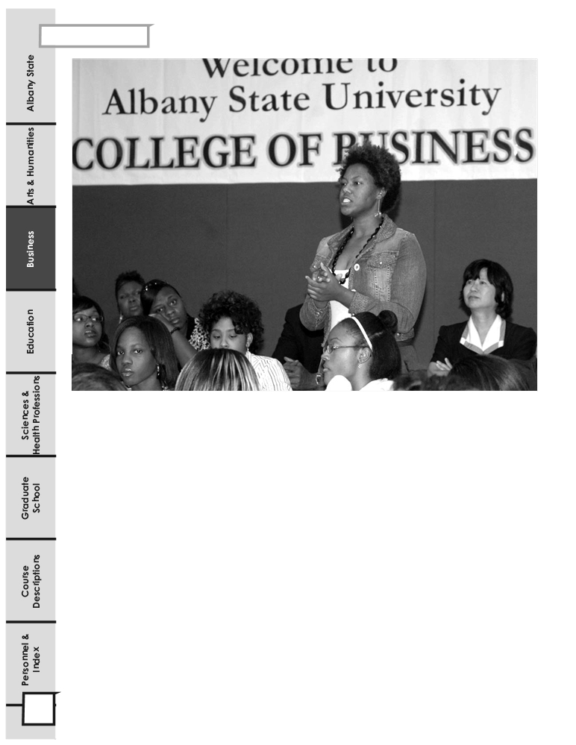

Program of Study for the Bachelor of Science Degree in Management (Health Care Concentration)
124 Semester Hours
Freshman Year (Fall)
ASU 1200 Freshman Seminar & Service to Leadership 3
ENGL 1101 English Composition I 3
MATH 1111 Mathematical Modeling or College Algebra 3
Area D Option Science/Math/Technology 4
Area D Select One 3
Subtotal 16

Freshman Year (Spring)
ENGL 1102 English Composition I 3
COMM 1100 Analytical Discussion of Global Issues 3
HIST 1002 Intro to the African Diaspora 2
Area C Option: Humanities ENGL 2111 3
Area D Options: Science/Math/Technology 4
Above Core Option 1
Subtotal 16
Freshman Year (Fall)
ASU 1200 Freshman Seminar & Service to Leadership 3
ENGL 1101 English Composition I 3
MATH 1111 Mathematical Modeling or College Algebra 3
Area D Option Science/Math/Technology 4
Area D Select One 3
Subtotal 16

Freshman Year (Spring)
ENGL 1102 English Composition I 3
COMM 1100 Analytical Discussion of Global Issues 3
HIST 1002 Intro to the African Diaspora 2
Area C Option: Humanities ENGL 2111 3
Area D Options: Science/Math/Technology 4
Above Core Option 1
Subtotal 16

Sophomore Year (Fall)
Above Core Option 1
Area C Humanities/Fine Arts - Select One 3
Area E Option Social Science 3
ACCT 2101 Principles of Accounting I 3
COMM 2040 Communication for Management 3
ECON 2106 Principles of Microeconomics 3
Subtotal 16
Sophomore Year (Spring)
Above Core Option 1
POLS 1101 U.S. & Georgia Government or
HONR 1161 3
Area E Option Social Science 3
ACCT 2102 Principles of Accounting II 3
ECON 2105 Principles of Macroeconomics 3
BISE 2010 Fundamentals of Computer Applications 3
Subtotal 16
Sophomore Year (Fall)
Above Core Option 1
Area C Humanities/Fine Arts - Select One 3
Area E Option Social Science 3
ACCT 2101 Principles of Accounting I 3
COMM 2040 Communications for Management 3
ECON 2106 Principles of Microeconomics 3
Subtotal 16
Sophomore Year (Spring)
Above Core Option 1
POLS 1101 U.S. & Georgia Government or
HONR 1161 3
Area E Option Social Science 3
ACCT 2102 Principles of Accounting II 3
ECON 2105 Principles of Macroeconomics 3
BISE 2010 Fundamentals of Computer Applications 3
Subtotal 16

Junior Year (Fall Semester)
MGHC 3110 Introduction Health Care Organizations 3
MGHC 3120 Ethical/Legal Issues in Health Care 3
MGHC 3310 Chronic Disease 3
MGHC 3420 Economics of Health Care 3
MGHC 4421 Insurance for Health Care 3
Subtotal 15

Junior Year (Spring Semester)
MGHC 2220 Medical Terminology 2
MGHC 3220 Research in Health/Biostatistics 3 3
MGHC 3411 Quality Management in Health Care 3
MGHC 4211 HC Practicum 4
MGHC 4410 Financial Management in Health Care 3
Subtotal 15

Senior Year (Fall Semester)
MGMT 4125 Human Resource Management 3
MGMT 4205 Management Information System 3
Area H Electives 6
Subtotal 12

Senior Year (Spring Semester)
MGMT 4127 Small Business Management 3
MKTG 3120 Principles of Marketing 3
Area H Electives 6
Subtotal 12

2008 -2012 Undergraduate Catalog 105

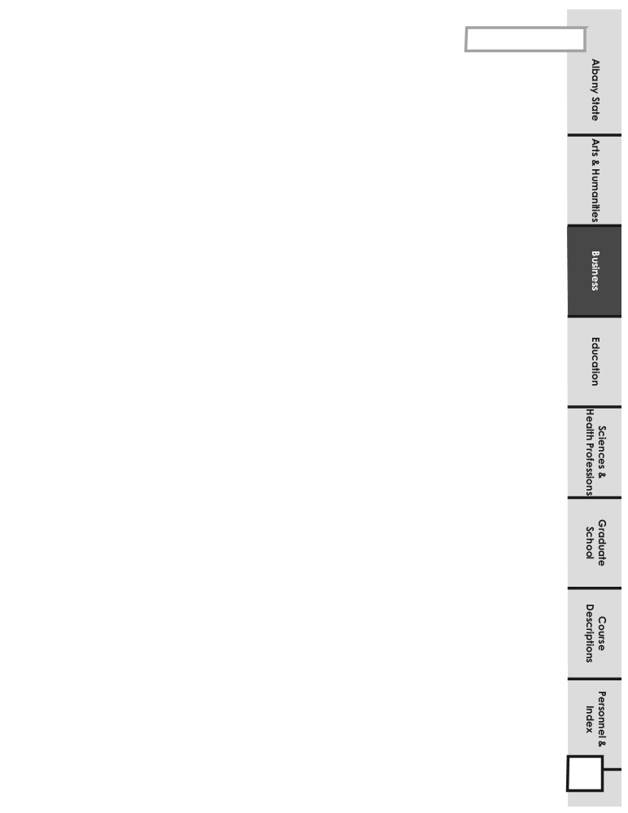

Business Administration
REQUIREMENTS FOR A BACHELOR OF APPLIED SCIENCE IN TECHNOLOGY MANAGEMENT

1. The student must earn an Associate of Applied Science (AAS degree in Technology or Associate of Applied Technology (AAT)
from a SACS accredited institution.

2. The student must complete 30 semester hours of business majors required courses beyond Area F courses plus additional 36
semester hours of technology management courses that include up to 27 semester hours of transfer coursework in technology and a grade of “C” or above in each course in Areas F, G, and H.

3. The student must complete a minimum of 123 semester hours with a minimum cumulative grade point average of 2.25 in
overall program.

4. The student must complete the Major Field Achievement Test (MFAT) as a part of course requirements of MGMT 4199.
BACHELOR OF APPLIED SCIENCE IN TECHNOLOGY MANAGEMENT
Courses Prerequisites Credit Hrs.
*Area F: Program of Study Related Courses (Bridge Courses*)
ACCT 2100 Survey of Accounting Math 1111 3
BISE 2010 Fundamental of Computer Applications 3
BISE 2040 Communication of Management ENGL 1102 3
ECON 2201 Survey of Economics 3
Subtotal 12

Area G: Business Majors Required Courses
BUSA 4105 International Business ECON 2105/ECON 2106, MGMT 3105 3
ECON 3205 Economics and Business Statistics ECON 2105/ ECON 2106 3
FINC 3105 Foundations of Financial Management ACCT 2101 3
MGMT 3105 Legal Environment of Business 3
MGMT 3106 Management Science and Operations Mgmt ECON 3205 3
MGMT 4110 Organizational Behavior MGMT 3105 3
MGMT 4205 Management Information Systems BISE 2010 3
MGMT 4199 Business Policy 3
MKTG 3120 Principles of Marketing ECON 2106 3
Subtotal 30

Area H: Technology Management Majors Required
MGMT 4126 Organizational Learning MGMT 4110 3
MGMT 4127 Small Business Management MGMT 4110, FINC 3105 3
Associate of Applied Science (AAS) in Technology or Associate of Applied Technology (AAT) Transfer Coursework.
Subtotal 36

Student may complete either the Bridged Curriculum or Area F Curriculum in Business Administration.

*Area F: Program of Study Related Courses (May be taken in lieu of Bridge Courses)
ACCT 2101 Principles of Accounting I
ACCT 2102 Principles of Accounting II
BISE 2010 Fundamentals of Computer Applications 3
BISE 2040 Communication for Management 3
ECON 2105 Principles of Macroeconomics 3
ECON 2206 Principles of Microeconomics 3
Subtotal 12

2008 -2012 Undergraduate Catalog 106
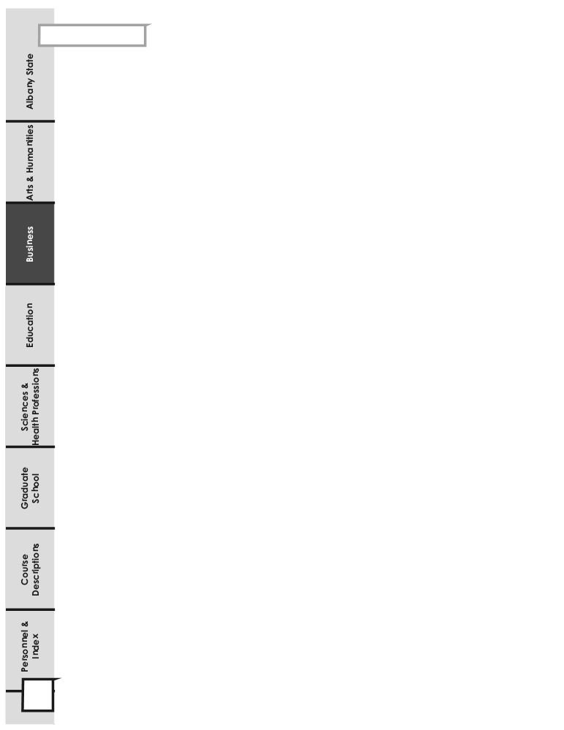

Business Administration
PROGRAM OF STUDY FOR THE BACHELOR OF APPLIED SCIENCE IN TECHNOLOGY MANAGEMENT
123 Semester Hours
Freshman Year (Fall Semester)
ENGL 1101 English Composition I 3
MATH 1111 Mathematical Modeling or College Algebra 3
Area D Science, Math, Technology 4
Area D Select One 3
Subtotal 13
Freshman Year (Spring Semester)
ENGL 1102 English Composition II 3
COMM 1100 Public Speaking 3
HIST 1002 Intro. to the African Diaspora 2
Area C Humanities/Fine Arts ENGL 2111 3
Area D Science, Math, Technology 4
Subtotal 5
Freshman Year (Fall Semester)
ENGL 1101 English Composition I 3
MATH 1111 Mathematical Modeling or College Algebra 3
Area D Science, Math, Technology 4
Area D Select One 3
Subtotal 13
Freshman Year (Spring Semester)
ENGL 1102 English Composition II 3
COMM 1100 Public Speaking 3
HIST 1002 Intro. to the African Diaspora 2
Area C Humanities/Fine Arts ENGL 2111 3
Area D Science, Math, Technology 4
Subtotal 5
Sophomore Year (Spring Semester)
POLS 1101 U.S. & Georgia Government or
HONR 1161 Honors U.S. & Georgia Government 3
Area E Options Social Science 3
ACCT 2100 Survey of Accounting 3
BISE 2010 Fundamentals of Computer Applications 3 Subtotal 12
Sophomore Year (Fall Semester)
BISE 2040 Communications for Management 3
ECON 2201 Survey of Economics 3
Area C Humanities/Fine Arts - Select One 3
Area E Options Social Science 3
Subtotal 12

Sophomore Year (Spring Semester)
POLS 1101 U.S. & Georgia Government or
HONR 1161 Honors U.S. & Georgia Government 3
Area E Options Social Science 3
ACCT 2100 Survey of Accounting 3
BISE 2010 Fundamentals of Computer Applications 3 Subtotal 12
Junior Year (Fall Semester)
ECON 3205 Economics/Business Statistics 3
MGMT 3105 Legal Environment of Business 3
MGMT 4110 Organizational Behavior 3
MGMT 4205 Management Information Systems 3
MKTG 3120 Principles of Marketing 3
Subtotal 15

Junior Year (Spring Semester)
BUSA 4105 International Business 3
FINC 3105 Foundations of Financial Management 3
MGMT 3106 Mgt. Science/Operations Mgt. 3
MGMT 4125 Human Resource Management 3
Area E Options: Social Science 3
Subtotal 15
Junior Year (Fall Semester)
ECON 3205 Economics/Business Statistics 3
MGMT 3105 Legal Environment of Business 3
MGMT 4110 Organizational Behavior 3
MGMT 4205 Management Information Systems 3
MKTG 3120 Principles of Marketing 3
Subtotal 15

Senior Year (Fall Semester)
MGMT 4127 Small Business Management 3

Subtotal 3+

Senior Year (Spring Semester)
MGMT 4111 Seminar in Org. Theory/Behavior OR
MGMT 4030 Quality Management Systems 3
MGMT 4126 Organizational Learning 3
MGMT 4199 Business Policy 3
Subtotal 9+
Senior Year (Fall Semester)
MGMT 4127 Small Business Management 3

Subtotal 3+

Senior Year (Spring Semester)
MGMT 4111 Seminar in Org. Theory/Behavior OR
MGMT 4030 Quality Management Systems 3
MGMT 4126 Organizational Learning 3
MGMT 4199 Business Policy 3
Subtotal 9+

AAS/AAT Applied Credits* (Up to 27 hrs.)

107 2008 -2012 Undergraduate Catalog
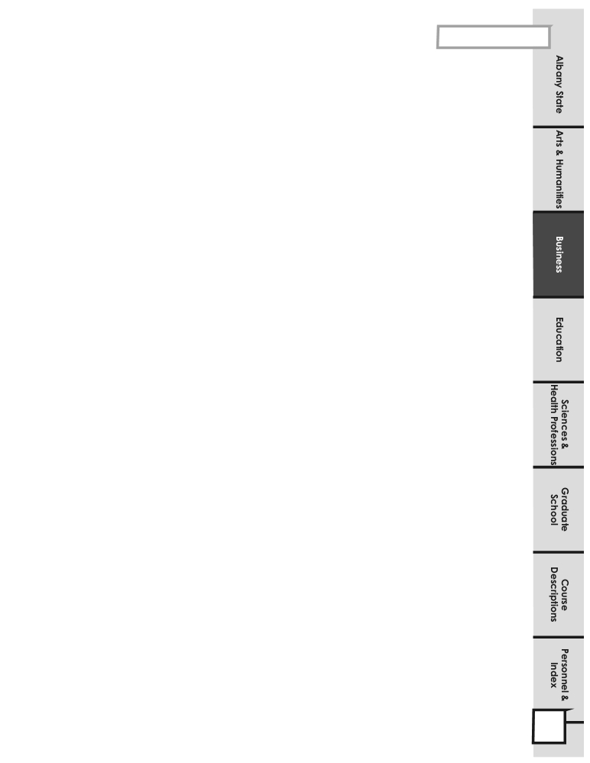
Accounting, Business Infor-
mation Systems & Marketing
DEPARTMENT OF ACCOUNTING,
BUSINESS INFORMATION SYSTEMS
AND MARKETING
The Accounting, Business Information Systems and Marketing Department offers undergraduate courses for the student who plans to enter
the business world in an administrative capacity. The programs are accredited by the Association of Collegiate Business Schools and Programs
(ACBSP).
The program of study in Accounting, Business Information Systems and Marketing leads to a Bachelor of Science degree in Accounting, Business Information Systems, or Marketing. Internships are available for students to apply what has been learned in the classroom to real- world situations. To be admitted to programs in Accounting, Business Information Systems, and Marketing as a major, the student must have a cumulative grade point average of 2.25 or higher.
The accounting program is designed to prepare accountants for the world of work. Students are given the opportunity to gain a wide variety of
needed skills. Courses in the program build a rich knowledge of accounting theory and practice on both public and private levels. Students
are also introduced and taught to use and interact with contemporary technology. Developing critical thinking and communications skills is
also emphasized in the program. Additionally, students are encouraged to sit for certification examinations at the completion of the program.
The business information systems program integrates information technology, people and business. The program provides professional preparation for persons who are interested in coordinating, facilitating and expediting functions of the office in business, industrial and governmental organizations. Focus is on the development of computer operation skills for text processing, human-computer interaction, technical and professional personnel, office environment management, processing of unstructured tasks, and the utilization of small systems. Interpersonal communication and organizational understanding are important skills that are developed. Career options are available in database administration, telecommunications, data communications, and management of business and office information.
The marketing program is designed to provide the student with opportunities to acquire the skills, concepts and knowledge needed to assume
responsible positions in marketing. Skills in problem solving, decision making, and applying the principles of economics, psychology and so-
ciology to consumer behavior are developed for future marketing professionals and marketing leaders. Career options are available in selling,
purchasing, advertising, promotion, physical distribution, industrial marketing, customer service, marketing research, consumer service and
many other specialties.
REQUIREMENTS FOR THE BACHELOR OF SCIENCE DEGREE IN ACCOUNTING

1. The student must have a cumulative grade point average of 2.25 or higher to be admitted to the program.
2. The student must complete 30 hours of business courses beyond Area F requirements plus an additional 27 hours of accounting concentration.
3. The student must complete a minimum of 124 semester hours with a cumulative grade point average of 2.25 in overall program, and a grade of “C” or above in all business courses.

4. The student must complete the Major Field Achievement Test (MFAT) as a part of course requirements for MGMT 4199
REQUIREMENTS FOR THE BACHELOR OF SCIENCE DEGREE IN BUSINESS INFORMATION SYSTEMS

1. The student must have a cumulative grade point average of 2.25 or higher to be admitted to the program.
2. The student must complete 30 hours of business courses beyond Area F requirements plus an additional 30 hours of information systems concentration.
3. The student must complete a minimum of 124 semester hours with a cumulative grade point average of 2.25 in overall program and a grade of “C” or above in all business courses.

4. The student must complete the Major Field Achievement Test (MFAT) as a part of a course requirement

for MGMT 4199.
2008 -2012 Undergraduate Catalog
108

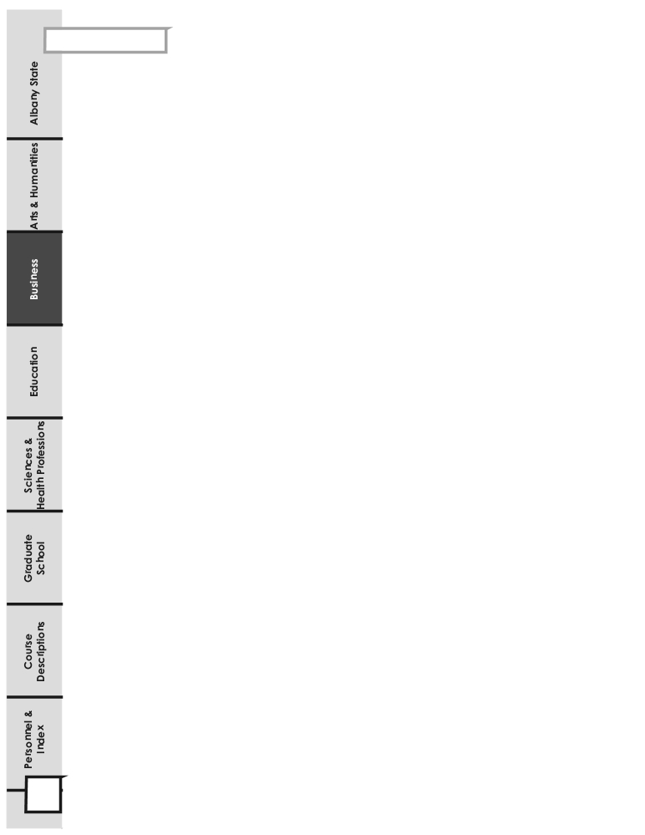

Accounting, Business Infor-
mation Systems & Marketing

REQUIREMENTS FOR A BACHELOR OF SCIENCE DEGREE IN MARKETING

1. The student must complete a minimum of 124 semester hours with a cumulative grade point average of 2.25 in overall program and a grade of “C” or above in all business courses.

2. The student must have a cumulative grade point average of 2.25 or higher to be admitted to the program.

3. The student must complete 30 hours of business courses beyond Area F requirements plus an additional 30 hours of marketing concentration.
4. The student must complete the Major Field Achievement Test (MFAT) as a part of course requirements for MGMT 4199.

REQUIREMENTS FOR A BACHELOR OF SCIENCE DEGREE IN MARKETING

1. The student must complete a minimum of 124 semester hours with a cumulative grade point average of 2.25 in overall program and a grade of “C” or above in all business courses.

2. The student must have a cumulative grade point average of 2.25 or higher to be admitted to the program.

3. The student must complete 30 hours of business courses beyond Area F requirements plus an additional 30 hours of marketing concentration.
4. The student must complete the Major Field Achievement Test (MFT) as a part of course requirements for MGMT 4199.
BACHELOR OF SCIENCE DEGREE IN ACCOUNTING

Courses Titles Prerequisites Credit
Area F: Program of Study Related Courses Hrs
ACCT 2101 Principles of Accounting I MATH 1111 3
ACCT 2102 Principles of Accounting II ACCT 2101 3
BISE 2010 Fundamentals of Computer Applications 3
BISE 2040 Communication for Management ENGL 1102 3
ECON 2105 Principles of Macroeconomics 3
ECON 2106 Principles of Microeconomics 3

Subtotal 18

Area G: Business Majors Required Courses
BUSA 4105 International Business ECON 2105/ECON 2106, MGMT 3105 3
ECON 3205 Economics and Business Statistics ECON 2105/ECON2106 3
FINC 3105 Foundations of Financial Management ACCT 2101 3
MGMT 3105 Legal Environment of Business 3
MGMT 3106 Management Science and Operations Mgmt ECON 3205 3
MGMT 4110 Organizational Behavior MGMT 3105 3
MGMT 4125 Human Resource Management MGMT 3105 3
MGMT 4205 Management Information Systems BISE 2010 3
MGMT 4199 Business Policy 3
MKTG 3120 Principles of Marketing ECON 2106 3

Subtotal 30

Area H: Accounting Majors Required Courses
ACCT 3101 Intermediate Accounting I ACCT 2102 3
ACCT 3102 Intermediate Accounting II ACCT 3101, FINC 3105 3
ACCT 3103 Intermediate Accounting III ACCT 3102 3
ACCT 4101 Cost Accounting I ACCT 2102 3
ACCT 4111 Auditing I ACCT 3102 3
ACCT 4121 Tax Accounting I ACCT 2102 3
ACCT 4205 Accounting Information Systems ACCT 2102, BISE 2010 3

BUSA 3100 Business Internship 3
Elective ** 3

Subtotal 27

** Approved Foreign Language or at least 2000 level course in any non-business course, including BUSA 4100 (Business Internship II).

109

2008 -2012 Undergraduate Catalog
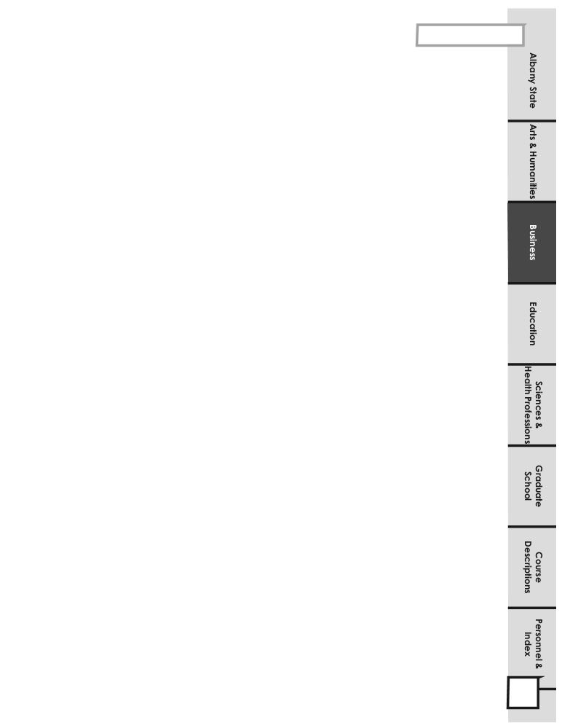

Accounting, Business Infor-
mation Systems & Marketing

PROGRAM OF STUDY FOR THE BACHELOR OF SCIENCE DEGREE IN ACCOUNTING
124 Semester Hours

Freshman Year (Fall)
ASU 1200 Freshman Seminar & Service to Leadership 3
ENGL 1101 English Composition I 3
MATH 1111 Mathematical Modeling or College Algebra 3
Area D Science, Math, Technology 4
Area D Select One 3
Subtotal 16
Freshman Year (Spring)
ENGL 1102 English Composition II 3
COMM 1100 Analytical Discussion of Global Issues 3
HIST 1002 Intro to the African Diaspora 2
Area C Humanities/Fine Arts ENGL 2111 3
Area D Science, Math, Technology 4
Above Core Option 1
Subtotal 16

Sophomore Year (Fall)
Above Core Option 1
BISE 2010 Fundamentals of Computer Applications 3
Area E Option: Social Science 3
ACCT 2101 Principles of Accounting I 3
ECON 2105 Principles of Macroeconomics 3
Area C Humanities/Fine Arts – Select One 3
Subtotal 16
Sophomore Year (Spring)
Above Core Option 1
Area E Option: Social Science 3
BISE 2040 Communication for Management 3
ACCT 2102 Principles of Accounting II 3
ECON 2106 Principles of Microeconomics 3
POLS 1101 U. S. & Georgia Government or
HONR 1161 Honors U.S. & Georgia Government 3
Subtotal 16

Junior Year (Fall Semester)
MKTG 3120 Principles of Marketing 3
FINC 3105 Foundations of Financial Management 3
MGMT 3105 Legal Environment of Business 3
ACCT 3101 Intermediate Accounting I 3
Area E Options: Social Science 3
Subtotal 15

Junior Year (Spring Semester)
MGMT 4205 Management Information Systems 3
ECON 3205 Economics and Business Statistics 3
MGMT 3106 Mgmt. Science and Operations Mgmt 3
MGMT 4125 Human Resource Management 3
ACCT 3102 Intermediate Accounting II 3
Subtotal 15
Senior Year (Fall Semester)
BUSA 3100 Business Internship I 3
ACCT 3103 Intermediate Accounting III 3
BUSA 4105 International Business 3
ACCT 4101 Cost Accounting I 3
ACCT 4121 Tax Accounting I 3
Subtotal 15
Senior Year (Spring Semester)
MGMT 4110 Organizational Behavior 3
ACCT 4111 Auditing I 3
ACCT 4205 Accounting Information Systems 3
Area H: Elective Non-Bus. Elect. (See Check sheet for Courses) 3
MGMT 4199 Business Policy 3
Subtotal 15

2008 -2012 Undergraduate Catalog 110
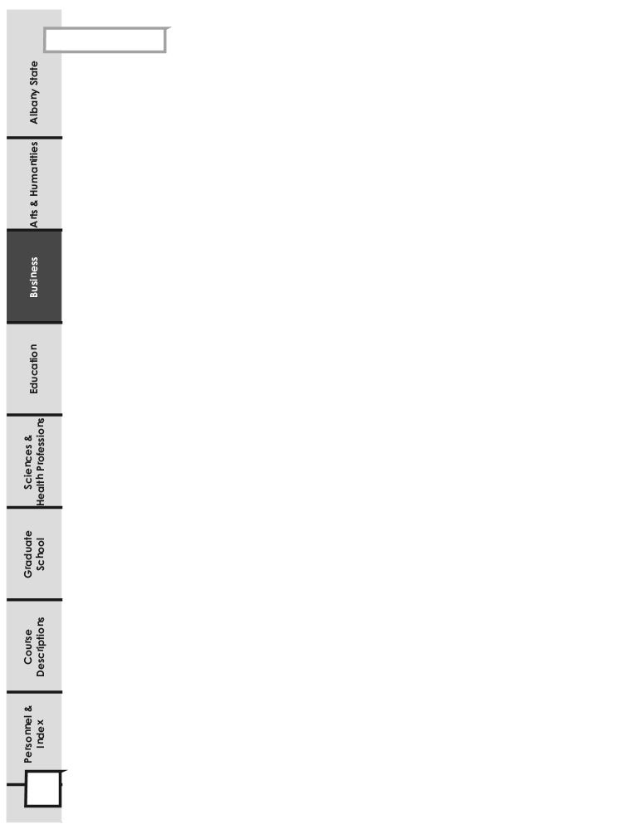

Accounting, Business Infor-
mation Systems & Marketing

BACHELOR OF SCIENCE DEGREE IN BUSINESS INFORMATION SYSTEMS

Courses Title Prerequisites Credit
Area F: Program of Study Related Courses Hours
ACCT 2101 Principles of Accounting I MATH 1111 3
ACCT 2102 Principles of Accounting II ACCT 2101 3
BISE 2010 Fundamentals of Computer Applications 3
BISE 2040 Communication for Management ENGL 1102 3
ECON 2105 Principles of Macroeconomics 3
ECON 2106 Principles of Microeconomics 3
Subtotal 18

Area G: Business Majors Required Courses
BUSA 4105 International Business ECON 2105/ECON 2106, MGMT 3105 3
ECON 3205 Economics and Business Statistics ECON 2105/ECON 2106 3
FINC 3105 Foundations of Financial Management ACCT 2101 3
MGMT 3105 Legal Environment of Business 3
MGMT 3106 Management Science and Operations Mgmt ECON 3205 3
MGMT 4110 Organizational Behavior MGMT 3105 3
MGMT 4125 Human Resource Management MGMT 3105 3
MGMT 4205 Management Information Systems BISE 2010 3
MGMT 4199 Business Policy 3
MKTG 3120 Principles of Marketing ECON 2106 3
Subtotal 30

Area H: Business Information Systems Majors Required Courses
BISE 3090 Information Systems Framework 3
BISE 3100 Information Resource Mgmt. BISE 3090 3
BISE 3330 Human-Computer Interaction 3
BISE 3350 Telecommunications Management BISE 2010 3
BISE 4206 Database Mgmt Systems# BISE 2010 3
BISE 4207 Systems Analysis & Design# BISE 2010, MGMT 4205 3
BUSA 3100 Business Internship I 3
Elective* 3
Elective** 3
Subtotal 27
* Any 3000 to 4000 level Business course, including BUSA 4100.
** Approved foreign language or at least 2000 level course in any non-business course, including Computer Science.
# Cross-listed under Management
INFORMATION SYSTEMS ELECTIVE OPTIONS
BISE 3210 Desktop Publishing & Multi-media 3
BISE 3300 Human-computer Interactions 3
BISE 4210 Decision Support Systems 3
BISE 4220 Special Topics and Research in Information Systems 3
BISE 4250 Information Systems Certifications 3
BISE 4260 E-Commerce 3

111 2008 -2012 Undergraduate Catalog

Accounting, Business Infor-
mation Systems & Marketing
PROGRAM OF STUDY FOR THE BACHELOR OF SCIENCE DEGREE IN BUSINESS INFORMATION SYSTEMS
124 Semester Hours
Freshman Year (Fall)
ASU 1200 Freshman Seminar & Service to Leadership 3
ENGL 1101 English Composition I 3
MATH 1111 Mathematical Modeling or College Algebra 3
Area D Science, Math, Technology 4
Area D Select One 3
Subtotal 16
Freshman Year (Spring)
ENGL 1102 English Composition II 3
COMM 1100 Analytical Discussion of Global Issues 3
HIST 1002 Intro to the African Diaspora 2
Area C Humanities/Fine Arts ENGL 2111 3
Area D Science, Math, Technology 4
Above Core Option 1
Subtotal 16

Sophomore Year (Fall)
Above Core Option 1
BISE 2010 Fundamentals of Computer Applications 3
Area E Option: Social Science 3
ACCT 2101 Principles of Accounting I 3
ECON 2105 Principles of Macroeconomics 3
Area C Humanities/Fine Arts – Select One 3
Subtotal 16
Sophomore Year (Spring)
Above Core Option 1
Area E Option: Social Science 3
BISE 2040 Communications for Management 3
ACCT 2102 Principles of Accounting II 3
ECON 2106 Principles of Microeconomics 3
POLS 1101 U. S. & Georgia Government or
HONR 1161 Honors U.S. & Georgia Government 3
Subtotal 16

Junior Year (Fall Semester)
MKTG 3120 Principles of Marketing 3
FINC 3105 Foundations of Financial Management 3
MGMT 3105 Legal Environment of Business 3
BUSA 4105 International Business 3
Area E: Options 3
Subtotal 15
Junior Year (Spring Semester)
MGMT 4205 Management Information Systems 3
BUSA 3100 Business Internship I 3
ECON 3205 Economic and Business Statistics 3
MGMT 3106 Management Science/Operations Mgt 3
MGMT 4125 Human Resource Mgt. 3
Subtotal 15

Senior Year (Fall Semester)
BISE 3090 Information Systems Framework 3
BISE 3100 Information Resource Management 3
BISE 3330 Human Computer Interaction 3
BISE 4206 Database Management Systems 3
Area H: ELECTIVE Non-Bus. Elective (See Check sheet for Courses) 3
Subtotal 15
Senior Year (Spring Semester)
MGMT 4110 Organizational Behavior 3
MGMT 4199 Business Policy 3
BISE 4207 Systems Analysis & Design 3
BISE 3350 Telecommunications Management 3
Area H: ELECTIVE Bus. Elective (3000/4000 Bus. Course) 3
Subtotal 15

2008 -2012 Undergraduate Catalog 112
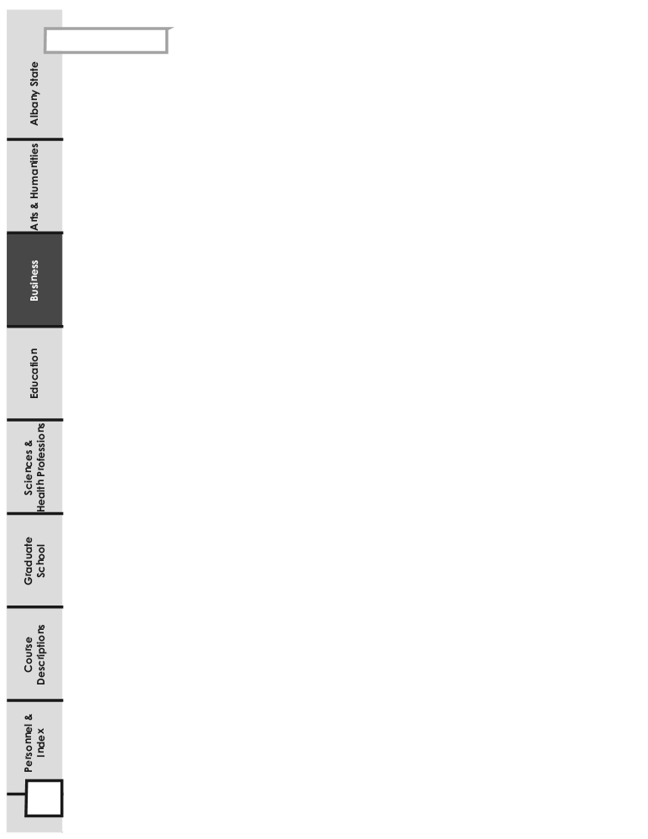
Accounting, Business Information
Systems & Marketing

BACHELOR OF SCIENCE DEGREE IN MARKETING
Courses Titles Prerequisites Credit
Area F: Program of Study Related Courses Hours
ACCT 2101 Principles of Accounting I MATH 1111 3
ACCT 2102 Principles of Accounting II ACCT 2101 3
BISE 2010 Fundamentals of Computer Applications 3
BISE 2040 Communication for Management ENGL 1102 3
ECON 2105 Principles of Macroeconomics 3
ECON 2106 Principles of Microeconomics 3

Subtotal 18

Area G: Business Majors Required Courses
BUSA 4105 International Business ECON 2105/ECON 2106, MGMT 3105 3
ECON 3205 Economics and Business Statistics ECON 2105/ECON 2106 3
FINC 3105 Foundations of Financial Management ACCT 2101 3
MGMT 3105 Legal Environment of Business 3
MGMT 3106 Management Science and Operations Mgmt ECON 3205 3
MGMT 4110 Organizational Behavior MGMT 3105 3
MGMT 4125 Human Resource Management MGMT 3105 3
MGMT 4205 Management Information Systems BISE 2010 3
MGMT 4199 Business Policy 3
MKTG 3120 Principles of Marketing ECON 2106 3

Subtotal 30

Area H: Marketing Major Required Courses
MKTG 3130 Consumer Behavior MKTG 3120 3
MKTG 3132 Fundamentals of Selling 3
MKTG 3134 Marketing Research MKTG 3120 3
MKTG 3136 Promotion and Advertising MKTG 3120 3
MKTG 4140 Retail Management MKTG 3120 3
MKTG 4170 Marketing Management MKTG 3120 3
MKTG 4180 Marketing Information Systems MKTG 3120 3
BUSA 3100 Business Internship I 3
Electives* 3

Subtotal 27

*Any 3000/4000 level business courses, including BUSA 4100.
**Approved foreign language or at least 2000 level course in any non-business course, including Computer Science.

113 2008 -2012 Undergraduate Catalog
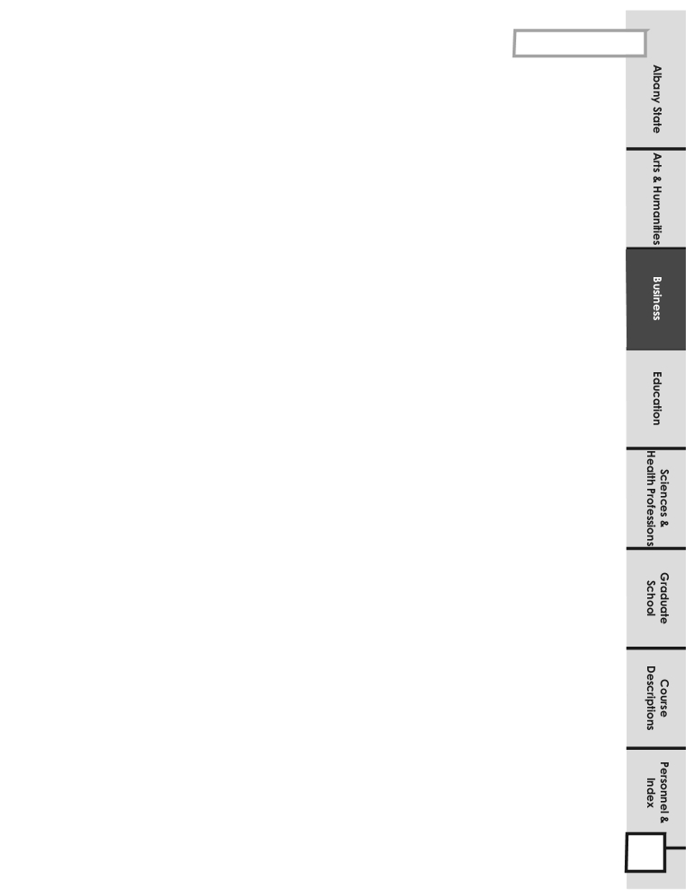

Accounting, Business Infor-
mation Systems & Marketing

PROGRAM OF STUDY FOR THE BACHELOR OF SCIENCE DEGREE IN MARKETING
124 Semester Hours
Freshman Year (Fall)
ASU 1200 Freshman Seminar & Service to Leadership 3
ENGL 1101 English Composition I 3
MATH 1111 Mathematical Modeling or College Algebra 3
Area D Science, Math, Technology 4
Area D Select One 3
Subtotal 16
Freshman Year (Spring)
ENGL 1102 English Composition II 3
COMM 1100 Analytical Discussion of Global Issues 3
HIST 1002 Intro to the African Diaspora 2
Area C Humanities/Fine Arts ENGL 2111 3
Area D Science, Math, Technology 4
Above Core Option 1
Subtotal 16

Sophomore Year (Fall)
Above Core Option 1
BISE 2010 Fundamentals of Computer Applications 3
Area E Option: Social Science 3
ACCT 2101 Principles of Accounting I 3
ECON 2105 Principles of Macroeconomics 3
Area C Humanities/Fine Arts – Select One 3
Subtotal 16
Sophomore Year (Spring)
Above Core Option 1
Area E Option: Social Science 3
BISE 2040 Communications for Management 3
ACCT 2102 Principles of Accounting II 3
ECON 2106 Principles of Microeconomics 3
POLS 1101 U. S. & Georgia Government or
HONR 1161 Honors U.S. & Georgia Government 3
Subtotal 16
Senior Year (Spring Semester)
BUSA 3100 Business Internship I 3
MKTG 3132 Fundamental of Selling 3
MKTG 4140 Retail Management 3
MGMT 4199 Business Policy 3
MKTG 4180 Marketing Information Systems 3 Subtotal 15

Junior Year (Fall Semester)
MKTG 3120 Principles of Marketing 3
FINC 3105 Foundations of Financial Management 3
MGMT 3105 Legal Environment of Business 3
Area E Options: Social Science 3
MGMT 4110 Organizational Behavior 3
Subtotal 15
Junior Year (Spring Semester)
BUSA 3100 Business Internship I 3
MGMT 4205 Management Information Systems 3
ECON 3205 Economics and Business Statistics 3
MKTG 3130 Consumer Behavior 3
MGMT 3106 Management Science and Operations Mgmt 3
Subtotal 15

Senior Year (Fall Semester)
MKTG 3136 Promotion and Advertising 3
MKTG 3132 Fundamental of Selling 3
BUSA 4105 International Business 3
Area H: ELECTIVE Non-Bus. Elect. (See Check sheet for
Courses) 3
MGMT 4199 Business Policy 3
Subtotal 15
Senior Year (Spring Semester)
MKTG 3134 Marketing Research 3
MKTG 4170 Marketing Management 3
MKTG 4130 Marketing Channel 3
Area H: ELECTIVE Bus. Elective (3000/4000 Bus. Course) 3 MGMT 4125 Human Resource Management 3
Subtotal 15

114

BACHELOR OF SCIENCE DEGREE IN LOGISTICS
Courses Titles Prerequisites Credit
Area F: Program of Study Related Courses Hours
ACCT 2101 Principles of Accounting I MATH 1111 3
ACCT 2102 Principles of Accounting II ACCT 2101 3
BISE 2010 Fundamentals of Computer Applications 3
BISE 2040 Communication for Management ENGL 1102 3
ECON 2105 Principles of Macroeconomics 3
ECON 2106 Principles of Microeconomics 3

Subtotal 18

Area G: Business Majors Required Courses
BUSA 4105 International Business ECON 2105/ECON 2106, MGMT 3105 3
ECON 3205 Economics and Business Statistics ECON 2105/ECON 2106 3
FINC 3105 Foundations of Financial Management ACCT 2101 3
MGMT 3105 Legal Environment of Business 3
MGMT 3106 Management Science and Operations Mgmt ECON 3205 3
MGMT 4110 Organizational Behavior MGMT 3105 3
MGMT 4125 Human Resource Management MGMT 3105 3
MGMT 4205 Management Information Systems BISE 2010 3
MGMT 4199 Business Policy Senior Standing 3
MKTG 3120 Principles of Marketing ECON 2106 3

Subtotal 30

Area H: Logistics Management Majors Required Courses
LOGM 3220 Contemporary Logistics ECON 3205 3
LOGM 3230 Logistics Security MGMT 3105 3
LOGM 4210 Transportation Management ECON 3205 3
LOGM 4220 Supply Chain Management Senior Standing 3
LOGM 4225 Warehousing LOGM 3220 3
LOGM 4230 Logistics Information Systems BISE 2010; MKTG 3120 3
LOGM 4270 Global Logistics Senior Standing 3
BUSA 3100 Business Internship I 3
BUSA 4100 Business Internship II 3

Subtotal 30

PROGRAM OF STUDY FOR THE BACHELOR OF SCIENCE DEGREE IN LOGISTICS
124 Semester Hours

Freshman Year (Fall Semester)
ASU 1200 Freshman Seminar & Service to Leadership 3
ENGL 1101 English Composition I 3
MATH 1111 Mathematical Modeling or College Algebra 3
Area D Science, Math, Technology 4
Area E Option 3
Subtotal 16
Freshman Year (Spring Semester)
ENGL 1102 English Composition II 3
COMM 1100 Analytical Discussion of Global Issues 3
Area C Humanities/Fine Arts 3
Area D Science, Math, Technology 4
MATH 1201 Survey of Calculus 3
Subtotal 16

Sophomore Year (Spring Semester)
Above Core Option 1
HIST 1002 Intro. To African Diaspora 2
POLD 1101 U.S. & Georgia Government 3
ACCT 2102 Principles of Accounting II 3
Area E Options Social Science 3
ECON 2106 Principles of Microeconomics 3
Subtotal 16
Sophomore Year (Fall Semester)
Above Core Option 1
ACCT 2101 Principles of Accounting I 3
ECON 2105 Principles of Macroeconomics 3
BISE 2010 Fundamentals of Computer Applications 3
ENGL 2111 World Literature 3
Area E Options Social Science 3
Subtotal 16

Junior Year (Fall Semester)
ECON 3205 Economics and Business Statistics 3
Above Core Option 1
MGMT 3105 Legal Environment of Business 3
LOGM 3220 Contemporary Logistics 3
LOGM 3230 Logistics Security 3
MGMT 4205 Management Information Systems 3
Subtotal 16
Junior Year (Spring Semester)
BISE 2040 Communications for Management 3
MKTG 3120 Principles of Marketing 3
FINC 3205 Foundations of Financial Management 3
MGMT 3106 Mgmt. Science and Operations Mgmt. 3
BUSA 3100 Business Internship I * 3
Subtotal 15

Senior Year (Fall Semester)
MGMT 4110 Organizational Behavior 3
LOGM 4210 Transportation Management 3
LOGM 4225 Warehousing 3
BUSA 4100 Business Internship II** 3
MGMT 4205 Management Information Systems 3
Subtotal 15
Senior Year (Spring Semester)
BUSA 4105 International Business 3
LOGM 4220 Supply Chain Management 3
LOGM 4230 Logistics Information Systems 3
LOGM 4270 Global Logistics 3
MGMT 4125 Human Resource Management 3
Subtotal 15

2008 -2012 Undergraduate Catalog
