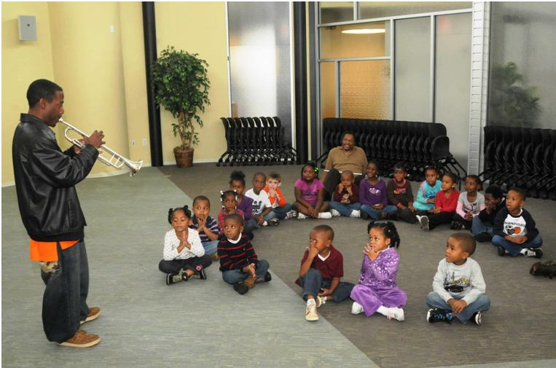

## SPECIAL PROGRAMS

[The Honors Program](special-honor.html)

[Outreach Programs](special-outreach.html)

[SDU Credit](special-sdu.html)

[Non-credit Courses](special-nonCreditCourses.html)

[Cooperative Education](special-cooperative.html)

[Off Campus Programs](special-offCampus.html)

[Department of Military Science Army ROTC Program](special-rotc.html)

[Learning Support](special-learningSupport.html)