COLLEGE OF ARTS & HUMANITIES

**CONTENTS**

Department of English and

Modern Languages . . . . . . . . . . . . . . . . . . . . . . . . . . . . . . . . . . . . .68

English Curriculum . . . . . . . . . . . . . . . . . . . . . . . . . . . . . . . . . . . . .69

Spanish Curriculum . . . . . . . . . . . . . . . . . . . . . . . . . . . . . . . . . . . . .71

Mass Communication . . . . . . . . . . . . . . . . . . . . . . . . . . . . . . . . . . .72

Department of Fine Arts . . . . . . . . . . . . . . . . . . . . . . . . . . . . . . . . .75

Arts Curriculum . . . . . . . . . . . . . . . . . . . . . . . . . . . . . . . . . . . . . . .76

Music Curriculum . . . . . . . . . . . . . . . . . . . . . . . . . . . . . . . . . . . . . .77

Speech & Theatre Curriculum . . . . . . . . . . . . . . . . . . . . . . . . . . . .81

Department of History, Political Science

and Public Administration . . . . . . . . . . . . . . . . . . . . . . . . . . . . . . . .84

Minor Programs . . . . . . . . . . . . . . . . . . . . . . . . . . . . . . . . . . . . . . .84

History Curriculum . . . . . . . . . . . . . . . . . . . . . . . . . . . . . . . . . . . . .85

Political Science Curriculum . . . . . . . . . . . . . . . . . . . . . . . . . . . . .87

Department of Psychology, Sociology

and Social Work . . . . . . . . . . . . . . . . . . . . . . . . . . . . . . . . . . . . . . .90

Psychology Curriculum . . . . . . . . . . . . . . . . . . . . . . . . . . . . . . . . . .92

Sociology Curriculum . . . . . . . . . . . . . . . . . . . . . . . . . . . . . . . . . . .94

Social Work Curriculum . . . . . . . . . . . . . . . . . . . . . . . . . . . . . . . . .95

**Education**

**Business**

**Arts & Humanities**

**Albany State**

**Graduate**

**School**

**Personnel &**

**Index**

**Course**

**Descriptions**

**Sciences &**

**Health**

**Professions**

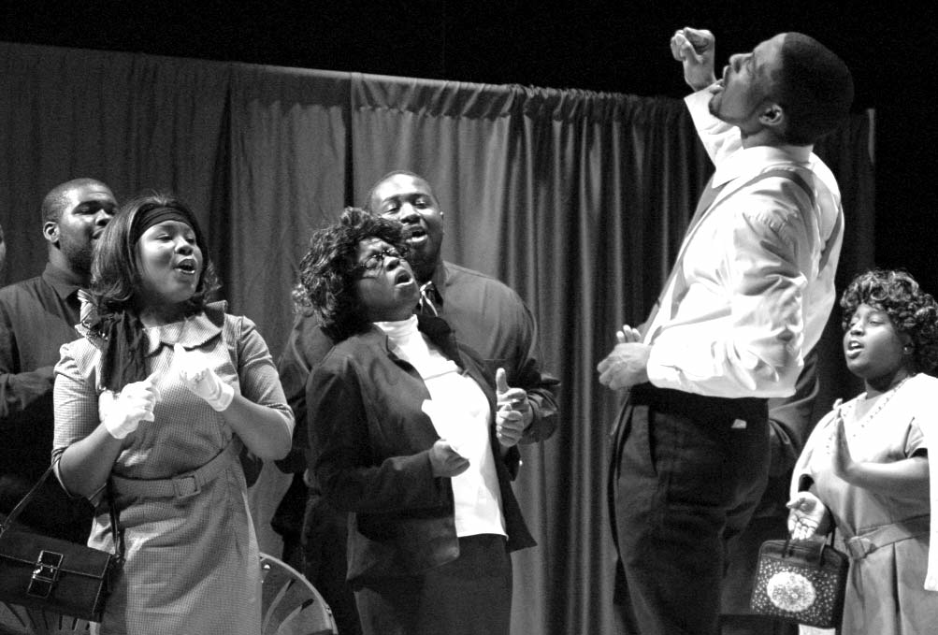

2008-2012 Undergraduate Catalog **67**

**English & Modern Languages**

**Albany State**

**Business**

**Education**

**Graduate**

**School**

**Course**

**Descriptions**

**Sciences &**

**Health**

**Professions**

**Personnel &**

**Index**

COLLEGE OF ARTS & HUMANITIES

**Arts & Humanities**

The College of Arts and Humanities includes the Departments of English, Modern Languages, Mass Communications, Fine Arts, History and

Political Science and Psychology, Sociology and Social Work.

Through the cooperation of several departments, the College of Arts and Humanities also offers training in the area of pre-law.

**68** 2008-2012 Undergraduate Catalog