**History & Political Science**

**Education**

**Business**

**Arts & Humanities**

**Albany State**

**Personnel &**

**Index**

**Course**

**Descriptions**

**Graduate**

**School**

**Sciences &**

**Health**

**Professions**

**Political Science**

**Education**

**Business**

**Albany State**

**Sciences &**

**Health**

**Professions**

**Personnel &**

**Index**

**Course**

**Descriptions**

**Graduate**

**School**

**BACHELOR OF ARTS DEGREE IN POLITICAL SCIENCE**

123-124 Semester Hours

**Area F (Political Science) 18 Hrs.**

**A. 2000 Level Courses (select two) 6 Hrs.**

**Arts & Humanities**

|  |  |  |
| --- | --- | --- |
| HIST | 2111 | Survey of American History I |
| HIST | 2112 | Survey of American History II |
| HIST | 2115 | African American History |
| ECON | 2105 | Principles of Macroeconomics |
| ECON | 2106 | Principles of Microeconomics |
| ECON | 2201 | Survey of Economics |
| HIST | 2115 | African American History |
| PHIL | 2101 | Intro. to Philosophy |
| POLS | 2102 | Intro to Law |
| SOCI | 2011 | Principles of Sociology |
| SOCI | 2031 | Intro. to Anthropology |

**B. Foreign Language Sequence 6 Hrs.**

SSCI 2402 Microcomputers in the SSCI 3 Hrs. C. POLS 2101 Intro. to Political Science 3 Hrs.

**PROFESSIONAL COURSES 48 HOURS A. General: 9 Hrs.**

|  |  |  |  |
| --- | --- | --- | --- |
| POLS | 4371 | Research Methods I | (3 hrs.) |
| POLS | 4372 | Research Methods II | (3 hrs.) |
| POLS | 4401 | History of Political Thought | (3 hrs.) |

**B. International Relations and Comparative Government 9 Hrs.**

|  |  |  |
| --- | --- | --- |
| POLS | 3511 | Comparative Government |
| POLS | 4514 | International Relations |
| Choose an additional 6 hours from any of the following: | | |
| POLS | 4513 | Issues in Global Politics |
| POLS | 4512 | Politics and Institutions in Developing Countries |
| POLS | 4515 | International Organizations |
| POLS | 4816 | Model United Nations |
| POLS | 4817 | Politics of Globalization |
| POLS | 4824 | Political Economy of Africa and the Caribbean |

**C. American National/State/Local Government 9 Hrs.**

(3 hours each)

POLS 3601 State and Local Government

Choose 6 hours from any American Government elective at the 3000-4000 level. These electives may include any of the following (3 hours each):

|  |  |  |
| --- | --- | --- |
| POLS | 3611 | Urban Politics |
| POLS | 3612 | African-American Politics |
| POLS | 3813 | Public Administration |
| POLS | 3614 | The Presidency |
| POLS | 3815 | Municipal Government |
| POLS | 3616 | Political Parties and Pressure Groups |
| POLS | 3617 | The Legislative Process |
| POLS | 3618 | Elections and Electoral Behavior |
| POLS | 4814 | Theory and Practice of Public Administration |
| POLS | 4818 | Public Administration Internship |

**D. Constitutional Law 9 Hrs.** POLS 3701 Judicial Process (3 hrs.) Choose 6 hours from any of the following:

|  |  |  |
| --- | --- | --- |
| POLS | 3702 | American Constitutional History |
| POLS | 3703 | Constitutional Law I |
| POLS | 3704 | Constitutional Law II |

2008-2012 Undergraduate Catalog **87**

**Political Science**

**Albany State**

**Arts & Humanities**

**Business**

**Education**

**Personnel &**

**Index**

**Sciences &**

**Health**

**Professions**

**Graduate**

**School**

**Course**

**Descriptions**

**D. Constitutional Law 9 Hrs.** POLS 3701 Judicial Process (3 hrs.) Choose 6 hours from any of the following:

|  |  |  |
| --- | --- | --- |
| POLS | 3702 | American Constitutional History |
| POLS | 3703 | Constitutional Law I |
| POLS | 3704 | Constitutional Law II |

**E. Professional Electives (3 hours each) 9 Hrs.**

POLS 3609 American Foreign Policy

POLS 3705 Trial Advocacy

POLS 3708 Civil Rights and Minorities

POLS 4515 International Organizations

POLS 4818 Public Administration Internship (3 hours) or POLS 4619 Legislative Internship (6 hours) C, or D that are not used to satisfy electives in those areas

**General Electives Up to 10 Hrs.**

**PROGRAM OF STUDY FOR THE BACHELOR OF ARTS DEGREE IN POLITICAL SCIENCE**

124 Semester Hours

|  |  |  |  |  |  |
| --- | --- | --- | --- | --- | --- |
| **Freshman Year**  ENGL 1101 | **Fall**  Eng. Comp. I | 3 | **Spring**  ENGL 1102 | Eng. Comp. II | **Credit Hrs.**  3 |
| MATH 1111 | College Algebra | 3 | Area B Elective |  | 2 |
| ASU 1200 | Freshman Seminar | 3 | COMM 1100 | Fundamental of Public Speaking | 3 |
| PEDH Elective |  | 1 |  |  |  |
| HIST 1002 | Intro. African. Dias. | 2 | Science Elec. |  | 4 |
| Science Elective |  | 4 | POLS 1101 | U.S. and GA Government | 3 |
| **Total** |  | **15** |  |  | **16** |
| **Sophomore Year** |  |  |  |  |  |
| ENGL 2111 World Lit. I | | 3 | Social Science Elec. | | 3 |
| Fine Arts Elective | | 3 | Social Science Elec. | | 3 |
| POLS 2101 Intro. to Pol. Sci. | | 3 | Foreign Language Sequence | | 6 |
| MATH Elective (Area A) | | 3 | PEDH | | 1 |
| Social Science Elective | | 3 | POLS Amer. Government Elec. 3 | |  |
| **Total** | | **15** |  | | **16** |
| **Junior Year** | |  |  | |  |
| Social Science Elective (Area E) | | 3 | POLS 3511 or POLS 4512 | | 3 |
| POLS 3601 St./Local Government | | 3 | POLS 4401 Hist. Pol. Thought | | 3 |
| Social Science Elective (Area F) | | 3 | POLS Const. Law Elective | | 3 |
| POLS 4371 Research Methods I | | 3 | POLS Inter./Comp. Government. | | 3 |
| POLS 3701 Judicial Process | | 3 | POLS Elective (3000-4000) | | 3 |
| PEDH Elective | | 1 |  | |  |
| **Total** | | **15** |  | | **16** |
| **Senior Year** | |  |  | |  |
| POLS 4372 Research Methods II | | 3 | POLS Elec. (3000-4000) | | 6 |
| POLS Amer. Government Elective | | 3 | General Elective | | 10 |
| POLS Inter./Comp. Government Elec. | | 3 |  | |  |
| POLS Const. Law Elec. | | 3 |  | |  |
| POLS Elective (3000-4000) | | 3 |  | |  |
| **Total** | | **15** |  | | **16** |

**88** 2008-2012 Undergraduate Catalog

**Political Science**

**Personnel &**

**Index**

**Course**

**Descriptions**

**Graduate**

**School**

**Sciences &**

**Health**

**Professions**

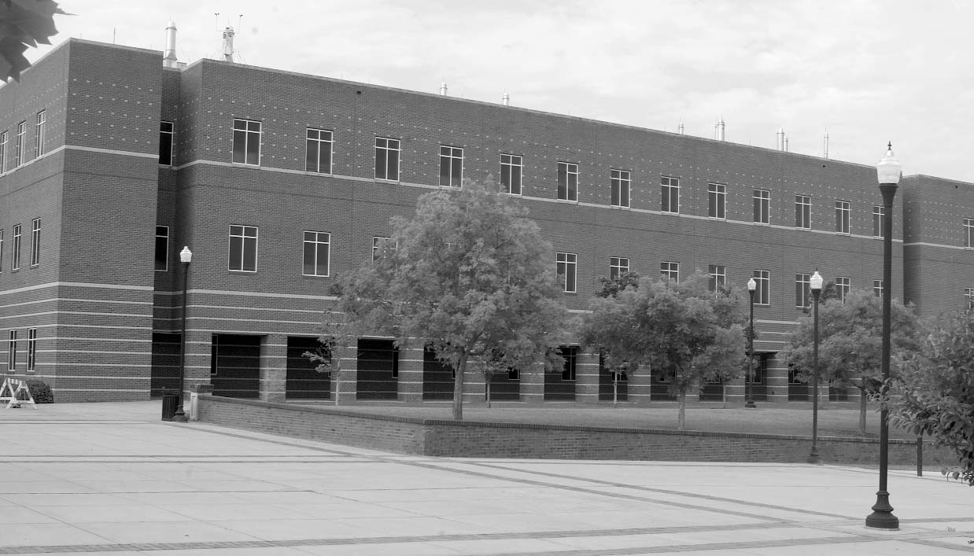

**Arts & Humanities**