**Albany State**

**Arts & Humanities**

**Business**

**Education**

**Sciences &**

**Health**

**Professions**

**Graduate**

**School**

**Course**

**Descriptions**

**Personnel &**

**Index**

DEPARTMENT OF PSYCHOLOGY,

SOCIOLOGY AND SOCIAL WORK

The Department of Psychology, Sociology and Social Work offers degrees in psychology, sociology and social work.

**PSYCHOLOGY**

The major in Psychology provides courses that lead to a Bachelor of Arts degree in psychology. The student who majors in psychology gains a fundamental understanding of the principles of human thought, emotion and behavior programs. In addition to the program’s emphasis on psychological factors and human learning, biological and social determinants of human behavior are also emphasized as well as research methods. This broad based training prepares students to understand, evaluate and influence their own behavior as well as the behavior of oth- ers. Because psychology is relevant to numerous fields, job opportunities for psychology majors are diverse and include employment in such areas as business and industry, educational settings, mental health agencies and hospitals, governmental agencies (including the military and law enforcement), etc. Students who plan to become professional psychologists or mental health practitioners will be prepared to continue their education in order to obtain a graduate degree in one of the more than 50 areas of specialization within psychology. The Psychology program is a member of the Council of Undergraduate Programs in Psychology. Departments with undergraduate programs in psychology, in institu- tions accredited for such purposes by their regional accrediting association, are eligible for membership on the council.

The major in Psychology requires:

1. Completion of a minimum of 120 semester hours with a cumulative grade-point average of at least 2.0.

2. Completion of all major courses with grades of “C” or above.

3. Completion of all required examinations: Psychology test of the Graduate Records Examination (GRE), or the Major Field Area Test and a departmental exit examination.

**90** 2008-2012 Undergraduate Catalog

**Psychology, Sociology**

**Education**

**Business**

**Arts & Humanities**

**Albany State**

**Personnel &**

**Index**

**Course**

**Descriptions**

**Graduate**

**School**

**Sciences &**

**Health**

**Professions**

**& Social Work**

**SOCIOLOGY**

The major in Sociology provides courses that lead to a Bachelor of Arts degree in sociology. The sociology program offers a variety of courses designed to enhance the knowledge of socio-cultural environments, human social behavior and social groups. In contrast to psychology, which focuses on individual behavior, sociology examines human behavior at the group level. Sociologists attempt to explain how and why society changes over time, and how and why societies differ from one another. The program of study in sociology provides students with adequate competencies for successful graduate study in sociology, other related behavior sciences, gerontology and religion. The degree provides some employment options at the bachelor’s level and by carefully selecting sociology and allied electives, students can enhance their employment possibilities. Sociology majors can also pursue a dual degree with either psychology or social work as the second major.

The major in Sociology requires:

1. Completion of 120 semester hours with a cumulative grade-point average of at least 2.0.

2. Completion of all major courses with grades of ”C” or above.

3. Completion of all required examinations: Sociology Test of the Graduate Records Examination (GRE), or the Major Field Area Test and a departmental examination.

**SOCIAL WORK**

(Accredited by the Council on Social Work Education, 2003)

The major in Social Work provides courses that lead to the Bachelor of Social Work (B.S.W.) degree. As of February 2003 the Social Work Program was awarded accreditation as a professional program by the Council of Social Work Education. The primary purpose of the B.S.W. program is to prepare students from a generalist practice perspective as an entry level social worker with the basic skills and knowledge base that include, but is not limited to, practice in social work and social welfare, maximizing human development and dignity, social justice and equality for diverse populations. The curriculum comprises of a liberal arts base, combined with professional courses, skills and ethics. Prepa- ration for a career as a generalist practice social worker is augmented by a supervised field practicum. The Child Welfare Certificate Program requires an internship with the Department of Family and Children Services. A Child Welfare Certificate is in conjunction with being a re- cipient of the IV-E Scholarship.

The major in Social Work requires:

1. Completion of 123 semester hours with a cumulative grade point average of at least 2.5.

2. Completion of all major courses with grades of “B” or above

3. Completion of the ACAT examination

A dual major program is available for students interested in combining three areas of study—Psychology and Social Work; Sociology and So- cial Work; Criminal Justice and Social Work. Students interested in a dual major must complete a field practicum in Social Work. Comple- tion of a dual major requires additional semester hours beyond the first degree. Arrangements for a dual major must be cleared with the Chair of the Department and the Social Work Director.

**MINORS IN PSYCHOLOGY AND SOCIOLOGY**

The Department of Psychology, Sociology and Social Work also offers minors in psychology and sociology. A minor program requires eight- een (18) semester hours in upper level prescribed courses along with elective courses. The department offers minors in psychology and soci- ology to enhance employment opportunities and/or preparation for graduate school. Each of the minors requires eighteen (18) semester hours of lower and upper level courses.

**MINOR IN PSYCHOLOGY**

Psychology 18 hours

**MINOR IN SOCIOLOGY** Anthropology 18 hours Gerontology 18 hours Sociology 18 hours Urban Studies 18 hours

2008-2012 Undergraduate Catalog **91**

**Psychology**

**Graduate**

**School**

**Personnel &**

**Index**

**Sciences &**

**Health**

**Professions**

**Course**

**Descriptions**

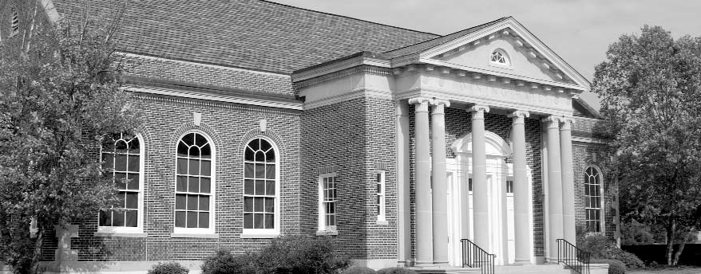

**CHILD WELFARE CERTIFICATE PROGRAM (TITLE IV-E)**

**Albany State**

Students accepted in the Social Work Program can apply for the Title IV-E Program. Interested students must contact the Social Work Pro- gram Office or the Title IV-E Coordinator. Three Social Work electives must be completed in conjunction with an internship with the De- partment of Family and Children Services. The three courses are:

SOWK 3291 – Family & Child Welfare SOWK 3383 – Social Work with Families SOWK 3275 – Forensic Interviewing

**Arts & Humanities**

**Sociology/Social Work**

**Education**

**Business**

**Arts & Humanities**

**Albany State**

**Course**

**Descriptions**

**Graduate**

**School**

**Personnel &**

**Index**

**Sciences &**

**Health**

**Professions**

|  |  |  |  |  |
| --- | --- | --- | --- | --- |
| **Junior Year** |  | | | |
| SOCI | 4300 | Behavioral Stats. | 3 |  |
| SOCI | 3317 | The Culture of Africa | 3 |  |
| SOCI | 3329 | Community Mental Health | 3 |  |
| Electives |  |  | 6 |  |
| SOCI | 4304 | Behavioral Research |  | 3 |
| SOCI | 3321 | Population |  | 3 |
| SOCI | 3311 | The Family |  | 3 |
| SOCI | 3380 | The Black Church |  | 3 |
| Electives |  |  |  | 3 |
| **Total** |  |  | **15** | **15** |
| **Senior Year** |  |  |  |  |
| SOCI | 4451 | Social Theory | 3 |  |
| SOCI | 4454 | Sociology Seminar | 3 |  |
| SOCI | 3371 | Juvenile Delinquency | 3 |  |
| SOCI | 4454 | Sociology Seminar | 3 |  |
| Electives |  |  | 3 |  |
| SOCI | 3360 | Urban Sociology |  | 3 |
| PSYC | 4464 | Social Psychology |  | 3 |
| Electives |  |  |  | 9 |
| **Total** |  |  | **15** | **15** |

**Social Work**

**Education**

**Business**

**Arts & Humanities**

**Albany State**

**Personnel &**

**Index**

**Course**

**Descriptions**

**Graduate**

**School**

**Sciences &**

**Health**

**Professions**

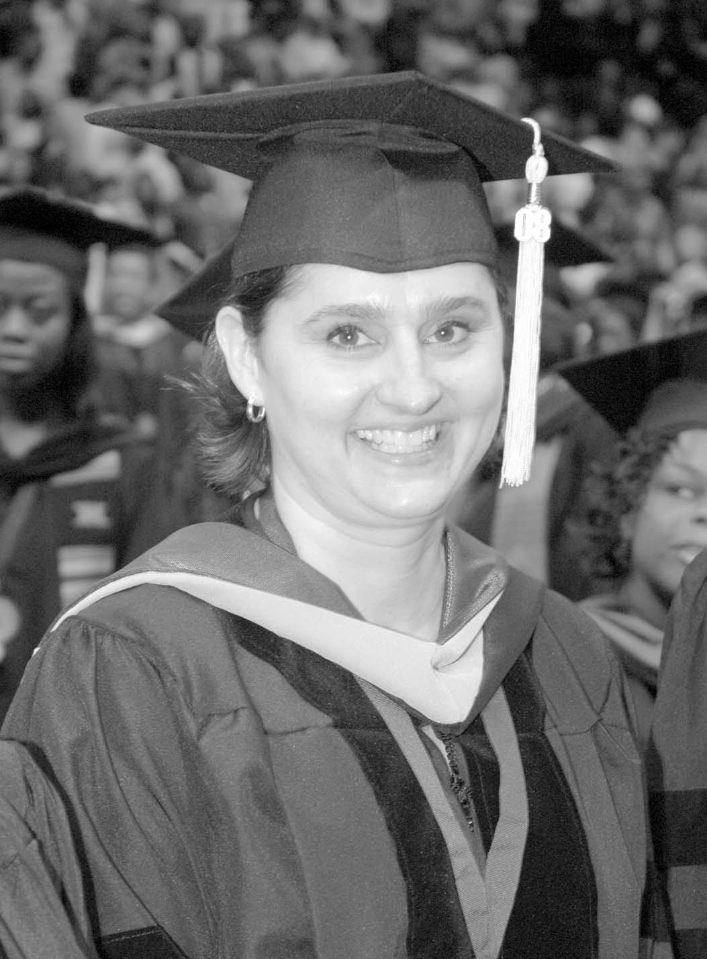

2008-2012 Undergraduate Catalog **97**