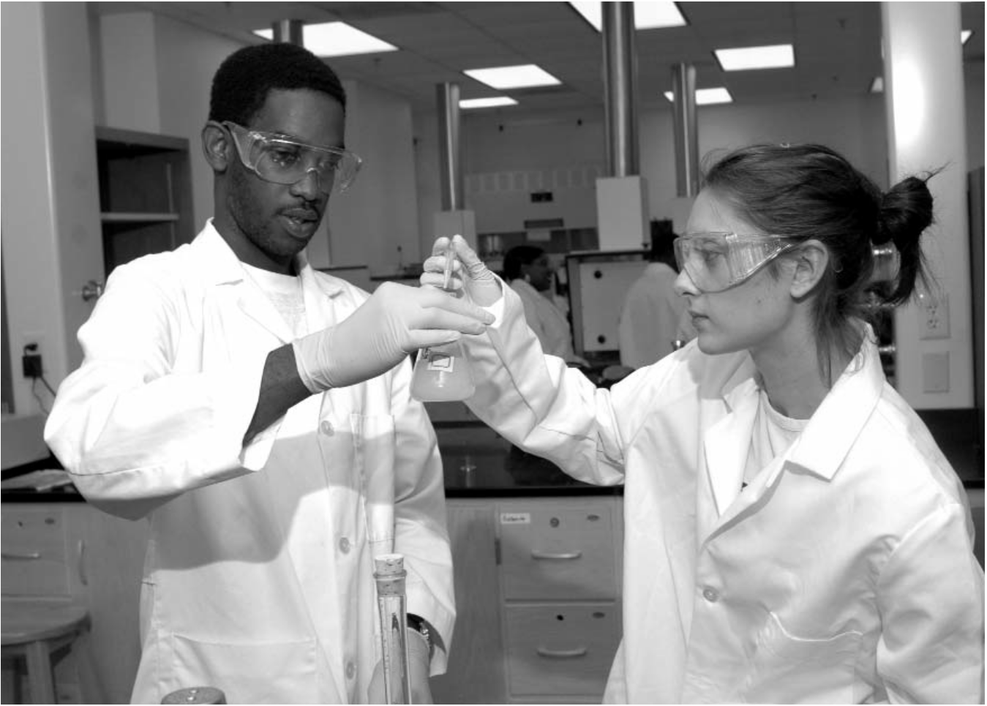

**Sciences &**

**Health**

**Professions**

**Graduate**

**School**

**Course**

**Descriptions**

**Personnel &Index**

**Albany State**

**Business**

**Education**

**Arts & Humanities**

**BACHELOR OF SCIENCE DEGREE IN SCIENCE EDUCATION**

**BROAD BASED SCIENCE**

**Courses Titles Credit Hrs.**

16 hours lower division (1000-2000 level)

|  |  |  |  |
| --- | --- | --- | --- |
| PHYS | 1111K | Introductory Physics I | 4 |
| PHYS | 1112K | Introductory Physics II | 4 |
| BIOL | 2111K | Biology I | 4 |
| BIOL | 2112K | Biology II | 4 |
| **Total Hours** |  |  | **16** |

**Major Courses Titles Credit Hrs.**

|  |  |  |  |
| --- | --- | --- | --- |
| EDUC | 2110 | Invest Critical/Contemporary Issues in Ed. | 3 |
| EDUC | 2120 | Explore Socio. Culture perspective on Diversity in | 3 |
| EDUC | 2130 | Expl Teaching/ Learning | 3 |
| EDUC | 4412 | Student Teaching | 12 |
| EDUC | 4405 | Methods/Material of Teaching Science | 3 |
| EDUC | 4400 | Prep. for Teaching | 2 |
| EDUC | 4441 | Teaching Reading in Sec. Sch. | 3 |
| CHEM | 2301K | Organic Chem I | 4 |
| CHEM | 2302K | Organic Chem II | 4 |
| CHEM | 3250K | Biochemistry | 4 |
| PHYS | 3002 | Advance Earth Space Science | 4 |
| BIOL | 2211K | Intro to Microbiology | 4 |
| BIOL | 3501K | Principle of Genetics | 4 |
| BIOL | 2311K | General Botany I | 4 |
| SPED | 3230 | Contemp. Perspective of Exceptional Students | 3 |
| **Total Hours** |  |  | **60** |

2008-2012 Undergraduate Catalog

**PROGRAM OF STUDY FOR THE BACHELOR OF SCIENCE DEGREE IN SCIENCE**

**Personnel &Index**

**Sciences &**

**Health**

**Professions**

**Course**

**Descriptions**

**Graduate**

**School**

**Education**

**Business**

**Arts & Humanities**

**Albany State State**

**EDUCATION BROAD BASED EMPHASIS**

**Freshman Year Fall Spring**

|  |  |  |  |  |
| --- | --- | --- | --- | --- |
| ASU | 1200 | Freshman Seminar & Service to Leadership | 3 |  |
| HEDP | 1001 | Introduction to Wellness or PEDH | 1 |
| HIST | 1002 | Intro. to the African Diaspora | 2 |
| ENGL | 1101 | English Composition I | 3 |
| ENGL | 1102 | English Composition II | 3 |
| MATH | 1113 | Pre-Calculus |  | 3 |
| BIOL | 2111K | Biology I | 4 |  |
| BIOL | 2112K | Biology II |  | 4 |
| CHEM | 1211K | General Chemistry I | 4 |  |
| CHEM | 1212K | General Chemistry II | 4 |  |
| EDUC | 2110 | Inves. Critical/Contemporary Issues in Edu. |  | 3 |
| **Totals** |  |  | **16** | **18** |

**Sophomore Year Fall Spring**

**Sciences &**

**Health**

**Professions**

|  |  |  |  |  |
| --- | --- | --- | --- | --- |
| ENGL | 2111 | World Literature | 3 |  |
| PEDH | 1002 | Fitness or other choice | 1 |
| MATH | 1211 | Calculus I | 4 |
| BIOL | 2311K | Botany I | 4 |
| EDU | 2120 | Explore Socio. Culture Perspective on Divers. | 3 |
| BIOL | 2211K | General Microbiology | 4 |
| POLS | 1101 | U.S. and GA Government | 3 |
| CHEM | 2301K | Organic Chemistry I | 4 |
| CHEM | 2302K | Organic Chemistry II | 4 |
| EDU | 2130 | Explore Teaching/Learning | 3 |
| PEDH | choice | 100X Physical Education choices | 1 |
| **Totals** |  |  | **16** | **18** |
| **Junior Year** |  |  | **Fall** | **Spring** |
| PHYS | 1111K | Introductory Physics I | 4 |  |
| PHYS | 1112K | Introductory Physics II | 4 |  |
| BIOL | 3501K | Principles of Genetics | 4 |  |
| CHEM | 3250K | Biochemistry | 4 |  |
| COMM | 1100 | Anal. Disc. Of Global Issues | 3 |  |
| Sped | 3230 | Contemp Perspective of Except Students | 3 |  |
| Area C | elective | Fine Arts/ Humanity elective | 3 |  |
| PHYS | 3002 | Adv Earth/ Space Science | 4 |  |
| Area E | elective | Social Science Elective | 3 |  |
| **Total** |  |  | **18** | **14** |

**Summer Session**

|  |  |  |  |  |
| --- | --- | --- | --- | --- |
| SPED | 2330 | Exceptional Children | 3 |  |
| MATH | 2411 | Statistics | 3 |
| **Total** |  |  | **6** |
| **Senior Year** |  |  | **Fall** | **Spring** |
| Area E |  | Social Science Elective | 3 |  |
| EDUC | 4400 | Prep. for Teaching | 2 |  |
| EDUC | 4441 | Teaching Reading | 3 |  |
| HIST | 1111 | World History I (or other history elective) | 3 |  |
| EDUC | 4405 | Methods of Teaching Science | 3 |  |
| EDUC | 4412 | Student Teaching | 12 |  |
| **Total** |  |  | **14** | **12** |